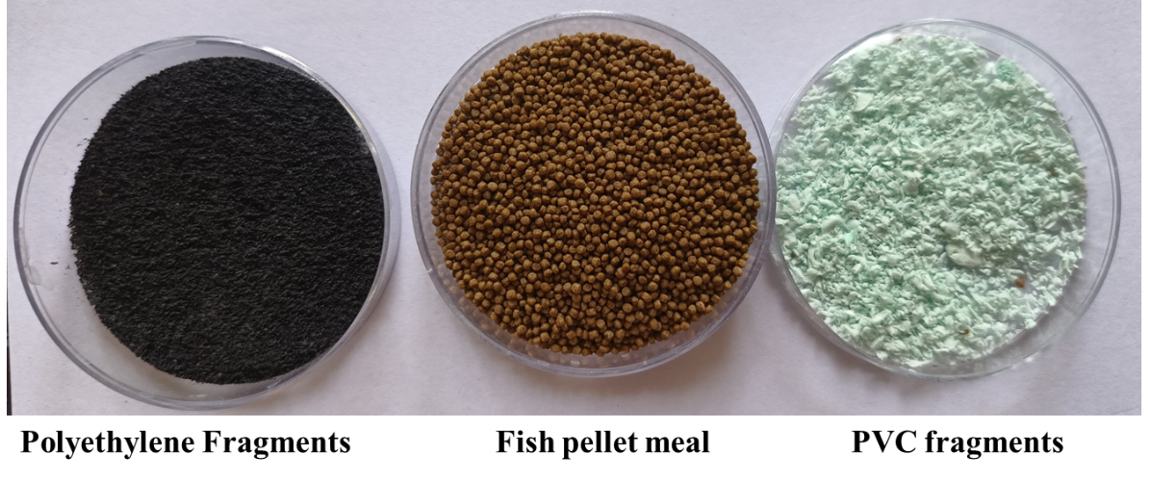

Fig. S1. Raw plastic fragments and fish pellet meals
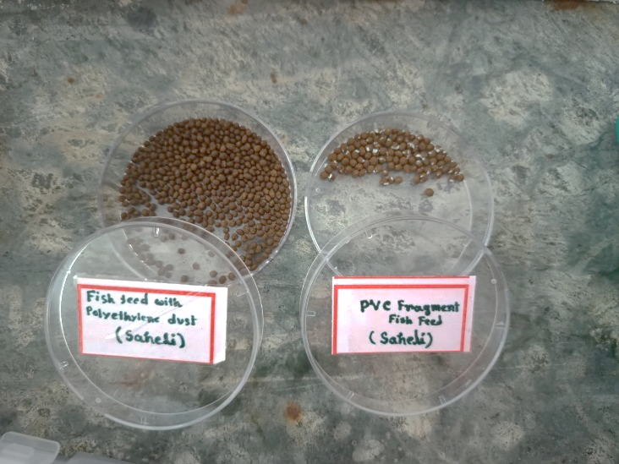

Fig. S2. Fish meal with PVC and PE fragments

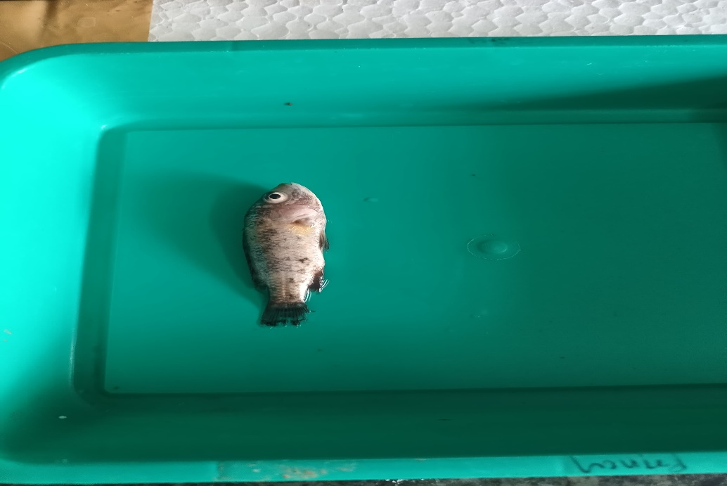
Fig.S3. Pigmentation of fish during the exposure experiments
a.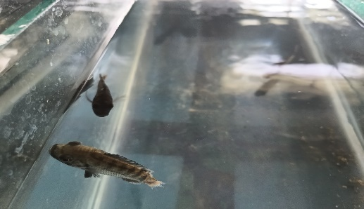 b. 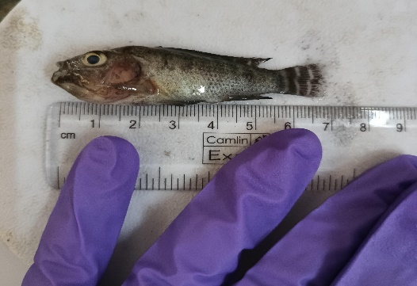
Fig. S4 a. Loss of anal fin and b. Swelling body during the exposure experiments

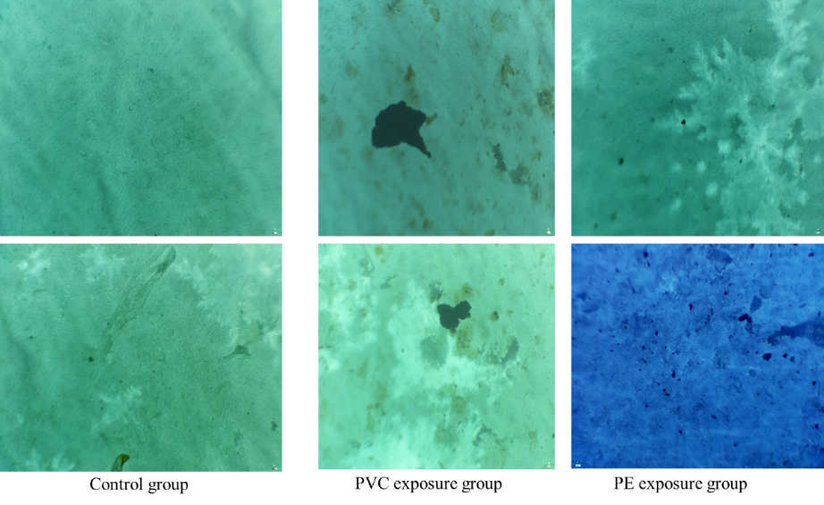
Fig S5- Ingestion and accumulation of PCV and Polyethylene MPs in Tilapia

