Supplementary information for: Unlocking innovation in climate services through meaningful co-production for nature-based solutions
Petra Holden^{a*}, Gerald Ngoma^{b}, Martine Visser^{b}, Leonard Kofitse Amekudzi^{c}, Millicent Amekugbe^{d}, Ebenezer Boahen^{d}, Eunice Boruru^{e}, Arthur Bostironnois^{f}, Sampson Dordaa^{d}, Daniel Esukuku Ekai^{g}, Cherie Forbesª, Christopher Gordon^{d}, Glynis Humphreyª, Doreen Lartey^{d}, Adelina Mensah^{d}, Lazaro Mngumi^{h}, Jane Wangui Mugo^{e}, Mark Newª, Linda Obiero^{e}, Gilbert Ouma^{e}, Lisa van Aardenne^{i}, Ruwani Walawegeª and Piotr Wolski^{i}.
ªAfrican Climate & Development Initiative, University of Cape Town, Cape Town, South Africa
^{b}School of Economics, University of Cape Town, Cape Town, South Africa
^{c}Department of Meteorology and Climate Science, Kwame Nkrumah University of Science & Technology, Ghana
^{d}Institute for Environment and Sanitation Studies, University of Ghana, Accra, Ghana
^{e}Department of Earth and Climate Sciences, University of Nairobi, Kenya
^{f}Bôndy International, Antananarivo, Madagascar
^{g}Department of Anthropology, Gender and African Studies, University of Nairobi, Nairobi, Kenya
^{h}Institute of Human Settlements Studies, Ardhi University, Dar Es Salaam, Tanzania
^{i}Climate System Analysis Group, University of Cape Town, Cape Town, South Africa

* Petra Holden
Email: petra.holden@uct.ac.za

Supplementary Methods

Interview schedule. Please find the interview schedule administered as a hard-copy (Interview schedule) and via a web-based platform (Online interview schedule). Please find the key terms that were explained and discussed with respondents before the interview commenced (Key terms for Albatross survey).
Albatross case sites. This study was conducted within a project known as Albatross which included seven case study sites across Sub-Saharan Africa. The ALBATROSS project (Grant Agreement No. 101137895) is an EU-funded research initiative to advance knowledge for long-term benefits and climate adaptation through climate services and nature-based solutions (NBS) in Su-Saharan Africa. (https://albatross-project.eu/hubs/) (Fig. S1, Table S1-2).
Data analysis. All statistical analyses were performed in R (v 4.4.1) (1) using the glmmTMB package for fitting zero‐inflated Tweedie generalized linear mixed models (2, 3), the DHARMa package for simulation‐based residual diagnostics—including dispersion and zero‐inflation testing (4, 5), the psych package for Cohen’s Kappa (6, 7), and ggplot2 for visualisations (8).
Handling missing ranks. Respondents could optionally omit one or more of their three ranked uses (U₁–U₃) or needs (N₁–N₃). To ensure that the use-need alignment score reflected only the priorities each respondent provided—and did not artificially deflate scores when ranks were unranked—we defined nine missing‐data conditions (Table S13). For each condition, the following applies: i) available points (Pavail), which is the sum of maximum points (3 per rank) for only the comparisons the respondent could make; ii) maximum available points (Pmax = 9), which is used for rescaling all scores to the 0-9 range; iii) scoring approach which handles how to treat NAs including whether each “missing” comparison is scored as a zero (no match) or treated as structurally missing (NA) and excluded from both numerator and denominator. For example, if only N₃ was omitted (Condition 1 in Table S13), Pavail = 9 (all three uses still compared to N1/N2) but comparisons between U₁–N₃, U₂–N₃, U₃–N₃ receive 0 points, and the score is scaled over 9 points. This contrasts with when both U₃ and N₃ are omitted (Condition 6 in Table S13). Here Pavail = 6 (only ranks 1 and 2 compared), any comparison involving the missing third rank is recorded as NA and excluded. These rules guarantee that a respondent’s use-need alignment score reflects exactly the set of comparisons they provided, without penalizing for unranked positions. The full set of conditions are detailed in Table S13).

Supplementary Results

Nature-based solution operating scales. Overall, the most reported operating scales for NbS work or livelihoods were sub-national (40%), national (37%), and local (36%). Fewer respondents reported operating at the international (18%) and transboundary (10%) scales (Fig. S3).
The distribution of operating scales varied by stakeholder type. Community groups predominantly operated at the local scale, while other scales had much lower representation. Sub-national operations were most common among government organizations, followed by private sector actors, parastatal agencies, research organizations, and NGOs (Fig. S3).
At the national level, parastatal agencies and research organizations had the highest representation, followed by NGOs, private sector actors, government organizations, and intergovernmental organizations. International operations were most frequently reported by Intergovernmental organizations, with lower representation across all other stakeholder types (Fig. S3).
Nature-based solution characteristics. Respondents reported a wide range of nature-based solution activities that they worked on in their organisations or used to support their livelihoods. Stakeholders interviewed were involved mostly in protection (70%), sustainable management (71%) and restoration (62%) nature-based solution. Design-based nature-based solution were the least frequent (25%) (Fig. S4). This pattern was similar across all the case sites however, the order of the top three differed.
Respondents from Umzimvubu and Turkana most frequently reported involvement in sustainable management and restoration. In contrast, sustainable management and protection were more commonly reported in the Keta, Kigamboni, Morondava, and Kumasi hubs. In Tamatave, protection and restoration were the most frequently reported nature-based solution activities, with significantly fewer stakeholders involved in sustainable management.
Protection nature-based solutions included protecting forests, mangroves, rivers, and grazing lands through community-led conservation initiatives, enforcement of bylaws, and education campaigns to reduce overfishing and deforestation. Restoration efforts focused on replanting native and fruit trees, rehabilitating wetlands and mangroves, reseeding rangelands, and using erosion control measures like gabions and vetiver grass to stabilize soils and prevent degradation. Sustainable management nature-based solutions included practices such as agroforestry, conservation agriculture, rotational grazing, and beekeeping. Further design-based nature-based solutions included integrating green-blue infrastructure with grey, such as constructing rainwater harvesting systems with soil pits to increase soil moisture, building irrigation canals to support agroforestry, and creating urban greening projects like tree planting to provide shade and mitigate extreme heat in urban areas.
Most respondents reported using nature-based solutions to address key challenges such as environmental degradation, climate change adaptation, socioeconomic development, food security, water security (Fig. S5). Additionally, in the Keta Basin, Kigamboni, Turkana, and Morondava hubs, nature-based solutions were also commonly used for climate change mitigation.
The top priorities for using nature-based solutions varied by hub (Fig. S5): i) Kumasi - disaster risk reduction and climate change adaptation; ii) Morondava - socioeconomic development; iii) Tamatave - environmental degradation and water security; iv) Turkana - food security and socioeconomic development; v) Umzimvubu - socioeconomic development, environmental degradation, and climate change adaptation; vi) Keta - climate change adaptation and climate change mitigation; vii) Kigamboni - environmental degradation and climate change adaptation.
Existing use and need for Climate Services for nature-based solutions. Almost all stakeholders reported using and/or needing climate services in their work on nature-based solutions. Among the stakeholders interviewed (n=530), 97% (n=514) either used or needed climate services (Table S4), and 78% fell into both categories i.e., both used existing and needed new climate services (n=412).
Of the 88% who used climate services (n=469), 91% (n=467) applied them directly to their work on nature-based solutions. Similarly, of the 86% (n=457) that needed new climate services, 94% (n=429) required them specifically for nature-based solutions, accounting for 81% of the total stakeholders.
Community groups, as well as the private and research sectors, primarily acted as users of climate services (Fig. S6). In contrast, NGOs, parastatal agencies, and intergovernmental organizations often played a dual role, both using and providing climate services. Governments, too, frequently serve as both users and providers, rather than being exclusively users.
Limitations in existing climate services used. Overall, respondents most frequently identified four key limitations in the climate services they currently use: i) lack of integration of local and Indigenous knowledge (ILK), ii) limited accessibility, iii) untimely delivery, iv) not well known/credible; and v) inappropriate delivery channels. However, the distribution of these limitations varied across different hubs and stakeholder groups (Fig. S7).
Climate change literacy for improving use of climate services. Most respondents (63%) identified a lack of competence or knowledge in climate change, its impacts, and its solutions as a major barrier to the active use of climate services for decision-making and planning for nature-based solutions and adaptation (Fig. S8). This trend was consistent across all stakeholder groups, with more respondents viewing it as a restriction rather than not. However, nearly half of the respondents from parastatal agencies, NGOs, research institutions, and intergovernmental organizations (IGov) felt that it was not a restriction. This contrasts with community groups and government institutions, where higher proportion of respondents perceived it as a limitation.
Among the hubs, the pattern shifted for Tamatave and Morondava, where more respondents indicated that it was not a restriction—particularly in Morondava, where this trend was most pronounced. In contrast, respondents from Kigamboni, Kumasi, and Turkana were far more likely to identify climate change literacy as a limitation compared to the overall pattern.
The most common needs (Fig. S9) for improving climate literacy were: i) a better understanding of climate change, ii) a better understanding of the climate system, iii) a better understanding of available climate services, and iv) more skills to use climate services for work or livelihoods. To a lesser extent, v) the ability to communicate about climate change was also noted. Additionally, motivation to use climate services was particularly important in Morondava and Kigamboni. In Umzimvubu, the ability to communicate about climate change was just as important as the top three overall needs.
Integration of Indigenous and/or Local Knowledge (ILK) into climate services. Almost all (91%) respondents indicated that it would be important to integrate indigenous and/or local knowledge into new climate services developed for nature-based solutions and other adaptation (Fig. S10). This was clearly important across hubs and stakeholder types. However most so in Umzimvubu and Turkana (100%) and for community groups (100%).

Priority existing uses & needs for nature-based solutions and other adaptation options
Decision making type and timescales. We observed a general trend between climate service needs and the decision-making and planning time horizon. Specifically, climate service needs were more frequently prioritized for shorter timescales (e.g., daily) and less frequently for longer timescales (e.g., 10–30 years or >30–150 years), reflecting the role of time preferences in decision-making (Fig. S11).
On average, stakeholders prioritized climate services to support urgent, daily decision-making related to nature-based solutions or adaptation practices or livelihoods, including responding to emergencies. This was followed by daily to weekly decision-making, while planning for 1–6 months ahead was ranked as the third priority. Almost no stakeholders (<3%) prioritized climate services for informing decisions beyond 30 years (30–150 years) as a first, second, or third priority.
However, not all case sites (Fig. S12) or stakeholder groups (Fig. S13) followed this pattern exactly. In the Umzimvubu hub, stakeholder preferences for timescales were evenly distributed across most categories, except for as with the common trend very few respondents prioritizing long-term horizons, which was consistent with other hubs (Fig. S12). In Turkana, climate services for 1–3-year timescales were as frequently ranked as important as shorter-term planning horizons such as daily, weekly and 1-6 months.
In terms of stakeholder groups, community groups appeared to prioritize climate services for short-term decision-making (daily, daily to weekly, and 1–6 months) over longer-term planning (1–3 years and 10–30 years) (Fig. S13). In contrast, other stakeholders (government agencies, intergovernmental organizations, NGOs, parastatals, private companies, and researchers) were more likely to prioritize longer-term planning (1–3 years and 10–30 years) than community groups while still valuing shorter time horizons (daily, daily to weekly, sub-seasonal, and seasonal scales) the most. Intergovernmental organizations stood out as the most likely to prioritize climate services for long-term planning (10-30 years), in contrast to other stakeholder groups.
Priority Hazards for climate services. Overall, three key hazards emerged as top priorities across hubs and stakeholder types, ranking first, second, and third, respectively: i) high temperatures and extreme heat, ii) high rainfall and flooding, and iii) low rainfall and drought (Fig. S14). Beyond these, wind, fire, and erosion were considered priorities by a smaller number of respondents, while cold extremes were the least prioritized.
There were notable exceptions to this general pattern. In Morondava, windstorms and windiness were considered as important as extreme heat. In Umzimvubu, fire was ranked a priority by nearly the same number of respondents who identified heat extremes, floods, and droughts as their top three hazards. In Kumasi, fire was also considered a priority alongside the top three hazards being as frequently chosen as low rainfall and drought (Fig. S12).
Unlike in decision-making contexts, there were no clear patterns between priority hazards and stakeholder groups. The only exception was community groups, who ranked windstorms and windiness higher than drought as their third priority, and government that ranked fire just higher than low rainfall and drought. Most other stakeholder groups either ranked wind lower or considered it equal to drought as a third priority (Fig. S13).
Climate Service information focus. Stakeholders prioritized weather and climate information as the most important and this was followed by biophysical or hydrological information (e.g., river flow, soil moisture, biomass, fire). Integrated climate risk information, which synthesizes multiple data categories, was in most cases cited as frequently as socio-economic information Fig. S13). It was evident that integrated climate risk information was an expanding need given the increased frequencies for incorporating it into new climate services as opposed to the number of respondents already using it. Deviations from this general pattern included Turkana and Umzimvubu, which had a higher frequency of stakeholders that ranked integrated climate risk information as a priority for climate services as opposed to weather/climate information (Fig. S12).
Climate Service format needs. For existing uses, high-priority formats included numeric data and narratives, followed by graphs and maps and then illustrations and animation/video. In contrast to the needs for new climate services, respondents similarly prioritized numeric formats but then found narratives, maps, illustrations and animation/video being of relative equal importance. For needs graphs was the format that was least prioritized (Fig. S11).
However, some deviations from this general trend were observed. In the Umzimvubu hub, a higher number of stakeholders ranked illustrations as a priority than numeric data. In Morondava, an equal number of stakeholders prioritized graphs and numeric information as their top choice (Fig. S12).
When analyzing stakeholder groups, we found that community groups and the private sector more frequently or just as often prioritized narratives over numeric data within both use and need categories, whereas intergovernmental agencies and researchers were more inclined to rank graphs as their priority over narratives. Preference for illustrations and animations/videos—rather than maps and graphs—was particularly pronounced among community groups (Fig. S12).
Climate Service geographical scale needs. Overall, stakeholders primarily required climate services to support decision-making at the community scale (Fig. S11) followed by the sub-national, ward and municipal levels. The fewest stakeholders across the hubs indicated a need for climate services at the national and transboundary levels. Hence a clear pattern emerges that the highest priorities align with finest level of geographical scale needs. However, Morondava and Turkana deviated from this trend, with more stakeholders prioritizing climate services at the municipal and sub-national levels, respectively, rather than at the community scale (Fig. S12).
Among stakeholder groups, intergovernmental agencies differed from the overall pattern, placing equal importance on sub-national, ward, and community levels (Fig. S13). Additionally, stakeholders in intergovernmental agencies were more likely than other groups to prioritize transboundary climate services.
Community groups, NGOs, and private sector stakeholders more frequently ranked the ward level as a second priority, whereas government and intergovernmental agencies tended to prioritize municipal or sub-national levels over the ward level. Parastatals showed a greater interest in sub-national levels as a second and third priority, while national-level climate services were prioritized by as many stakeholders as those who prioritized community-level services (Fig. S13).
Climate Service delivery mechanisms. The highest-priority delivery channels currently being used were mobile devices and extension services whereas this shifted to mobile devices and community radio for needs for new climate services (Fig. S11). Other channels that were occasionally ranked as the top choice across hubs and stakeholder groups included computers, national radio and tv.
Some notable deviations from this overall trend were observed. In Umzimvubu, extension services were more frequently ranked as the top priority, while in Kigamboni and Tamatave, national radio was more commonly prioritized (Fig. S12). Research institutions were more likely to rank computers as their first choice, and computers were also important for NGOs, parastatals, and intergovernmental organizations (Fig. S13). Extension services were frequently ranked as a top priority by most stakeholder groups, particularly NGOs and government entities, but were less commonly prioritized by intergovernmental institutions.
Climate Service receiving platforms. The highest priority receiving platforms for use were websites, news, social media, and technical reports. For needs this pattern shifted to sms/whatsapp/instant messaging, social media, news and in-person followed by apps and then websites (Fig. S11).
Some notable deviations from this overall pattern were observed. In Morondava, social media was ranked as the most important platform, while in Kigamboni, it was frequently ranked as a second priority (Fig. S12). In-person interactions were the top priority in Keta and Turkana, whereas apps, socials and instant messaging were the most preferred platform in Umzimvubu .

Supplementary Figures
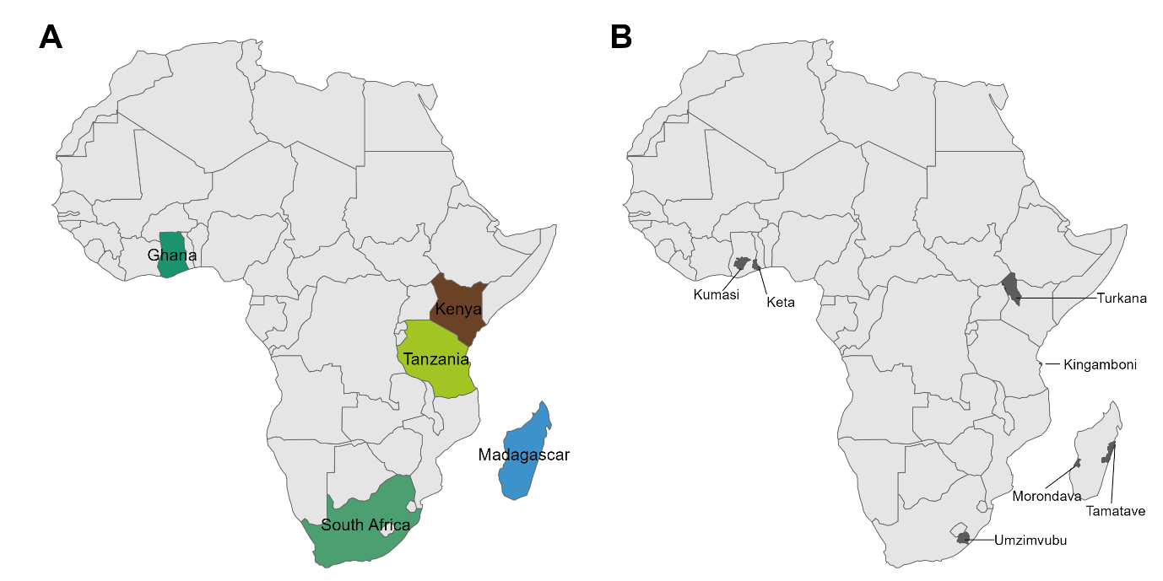
Fig. S1. Case sites and countries from which respondents were asked about their climate service current uses and desired needs for nature-based solutions. These sites form the Albatross Climate Resilient Development Network and referred to as hubs within the project (https://albatross-project.eu/hubs/).

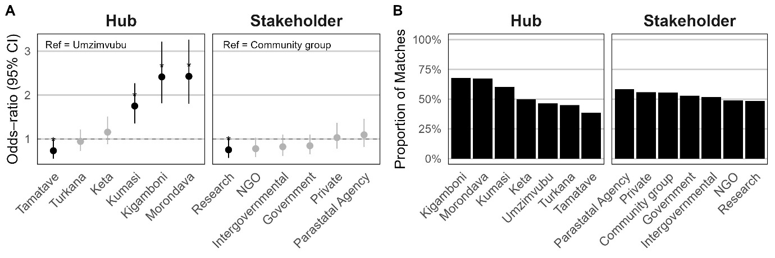
Fig. S2. Effects of geographical location and stakeholder type on the likelihood of climate service use-need overlap at first rank (U₁-N₁ overlaps) in Sub-Saharan Africa. (A) Shows conditional odds‐ratios (RR) and 95 % confidence intervals for case sites (hubs) and, stakeholder types (stakeholder) on the binary outcome of match or no match (0/1) estimated from a binomial logistic regression. Points marked * differ significantly (p < 0.05) from their reference levels (shown at top-left of each panel). (B) shows proportions of respondents with first rank use of existing climate services matched with their first rank need for a completely new climate service.
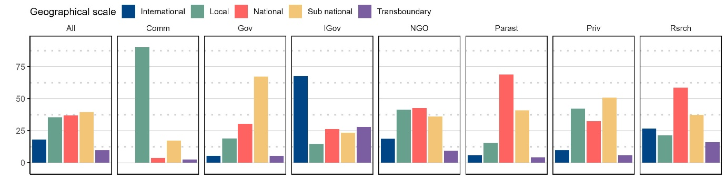
Fig. S3. Stakeholder type and their respective operating geographical scales for their work or livelihoods relating to nature-based solutions. Bars show percentage of respondents per geographical scale for across. Sample sizes are shown in Table S3.

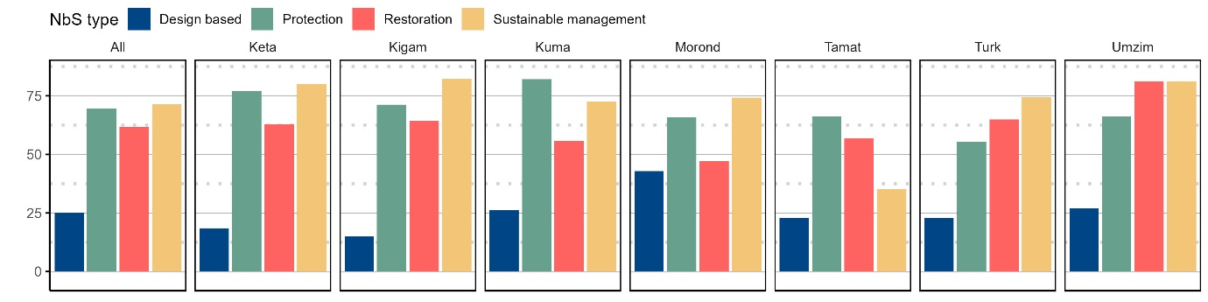
Fig. S4. The distribution of nature-based solution types across the surveyed case sites (Fig. S1, Table S2). Each bar shows the percentage of respondents. Sample sizes are shown in Table S3.

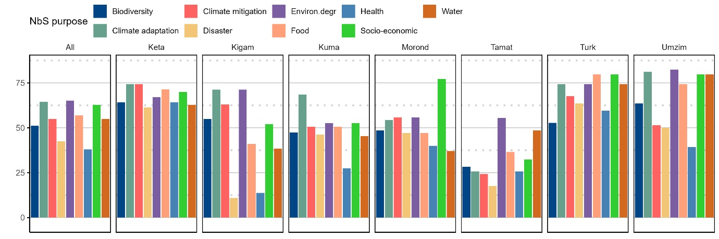
Fig. S5. The distribution of main purpose for using nature-based solution across the case sites (Fig. S1, Table S2). Each bar shows the percentage of respondents. Sample sizes are shown in Table S3.
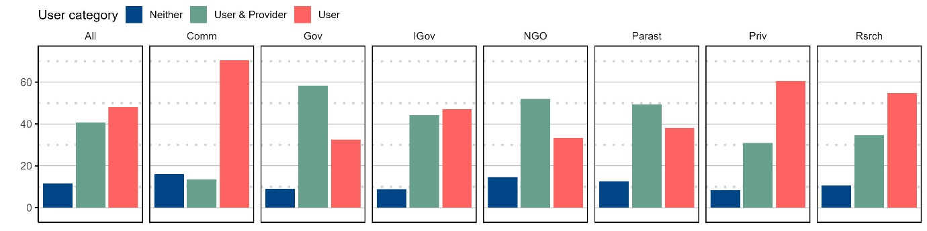
Fig. S6. Stakeholder roles in the use and provision of climate services. The variation in roles stakeholders play in using and providing (user & provider) or solely using (user) climate services for nature-based solutions. Each bar shows the percentage of respondents. Sample sizes are shown in Table S3.

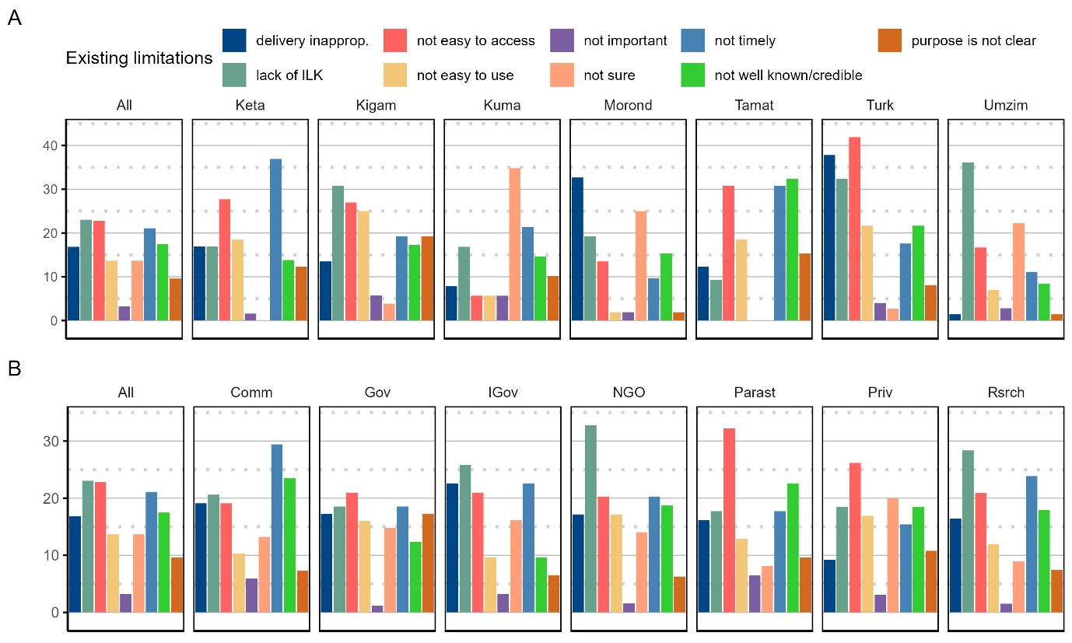
Fig. S7. Limitations of existing climate services used by respondents across case sites and stakeholder types (Fig. S1, Table S2). Each bar shows the percentage of respondents. Sample sizes are shown in Table S3.
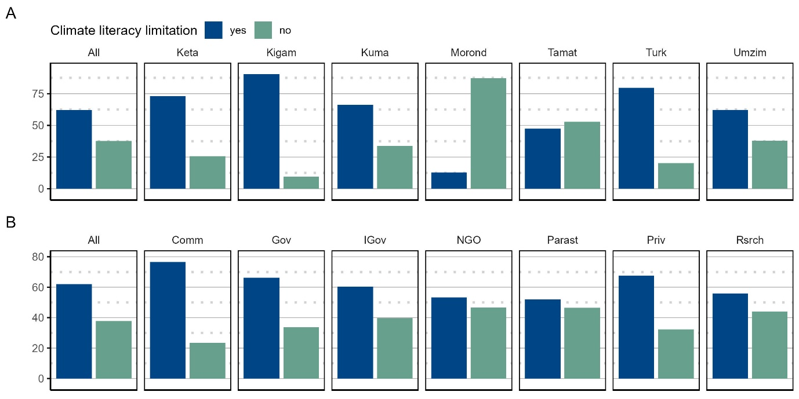
Fig. S8. Percentage of respondents indicating that a lack of climate change literacy (knowledge about climate change) is limiting the use of climate services by their institution across A) the case sites (Fig S1, Table S2); and B) stakeholder types. Each bar shows the percentage of respondents. Sample sizes are shown in Table S3.

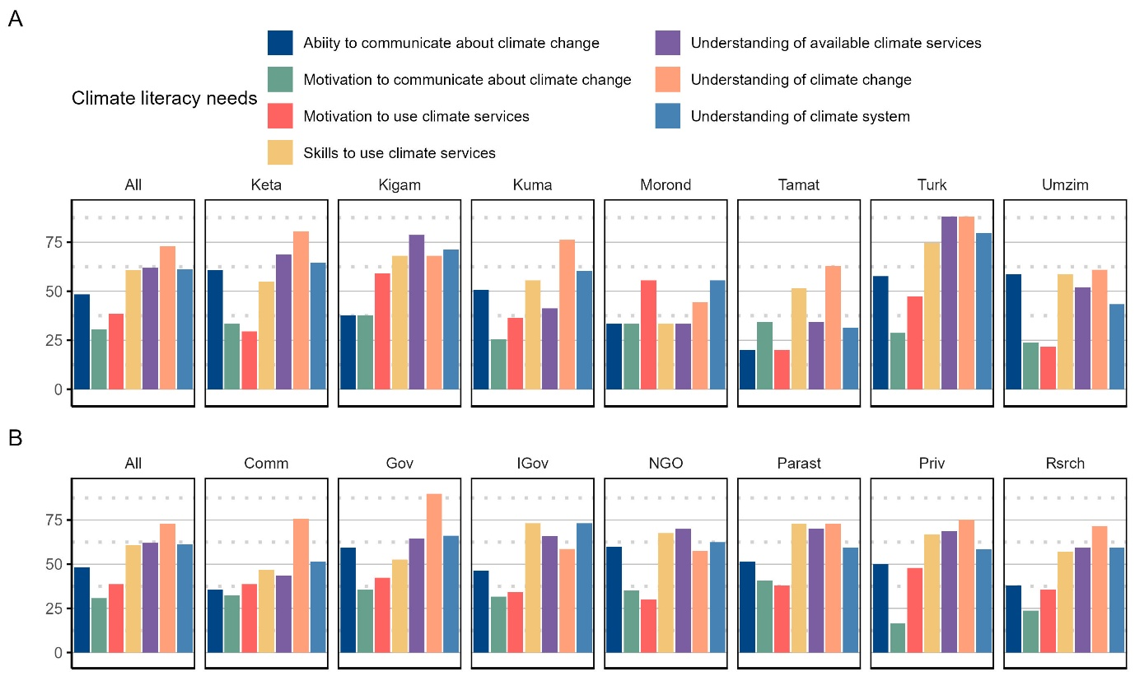
Fig. S9. Elements of climate change literacy that require strengthening according to respondents that felt that a lack of climate change literacy was hampering the use of climate services by their institution across A) the case sites (Fig S1, Table S2); and B) stakeholder types. Each bar shows the percentage of respondents. Sample sizes are shown in Table S3.
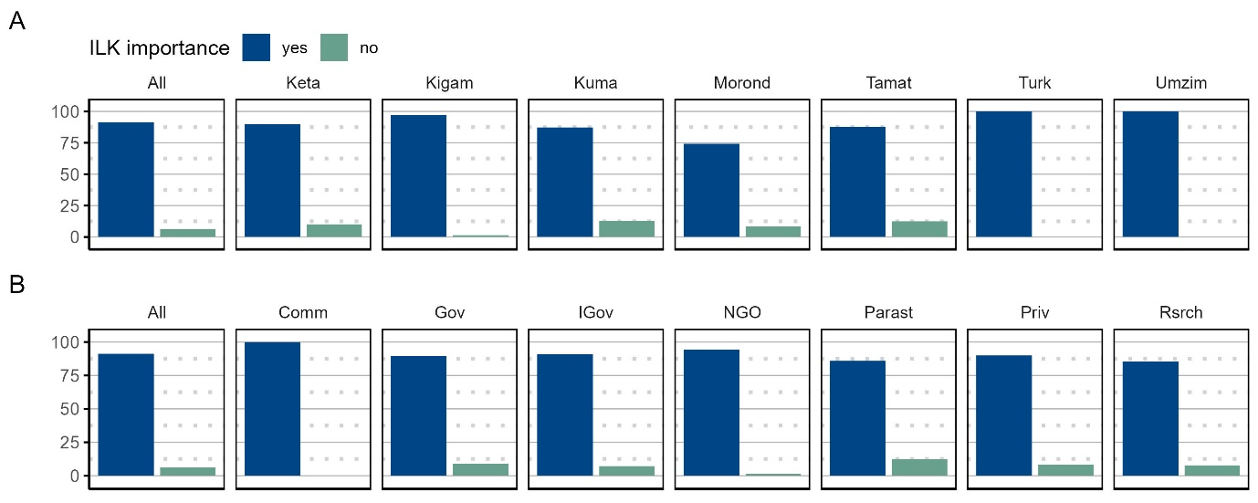
Fig. S10. Percentage of respondents indicating that they feel it is important to integrate indigenous and/or local knowledge into new climate services developed for nature-based solutions and other adaptation across A) the case sites (Fig S1, Table S2); and B) stakeholder types. Each bar shows the percentage of respondents. Sample sizes are shown in Table S3.

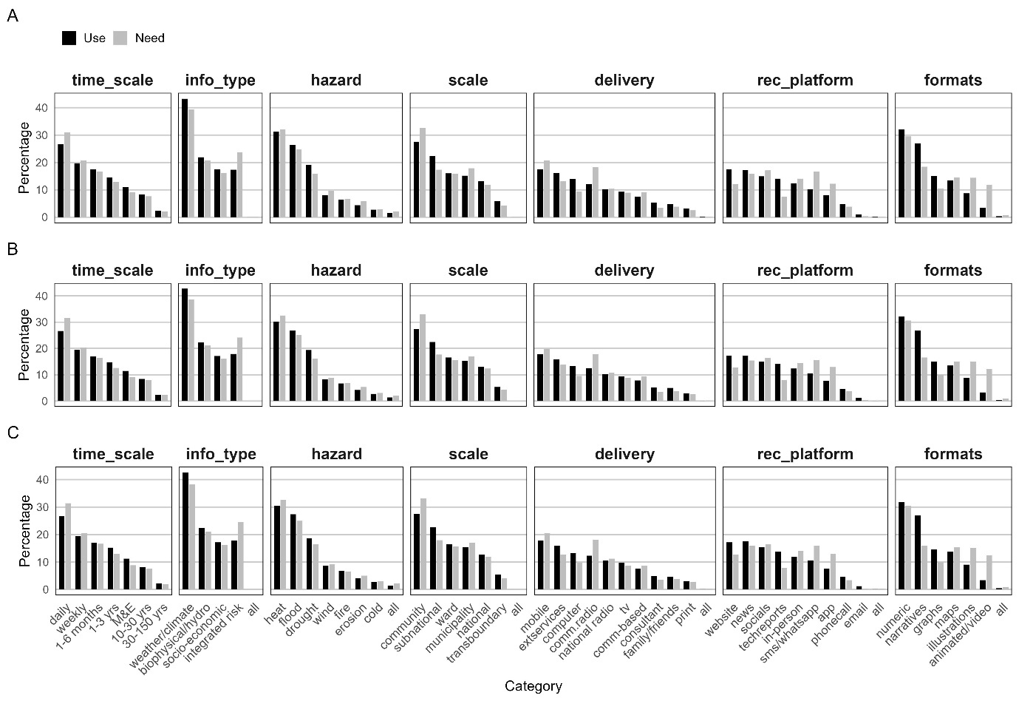
Fig. S11. Overall priority top three existing climate service use and needs for seven climate service themes for nature-based solutions and other adaptation options in the case sites. For the full x axes categories see Table S6. A) for all respondents (n=514) that either currently use or need climate services for nature-based solutions or other adaptation; B) for only respondents (n=412) that were both existing users but also had desired needs for new climate services for nature-based solutions or other adaptation; C) for only respondents (n=386) in B but that exclusively needed these for nature-based solutions so excluding other adaptation. The distributions do not differ depending on these different combinations of use and needs.
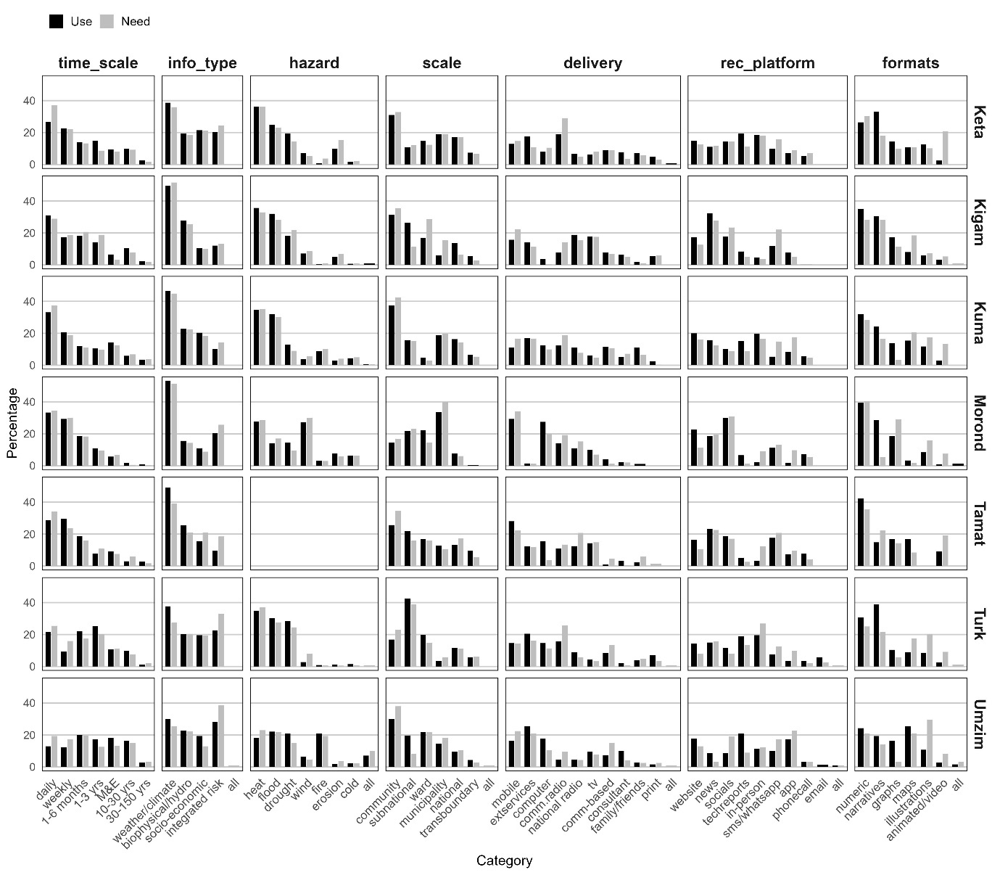
Fig. S12. Overall priority climate service use and need priorities for all respondents that either used or needed climate services (n=514) disaggregated by location in Sub-Saharan Africa for seven main climate service themes. For the full x axes categories see Table S6.

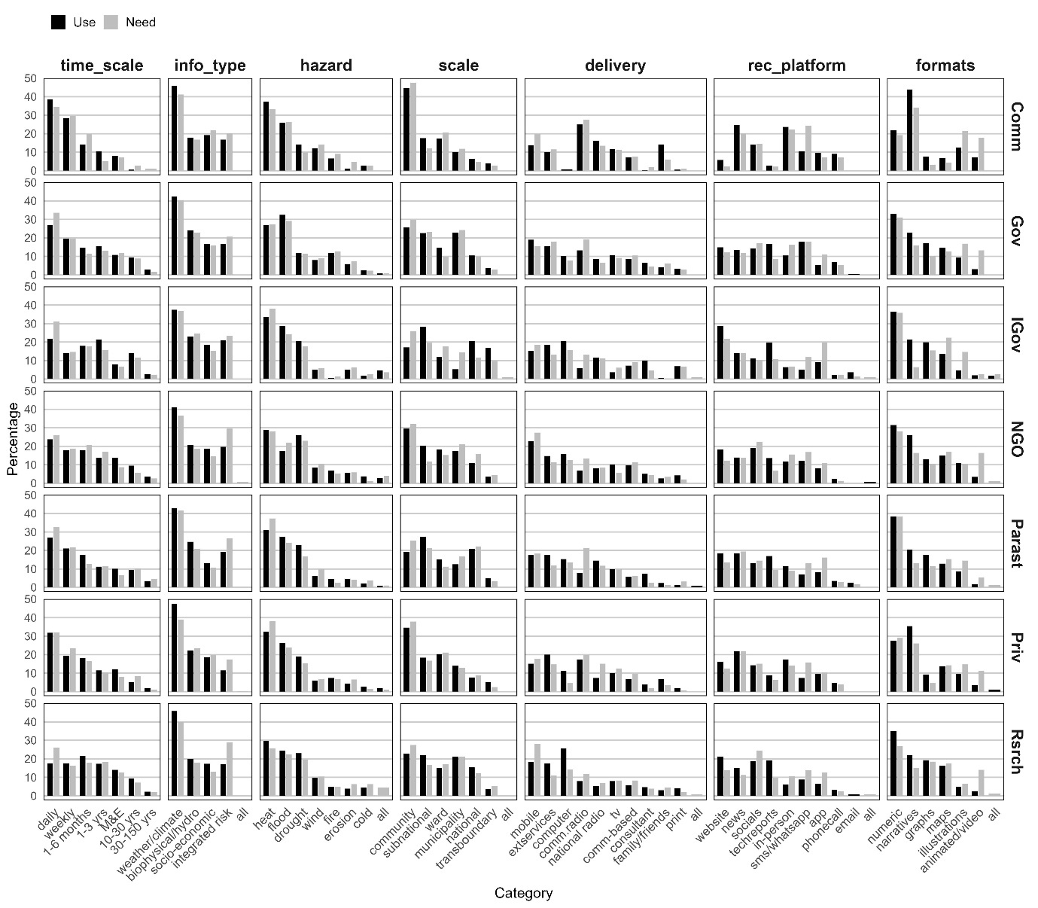
Fig. S13. Overall priority climate service use and need priorities for all respondents that either used or needed climate services (n=514) disaggregated by stakeholder type in Sub-Saharan Africa for seven main climate service themes. For the full x axes categories see Table S6.

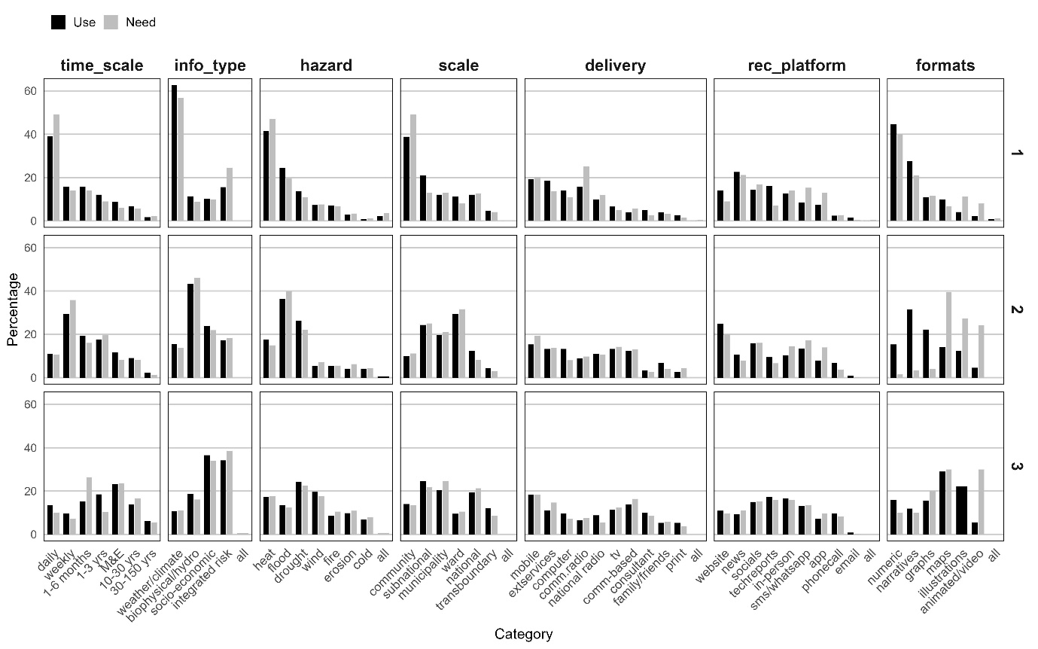
Fig. S14. Overall priority climate service use and need priorities for all respondents that either used or needed climate services (n=514) disaggregated by rank level 1-3 in Sub-Saharan Africa for seven main climate service themes. For the full x axes categories see Table S6.

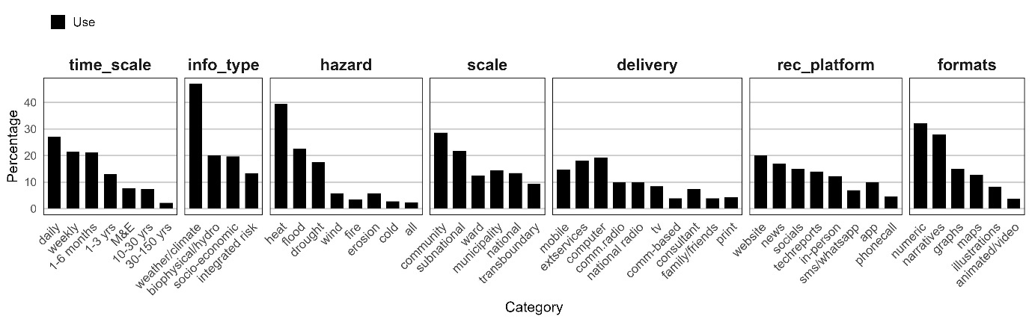
Fig. S15. Overall priority climate service existing use priorities for respondents that currently used climate services but did not need a new climate service (n=57). For the full x axes categories see Table S6.

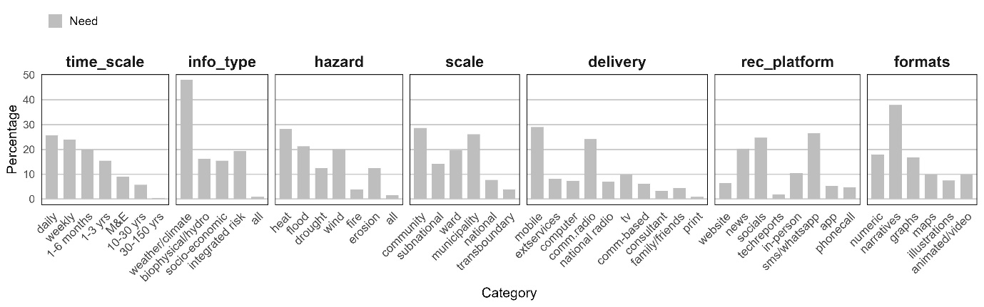
Fig. S16. Overall priority climate service need priorities for respondents that did not currently use climate services but had desired needs for a new climate service (n=45). For the full x axes categories see Table S6.

Supplementary Tables

Table S1. Climate financing flows to focal study case site countries. Statistics represent percentage of total funding in Sub-Saharan Africa excluding multi-country and regional projects. Total funding = grants + concessional loans and equity (source: Climate Funds Update. https://climatefundsupdate.org/).
Country | Grant (%) | Total funding (%)
Ghana | 4.06 | 3.75
Kenya | 1.77 | 2
Madagascar | 3.35 | 2.83
South Africa | 2.46 | 11.91
Tanzania | 4.31 | 4.71

Table S2. Case site ecological, climatic, socio-economic characteristics, climate literacy (9-11) (https://albatross-project.eu/hubs/), frequency of extremes during 2015-2024 (https://public.emdat.be/)
Hub | Country | Ecoregion | Pop. density | Climatic zone | Type of residence | Main economic activities | Climate literacy (%) | Floods | Storm | Fire | Drought | Heat wave | Landslides
Keta | Ghana | Mostly forest-savanna (82%) with small areas of Central African mangroves (13%) and Eastern Guinean forests (5%) | 302.24 | Tropical wet-dry or Savanna | Rural | Livestock rearing,fisheries, salt and sand mining, construction, trade, transport, and eco-tourism | 38 | 8 | 1 | 0 | 0 | 0 | 0
Kigamboni | Tanzania | Mostly Northern Swahili coastal forests (96%) with small areas of East African mangroves | 3329.09 | Tropical wet-dry or Savanna | Urban, Coastal | Petty-trading, subsistence rain-fed farming, and fishing | 38 | 24 | 4 | 0 | 1 | 0 | 2
Kumasi | Ghana | Eastern Guinean forests (74%) and Guinean forest-savanna (26%) | 13613.95 | Tropical wet-dry or Savanna | Urban | Agriculture, industrial and commercial activities | 32 | 8 | 1 | 0 | 0 | 0 | 0
Morondave | Madagascar | Succulent woodlands (96%) and mangroves (4%) | 36.58 | Tropical wet and dry or savanna | Mostly rural | Agriculture and fishing | 37 | 5 | 10 | 0 | 4 | 0 | 0
Tamatave | Madagascar | Mostly humid forest (97%) with small areas of sub-humid forests (3%) | 900.07 | Tropical rainforest | Mostly rural, coastal | Agriculture, agroforestry, oil refinery, tourism and trade | 42 | 5 | 10 | 0 | 4 | 0 | 0
Turkana | Kenya | Mostly Northern Acacia-Commiphora bushlands and thickets (88%) with portions of Masai xeric grasslands and shrublands (16%) | 25.21 | Arid hot desert | Mostly rural | Livestock production (Pastoralism) | 44 | 19 | 0 | 0 | 4 | 0 | 1
Umzimvubu | South Africa | Drakensberg grasslands (86%) and Drakensberg Escarpment savanna and thicket (14%) | 12.99 | Temperate without dry season cold summer | Mostly rural | Livestock rearing and small-scale agricultural activities | 23 | 25 | 10 | 2 | 4 | 1 | 0
Table S3. The number of respondents in the sample per stakeholder group across the seven case sites.
Stakeholder type | Keta | Tamatave | Kigamboni | Kumasi | Morondave | Turkana | Umzimvubu | Total
Community group | 10 | 10 | 11 | 18 | 10 | 10 | 12 | 81
Government | 10 | 10 | 11 | 27 | 10 | 10 | 11 | 89
Intergovernmental | 10 | 7 | 10 | 10 | 10 | 15 | 6 | 68
NGO | 10 | 11 | 10 | 9 | 10 | 10 | 15 | 75
Parastatal Agency | 10 | 10 | 10 | 12 | 10 | 9 | 10 | 71
Private | 10 | 10 | 11 | 9 | 10 | 11 | 10 | 71
Research | 10 | 16 | 10 | 10 | 10 | 9 | 10 | 75
Total | 70 | 74 | 73 | 95 | 70 | 74 | 74 | 530

Table S4. Sample sizes for different combinations of use and need and in relation to nature-based solutions and other adaptation options.
short_name | name | n | percent of total | percent of those  that use | needed | % of use OR % of need
total | Total respondents | 530
use | need | Total that used or needed CS | 514 | 97%
nbs use | nbs need | Total that used for nbs and needed for nbs | 511 | 96% | 99%
nothing | Total that did not use or need CS | 16 | 3%
use | Total that used CS for nbs and other | 469 | 88% | 91.2%
need | Total that needed CS for nbs and other | 457 | 86% | 89%
use & need | Total both used and needed CS | 412 | 78% | 80%
nbs use | Total that used CS for nbs | 467 | 88% | 91% | 99.6%
nbs need | Total that needed CS for nbs | 429 | 81% | 83% | 94%
nbs use & nbs need | Total both used and needed CS for nbs | 386 | 73% | 75% | 94%
use NOT need | Total that used CS but did not need for nbs or other | 57 | 11% | 12%
need NOT use | Total that needed CS but did not use for nbs or other | 45 | 9% | 10%
use nbs NOT need nbs | Total that used CS for nbs but did not need for nbs | 81 | 16% | 17%
need nbs NOT use nbs | Total that needed CS for nbs but did not use it for nbs | 1 | 0.2% | 0.2%

Table S5. The full list of questions, type of question, response format, and select options, administered in the Interview Schedule. To find the full list of choices please see the linked supplementary file in the column select_options and Table S6 below.
Q_category  _no | full_question | question_type | response_format | select_options | use-need_group
0 | ALBATROSS case study site - hub name | close-ended | multiple choice (single-select) | see choice_options tab in Supplementary tables – book 1 | na
1 | I have listed you as representing a [insert one option below]. Is this correct? If not, what one option best describes the institution or group that you represent? | close-ended | multiple choice (single-select) | see choice_options tab in Supplementary tables – book 1 | na
2 | At what geographic scale does your institution/community group operate? | close-ended | check boxes (multi-select) | see choice_options tab in Supplementary tables – book 1 | na
3 | Is your institution/community group a user or a user and provider of climate services? | close-ended | multiple choice (single-select) | see choice_options tab in Supplementary tables – book 1 | na
4 | What nature-based approaches are your institution/community group involved in? | close-ended | check boxes (multi-select) | see choice_options tab in Supplementary tables – book 1 | na
5 | Please describe the work or livelihoods of relevance to nature-based approaches that your institution/community group is involved in. | open-ended | text | na | na
6 | What is the main objective or target societal challenge that best captures your institution/community group's work or livelihoods related to nature-based approaches? | close-ended | check boxes (multi-select) | see choice_options tab in Supplementary tables – book 1 | na
7 | Does your institution/community group use climate services to support its work or livelihoods related to nature-based approaches? | close-ended | binary (single-select) | yes/no | USE
8 | If not for nature-based approaches, then briefly describe why in one sentence your institution/community group uses climate service/s? | open-ended | text | na | na
9 | Please provide more details on why your institution or community group use the climate service/s as specified above? | close-ended (rank order) | top-3 ranking (single select per rank) | see choice_options tab in Supplementary tables – book 1 | USE
10 | What type of information is used from the climate service/s? | close-ended (rank order) | top-3 ranking (single select per rank) | see choice_options tab in Supplementary tables – book 1 | USE
11 | What specific hazard(s) does the climate service/s focus on? | close-ended (rank order) | top-3 ranking (single select per rank) | see choice_options tab in Supplementary tables – book 1 | USE
12 | What type of formats are included in the climate service/s used? | close-ended (rank order) | top-3 ranking (single select per rank) | see choice_options tab in Supplementary tables – book 1 | USE
13 | What geographic scale does the climate service/s focus on? | close-ended (rank order) | top-3 ranking (single select per rank) | see choice_options tab in Supplementary tables – book 1 | USE
14 | How does your institution/community group access the climate service/s? | close-ended (rank order) | top-3 ranking (single select per rank) | see choice_options tab in Supplementary tables – book 1 | USE
15 | What platform is used mostly for receiving the climate service/s? | close-ended (rank order) | top-3 ranking (single select per rank) | see choice_options tab in Supplementary tables – book 1 | USE
16 | Which of the following aspects about the climate service/s used serves your needs extremely well? | close-ended | check boxes (multi-select) | see choice_options tab in Supplementary tables – book 1 | na
17 | What, if any, are the limitations of the existing climate service/s that your institution/community group uses? | close-ended | check boxes (multi-select) | see choice_options tab in Supplementary tables – book 1 | na
18 | Why does your institution/community group not use climate service/s for decisions or work? | close-ended | check boxes (multi-select) | see choice_options tab in Supplementary tables – book 1 | na
19 | Does a lack of knowledge about climate change amongst people in your institution/community group limit the use of climate services? | close-ended | binary (single-select) | yes/no | na
20 | What elements of climate change knowledge do you think need to be strengthened in your institution/community group? | close-ended | check boxes (multi-select) | see choice_options tab in Supplementary tables – book 1 | na
21 | Does your institution/community group need any new climate service/s for decisions or work related to nature-based approaches? | close-ended | binary (single-select) | yes/no | NEED
22 | If not for nature-based approaches, does your institution/community group need a new climate service for other decisions or work? | close-ended | binary (single-select) | yes/no | NEED
23 | Why would this new climate service be needed? | close-ended (rank order) | top-3 ranking (single select per rank) | see choice_options tab in Supplementary tables – book 1 | NEED
24 | What type of information would be most relevant for this new climate service? | close-ended (rank order) | top-3 ranking (single select per rank) | see choice_options tab in Supplementary tables – book 1 | NEED
25 | What specific hazard(s) should this new climate service/s focus on? | close-ended (rank order) | top-3 ranking (single select per rank) | see choice_options tab in Supplementary tables – book 1 | NEED
26 | What type of formats would be most useful for this new climate service? | close-ended (rank order) | top-3 ranking (single select per rank) | see choice_options tab in Supplementary tables – book 1 | NEED
27 | What geographic scale should this new climate service focus on? | close-ended (rank order) | top-3 ranking (single select per rank) | see choice_options tab in Supplementary tables – book 1 | NEED
28 | How should this new climate service be delivered to your institution/community group? | close-ended (rank order) | top-3 ranking (single select per rank) | see choice_options tab in Supplementary tables – book 1 | NEED
29 | What would be the most useful way of receiving this new climate service? | close-ended (rank order) | top-3 ranking (single select per rank) | see choice_options tab in Supplementary tables – book 1 | NEED
30 | Would it be important for your institution/community group to incorporate local and indigenous knowledge into this new climate service? | close-ended | binary (single-select) | yes/no | na
31 | How could local and indigenous knowledge be incorporated into this new climate service? | open-ended | text | na | na
32 | Is there anything else you would like to share? | open-ended | text | na | na

Table S6. Climate service themes and related options which were used during the interview process for ranking by respondents.
Theme | Options to choose (maximum of 3, ranked 1-3) | Names in Figs
Decision making time-horizon  (time_scale) | To help with emergencies or urgent daily decisions | daily
Decision making time-horizon  (time_scale) | To make daily or weekly decisions | weekly
Decision making time-horizon  (time_scale) | To make decisions or plan considering 1-6 months ahead | 1-6 mths
Decision making time-horizon  (time_scale) | To make decisions or plan or create policies or guidance considering 1 to 3 years ahead | 1-3 yrs
Decision making time-horizon  (time_scale) | To make decisions or plan or create policies or guidance for 10-30 years ahead | 10-30 yrs
Decision making time-horizon  (time_scale) | To make decisions or plan or create policies or guidance considering >30 years to 150 years ahead | 30-150 yrs
Decision making time-horizon  (time_scale) | For monitoring and evaluation efforts | M&E
Information focus  (info_type) | Weather and climate (temperature, rainfall, wind etc.) | weather/climate
Information focus  (info_type) | Biophysical or hydrological (e.g., river flow, soil moisture, biomass, fire) | biophysical/hydro
Information focus  (info_type) | Social, health or economic (e.g., human or livestock disease, human or animal migration, unemployment) | socio-economic
Information focus  (info_type) | Integrated climate risk (e.g., combining the three options above into one format) | Integrated risk
Information focus  (info_type) | Other | other
Priority hazards  (hazard) | High temperature or extreme heat | heat
Priority hazards  (hazard) | Too much rainfall or river, urban, settlement or agricultural land flooding | rain
Priority hazards  (hazard) | Landslides or erosion | erosion
Priority hazards  (hazard) | Too little rainfall, too little water in the rivers or too dry agricultural lands | drought
Priority hazards  (hazard) | Severe windiness or windstorms | wind
Priority hazards  (hazard) | Low temperature, extreme cold, frost or hail | cold
Priority hazards  (hazard) | Fire | fire
Priority hazards  (hazard) | Other | other
Format  (format) | Numeric data (e.g., numbers, percentages) | numeric
Format  (format) | Narratives (e.g., text, verbal, stories, guidance) | narrative
Format  (format) | Graphs | graphs
Format  (format) | Pictures or illustrations | illustrations
Format  (format) | Maps | maps
Format  (format) | Animated or video | Animated/video
Format  (format) | Other | other
Spatial information scale  (scale) | Community or settlement scale | community
Spatial information scale  (scale) | Sub catchment, ward scale | ward
Spatial information scale  (scale) | Municipality | municipality
Spatial information scale  (scale) | Sub-national e.g., provincial, district, county | subnational
Spatial information scale  (scale) | National | national
Spatial information scale  (scale) | Transboundary (cross >1 nations) | transboundary
Delivery mechanisms  (delivery) | Community radio | comm.radio
Delivery mechanisms  (delivery) | National radio | national radio
Delivery mechanisms  (delivery) | Extension services (NGO, government, or other) | extservices
Delivery mechanisms  (delivery) | TV | TV
Delivery mechanisms  (delivery) | Mobile device | mobile
Delivery mechanisms  (delivery) | Computer | computer
Delivery mechanisms  (delivery) | Family, friends, neighbours and/or community representatives | Family/friends
Delivery mechanisms  (delivery) | Community-based (e.g., coordinated by formalised local level village representatives) | comm-based
Delivery mechanisms  (delivery) | Consultant | consultant
Delivery mechanisms  (delivery) | Printed newspaper or other printed information | print
Delivery mechanisms  (delivery) | Other | other
Receiving platform  (rec_platform) | News channel or outlet | news
Receiving platform  (rec_platform) | Weather/climate App | app
Receiving platform  (rec_platform) | Weather/climate website | website
Receiving platform  (rec_platform) | Social media | socials
Receiving platform  (rec_platform) | SMS or WhatsApp | sms/whatsapp
Receiving platform  (rec_platform) | In-person verbal communication (including community meetings) | in-person
Receiving platform  (rec_platform) | Phone calls | phonecall
Receiving platform  (rec_platform) | Technical reports | techreports
Receiving platform  (rec_platform) | Other | other

Table S7. Cohen’s Kappe overall. Table S7-S12 can also be found in this linked workbook.
theme | u | n | kappa | p_value
Overall | u_choice1 | n_choice1 | 0.5131728 | 0
Overall | u_choice2 | n_choice1 | 0.1433569 | 0
Overall | u_choice3 | n_choice1 | 0.0747073 | 0
Overall | u_choice1 | n_choice2 | 0.1410778 | 0
Overall | u_choice2 | n_choice2 | 0.3745084 | 0
Overall | u_choice3 | n_choice2 | 0.1699624 | 0
Overall | u_choice1 | n_choice3 | 0.0820819 | 0
Overall | u_choice2 | n_choice3 | 0.1389152 | 0
Overall | u_choice3 | n_choice3 | 0.4014944 | 0

Table S8. Proportion of overlap overall. Table S7-S12 can also be found in this linked workbook.
theme | u | n | prop_agreement
Overall | u_choice1 | n_choice1 | 0.530453258
Overall | u_choice2 | n_choice1 | 0.162318841
Overall | u_choice3 | n_choice1 | 0.093875215
Overall | u_choice1 | n_choice2 | 0.160225792
Overall | u_choice2 | n_choice2 | 0.392483349
Overall | u_choice3 | n_choice2 | 0.189001264
Overall | u_choice1 | n_choice3 | 0.103553922
Overall | u_choice2 | n_choice3 | 0.160181582
Overall | u_choice3 | n_choice3 | 0.417956656

Table S9. Cohen’s Kappa per climate service theme. Table S7-S12 can also be found in this linked workbook.
theme | u | n | kappa | p_value
time_scale | u_choice1 | n_choice1 | 0.360253516 | 0
time_scale | u_choice1 | n_choice2 | -0.003472723 | 0.872959123
time_scale | u_choice1 | n_choice3 | -0.058263508 | 0.001795162
time_scale | u_choice2 | n_choice1 | 0.014930882 | 0.480789603
time_scale | u_choice2 | n_choice2 | 0.301549132 | 0
time_scale | u_choice2 | n_choice3 | -0.019660084 | 0.388319173
time_scale | u_choice3 | n_choice1 | -0.069654898 | 6.34E-05
time_scale | u_choice3 | n_choice2 | 0.013669723 | 0.576564659
time_scale | u_choice3 | n_choice3 | 0.369689077 | 0
info_type | u_choice1 | n_choice1 | 0.443297719 | 0
info_type | u_choice1 | n_choice2 | -0.044958423 | 0.073645301
info_type | u_choice1 | n_choice3 | -0.093379036 | 0.000272032
info_type | u_choice2 | n_choice1 | -0.075834337 | 0.001836185
info_type | u_choice2 | n_choice2 | 0.335842758 | 2.22E-16
info_type | u_choice2 | n_choice3 | -0.010045662 | 0.779209908
info_type | u_choice3 | n_choice1 | -0.096722984 | 0.000408534
info_type | u_choice3 | n_choice2 | -0.018776805 | 0.621245978
info_type | u_choice3 | n_choice3 | 0.331498147 | 1.73E-09
hazard | u_choice1 | n_choice1 | 0.445680734 | 0
hazard | u_choice1 | n_choice2 | -0.022345627 | 0.397820775
hazard | u_choice1 | n_choice3 | -0.085854293 | 0.000234869
hazard | u_choice2 | n_choice1 | -0.033996371 | 0.17728396
hazard | u_choice2 | n_choice2 | 0.306885613 | 2.22E-16
hazard | u_choice2 | n_choice3 | 0.037196784 | 0.173546803
hazard | u_choice3 | n_choice1 | -0.082860492 | 0.000106382
hazard | u_choice3 | n_choice2 | 0.02904824 | 0.282709853
hazard | u_choice3 | n_choice3 | 0.350352037 | 0
formats | u_choice1 | n_choice1 | 0.333723898 | 0
formats | u_choice1 | n_choice2 | 0.010950827 | 0.527188416
formats | u_choice1 | n_choice3 | -0.19047619 | 0.002399091
formats | u_choice2 | n_choice1 | -0.021987417 | 0.372121595
formats | u_choice2 | n_choice2 | 0.048012152 | 0.084238556
formats | u_choice2 | n_choice3 | 0.047619048 | 0.685277208
formats | u_choice3 | n_choice1 | -0.076543026 | 0.000575132
formats | u_choice3 | n_choice2 | 0.193098385 | 2.81E-06
formats | u_choice3 | n_choice3 | 0.111111111 | 0.454643637
scale | u_choice1 | n_choice1 | 0.426284296 | 0
scale | u_choice1 | n_choice2 | -0.015301569 | 0.507549797
scale | u_choice1 | n_choice3 | -0.058437646 | 0.016310064
scale | u_choice2 | n_choice1 | 0.007666176 | 0.723538481
scale | u_choice2 | n_choice2 | 0.273065387 | 1.53E-14
scale | u_choice2 | n_choice3 | -0.033757999 | 0.190096395
scale | u_choice3 | n_choice1 | -0.063145363 | 0.012914198
scale | u_choice3 | n_choice2 | -0.001314977 | 0.9646344
scale | u_choice3 | n_choice3 | 0.359296638 | 0
delivery | u_choice1 | n_choice1 | 0.315843416 | 0
delivery | u_choice1 | n_choice2 | 0.071071467 | 0.001426514
delivery | u_choice1 | n_choice3 | 0.002670716 | 0.896115177
delivery | u_choice2 | n_choice1 | 0.087822447 | 9.43E-05
delivery | u_choice2 | n_choice2 | 0.20128045 | 5.34E-13
delivery | u_choice2 | n_choice3 | 0.052668955 | 0.031135217
delivery | u_choice3 | n_choice1 | -0.004777536 | 0.816042971
delivery | u_choice3 | n_choice2 | 0.056705009 | 0.030740165
delivery | u_choice3 | n_choice3 | 0.240459636 | 1.16E-11
rec_platform | u_choice1 | n_choice1 | 0.342788122 | 0
rec_platform | u_choice1 | n_choice2 | 0.063528184 | 0.00380456
rec_platform | u_choice1 | n_choice3 | 0.006019107 | 0.791328968
rec_platform | u_choice2 | n_choice1 | 0.053347174 | 0.018190258
rec_platform | u_choice2 | n_choice2 | 0.207902722 | 1.73E-12
rec_platform | u_choice2 | n_choice3 | 0.021539388 | 0.369205125
rec_platform | u_choice3 | n_choice1 | -0.032027009 | 0.123018718
rec_platform | u_choice3 | n_choice2 | 0.006078055 | 0.797823793
rec_platform | u_choice3 | n_choice3 | 0.168201159 | 9.07E-07

Table S10. Proportion of overlap per theme. Table S7-S12 can also be found in this linked workbook.
theme | u | n | prop_agreement
time_scale | u_choice1 | n_choice1 | 0.524271845
time_scale | u_choice1 | n_choice2 | 0.155080214
time_scale | u_choice1 | n_choice3 | 0.083333333
time_scale | u_choice2 | n_choice1 | 0.160427807
time_scale | u_choice2 | n_choice2 | 0.442253521
time_scale | u_choice2 | n_choice3 | 0.124113475
time_scale | u_choice3 | n_choice1 | 0.081850534
time_scale | u_choice3 | n_choice2 | 0.153284672
time_scale | u_choice3 | n_choice3 | 0.47107438
info_type | u_choice1 | n_choice1 | 0.673965937
info_type | u_choice1 | n_choice2 | 0.155487805
info_type | u_choice1 | n_choice3 | 0.087155963
info_type | u_choice2 | n_choice1 | 0.13030303
info_type | u_choice2 | n_choice2 | 0.5395189
info_type | u_choice2 | n_choice3 | 0.221674877
info_type | u_choice3 | n_choice1 | 0.105769231
info_type | u_choice3 | n_choice2 | 0.22513089
info_type | u_choice3 | n_choice3 | 0.530487805
hazard | u_choice1 | n_choice1 | 0.595505618
hazard | u_choice1 | n_choice2 | 0.183229814
hazard | u_choice1 | n_choice3 | 0.086142322
hazard | u_choice2 | n_choice1 | 0.167164179
hazard | u_choice2 | n_choice2 | 0.475884244
hazard | u_choice2 | n_choice3 | 0.187022901
hazard | u_choice3 | n_choice1 | 0.09057971
hazard | u_choice3 | n_choice2 | 0.180076628
hazard | u_choice3 | n_choice3 | 0.455319149
formats | u_choice1 | n_choice1 | 0.508515815
formats | u_choice1 | n_choice2 | 0.079207921
formats | u_choice1 | n_choice3 | 0
formats | u_choice2 | n_choice1 | 0.159159159
formats | u_choice2 | n_choice2 | 0.166666667
formats | u_choice2 | n_choice3 | 0.2
formats | u_choice3 | n_choice1 | 0.087301587
formats | u_choice3 | n_choice2 | 0.375796178
formats | u_choice3 | n_choice3 | 0.25
scale | u_choice1 | n_choice1 | 0.575242718
scale | u_choice1 | n_choice2 | 0.153614458
scale | u_choice1 | n_choice3 | 0.119402985
scale | u_choice2 | n_choice1 | 0.14953271
scale | u_choice2 | n_choice2 | 0.431506849
scale | u_choice2 | n_choice3 | 0.141129032
scale | u_choice3 | n_choice1 | 0.104072398
scale | u_choice3 | n_choice2 | 0.169811321
scale | u_choice3 | n_choice3 | 0.477386935
delivery | u_choice1 | n_choice1 | 0.411192214
delivery | u_choice1 | n_choice2 | 0.180592992
delivery | u_choice1 | n_choice3 | 0.112627986
delivery | u_choice2 | n_choice1 | 0.194070081
delivery | u_choice2 | n_choice2 | 0.296187683
delivery | u_choice2 | n_choice3 | 0.15942029
delivery | u_choice3 | n_choice1 | 0.099236641
delivery | u_choice3 | n_choice2 | 0.165322581
delivery | u_choice3 | n_choice3 | 0.328888889
rec_platform | u_choice1 | n_choice1 | 0.433090024
rec_platform | u_choice1 | n_choice2 | 0.179144385
rec_platform | u_choice1 | n_choice3 | 0.131944444
rec_platform | u_choice2 | n_choice1 | 0.170940171
rec_platform | u_choice2 | n_choice2 | 0.32208589
rec_platform | u_choice2 | n_choice3 | 0.141762452
rec_platform | u_choice3 | n_choice1 | 0.093117409
rec_platform | u_choice3 | n_choice2 | 0.129707113
rec_platform | u_choice3 | n_choice3 | 0.278538813

Table S11. Rate Ratios: shows conditional rate‐ratios (RR) and 95 % confidence intervals for case sites an, stakeholder types on a continuous use–need match score which was bounded between 0-9 (0=zero overlap and 9 maximum possible overlap). Table S7-S12 can also be found in this linked workbook.
term | RR | CI_low | CI_high | p.value | pct_change | pct_low | pct_high
(Intercept) | 5.023384509 | 4.733028823 | 5.331552559 | 0 | 402.3384509 | 373.3028823 | 433.1552559
Q1_type_institutionGovernment | 0.963668858 | 0.907974362 | 1.022779615 | 0.223070822 | -3.633114214 | -9.202563841 | 2.277961459
Q1_type_institutionIntergovernmental | 0.973319567 | 0.910690964 | 1.040255165 | 0.425491267 | -2.668043329 | -8.930903586 | 4.025516475
Q1_type_institutionNGO | 0.945120034 | 0.886087154 | 1.008085802 | 0.086302031 | -5.487996608 | -11.39128464 | 0.808580163
Q1_type_institutionParastatal Agency | 0.986769631 | 0.924745388 | 1.052953945 | 0.687604551 | -1.323036881 | -7.525461174 | 5.295394539
Q1_type_institutionPrivate | 0.987130687 | 0.925987564 | 1.052311102 | 0.691341281 | -1.286931257 | -7.401243609 | 5.231110226
Q1_type_institutionResearch | 0.958884925 | 0.898262237 | 1.023598969 | 0.207679518 | -4.111507475 | -10.17377626 | 2.359896879
hub_nameKeta | 1.063935674 | 0.99728017 | 1.135046252 | 0.060455391 | 6.393567435 | -0.271982982 | 13.50462518
hub_nameKigamboni | 1.225547083 | 1.150948907 | 1.304980302 | 2.18728E-10 | 22.55470832 | 15.09489074 | 30.49803025
hub_nameKumasi | 1.145033454 | 1.078011111 | 1.216222725 | 1.07799E-05 | 14.50334541 | 7.801111071 | 21.62227254
hub_nameMorondava | 1.27008396 | 1.19062947 | 1.3548407 | 4.05597E-13 | 27.008396 | 19.06294704 | 35.48407002
hub_nameTamatave | 0.876206143 | 0.813056767 | 0.944260274 | 0.000534643 | -12.37938569 | -18.6943233 | -5.573972642
hub_nameTurkana | 1.023369313 | 0.960426781 | 1.090436848 | 0.475687577 | 2.336931344 | -3.957321902 | 9.04368479

Table S12. Odd Ratios. Shows conditional odds‐ratios (RR) and 95 % confidence intervals for case sites (hubs) and, stakeholder types (stakeholder) on the binary outcome of match or no match (0/1) estimated from a binomial logistic regression. Table S7-S12 can also be found in this linked workbook.
term | OR | CI_low | CI_high | p.value | pct_change
Q1_type_institutionGovernment | 0.846207886 | 0.650508277 | 1.100781974 | 0.213346943 | -15.37921144
Q1_type_institutionIntergovernmental | 0.823073892 | 0.615995133 | 1.099766207 | 0.187899351 | -17.69261085
Q1_type_institutionNGO | 0.779069455 | 0.589763448 | 1.029140104 | 0.078793215 | -22.09305447
Q1_type_institutionParastatal Agency | 1.094689634 | 0.820639307 | 1.460258344 | 0.538297948 | 9.468963409
Q1_type_institutionPrivate | 1.031416427 | 0.777674113 | 1.367950697 | 0.829999909 | 3.141642656
Q1_type_institutionResearch | 0.752904105 | 0.56902502 | 0.996203279 | 0.046967868 | -24.70958954
hub_nameKeta | 1.156051114 | 0.883121164 | 1.513330483 | 0.291255806 | 15.60511137
hub_nameKigamboni | 2.414082532 | 1.812609901 | 3.215139929 | 1.65925E-09 | 141.4082532
hub_nameKumasi | 1.751783623 | 1.352414544 | 2.269086706 | 2.16868E-05 | 75.1783623
hub_nameMorondava | 2.427051652 | 1.805360914 | 3.262826661 | 4.28531E-09 | 142.7051652
hub_nameTamatave | 0.733305604 | 0.552468816 | 0.973334773 | 0.031790422 | -26.66943955
hub_nameTurkana | 0.944561456 | 0.732463802 | 1.218075681 | 0.660248672 | -5.543854386

Table S13. Rules for handing missing ranks in the construction of the use-need match score (SI Appendix Methods, Methods in the paper)
# | Condition | Available points | Max points | Approach for scoring
1 | all ranks have options present except N₃ = NA | 9 | 9 | if no matches present and hits the NA returns a zero
2 | all ranks have options present except U₃ = NA | 9 | 9 | if no matches present and hits the NA returns a zero
3 | all ranks have options present except N₂ & N₃ = NA | 9 | 9 | if no matches present and hits the NA returns a zero
4 | all ranks have options present except U₂ & U₃ = NA | 9 | 9 | if no matches present and hits the NA returns a zero
5 | All ranks have options present i.e., zero NAs present for any ranks | 9 | 9 | No NAs therefore score zero when there are no matches
6 | all ranks have options present except U₃ & N₃ = NA | 6 | 9 | Returns NAs and not zeros when hit NAs
7 | all ranks have options present except U₂, U₃ & N₃ = NA | 6 | 9 | If no matches in U₂ returns zeros when hits NAs but returns NAs and not zeros when hits NAs for U/N₃
8 | all ranks have options present except N₂, N₃ & U₃ = NA | 6 | 9 | If no matches in N₂ returns zeros when hits NAs but returns NAs and not zeros when hits NAs for U/N3
9 | all ranks have options present except U₂, U₃, N₂ & N₃ | 3 | 9 | Returns NAs so no zeros when hit NAs

Supplementary References
1. R Core Team, R: A language and environment for statistical computing (R Foundation for Statistical Computing. URL https://www.R-project.org/, Vienna, Austria, 2024).
2. M. E. Brooks et al., glmmTMB balances speed and flexibility among packages for zero-inflated generalized linear mixed modeling. The R Journal 9, 378-400 (2017).
3. P. K. Dunn, G. K. Smyth, Series evaluation of Tweedie exponential dispersion model densities. Statistics and Computing 15, 267-280 (2005).
4. F. Hartig, DHARMa: residual diagnostics for hierarchical (multi-level/mixed) regression models. CRAN: Contributed Packages (2016).
5. P. K. Dunn, G. K. Smyth, Randomized quantile residuals. Journal of Computational and graphical statistics 5, 236-244 (1996).
6. J. Cohen, A coefficient of agreement for nominal scales. Educational and psychological measurement 20, 37-46 (1960).
7. W. Revelle, psych: Procedures for psychological, psychometric, and personality research, R package version (Evanston, Illinois, 2025), vol. 2.
8. H. Wickham, C. Sievert, ggplot2: elegant graphics for data analysis (springer New York, 2009), vol. 10.
9. E. Dinerstein et al., An Ecoregion-Based Approach to Protecting Half the Terrestrial Realm. Bioscience 67, 534-545 (2017).
10. S. Goodman, A. BenYishay, Z. Lv, D. Runfola, GeoQuery: Integrating HPC systems and public web-based geospatial data tools. Computers & Geosciences 122, 103-112 (2019).
11. N. P. Simpson et al., Climate change literacy in Africa. Nature Climate Change 11, 937-944 (2021).

