Supplementary Information:
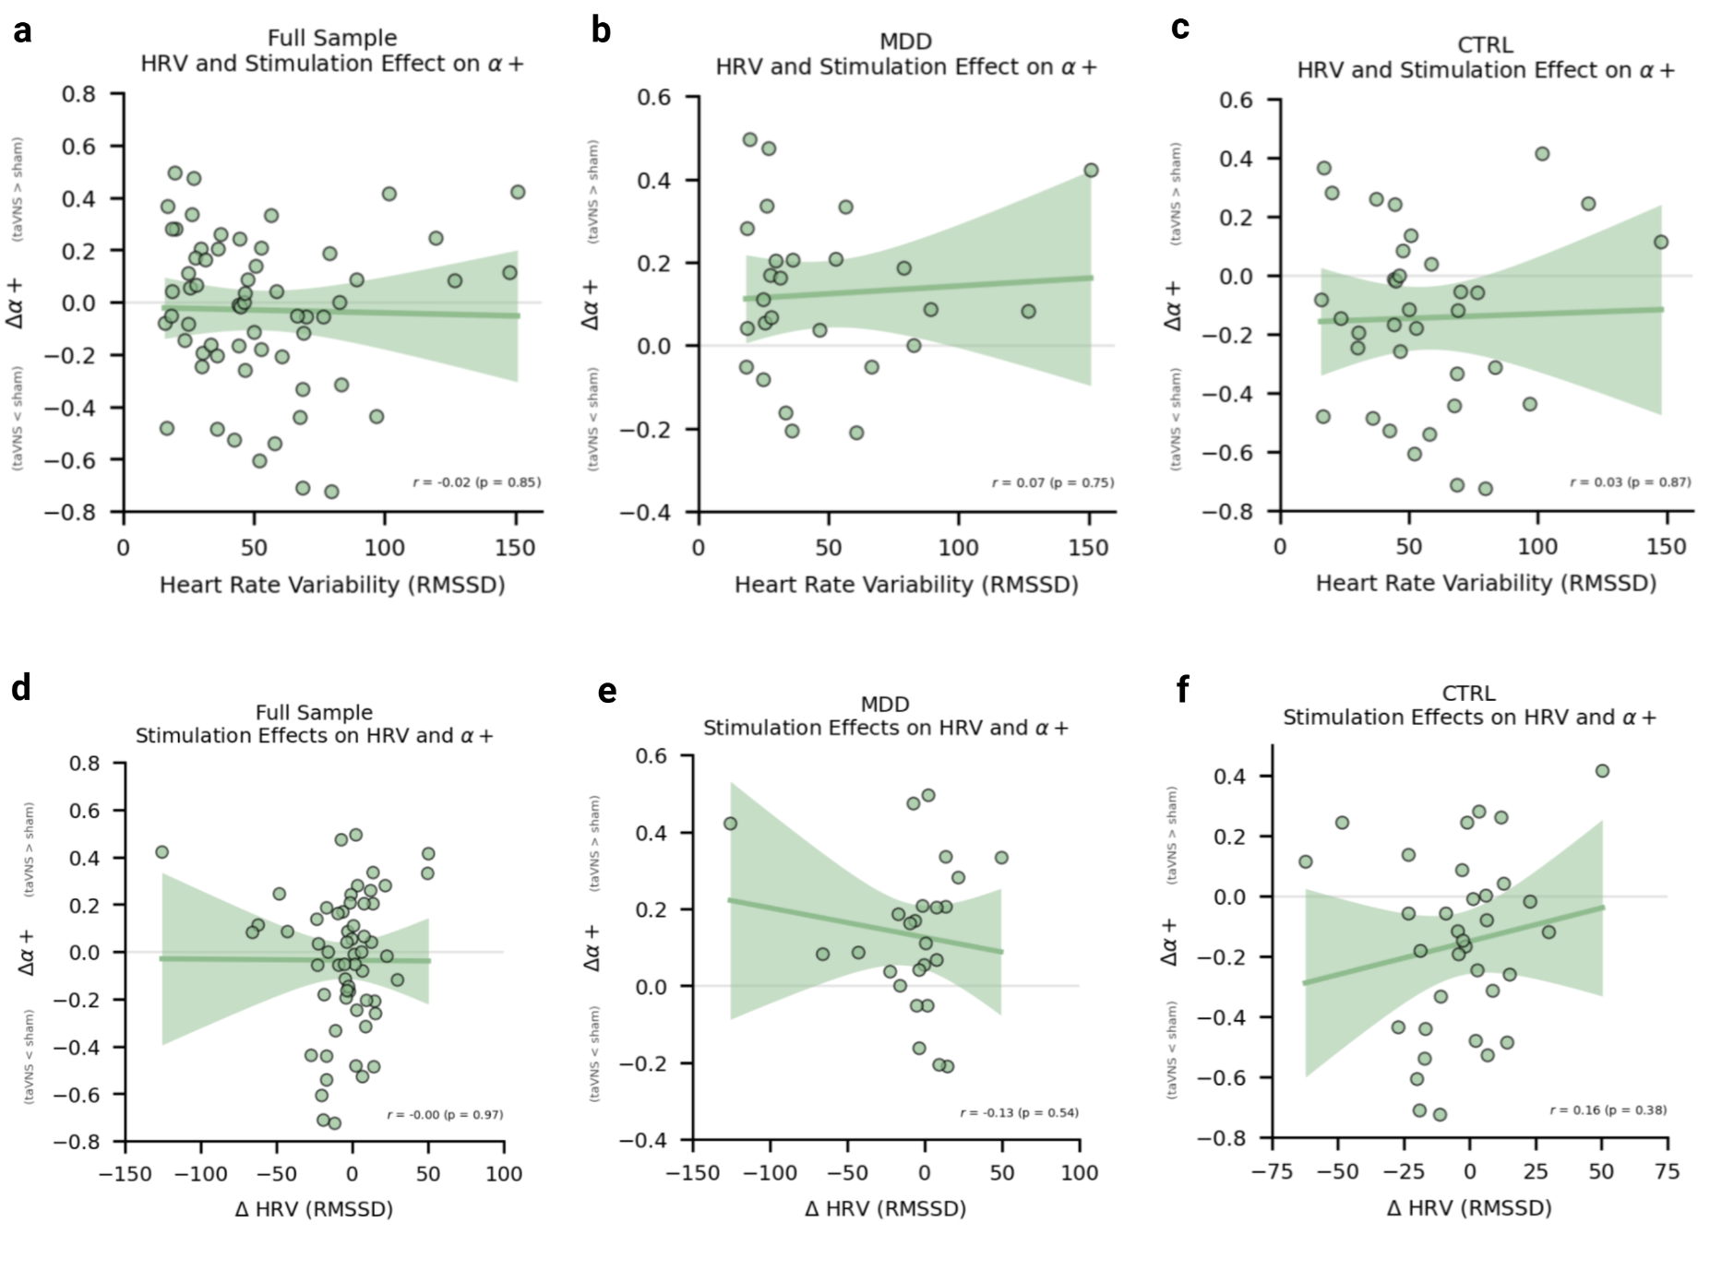
Supplementary Fig. S1. No associations between Heart Rate Variability (HRV) and stimulation-induced changes in α+. a-c: Associations between baseline HRV and Δα+ for the combined sample (a), patients (b), and healthy controls (c). d-e: Associations between stimulation-induced changes in HRV and Δα+ for the combined sample (d), patients (e), and healthy controls (f).

Supplementary Table S1. Effect of stimulation on reaction time in the training phase.
Effect/parameter | numDF | denDF | F-value | p-value
(Intercept) | 1 | 1957 | 0.00 | 0.95
Group (MDD) | 1 | 89 | 0.64 | 0.43
Stimulation (taVNS) | 1 | 1957 | 0.52 | 0.47
Trial type | 2 | 1957 | 0.45 | 0.64
Block | 3 | 1957 | 135.74 | < 0.001
Test day | 1 | 1957 | 36.58 | < 0.001
Age | 1 | 89 | 11.13 | 0.00
Sex | 1 | 89 | 0.00 | 0.96
Group:intervention | 1 | 1957 | 0.27 | 0.61
Group:trialtype | 2 | 1957 | 0.56 | 0.57
Intervention:trialtype | 2 | 1957 | 2.11 | 0.12
Group:intervention:trialtype | 2 | 1957 | 0.02 | 0.98

Supplementary Table S2. Mean (s.d.) RLDDM parameter estimates by group and stimulation condition.
 |  | Neg. learning rate α– |  | Pos. learning rate α+ |  | Drift rate  v |  | Boundary separation a |  | Non-decision time  τ |  | Boundary decay  bp
Control | sham | 0.18 (0.27) |  | 0.42 (0.26) |  | 2.45  (1.31) |  | 2.01  (0.24) |  | 0.32  (0.09) |  | -0.07  (0.08)
Control | taVNS | 0.18  (0.27) |  | 0.32  (0.22) |  | 2.66  (1.51) |  | 1.95  (0.32) |  | 0.34  (0.09) |  | -0.08  (0.07)
MDD | sham | 0.13  (0.22) |  | 0.17  (0.10) |  | 2.95  (2.05) |  | 1.99  (0.31) |  | 0.36  (0.12) |  | -0.05  (0.09)
MDD | taVNS | 0.09  (0.19) |  | 0.29  (0.17) |  | 2.97  (1.77) |  | 1.94  (0.33) |  | 0.36  (0.11) |  | -0.06  (0.06)

Supplementary Table S3. Effect of stimulation on accuracy and reaction time during choose-A trials.
Accuracy
Effect/parameter | numDF | denDF | F-value | p-value
(Intercept) | 1 | 89 | 0.01 | 0.91
Group | 1 | 89 | 0.31 | 0.58
Stimulation | 1 | 76 | 4.03 | 0.05
Test day | 1 | 76 | 28.38 | < 0.001
Age | 1 | 89 | 0.02 | 0.90
Sex | 1 | 89 | 0.14 | 0.71
Group:intervention | 1 | 76 | 0.02 | 0.88
Reaction time
Effect/parameter | numDF | denDF | F-value | p-value
(Intercept) | 1 | 89 | 0.026 | 0.87
(Intercept) | 1 | 89 | 0.026 | 0.87
Group | 1 | 89 | 0.01 | 0.93
Stimulation | 1 | 76 | 0.28 | 0.60
Test day | 1 | 76 | 4.02 | 0.05
Age | 1 | 89 | 0.43 | 0.51
Sex | 1 | 89 | 0.41 | 0.53
Group:intervention | 1 | 76 | 0.35 | 0.56

Supplementary Table S4. Effect of stimulation on accuracy and reaction time during avoid-B trials.
Accuracy
Effect/parameter | numDF | denDF | F-value | p-value
(Intercept) | 1 | 89 | 0.02 | 0.90
Group | 1 | 89 | 0.27 | 0.61
Stimulation | 1 | 76 | 0.06 | 0.81
Test day | 1 | 76 | 24.72 | < 0.001
Age | 1 | 89 | 3.12 | 0.08
Sex | 1 | 89 | 2.04 | 0.16
Group:intervention | 1 | 76 | 0.00 | 1.00
Reaction time
Effect/parameter | numDF | denDF | F-value | p-value
(Intercept) | 1 | 89 | 0.00 | 0.95
Group | 1 | 89 | 0.03 | 0.86
Stimulation | 1 | 76 | 0.40 | 0.53
Test day | 1 | 76 | 12.37 | < 0.001
Age | 1 | 89 | 0.44 | 0.51
Sex | 1 | 89 | 0.58 | 0.45
Group:intervention | 1 | 76 | 0.13 | 0.72

Supplementary Table S5: Effect of stimulation on accuracy and reaction time in the training phase - corrected for SNRI and tricyclic drugs.
Accuracy
Effect/parameter | numDF | denDF | F-value | p-value
(Intercept) | 1 | 1900 | 0.27 | 0.60
Group | 1 | 86 | 0.50 | 0.48
Stimulation | 1 | 1900 | 0.00 | 1.00
Trial type | 2 | 1900 | 154.25 | < 0.001
Block | 3 | 1900 | 33.10 | < 0.001
Test day | 1 | 1900 | 160.65 | < 0.001
Age | 1 | 86 | 8.18 | 0.01
Sex | 1 | 86 | 0.66 | 0.42
Group:intervention | 1 | 1900 | 6.34 | 0.01
Group:trial type | 2 | 1900 | 5.34 | 0.00
Intervention:trial type | 2 | 1900 | 4.87 | 0.01
Group:intervention:trial type | 2 | 1900 | 2.72 | 0.07
Reaction time
Effect/parameter | numDF | denDF | F-value | p-value
(Intercept) | 1 | 1900 | 0.00 | 0.95
Group | 1 | 86 | 0.29 | 0.59
Stimulation | 1 | 1900 | 0.01 | 0.91
Trial type | 2 | 1900 | 0.31 | 0.73
Block | 3 | 1900 | 90.73 | < 0.001
Test day | 1 | 1900 | 416.07 | < 0.001
Age | 1 | 86 | 7.66 | 0.01
Sex | 1 | 86 | 0.00 | 0.96
Group:intervention | 1 | 1900 | 0.09 | 0.76
Group:trialtype | 2 | 1900 | 0.42 | 0.65
Intervention:trialtype | 2 | 1900 | 1.06 | 0.35
Group:intervention:trialtype | 2 | 1900 | 0.01 | 0.99

Supplementary Table S6: Estimated marginal means and post-hoc contrasts for stimulation effects by group. Results from the training phase - corrected for SNRI and tricyclic drugs.
Stimulation | Group
Group | Contrast | estimate | SE | df | t.ratio | p.value
MDD | sham-tvns | -0.13 | 0.0547 | 1900 | -2.433 | 0.0151
CTRL | sham-tvns | 0.05 | 0.0494 | 1900 | 1.062 | 0.2886
Stimulation | Trial type
Trial type | Contrast | estimate | SE | df | t.ratio | p.value
AB | sham-tvns | -0.20 | 0.06 | 1900 | -3.19 | < 0.01
CD | sham-tvns | 0.02 | 0.06 | 1900 | 0.25 | 0.80
EF | sham-tvns | 0.06 | 0.06 | 1900 | 1.00 | 0.32

Supplementary Table S7. Results from the test phase. Effect of stimulation on accuracy and reaction time during choose-A trials - corrected for SNRI and tricyclic drugs.
Accuracy
Effect/parameter | numDF | denDF | F-value | p-value
(Intercept) | 1 | 88 | 0.00 | 0.97
Group | 1 | 88 | 0.39 | 0.53
Stimulation | 1 | 75 | 4.27 | 0.04
Test day | 1 | 75 | 29.39 | < 0.001
Age | 1 | 88 | 0.01 | 0.92
Sex | 1 | 88 | 0.16 | 0.69
Group:stimulation | 1 | 75 | 0.06 | 0.81
Reaction time
(Intercept) | 1 | 88 | 0.02 | 0.88
Group | 1 | 88 | 0.04 | 0.84
Stimulation | 1 | 75 | 0.41 | 0.52
Test day | 1 | 75 | 6.65 | 0.01
Age | 1 | 88 | 0.48 | 0.49
Sex | 1 | 88 | 0.11 | 0.74
Group:stimulation | 1 | 75 | 0.35 | 0.56

Supplementary Table S8. Results from the test phase. Effect of stimulation on accuracy and reaction time during avoid-B trials - corrected for SNRI and tricyclic drugs.
Accuracy
 | numDF | denDF | F-value | p-value
(Intercept) | 1 | 88 | 0.01 | 0.90
Group | 1 | 88 | 0.37 | 0.55
Stimulation | 1 | 75 | 0.00 | 0.96
Test day | 1 | 75 | 23.52 | < 0.001
Age | 1 | 88 | 2.80 | 0.10
Sex | 1 | 88 | 0.89 | 0.35
Group:stimulation | 1 | 75 | 0.00 | 0.95
Reaction time
(Intercept) | 1 | 88 | 0.00 | 0.96
Group | 1 | 88 | 0.10 | 0.75
Stimulation | 1 | 75 | 0.59 | 0.45
Test day | 1 | 75 | 16.98 | < 0.001
Age | 1 | 88 | 0.49 | 0.49
Sex | 1 | 88 | 0.07 | 0.79
Group:stimulation | 1 | 75 | 0.16 | 0.69

Supplementary Table S9. Effect of stimulation on accuracy and reaction time during the training phase. Control for potential repetition effect - between‐subjects analysis limited to test day 1 data.
Accuracy
Effect/parameter | numDF | denDF | F-value | p-value
(Intercept) | 1 | 1012 | 1.68 | 0.19
Group | 1 | 87 | 0.25 | 0.62
Stimulation | 1 | 87 | 0.07 | 0.80
Trial type | 2 | 1012 | 54.79 | < 0.001
Block | 3 | 1012 | 16.54 | < 0.001
Age | 1 | 87 | 6.74 | 0.01
Sex | 1 | 87 | 0.47 | 0.49
Group:stimulation | 1 | 87 | 0.24 | 0.63
Group:trial type | 2 | 1012 | 1.11 | 0.33
Stimulation:trial type | 2 | 1012 | 1.80 | 0.17
Group:stimulation:trial type | 2 | 1012 | 0.38 | 0.69
Reaction time
(Intercept) | 1 | 1012 | 0.00 | 0.98
Group | 1 | 87 | 0.13 | 0.72
Stimulation | 1 | 87 | 0.18 | 0.67
Trial type | 2 | 1012 | 4.74 | 0.01
Block | 3 | 1012 | 56.41 | < 0.001
Age | 1 | 87 | 1.80 | 0.18
Sex | 1 | 87 | 0.03 | 0.87
Group:stimulation | 1 | 87 | 0.81 | 0.37
Group:trial type | 2 | 1012 | 0.13 | 0.88
Stimulation:trial type | 2 | 1012 | 0.67 | 0.51
Group:stimulation:trial type | 2 | 1012 | 1.31 | 0.27

Supplementary Table 10. Effect of stimulation on accuracy during the choice phase for choose-A and avoid-B trials. Control for potential repetition effect - between‐subjects analysis limited to test day 1 data.
Accuracy Choose-A
 | numDF | denDF | F-value | p-value
(Intercept) | 1 | 87 | 0.00 | 0.95
Group | 1 | 87 | 0.04 | 0.84
Stimulation | 1 | 87 | 0.88 | 0.35
Age | 1 | 87 | 0.82 | 0.37
Sex | 1 | 87 | 1.90 | 0.17
Group:stimulation | 1 | 87 | 0.23 | 0.63
Accuracy Avoid-B
(Intercept) | 1 | 87 | 0.00 | 0.10
Group | 1 | 87 | 0.62 | 0.43
Stimulation | 1 | 87 | 0.11 | 0.74
Age | 1 | 87 | 0.28 | 0.60
Sex | 1 | 87 | 0.24 | 0.63
Group:stimulation | 1 | 87 | 0.49 | 0.49

