Table 1: Material properties
Material | Modulus of Elasticity (GPa) | Poisson's Ratio
Compact Bone | 13.7 | 0.30
Cancellous Bone | 0.142 | 0.3
Titanium alloy Mini-Implants | 0.113 | 0.342
Periodontal Ligament (PDL) | 0.07 | 0.45
Gingiva (Soft Tissue) | 0.0001 | 0.4
Dentine | 18.6 | 0.31
Filtek z250 Composite | 14 | 0.31

Table 2: Mesh Nodes and Element distribution for the two models
Models | Nodes | Elements
Model A | 635141 | 362625
Model B | 574684 | 346294

Table 3: Maximum Von-Mises Stress and Total Deformation on Mini-Screws (Pa, mm) Across Model A and B:
Teeth | Model A | Model B
Equivalent Stress (Von-Mises) (Pascal) | 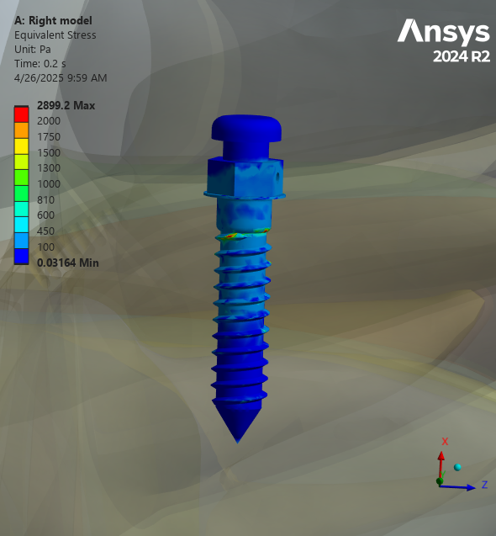2889.2 | 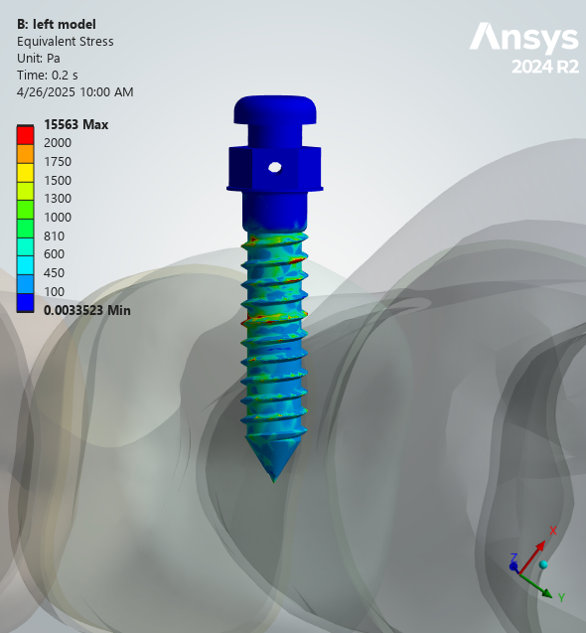15563
Total Deformation (mm) | 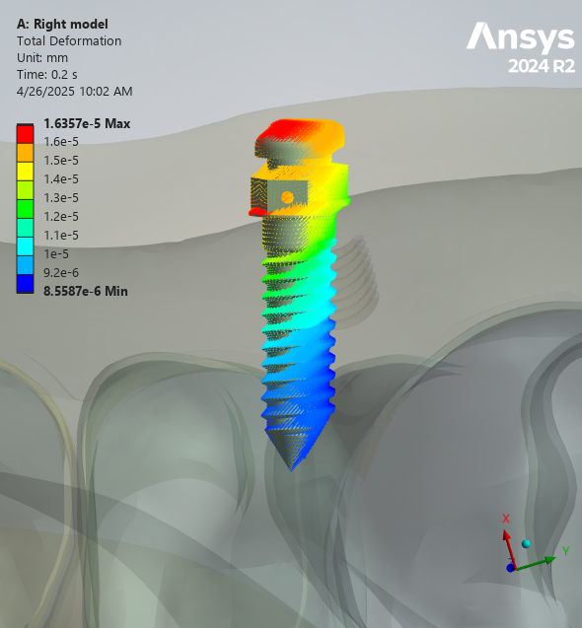1.64E-05 | 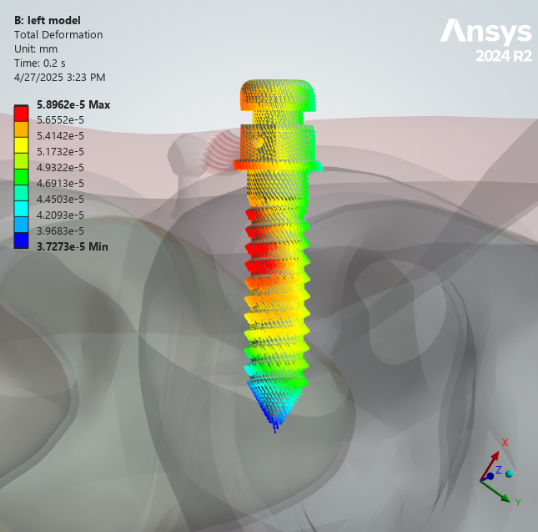5.90E-05

Table 4: Maximum Von-Mises Stress on PDL (Pa) Across Models:
Teeth | Model A (Pa) | Model B (Pa)
Central Incisor | 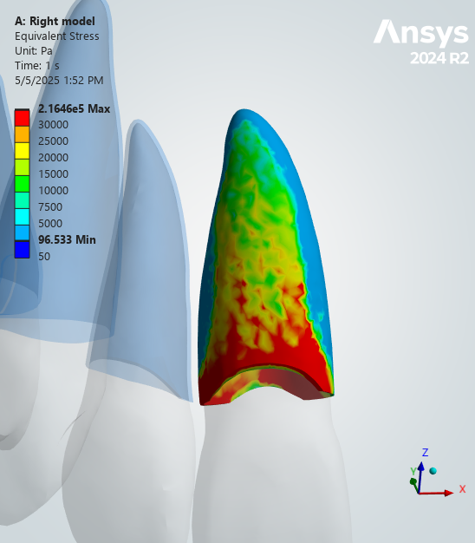2.16E+05 | 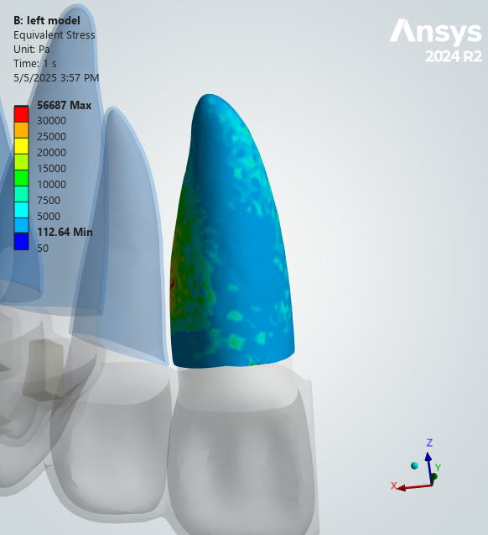56687
Lateral Incisor | 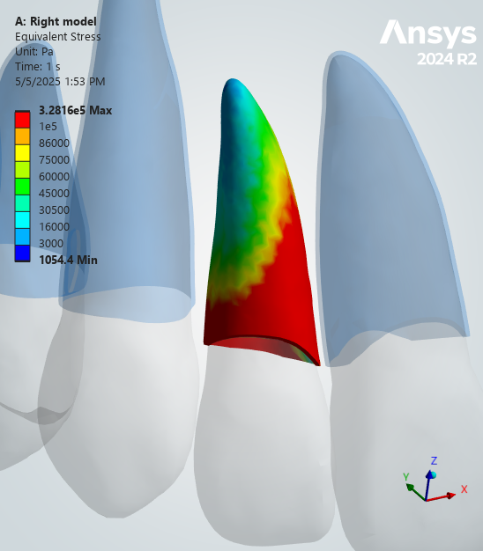3.28E+05 | 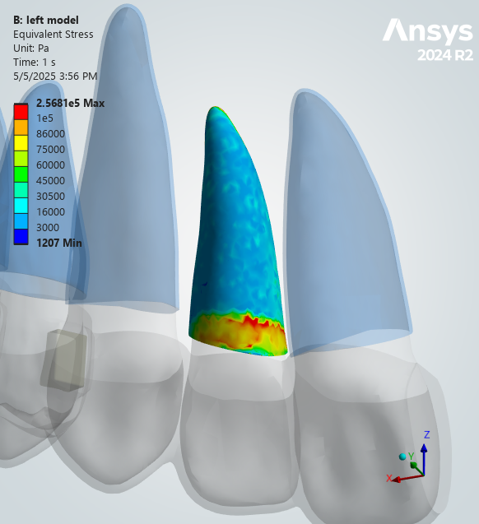2.57E+05
Canine | 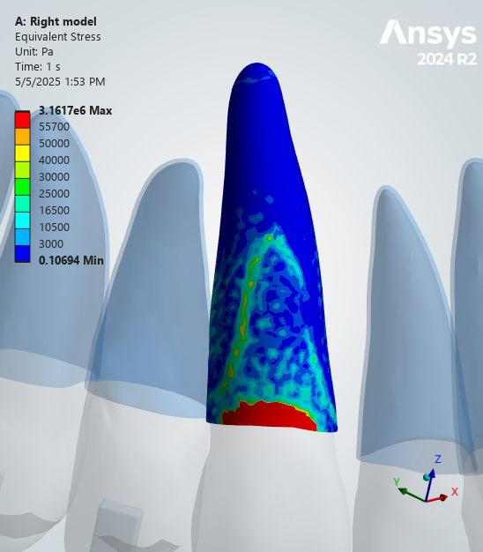3.16E+06 | 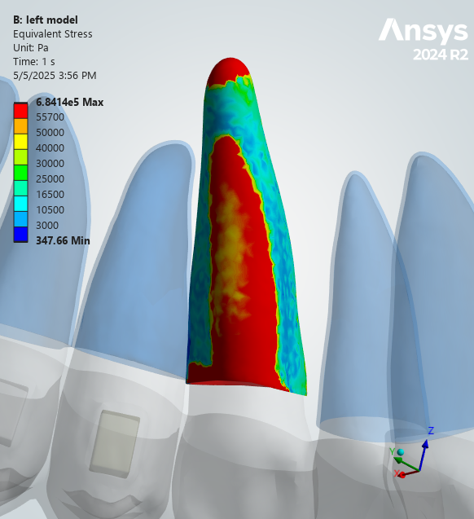6.84E+05
First Premolar | 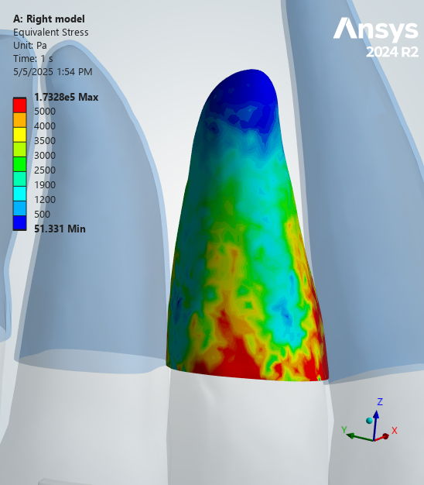1.73E+05 | 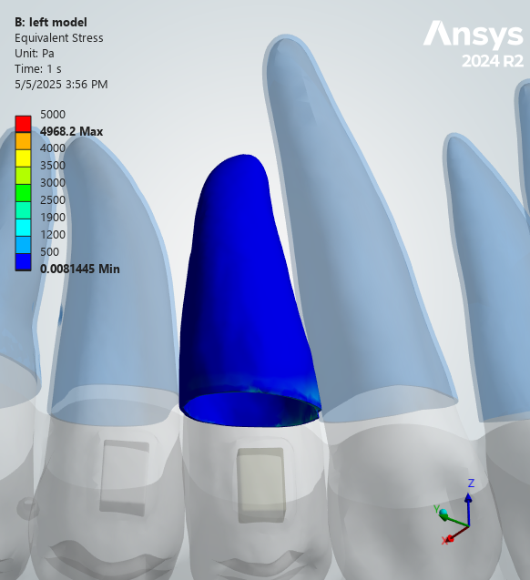4968.2
Second Premolar | 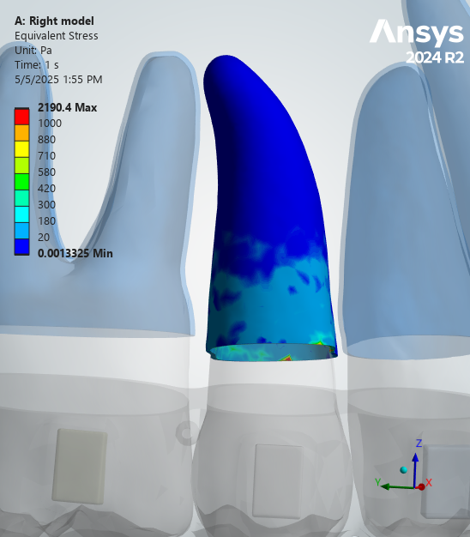2190.4 | 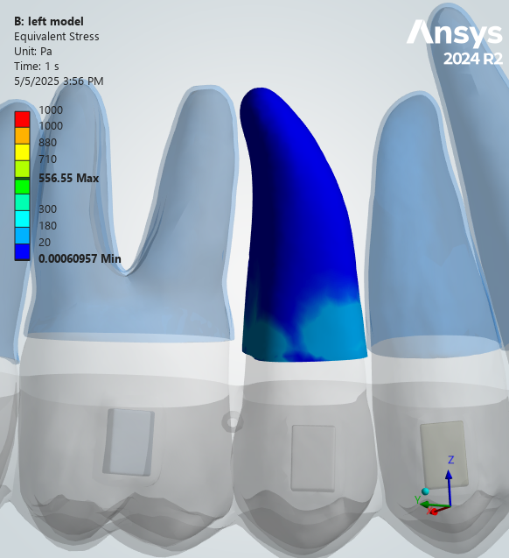556.55
First Molar | 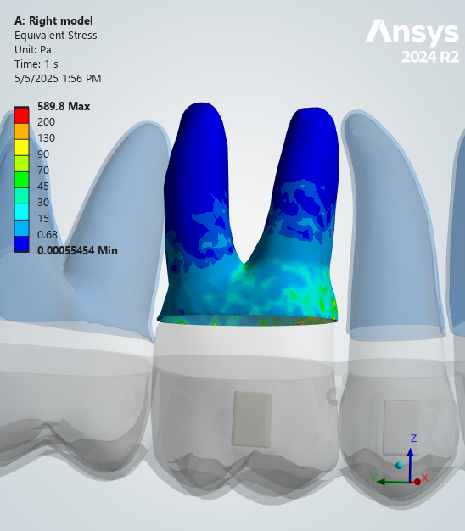589.8 | 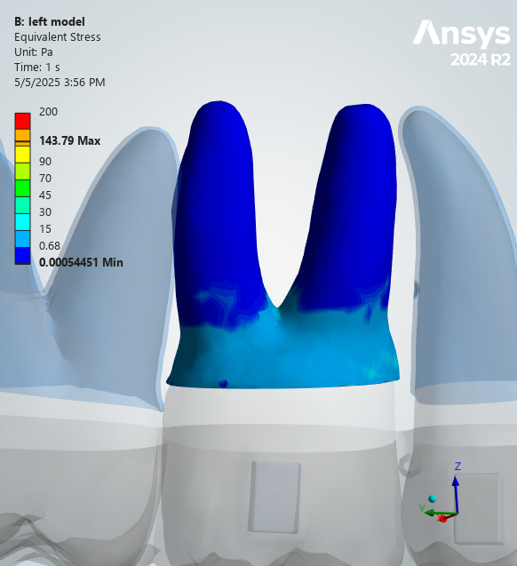143.79
Second Molar | 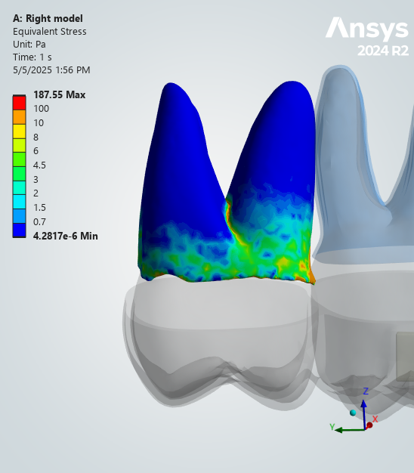187.55 | 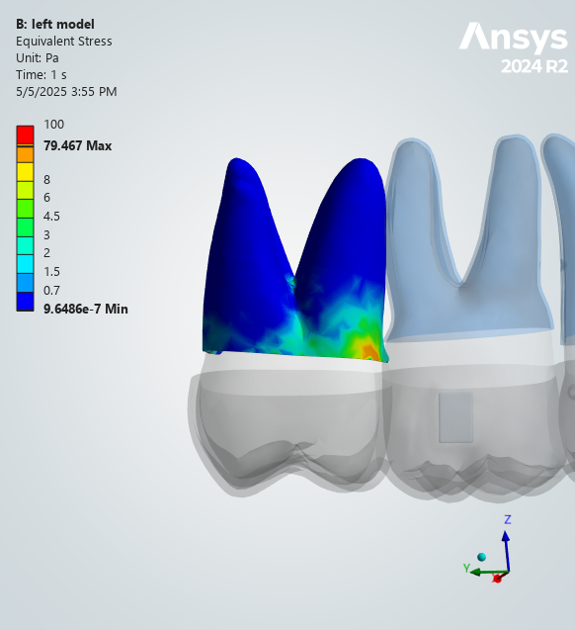79.467

Table 5: Total Deformation of PDL (mm) Across Models:
 | Central Incisor | Lateral Incisor | Canine | First Premolar | Second Premolar | First Molar | Second Molar
Model A | 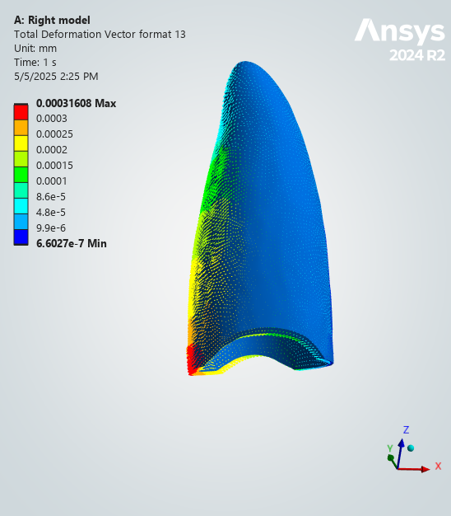0.00031608 | 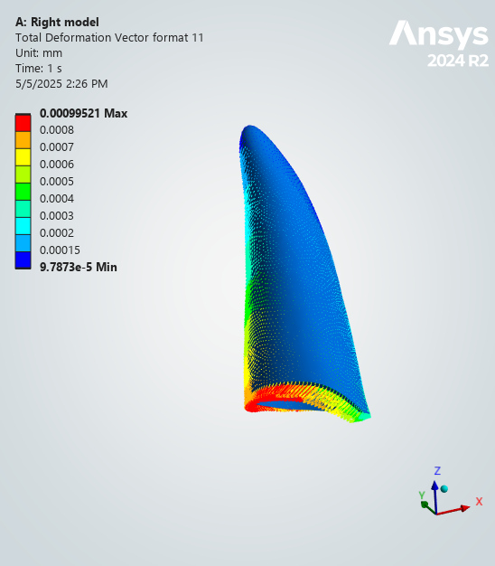0.00099521 | 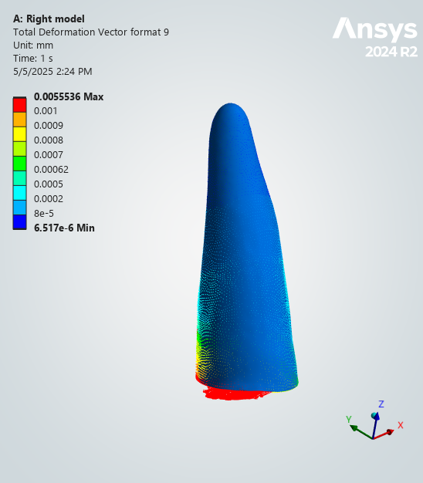0.0055536 | 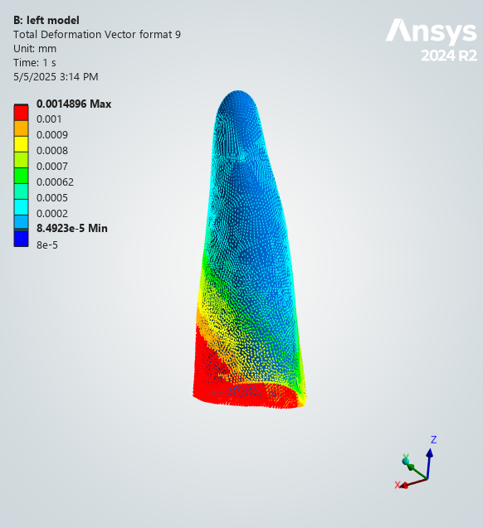0.2211 | 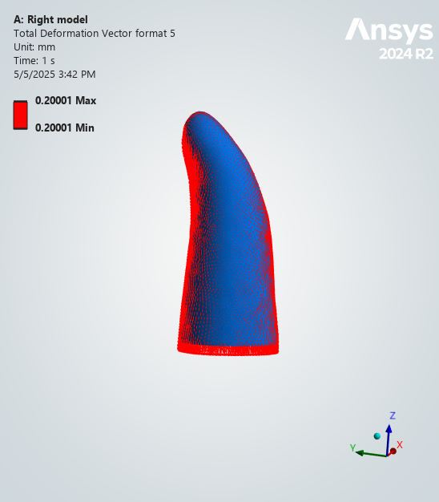0.20001 | 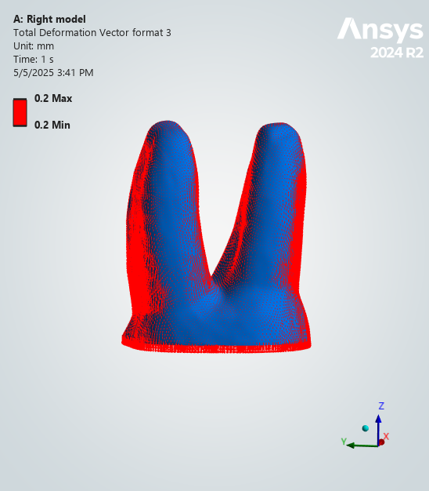0.2 | 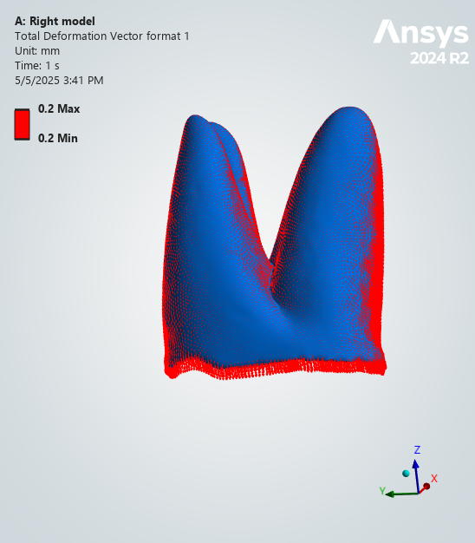0.2
Model B | 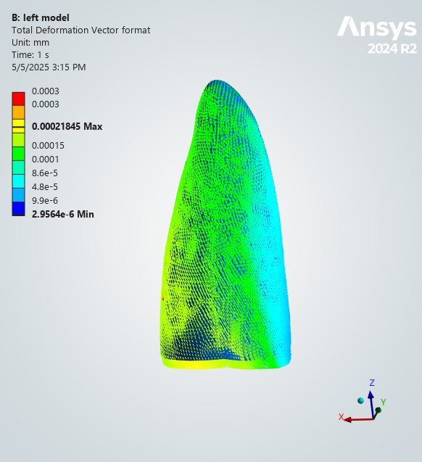0.00021845 | 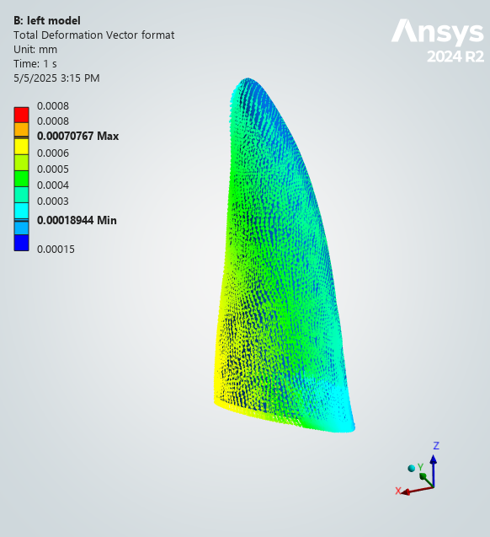0.00070767 | 0.0014896 | 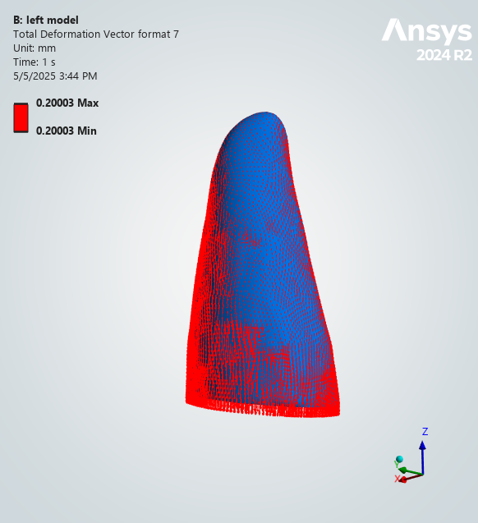0.20003 | 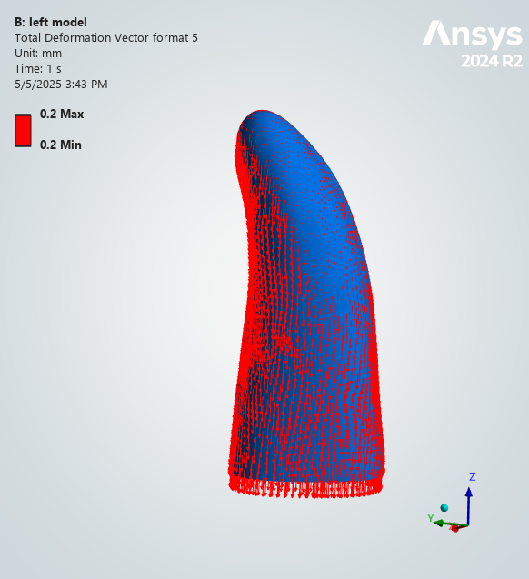0.2 | 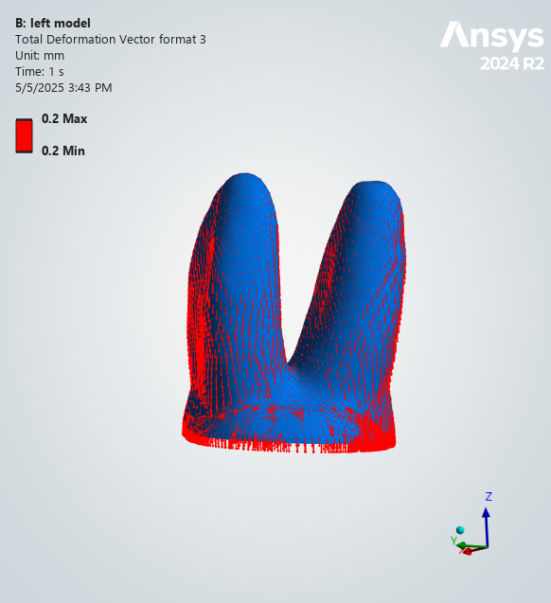0.2 | 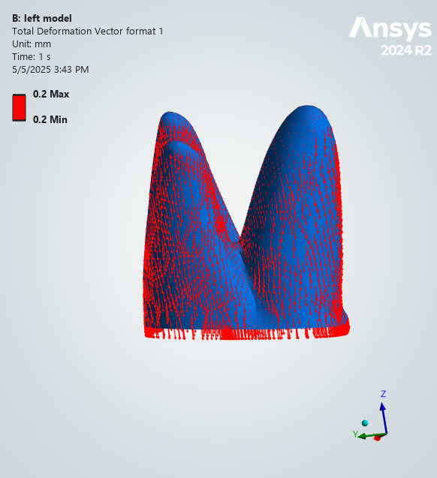0.2

Table 6: Direction Deformation on Dentine (mm) Across Models
Teeth |  | Model A | Model B
Central Incisor | X | 0.00028202 | 5.25E-05
Central Incisor | Y | 0.000279 | 6.71E-05
Central Incisor | Z | 0.00010578 | 0.0002244
Lateral Incisor | X | 0.0010393 | 0.00016981
Lateral Incisor | Y | 0.0013575 | 0.00041201
Lateral Incisor | Z | 9.85E-05 | 3.42E-05
Canine | X | 0.0046286 | 0.00017385
Canine | Y | 0.0043005 | 0.0012152
Canine | Z | Intrusion N/A | 0.00021645
Canine | Z | Extrusion 8.14E-05 | N/A
First Premolar | X | 0.019804 | 0.00012686
First Premolar | Y | 0.08923 | 0.00023874
First Premolar | Z | 0.13495 | 0.19992
Second Premolar | X | 1.99E-05 | 2.30E-05
Second Premolar | Y | 2.30E-05 | 1.93E-05
Second Premolar | Z | 0.2 | 0.2
First Molar | X | 6.48E-06 | 1.40E-06
First Molar | Y | 7.18E-06 | 2.34E-06
First Molar | Z | 0.19999 | 0.2
Second Molar | X | 6.88E-07 | 6.20E-07
Second Molar | Y | 8.08E-07 | 3.87E-07
Second Molar | Z | 0.2 | 0.2

Table 7: Total Deformation on Dentine (mm) Across Models
 | Central Incisor | Lateral Incisor | Canine | First Premolar | Second Premolar | First Molar | Second Molar
Model A | 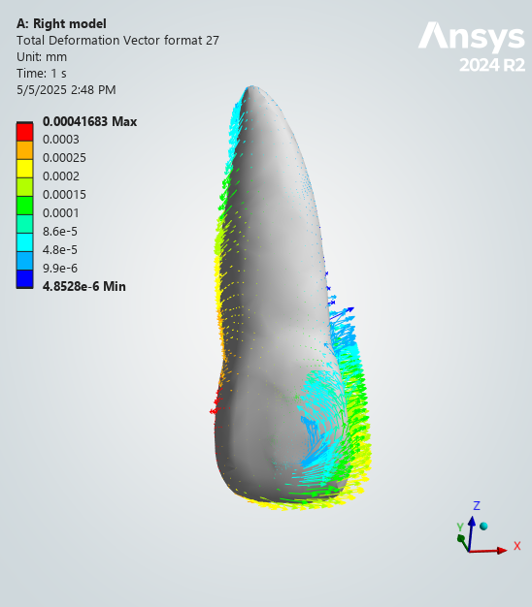0.00041683 | 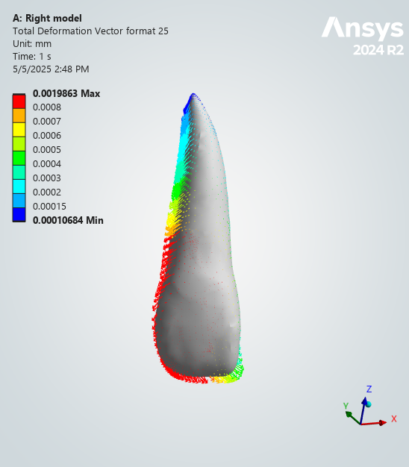0.0019863 | 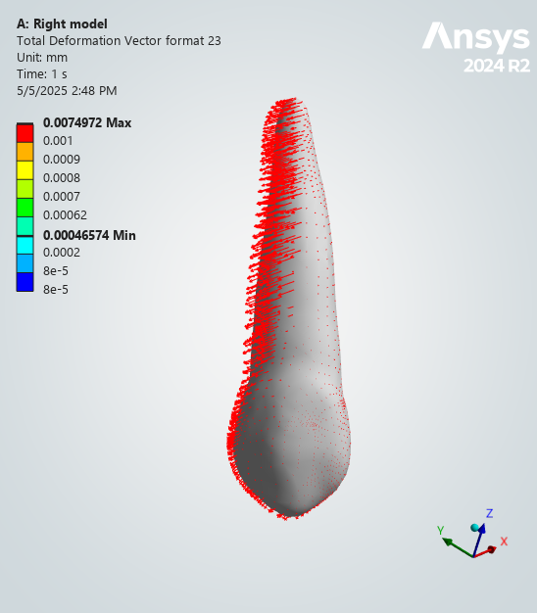0.0074972 | 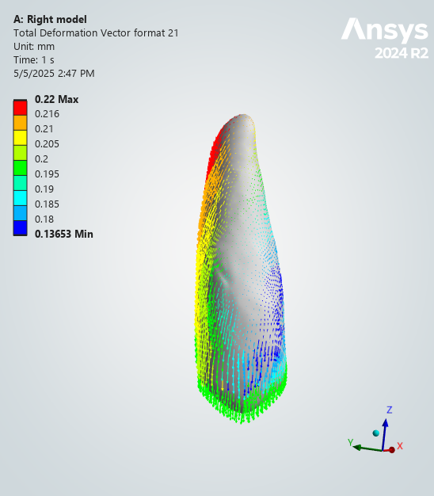0.22 | 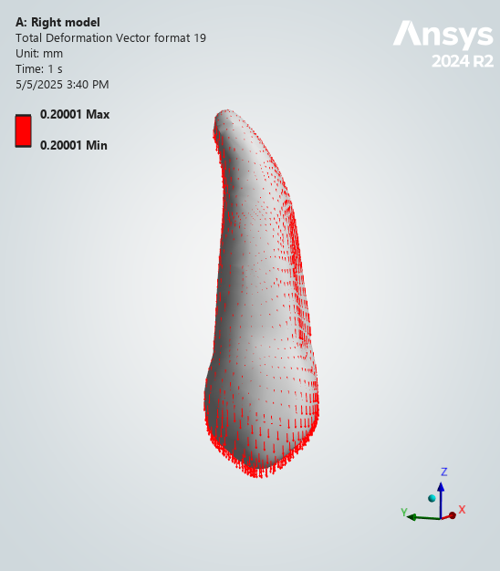0.20001 | 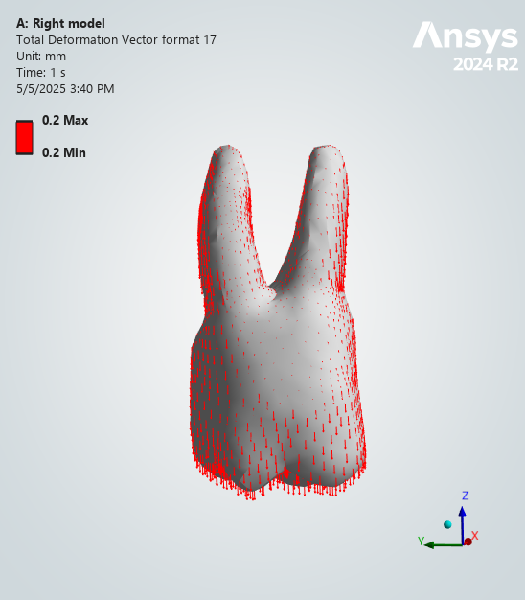0.2 | 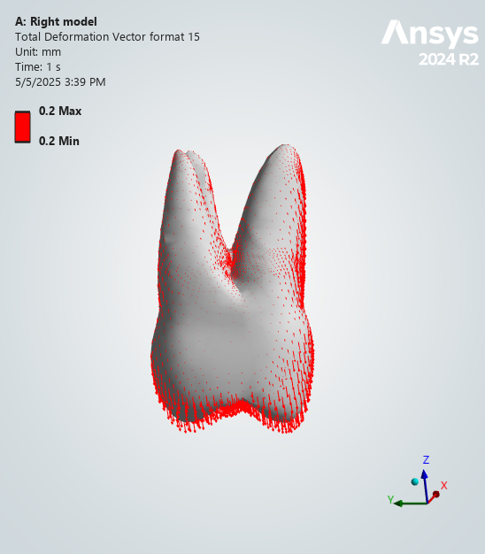0.2
Model B | 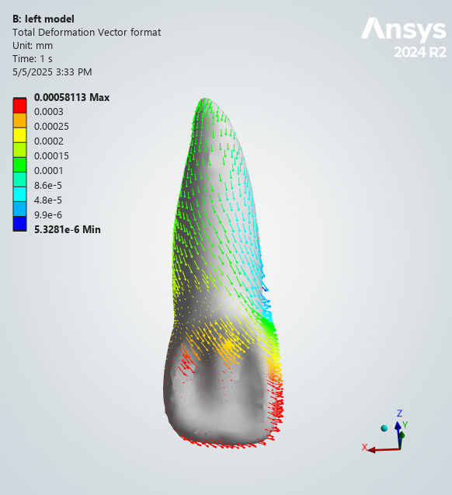0.00058113 | 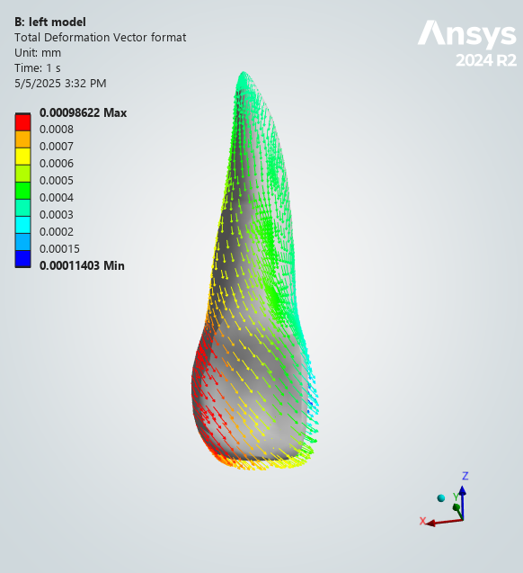0.00095622 | 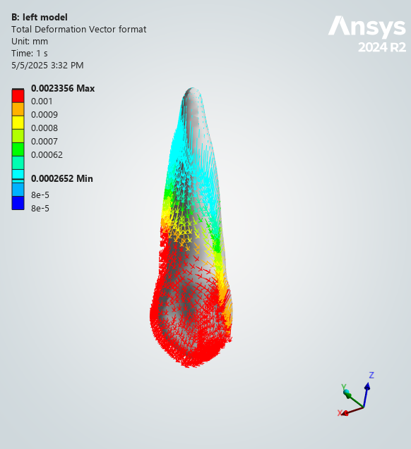0.0023356 | 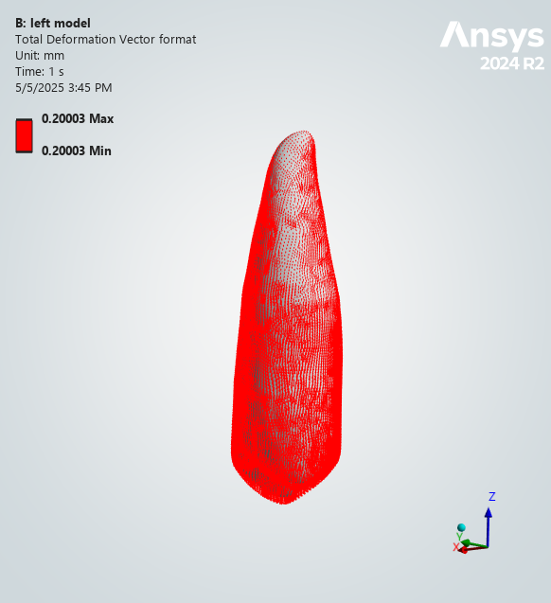0.20003 | 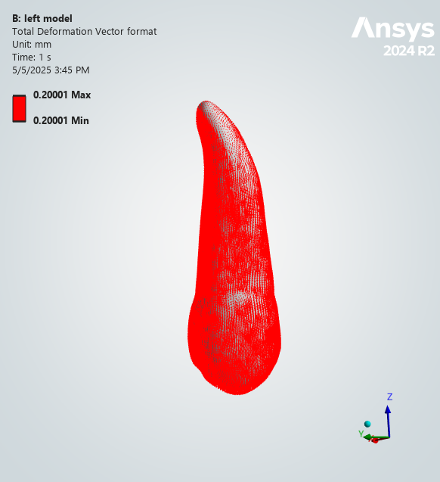0.20001 | 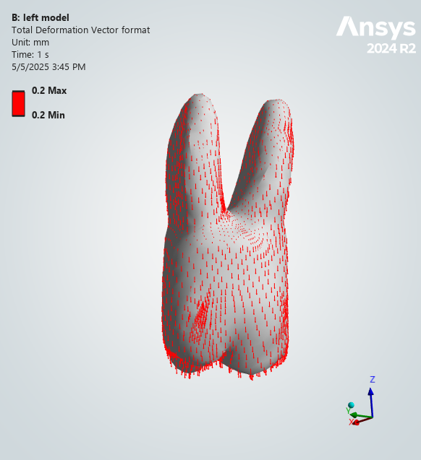0.2 | 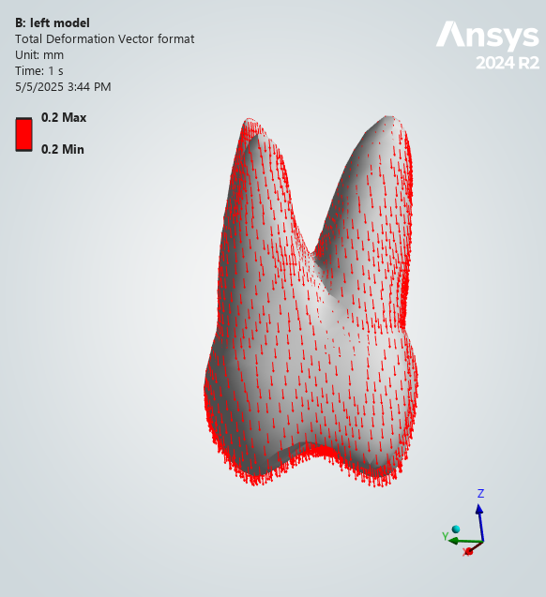0.2

Table 8: Maximum Von-Mises Stress on aligners (Pa) Across Models:
Aligners | Model A | Model B
Aligners | 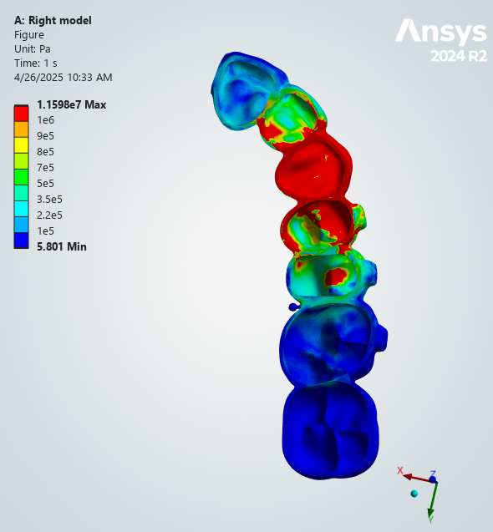1.16E+07 | 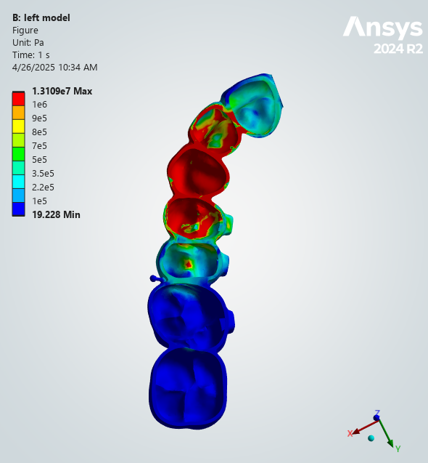1.31E+07

Table 9: Maximum Principal Stress on Bone (Pa) Across Models:
Compact Bone | Model A | Model B
Compact Bone | 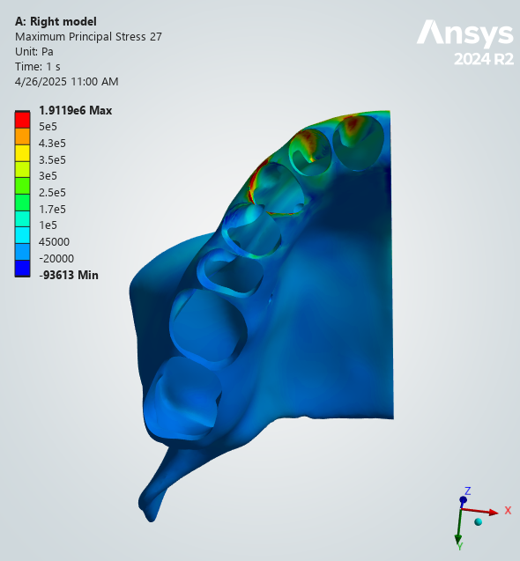1.91E+06 | 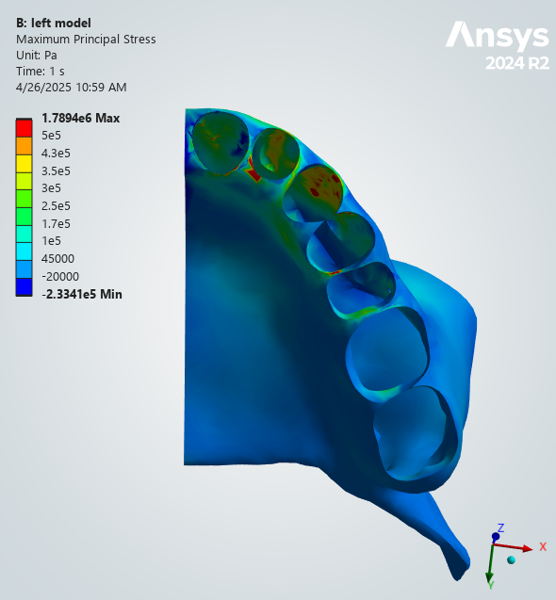1.79E+06

