Supporting Information

Biocatalytic Synthesis of Asymmetric Pyrazines: Mechanistic Insights and Industrial Potential
Jorge González-Rodríguez,^{a,b} Valentina Jurkaš,^{a, c} Eva Puchľová,^{d} Maren Podewitz,^{e} Fabio Parmeggiani,^{f} Margit Winkler,^{a, c} Peter Both,^{d} Peter Šiška,^{d} Florian Rudroff*^{b}

[a] Austrian Centre of Industrial Biotechnology (ACIB), Krenngasse 37/2, 8010 Graz, Austria.

[b] Institute of Applied Synthetic Chemistry. TU Wien. Getreidemarkt 9/163-OC, 1060 Wien, Austria.

[c] Institute of Molecular Biotechnology, TU Graz, Petersgasse 14,
Graz, 8010 Austria.

[d] Axxence Slovakia s.r.o., Mickiewiczova 9, 81107 Bratislava, Slovakia.

[e] Institute of Materials Chemistry. TU Wien. Getreidemarkt 9/165, 1060 Wien, Austria.

[f] Dipartimento di Chimica, Materiali ed Ingegneria Chimica “Giulio Natta”, Politecnico di Milano, Piazza Leonardo Da Vinci 32, 20133 Milan, Italy.

Email: florian.rudroff@tuwien.ac.at

Index (Page 1 out of 36)
I. General considerations S2
II. Compounds described in this contribution S3
III. Synthesis of starting materials S5
III.1. Synthesis of N,N-dimethylpropiolamide 2o S5
IV. Selective synthesis of di- and trisubstituted pyrazines 3a-u S6
V. Mechanistic studies S8
V.1. Experiments under oxygen-free conditions S8
V.2. Detailed 3/3b ratios for each derivative S8
V.3. Deuteration experiments S9
V.4. Autotitration experiments S9
VI. Computational methodology S11
VI.1. Reaction profile calculated for I-II S12
VII Growth protocol of CnThrDH and TkThrDH S13
VIII. Biocatalytic synthesis of pyrazine 3a S13
IX. GC analyses for the determination of product percentages S14
IX.1. Calibration curves for 3a and 3b S15
X. HPLC analyses for the determination of product percentages S15
X.1. Calibration curves for 3a and 3b S16
XI. NMR spectra S17
XII. Reference section S38

I. General considerations
Chemical reagents and nicotinamide cofactors (NADP⁺ and NAD⁺) were purchased from Sigma-Aldrich. Threonine dehydrogenases from Cupriavidus necator and Thermococcus Kodakaraensis were cloned, overexpressed and lysed as mentioned hereunder. All starting products were purchased from Sigma-Aldrich, BLD Pharmatech, Fluorochem or TCI except electrophile 2o, which was synthesised as reported in this file. Reactions were performed in 10 mL closed glass vials. A Mettler Toledo T50 autotitrator was used for the autotitration reactions.
NMR spectra were recorded on a 400 MHz spectrometer including ¹H, and ¹³C. All chemical shifts (δ) are given in parts per million (ppm) and referenced to the residual solvent signal as internal standard.
Gas chromatography (GC) analyses for screening purposes and quantification of the enzymatic reactions were performed on a Thermo Scientific GC trace 1300 equipped with an FID detector employing a Restek Rxi-5Sil MS column (15 m x 0.25 mm x 1 μm). For the identification of product 3p, a Thermo Scientific GC trace 1300 coupled with an ISQ LT single quadrupole mass spectrometer and equipped with the same column mentioned before was employed. High performance Liquid Chromatography coupled with mass spectroscopy (HPLC-MS) analyses were performed to study the composition of the autotitration experiments on a Shimadzu LCMS 2020 equipped with a DGU-20A3/5 degasser, LC-30AD Nexera pump, SIL-30AC Nexera autosampler, CTO-20AC thermostated column compartment, CBM-20A communication device and SPD-M20A detector. The analysis was carried out with a Macherey-Nagel EC 150/3 NUCLEODUR C18 Gravity 3ºμm column equipped with a CC 8/3 NUCLEODUR C18 Gravity 3ºμm guard column. All masses were detected in positive ionization modes.
High resolution mass spectra (HRMS) experiments were carried out by electrospray ionization in positive mode (ESI⁺). Thin-layer chromatography (TLC) was conducted with Silica Gel 60 F254 precoated plates and visualized with a UV lamp, plus either potassium permanganate or vanillin stains. Column chromatography was performed using silica gel 60 (230-240 mesh).
II. Compounds described in this contribution

Figure S1. Structures of aminoketones 1a-c studied in this contribution.

Figure S2. Structures of electrophiles 2a-z studied in this contribution.

Figure S3. Structures of pyrazines 3a-aa studied in this contribution (examples in orange were not synthesised).

Figure S4. Structure of pyrazine 4a studied in this contribution.

III. Synthesis of starting materials
III.1. Synthesis of N,N-dimethylpropiolamide 2o
Compound 2o was synthesised following an adapted procedure from the one described by Duan et al.¹
Scheme S1. Synthesis of cyanoalkynes 1a,h-o,q.
To a mixture of amine (5 mmol) and propiolic acid (5 mmol) in DCM (30 mL) was added a
solution of DMAP (0.5 mmol, 10 mol%) and DCC (7.5 mmol, 1.5 equiv) in DCM (20 mL) at 0°C. The reaction mixture was stirred for 12 hours at room temperature and filtered through a short plug of silica gel, which was rinsed with EtOAc. The filtrate was concentrated in νacuo and the residue was purified by column chromatography on silica gel (petroleum ether /ethyl acetate = 4/1). The spectroscopical data of compound 2o matched with the one already reported in literature² and its identity was confirmed through ¹H- and ¹³C-NMR spectroscopy.

IV. Selective synthesis of di- and trisubstituted pyrazines 3a-u
The corresponding aminoketone 1 (25 mM) and the desired electrophile 2 (100 mM) were dissolved in 6 mL of Kpi 100 mM buffer pH 9 in a closed 30 mL glass vial and the solution was shaken for 2 h at 50 ºC in an orbital shaker at 200 rpm. After this time, the mixture was extracted with AcOEt (2 × 6 mL) or Et₂O (2 x 6 mL) depending on the volatility and solubility of the compound. The combined organic layers were dried over Na₂SO₄, filtered, and purified through SiO₂ flash column chromatography employing mixtures of pentane:Et₂O or pentane:AcOEt. The only exception was cyclohexanecarboxaldehyde derivative 3e, which showed to be unstable when treated with SiO₂. For this example, reverse phase flash column chromatography was carried out employing a Büchi Pure C-850 FlashPrep equipped with a Waters Atlantis C-18 preparative column, using mixtures of water and acetonitrile under neutral conditions. Afterwards, the desired product 3e was extracted employing EtOAc (3 x 10 mL) dried over Na₂SO₄ and filtered. ¹H-NMR, ¹³C-NMR and Mass spectroscopy have been carried out for every compound and compared with the ones previously reported in literature 3a-d,³ 3e-g, j, l,⁴ 3i, m,⁵ 3s,⁶ 3t,⁷ 3u.⁸ The spectroscopic data of the compounds not described previously 3h-i, k, m-r is given below, except 3o, which could not be isolated. Due to the extreme volatility of 3s, it could be only isolated with significant amounts of diethyl ether.
3-(4-(tert-butyl)benzyl)-2,5-dimethylpyrazine (3h): bright yellow oil. ¹H-NMR (400 MHz, CDCl₃): δ 8.20 (s, 1 H), 7.31-7.25 (m, 2 H), 7.14-7.09 (m, 2 H), 4.13 (s, 2 H), 2.53 (s, 3 H), 2.46 (s, 3 H). 1.28 (s, 9 H). ¹³C-NMR (100 MHz, CDCl₃): δ 153.3 (C), 150.2 (C), 149.4 (C), 149.3 (C), 141.3 (CH), 134.9 (C), 128.3 (2 x CH), 125.4 (2 x CH), 41.2 (CH₂), 34.4 (C), 31.4 (3 x CH₃), 21.5 (CH₃), 21.1 (CH₃). HRMS (ESI⁺, m/z): calcd for (C₁₇H₂₃N₂)⁺ (M+H)⁺: 247.2174; found 247.2170.
3-(4-chlorobenzyl)-2,5-dimethylpyrazine (3i): brown oil. ¹H-NMR (400 MHz, CDCl₃): δ 8.21 (s, 1 H), 7.24-7.20 (m, 2 H), 7.11-7.07 (m, 2 H), 4.10 (s, 2 H), 2.51 (s, 3 H), 2.42 (s, 3 H). 1.28 (s, 9 H). ¹³C-NMR (100 MHz, CDCl₃): δ 152.4 (C), 150.4 (C), 149.2 (C), 141.6 (CH), 136.7 (C), 132.3 (C), 130.0 (2 x CH), 128.6 (2 x CH), 40.9 (CH₂), 21.4 (CH₃), 21.1 (CH₃). HRMS (ESI⁺, m/z): calcd for (C₁₃H₁₄ClN₂)⁺ (M+H)⁺: 233.0846; found 233.0840.
methyl 4-((3,6-dimethylpyrazin-2-yl)methyl)benzoate (3k): bright yellow oil. ¹H-NMR (400 MHz, CDCl₃): δ 8.22 (s, 1 H), 7.95-7.90 (m, 2 H), 7.25-7.20 (m, 2 H), 4.19 (s, 2 H), 3.87 (s, 3 H), 2.51 (s, 3 H). 2.41 (s, 3 H). ¹³C-NMR (100 MHz, CDCl₃): δ 166.9 (C), 152.1 (C), 150.5 (C), 149.3 (C), 143.4 (C), 141.3 (CH), 129.8 (2 x CH), 128.7 (2 x CH), 128.5 (C), 52.0 (CH₃), 41.6 (CH₂), 21.4 (CH₃), 21.0 (CH₃). HRMS (ESI⁺, m/z): calcd for (C₁₅H₁₇N₂O₂)⁺ (M+H)⁺: 257.1290; found 257.1286.
2,5-dimethyl-3-(thiophen-3-ylmethyl)pyrazine (3m): pale yellow oil. ¹H-NMR (400 MHz, CDCl₃): δ 8.21 (s, 1 H), 7.24 (dd, J = 4.9, 3.0 Hz, 1 H), 6.94 (dd, J = 4.9, 1.3 Hz, 1 H), 6.92-6.87 (m, 1 H), 4.15 (s, 2 H), 2.52 (s, 3 H). 2.47 (s, 3 H). ¹³C-NMR (100 MHz, CDCl₃): δ 152.6 (C), 150.3 (C), 149.2 (C), 141.5 (CH), 138.1 (C), 128.2 (CH), 125.7 (CH), 121.4 (CH), 36.7 (CH₂), 21.3 (CH₃), 21.1 (CH₃). HRMS (ESI⁺, m/z): calcd for (C₁₁H₁₃N₂S)⁺ (M+H)⁺: 205.0799; found 205.0792.
4-(3,6-dimethylpyrazin-2-yl)butan-2-one (3n): dark yellow oil. ¹H-NMR (400 MHz, CDCl₃): δ 8.11 (s, 1 H), 3.03 (t, J = 6.8 Hz, 2 H), 2.95-291 (m, 2 H), 2.51 (s, 3 H). 2.43 (s, 3 H), 2.24 (s, 3 H). ¹³C-NMR (100 MHz, CDCl₃): δ 208.1 (C), 152.5 (C), 149.8 (C), 148.9 (C), 140.6 (CH), 40.1 (CH₂), 30.3 (CH₃), 28.1 (CH₂), 21.1 (CH₃), 21.0 (CH₃). HRMS (ESI⁺, m/z): calcd for (C₁₀H₁₅N₂O)⁺ (M+H)⁺: 179.1184; found 179.1190.
methyl 3-(3,6-dimethylpyrazin-2-yl)propanoate (3o): pale yellow oil. R_{f} (5% EtOAc/hexane): 0.45. IR: ν 2213, 1612, 1575, 1447, 1241, 864, 785 and 674 cm⁻¹. ¹H-NMR (400 MHz, CDCl₃): δ 8.13 (s, 1 H), 3.67 (s, 3 H), 3.06 (t, J = 7.3 Hz, 2 H), 2.81 (t, J = 7.3 Hz, 2 H), 2.51 (s, 3 H). 2.44 (s, 3 H). ¹³C-NMR (100 MHz, CDCl₃): δ 173.7 (C), 152.2 (C), 150.0 (C), 148.7 (C), 140.8 (CH), 51.7 (CH₃), 31.3 (CH₂), 29.0 (CH₂), 21.1 (CH₃), 21.0 (CH₃). HRMS (ESI⁺, m/z): calcd for (C₉H₇FN)⁺ (M+H)⁺: 195.1134; found 195.1126.
1-(3,6-dimethylpyrazin-2-yl)propan-2-one (3q): pale yellow oil. ¹H-NMR (400 MHz, CDCl₃): δ 8.33 (s, 1 H), 5.28 (d, J = 6.0 Hz, 1 H), 4.70 (d, J = 6.2 Hz, 1 H), 2.59 (s, 3 H). 2.53 (s, 3 H), 2.16 (s, 3 H). ¹³C-NMR (100 MHz, CDCl₃): δ 206.7 (C), 150.0 (C), 149.9 (C), 148.6 (C), 143.3 (CH), 77.8 (CH₂), 30.3 (CH₃), 25.6 (CH₂), 20.9 (CH₃), 20.7 (CH₃). The compound decomposed under the HRMS conditions.
3-(3,7-dimethyloct-6-en-1-yl)-2,5-dimethylpyrazine (3r): pale yellow oil. ¹H-NMR (400 MHz, CDCl₃): δ 8.14 (s, 1 H), 5.12-5.06 (m, 1 H), 2.85-2.70 (m, 2 H), 2.52 (s, 3 H), 2.48 (s, 3 H), 2.06-1.85 (m, 2H), 1.75-1.65 (m, 4 H), 1.60 (s, 3 H), 1.48-1.37 (m, 4 H), 0.97 (d, J = 6.4 Hz, 3 H). ¹³C-NMR (100 MHz, CDCl₃): δ 155.2 (C), 151.0 (C), 148.4 (C), 140.6 (CH), 131.2 (C), 124.8 (CH), 36.9 (CH₂), 35.8 (CH₂), 33.0 (CH₂), 32.7 (CH), 25.7 (CH₃), 25.5 (CH₂), 21.1 (CH₃), 21.0 (CH₃), 19.5 (CH₃), 17.7 (CH₃). HRMS (ESI⁺, m/z): calcd for (C₁₆H₂₇N₂)⁺ (M+H)⁺: 247.2174; found 247.2170.
V. Mechanistic studies
V.1. Experiments under oxygen-free conditions
The corresponding aminoketone 1 (25 mM) and the desired electrophile 2 (100 mM) were dissolved in 6 mL of Kpi 100 mM buffer pH 9, previously degassed through cycles of vacuum and argon, followed by bubbling of argon through the solution for 10 minutes. The buffer was transferred to the vials under inter atmosphere employing a cannula. Then, the reaction was stirred for 2 h at 50 ºC in an orbital shaker at 200 rpm. After this time, the mixture was extracted with AcOEt (2 × 6 mL) or Et₂O (2 x 6 mL) depending on the volatility and solubility of the compound. The combined organic layers were dried over Na₂SO₄ and injected directly in the GC for quantification of the products.
Employment of ketones 2r and 2s under these conditions, to force the nucleophilic addition did not yield detectable amounts of product.
V.2. Detailed ratios 3/3b ratios for each derivative
Table S1. Detailed ratios of 3/3b obtained for each pyrazine derivative.
Entry | Substrate | 3/3bª
1 | 2a | 90/10
2 | 2b | 90/10
3 | 2c | >99/1
4 | 2d | 97/3
5 | 2e | 90/10
6 | 2f | 43/57
7 | 2g | 34/66
8 | 2h | 69/31
9 | 2i | 60/40
10 | 2j | 65/35
11 | 2k | >99/1
12 | 2l | >99/1
13 | 2m | >99/1
14 | 2n | >99/1
15 | 2p | 92/8
16 | 2q | 58/42
ª Measured in the crude ¹H-NMR spectra
V.3. Deuteration experiments
Aminoketone 1a (25 mM) and acetaldehyde 2a (100 mM) were dissolved in 6 mL of deuterated Kpi 100 mM buffer pH 9 in a closed 30 mL glass vial and the solution was shaken for 2 h at 50 ºC in an orbital shaker at 200 rpm. After this time, the mixture was extracted with deuterated chloroform (2 × 6 mL). The combined organic layers were dried over Na₂SO₄, filtered and analysed through ¹H-NMR spectroscopy.
V.4. Autotitration experiments
Aminoacetone 1a (25 mM) and acetaldehyde 2a were added (75 mM) to the autotitrator dissolved in KP_{i} buffer (100, 10 or 1 mM), HEPES 100 mM or NaOH 10 mM (pH 8) to a total reaction volume of 30 mL and incubated for 2 h at 50 °C in a plastic, non air-tight beaker with 30% stirring at a Mettler Toledo T50 autotitrator. For experiments with lower phosphate concentrations (10, 1, and 0 mM KPi), sodium hydroxide (10 mM) was added to the buffer to maintain the starting pH close to 8.0 The pH was kept at 8.0 with NaOH (0.2 M).
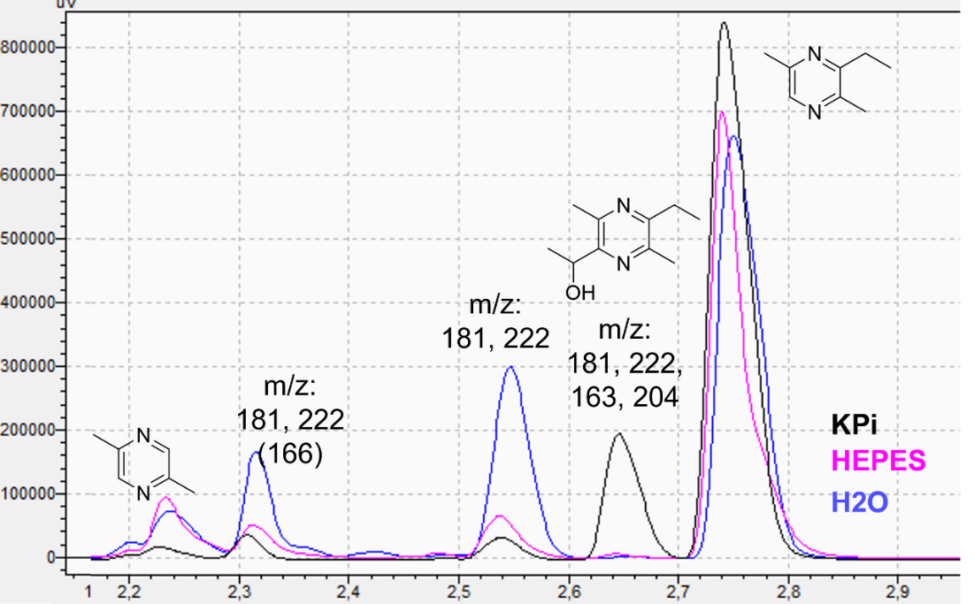
Figure S5. HPLC chromatograms obtained for each autotitration experiment in which different product profiles can be observed.

Figure S6. Graphic description of the HPLC chromatogram depicted above.

Figure S7. Comparison between the autotitration experiments and the ones with no pH control. The differences in total mass are attributed to evaporation due to our autotitration setup.

Figure S8. Autotitration results when varying phosphate concentration.

VI. Computational Methodology
Computations in the present study were performed with the ORCA 5.0⁹ utilizing the local high performance computing infrastructure. Electronic ground state calculations, including geometry optimizations, frequencies, and transition-state searches, were carried out with density functional theory (DFT) utilizing ORCA and the ωB97x hybrid GGA functional¹⁰ together with Grimme’s D4 dispersion correction¹¹ and Ahlrichs’ def2-TZVP basis set.¹² Gibbs free energies at 323.15 K were calculated using the rigid-rotor harmonic oscillator approximation as implemented in ORCA. For geometry optimizations and single-point calculations, implicit solvation was included via the CPCM model and water as solvent.¹³ Transition States (TSs) were localized with the help of the nudged elastic band method as implemented in the ORCA and confirmed to be first-order saddle points by analysis of the Hessian. Intrinsic reaction coordinate calculations have been employed to verify the correct assignment of TSs by following the eigenvector of the corresponding imaginary frequency, starting from the TS structures and connecting to reactants and products. Optimized structures were visualized with ChemCraft.¹⁴

VI.1. Reaction profile calculated for I-II
Figure S9. Reaction profile for the formation of intermediate II in kJ mol⁻¹.

VII. Growth protocol of CnThrDH and TkThrDH

General information
All steps were carried out on ice and under sterile conditions if applicable. A single colony of the respective E. coli strain was incubated in 4 ml LB-Miller medium at 37 °C with shaking (200 rpm) for approximately 12 h. A LB-Miller main culture (100 ml) was inoculated with 1 % (ν/ν) of the overnight culture (1 ml) and grown to an OD590 of approximately 0.35.

Preparation of RbCl competent cells for storage
Cells were harvested by centrifugation (4000 x g, 4 °C, 10 min) and resuspended in 20 ml RF1 buffer (1/5 volume of the main culture). Cells were incubated for 15 min, centrifuged, and resuspended in 4 ml RF2 buffer (1/5 volume of the RF1 suspension). Cells were divided into 100 μl aliquots (1.5 ml Eppendorf tubes), snap frozen in liquid nitrogen and stored at -80 °C.

Table S2. RF1 and RF2 buffer compositions.
RF1 buffer (100 ml, pH 5.8)ª | RF2 buffer (100 ml, pH 6.8)ª
1.21 g RbCl | 0.12 g RbCl
0.99 g MnCl₂ ⋅ 2 H₂O | 0.21 g MOPS
0.294 g KOAc | 0.11 g CaCl₂ ⋅ 2 H₂O
0.148 g CaCl₂ ⋅ 2 H₂O | 15 g glycerol
15 g glycerol
ª pH was adjusted by addition of 0.2 M acetic acid or 1 M NaOH and it was sterilized by filtration.

Transformation of Chemically Competent Cells
1 μl of plasmid DNA (with a concentration of 50–100 ng/μl) was added to 100 µl of RbCl competent cells. Cells were incubated on ice for 1 h. The heat shock was performed at 42 °C for 30 seconds or 1 minute (Biometra TS1 Thermoshaker Analytik Jena) and cells were put on ice for 2 min. 0.5 ml prewarmed SOC medium were added for recovery and cells were incubated at 37 °C with shaking (650 rpm, Biometra TS1 Thermoshaker Analytik Jena) for 1 h. Subsequently, 50 μl were plated on one half of a pre-warmed LB agar plate supplemented with ampicillin and the rest was centrifuged (7000 rpm, 1 min). The supernatant was discarded, cells were resuspended and plated on the other half of the plate. Plates were incubated upside down at 37 °C for 12–24 h (INCU-line VWR).

Growth, expression and lysis
Single colonies of the plasmids were cultivated in 5 ml of Luria–Bertani (LB) medium containing 0.2 mM ampicillin. The culture was aerobically cultivated for 16 h at 37 ºC, and then the starters were inoculated into 600 ml of LB medium containing 0.2 mM ampicillin for 24 h at 37 ºC. The induction of both ThrDHs was started by adding isopropyl β-D-1-thiogalactopyranoside (IPTG) to a final concentration of 0.45 mM, and the cultures were further cultivated for 16 h at 30 ºC for CnThrDH and 20 ºC for TkThrDH. After that, the recombinant cells were harvested by centrifugation at 5000g for 15 min at 4 ºC and then washed twice with KP_{i} buffer 10 mM pH 7. The cells were then resuspended in 10 mM potassium phosphate buffer (pH 7.0) and disrupted by ultrasonication for 2 rounds of 3.30 min, 40% amplitude with 30 s pulses and centrifuged at 28,000g for 45 min at 4 ºC. The cell-free extract was then lyophilised and employed as a solid in the biotransformations.

VIII. Biocatalytic synthesis of pyrazine 3a

L-threonine (50 mM), NAD⁺ (0.5 mM) and the desired electrophile (2.5 eq., 150 mM) were dissolved in 6 mL of KP_{i} 100 mM buffer pH 8 in a 30 mL glass vial. Then, 10 mg of CnThrDH lyophilised CFE was added, the vial closed and the solution was shaken for 16 h at 50 ºC in an orbital shaker at 200 rpm. After this time, the mixture was extracted with or Et₂O (2 x 6 mL). The combined organic layers were dried over Na₂SO₄, filtered, and purified through SiO₂ flash column chromatography employing mixtures of pentane:Et₂O.

IX. GC analyses for the determination of product percentages
Table S3. GC analytical conditions and retention times for the determination of conversion values.
Entry | Substrate | Program^{[a]} | Retention time (min)
1 | 3a | 70/2/30/120/5/35/280/2 | 5.6
2 | 3b | 70/2/30/120/5/35/280/2 | 3.6
^{[a]} GC program: initial temp. (ºC) / time (min) / ramp (ºC/min) / temp. (ºC) / time (min) / ramp (ºC/min) / final temp. (ºC) / time (min).

IX.1. Calibration curves for 3a and 3b

Figure S10. GC calibration curves for pyrazines 3a and 3b.

X. HPLC analyses for the determination of product percentages

The HPLC analyses were carried out employing as mobile phases H₂O with formic acid (0.1% v/v) and ACN at a flowrate of 1.0 mL min−1. The following program was used for elution: 10% ACN for 0-0.7 min, gradient to 90% ACN for 0.7-3.1 min, 90% ACN for 3.1-4.8 min and 10% ACN from 4.81-6.0 min. Compounds were detected at 280 nm. The retention times were as follows: 3b, 2.25 min (m/z 109 [M+1], 150 [M+42]) and 3a, 2.75 min (m/z 137 [M+1], 178 [M+42]). All masses were detected in positive ionization mode.

X.1. Calibration curves for 3a and 3b
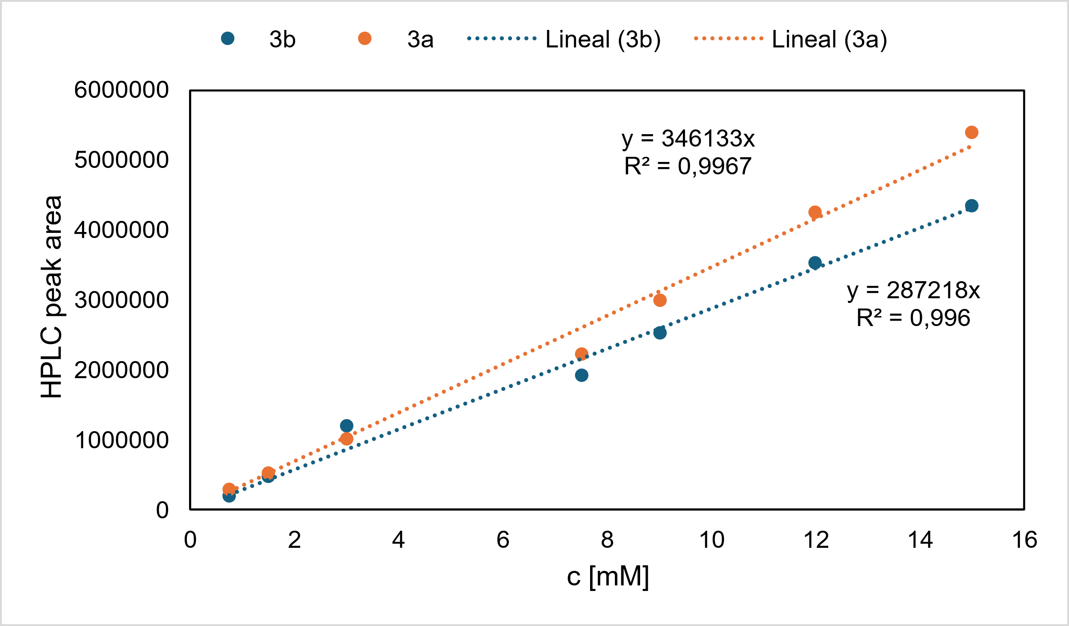

Figure S11. HPLC calibration curves for pyrazines 3a and 3b.

XI. NMR spectra
Figure S12. ¹H-NMR spectrum (CDCl₃) of compound 2o.

Figure S13. ¹H-NMR spectrum (CDCl₃) of compound 3a.

Figure S14. ¹³C-NMR spectrum (CDCl₃) of compound 3a.
Figure S15. ¹H-NMR spectrum (CDCl₃) of compound 3b.

Figure S16. ¹³C-NMR spectrum (CDCl₃) of compound 3b.

Figure S17. ¹H-NMR spectrum (CDCl₃) of compound 3c.

Figure S18. ¹³C-NMR spectrum (CDCl₃) of compound 3c.

Figure S19. ¹H-NMR spectrum (CDCl₃) of compound 3d.

Figure S20. ¹³C-NMR spectrum (CDCl₃) of compound 3d.

Figure S21. ¹H-NMR spectrum (CDCl₃) of compound 3e.

Figure S22. ¹³C-NMR spectrum (CDCl₃) of compound 3e.
Figure S23. ¹H-NMR spectrum (CDCl₃) of compound 3f.

Figure S24. ¹³C-NMR spectrum (CDCl₃) of compound 3f.
Figure S25. ¹H-NMR spectrum (CDCl₃) of compound 3g.

Figure S26. ¹³C-NMR spectrum (CDCl₃) of compound 3g.

Figure S27. ¹H-NMR spectrum (CDCl₃) of compound 3h.

Figure S28. ¹³C-NMR spectrum (CDCl₃) of compound 3h.
Figure S29. ¹H-NMR spectrum (CDCl₃) of compound 3i.

Figure S30. ¹³C-NMR spectrum (CDCl₃) of compound 3i.

Figure S31. ¹H-NMR spectrum (CDCl₃) of compound 3j.

Figure S32. ¹³C-NMR spectrum (CDCl₃) of compound 3j.

Figure S33. ¹H-NMR spectrum (CDCl₃) of compound 3k.

Figure S34. ¹³C-NMR spectrum (CDCl₃) of compound 3k.

Figure S35. ¹H-NMR spectrum (CDCl₃) of compound 3l.

Figure S36. ¹³C-NMR spectrum (CDCl₃) of compound 3l.
Figure S37. ¹H-NMR spectrum (CDCl₃) of compound 3m.

Figure S38. ¹³C-NMR spectrum (CDCl₃) of compound 3m.
Figure S39. ¹H-NMR spectrum (CDCl₃) of compound 3n.

Figure S40. ¹³C-NMR spectrum (CDCl₃) of compound 3n.

Figure S41. ¹H-NMR spectrum (CDCl₃) of compound 3o.

Figure S42. ¹³C-NMR spectrum (CDCl₃) of compound 3o.

Figure S43. ¹H-NMR spectrum (CDCl₃) of compound 3p.

Figure S44. ¹³C-NMR spectrum (CDCl₃) of compound 3p.
Figure S45. ¹H-NMR spectrum (CDCl₃) of compound 3r.

Figure S46. ¹³C-NMR spectrum (CDCl₃) of compound 3r.

Figure S47. ¹H-NMR spectrum (CDCl₃) of compound 3s.

Figure S48. ¹³C-NMR spectrum (CDCl₃) of compound 3s.

Figure S49. ¹H-NMR spectrum (CDCl₃) of compound 3t.

Figure S50. ¹³C-NMR spectrum (CDCl₃) of compound 3t.

Figure S51. ¹H-NMR spectrum (CDCl₃) of compound 3u.

Figure S52. ¹³C-NMR spectrum (CDCl₃) of compound 3u.

XII. Reference section

1. Duan, L., Jiang, K., Zhu, H. & Yin, B. CuCl₂-catalyzed highly stereoselective and chemoselective reduction of alkynyl amides into α,β-unsaturated amides using silanes as hydrogen donors. Org. Biomol. Chem. 19, 365–369 (2021).
2. Silvestri, A. P. & Oakdale, J. S. Intermolecular cyclotrimerization of haloketoalkynes and internal alkynes: facile access to arenes and phthalides. Chem. Commun. 56, 13417–13420 (2020).
3. Dickschat, J. S., Wickel, S., Bolten, C. J., Nawrath, T., Schulz, S. & Wittman, C. Pyrazine Biosynthesis in Corynebacterium glutamicum. Eur. J. Org. Chem. 2010, 2687–2695 (2010).
4. Tsurugi, H., Matsuno, M., Kawakami, T. & Mashima, K. Pyrazine Alkylation with Aldehydes and Haloalkanes Using N,N’‐Bis(trimethylsilyl)‐1,4‐dihydropyrazine Derivatives. Eur. J. Org. Chem. 2022, e202200862 (2022).
5. Nie, Q., Yao, F., Yi, F. & Cai, M. A heterogeneous gold(I)-catalyzed cascade annulation of aldehydes with propargylamine leading to 3-substituted 2,5-dimethylpyrazines. J. Organomet. Chem. 846, 343–350 (2017).
6. Seeman, J. I., Paine, J. B., Secor, H. V., Im, H. S. & Bernstein, E. R. Supersonic jet studies of alkyl-substituted pyrazines and pyridines. Minimum-energy conformations and torsional motion. J. Am. Chem. Soc. 114, 5269–5280 (1992).
7. Ohta, A. et al. Ethylation of Pyrazines Using Alkylmetals, Such as Triethylaluminum, Diethylzinc, and Triethylborane. Heterocycles 26, 2449 (1987).
8. Suzuki, H., Kawaguchi, T. & Takaoka, K. Reactions of Sodium Hydrogentelluride with α-Azido Ketones and α-Azido Bromides. Bull. Chem. Soc. Jpn. 59, 665–666 (1986).
9. Neese, F. Software update: The ORCA program system—Version 5.0. WIREs Computational Molecular Science 12, (2022).
10. Najibi, A. & Goerigk, L. DFT -D4 counterparts of leading meta- generalized‐gradient approximation and hybrid density functionals for energetics and geometries. J. Comput. Chem. 41, 2562–2572 (2020).
11. Grimme, S., Antony, J., Ehrlich, S. & Krieg, H. A consistent and accurate ab initio parametrization of density functional dispersion correction (DFT-D) for the 94 elements H-Pu. J. Chem. Phys. 132, 154104 (2010).
12. Weigend, F. & Ahlrichs, R. Balanced basis sets of split valence, triple zeta valence and quadruple zeta valence quality for H to Rn: Design and assessment of accuracy. Phys. Chem. Chem. Phys. 7, 3297 (2005).
13. Barone, V. & Cossi, M. Quantum Calculation of Molecular Energies and Energy Gradients in Solution by a Conductor Solvent Model. J. Phys. Chem. A 102, 1995–2001 (1998).
14. Chemcraft, version 1.8. https://www.chemcraftprog.com. (2023).

