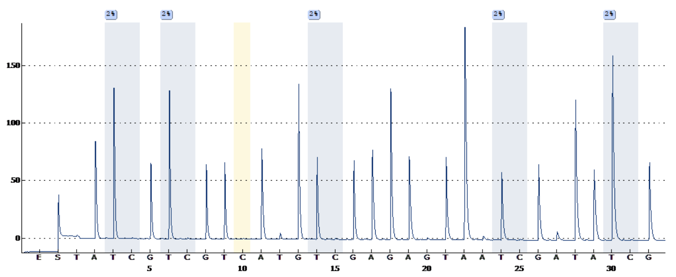
Igf1r
A.
Adipor1
B.
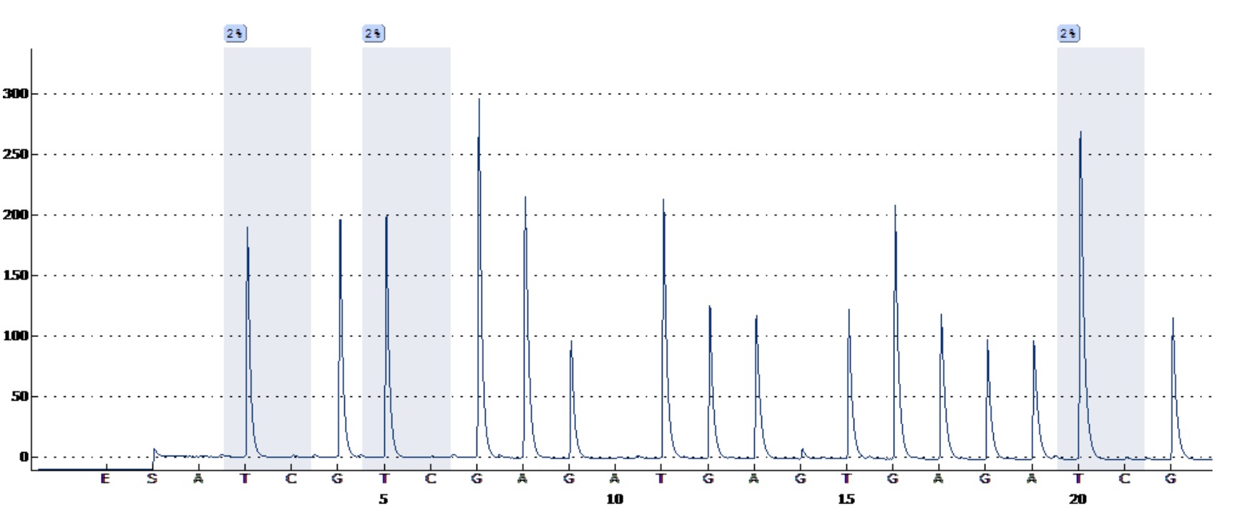
Foxo1
C.
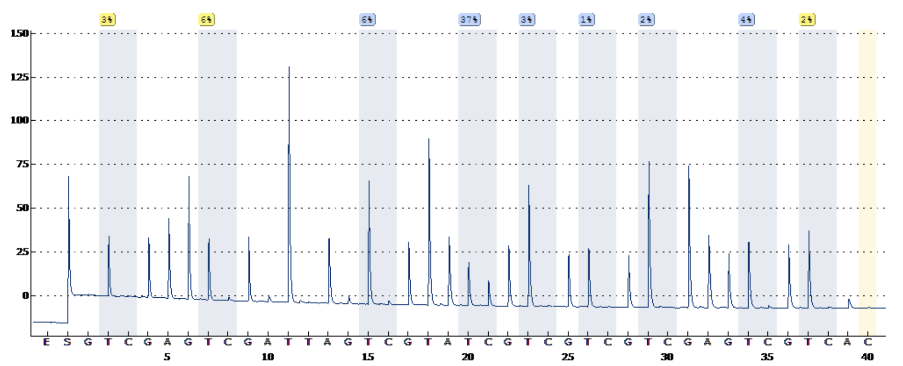

Supplementary Figure 1. Representative pyrogram results for each gene (A) Igf1r, (B) Adipor1, (C) Foxo1. All pyrogram results belong to the same sample.

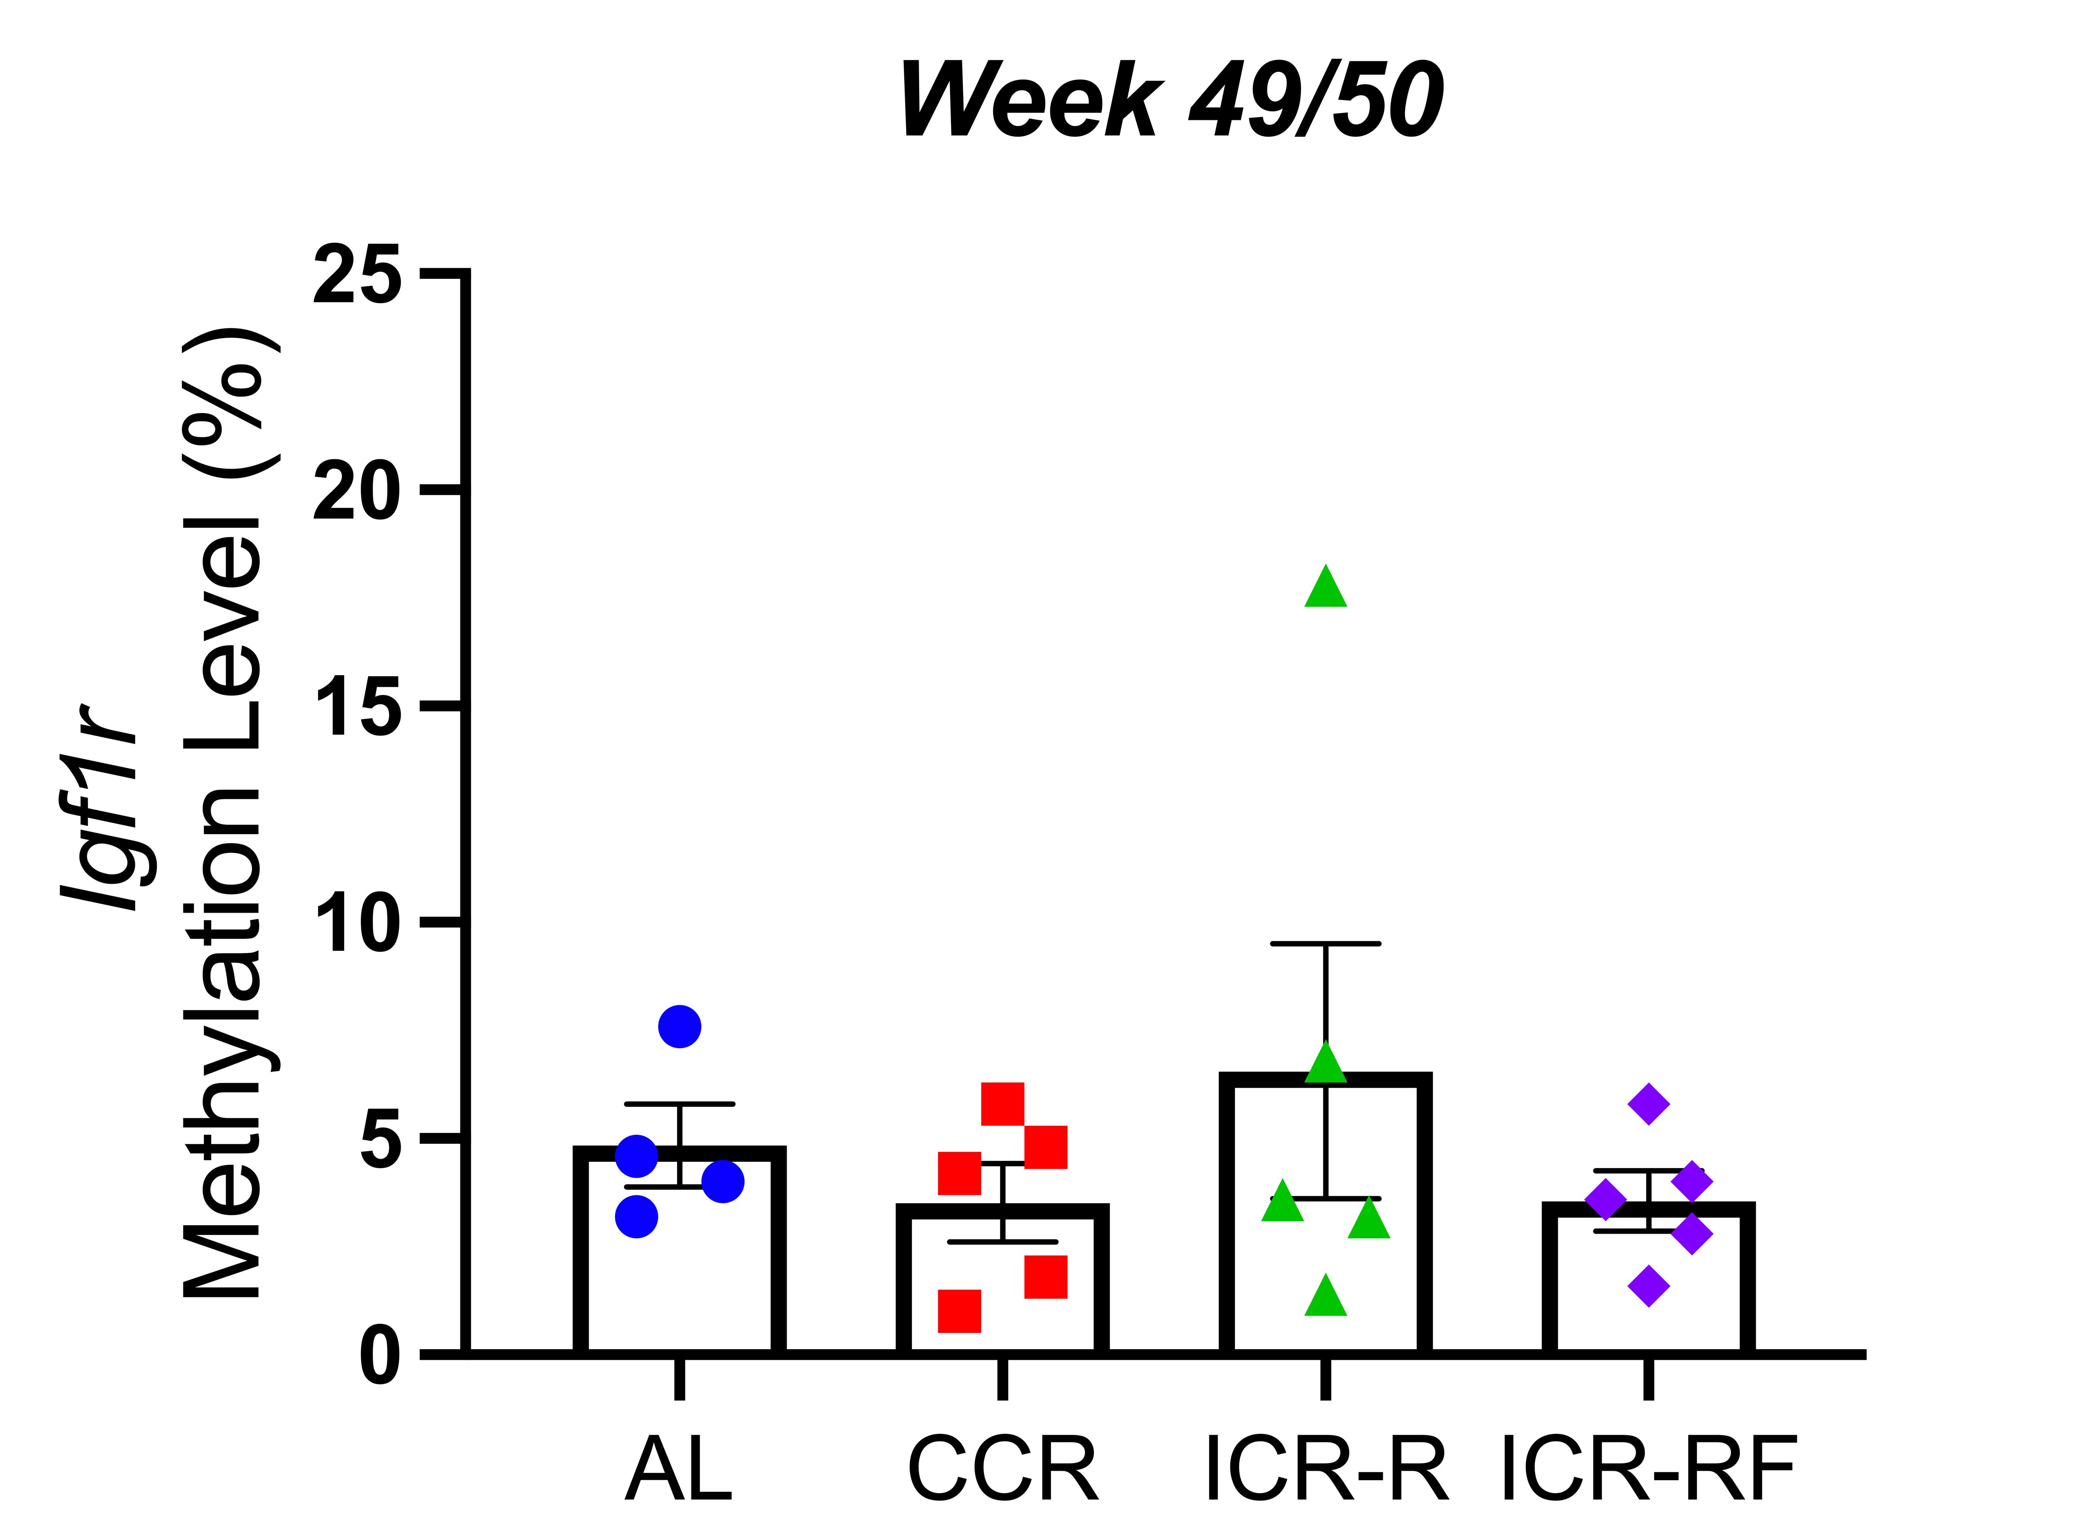
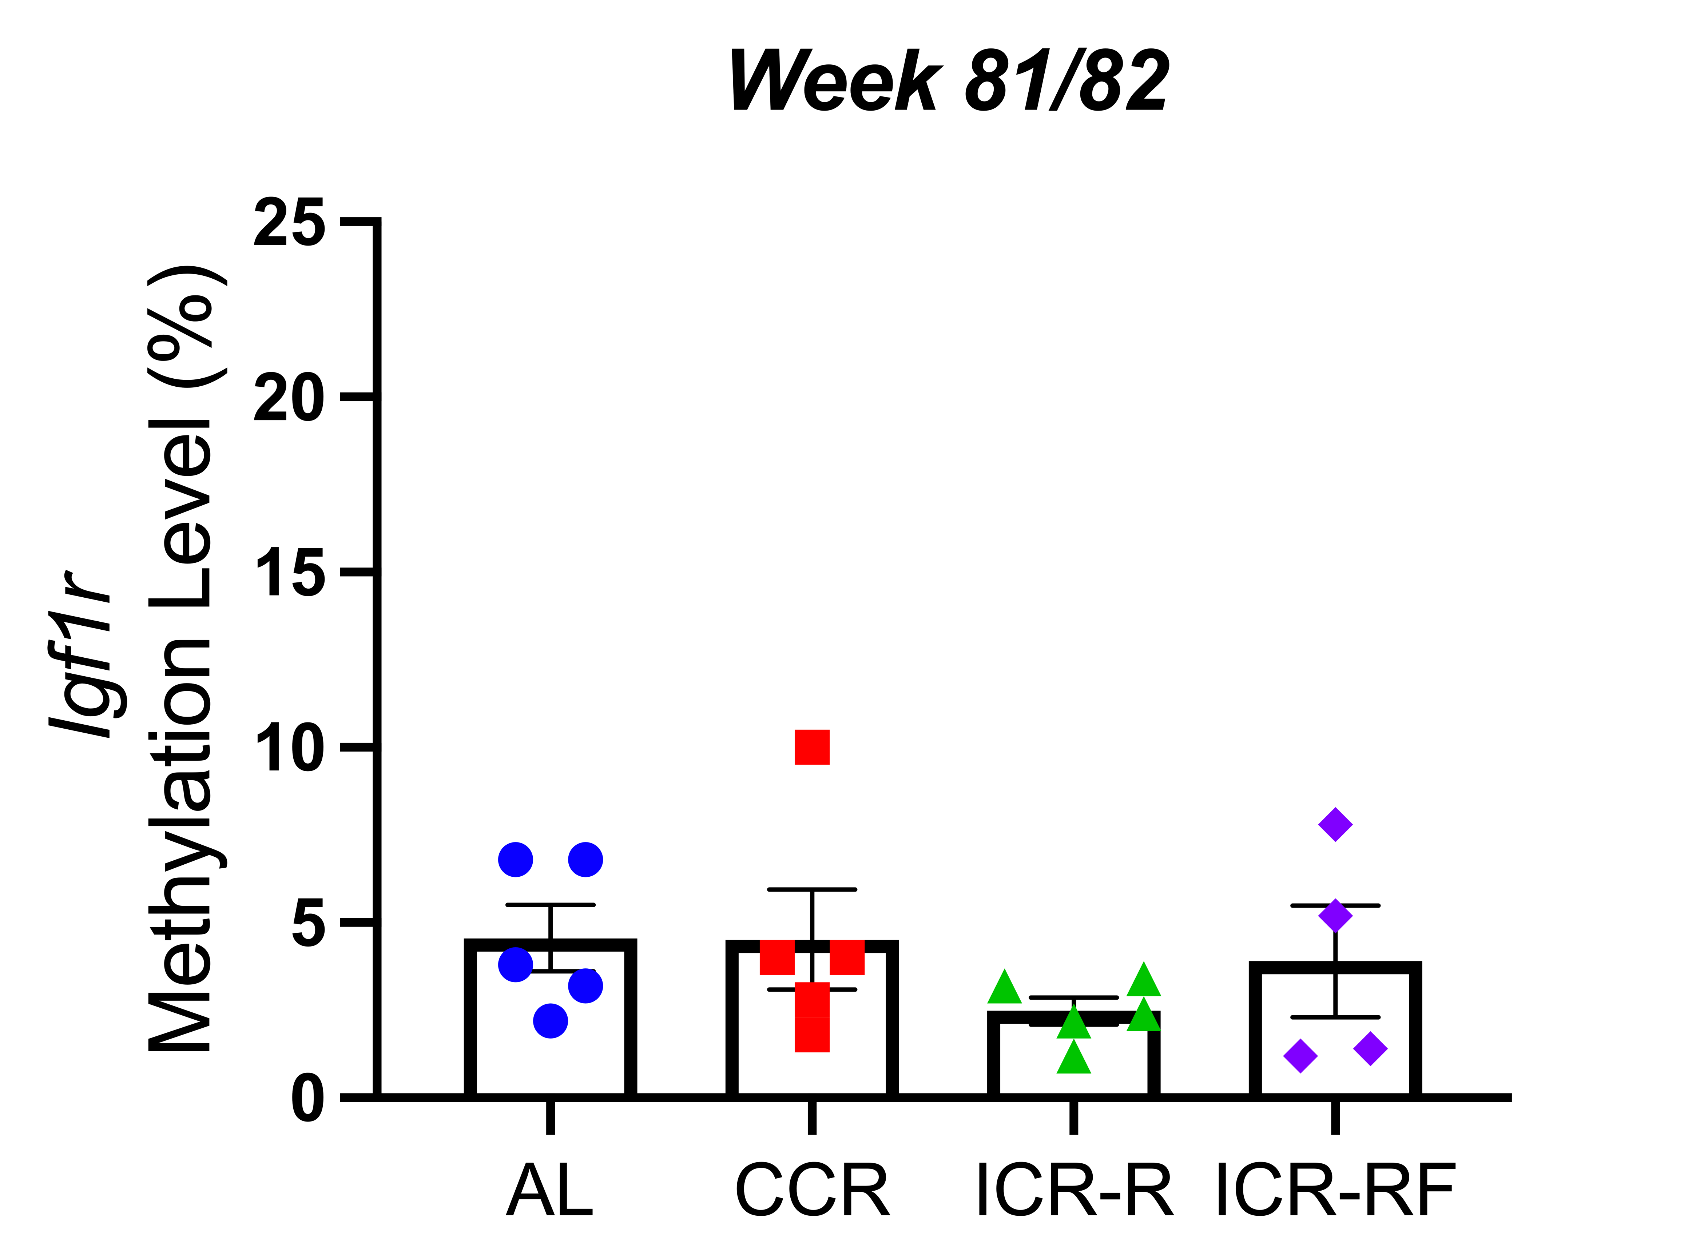
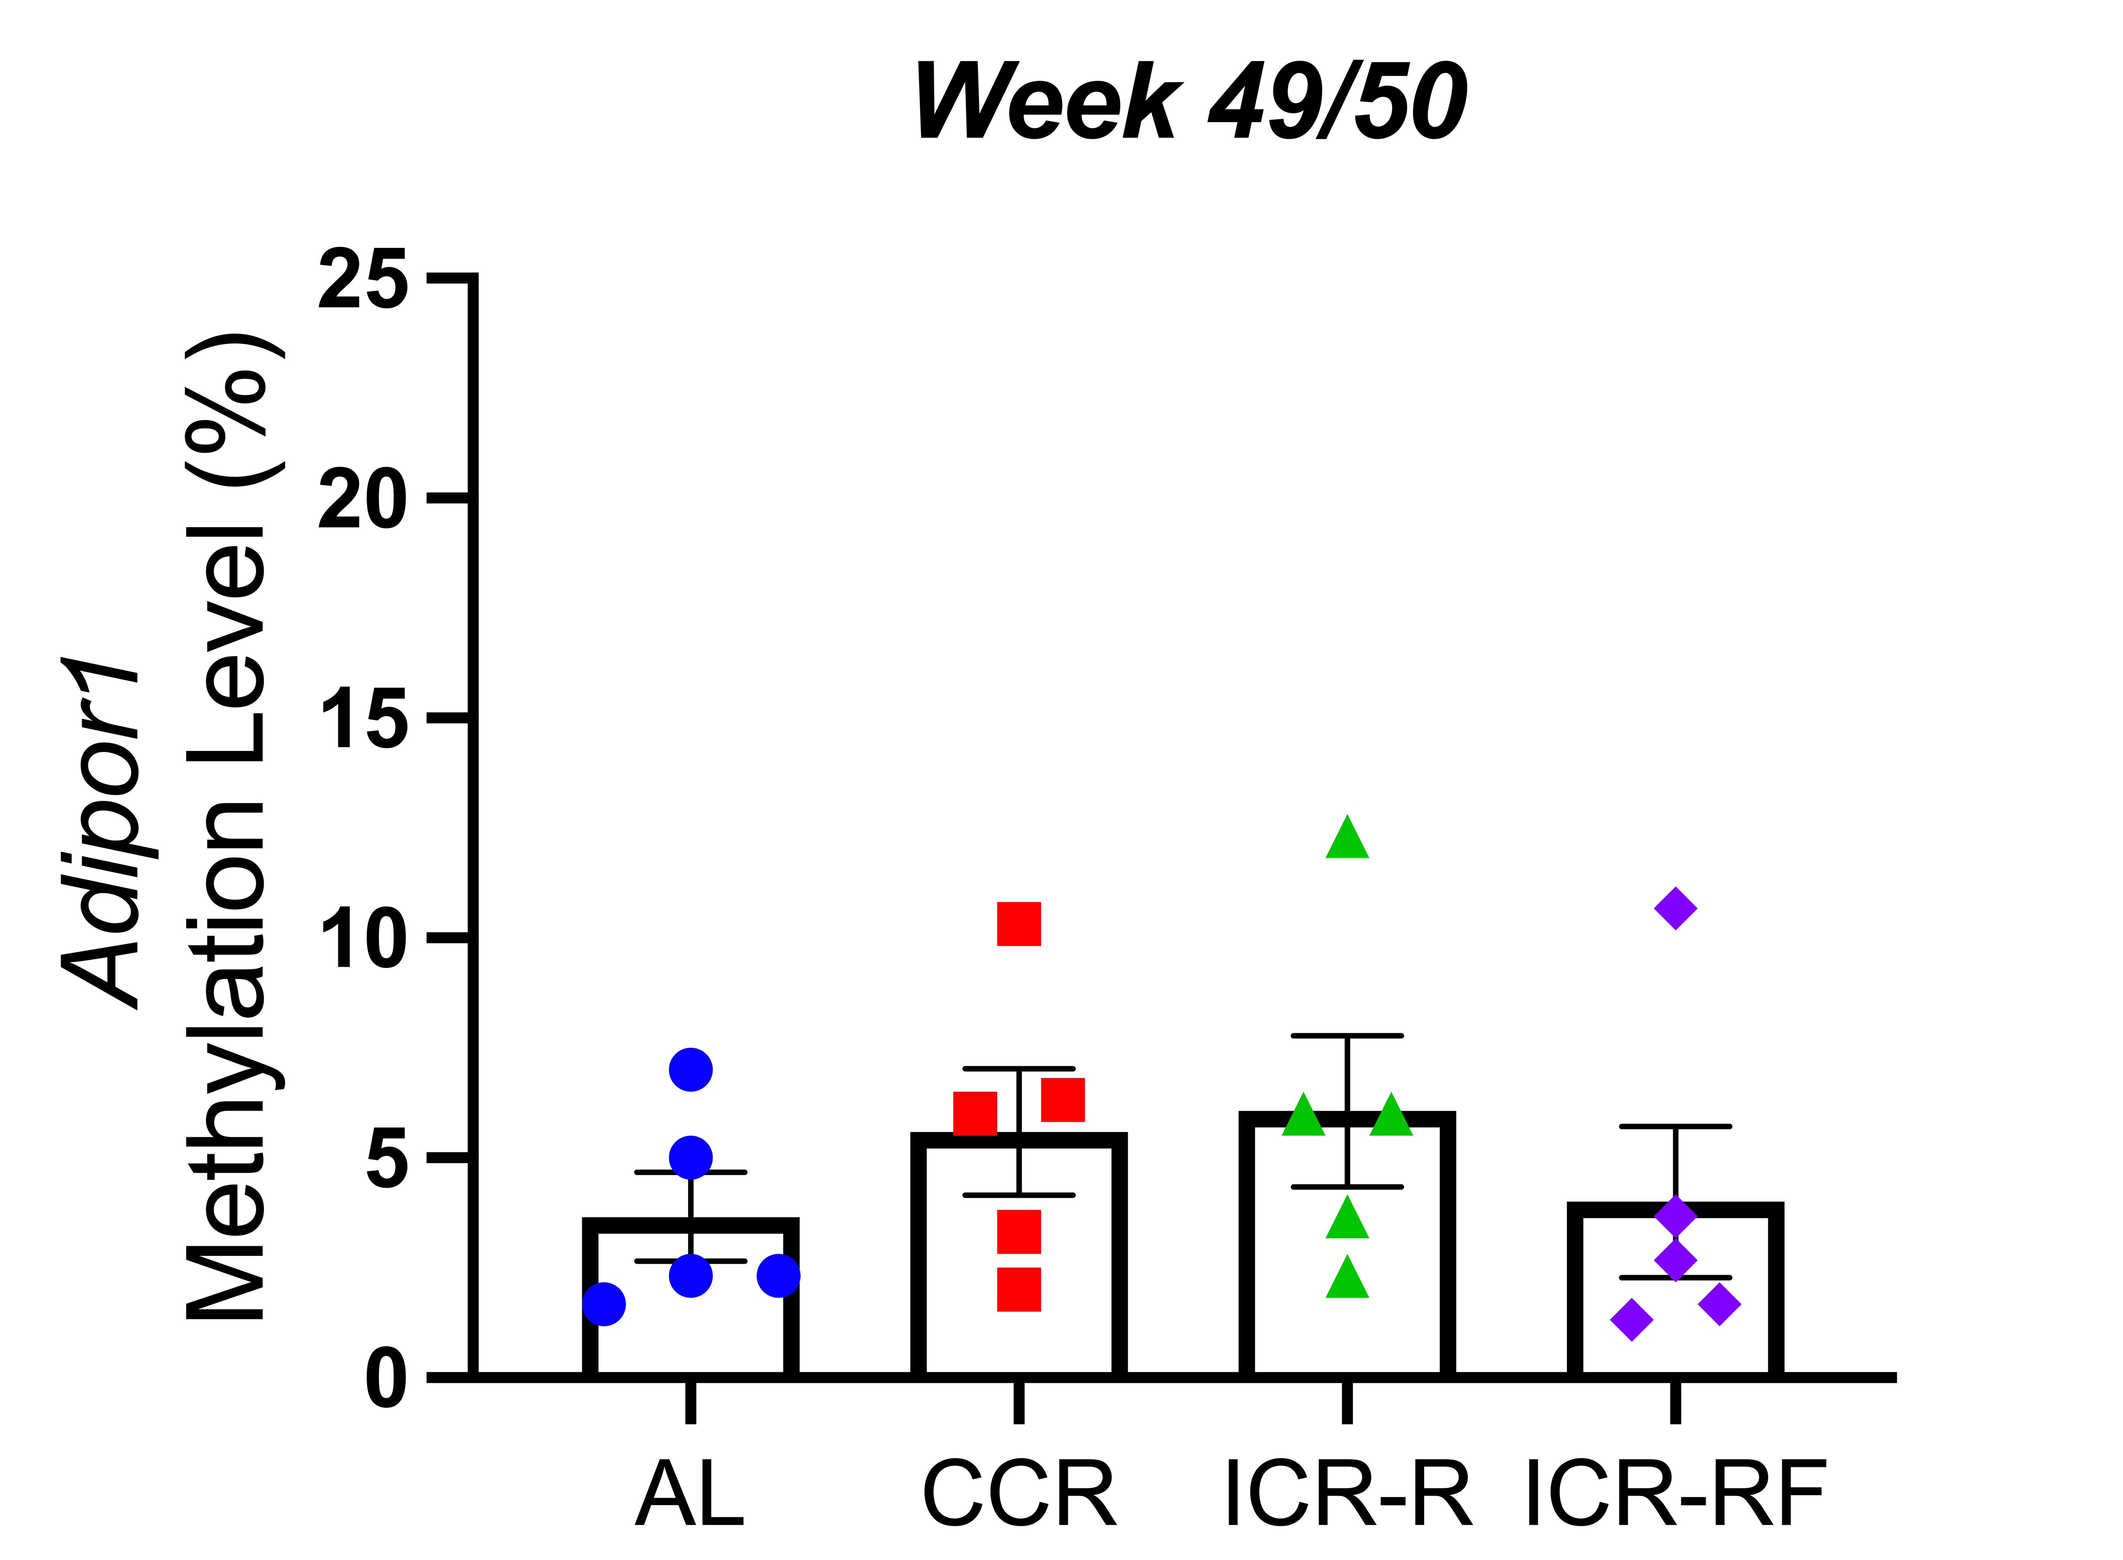
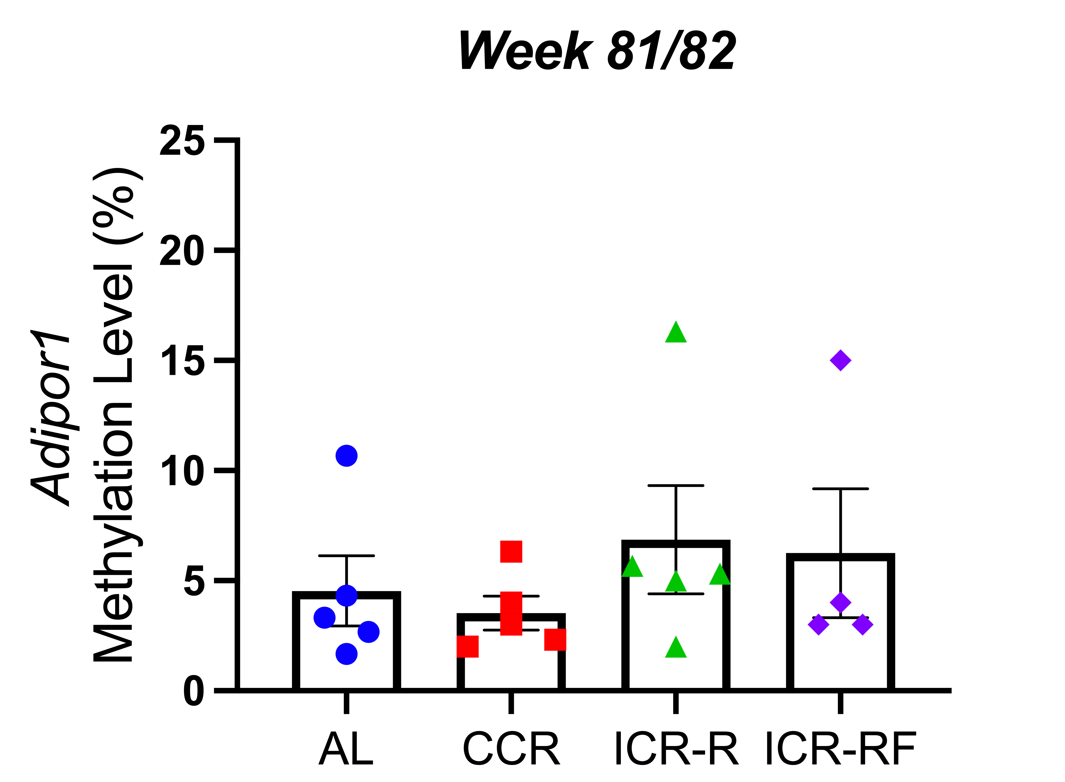
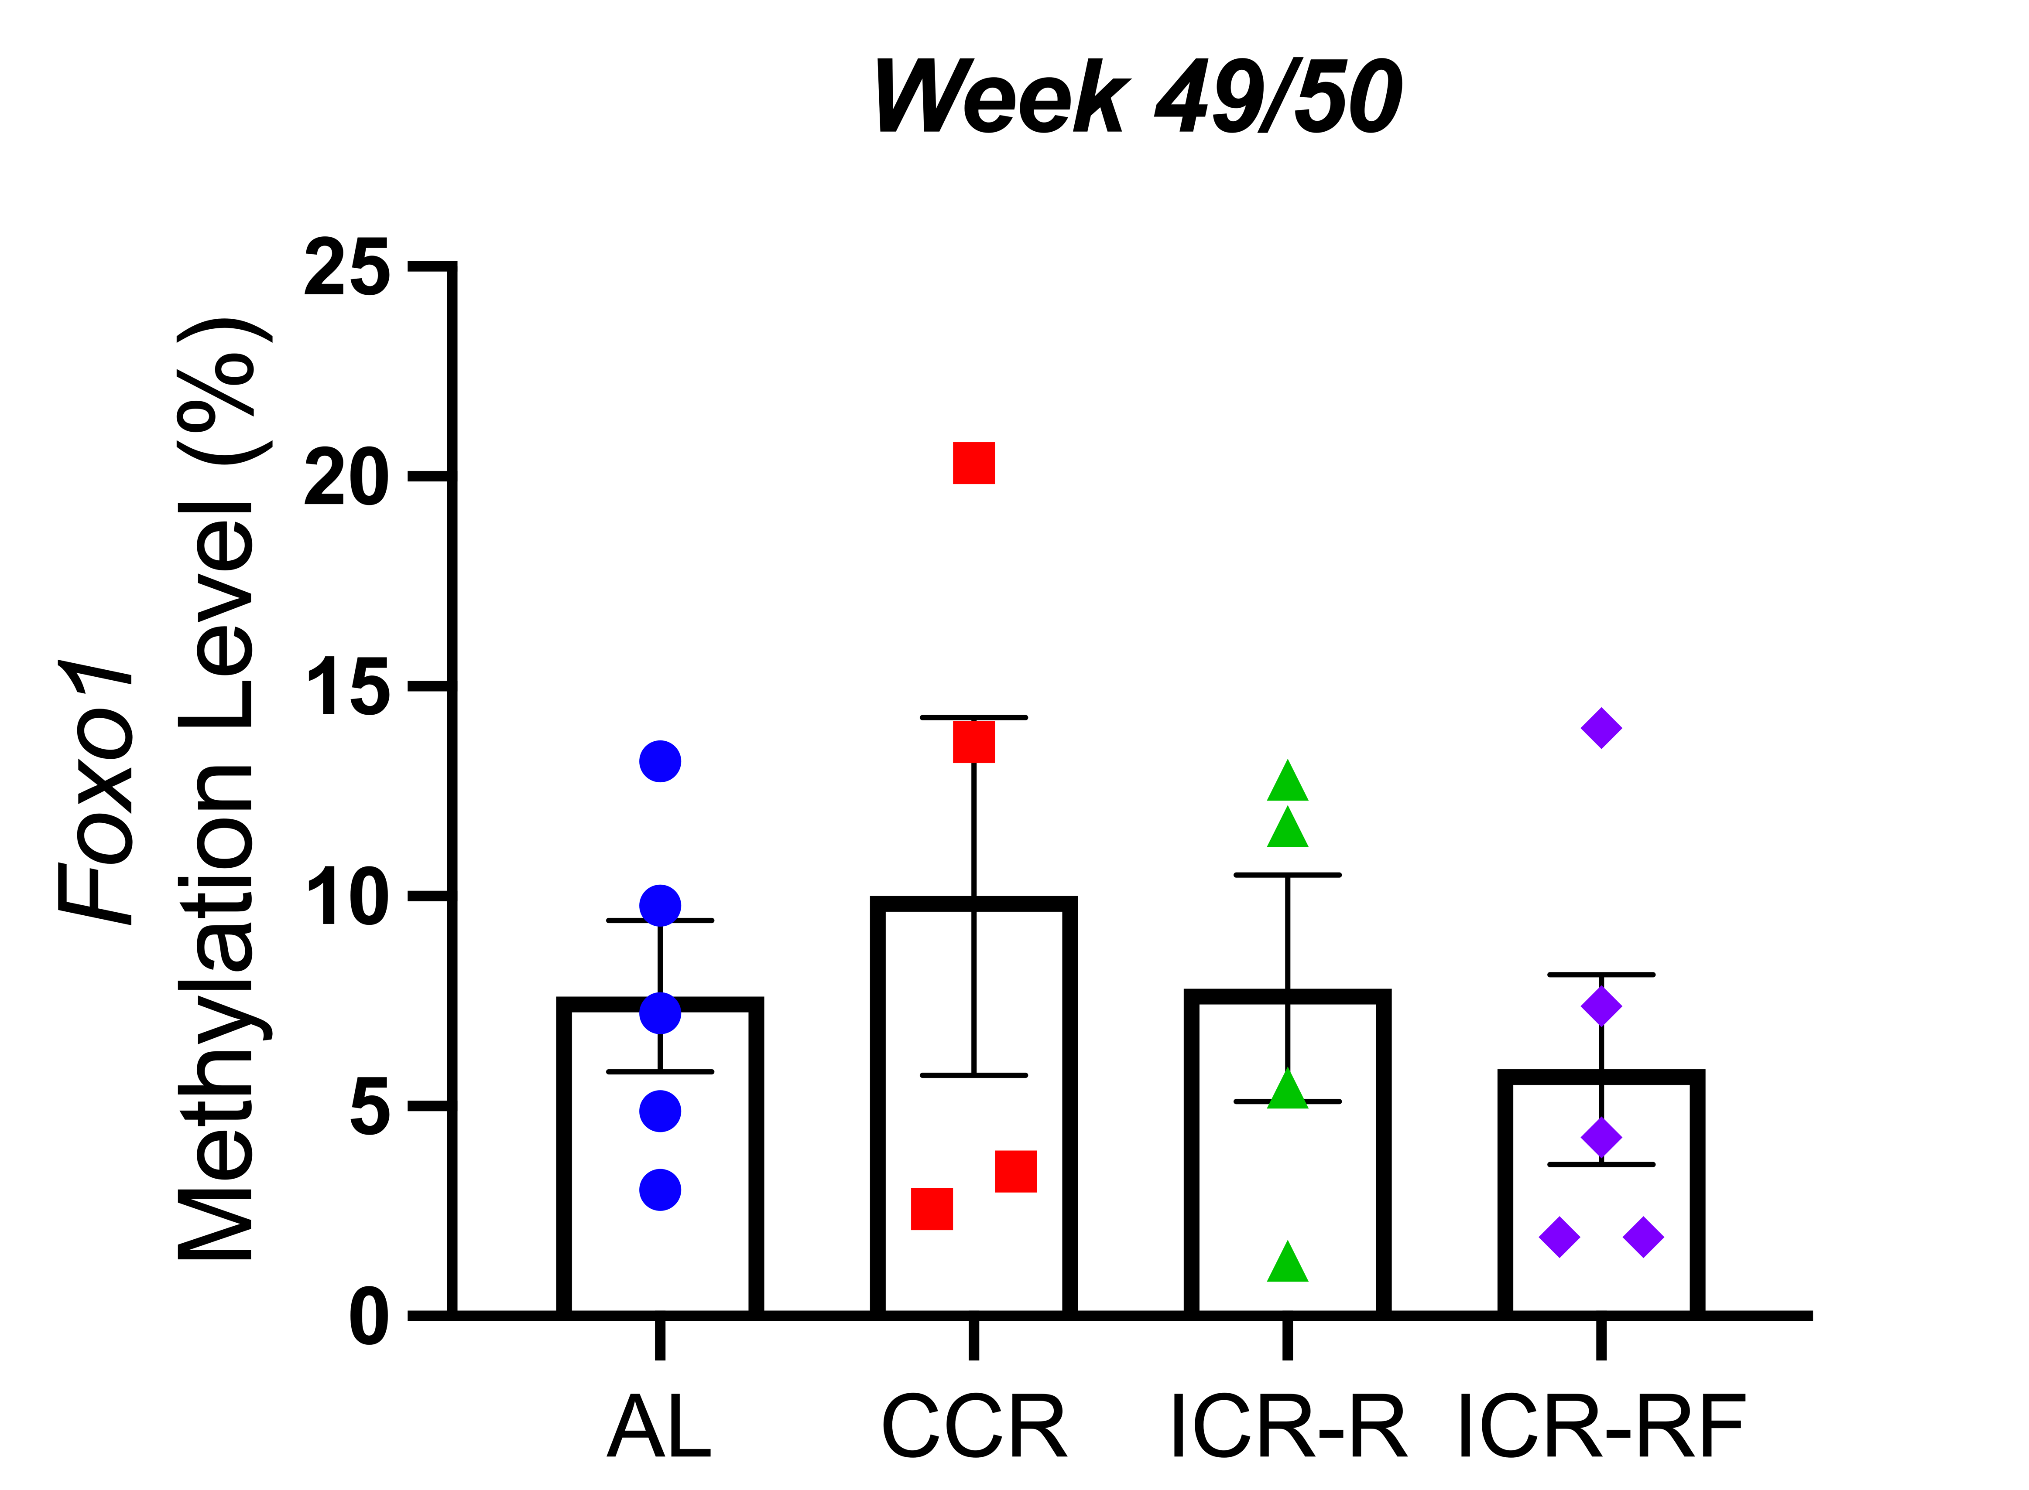
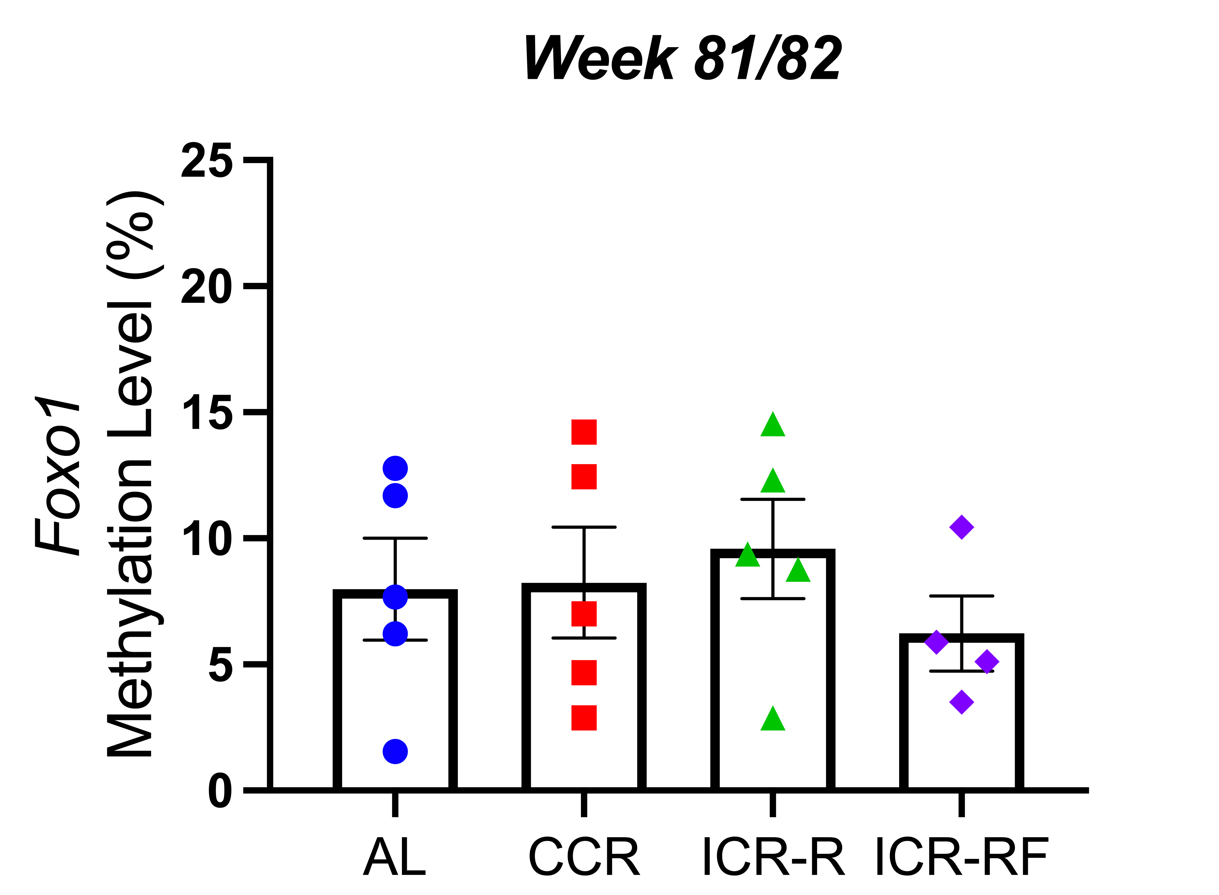
A.
B.
C.

Supplementary Figure 2. The effects of different types of calorie restriction on the average promoter CpG site methylation of (A) Igf1r, (B) Adipor1, (C) Foxo1 in aging mouse brain. Mean ± SEM are presented for each group, n=4-5 biological replicates. Statistical significance determined using one-way ANOVA.

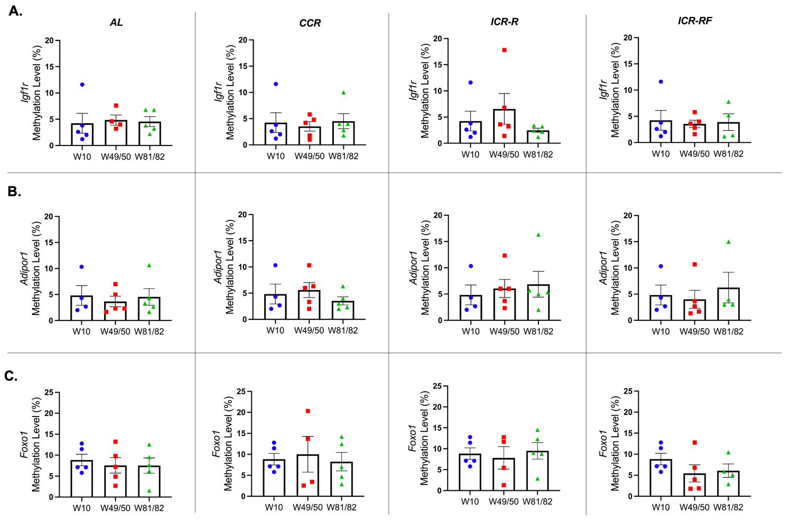

Supplementary Figure 3. The effects of aging on the average promoter CpG site methylation of (A) Igf1r, (B) Adipor1, (C) Foxo1 promoter in mouse brain. Mean ± SEM are presented for each group, n=4-5 biological replicates. Statistical significance determined using one-way ANOVA.

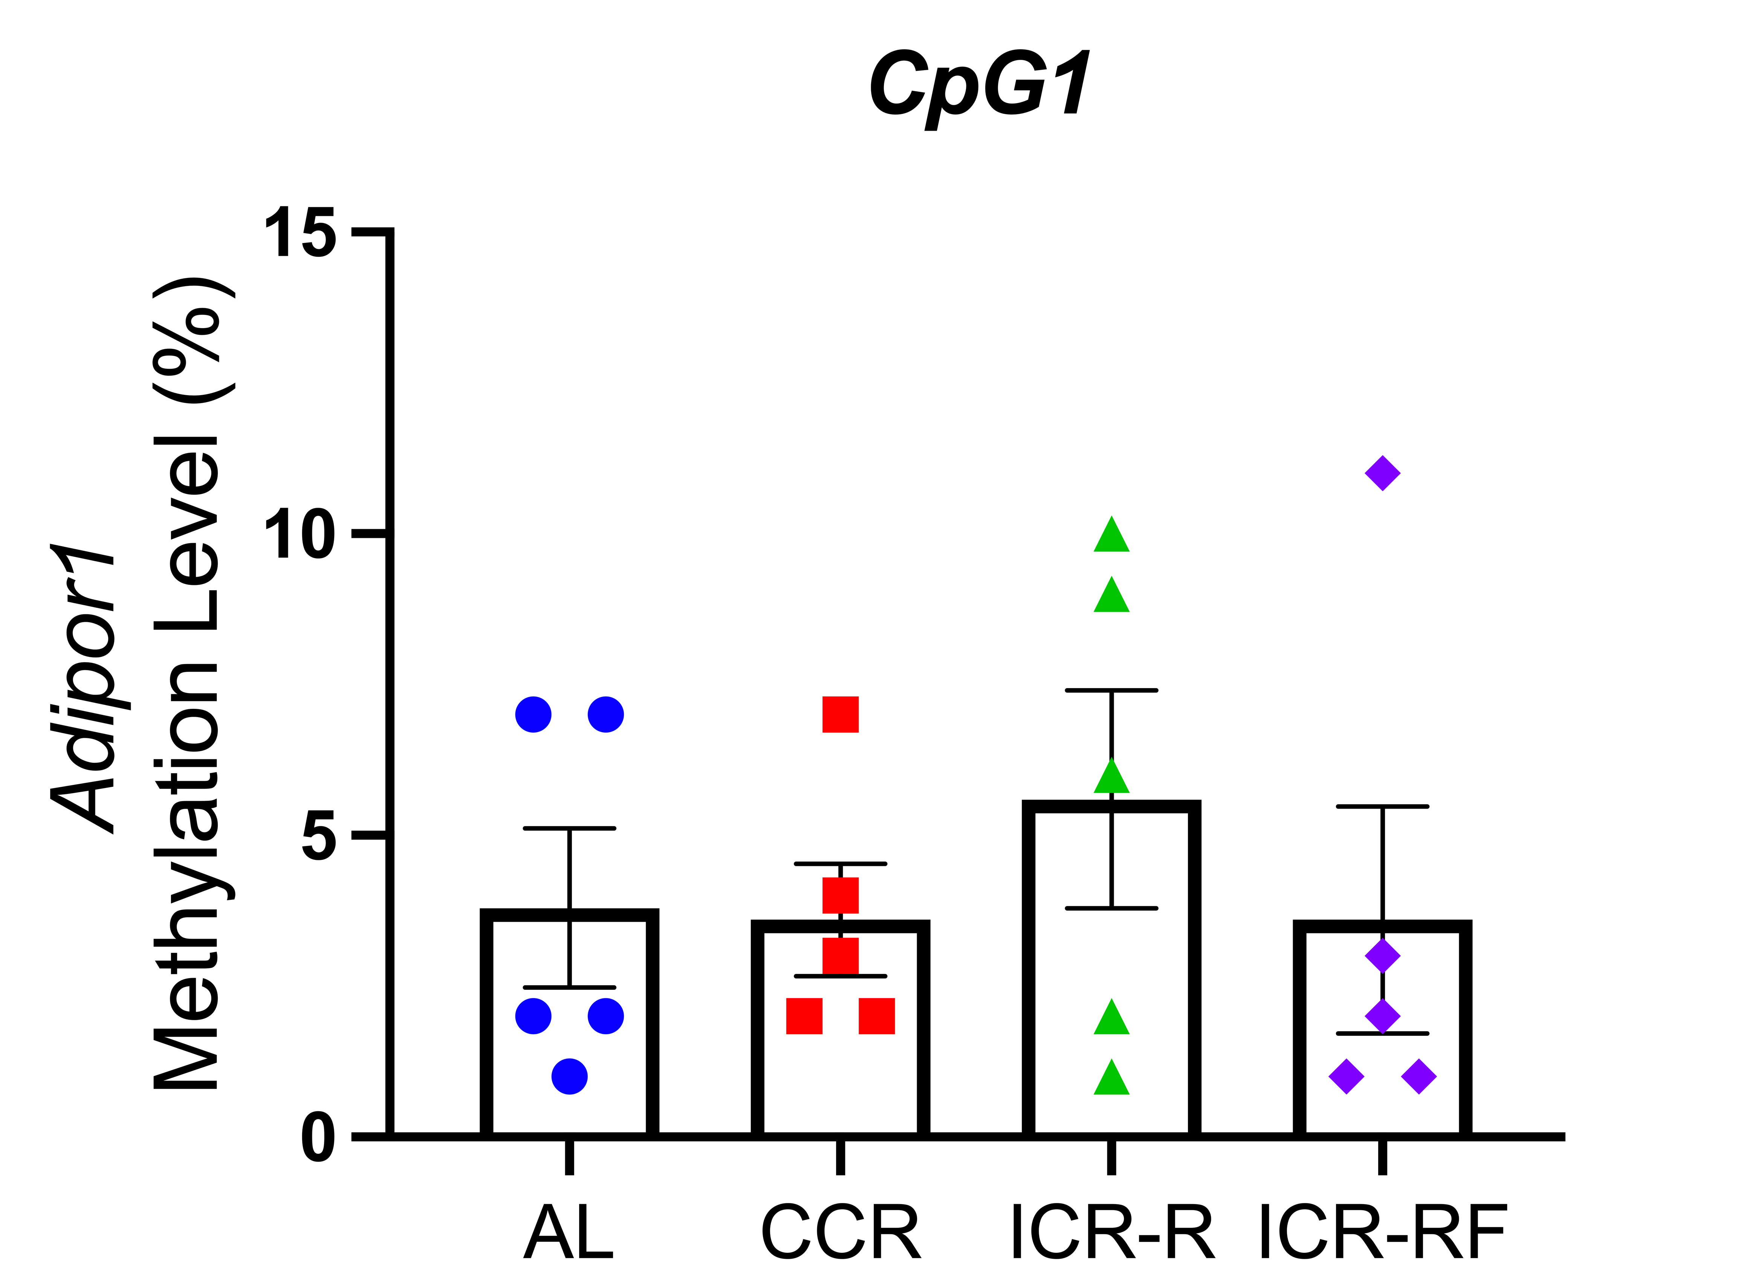
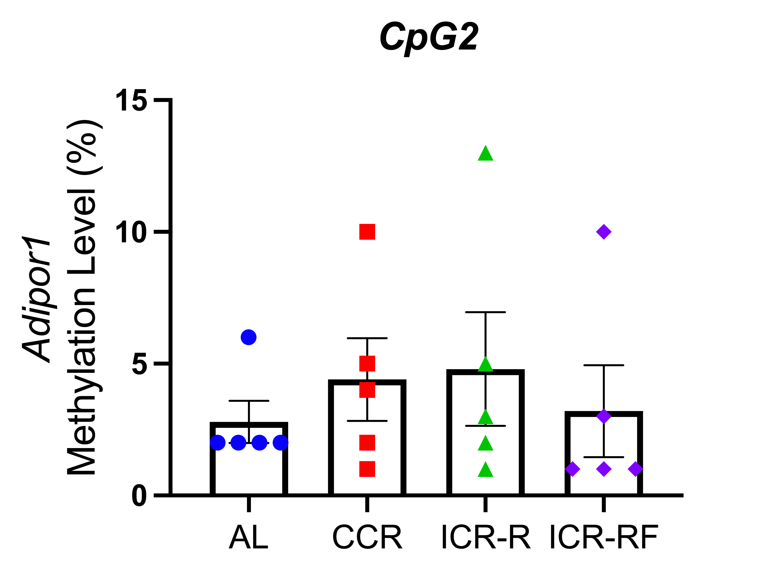
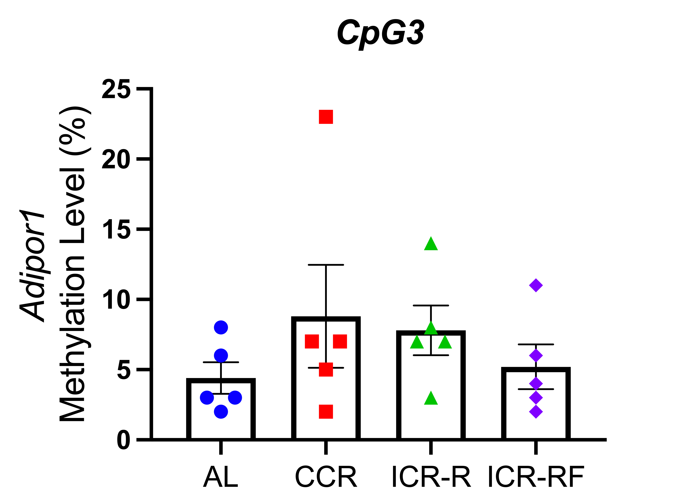
A.
Week 49/50

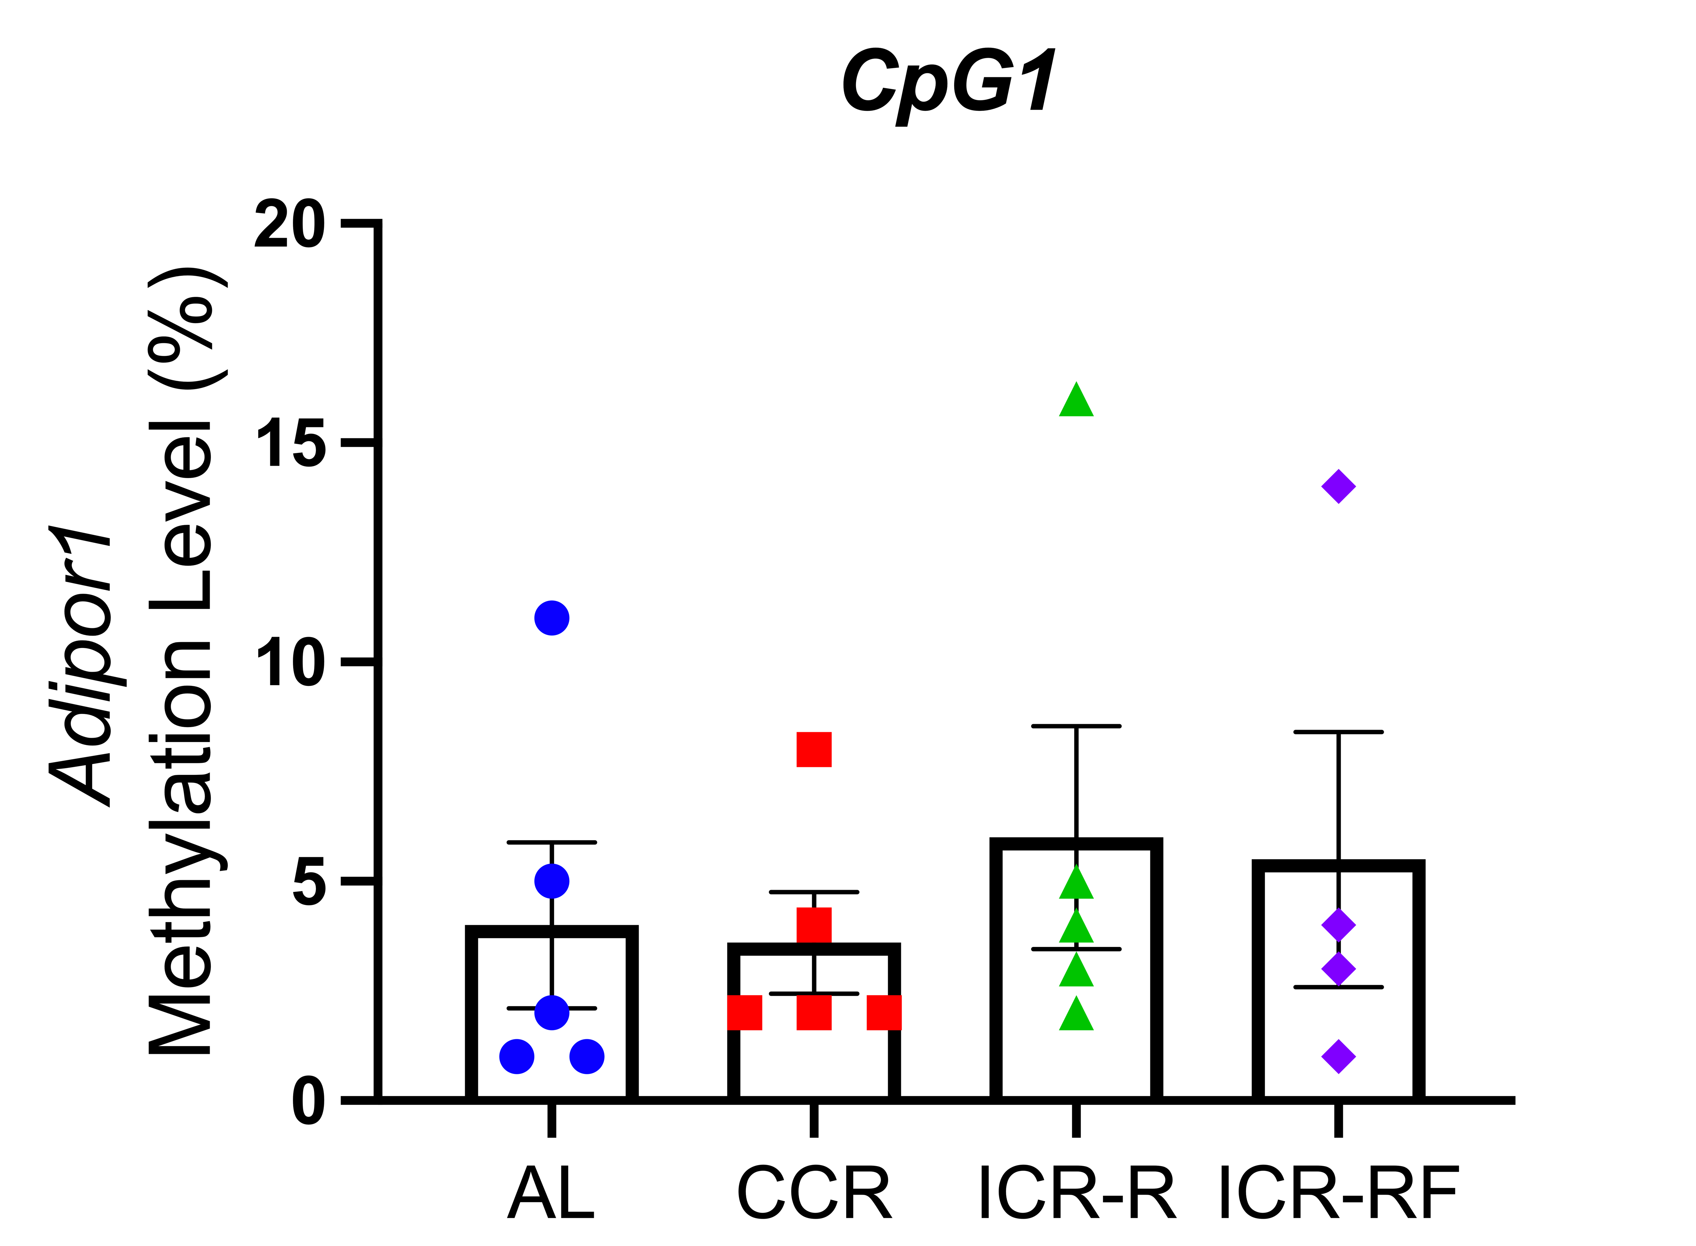
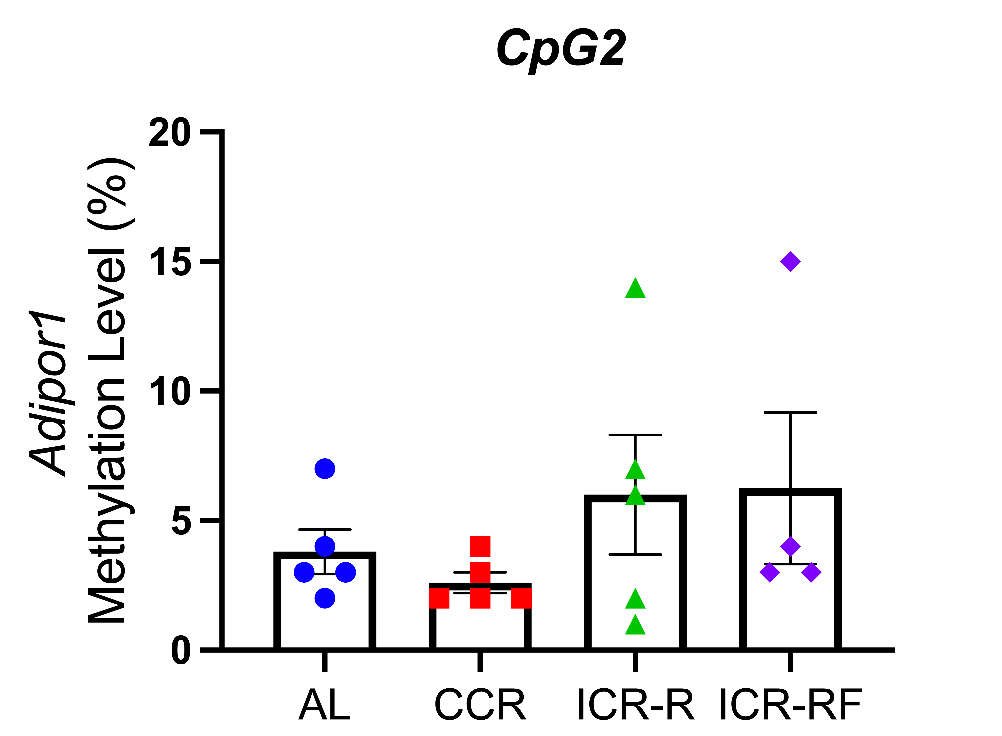
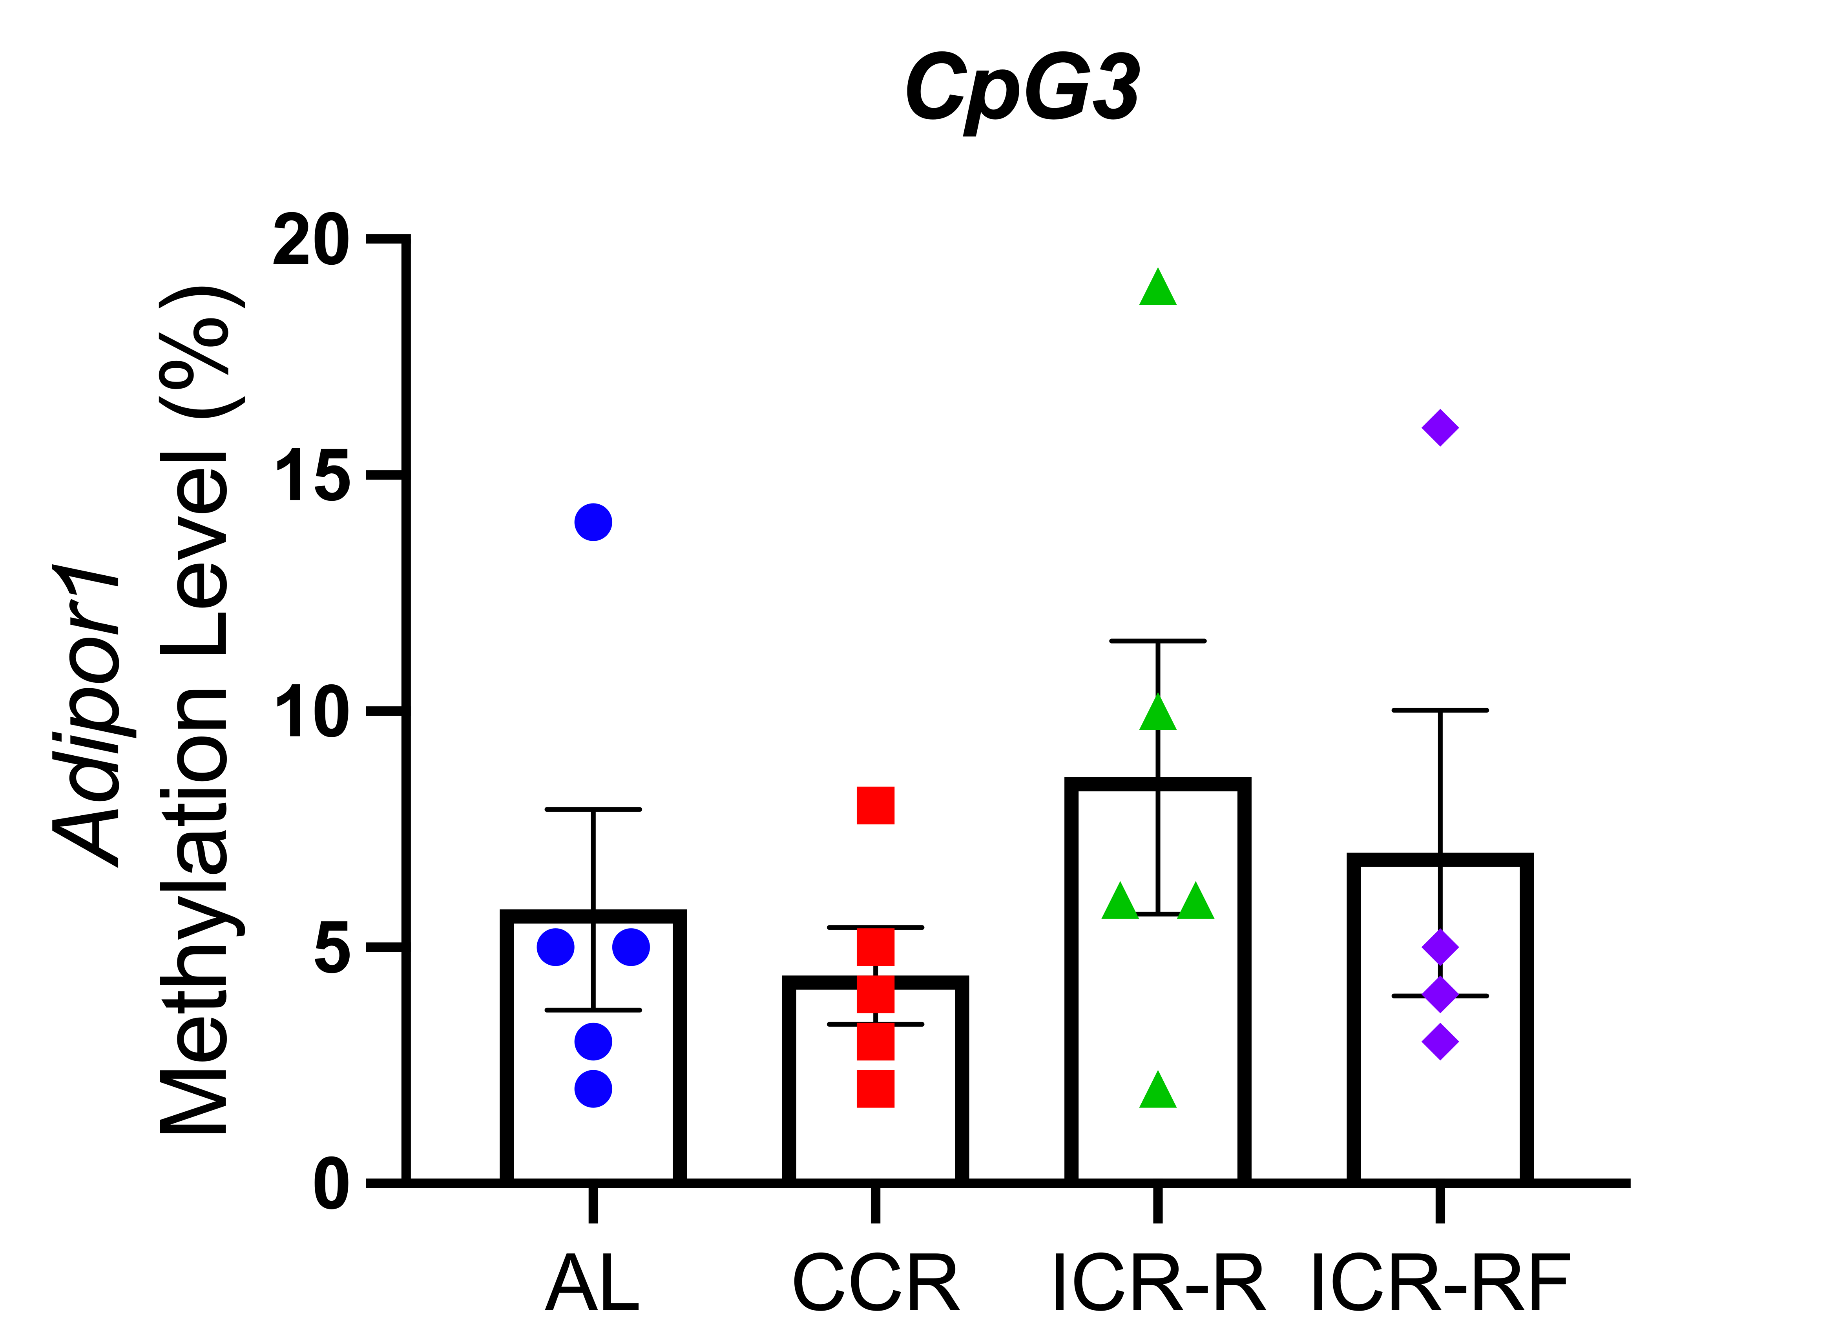
B.
Week 81/82

Supplementary Figure 4. The effects of different types of calorie restriction on three individual CpG sites on Adipor1 promoter in mouse brain at (A) week 49/50 (B) week 81/82. Mean ± SEM are presented for each group, n=4-5 biological replicates. Statistical significance determined using one-way ANOVA.

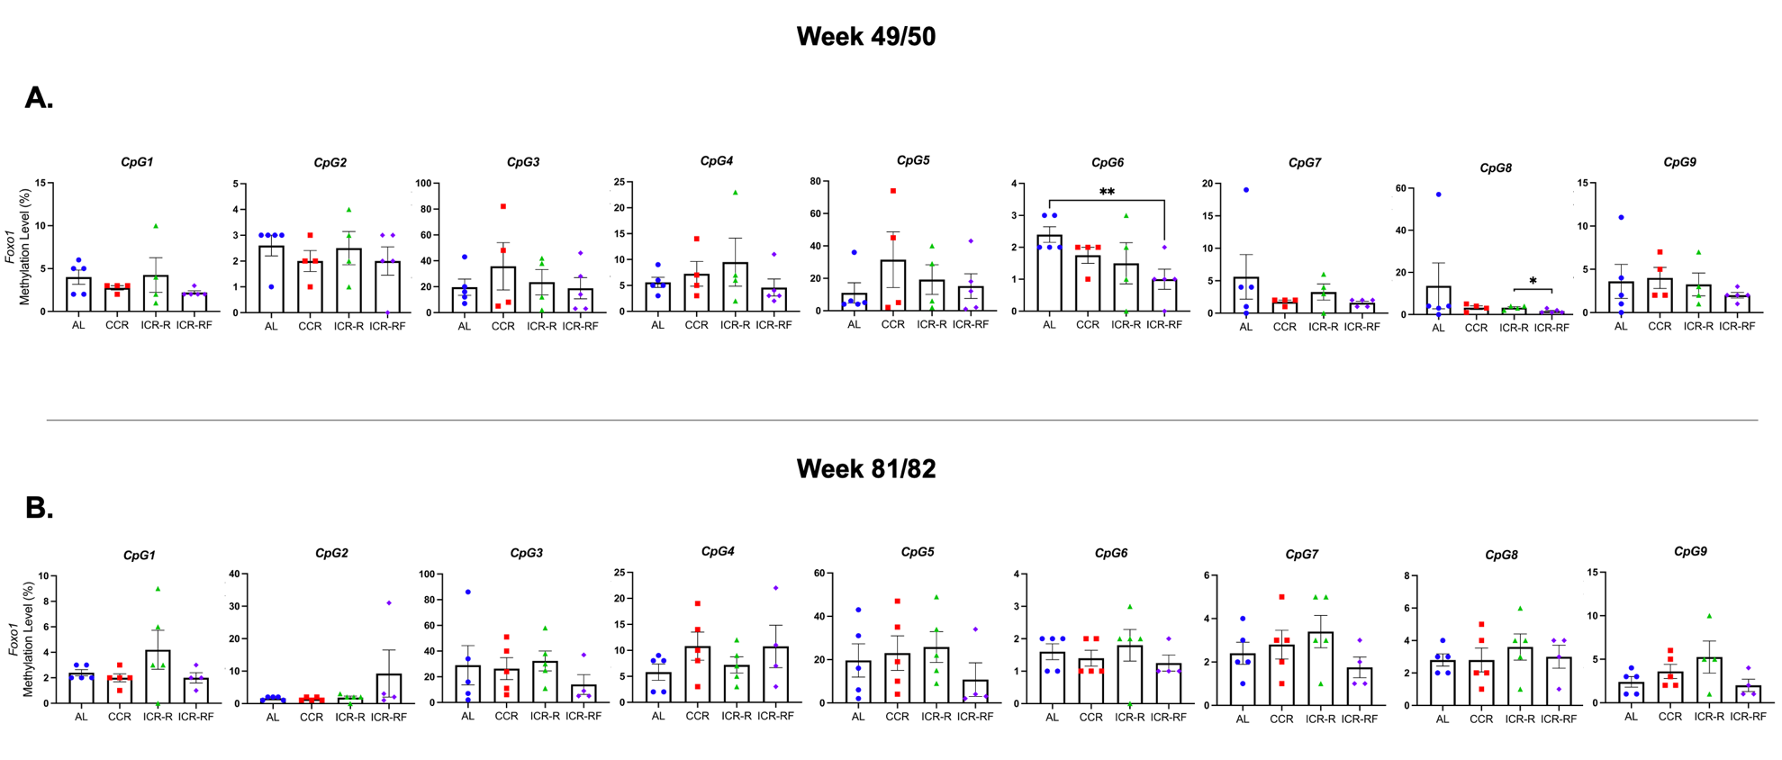
Supplementary Figure 5. The effects of different types of calorie restriction on nine individual CpG sites of Foxo1 promoter in mouse brain at (A) week 49/50 (B) week 81/82. Mean ± SEM are presented for each group, n=4-5 biological replicates. Statistical significance determined using one-way ANOVA. *p<0.05, **p<0.01.

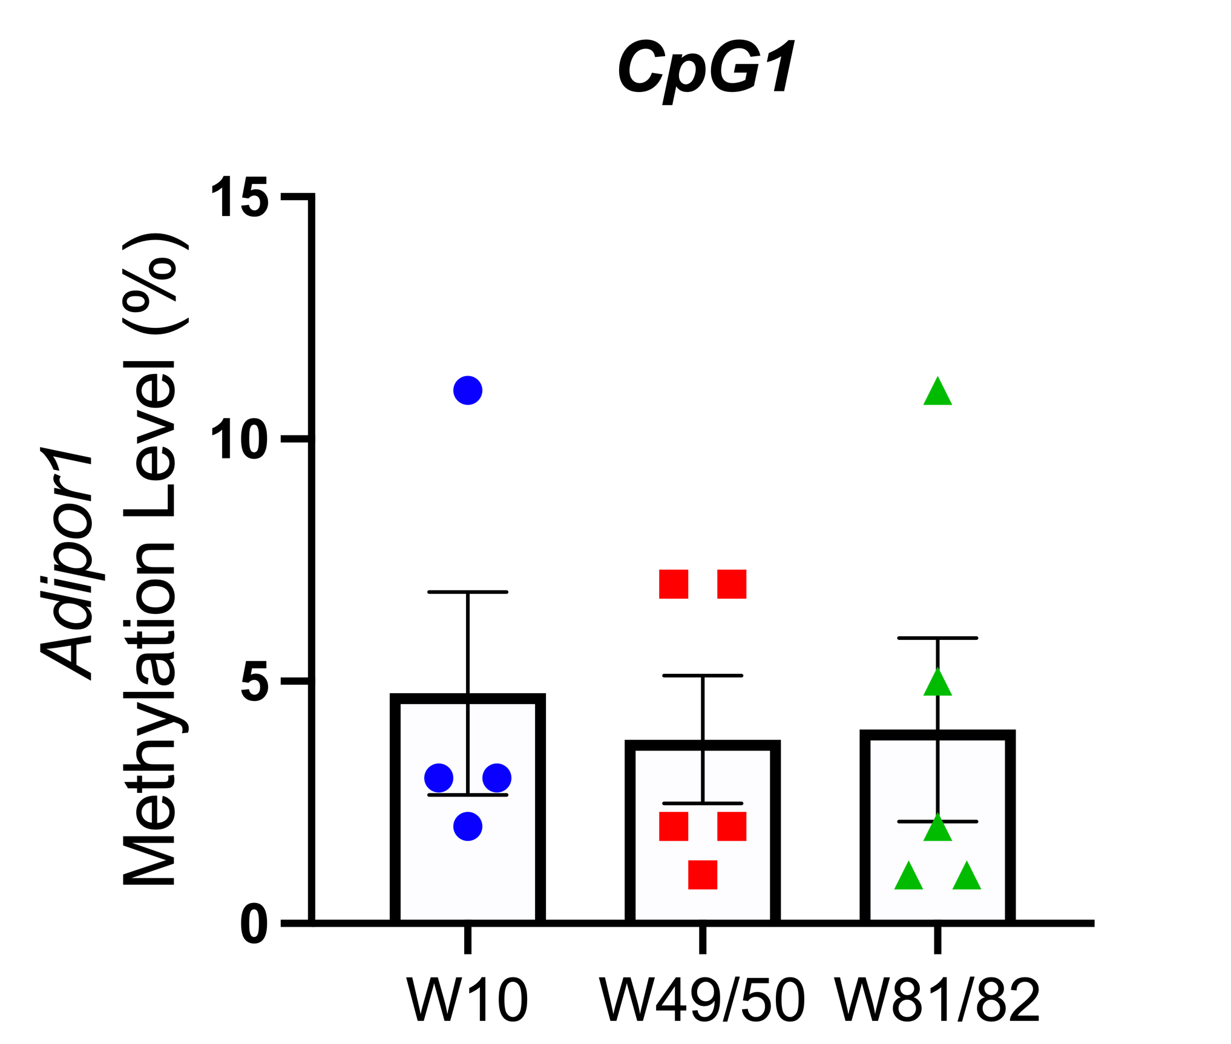
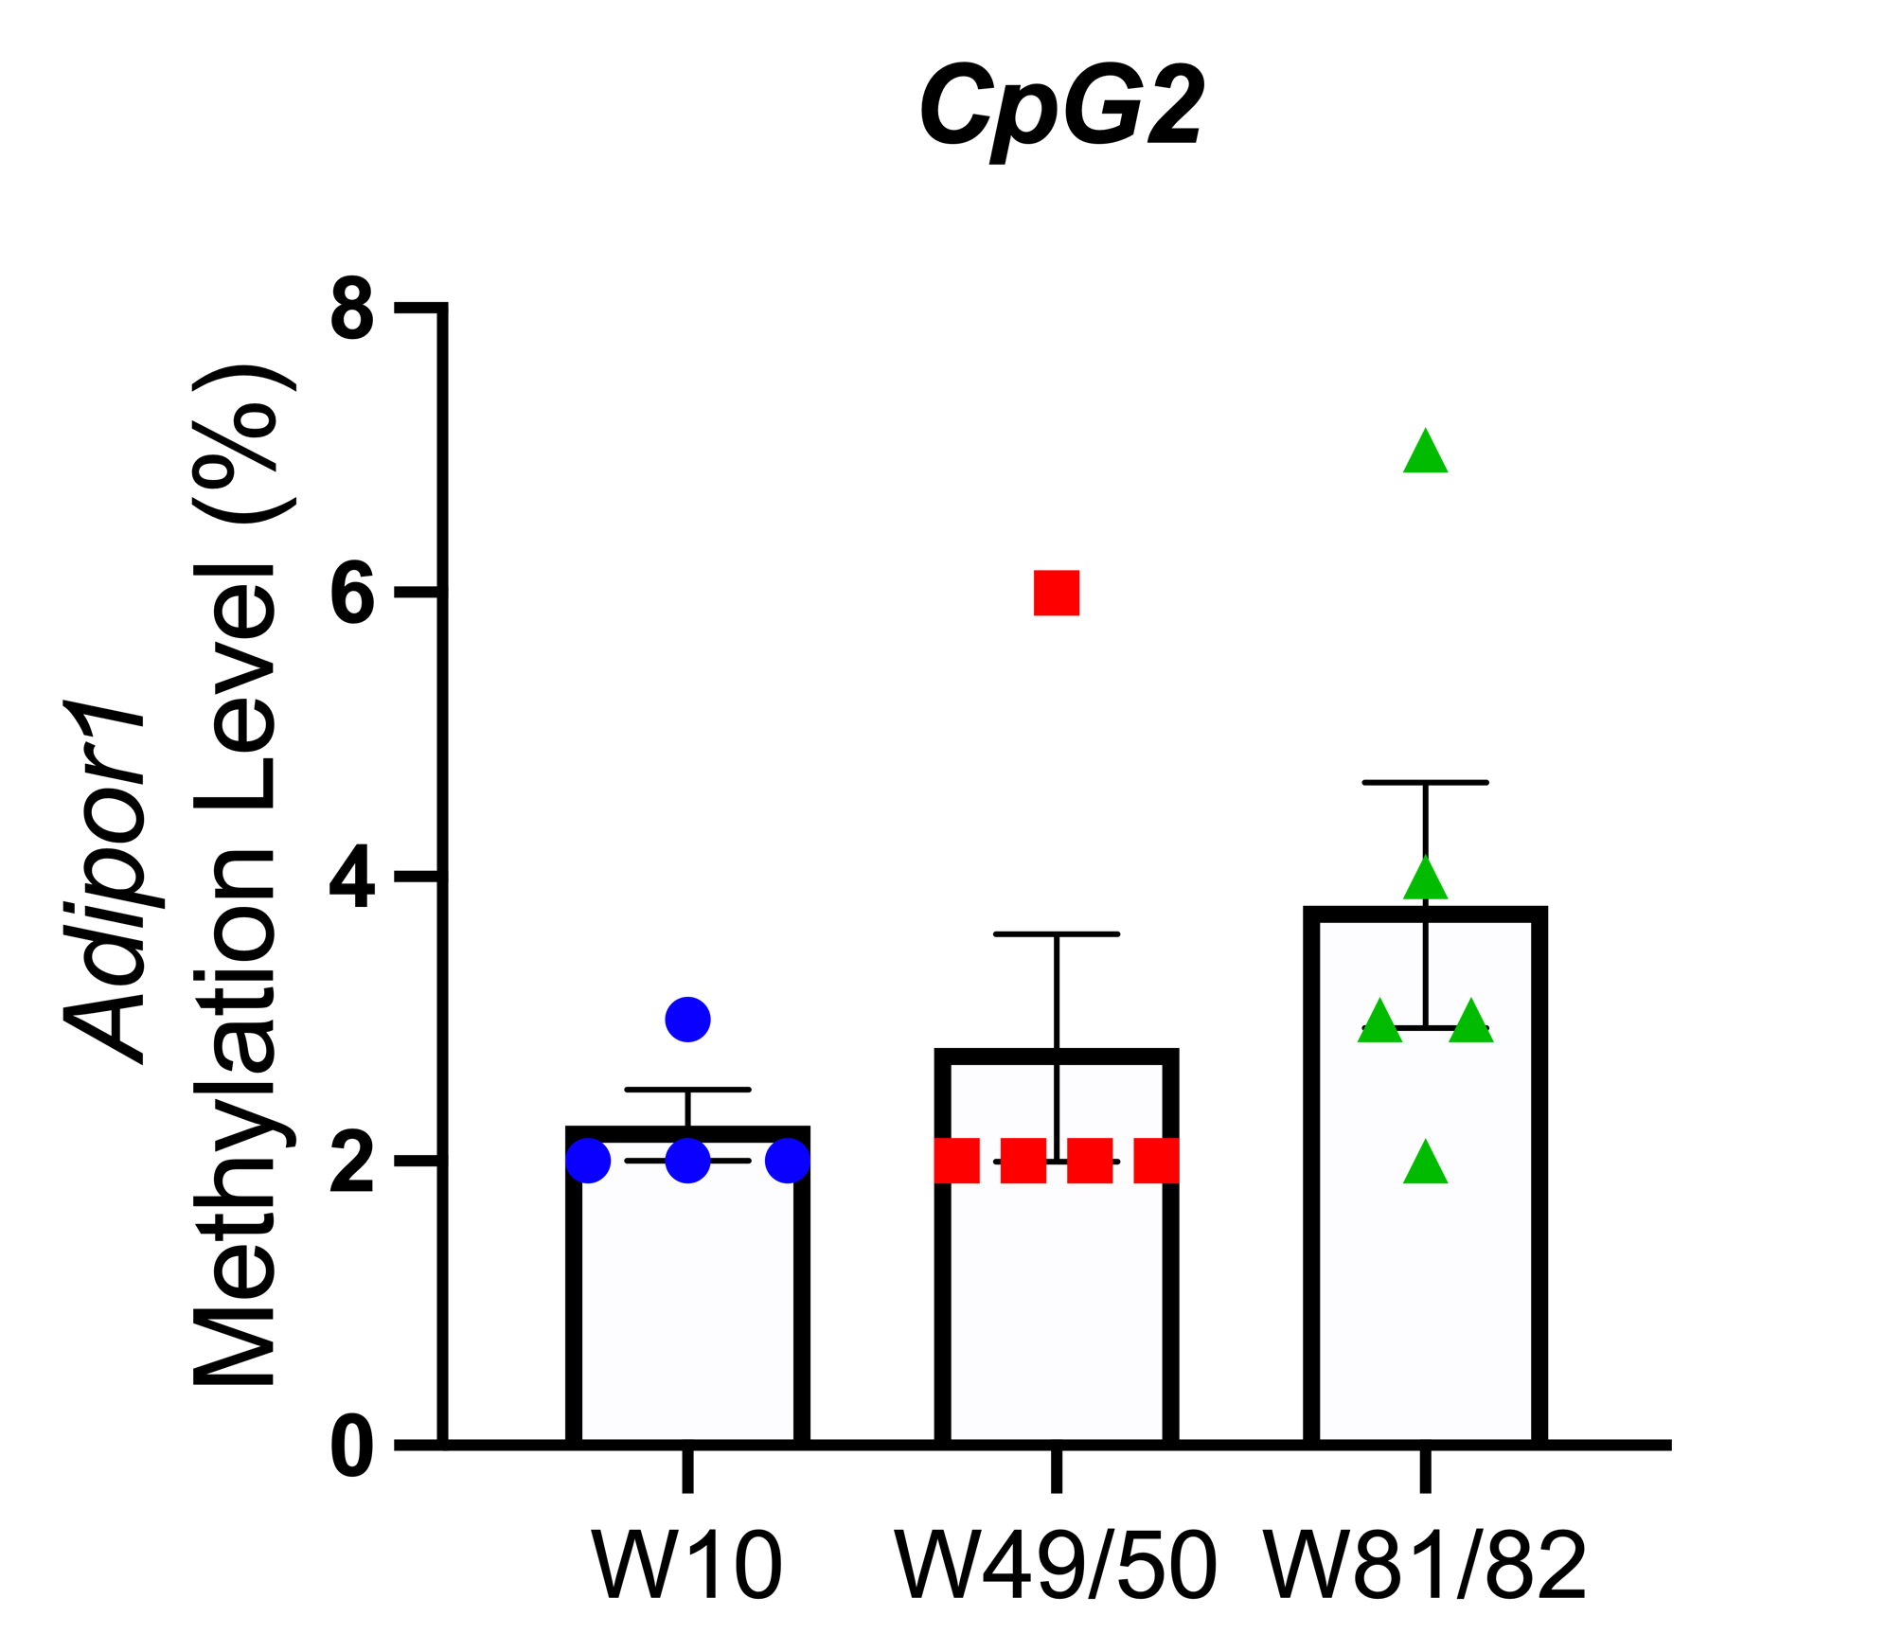
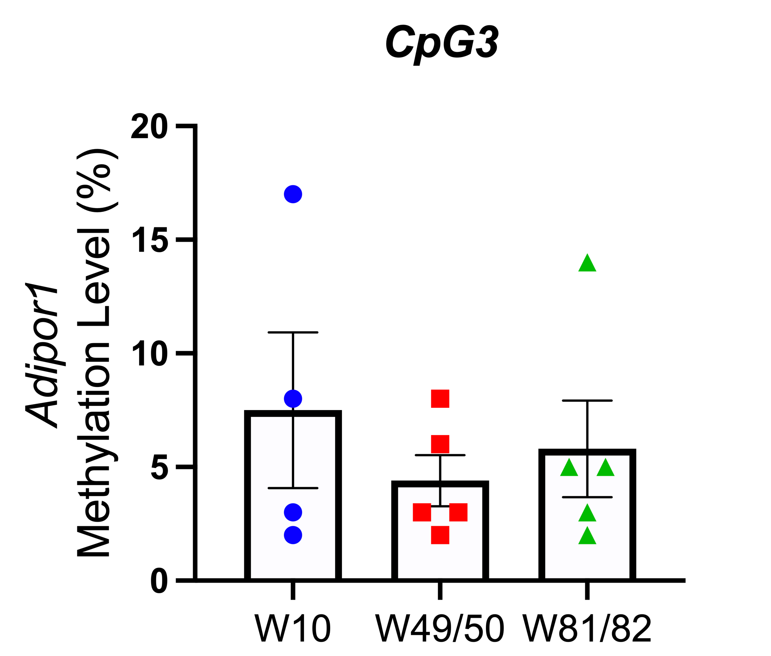
A.

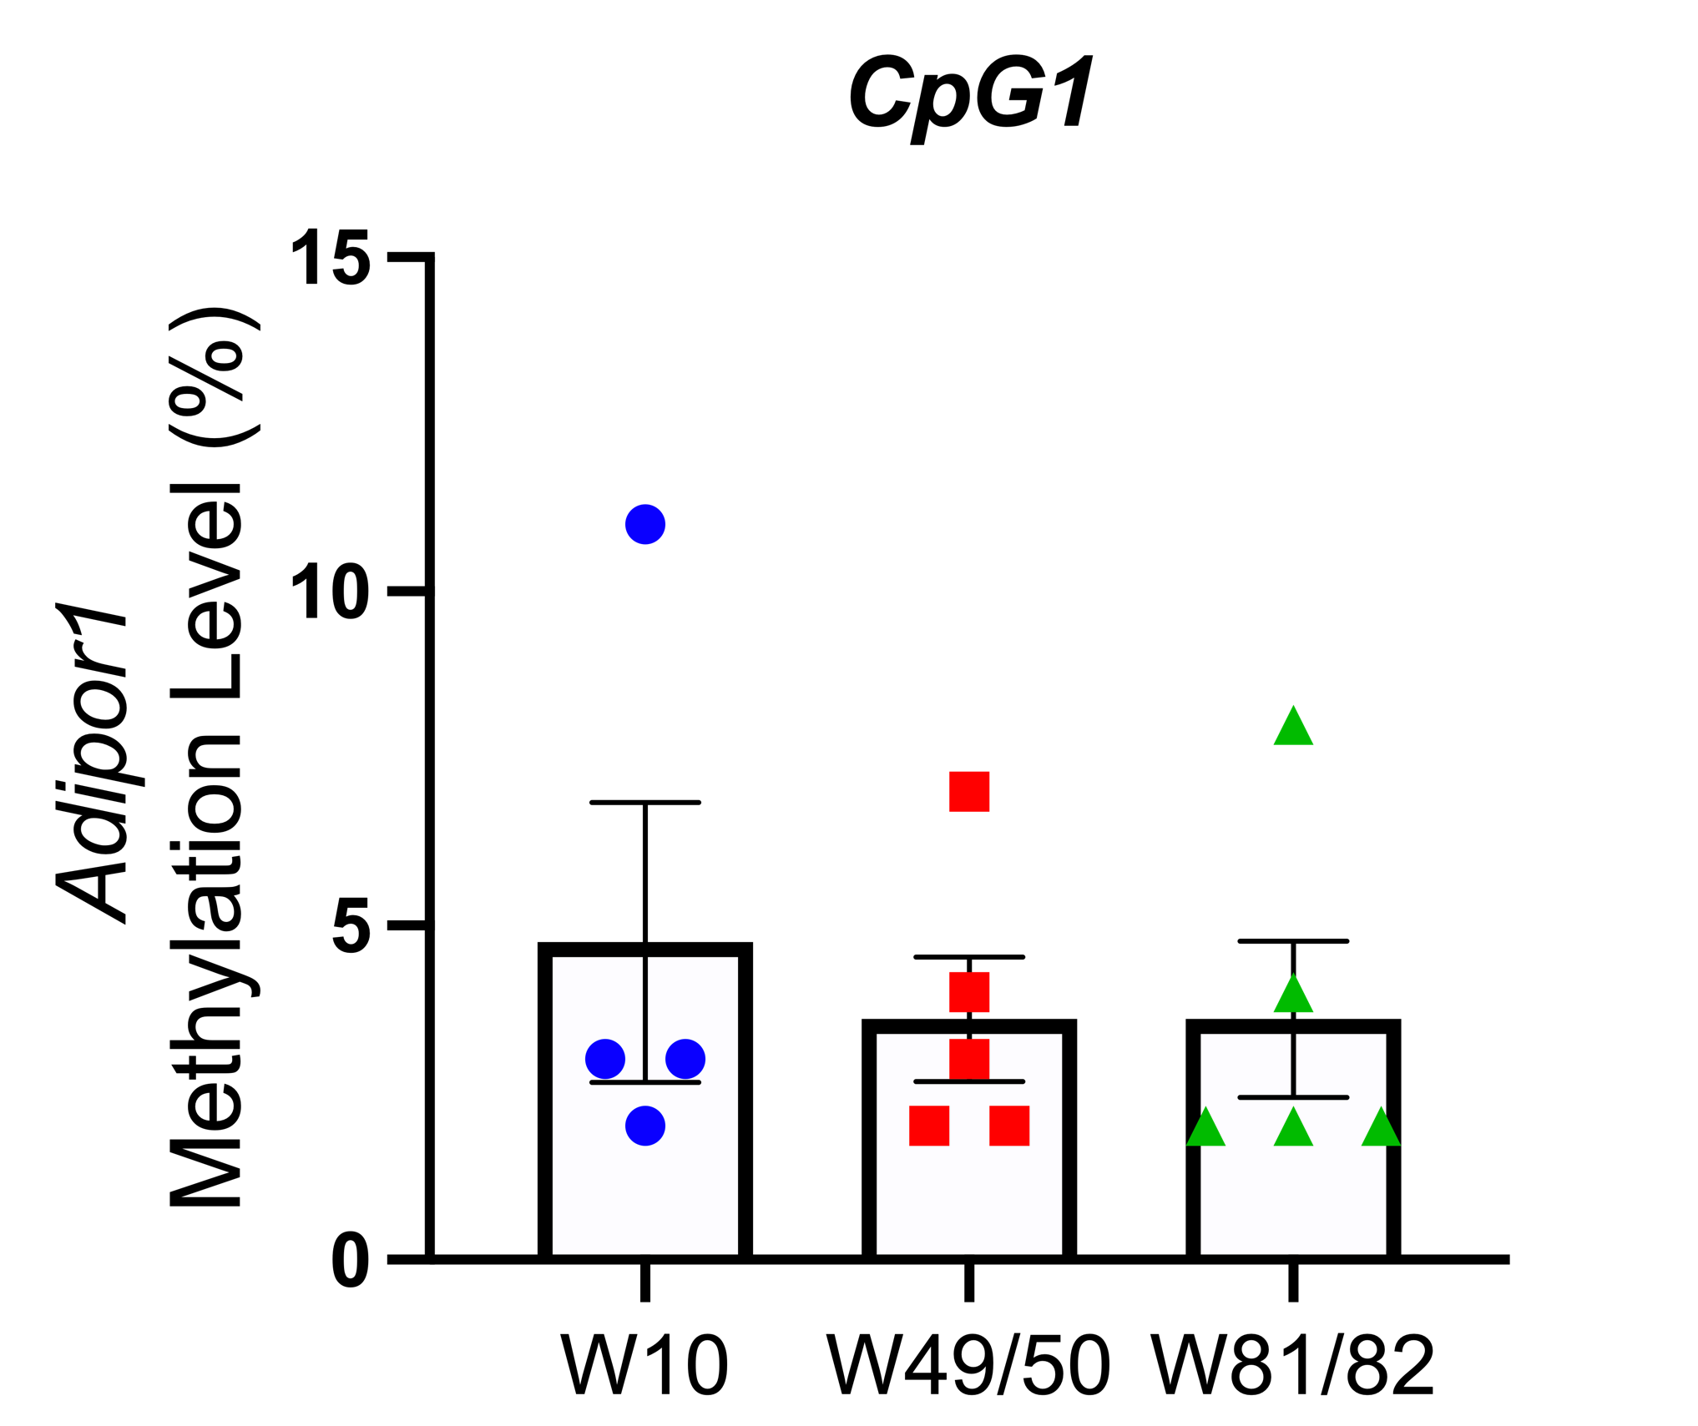
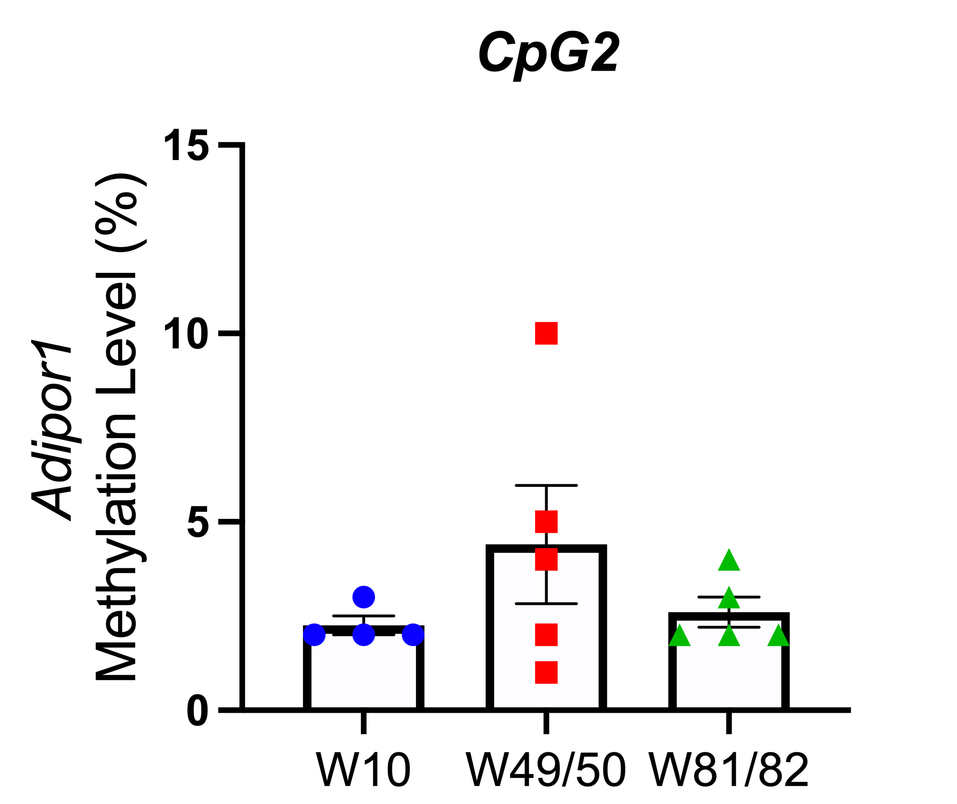
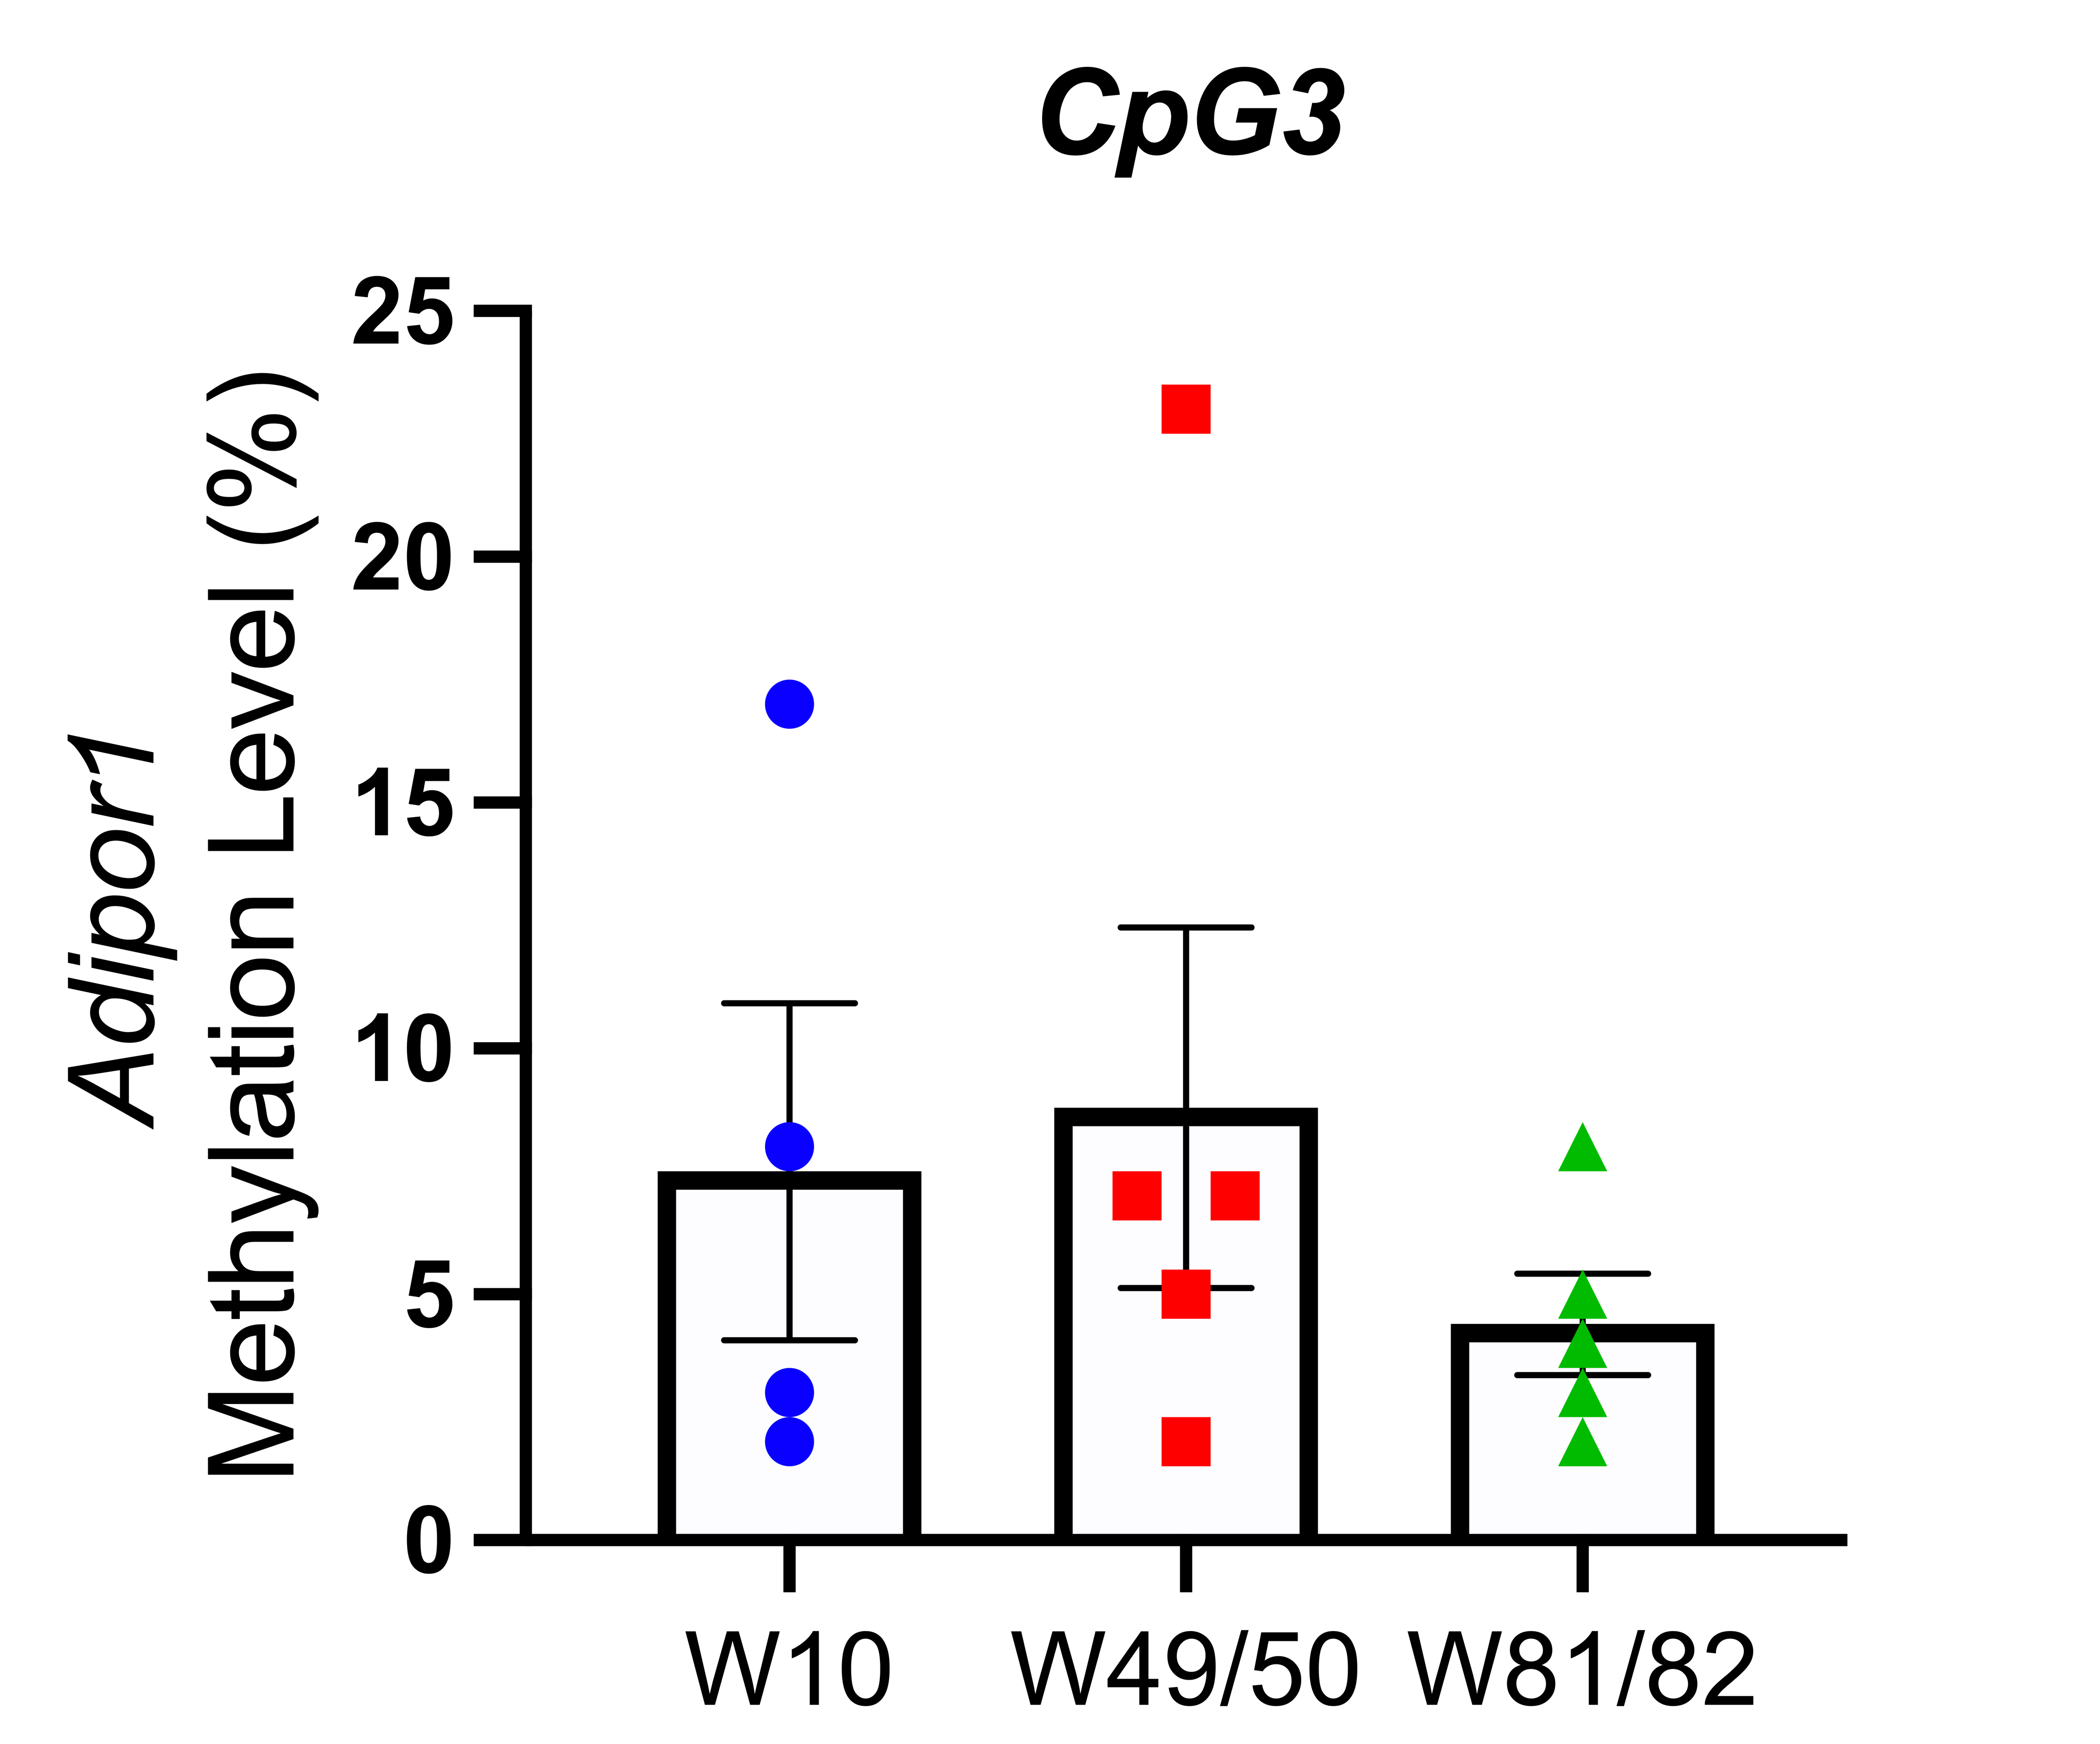
B.

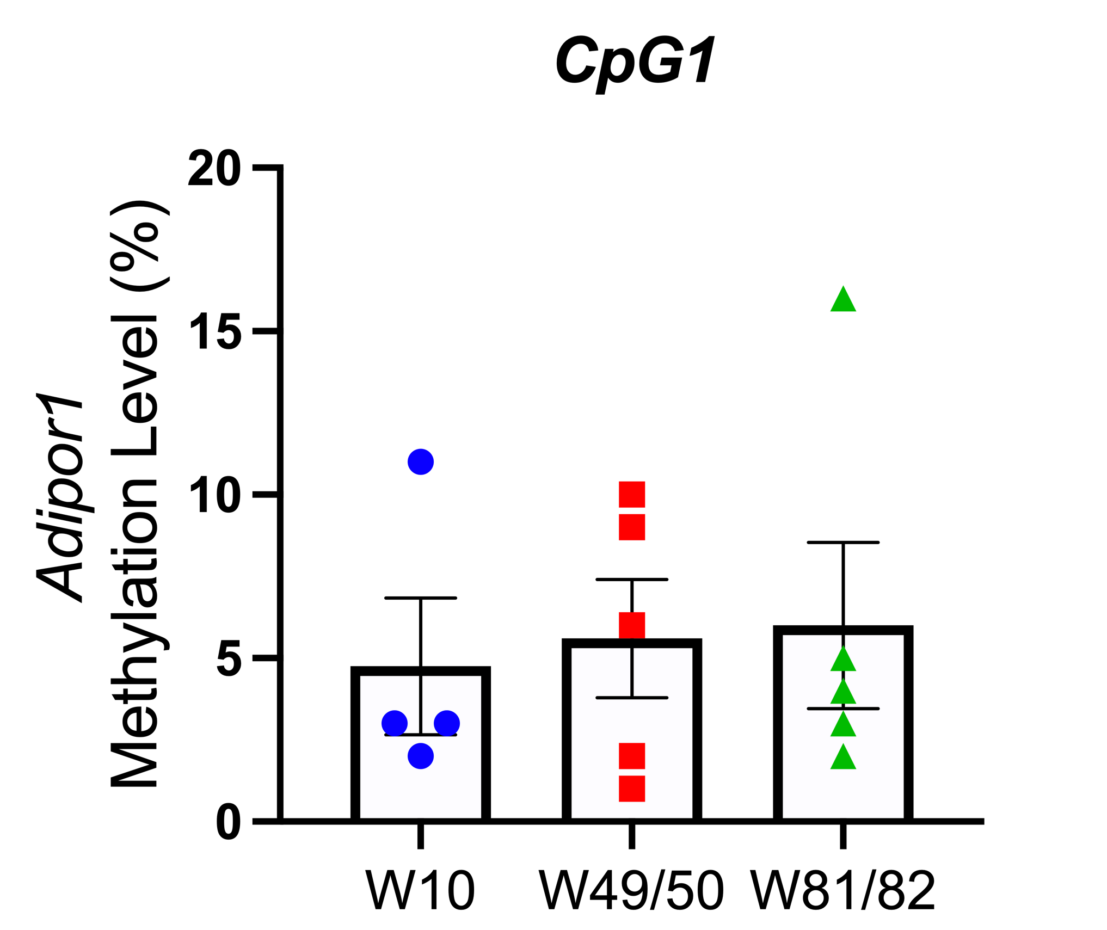
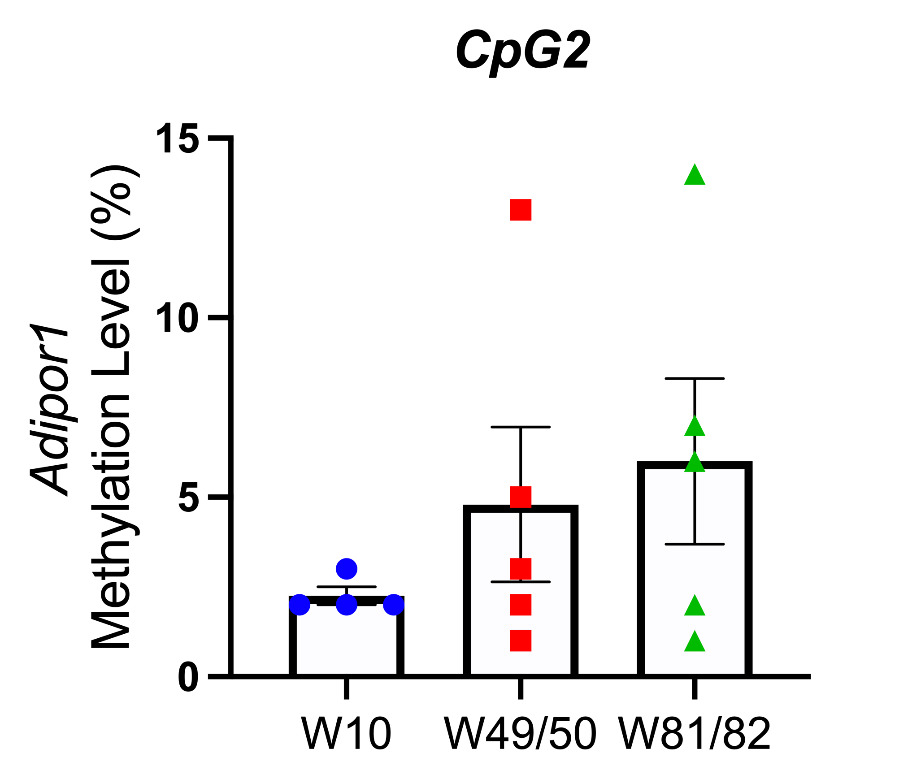
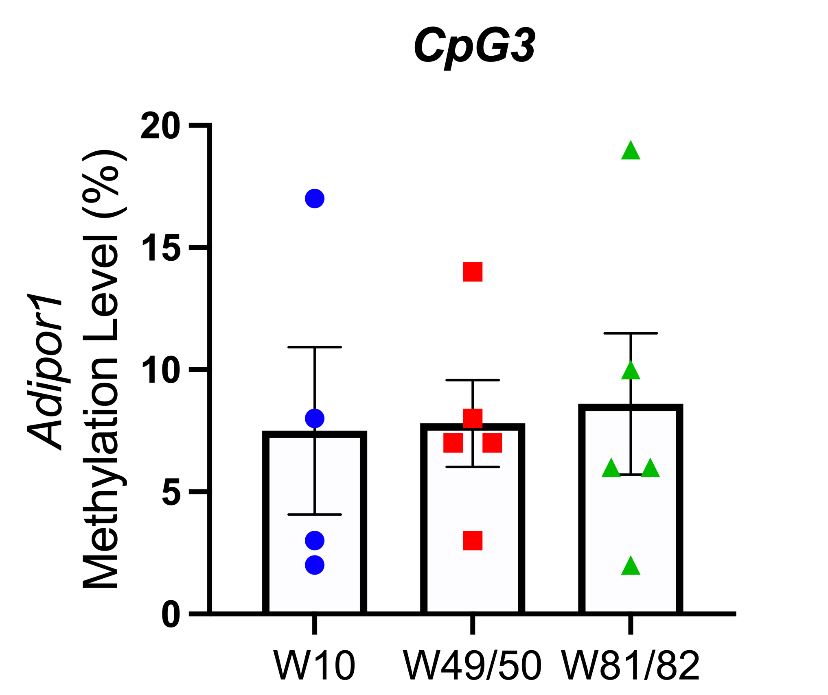
C.

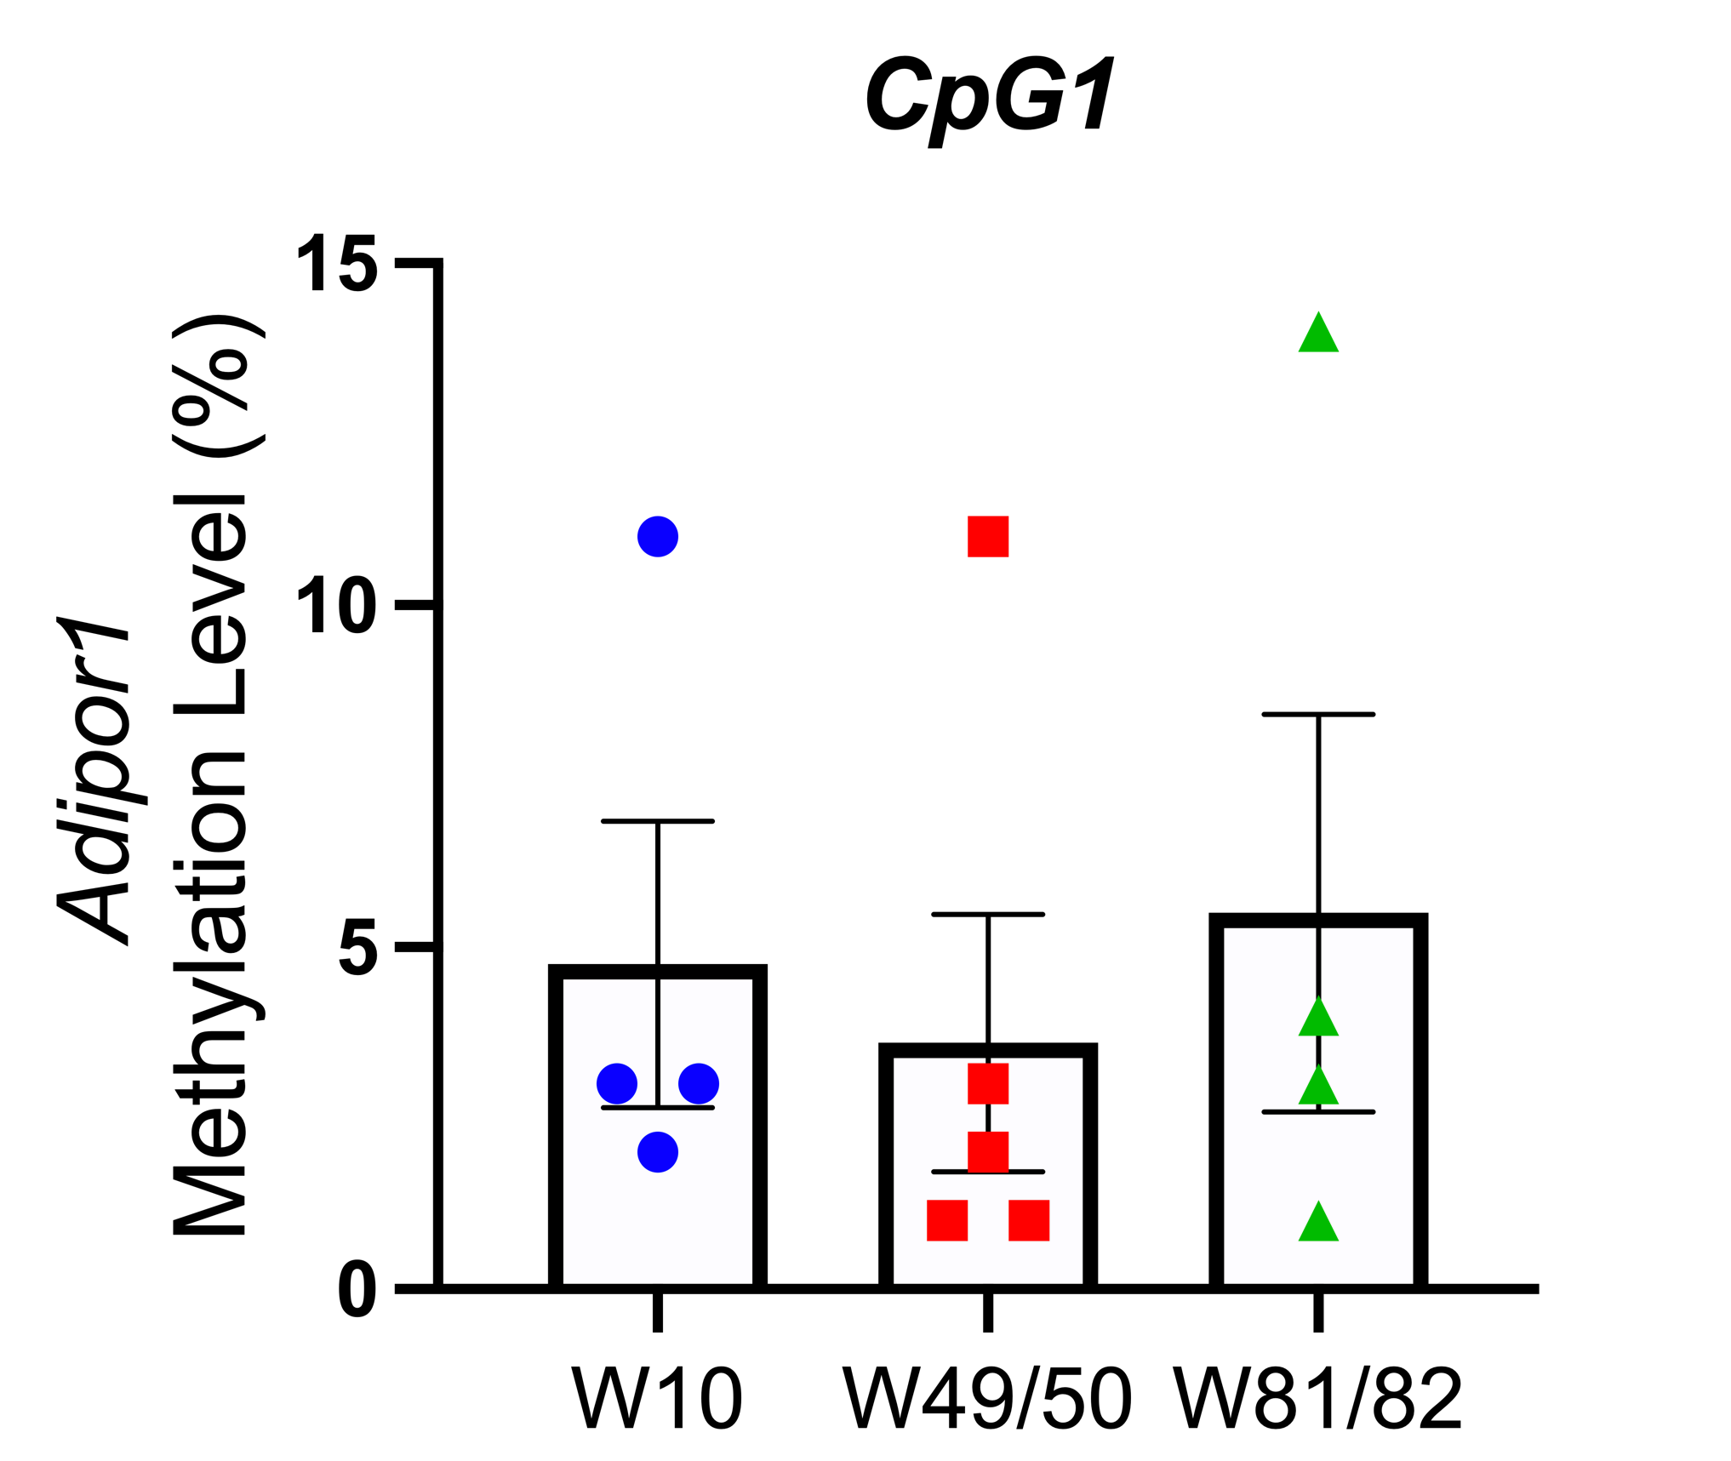
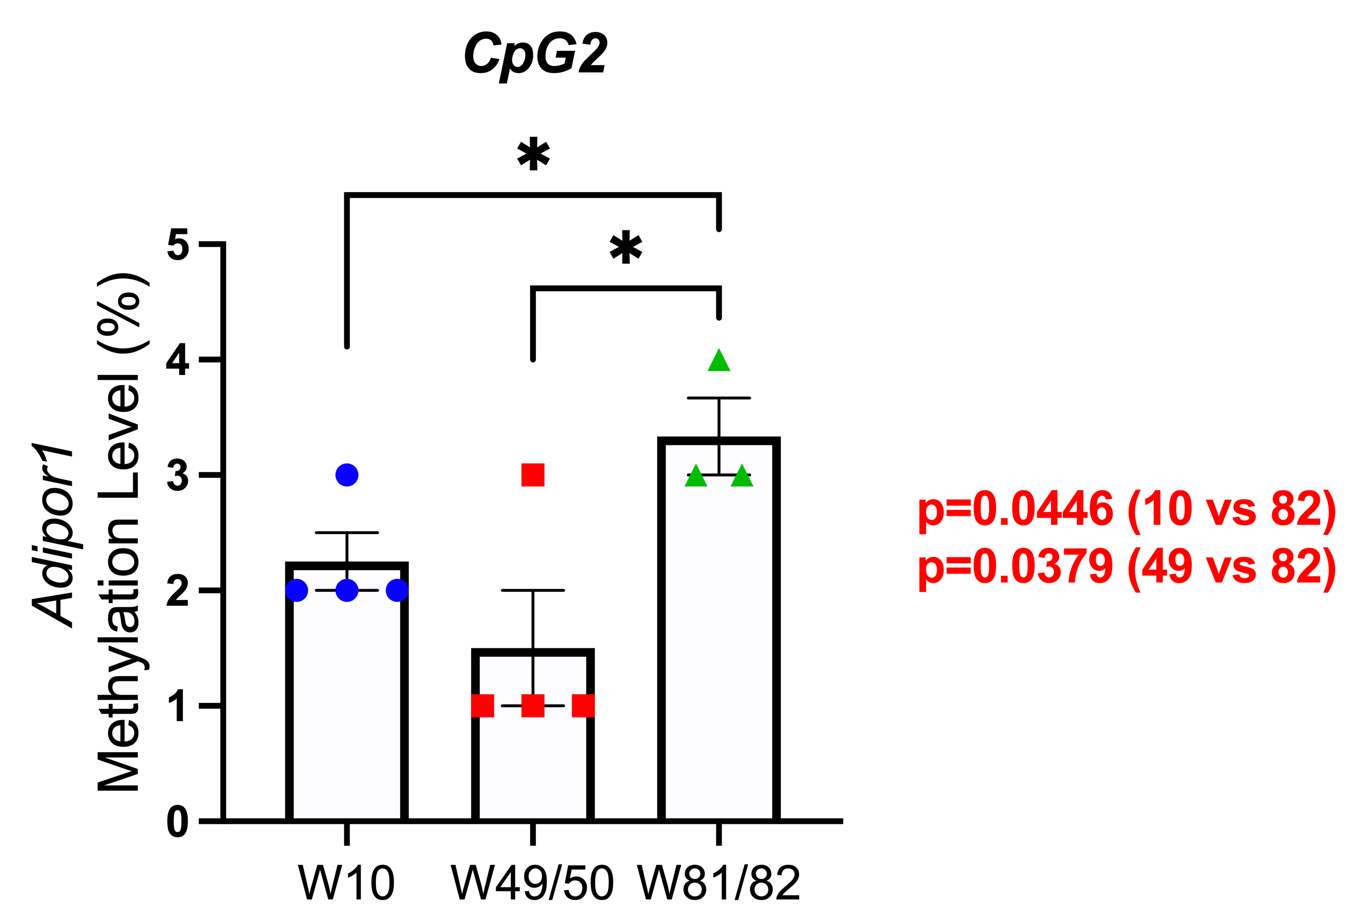
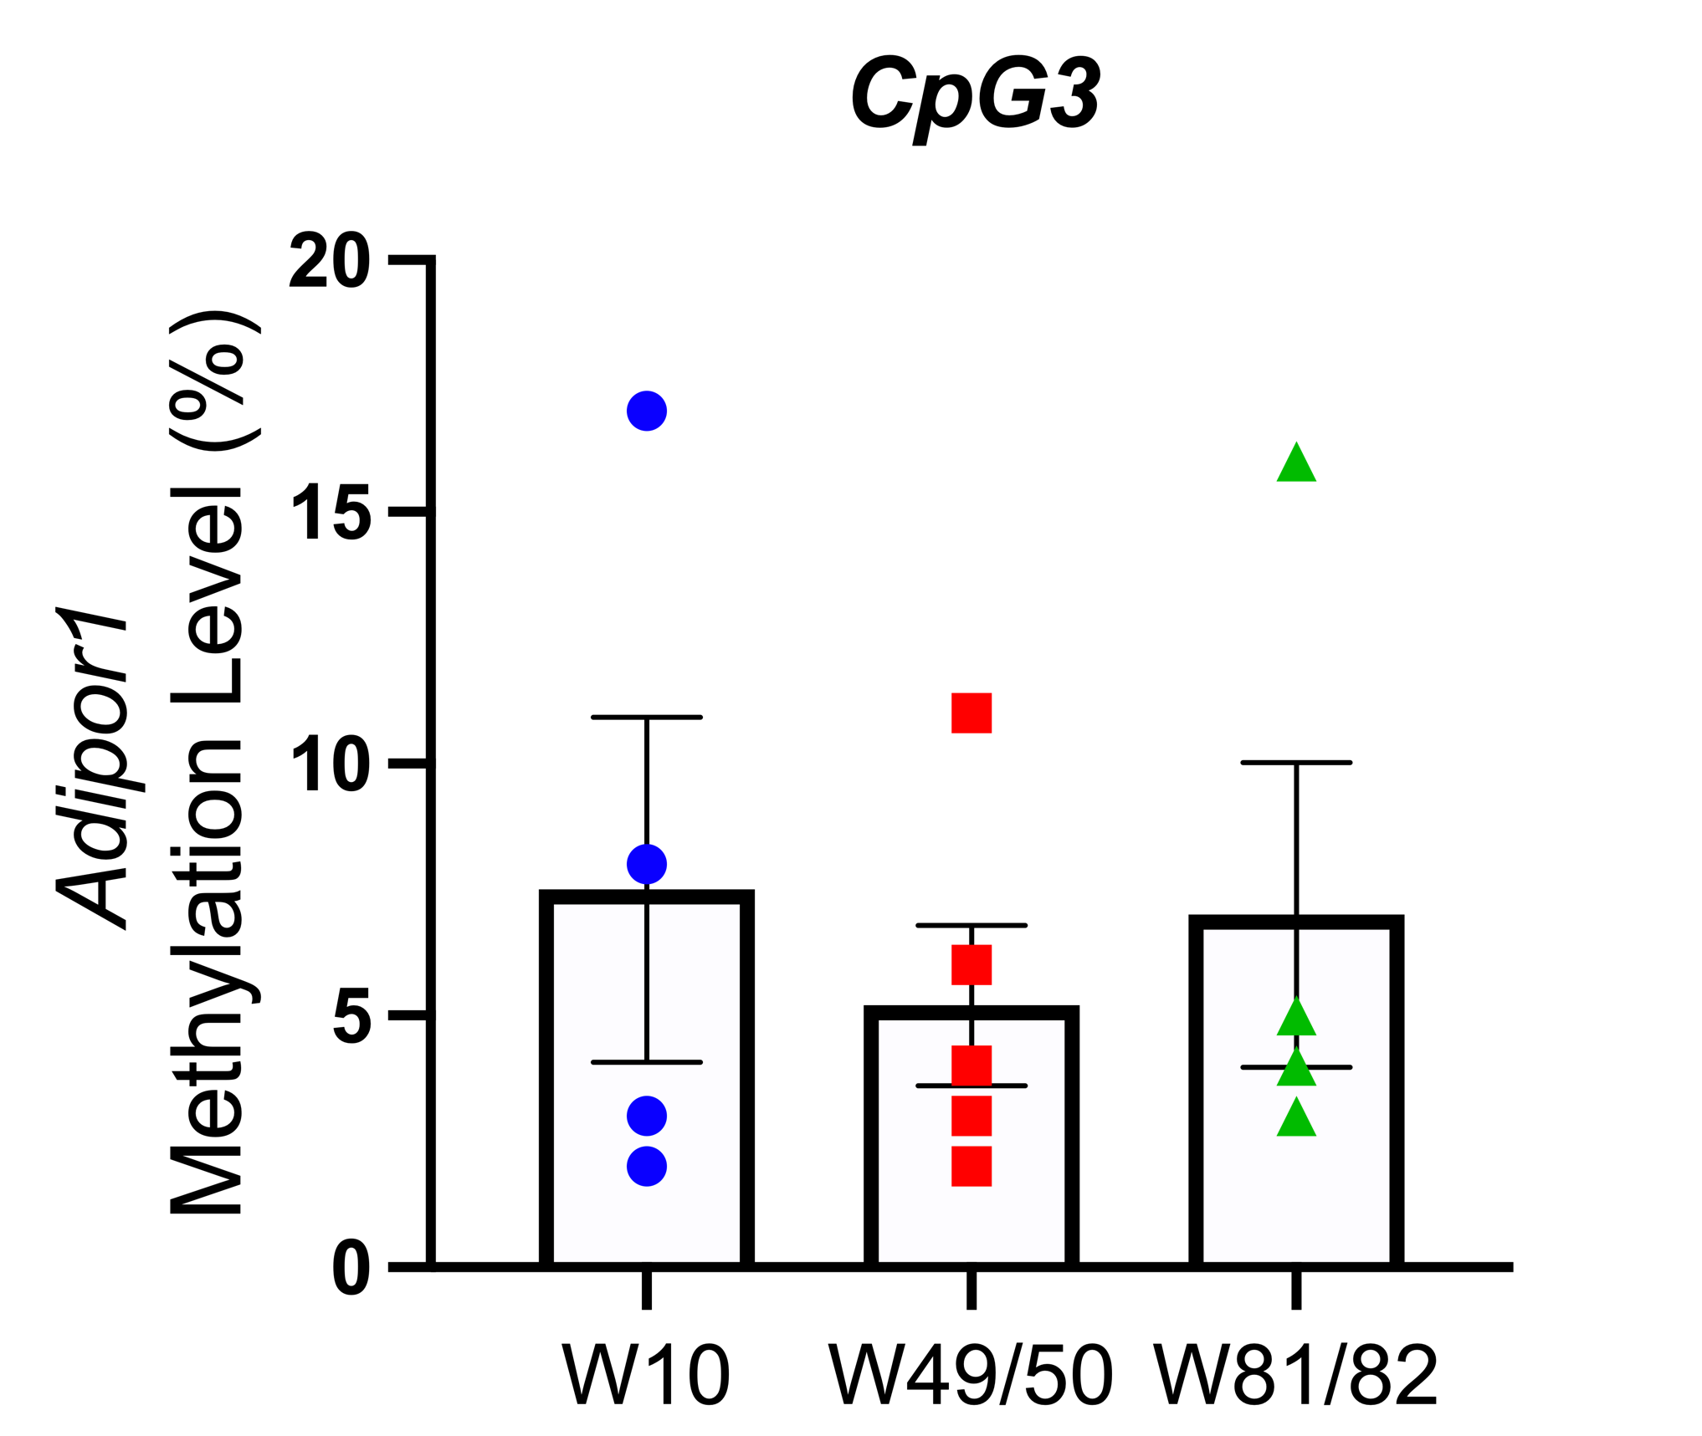
D.

Supplementary Figure 6. The effects of aging on three individual CpG sites on Adipor1 promoter in mouse brain; (A) AL (B) CCR (C) ICR-R (D) ICR-RF. Mean ± SEM are presented for each group, n=4-5 biological replicates. Statistical significance determined using one-way ANOVA. *p<0.05.

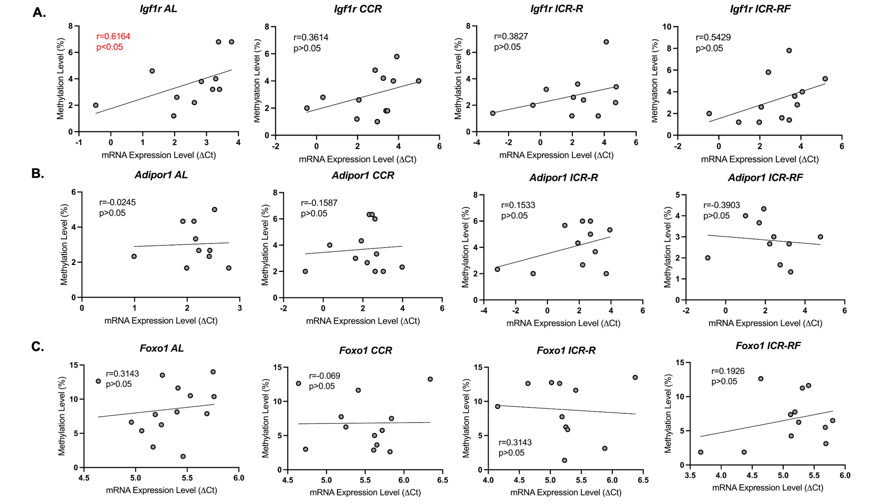

Supplementary Figure 7. The Spearman's correlation between the DNA methylation and mRNA expression levels of (A) Igf1r, (B) Adipor1, (C) Foxo1 by different types of dietary groups.

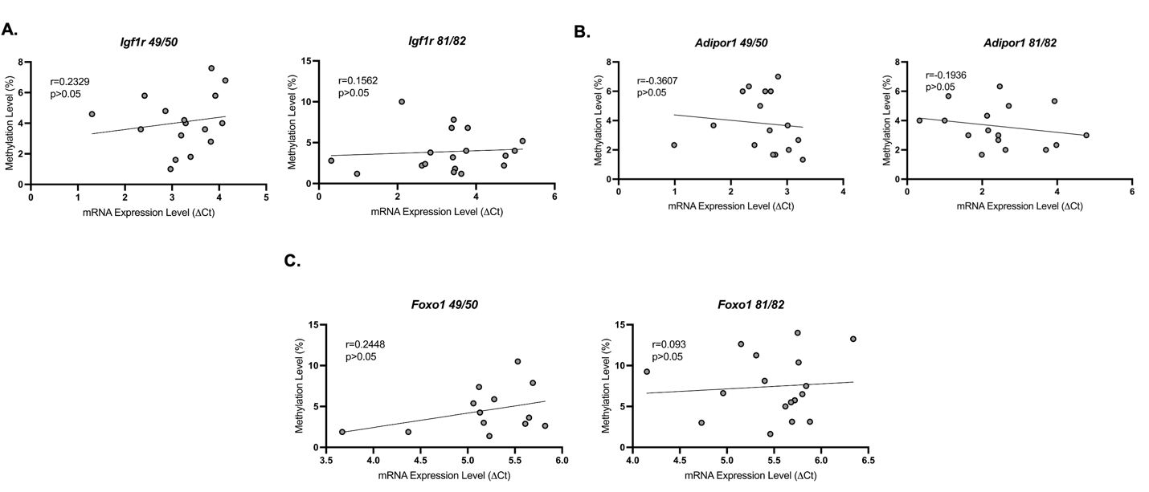

Supplementary Figure 8. The correlation between the DNA methylation and mRNA expression levels of (A) Igf1r, (B) Adipor1, and (C) Foxo1 levels at different time points.

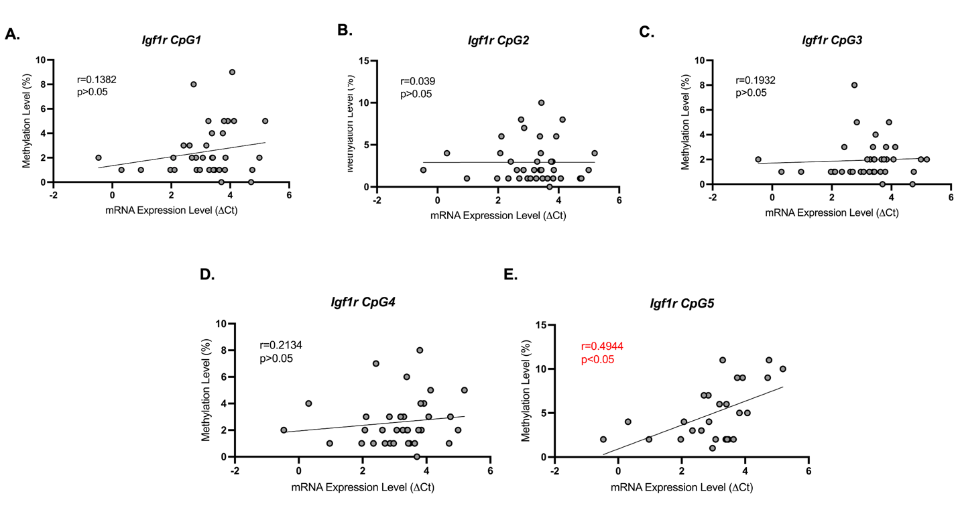

Supplementary Figure 9. The correlation between the individual CpG site methylation on Igf1r promoter and mRNA expression of Igf1r.

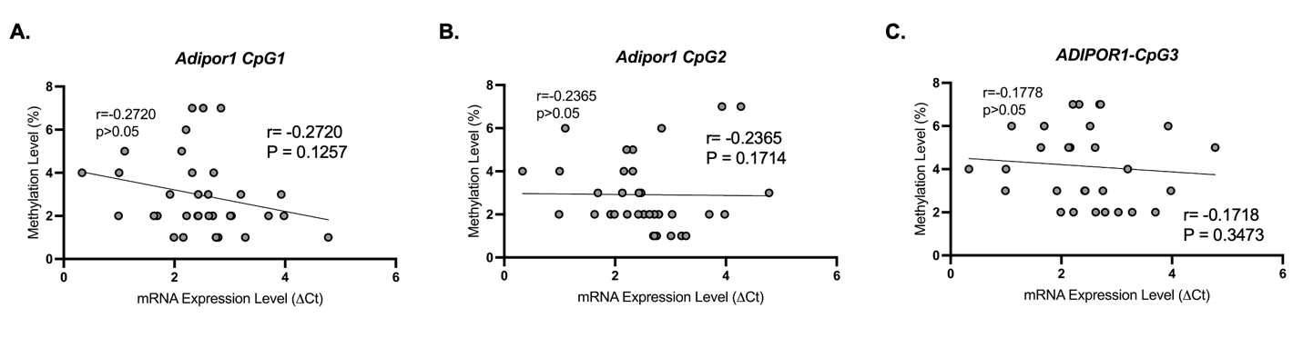

Supplementary Figure 10. The correlation between the individual CpG site methylation on Adipor1 promoter and mRNA expression of Adipor1.

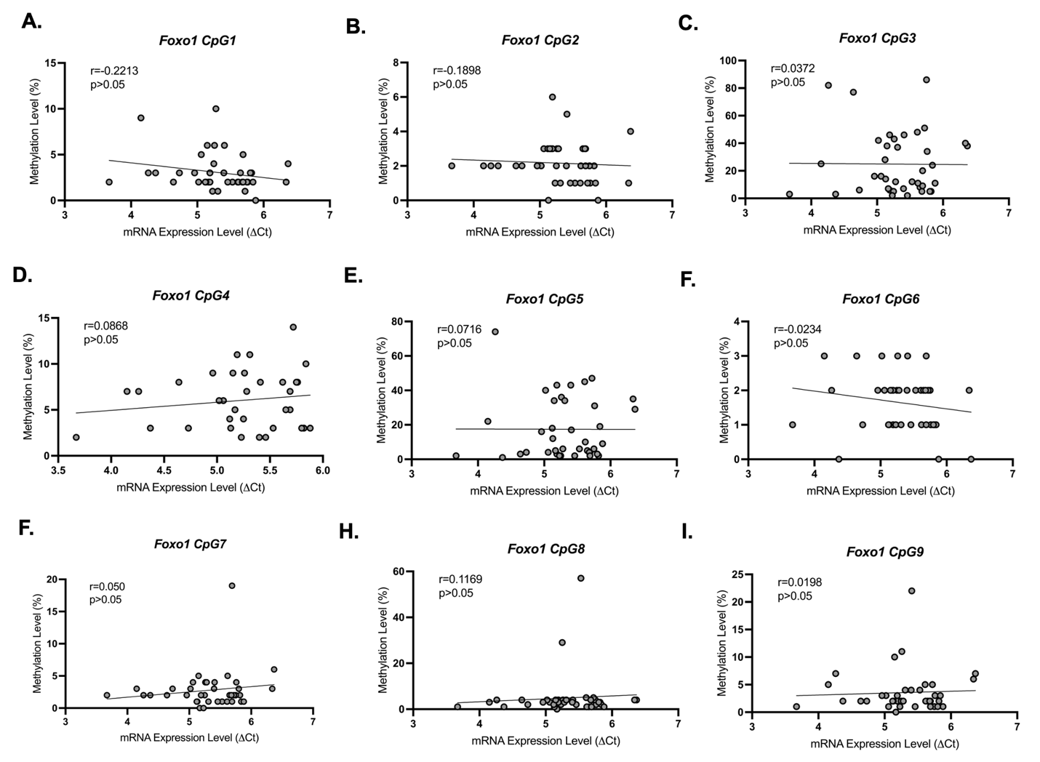

Supplementary Figure 11. The correlation between the individual CpG site methylation on Foxo1 promoter and mRNA expression of Foxo1.

