EXTENDED DATA INFORMATION
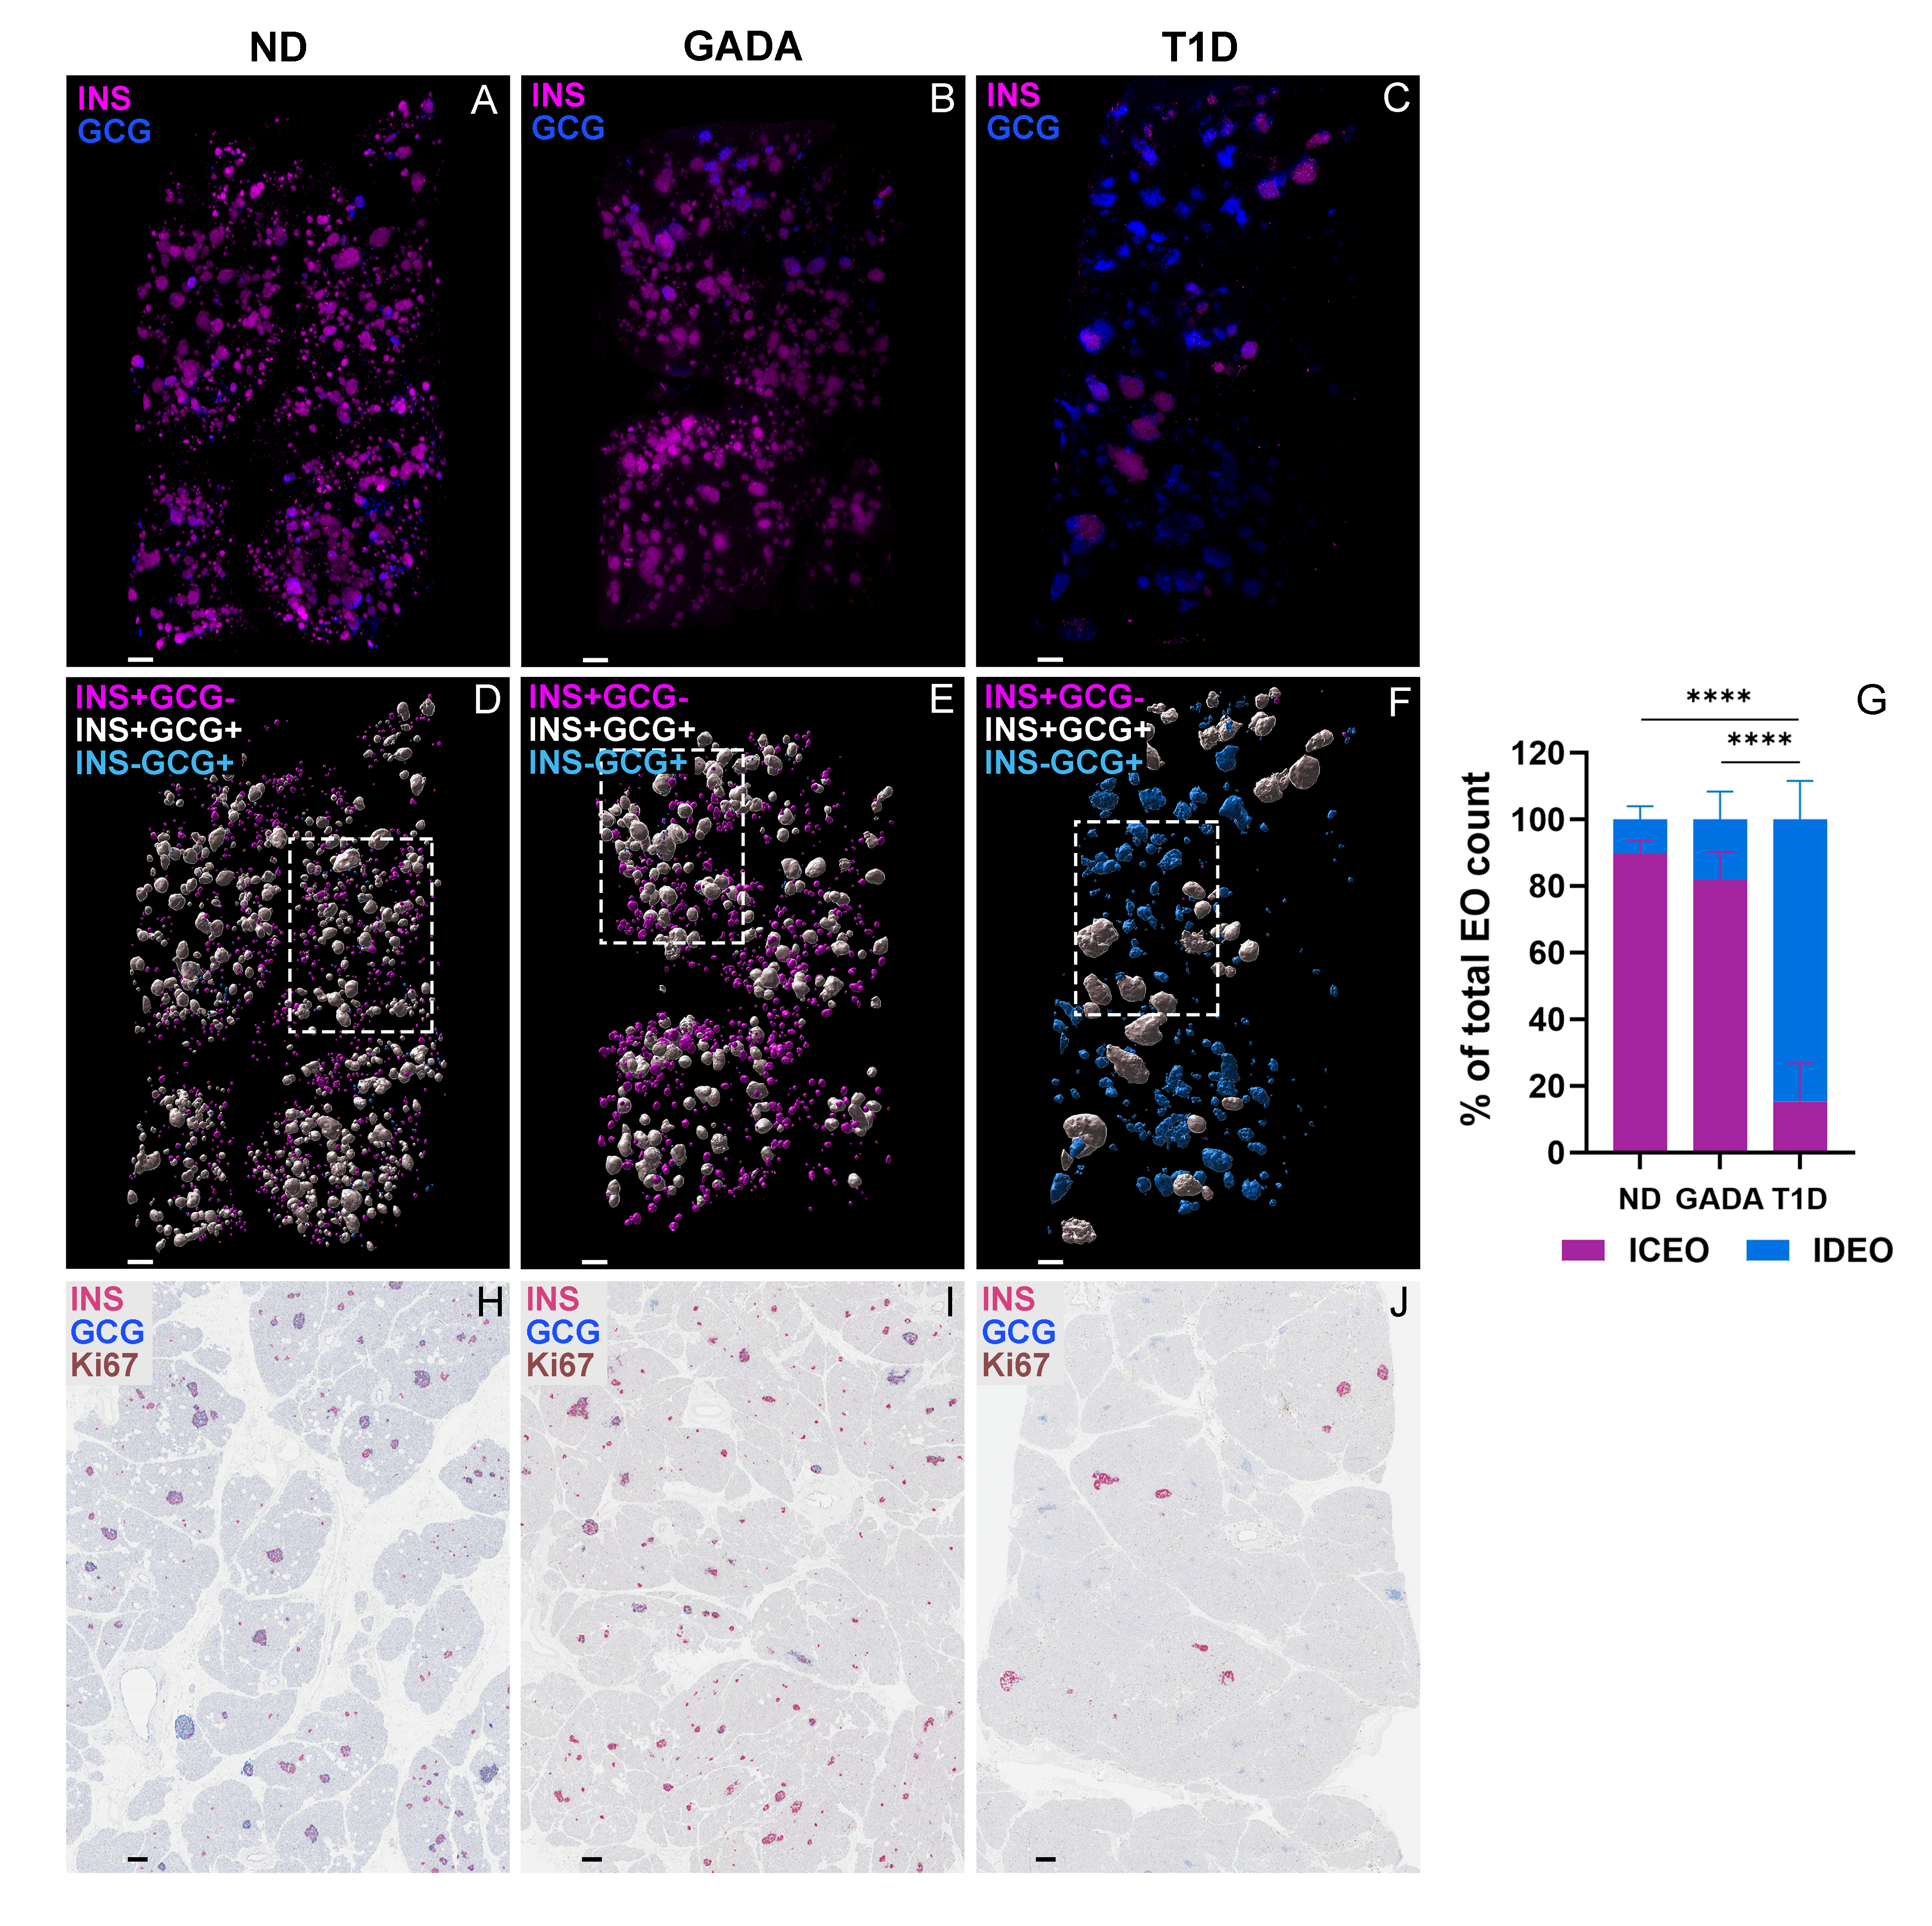Extended Data Figure 1. Spatial arrangement of islet type categories across samples in ND, GADA, and T1D pancreas.
(A-C) LSFM image overlays of INS+ (magenta) and GCG+ (blue) in pancreas tail from representative ND [nPOD 6612], GADA+ [nPOD 6582], and T1D [nPOD 6579] donors.
(D-F) Digital surface renderings for color-coded endocrine object (EO) types shown as overlays of INS+GCG- (magenta), INS+GCG+ (white), and INS-GCG+ (cyan) with dashed lines around the region of interest shown in Fig. 1L, O, R.
(G) INS-containing endocrine objects (ICEO) and INS-deficient endocrine objects (IDEO) normalized as a percentage of total EO count, ****p < 0.0001, one-way ANOVA.
(H-J) INS (pink), GCG (blue), and Ki67 (brown) immunohistochemistry (IHC) images from the nPOD Aperio digital pathology database for the same three donors.
All scale bars are 300 mm.

