Supplementary information for

The respective role of climate mitigation, sustainable land use and area-based conservation to curb future biodiversity loss

Chantal Hari et al.

*Corresponding authors. Email: chantal.hari@unibe.ch; edouard.davin@unibe.ch

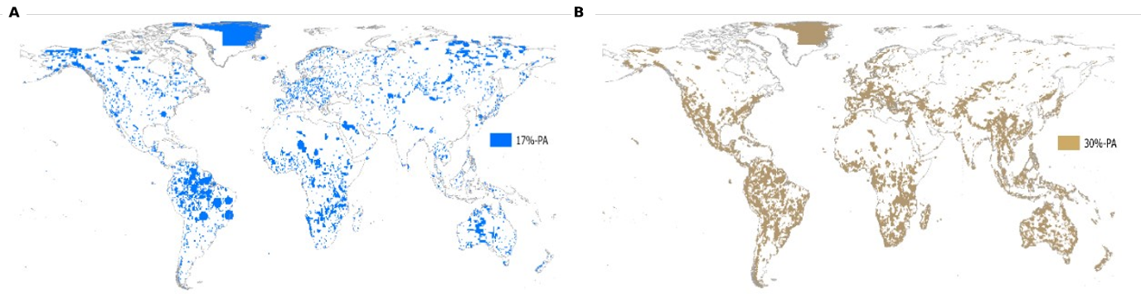

Fig. S1: Global map of the 17%-PA expansion scenario (A) and the 30%-PA expansion scenario (B) included in this study.

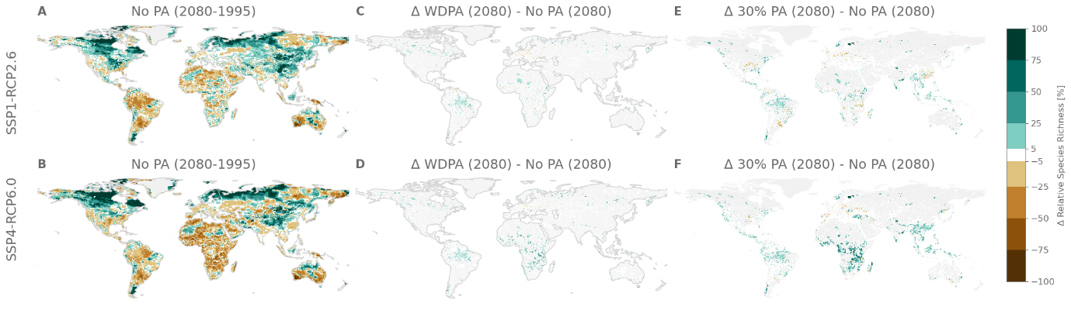
Figure S2: Same as Fig. 1 in main text but for Amphibians only.
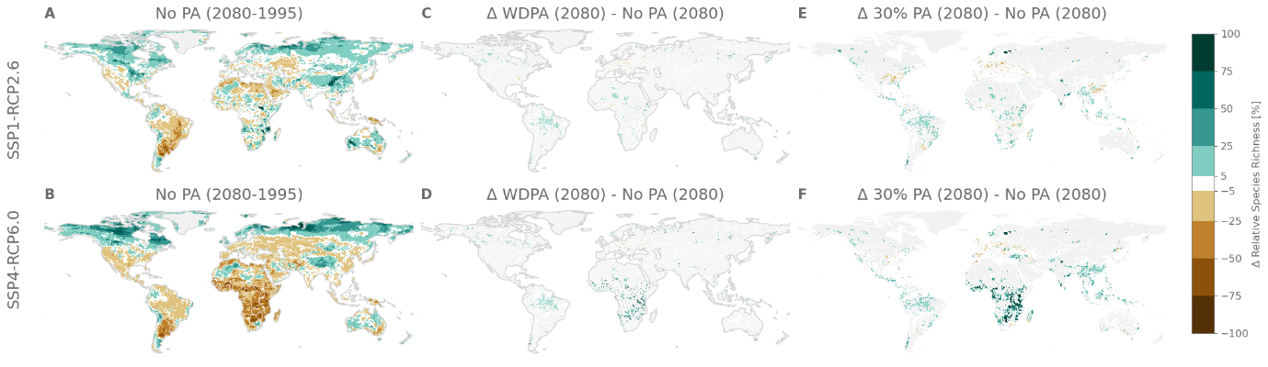
Figure S3: Same as Fig. 1 in main text but for Birds only.
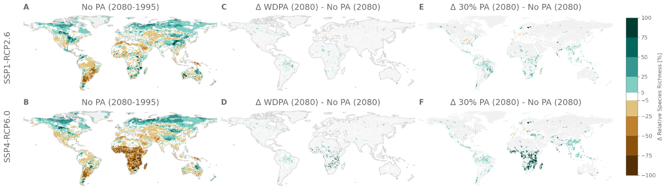
Fig. S4: Same as Fig. 1 in main text but for Mammals only.

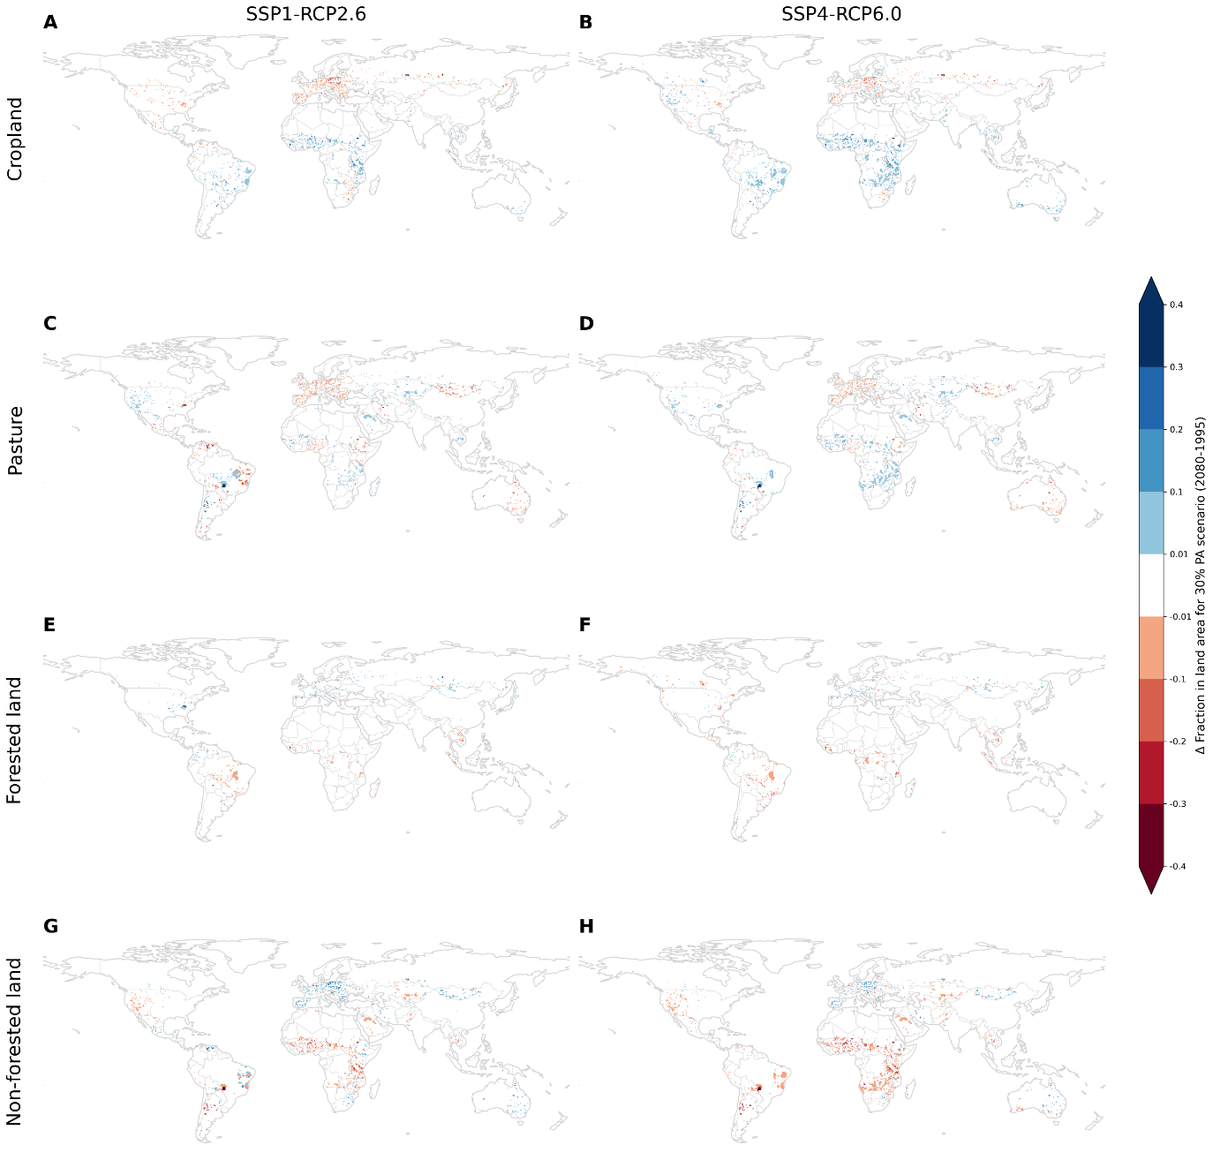
Fig. S5 Future (2080) LUH2 projections frozen at the year 2030 where they overlap with the current protected area network (WDPA) data compared to LUH2 in the year 1995.

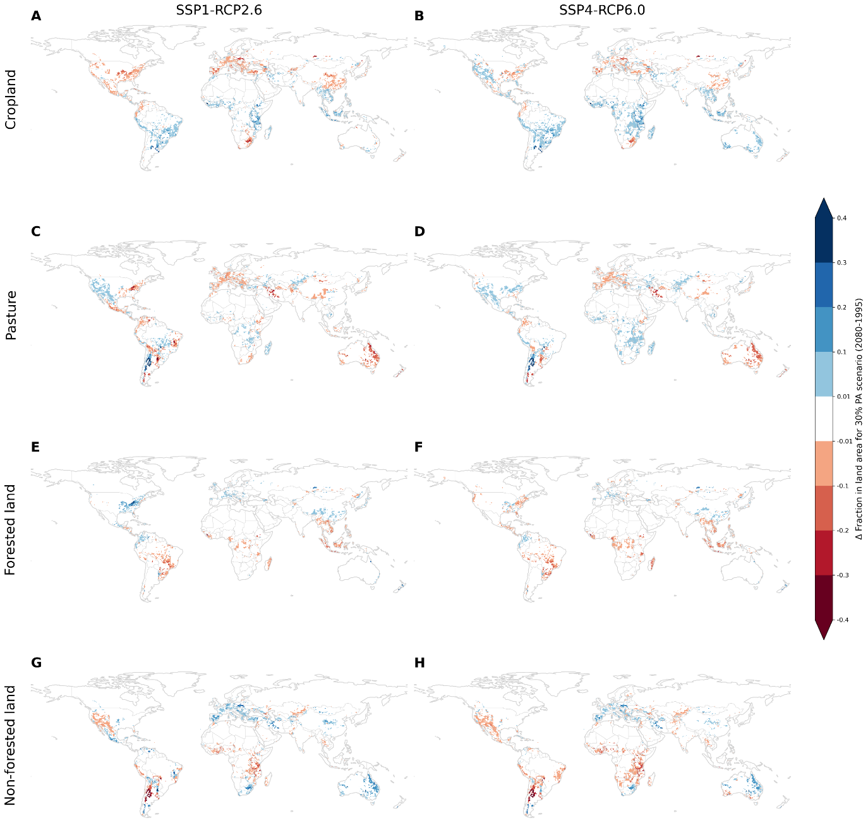
Fig. S6 Future (2080) LUH2 projections frozen at the year 2030 where they overlap with a 30% PA scenario data compared to LUH2 in the year 1995.

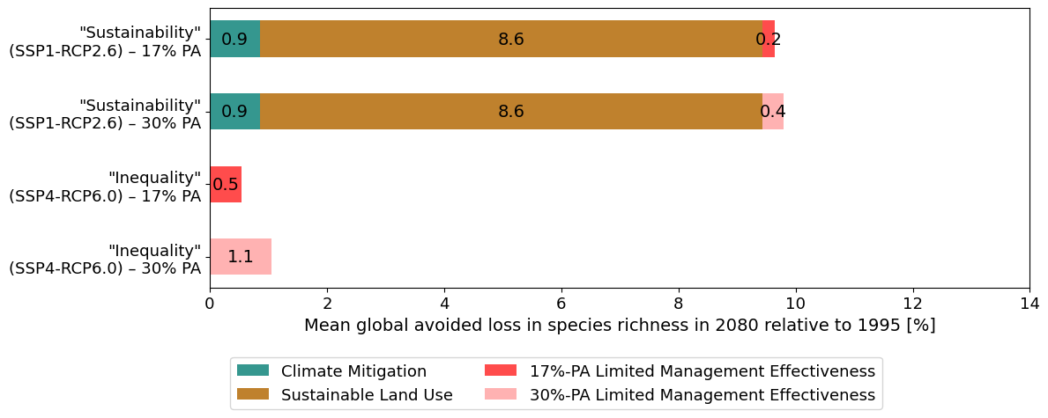
Fig. S7: Same as Fig. 2 but under a limited management effectiveness assumption of 23.6%.

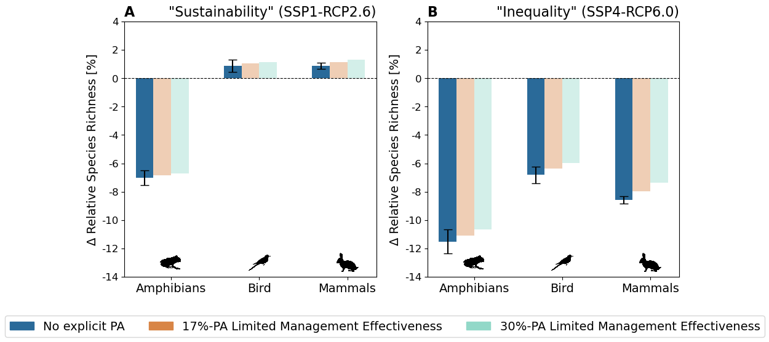
Fig. S8: Same as Fig. 4 but under a limited management effectiveness assumption.

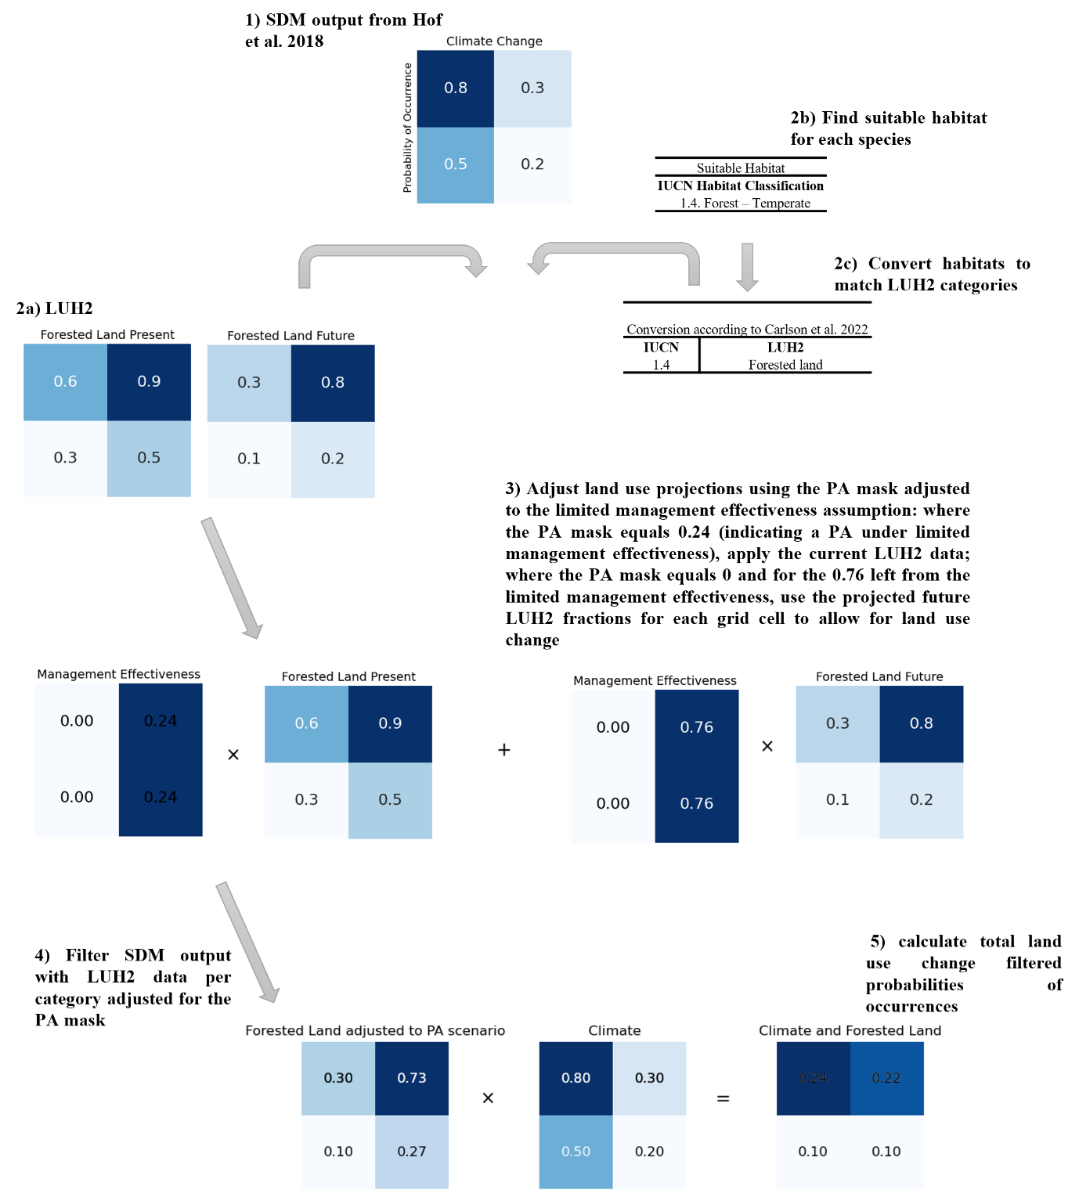
Fig. S9: Schematic overview of the methodological steps to apply a land use filtering approach and including PA masks under a limited effectiveness assumption of 24%.

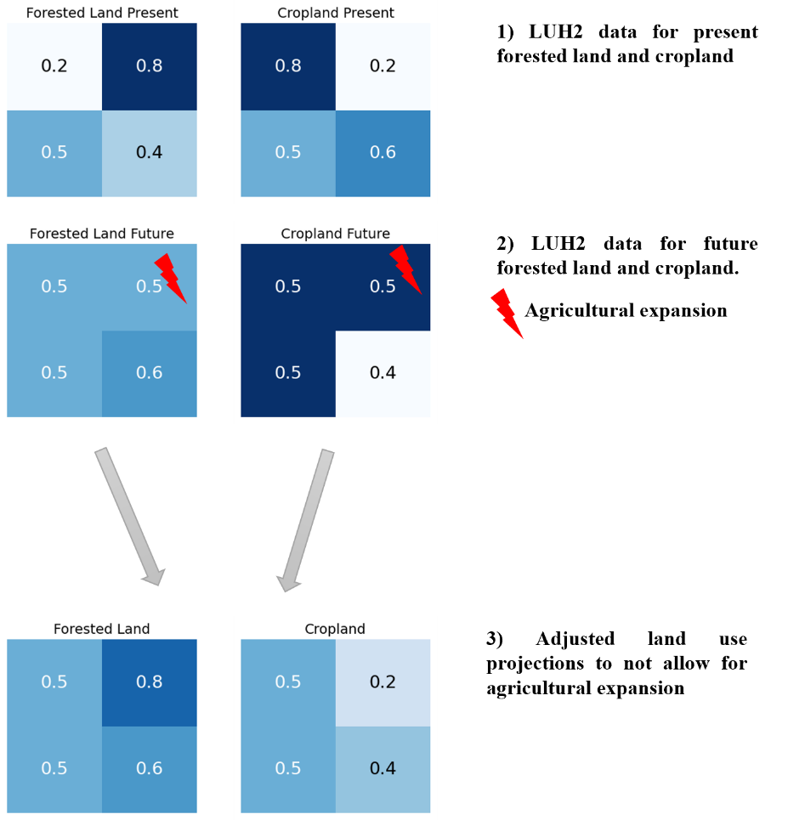
Fig.S10: Schematic overview of the methodological steps behind the agricultural expansion assumption.

