Supplemental Information
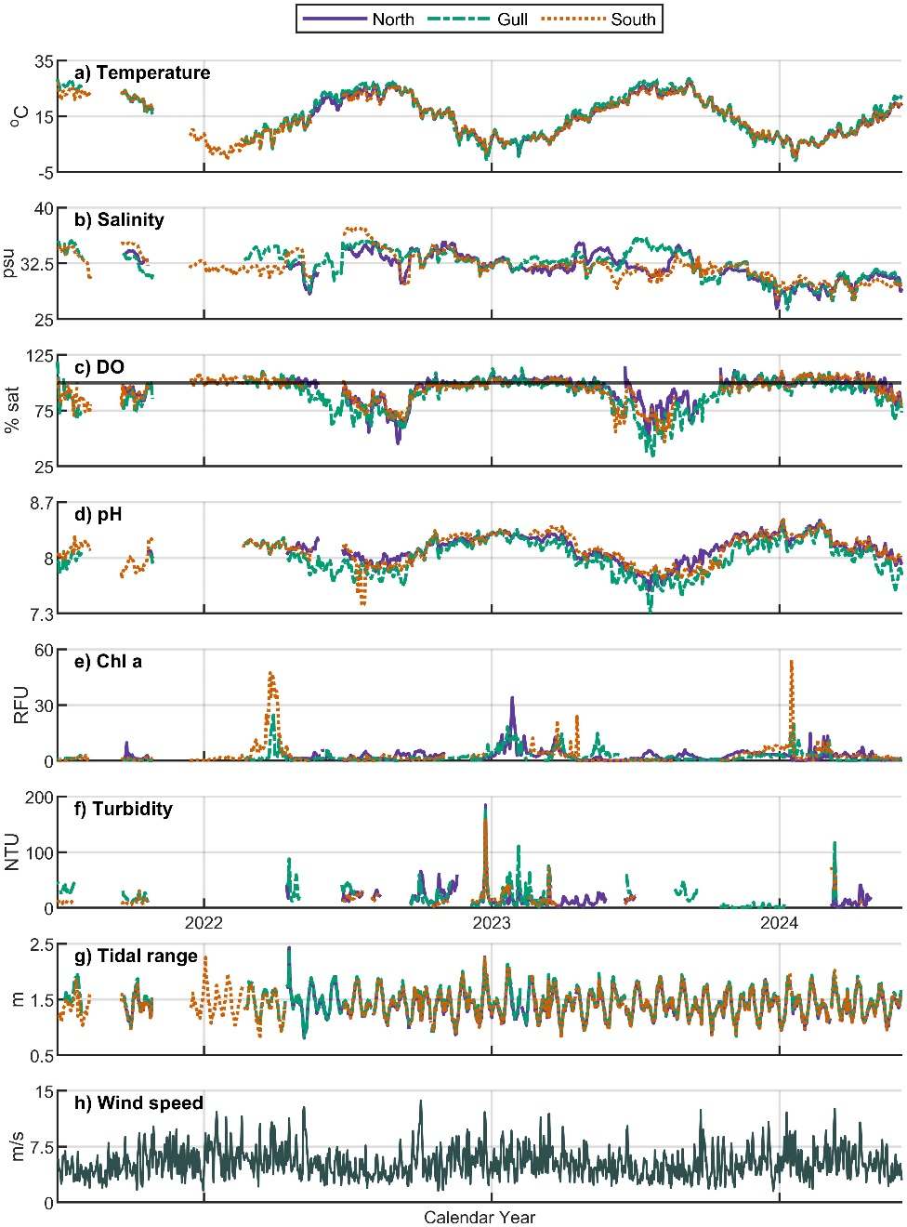
Fig. S1 Daily means of environmental parameters at three open-water platforms in the Seven Mile Island Innovation Laboratory (July 2021–June 2024): a) temperature, b) salinity, c) DO %saturation (with 100% saturation shown as a horizontal black line), and d) pH, e) chlorophyll a, f) turbidity, g) tidal range, and i) wind speed. Gaps in data are due to sensor malfunction, biofouling, or sediment coverage. Wind speed data were obtained from the ERA5 atmospheric reanalysis.
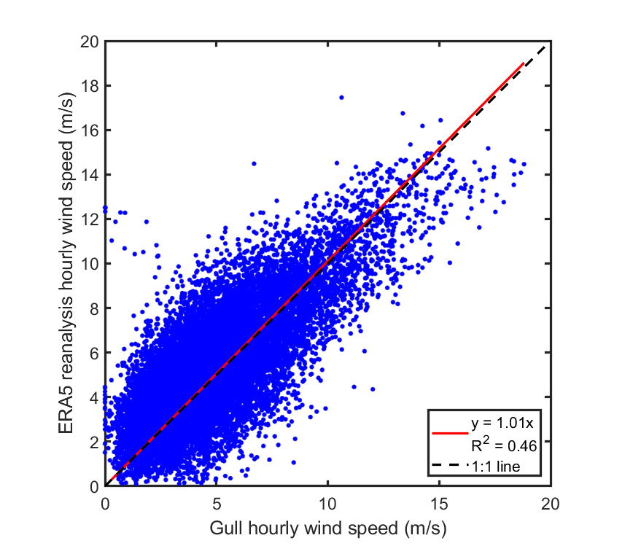
Figure S2. Comparison of hourly wind speeds obtained from the ERA5 reanalysis and Gull platform, when measurements from the former are available. The ERA5 wind speeds are slightly higher (mean 1.53 m/s), leading to a slight overestimate in our gas exchange calculation.
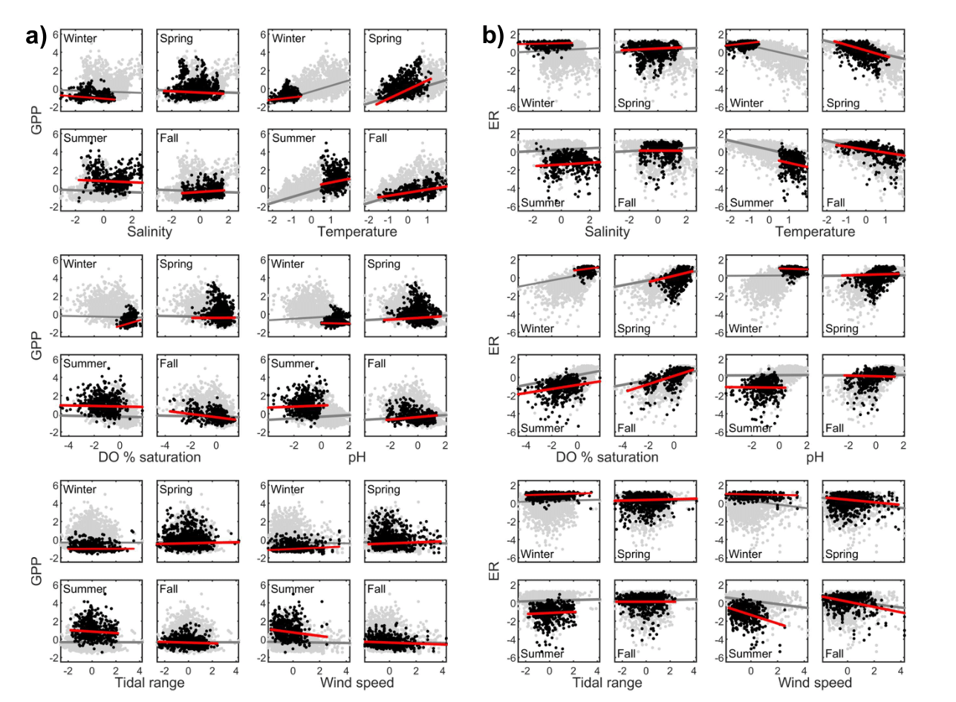
Figure S3. Multiple linear regressions of a) GPP and b) ER vs. six environmental drivers, combining data from all three sites. Black points represent the season-specific values across all three years of sampling, while light grey points represent year-round values. Red lines represent the season-specific multiple regression relationships, varying the parameter indicated while holding all other parameters at their mean values. Light grey lines represent the year-round multiple regression relationships, calculated similarly. Response and predictor variables are scaled to (x – x̄)/s and are therefore unitless.
Table S1. Thresholds for the initial data quality control tests for the parameters specified. Data exceeding these thresholds were flagged as suspect and removed prior to subsequent quality control tests.
Parameter | Gross Range Test Limits (lower, upper) | Spike Test Threshold
Depth (m) | (0, 5) | 0.1
Temperature (ºC) | (-2, 35) | 1
DO conc (μmol/L) | (0, 650) | 50
Salinity (psu) | (10, 50) | 10
pH | (6, 9) | 0.25
Turbidity (NTU) | (0, 350) | 50
Chl a (RFU) | (0, 100) | 10

Table S2. Estimated coefficients from bivariate associations between explanatory variables (salinity, temperature, DO % saturation, pH, tidal range, and wind speed). All variables are scaled to (x – x̄)/s and are therefore unitless.
 | Temp. | DO %sat | pH | Tidal | Wind
Sal. | 0.499**  (0.019) | -0.306**  (0.020) | -0.350**  (0.020) | 0.019  (0.021) | -0.150**  (0.021)
Temp. |  | -0.790**  (0.013) | -0.838**  (0.012) | -0.007  (0.021) | -0.293**  (0.021)
DO %sat |  |  | 0.829**  (0.012) | -0.086**  (0.021) | 0.236**  (0.021)
pH |  |  |  | -0.107**  (0.021) | 0.213**  (0.021)
Tidal |  |  |  |  | 0.002  (0.021)
Standard errors are reported in parentheses.
*, ** indicates significance at the 95% and 99% level, respectively.

