Supplementary materials for
Generative T2/FLAIR mismatch sign in glioma: Optimizing phenotypic augmentation for isocitrate dehydrogenase mutation prediction

- Supplementary Materials: Deep generative artificial intelligence (AI) using score-based diffusion models
- Supplementary Table 1: Details of the most commonly used parameters for image acquisition in our institution and the Cancer Genome Atlas (TCGA) sets
- Supplementary Table 2: Diagnostic performance for prediction of isocitrate dehydrogenase (IDH) mutation using generative images
- Supplementary Figure 1: Architecture of the score-based diffusion model through the stochastic differential equation (SDE)
- Supplementary Figure 2: The only image set of a generative IDH-wildtype glioma exhibiting the T2-FLAIR mismatch sign

Supplementary materials: Deep generative artificial intelligence (AI) using score-based diffusion models
Score-based generative models¹⁻³ and denoising diffusion probabilistic models⁴⁻⁷ are capable of generating high-fidelity data without relying on an auxiliary network. In contrast, generative adversarial networks⁸ need a discriminator, while variational autoencoders⁹ require a Gaussian encoder. Both score-based generative models and denoising diffusion probabilistic models operate through two key processes: a forward process, which generates perturbed data by introducing random noise from a predefined noise distribution at each step, and a backward process, which employs a score network to denoise the perturbed data. The primary distinction between these models lies in their approach to data perturbation. The score-based generative model can expand the initial noise distribution, whereas the diffusion model limits the variance of each noise distribution. Collectively, these two models are referred to as score-based diffusion models.

The perturbation method is defined as a stochastic differential equation (SDE)³. A continuous process is represented as ${\left\{x\left(t\right)\right\}}_{t=0}^{T}$with $x\left(0\right) \sim p_{data}$ and $x\left(T\right) \sim p_{T}$, where $t∈\left[0, T\right]$ and $p_{data}, p_{T}$ denote the data distribution and prior noise distribution, respectively. The forward process is defined as the following SDE:
$dx=f\left(x, t\right)dt+ g\left(t\right)dw$ (1)

where f and g are the coefficients of the drift and diffusion terms in the SDE, respectively, and w represents the Wiener process (i.e., Brownian motion). The backward process is defined by the following reverse-SDE:
$dx=\left[f\left(x,t\right)-g{\left(t\right)}^{2}∇x\log{p_{t}}\left(x\right)\right]dt+g\left(t\right)dw$ (2)

where w is the backward Wiener process. Each variance $σ_{t}$ is defined as a monotonically increasing function. A perturbation kernel $p\left(x_{t} | x_{0}\right)=N\left(x_{t};x_{0},σ_{t}^{2}\right)$is applied, and the drift and diffusion coefficients of the SDE are set to $f=0$ and $g=\sqrt{d\left[σ_{t}^{2}\right]/dt}dw,$ respectively. This formulation is referred to as the variance exploding SDE (VESDE).

To solve the reverse-SDE as described by Eq. (2), we trained a score network $S_{θ}(x, t)$ to estimate the score function of the perturbation kernel $∇x\log{p_{t}}\left(x_{t}|x_{0}\right).$ Consequently, the objective of the score network was formulated as the following loss function:
$$θ^{*}=\arg{\min{θ}}∫λ\left(t\right)E_{x\left(0\right)}E_{x\left(t\right)|x\left(0\right)}{\left\|S_{θ}\left(x\left(t\right), t\right)-∇x\log{p_{t}}\left(x\left(t\right) | x\left(0\right)\right)\right\|}_{2}^{2}dt, \left( SEQ "equation" \backslash n \backslash * MERGEFORMAT 3\right)$$

where $λ\left(t\right)$ equals $σ{\left(t\right)}^{2}$ if the perturbed SDE is a VESDE. By training the score network using Eq. (3), we approximate the score network $S_{θ}\left(x, t\right)$ as $∇x\log{p_{t}}\left(x\left(t\right) | x\left(0\right)\right)$. We trained the score network using single NVIDIA RTX3090 24GB GPU with Adam optimizer for 380,000 iterations. Batch size was 32 and learning rate was 2e-4. We resized the resolution of images by 256 × 256. For quantitative analysis of generative AI, we calculated the Fréchet Inception Distance (FID) score in a prior study¹⁰. The FID scores for IDH-mutant type and IDH-wild type gliomas were 23.53 and 34.96, respectively. The calculated FID score was sufficiently low, indicating diversity of the generated images. Based on these findings, we selected representative images that reflect realistic and varied morphologic feature for our study. The SDE is then solved using a numerical solver with a score-based Markov chain Monte Carlo (MCMC) approach. A numerical solver, such as a reverse diffusion SDE solver, computes the reverse-time SDE using a fixed discretization strategy and is referred to as the Predictor. Additionally, a score-based MCMC approach, such as annealed Langevin dynamics, adjusts the gradient ascent direction and is referred to as the Corrector. We adopted a predictor-corrector sampler that alternately applies the predictor and corrector proposed in a previous study³. We used vanilla NCSN++ model³ with U-Net architecture, which consists of residual and attention blocks. More details about the architecture of the model are illustrated in Supplementary Figure 1.

References
1 Song, Y. & Ermon, S. Generative modeling by estimating gradients of the data distribution. Advances in neural information processing systems 32 (2019).
2 Song, Y. & Ermon, S. Improved techniques for training score-based generative models. Advances in neural information processing systems 33, 12438-12448 (2020).
3 Song, Y. et al. Score-based generative modeling through stochastic differential equations. arXiv preprint arXiv:2011.13456 (2020).
4 Dhariwal, P. & Nichol, A. Diffusion models beat gans on image synthesis. Advances in neural information processing systems 34, 8780-8794 (2021).
5 Ho, J., Jain, A. & Abbeel, P. Denoising diffusion probabilistic models. Advances in neural information processing systems 33, 6840-6851 (2020).
6 Nichol, A. Q. & Dhariwal, P. in International conference on machine learning. 8162-8171 (PMLR).
7 Song, J., Meng, C. & Ermon, S. Denoising diffusion implicit models. arXiv preprint arXiv:2010.02502 (2020).
8 Goodfellow, I. et al. Generative adversarial nets. Advances in neural information processing systems 27 (2014).
9 Kingma, D. P. & Welling, M. Auto-encoding variational bayes. arXiv preprint arXiv:1312.6114 (2013).
10 Moon, H. H. et al. Generative AI in glioma: ensuring diversity in training image phenotypes to improve diagnostic performance for IDH mutation prediction. Neuro-oncology 26, 1124-1135 (2024).

Supplementary Table 1. Details of the most commonly used parameters for image acquisition in our institution and the Cancer Genome Atlas (TCGA) sets
Acquisition parameters | Values
Acquisition parameters | Our institution | TCGA
Magnetic field strength | 3 T | 1.5–3.0 T
Manufacturer | Philips | General Electric  SIEMENS
Spatial resolution
T2WI
FOV (mm)/matrix | 0.47 × 0.47 | 0.43 × 0.43–1.10 × 1.10
Slice thickness (mm) | 4.0 | 0.9–5.0
FLAIR
FOV (mm)/matrix | 0.5 × 0.5 | 0.38 × 0.38–1.10 × 1.10
Slice thickness (mm) | 3.0 | 3.0–5.0
CE-T1WI
FOV (mm)/matrix | 0.25 × 0.25 | 0.43 × 0.43–1.10 × 1.10
Slice thickness (mm) | 1.0 | 0.9–5.0
Echo time (ms)
T2WI | 100 | 65–458
FLAIR | 110 | 75–148.5
CE-T1WI | 4.6 | 1.3–20
Repetition time (ms)
T2WI | 5826.9 | 900–7370
FLAIR | 9000 | 9900–10200
CE-T1WI | 9.8 | 5–2200
Note.—FOV = field of view, CE-T1WI = contrast-enhanced T1-weighted imaging

Supplementary Table 2. Diagnostic performance for prediction of isocitrate dehydrogenase (IDH) mutation using generative images

 | Real |  |  | Synthetic |  |  | Augmented real and synthetic |  |  | Augmented real and synthetic (×2) |  |  | Augmented real and synthetic (×3) |  |  | Augmented real and synthetic (×4) |  |  | Augmented real and synthetic (×5)
 | AUC | Sens | Spec | AUC | Sens | Spec | AUC | Sens | Spec | AUC | Sens | Spec | AUC | Sens | Spec | AUC | Sens | Spec | AUC | Sens | Spec
Apparent test  (in training set) | 0.883 | 79.2% | 83.2% | 0.802 | 94.9% | 61.0% | 0.840 | 83.3% | 75.4% | 0.830 | 87.1% | 70.9% | 0.828 | 85.1% | 71.9% | 0.819 | 90.4% | 63.8% | 0.818 | 87.1% | 66.9%
Internal test | 0.886 | 96.2% | 73.0% | 0.835 | 84.6% | 74.6% | 0.892 | 84.6% | 81.7% | 0.886 | 84.6% | 81.7% | 0.885 | 84.6% | 82.5% | 0.883 | 76.9% | 86.5% | 0.883 | 76.9% | 86.5%
External test | 0.909 | 91.9% | 83.8% | 0.908 | 98.4% | 73.0% | 0.905 | 98.4% | 73.0% | 0.895 | 98.4% | 73.0% | 0.893 | 98.4% | 73.0% | 0.902 | 98.4% | 73.0% | 0.902 | 98.4% | 73.0%
Note.—AUC = Area under the receiver operating characteristics curve, Sens = sensitivity, Spec = specificity

Supplementary Figure 1. Architecture of the score-based diffusion model through the stochastic differential equation (SDE). The score-based diffusion model is U-Net architecture with timestep embedding. Each block contains residual and attention blocks. CE-T1WI, T2WI, FLAIR images are concatenated into channels and the model predicts their noise simultaneously.
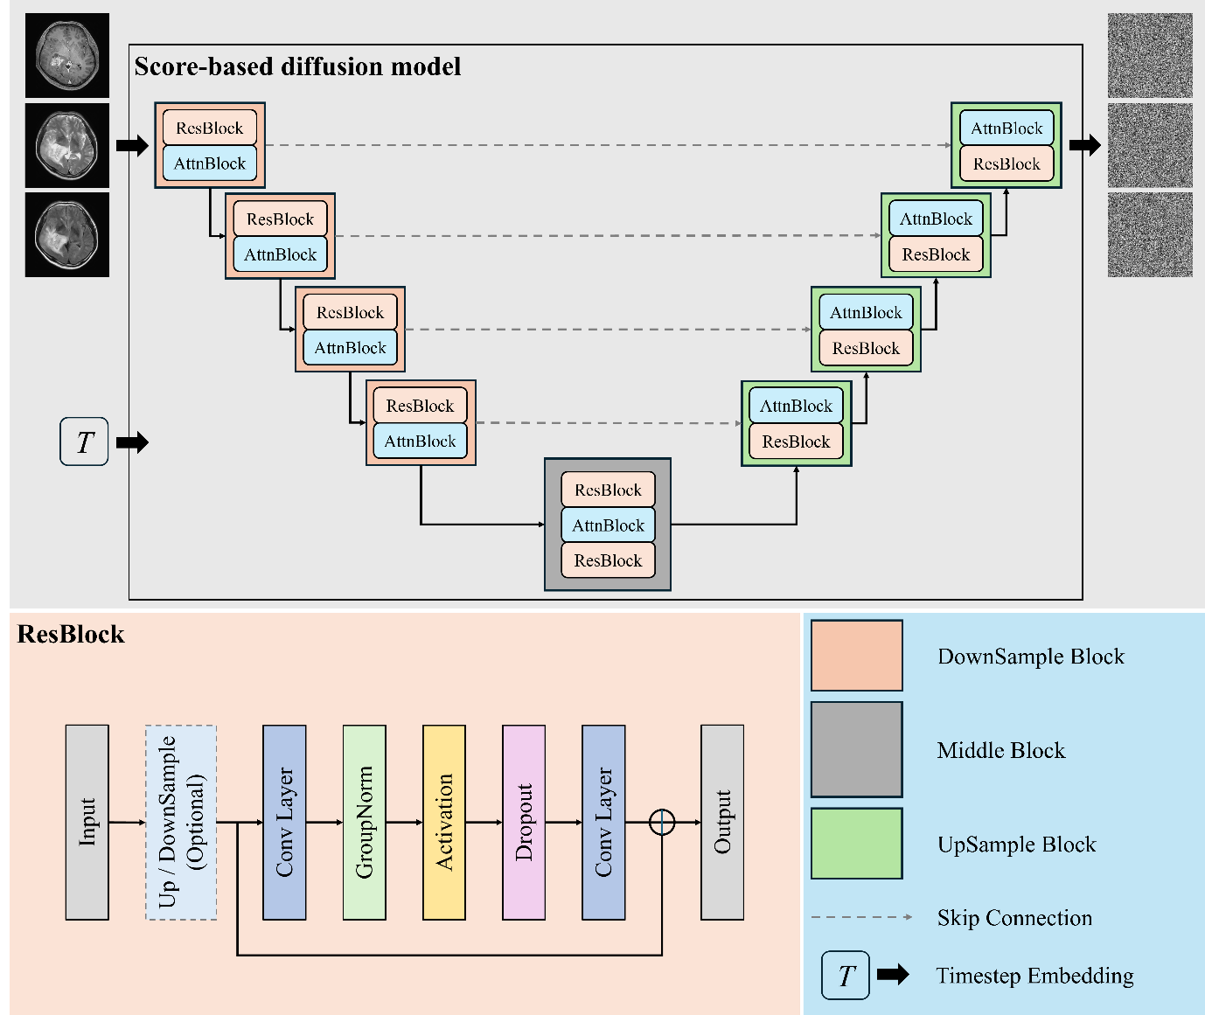

Supplementary Figure 2. The only image set of a generative IDH-wildtype glioma exhibiting the T2-FLAIR mismatch sign. The nonenhancing tumor, without necrosis or cyst on CE-T1WI (a), displays a complete hyperintense signal on T2WI (b), along with a heterogeneous hypointense signal on FLAIR (c), except for a hyperintense peripheral rim.

