Supplementary Figure 1. Flow diagram of participants within the cohort

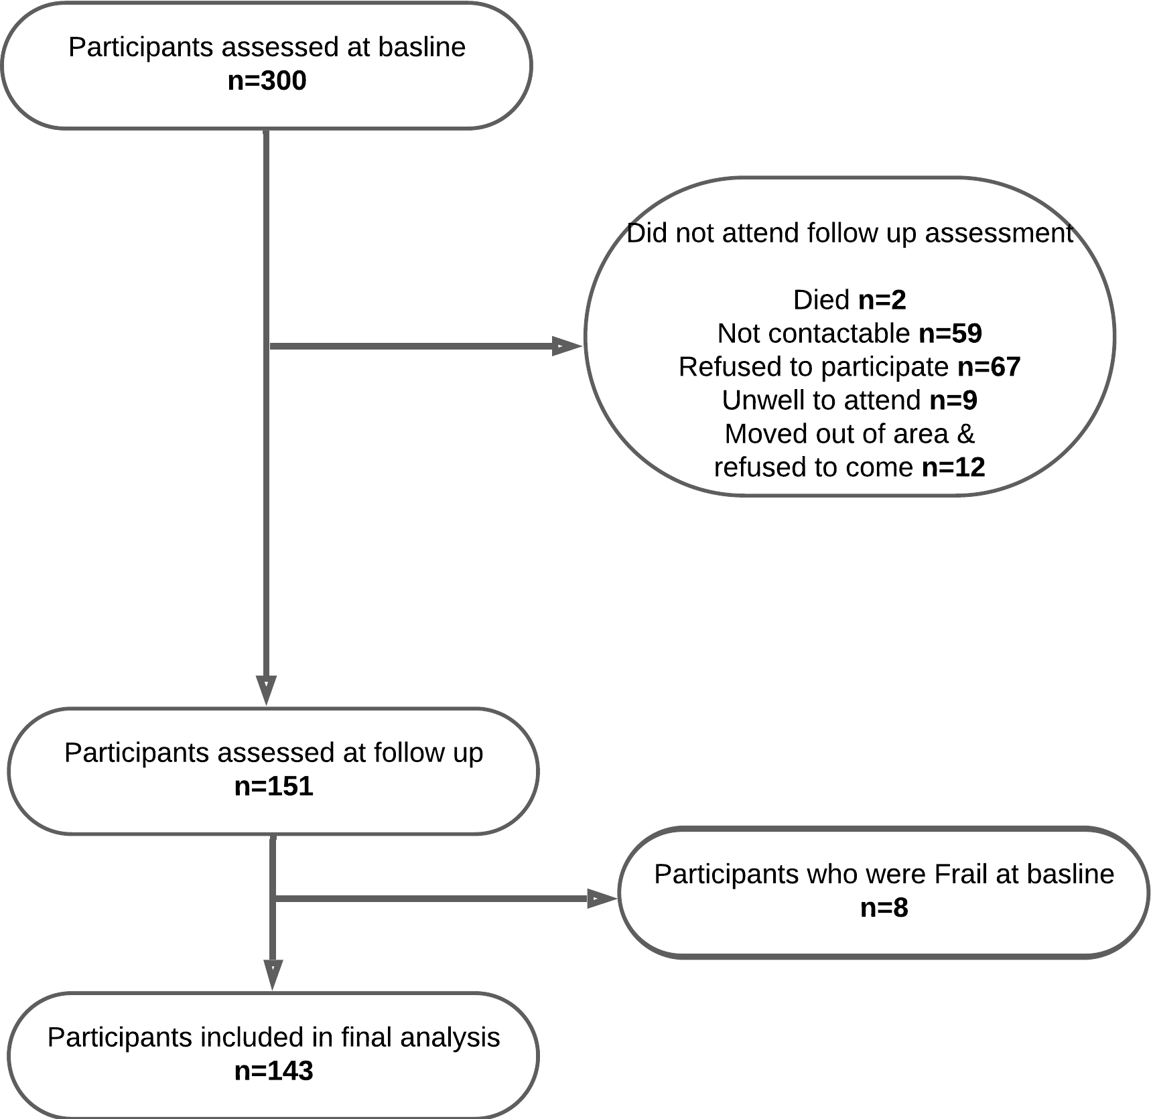

Supplementary Figure 2. Transitioning between frailty states (robust, prefrail, and frail) of participants from baseline to follow-up over an average period of four years.

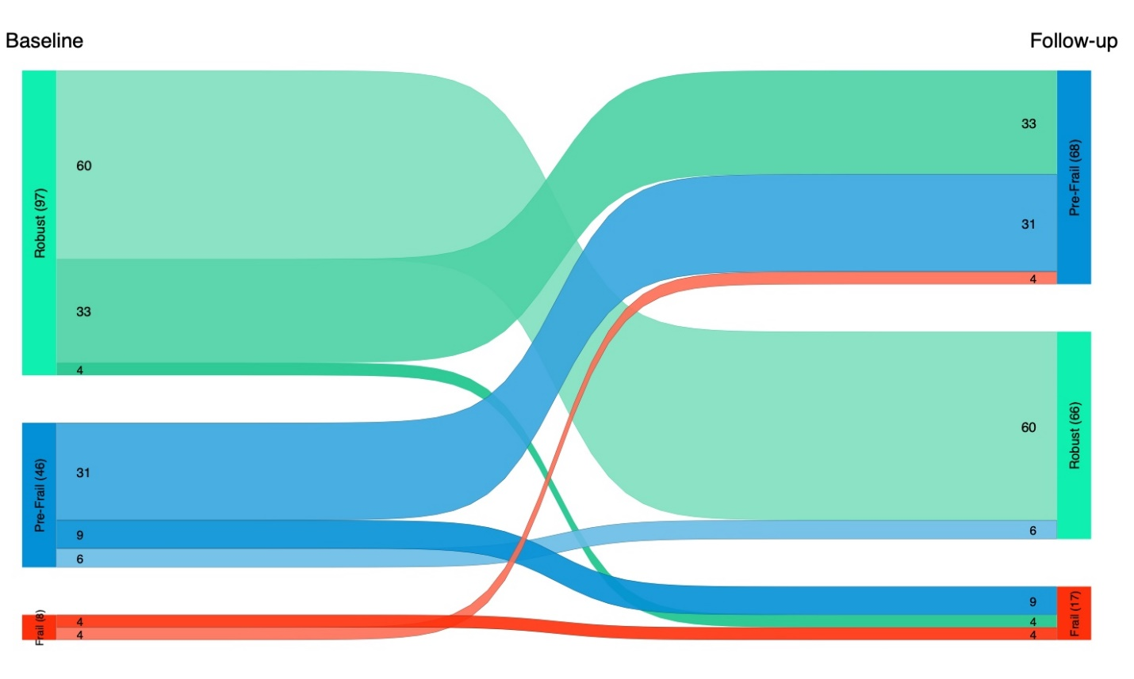

Supplementary Figure 3. The transition between frailty states (non-frail and frail) of participants from baseline to follow-up over an average period of four years.

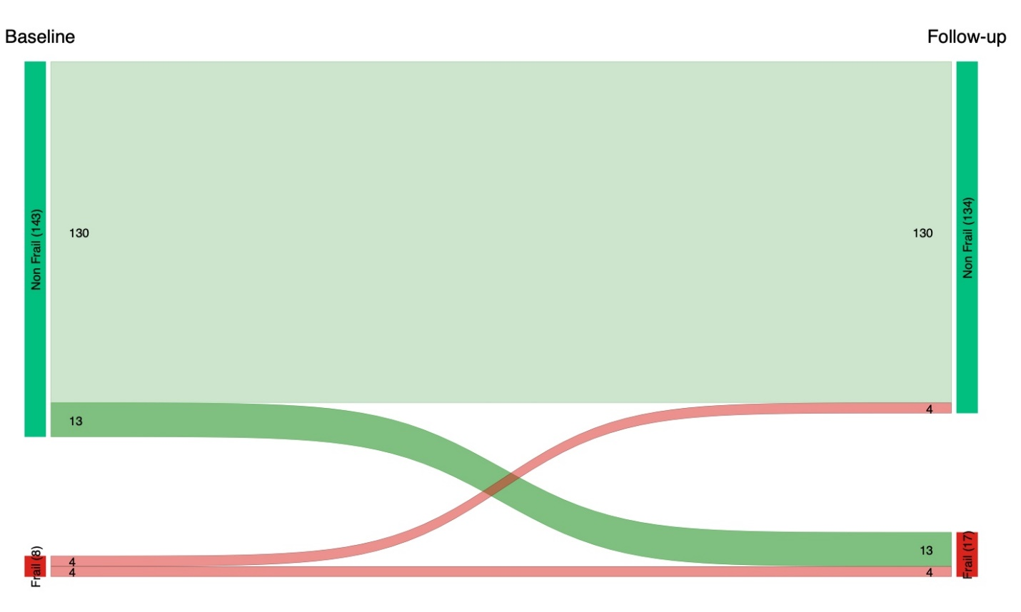

Supplementary Figure 4. Venn diagram of overlap of participants with osteopenia/osteoporosis, sarcopenia and osteosarcopenia at baseline. 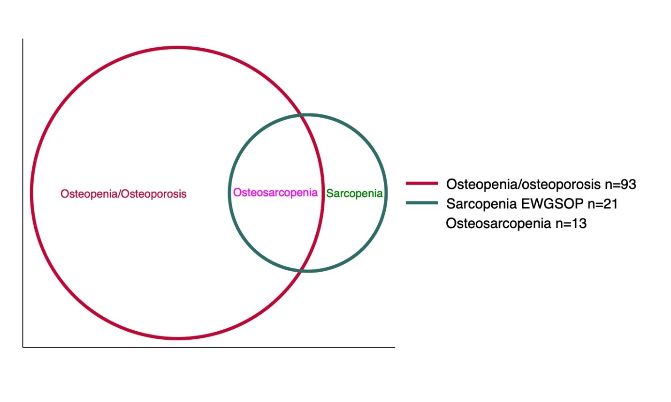

Supplementary Table 1: Comparison of participants’ characteristics who attended follow-up compared to those who did not.
 | Non-Follow up | Follow up | Total | p-value
Numbers | 149 (49.7%) | 151 (50.3%) | 300 (100.0%)
Age at first visit | 68.6 (9.0) | 65.1 (6.3) | 66.8 (8.0) | <0.001
Women | 95 (63.8%) | 90 (59.6%) | 185 (61.7%) | 0.459
Lives alone | 34 (22.8%) | 34 (22.5%) | 68 (22.7%) | 0.950
Born in Australia | 108 (72.5%) | 101 (66.9%) | 209 (69.7%) | 0.292
Aboriginal or Torres Strait Islander | 1 (0.7%) | 1 (0.7%) | 2 (0.7%) | 0.992
Speak English at Home | 140 (94.0%) | 145 (96.0%) | 285 (95.0%) | 0.412
Has private health insurance | 99 (67.3%) | 104 (68.9%) | 203 (68.1%) | 0.777
Has health card | 69 (47.3%) | 51 (33.8%) | 120 (40.4%) | 0.018
Highest level of education
Completed less than primary school | 3 (2.0%) | 0 (0.0%) | 3 (1.0%) | 0.002
Completed all of primary school | 7 (4.8%) | 1 (0.7%) | 8 (2.7%)
Completed some or all of high school | 39 (26.5%) | 28 (18.5%) | 67 (22.5%)
Completed some post-secondary/tertiary qualification | 36 (24.5%) | 28 (18.5%) | 64 (21.5%)
Completed all of post-secondary/tertiary qualification | 62 (42.2%) | 94 (62.3%) | 156 (52.3%)
Education (post-secondary/tertiary)
High school or less | 49 (33.3%) | 29 (19.2%) | 78 (26.2%) | 0.006
Post-secondary/tertiary qualification | 98 (66.7%) | 122 (80.8%) | 220 (73.8%)
Annual Household Income (AUD)
≤ $40,000 AUD/yr | 48 (32.7%) | 42 (27.8%) | 90 (30.2%) | 0.048
$40,000 to $69,000 AUD/yr | 42 (28.6%) | 34 (22.5%) | 76 (25.5%)
$70,000 to $99,000 AUD/yr | 20 (13.6%) | 40 (26.5%) | 60 (20.1%)
≥ $100,000 AUD/yr | 37 (25.2%) | 35 (23.2%) | 72 (24.2%)
Annual income >40K AUD | 99 (67.3%) | 109 (72.2%) | 208 (69.8%) | 0.363
Employment Category
Full-time | 17 (11.6%) | 12 (7.9%) | 29 (9.7%) | 0.215
Part-time or casual | 25 (17.0%) | 39 (25.8%) | 64 (21.5%)
Retired | 62 (42.2%) | 70 (46.4%) | 132 (44.3%)
Volunteer | 30 (20.4%) | 22 (14.6%) | 52 (17.4%)
Home-based duties | 6 (4.1%) | 2 (1.3%) | 8 (2.7%)
Carer | 1 (0.7%) | 2 (1.3%) | 3 (1.0%)
Other | 6 (4.1%) | 4 (2.6%) | 10 (3.4%)
Smoking (past or present) | 66 (44.9%) | 66 (43.7%) | 132 (44.3%) | 0.836
Smoking (current)
No, not at all | 62 (89.9%) | 64 (91.4%) | 126 (90.6%) | 0.836
Yes, but not daily | 5 (7.2%) | 5 (7.1%) | 10 (7.2%)
Yes, daily | 2 (2.9%) | 1 (1.4%) | 3 (2.2%)
Duration smoking (years) | 46.0 (6.2) | 27.7 (18.5) | 34.4 (17.4) | 0.047
Smoking (past) | 52 (75.4%) | 61 (82.4%) | 113 (79.0%) | 0.299
Alcohol (past or present) | 135 (91.8%) | 143 (94.7%) | 278 (93.3%) | 0.323
Alcohol (last month) | 110 (81.5%) | 116 (80.0%) | 226 (80.7%) | 0.754
Alcohol amount last year
No days | 15 (11.1%) | 17 (11.6%) | 32 (11.4%) | 0.603
Less than once a month | 24 (17.8%) | 22 (15.1%) | 46 (16.4%)
One to three days per month | 25 (18.5%) | 37 (25.3%) | 62 (22.1%)
One to four days per week | 40 (29.6%) | 44 (30.1%) | 84 (29.9%)
Five or more days per week | 31 (23.0%) | 26 (17.8%) | 57 (20.3%)
Alcohol (average) over 12 months | 1.9 (1.5) | 2.1 (2.7) | 2.0 (2.2) | 0.684
Comorbidities | 117 (79.6%) | 115 (76.2%) | 232 (77.9%) | 0.476
Arthritis | 49 (33.3%) | 53 (35.1%) | 102 (34.2%) | 0.748
Chronic Back pain | 49 (33.3%) | 46 (30.5%) | 95 (31.9%) | 0.595
Cardiovascular Disease | 22 (15.0%) | 22 (14.6%) | 44 (14.8%) | 0.923
Chronic Lung disease | 14 (9.5%) | 14 (9.3%) | 28 (9.4%) | 0.941
Cancer | 8 (5.4%) | 10 (6.6%) | 18 (6.0%) | 0.669
Depression or Anxiety | 25 (17.0%) | 17 (11.3%) | 42 (14.1%) | 0.154
Diabetes | 12 (8.2%) | 11 (7.3%) | 23 (7.7%) | 0.776
Cerebrovascular disease | 2 (1.4%) | 4 (2.6%) | 6 (2.0%) | 0.429
Other comorbidities | 26 (17.7%) | 26 (17.2%) | 52 (17.4%) | 0.915
Any fracture | 71 (48.3%) | 83 (55.0%) | 154 (51.7%) | 0.250
Any fracture in last 5 years | 22 (15.2%) | 23 (15.6%) | 45 (15.4%) | 0.911
Total number of fractures | 0.8 (1.1) | 1.1 (1.5) | 0.9 (1.3) | 0.066
Vertebral fracture | 7 (4.8%) | 4 (2.7%) | 11 (3.7%) | 0.333
Non-vertebral fractures | 61 (40.9%) | 78 (51.7%) | 139 (46.3%) | 0.063
Hip fractures | 10 (6.8%) | 6 (4.0%) | 16 (5.4%) | 0.278
Physical Activity Scale (IPAQ)
Low | 30 (20.1%) | 30 (19.9%) | 60 (20.0%) | 0.973
Moderate | 25 (16.8%) | 24 (15.9%) | 49 (16.3%)
High | 94 (63.1%) | 97 (64.2%) | 191 (63.7%)
Total METS/week (as per IPAQ) | 5017.0 (3929.4) | 5618.4 (4351.7) | 5319.7 (4151.3) | 0.239
Mini Nutritional Assessment (MNA) Score | [40] 13.1 (1.3) | [40] 12.8 (1.5) | [80] 13.0 (1.4) | 0.389
At risk of malnutrition MNA <=12 | 2 (5.1%) | 6 (15.0%) | 8 (10.1%) | 0.146
Normal nutritional status | 37 (94.9%) | 34 (85.0%) | 71 (89.9%)
Is participant taking any medication? | 100 (67.1%) | 104 (68.9%) | 204 (68.0%) | 0.744
Is participant taking any supplement? | 52 (34.9%) | 58 (38.4%) | 110 (36.7%) | 0.528
Number of Medications | 2.3 (2.8) | 2.1 (2.3) | 2.2 (2.6) | 0.865
Number of Supplements | 0.8 (1.5) | 0.8 (1.3) | 0.8 (1.4) | 0.749
Polypharmacy (>=5 medications) at first visit | 23 (15.4%) | 21 (13.9%) | 44 (14.7%) | 0.708
Psychological Distress Scale K6+ (Cat)
No/Low distress | 129 (90.8%) | 135 (91.2%) | 264 (91.0%) | 0.182
Moderate distress | 13 (9.2%) | 10 (6.8%) | 23 (7.9%)
High distress | 0 (0.0%) | 3 (2.0%) | 3 (1.0%)
Systolic BP (mmHg) | 135.0 (17.0) | 135.2 (18.4) | 135.1 (17.8) | 0.985
Diastolic BP (mmHg) | 83.2 (10.7) | 85.4 (10.7) | 84.4 (10.7) | 0.185
Body Mass Index | 28.0 (5.1) | 27.8 (5.3) | 27.9 (5.2) | 0.704
Hip circumference (cm) | 105.0 (16.9) | 105.0 (12.8) | 105.0 (14.7) | 0.899
Waist circumference (cm) | 94.7 (14.4) | 94.0 (16.8) | 94.3 (15.8) | 0.954
Vitamin D levels | 64.9 (21.4) | 66.2 (22.6) | 65.6 (22.0) | 0.713
Hs_CRP | 3.2 (10.8) | 2.1 (3.1) | 2.6 (7.6) | 0.990
Hand Grip Strength Max (Kg) | 32.6 (9.5) | 34.6 (9.8) | 33.6 (9.6) | 0.034
Hand Grip Strength Max (Kg)/BMI | 1.2 (0.4) | 1.3 (0.4) | 1.2 (0.4) | 0.048
5x Sit to Stand (sec) | 14.0 (12.1) | 12.3 (9.8) | 13.1 (11.0) | 0.190
Short Physical Performance battery | 11.1 (1.4) | 11.1 (1.5) | 11.1 (1.5) | 0.420
Gait speed best(m/s) | 1.2 (0.3) | 1.3 (0.3) | 1.2 (0.3) | 0.004
ALM | 20.3 (7.6) | [20.5 (5.4) | 20.4 (6.5) | 0.286
ALM/height | 7.3 (2.6) | 7.3 (1.3) | 7.3 (2.0) | 0.404
Subtotal bodyfat, %age | 37.2 (8.8) | 35.7 (9.0) | 36.4 (8.9) | 0.103
Whole body fat, %age | 36.4 (8.4) | 35.0 (8.5) | 35.7 (8.5) | 0.104
Lowest site BMD (g/cm2) | 0.5 (0.1) | 0.5 (0.1) | 0.5 (0.1) | 0.877
Lumbar spine BMD (g/cm2) | 1.0 (0.2) | 1.0 (0.2) | 1.0 (0.2) | 0.743
Femoral Neck BMD (g/cm2) | [0.7 (0.1) | 0.7 (0.1) | 0.7 (0.1) | 0.297
Hip total BMD (g/cm2) | 0.9 (0.1) | 0.9 (0.2) | 0.9 (0.1) | 0.203
Ward's triangle BMD (g/cm2) | 0.5 (0.1) | 0.6 (0.1) | 0.5 (0.1) | 0.317
Distal 1/3 Radius BMD (g/cm2) | 0.7 (0.1) | 0.7 (0.1) | 0.7 (0.1) | 0.918
Total radius and ulna BMD (g/cm2) | 0.5 (0.1) | 0.6 (0.2) | 0.6 (0.1) | 0.746
Lowest site T-score | -1.4 (1.1) | -1.3 (1.0) | -1.4 (1.1) | 0.364
Lumbar spine (T-score) | -0.6 (1.6) | -0.6 (1.5) | -0.6 (1.5) | 0.896
Femoral neck (T-score) | -1.3 (0.9) | -1.1 (0.9) | -1.2 (0.9) | 0.218
Distal 1/3 forearm (T-score) | -1.0 (1.5) | -0.8 (1.2) | -0.9 (1.4) | 0.337
Fried Frailty categories
Robust | 68 (45.6%) | 97 (64.2%) | 165 (55.0%) | <0.001
Pre-Frail | 79 (53.0%) | 46 (30.5%) | 125 (41.7%)
Frail | 2 (1.3%) | 8 (5.3%) | 10 (3.3%)
Fried - Exhaustion | 1 (0.7%) | 6 (4.0%) | 7 (2.4%) | 0.064
Fried - Weight loss | 3 (2.0%) | 7 (4.6%) | 10 (3.3%) | 0.210
Fried - Low physical activity | 30 (20.1%) | 30 (19.9%) | 60 (20.0%) | 0.954
Fried - Slowness | 44 (29.5%) | 20 (13.2%) | 64 (21.3%) | <0.001
Fried - Weakness | 26 (17.4%) | 23 (15.2%) | 49 (16.3%) | 0.603
Osteoporosis (WHO criteria)
Normal | 44 (29.7%) | 54 (35.8%) | 98 (32.8%) | 0.525
Osteopenia | 86 (58.1%) | 79 (52.3%) | 165 (55.2%)
Osteoporosis | 18 (12.2%) | 18 (11.9%) | 36 (12.0%)
Sarcopenia EWGSOP Confirmed | 34 (22.8%) | 28 (18.5%) | 62 (20.7%) | 0.360
Sarcopenia EWGSOP Severe | 14 (9.4%) | 13 (8.6%) | 27 (9.0%) | 0.812
Sarcopenia SDOC 1(hgs + gs) | 43 (28.9%) | 26 (17.2%) | 69 (23.0%) | 0.017
Sarcopenia SDOC 2(hgs/bmi + gs) | 45 (30.2%) | 27 (17.9%) | 72 (24.0%) | 0.012
Osteosarcopenia (EWGSOP2)
Healthy | 35 (23.5%) | 42 (27.8%) | 77 (25.7%) | 0.386
Osteopenia or osteoporosis only | 80 (53.7%) | 81 (53.6%) | 161 (53.7%)
Sarcopenia only | 9 (6.0%) | 12 (7.9%) | 21 (7.0%)
Osteosarcopenia | 25 (16.8%) | 16 (10.6%) | 41 (13.7%)
Osteosarcopenia (SDOC-1)
Healthy | 35 (23.6%) | 44 (29.1%) | 79 (26.4%) | 0.040
Osteopenia or osteoporosis only | 70 (47.3%) | 81 (53.6%) | 151 (50.5%)
Sarcopenia only | 9 (6.1%) | 10 (6.6%) | 19 (6.4%)
Osteosarcopenia | 34 (23.0%) | 16 (10.6%) | 50 (16.7%)
Osteosarcopenia (SDOC-2)
Healthy | 35 (23.5%) | 40 (26.5%) | 75 (25.0%) | 0.003
Osteopenia or osteoporosis only | 69 (46.3%) | 84 (55.6%) | 153 (51.0%)
Sarcopenia only | 9 (6.0%) | 14 (9.3%) | 23 (7.7%)
Osteosarcopenia | 36 (24.2%) | 13 (8.6%) | 49 (16.3%)
Unless otherwise specified, Mean (SD) for continuous variables and number (%age) for categorical variables

