a
b
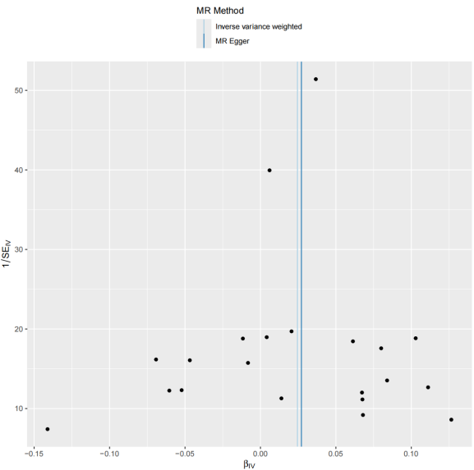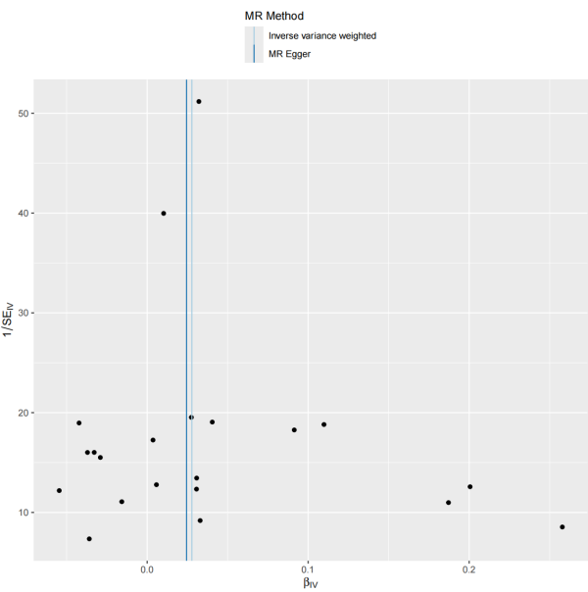
c
d

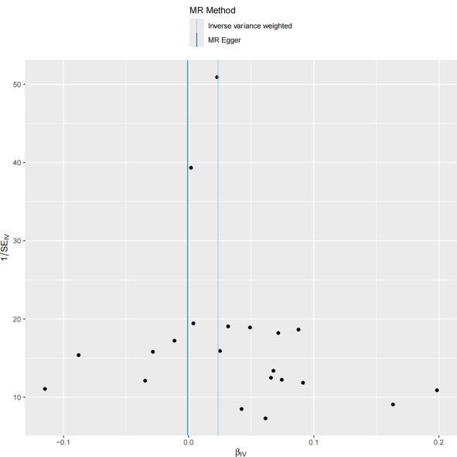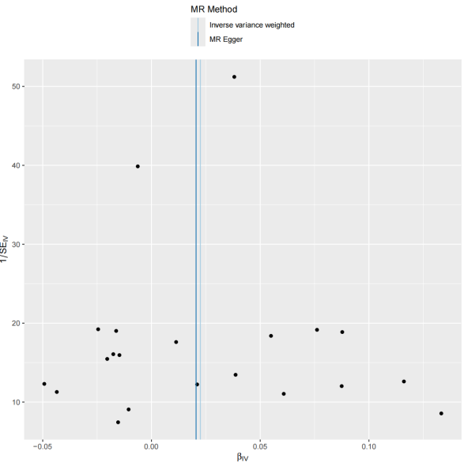
e
f

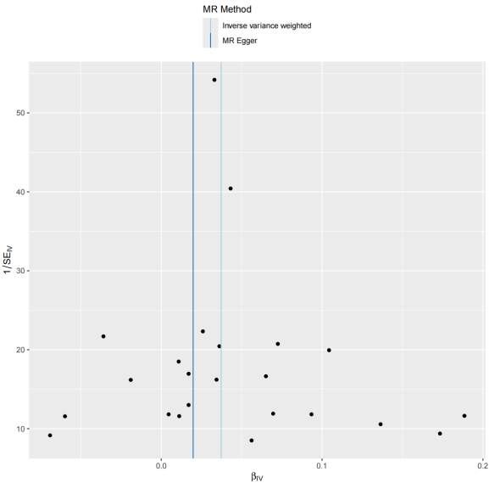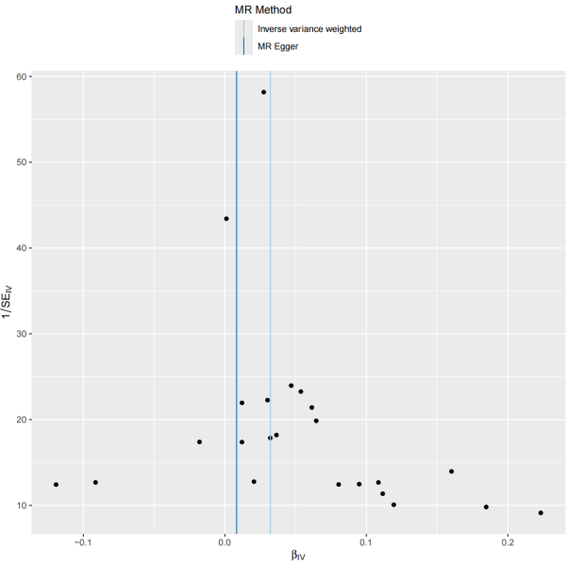

g
h
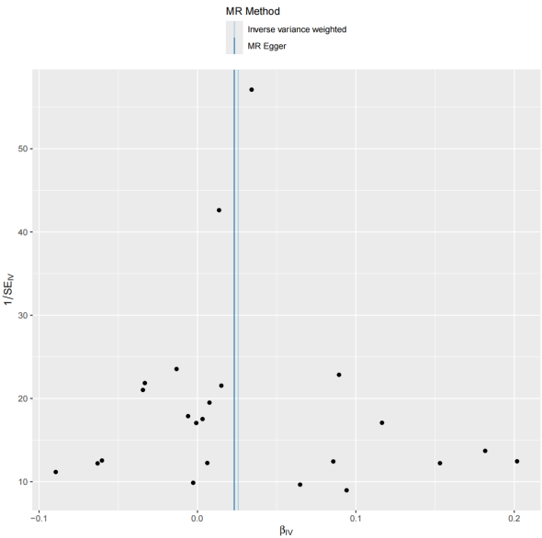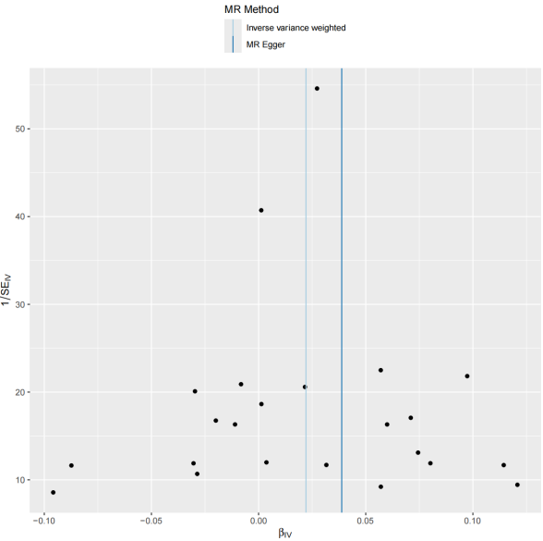
Figure S4. Funnel plots assessing directional pleiotropy of NLRC5 expression quantitative trait loci (eQTL)-associated SNPs across cohorts.
(a–d) Funnel plots of SNP-specific causal effect estimates (β) against precision (1/SE) for NLRC5 eQTL effects on GABARAP, BRSK2, TNFSF12, and BCL2 pQTLs in the deCODE Iceland cohort. Asymmetry was evaluated via MR-Egger regression intercept tests (reported in lower-left corners). The solid vertical line indicates inverse-variance weighted (IVW) pooled estimates, with dashed lines representing 95% confidence intervals.
(e–h) Corresponding funnel plots for NLRC5 eQTL effects on GABARAP, BRSK2, TNFSF12, and BCL2 pQTLs in the UK Biobank Pharma Proteomics Project (UKB-PPP).

