b
a
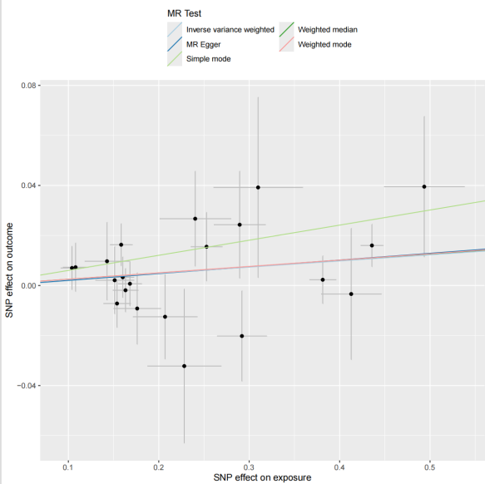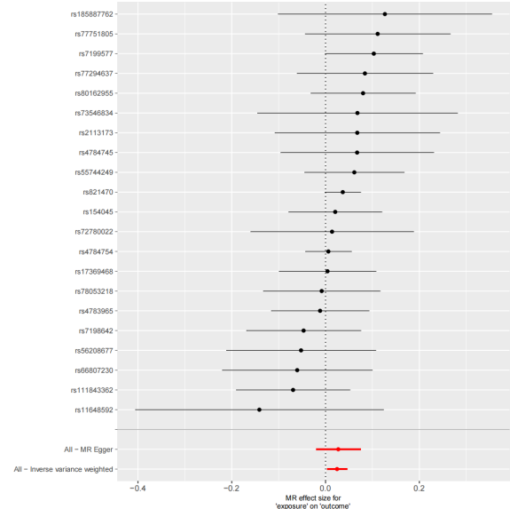
c
d

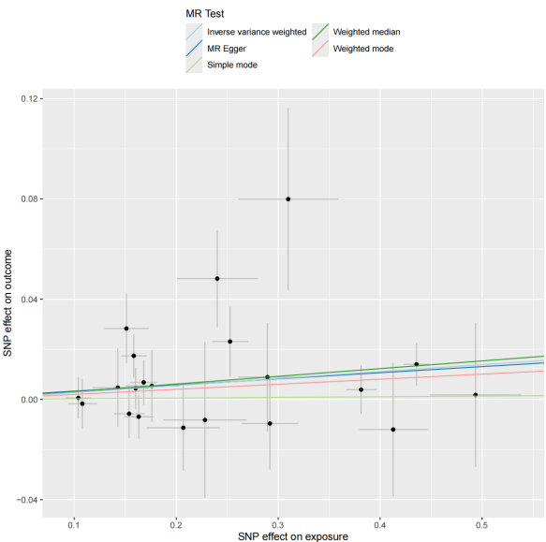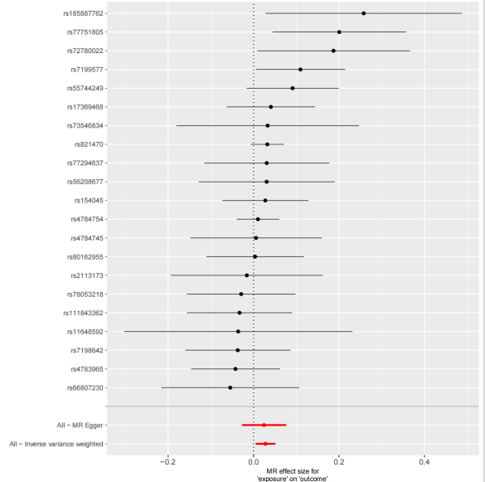
f
e
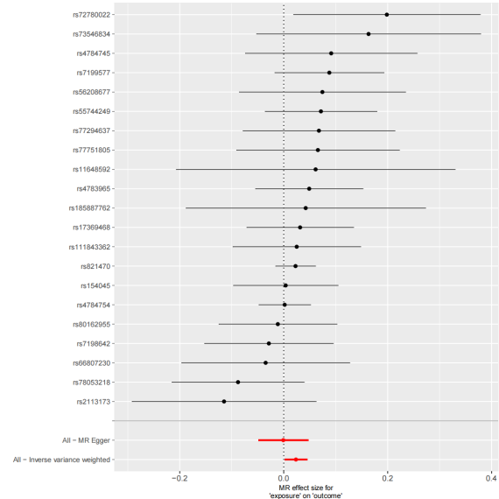
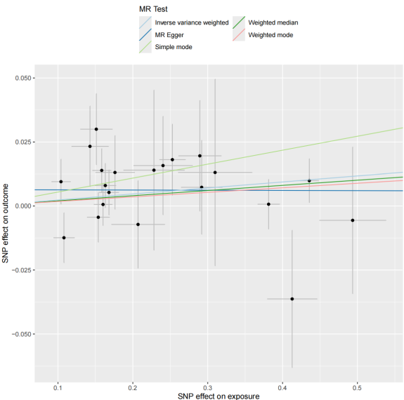

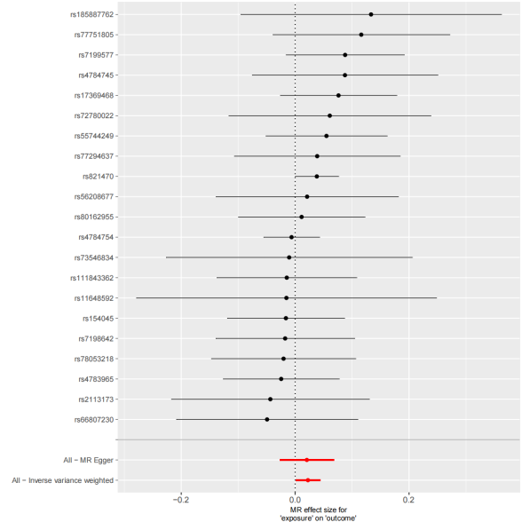
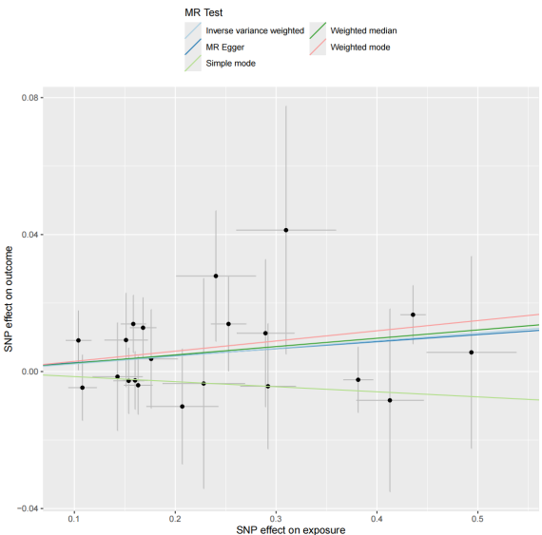
h
g

Figure S1. Mendelian randomization (MR) analysis of causal effects between NLRC5 expression quantitative trait loci (eQTL) and protein quantitative trait loci (pQTL) from deCODE Iceland cohort.
(a)Scatterplot of genetic variant associations between NLRC5 eQTL (x-axis) and GABARAP pQTL (y-axis). Each point represents a single nucleotide polymorphism (SNP), with slopes of regression lines indicating causal effect estimates (β) from inverse-variance weighted (IVW), MR-Egger, and weighted median methods. Error bars denote 95% confidence intervals (CI).
(b) Forest plot of individual SNP-specific and IVW-combined MR effect sizes (β ± 95% CI) for NLRC5 eQTL on GABARAP pQTL.
(c-d) Corresponding scatterplot (c) and forest plot (d) for NLRC5 eQTL effects on BRSK2 pQTL.
(e-f) Scatterplot (e) and forest plot (f) for NLRC5 eQTL effects on TNFSF12 pQTL.
(g-h) Scatterplot (g) and forest plot (h) for NLRC5 eQTL effects on BCL2 pQTL.

