Supplementary material
Supplementary Figures
a
b
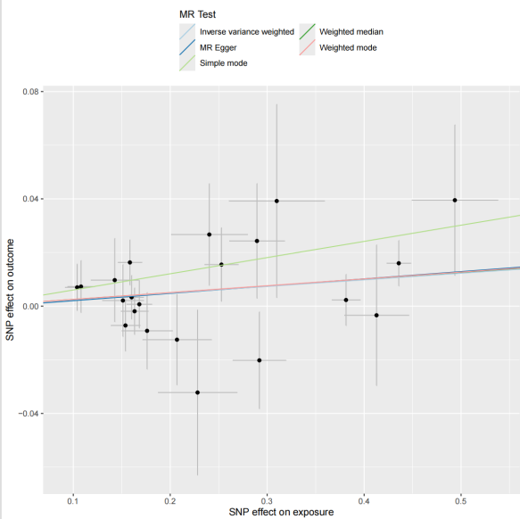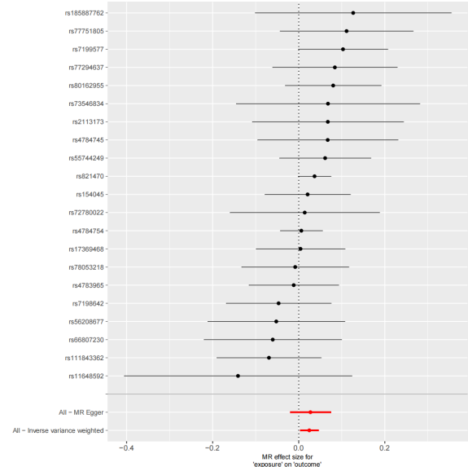
c
d

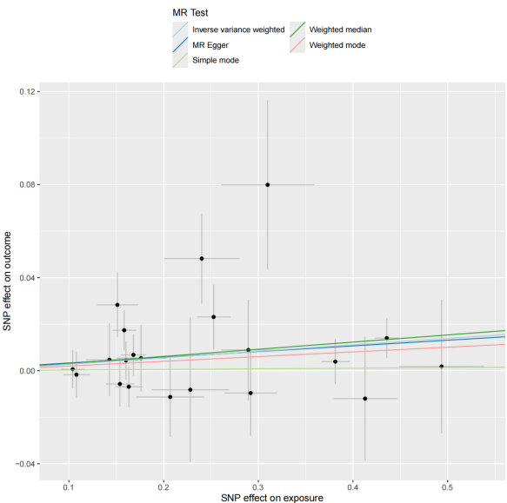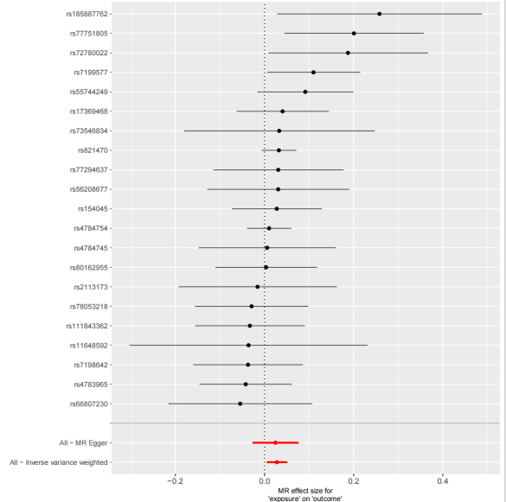
f
e
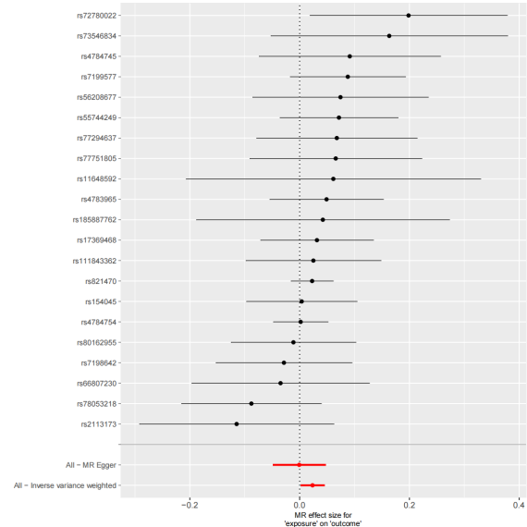
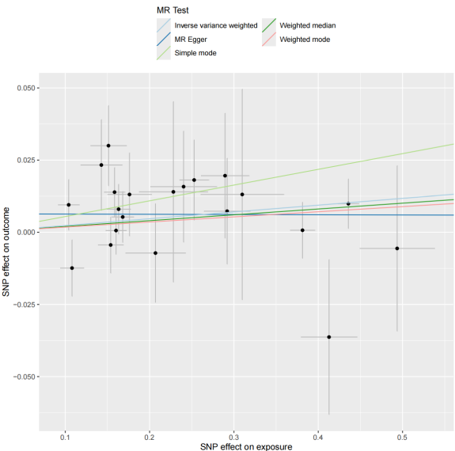

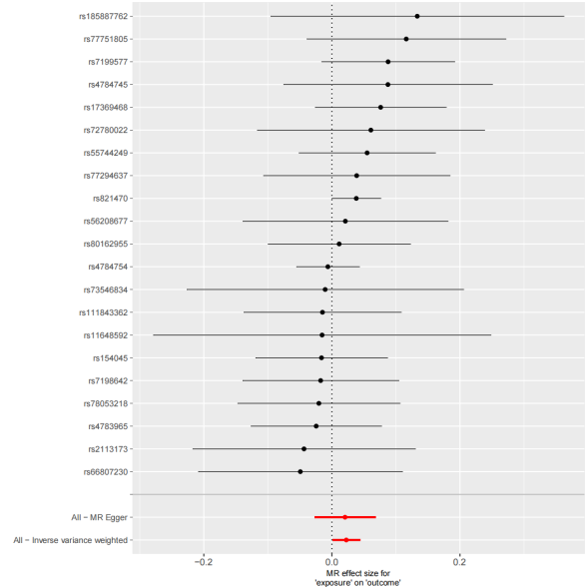
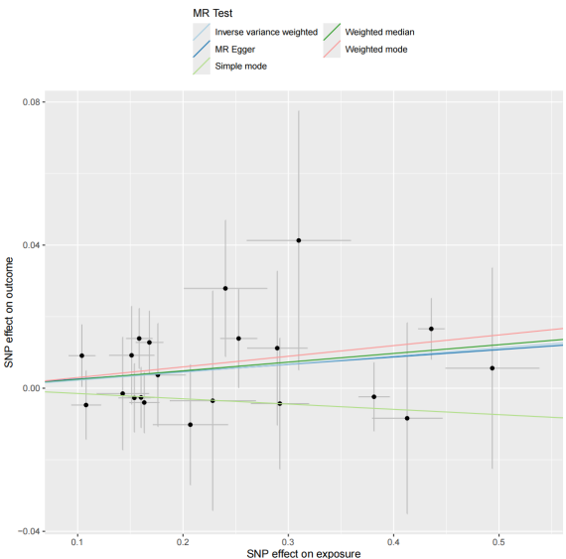
h
g

Fig S1. Mendelian randomization (MR) analysis of causal effects between NLRC5 expression quantitative trait loci (eQTL) and protein quantitative trait loci (pQTL) from deCODE Iceland cohort.
(a)Scatterplot of genetic variant associations between NLRC5 eQTL (x-axis) and GABARAP pQTL (y-axis). Each point represents a single nucleotide polymorphism (SNP), with slopes of regression lines indicating causal effect estimates (β) from inverse-variance weighted (IVW), MR-Egger, and weighted median methods. Error bars denote 95% confidence intervals (CI).
(b) Forest plot of individual SNP-specific and IVW-combined MR effect sizes (β ± 95% CI) for NLRC5 eQTL on GABARAP pQTL.
(c-d) Corresponding scatterplot (c) and forest plot (d) for NLRC5 eQTL effects on BRSK2 pQTL.
(e-f) Scatterplot (e) and forest plot (f) for NLRC5 eQTL effects on TNFSF12 pQTL.
(g-h) Scatterplot (g) and forest plot (h) for NLRC5 eQTL effects on BCL2 pQTL.

a
b
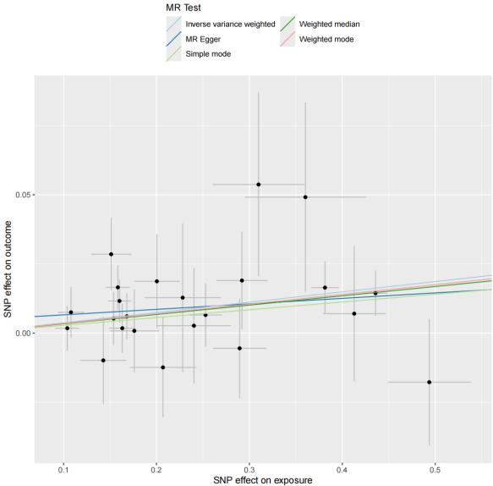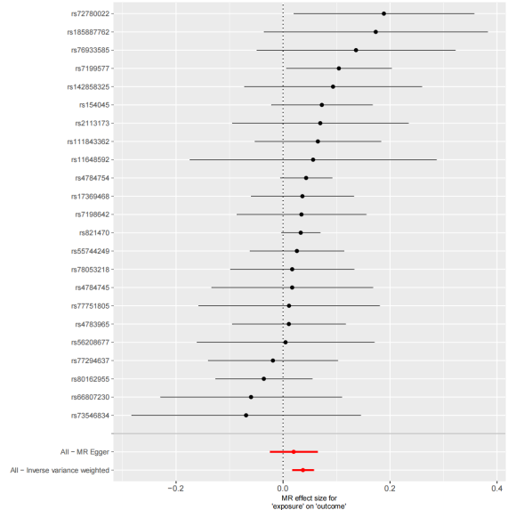
c
d

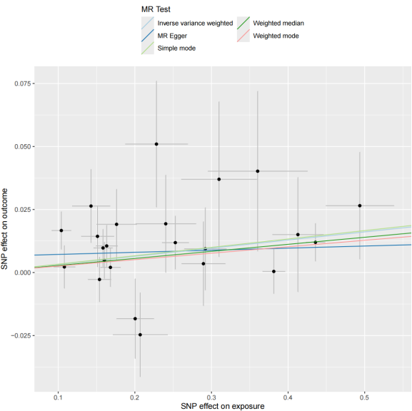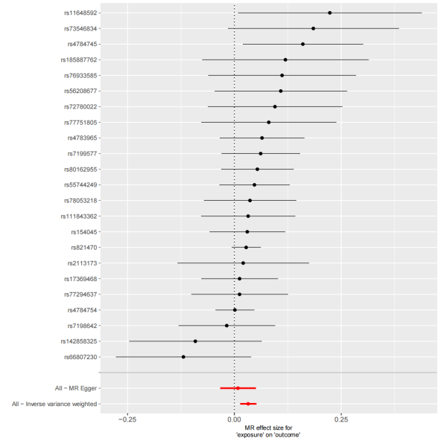
e
f
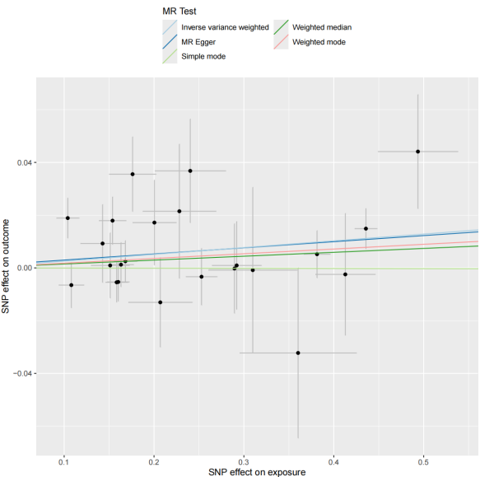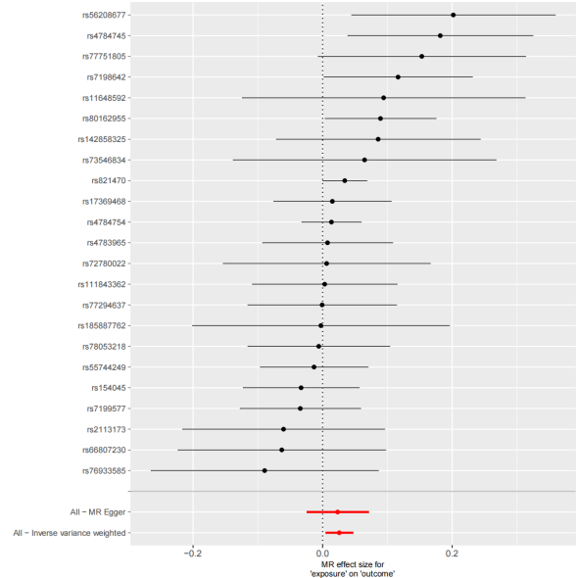

h
g
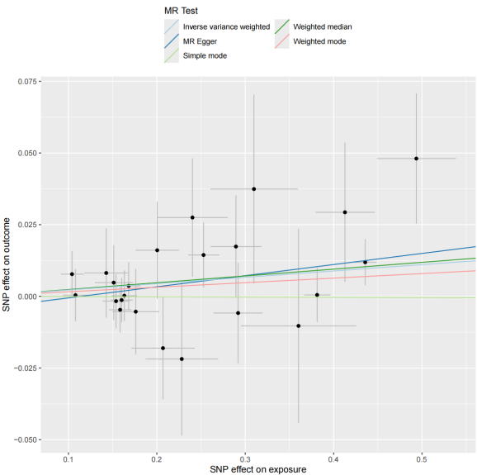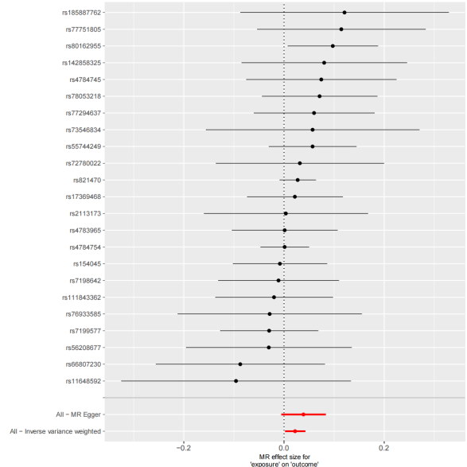
Fig S2. Mendelian randomization (MR) analysis of causal effects between NLRC5 expression quantitative trait loci (eQTL) and protein quantitative trait loci (pQTL) from UKB-PPP cohort.
(a)Scatterplot of genetic variant associations between NLRC5 eQTL (x-axis) and GABARAP pQTL (y-axis). Each point represents a single nucleotide polymorphism (SNP), with slopes of regression lines indicating causal effect estimates (β) from inverse-variance weighted (IVW), MR-Egger, and weighted median methods. Error bars denote 95% confidence intervals (CI).
(b) Forest plot of individual SNP-specific and IVW-combined MR effect sizes (β ± 95% CI) for NLRC5 eQTL on GABARAP pQTL.
(c-d) Corresponding scatterplot (c) and forest plot (d) for NLRC5 eQTL effects on BRSK2 pQTL.
(e-f) Scatterplot (e) and forest plot (f) for NLRC5 eQTL effects on TNFSF12 pQTL.
(g-h) Scatterplot (g) and forest plot (h) for NLRC5 eQTL effects on BCL2 pQTL.

a
b
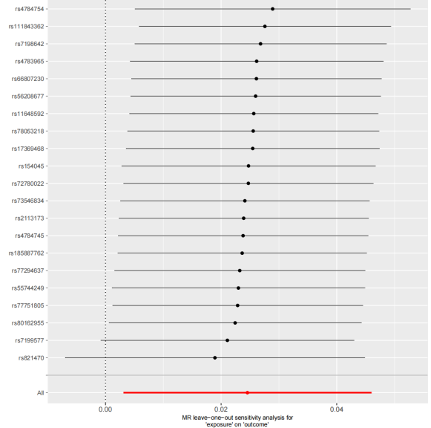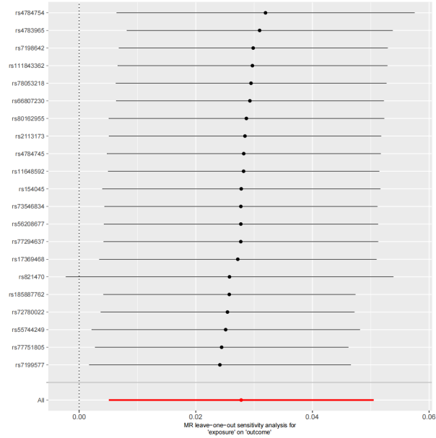
c
d

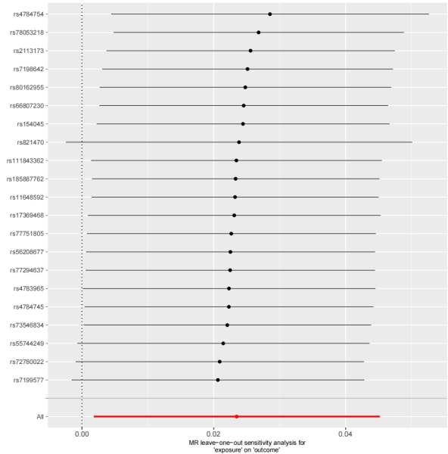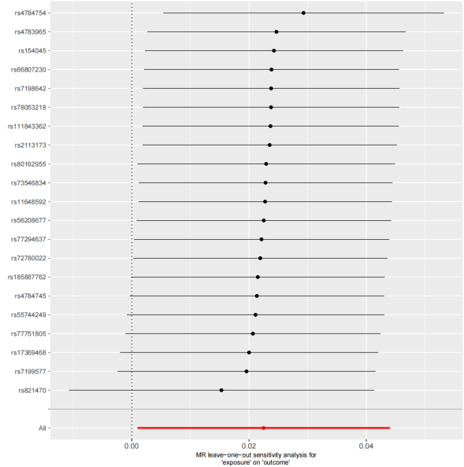
e
f

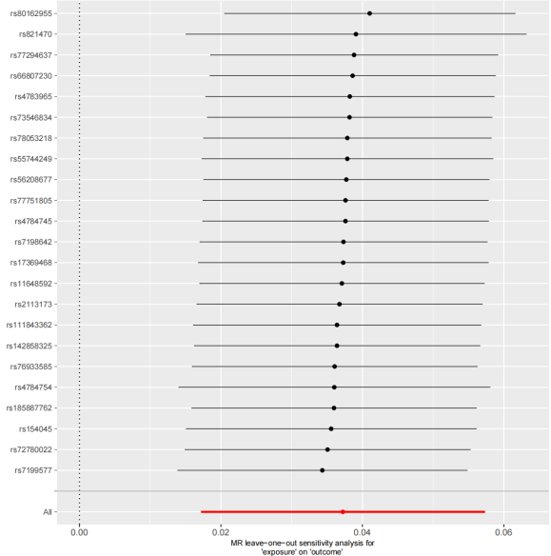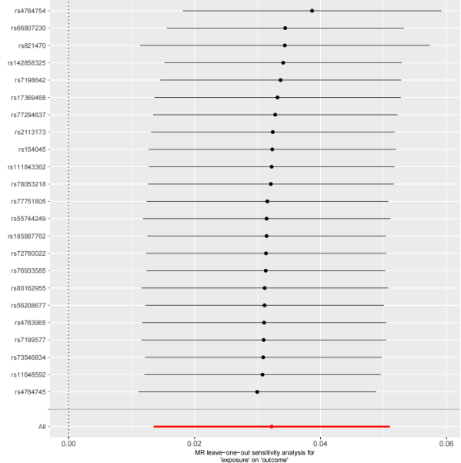

g
h
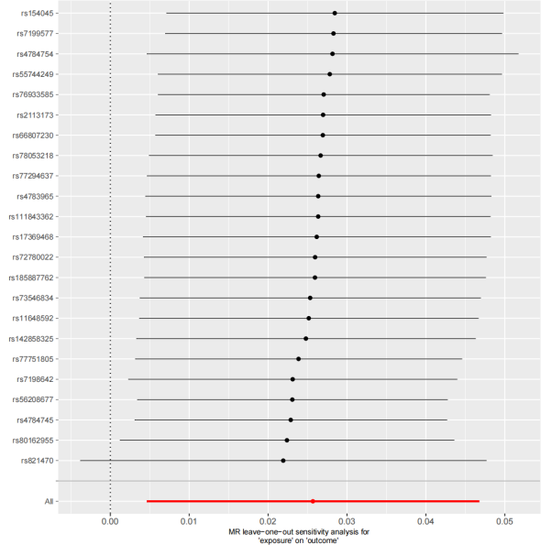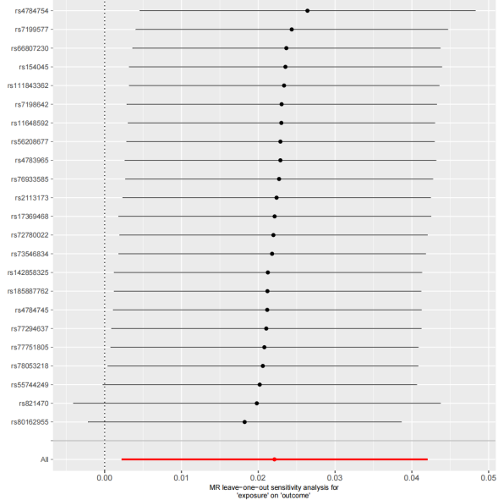
Fig S3. Leave-one-out sensitivity analyses of NLRC5 eQTL effects on pQTLs across cohorts.
(a–d) Leave-one-out analysis for the causal effects of NLRC5 eQTL on pQTLs of GABARAP, BRSK2, TNFSF12, and BCL2 in the deCODE Iceland cohort. Each panel displays the inverse-variance weighted (IVW) estimate (solid horizontal line) with 95% confidence intervals (shaded area) after iteratively excluding individual single nucleotide polymorphisms (SNPs). The vertical dashed line represents the null effect (β = 0).
(e–h) Corresponding leave-one-out analysis for NLRC5 eQTL effects on pQTLs of GABARAP, BRSK2, TNFSF12, and BCL2 in the UKB-PPP cohort.

a
b
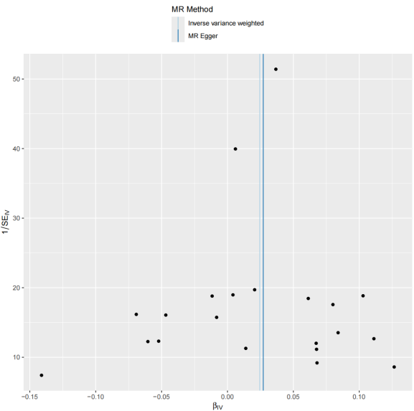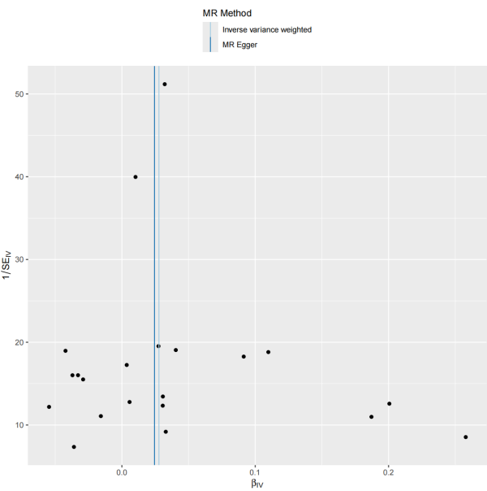
c
d

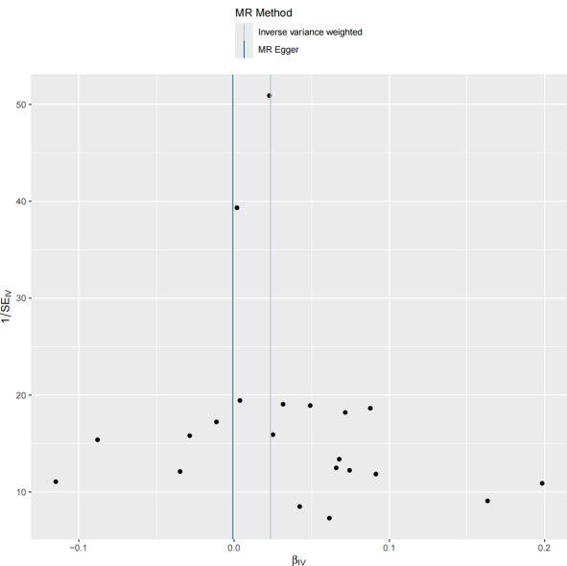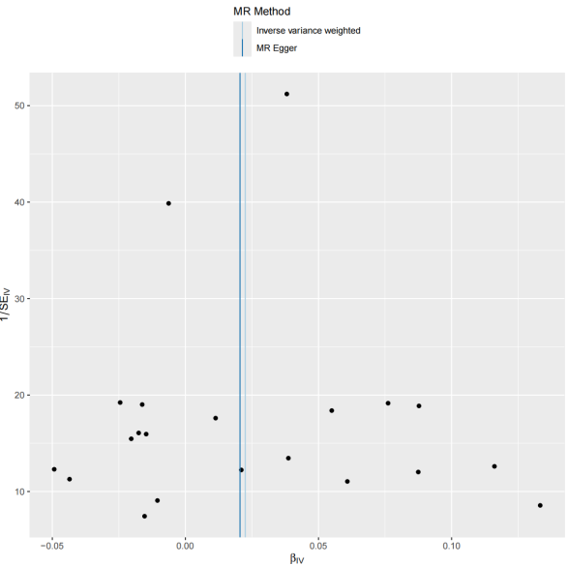
e
f

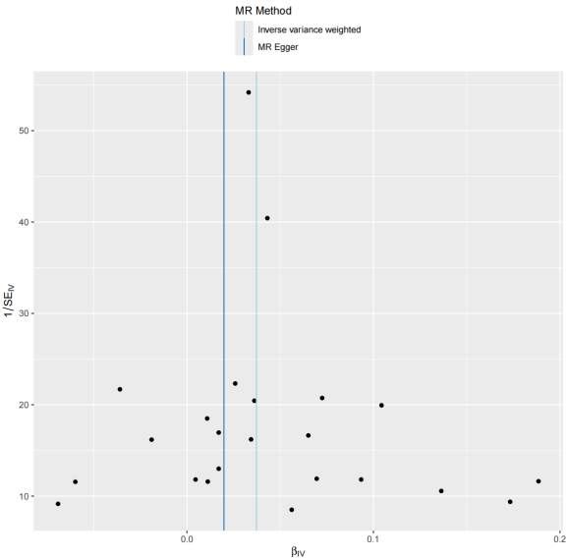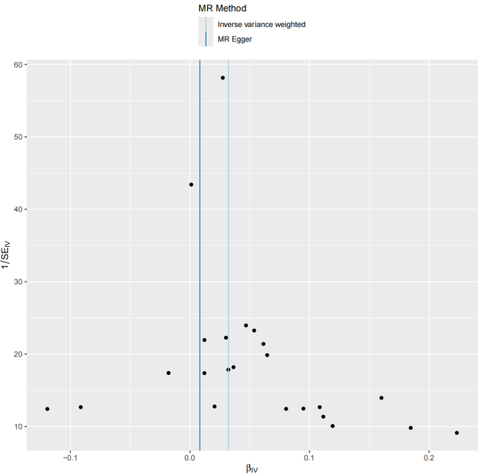

g
h
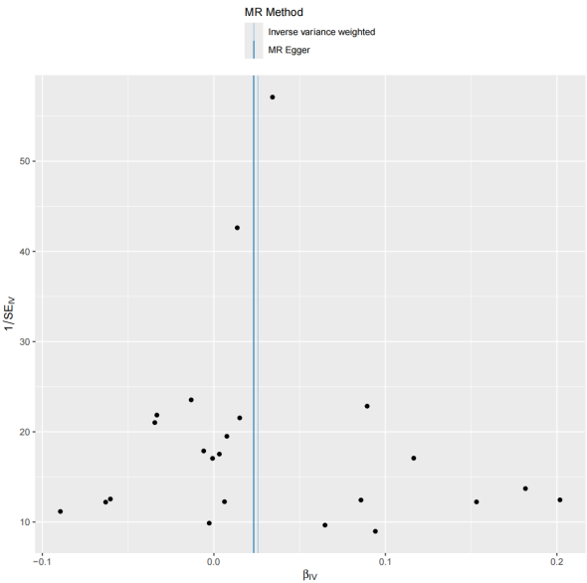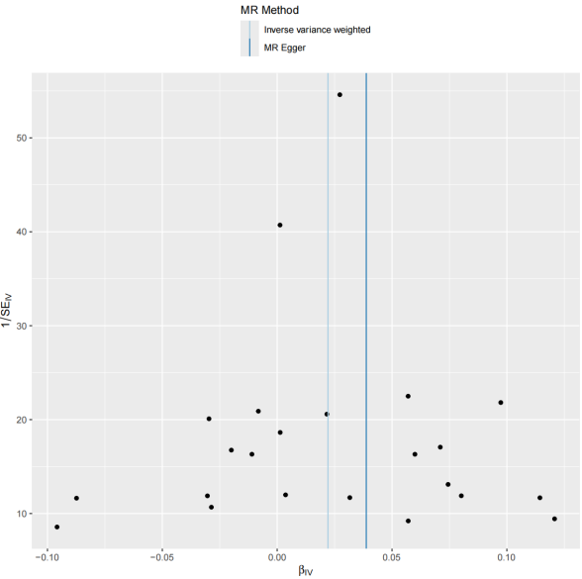
Fig S4. Funnel plots assessing directional pleiotropy of NLRC5 expression quantitative trait loci (eQTL)-associated SNPs across cohorts.
(a–d) Funnel plots of SNP-specific causal effect estimates (β) against precision (1/SE) for NLRC5 eQTL effects on GABARAP, BRSK2, TNFSF12, and BCL2 pQTLs in the deCODE Iceland cohort. Asymmetry was evaluated via MR-Egger regression intercept tests (reported in lower-left corners). The solid vertical line indicates inverse-variance weighted (IVW) pooled estimates, with dashed lines representing 95% confidence intervals.
(e–h) Corresponding funnel plots for NLRC5 eQTL effects on GABARAP, BRSK2, TNFSF12, and BCL2 pQTLs in the UK Biobank Pharma Proteomics Project (UKB-PPP).

b
a
ZBP1
68kDa
Control EAE Control EAE Control EAE

NLRC5
154kDa
Control EAE Control EAE Control EAE

d
c
Control EAE Control EAE Control EAE

Control EAE Control EAE Control EAE

caspase-8
57kDa

ASC
23kDa

f
e
Control EAE Control EAE Control EAE

Control EAE Control EAE Control EAE

RIPK3
57kDa
β-actin
42kDa

Fig S5: Original Western blot images (uncropped and unprocessed) . (a) NLRC5, (b) ZBP1, (c) caspase-8, (d) ASC, (e) RIPK3, (f) β-actin

