a
b
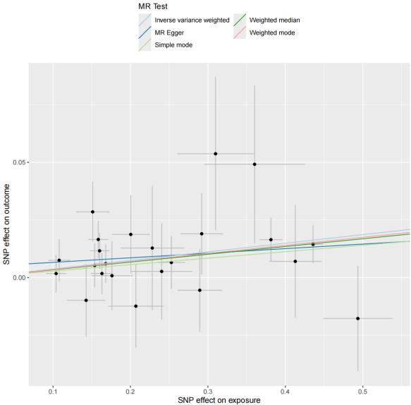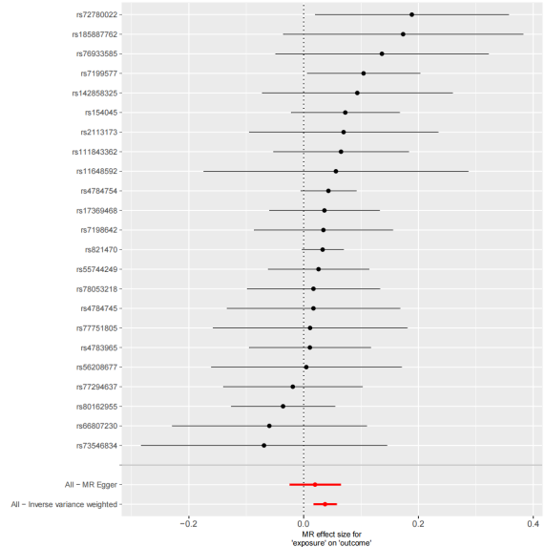
c
d

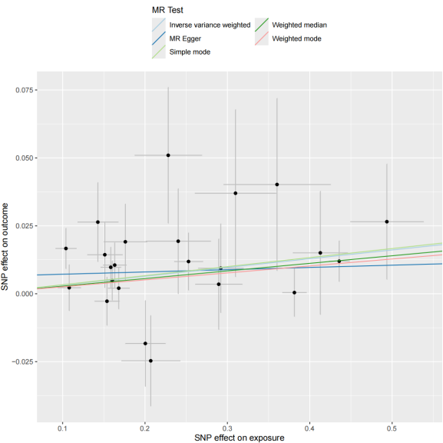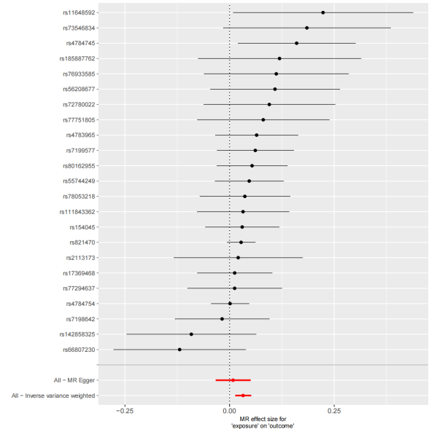
e
f
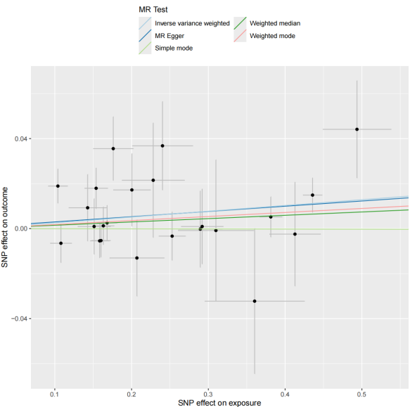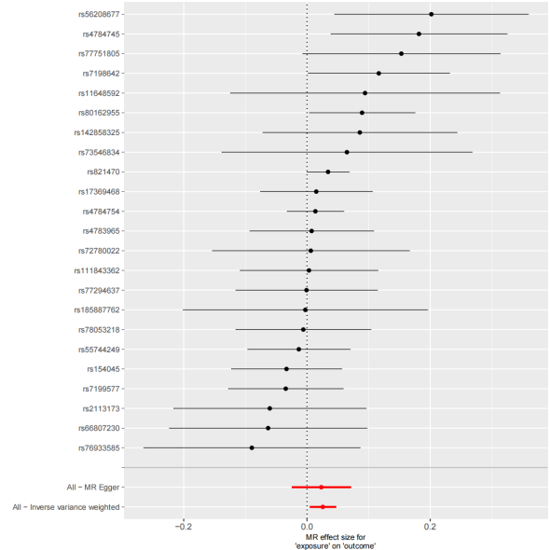

h
g
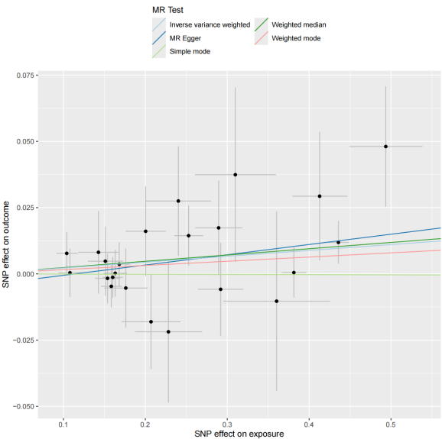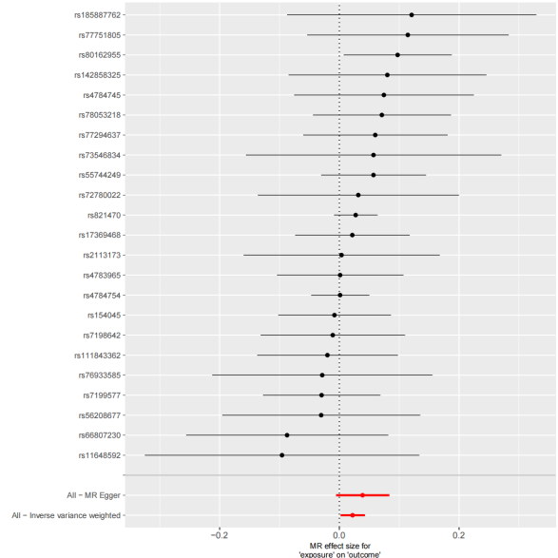
Figure S2. Mendelian randomization (MR) analysis of causal effects between NLRC5 expression quantitative trait loci (eQTL) and protein quantitative trait loci (pQTL) from UKB-PPP cohort.
(a)Scatterplot of genetic variant associations between NLRC5 eQTL (x-axis) and GABARAP pQTL (y-axis). Each point represents a single nucleotide polymorphism (SNP), with slopes of regression lines indicating causal effect estimates (β) from inverse-variance weighted (IVW), MR-Egger, and weighted median methods. Error bars denote 95% confidence intervals (CI).
(b) Forest plot of individual SNP-specific and IVW-combined MR effect sizes (β ± 95% CI) for NLRC5 eQTL on GABARAP pQTL.
(c-d) Corresponding scatterplot (c) and forest plot (d) for NLRC5 eQTL effects on BRSK2 pQTL.
(e-f) Scatterplot (e) and forest plot (f) for NLRC5 eQTL effects on TNFSF12 pQTL.
(g-h) Scatterplot (g) and forest plot (h) for NLRC5 eQTL effects on BCL2 pQTL.

