a
b
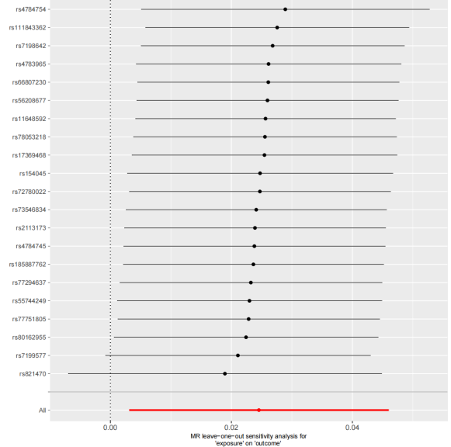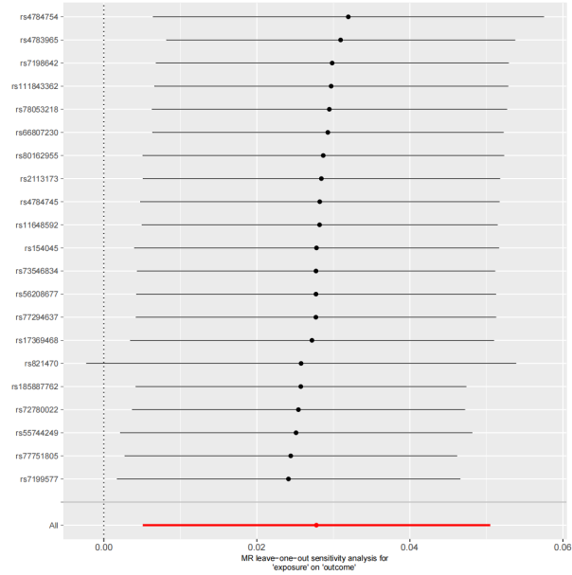
c
d

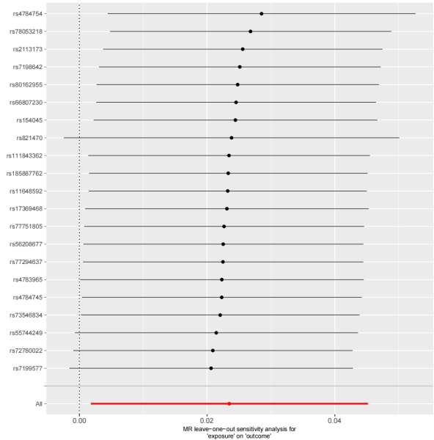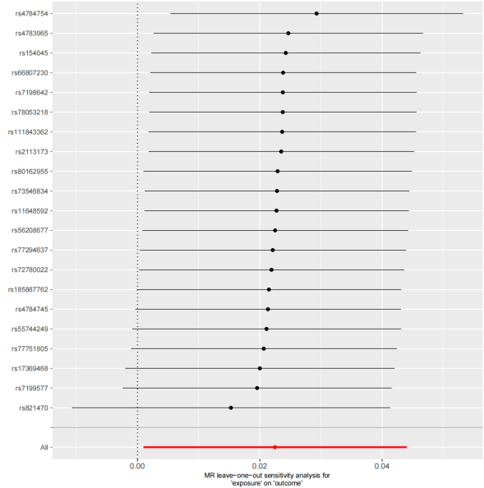
e
f

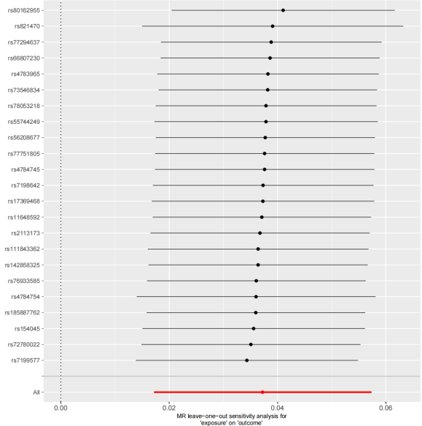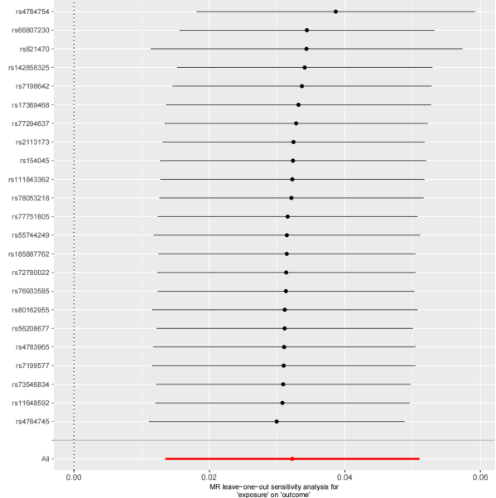

g
h
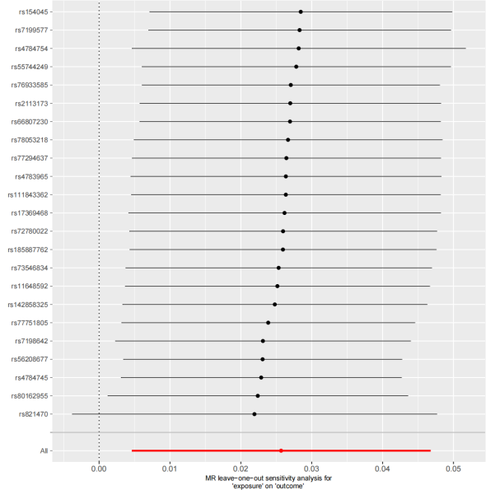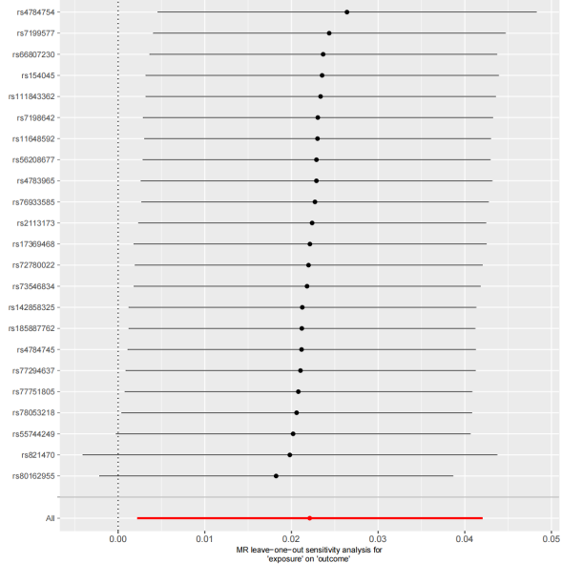
Figure S3. Leave-one-out sensitivity analyses of NLRC5 eQTL effects on pQTLs across cohorts.
(a–d) Leave-one-out analysis for the causal effects of NLRC5 eQTL on pQTLs of GABARAP, BRSK2, TNFSF12, and BCL2 in the deCODE Iceland cohort. Each panel displays the inverse-variance weighted (IVW) estimate (solid horizontal line) with 95% confidence intervals (shaded area) after iteratively excluding individual single nucleotide polymorphisms (SNPs). The vertical dashed line represents the null effect (β = 0).
(e–h) Corresponding leave-one-out analysis for NLRC5 eQTL effects on pQTLs of GABARAP, BRSK2, TNFSF12, and BCL2 in the UKB-PPP cohort.

