About the Authors

Borun Chandra is an international PhD student in Sociology at Galgotias University, India, with more than10 years of administrative experience and two years of research fieldwork. He is dynamic, disciplined, and enthusiastic about public welfare, lifelong learning, and practical application of knowledge.

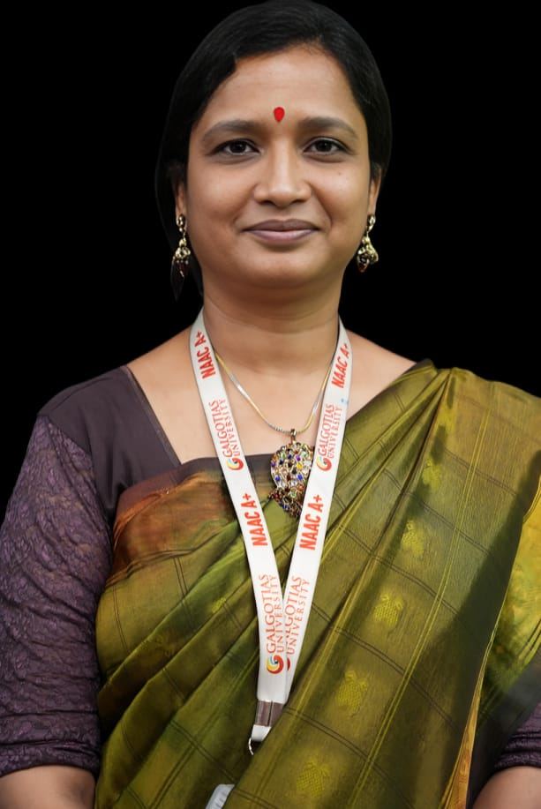

Prof. (Dr.) Anuradha Parasar is a Professor at Galgotias University School of Liberal Education. A Commonwealth Fellow with 28 years of experience, she innovates interdisciplinary education, has written 7 books, 55+ papers, and has several patents. She is a promoter of experiential learning, rural welfare, and all-round education.

