Supplementary material

Phytochemical | Observation
Flavonoids | +
Alkaloids | +
Tannins | +
Phenol | +
Glycosides | -
Terpenoid/terpene | +
Saponins | -
Proteins | -
Carbohydrates | +
Supplementary Table-1: Phytochemical analysis of plant extract

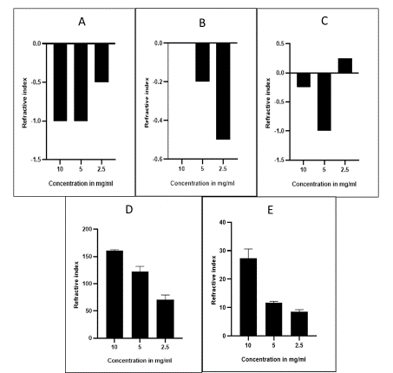
Supplementary figure- 1: Treatment of SL extract on larvae in different concentration A) Olfactory assay B) Chemosensory assay C) Phototaxis assay D) Plasticity assay E) Motor function assay

