Intestinal absorption mechanisms of five flavonoids from Malus hupehensis (Pamp.) Rehd. extracts in situ single-pass intestinal perfusion and in vitro Caco-2 cell model

Hui Yang¹, Zhishu Tang², Jiangxue Cheng¹, Jing Wang¹, Junbo Zou¹, Xiaofei Zhang¹, Yajun Shi¹, Dongyan Guo^{1,*}

¹ Shaanxi Province Key Laboratory of New Drugs and Chinese Medicine Foundation Research, College of Pharmacy, Shaanxi University of Chinese Medicine, Xianyang 712046, China
2 Shaanxi University of Chinese Medicine, Xianyang 712046, China

* Correspondence: Dongyan Guo, Tel: 02938185180 E-mail: xmc2051080@163.com
Supporting information
- Method
1.1The single-pass intestinal perfusion in situ model
1.1.1. Method validation
1.1.1.1. Preparation of standard stock solution
An appropriate amount of hyperin, quercitrin, phloridzin, quercetin, and phloretin was accurately weighed and dissolved in methanol to prepare a mixed stock solution with concentration of 231, 160, 210, 209, and 183 μg·mL⁻¹, respectively.
1.1.1.2. Linearity
0.25, 0.5, 1.0, 1.5, 2.0, 2.5 mL standard stock solutions were diluted with K-R bufferin 10 mL volumetric flasks, and these dilutions were measured by HPLC according to “2.3.4. Sample determination”. The concentration of QC samples was represented by x, and the peak area of the analyte by y. Then the standard curve was calculated, and a standard curve equation of hyperin, quercitrin, phloridzin, quercetin, and phloretin under the chromatographic conditions was derived.
1.1.1.3. Precision
QC samples with high, medium, and low concentrations of stock solution in K-R buffer were prepared and measured on three consecutive days to calculate interday precision, and six replicates of each concentration were evaluated on a single day to calculate the intraday precision. The QC sample concentration was calculated from the standard curve, and the results were analyzed for variance to obtain the precision (standard deviation of the measured QC sample value).
1.1.1.4. Specificity
The specificity of the method was assessed by comparing chromatograms of a blank intestinal perfusate buffer, standard sample and a sample of an intestinal perfusate of hupehensis (Pamp.) Rehd. extracts after perfusion, respectively. Samples were measured by HPLC.
      - Extraction recovery
Six batches of blank intestinal perfusate from independent sources were used to obtain extracted samples and post-extracted spiked samples at low, middle, and high concentration. The peak areas of the three types of samples were recorded as A and B, respectively. Extraction recovery was evaluated by A/B.
      - Stability
Stability was evaluating using three different QC samples of five analytes, which were measured at 12, 24, and 48 h, and the peak area was recorded.
1.2. Caco-2 cell model
1.2.1. Method validation
1.2.1.1. Preparation of standards
Take the appropriate amount of hyperin, quercitrin, phloridzin, quercetin, and phloretin standard to prepare stock solutions with a concentration of 1 mg·mL⁻¹. Before the experiment, 50% methanol were used to make a gradient dilution of hyperin, phloridzin, and phloretin are 8.1-880 ng·mL⁻¹, as well as quercitrin and quercetin are in the series concentration of 4.1-415 ng·mL⁻¹, which were stored at -4 ° C.
1.2.1.2. Linearity
10μL of the different concentrations of the mixed reference working solutions and bergenin (IS) were added to 190 μL of HBSS to adjust the concentrations. These solutions were measured injected into the LC-MS/MS, as described in “2.4.6. Sample determination” to determine the sample. The concentration was represented by x, and the peak area of the analyte by y. Then the standard curve was calculated, and a standard curve equation under the chromatographic conditions was derived.
1.2.1.3. Precision
Prepared quality control samples (QC) with high, medium, and low concentrations of the mixed reference in HBSS were determined on three consecutive days to calculate the interday precision and six replicates of each concentration were evaluated on a single day to calculate intraday precision. The QC sample concentration was calculated from the standard curve, and the results were analyzed for variance to obtain the precision (standard deviation of the measured QC sample value).
1.2.1.4. Specificity
The specificity of the method was assessed by comparing chromatograms of a blank HBSS buffer, HBSS containing mixed reference and 2μg·mL⁻¹ bergenin, used as an internal standard (IS) and samples of hupehensis (Pamp.) Rehd. extracts from cell culture media after 90 min incubation. Samples were measured by LC-MS/MS.
1.2.1.5. Matrix effect and extraction recovery
Six batches of blank HBSS from independent sources were used to obtain extracted samples, post-extracted spiked samples, and unextracted samples at low, middle, and high concentration. The peak areas of the three types of samples were recorded as A, B, and C, respectively. Extraction recovery was evaluated by A/B. Matrix effects were calculated by comparing the A/C of analytes.
1.2.1.6 Stability
Stability was evaluating using three different QC samples of five analytes, which were frozen at -4 ℃ for 24 h (short-term stability), frozen and thawed thrice at -20 ℃ (freeze-thaw stability), and stored at -20 ℃ one month (long-term stability).
2. Results
2.1 The single-pass intestinal perfusion in situ model
2.1.1. Method validation
2.1.1.1. Linearity
Good linearity (r² > 0.99) was achieved in a linear range for the five analytes. The regression equation for the calibration curve of five analytes. Data for the calibration curves, r², and linear range are shown in Supplementary Table 1. Calibration curves of the five analytes exhibited good linearity with regression parameters (r²) above 0.99.
2.1.1.2. Precision
The results of data for the precision of five analytes at three different concentration levels are presented in Supplementary Table 2. At each concentration level, the accuracy of five analytes ranged from 88.75% to 103.3%, intra-day precision RSD% ranged from 1.63% to 4.66%, and inter-day precision RSD% ranged from 2.51% to 7.75%. These findings indicated the high accuracy and precision of the method.
2.1.1.3. Specificity
Typical chromatograms obtained from blank intestinal perfusate buffer, blank intestinal perfusate buffer spiked with five analytes and intestinal perfusate samples from the rats after oral administration of Malus hupehensis (Pamp.) Rehd. extracts are shown in Supplementary Figure 1. No interfering endogenous substances were found at the respective retention times.
The specificity of the method was assessed by comparing chromatograms of a blank intestinal perfusate buffer, and a sample of an intestinal perfusate of hupehensis (Pamp.) Rehd. extracts after perfusion, respectively. Samples were measured by HPLC.
2.1.1.4. Extraction recovery
The data of extraction recovery for the five analytes are displayed in Supplementary Table 3. In the three QC samples of the five analytes, extraction recoveries ranged from 87.1% to 104.2% in the three different quality control samples of the five analytes.
2.1.1.5. Stability
By analyzing samples measured at 12, 24, and 48 h, all analytes were found to be stable, indicating the good stability of the Malus hupehensis (Pamp.) Rehd. Extracts were well, and the RSD% was less than 15%. The data were summarized in Supplementary Table 4.
2.2. Caco-2 cell model
2.2.1. Method validation
2.2.1.1. Linearity
Good linearity (r² > 0.99) was achieved in a linear range for the five analytes. The regression equation for the calibration curve of five analytes. Data for the linear range calibration curves, r², LLOQ, and LLOD and linear range are shown in Supplementary Table 5. Calibration curves of the five analytes exhibited good linearity with regression parameters (r²) above 0.99.
2.2.1.2. Precision
The results of data for the precision of five analytes at three different concentration levels are presented in Supplementary Table 6. At each concentration level, the accuracy of five analytes ranged from 85.7% to 104.3%, intra-day precision RSD% ranged from 1.6% to 7.7%, and inter-day precision RSD% ranged from 2.0% to 9.7%. These findings indicated the high accuracy and precision of the method.
2.2.1.3. Specificity
The specificity results were shown in the Supplementary Fig.2, indicating that the HBSS buffer had no effect on the measurement of five analytes.

2.2.1.4. Matrix effect and extraction recovery
The data of extraction recovery and matrix effect for the five analytes are displayed in Supplementary Table 7. In the three QC samples of the five analytes, extraction recovery ranged from 76.3% to 94.1% and matrix effects ranged from 79.9% to 103.4% in the three different quality control samples of the five analytes, indicating that the method was accurate.
2.2.1.5. Stability
By analyzing the samples stored at 4 ℃ for 24 h, -20 ℃ for one month, and three freeze-thaw cycles, all analytes were found to be stable, indicating the good stability of the Malus hupehensis (Pamp.) Rehd. extracts were well, and the data were summarized in Supplementary Table 1.

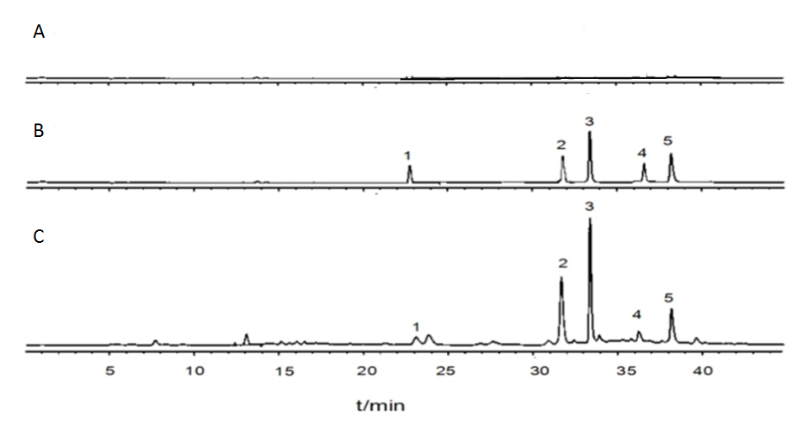
Supplementary Figure 1. Chromatograms of five analytes in K-R buffer solution.
A. Blank intestinal perfusate. B. Standard samples C. Intestinal perfusate of hupehensis (Pamp.) Rehd. extracts.

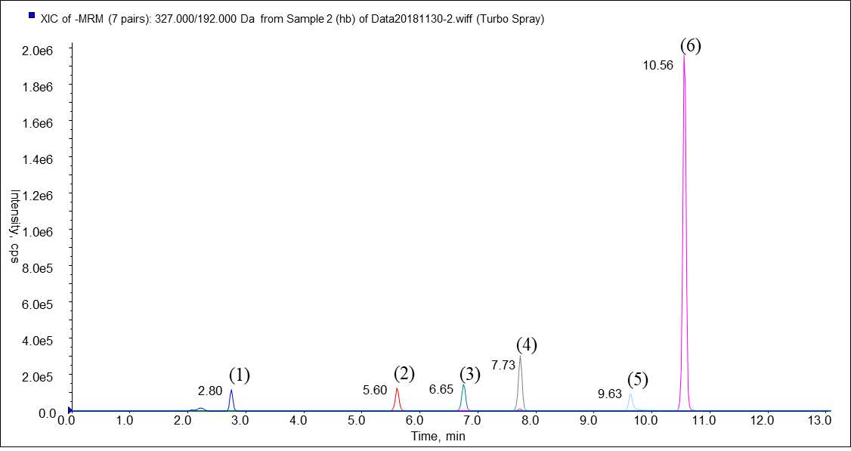
B
A

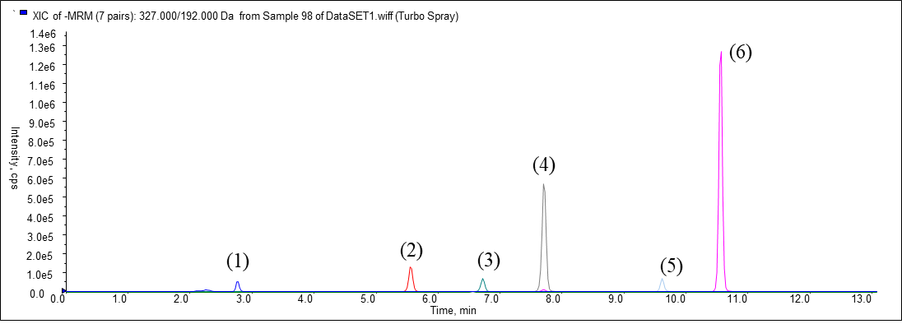
C
Supplementary Figure 2. Chromatograms of five analytes and the internal standard in the Caco-2 Cell culture solution. for UPLC-MS / MS.
- Blank Caco-2 Cell incubation HBSS B. Blank HBSS plus mixed control C. 90 min after
administration.
- Bergenin, (2) Hyperin, (3) Quercitrin, (4) Phloridzin, (5) Quercetin (6) Phloretin

Supplementary Table 1 Calibration curves, linear range, and r² of the five analytes.
Analytes | Calibration curves | r² | Linear range (μg·mL⁻¹)
hyperin | Y = 4.094X－1.058 | 0.9994 | 5.775～57.75
quercitrin | Y = 2.413X－14.11 | 0.9995 | 4.000～40.00
phloridzin | Y =15.74X－15.40 | 0.9998 | 5.251～52.52
quercetin | Y =12.66X + 24.73 | 0.9995 | 5.251～52.52
phloretin | Y =7.062X + 32.09 | 0.9992 | 4.575～45.75

Supplementary Table 2 Intra-day and inter-day precision for the four analytes. Data are expressed as mean ± SD (n=6).
Analytes | Concentration  (μg·mL⁻¹) | Accuracy (%) | Precision (%)
Analytes | Concentration  (μg·mL⁻¹) | Accuracy (%) | Intra-day | Inter-day
 | 10.11 | 94.1±3.21 | 4.53 | 2.51
hyperin | 20.22 | 93.0±2.01 | 2.32 | 6.63
 | 40.44 | 98.2±3.08 | 2.13 | 4.52
 | 8.08 | 102.4±1.77 | 3.95 | 5.75
quercitrin | 16.16 | 91.8±1.56 | 4.66 | 3.12
 | 32.32 | 99.2±1.29 | 1.97 | 2.92
 | 10.05 | 92.0±1.39 | 3.72 | 2.81
phloridzin | 20.10 | 94.5±1.05 | 2.80 | 3.60
 | 40.20 | 96.2±2.45 | 3.33 | 3.79
 | 10.02 | 96.5±3.01 | 3.41 | 4.48
quercetin | 20.04 | 92.7±2.73 | 3.62 | 5.23
 | 40.08 | 94.5±2.80 | 1.63 | 2.84
 | 10.05 | 90.7±2.18 | 2.62 | 3.01
phloretin | 20.10 | 88.7±3.40 | 1.96 | 4.32
 | 40.20 | 103.3±2.64 | 2.22 | 7.75

Supplementary Table 3 Extraction recovery for the five analytes. Data are expressed as mean ± SD (n=6).
Analytes | Concentration  (μg·mL⁻¹) | Extraction recovery (%) | RSD (%)
 | 10.11 | 89.2±1.44 | 1.61
hyperin | 20.22 | 87.1±1.99 | 2.28
 | 40.44 | 85.9±1.48 | 1.72
 | 8.08 | 87.1±2.87 | 3.30
quercitrin | 16.16 | 104.2±2.66 | 2.55
 | 32.32 | 94.2±1.19 | 1.26
 | 10.05 | 95.2±2.28 | 2.39
phloridzin | 20.10 | 96.2±3.17 | 3.30
 | 40.20 | 92.1±1.66 | 1.80
 | 10.02 | 105.7±0.99 | 0.94
quercetin | 20.04 | 101.8±3.02 | 2.97
 | 40.08 | 88.7±4.81 | 5.42
 | 10.05 | 95.4±1.28 | 1.34
phloretin | 20.10 | 92.4±4.82 | 5.21
 | 40.20 | 101.4±7.1 | 7.00

Supplementary Table 4 Stability of all five analytes at 12, 24, and 48 h. Data are expressed as mean ± SD (n=6).
Analytes | Concentration  (μg·mL⁻¹) |  | 12h（RSD%） | 24h（RSD%） | 48h（RSD%）
 | 10.11 | 2.21 |  | 4.44 |  | 3.77
hyperin | 20.22 | 3.44 |  | 3.09 |  | 3.09
 | 40.44 | 4.01 |  | 2.89 |  | 4.10
 | 8.08 | 1.99 |  | 2.76 |  | 2.98
quercitrin | 16.16 | 0.85 |  | 2.80 |  | 2.77
 | 32.32 | 1.62 |  | 2.75 |  | 2.12
 | 10.05 | 1.27 |  | 1.27 |  | 3.20
phloridzin | 20.10 | 2.08 |  | 2.08 |  | 2.10
 | 40.20 | 3.36 |  | 3.30 |  | 2.59
 | 10.02 | 3.72 |  | 1.28 |  | 2.45
quercetin | 20.04 | 3.41 |  | 1.26 |  | 2.65
 | 40.08 | 4.66 |  | 1.36 |  | 3.02
 | 10.05 | 1.97 |  | 1.26 |  | 3.06
phloretin | 20.10 | 3.72 |  | 1.30 |  | 3.09
 | 40.20 | 2.28 |  | 4.44 |  | 2.89

Supplementary Table 5 Calibration curves, linear range, r2, LLOQ, and LLOD of the five analytes.
Analytes | Linear range  (ng·mL⁻¹) | Calibration curves | r² | LLOQ  (ng·mL⁻¹) | LLOD  (ng·mL⁻¹)
hyperin | 8.1-880 | Y = 1.20e⁶X - 10254 | 0.9982 | 1.6 | 0.2
quercitrin | 4.1-415 | Y = 4.01e⁶X - 9309.6 | 0.9995 | 6.4 | 0.8
phloridzin | 8.1-880 | Y = 3.88e⁶X +22373 | 0.9992 | 0.8 | 0.1
quercetin | 4.1-415 | Y = 3.36e⁶X - 19224 | 0.9995 | 2.1 | 0.4
phloretin | 8.1-880 | Y = 1.23e⁷X + 26593 | 0.9981 | 3.3 | 0.1

Supplementary Table 6 Intra-day and inter-day precision for the five analytes. Data are expressed as mean ± SD (n=6).
Analytes | Concentration  (ng·mL⁻¹) | Accuracy (%) | Precision (%)
Analytes | Concentration  (ng·mL⁻¹) | Accuracy (%) | Intra-day | Inter-day
 | 1000 | 89.7±3.3 | 7.5 | 4.2
hyperin | 100 | 98.2±2.8 | 4.3 | 8.7
 | 1 | 104.3±1.0 | 6.8 | 9.6
 | 500 | 93.4±2.4 | 1.9 | 6.7
quercitrin | 50 | 92.5±2.6 | 2.2 | 8.3
 | 5 | 97.1±0.8 | 5.7 | 4.9
 | 1500 | 96.1±3.7 | 7.7 | 9.3
phloridzin | 150 | 85.7±1.9 | 4.2 | 3.1
 | 15 | 91.1±1.4 | 3.5 | 8.8
 | 800 | 93.5±1.3 | 3.4 | 7.7
quercetin | 80 | 92.7±1.6 | 3.6 | 8.6
 | 8 | 95.4±2.3 | 1.6 | 3.0
 | 700 | 90.7±2.6 | 4.8 | 2.0
phloretin | 70 | 93.2±2.8 | 1.9 | 4.3
 | 7 | 99.1±1.5 | 2.2 | 9.7

Supplementary Table 7 Extraction recovery and matrix effect for the five analytes. Data are expressed as mean ± SD (n=6).
Analytes | Concentration  (ng·mL⁻¹) | Matrix Effect  (%) | RSD% | Extraction recovery (%) | RSD%
hyperin | 1000 | 95.7±2.6 | 2.7 | 90.1±5.6 | 8.8
hyperin | 100 | 103.4±3.5 | 3.4 | 79.4±4.6 | 7.3
hyperin | 1 | 88.9±2.5 | 2.8 | 81.1±9.7 | 4.4
quercitrin | 500 | 90.0±6.8 | 7.6 | 94.1±4.5 | 6.5
quercitrin | 50 | 95.7±4.1 | 4.8 | 92.1±6.8 | 2.3
quercitrin | 5 | 90.4±2.6 | 2.9 | 87.3±1.7 | 8.4
phloridzin | 1500 | 89.3±1.8 | 2.0 | 87.5±3.1 | 4.2
phloridzin | 150 | 86.3±3.2 | 3.7 | 87.6±4.6 | 3.3
phloridzin | 15 | 90.0±4.4 | 4.9 | 79.3±4.1 | 8.8
quercetin | 800 | 85.6±1.9 | 2.2 | 76.3±5.7 | 9.7
quercetin | 80 | 86.4±3.4 | 3.9 | 80.3±5.6 | 8.8
quercetin | 8 | 79.9±5.1 | 6.4 | 84.5±3.4 | 5.7
phloretin | 700 | 85.4±3.4 | 4.0 | 80.8±3.3 | 2.8
phloretin | 70 | 84.7±6.5 | 7.7 | 93.1±7.7 | 3.4
phloretin | 7 | 90.2±4.7 | 5.2 | 86.4±4.8 | 7.7

Supplementary Table 8 Stability of all five analytes under various condition. Data are expressed as mean ± SD (n=6).
Analytes | Concentration(ng·mL⁻¹) | 4 ℃ for 24h | Storage at -20 ℃ for a month | Three freeze-thraw cycles
 | 1000 | 95.3±5.3 | 90.1±2.5 | 96.2±4.3
hyperin | 100 | 86.5±4.5 | 88.1±8.1 | 88.3±4.3
 | 1 | 77.5±10.4 | 82.3±3.9 | 84.4±6.6
 | 500 | 92.4±7.4 | 107.4±6.7 | 88.8±6.3
quercitrin | 50 | 90.8±6.9 | 102.4±3.9 | 90.4±8.5
 | 5 | 87.1±3.9 | 96.4±8.5 | 90.8±4.7
 | 1500 | 85.2±8.1 | 85.6±4.1 | 91.2±6.9
phloridzin | 150 | 86.2±4.5 | 83.0±5.6 | 92.2±2.9
 | 15 | 103.1±3.9 | 79.8±3.9 | 85.4±5.0
 | 800 | 89.3±4.1 | 104.8±12.1 | 83.7±4.6
quercetin | 80 | 93.8±7.8 | 94.6±3.7 | 89.2±3.9
 | 8 | 79.1±4.3 | 84.5±3.4 | 89.5±4.8
 | 700 | 95.7±6.7 | 86.4±5.8 | 94.5±3.5
phloretin | 70 | 90.2±8.5 | 94.3±7.6 | 95.6±4.0
 | 7 | 93.1±5.6 | 91.6±5.1 | 105.2±7.7

