Supplementary Material
Supplementary Figure 1
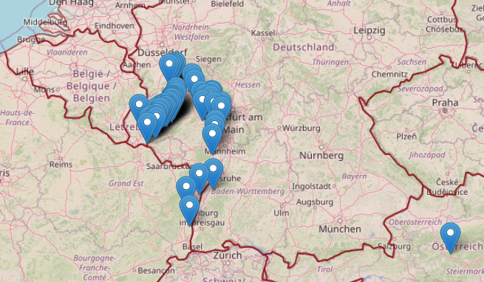
Supp. Fig. S1 Sampling locations for the Riesling clonal population (as an example). Each blue pin marks a unique location of origin for one or several clones. The Riesling clones originate predominately from Germany but also Austria, France and Luxembourg.

Supplementary Figure 2
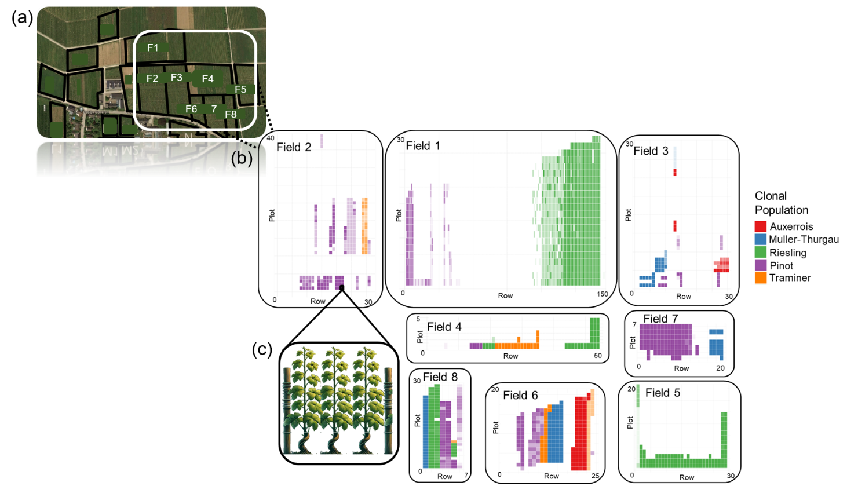
Supp. Fig. S2 Overview of the experimental site and sampling structure. (a) Aerial photograph indicating the location and orientation of the experimental fields. (b) Detailed plot maps for representative fields, illustrating the distribution of clonal populations (indicated by colour). The density of the plot colour reflects sampling frequency, with lighter colours representing plots sampled less often. (c) Schematic showing a single experimental plot containing three vines.
Supplementary Figure 3
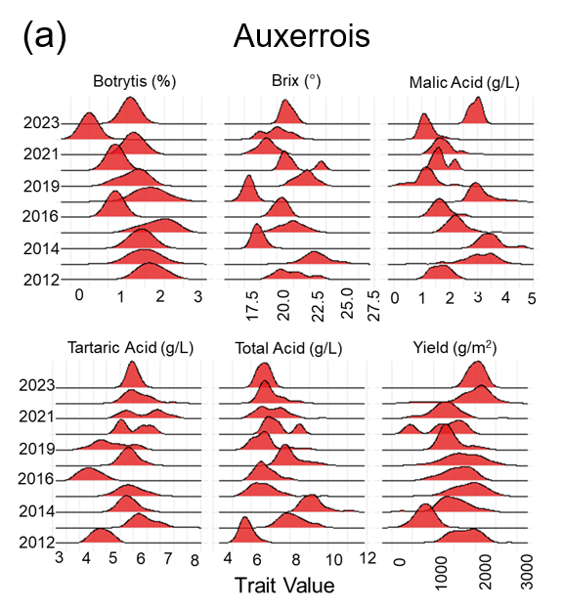
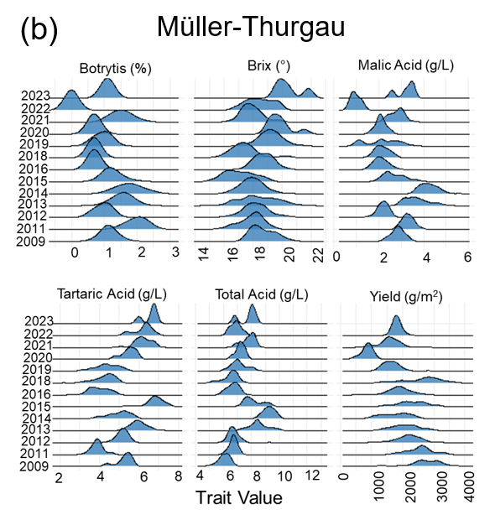

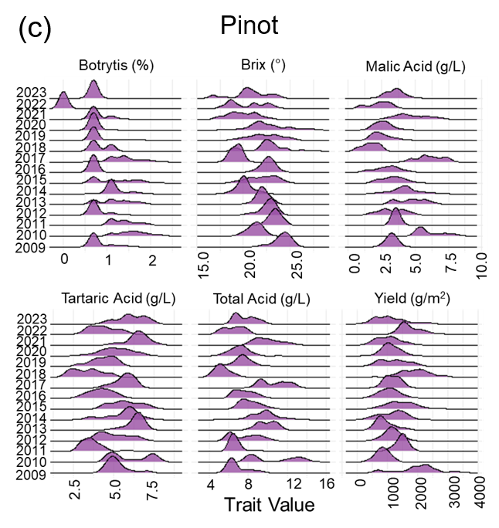
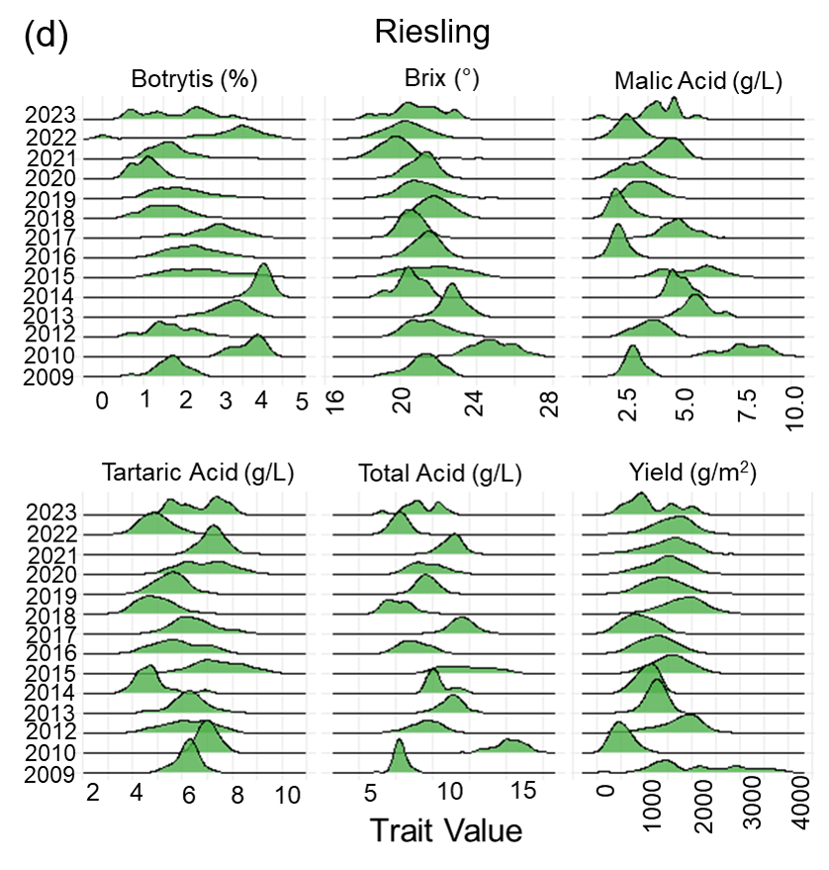

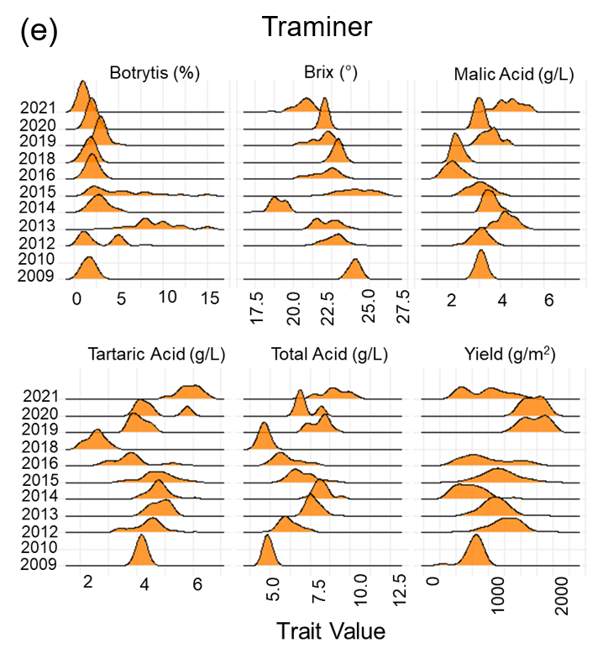

Supp. Fig. S3 Yearly distributions of key trait values for five clonal populations. Panels show data for (a) Auxerrois, (b) Muller Thurgau, (c) Pinot, (d) Riesling, and (e) Traminer. Within each panel, density plots illustrate the distribution of scaled Botrytis susceptibility (%), Brix (°), Malic acid (g/L), Tartaric Acid (g/L), Total Acid (g/L) and Yield (g/m²) (columns, left to right, top to bottom) for each year of the study (indicated by row numbers). The height and shape of each curve represent the density distribution of observations within that year.
Supp. Mat. S4. Final model fit ASReml-r script
asreml(Trait ~ 1,
random= ~CloneID + Year + Field + diag(Year):(Field),
residual= ~diag(Year):PlotID,
data= data.df, na.action = na.method(x = "include"))

