Table 1: Patient characteristics of repeated bevacizumab responders
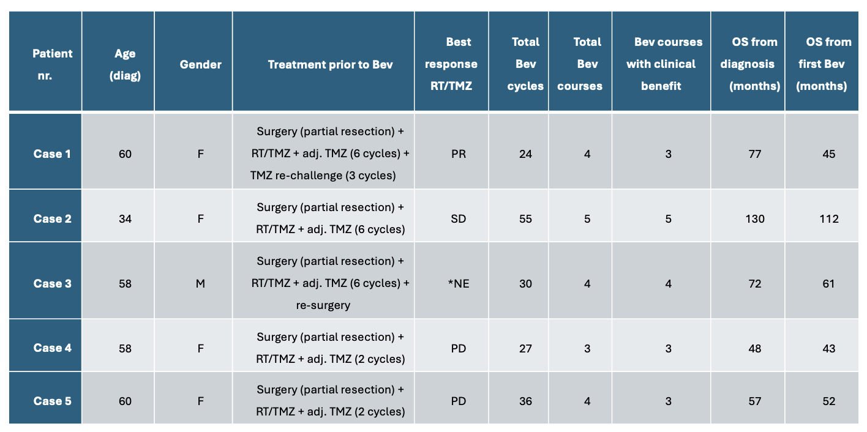
*NE = not evaluable according to RANO response assessment criteria. Abbreviations: Bev, bevacizumab; RT, radiotherapy; TMZ, temozolomide; OS, overall survival; PR, partial response; SD, Stable disease; PD, progressive disease.

Table 2: Pathology data on repeated bevacizumab responders
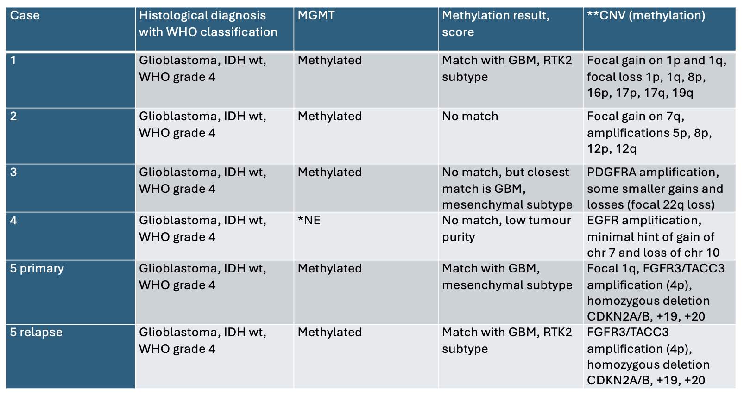
*NE = not evaluable due to low tumour purity
**CNV = copy number variations

