Supplementary material

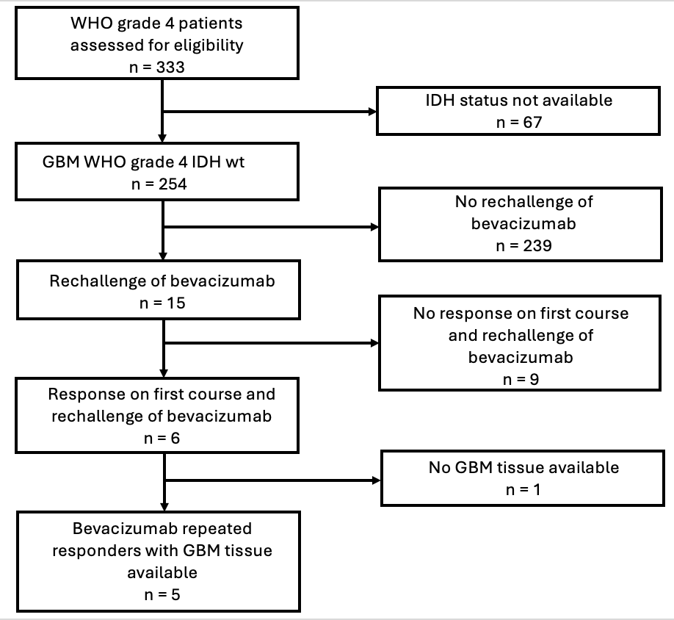
Supplementary figure S1: REMARK diagram

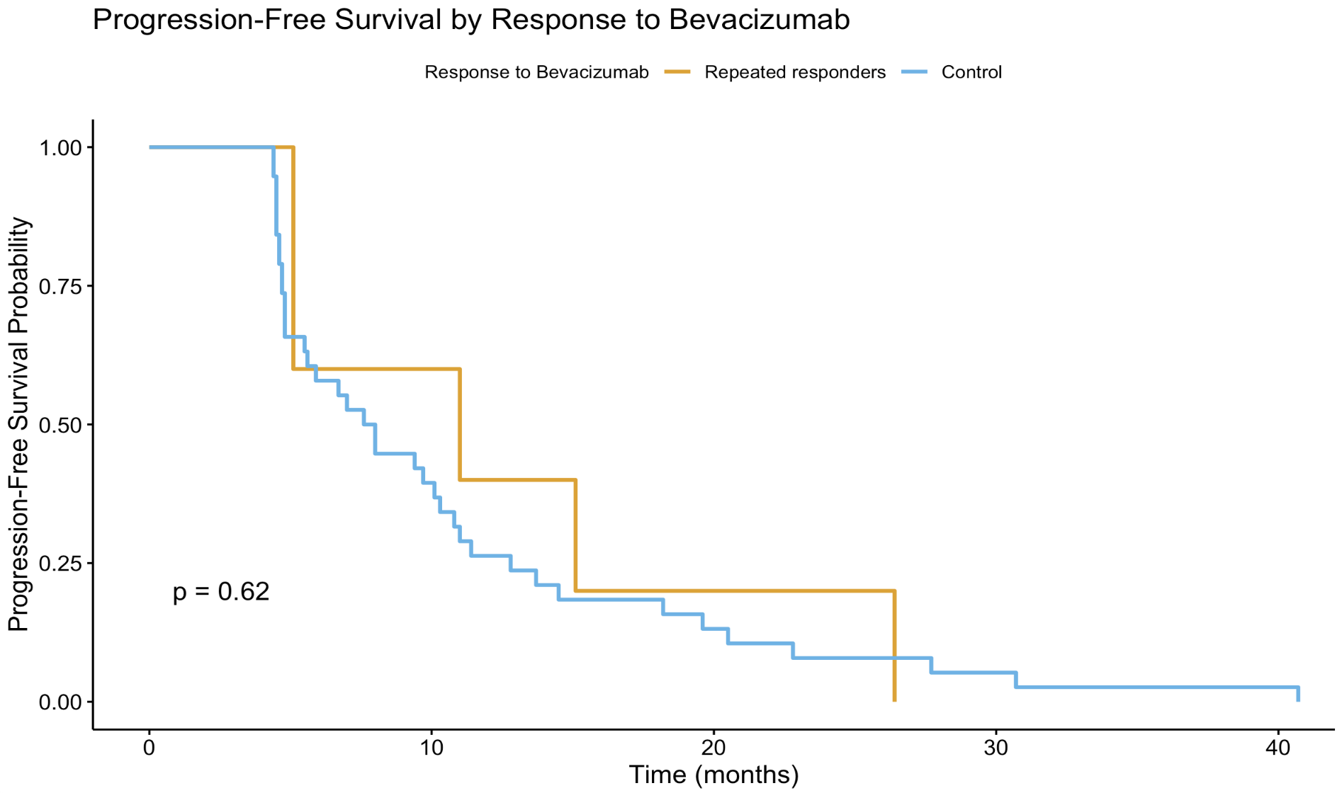
Supplementary figure S2: Kaplan-Meier curves of progression free survival between diagnosis and 1st relapse in repeated responders (orange) and control samples (light blue).

