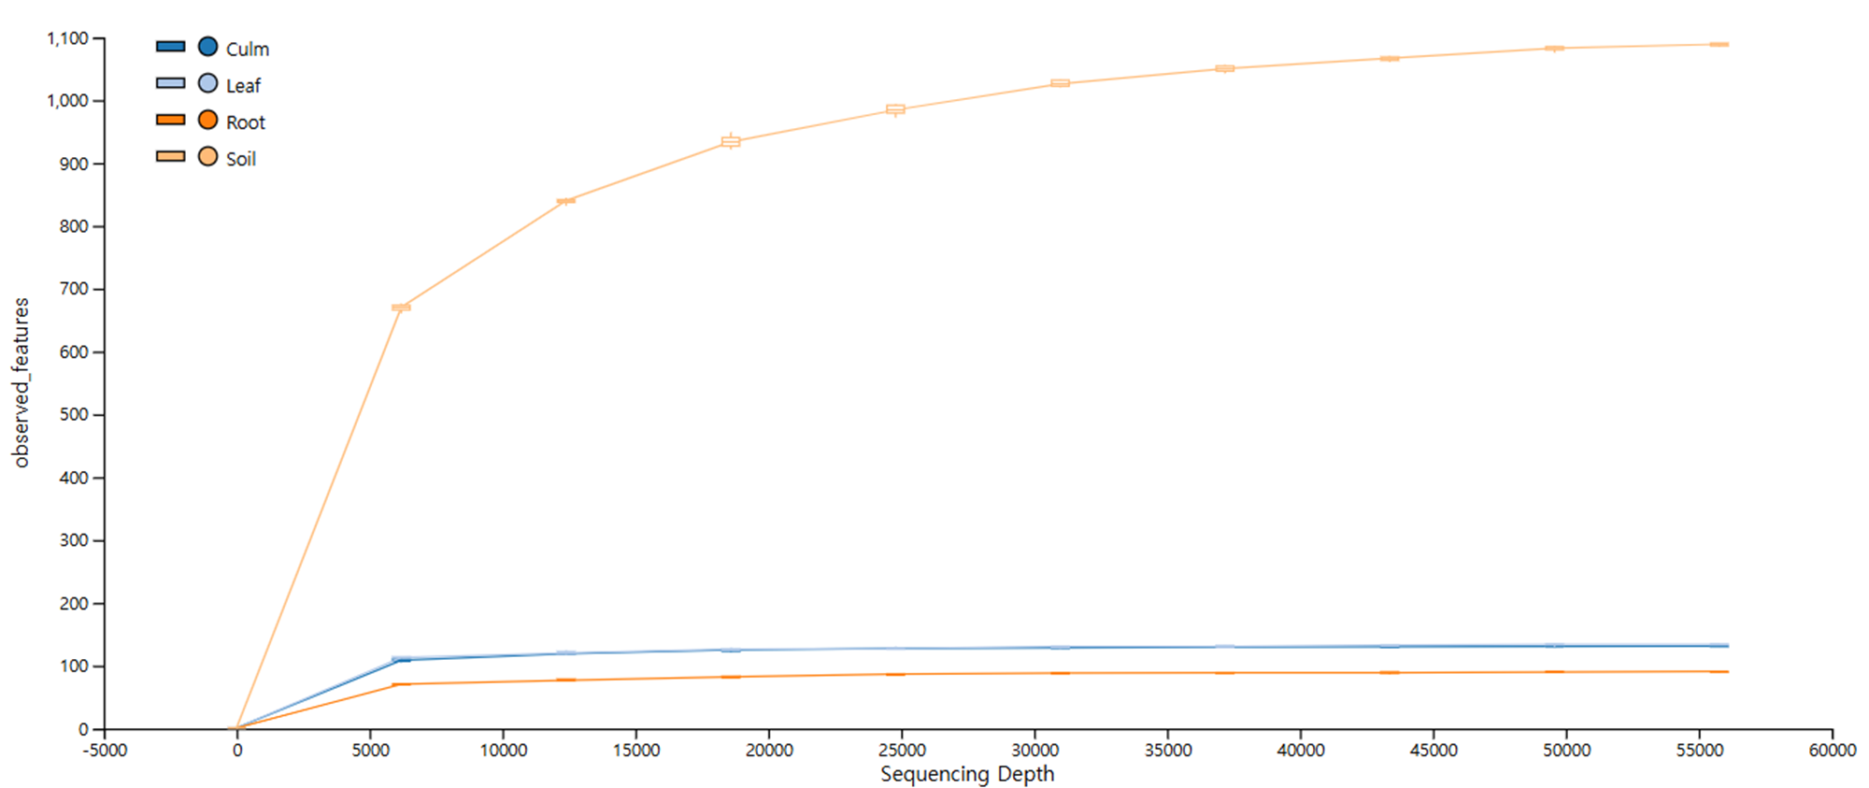
Fig. S1. Rarefaction curves of the fungal community at different compartment in bamboo forest.

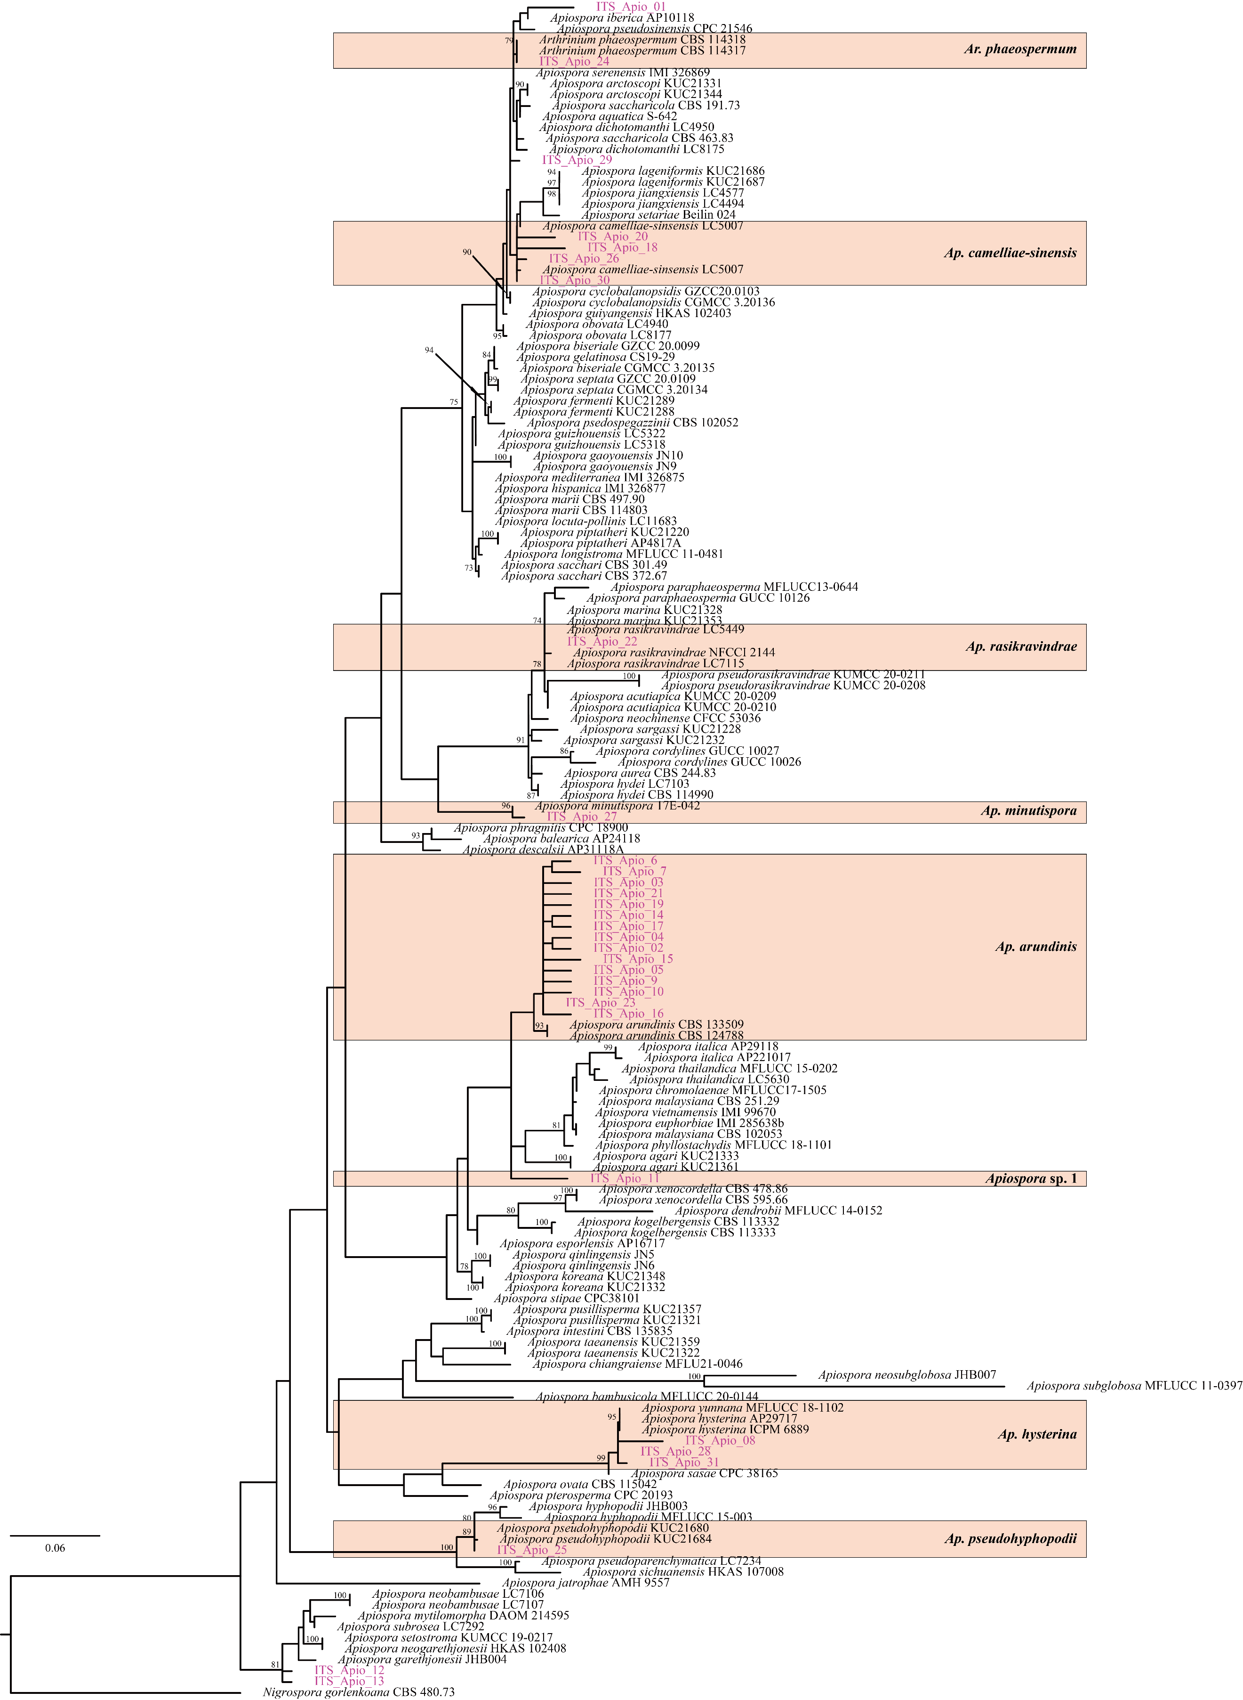
Fig. S2. Phylogenetic analysis of bambusicolous endophytic Apiospora. ML tree based on ITS datasets. The node numbers indicate the ML bootstrap support (BS) > 70%. Apiospora candidates examined in this study are shown in purple color. The boxes indicate the identified Apiospora species at the species level.

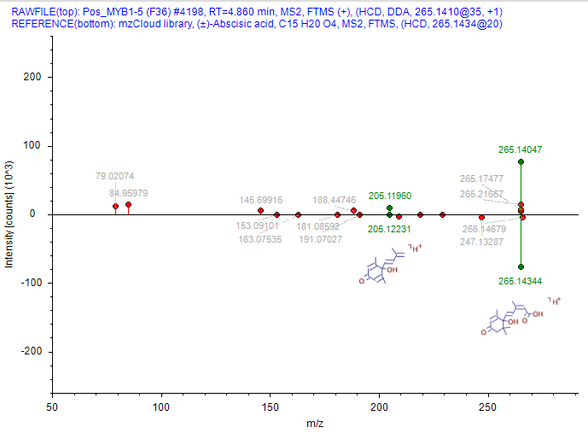
Fig. S3. The MS/MS spectral matching of the experimental spectrum and ABA standard spectrum in mzCloud library.

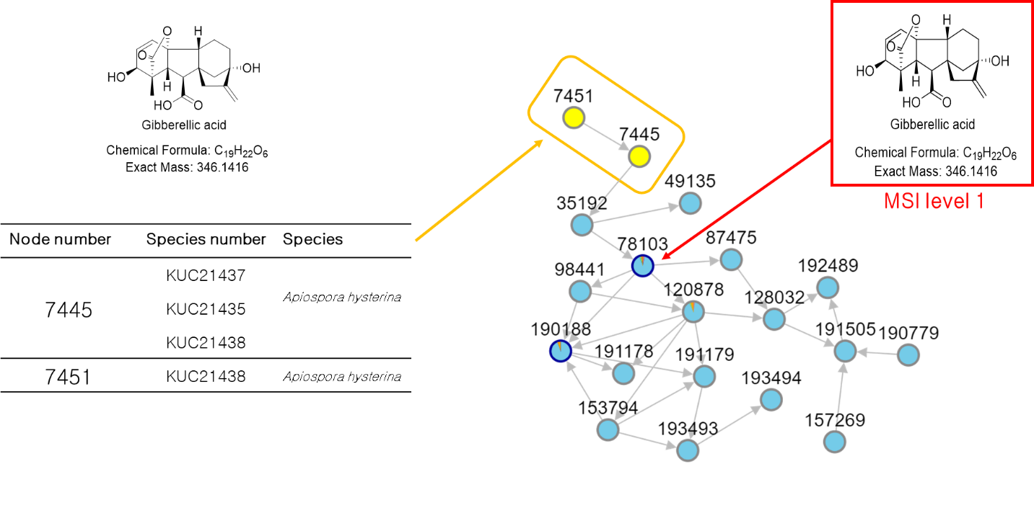
Fig. S4. Molecular networking of EtOAc extracts of Apiospora spp. culture medium.

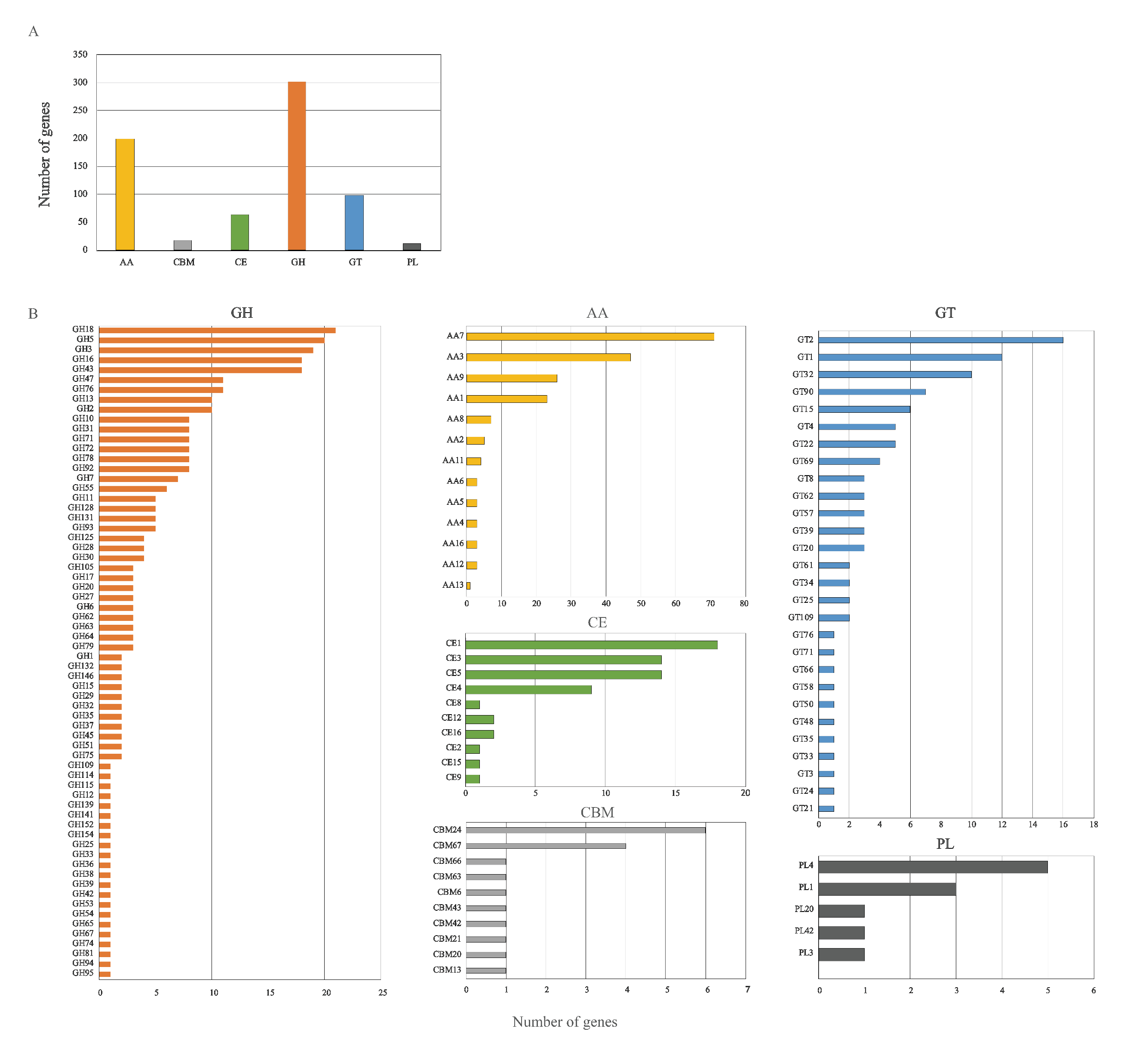
Fig. S5. Distribution of Carbohydrate-active enzyme (CAZyme). A Gene numbers of CAZyme classes: auxiliary activity (AA), carbohydrate-binding modules (CBM), carbohydrate esterase (CE), glycoside hydrolase (GH), glycosyl transferase (GT), and polysaccharide lyase activity (PL); B Gene numbers of CAZymes families according to CAZyme classes.

Fig. S6. The number of Biosynthetic Gene Clusters (BGCs) of Ap. hysterina KUC21437.

