Manas Ranjan Dash^{a,1} Naga Venkateswara Rao Nulakani^{b,c,1} and Mohamad Akbar Ali*^{b,c}
ªDepartment of Chemistry, School of Physical Sciences, DIT University, Uttarakhand 248009, India
^{b}Department of Chemistry, Khalifa University of Science and Technology, Abu Dhabi, United Arab Emirates
^{c}Center for Catalysis and Separation, Khalifa University of Science and Technology, P.O. Box 127788, Abu Dhabi, UAE.
¹Equal contribution
*Corresponding author e-mail: akbar.mohamad@ku.ac.ae
Table of Contents
Table S1: Comparison of each species enthalpies (in kcal mol⁻¹) for CH2OO + CH2NH reaction with its isoelectronic analogous reactions.……………………………………………………….Page 2

Table S2: Cartesian coordinates of reactants, complexes, intermediates, products and transition states using M06-2X/6-311++G(3df,3pd) level ……………………………………………………….Page 3-15

Figure S1: Zero-point corrected potential energy surface for the water assisted CH₂OO + CH₂CH₂ reaction obtained using CCSD(T)/6-311++G (3df,3pd)//M06-2X/6-311++G(3df,3pd) level.………………………………………………………………………………….. Page 16

Figure S2. Structural and geometrical changes for the water-assisted CH₂O + CH₂CH₂ reaction calculated using M06-2X/6–311++G (3df,3pd).……………………………..Page 16

Figure S3. Dynamic trajectories and varying bond lengths for the cyclic ozonide (SOZ) formation from CH₂OO and CH₂O reaction at the air-water interface..………………………………………………………………………………Page 17

Methodology

The <Ŝ²> eigenvalues were monitored to evaluate the spin contamination for the wave function of the open-shell radicals. The T1-diagnostic values obtained at the CCSD(T)/6-311++G(3df, 3pd) level of theory were analyzed to validate the single-reference method and were found to be within the acceptable range (i.e., ≤ 0.02) for all important species (Lee and Taylor, 1989) Overall, the combination of CCSD(T)//M06-2X functional has been employed in numerous research studies, providing a reasonably accurate description of the thermochemistry and chemical kinetics of many atmospheric reactions (Ali, 2020; Ali et al., 2022, 2019; Ali & Balaganesh, 2023; Ali and Muthiah, 2022; Dash et al., 2024; Dash and Ali, 2023a, 2023b; Dash and Mishra, 2022; Pandit and Dash, 2024).

2.2. Chemical Kinetics Analysis
For pressure-dependent kinetics, Rice–Ramsperger–Kassel–Marcus (RRKM)/master equation (ME) was used, and the energy-dependent specific unimolecular rate constants k(E) is given by Eq. (1)
$k\left(E\right)=\frac{L^{≠}}{h}\frac{G^{≠}(E-E_{0})}{ρ(E)}$ (1)
where L≠ is the reaction path degeneracy, h is Planck's constant, $ρ$(E) is the density of states of the reactant molecule; $G^{≠}\left(E-E_{0 }\right)$is the sum-of-states of the transition state, and E₀ is the reaction critical energy, which depends on angular momentum. The sums and densities of states were computed using the DenSum code implemented in the MultiWell Program (Barker, 2023, 2009, 2001). The obtained vibrational frequencies and the rotational constants (M062X) were applied to compute the density of states and the sum of states based on the Stein–Rabinovitch version of the Beyer–Swinehart algorithm (Beyer and Swinehart, 1973; Stein and Rabinovitch, 1973).
The total rate constants k^{bimol} (T, M) on each surface were determined by utilizing Eq. (2)
$k^{bimol}\left(T,M\right)=K_{eq} ×k_{∞}^{uni} (1-f_{RC}$) (2)
The k(E) calculated using the modified sums of states of the transition state reflect the tunneling effects. Eckart’s tunneling was used to initialize the chemical activation distribution if the "CHEMACT" and "TUN" keywords were selected. The $f_{RC }$is the branching fraction (f) of the reaction going back to the reactants and $k_{∞}^{uni}$is a high-pressure limit rate constant

Table S1. Comparison of each species enthalpies (in kcal mol⁻¹) for •CH₂OO• + •CH₂NH reaction with its isoelectronic analogous reactions.

•CH₂OO + CH₂NH →  ªThis Work |  | CH₂OO + HCHO →  ^{b}Jalan et al. (^{c}Long et al.) [^{d}Zhang et al.] |  | CH₂OO + CH₂CH₂ →  ^{e}Sun et al.
CH₂OO···CH₂NH | -4.9 | CH₂OO···HCHO | -6.9 (-6.3)  [-6.5] | ComA | -1.9
TS_{adn} | -3.8 | TS_{C} | -6.3 (-5.3)  [-5.1] | TSA | 1.1
IM_{n} | -55.7 | SOZ | -51.3 (-49.5)  [-50.7] | IMA | -60.9
TS_{ison} | -15.3 | TS_{iso} | -22.6 | TSIso | -24.3
HMF_{n} | -134.1 | HMF | -128.2 | IMIso | -120.7
TS_{dn} | -6.9 | TS_{D} | -9.6 | TSD3 | -19.5
TS_{HMF1n} | -104.7 | TS_{HMF} | -107.4 | TSD1 | -83.0
TS_{HMF2n} | -79.2 | - | - | TSD2 | -19.4
OH-CH=NH +  HCHO | -108.9 | HCOOH···HCHO | -124.0 | CH₂=CH-OH +  HCHO | -95.6
NH₂CHO +  HCHO | -120.0 | - | - | CH₃CHO +  HCHO | -105.4
ª CCSD(T)/6-311++G(3df,3pd)//M06-2X/6-311++G(3df,3pd)
^{b} RCCSD(T)-F12a/VTZ-F12//B3LYP/MG3S
^{c} W3XL//CCSD(T)-F12a/cc-pVDZ-F12
^{d} CCSD(T)-F12/cc-pVDZ-F12//M06-2X/6-311++G(3df,2pd)
^{e} HL//M06-2X/AUG-cc-pVTZ

Table S2: Cartesian coordinates of reactants, complexes, intermediates, products and transition states using M06-2X/6-311++G(3df,3pd) level.

CH₂NH

---------------------------------------------------------------------
Center Atomic Atomic Coordinates (Angstroms)
Number Number Type X Y Z
---------------------------------------------------------------------
1 6 0 0.001584 0.000000 -0.000651
2 1 0 -0.005232 0.000000 1.092228
3 1 0 0.976583 0.000000 -0.486096
4 7 0 -1.035597 0.000000 -0.716465
5 1 0 -1.874109 0.000000 -0.136286
---------------------------------------------------------------------

CH₂OO

---------------------------------------------------------------------
Center Atomic Atomic Coordinates (Angstroms)
Number Number Type X Y Z
---------------------------------------------------------------------
1 6 0 0.000000 0.242431 -1.121725
2 8 0 0.000000 -0.431500 -0.083112
3 8 0 0.000000 0.196917 1.095843
4 1 0 0.000000 1.324368 -1.040018
5 1 0 0.000000 -0.319878 -2.045609
---------------------------------------------------------------------

CH₂OO···CH₂NH

---------------------------------------------------------------------
Center Atomic Atomic Coordinates (Angstroms)
Number Number Type X Y Z
---------------------------------------------------------------------
1 6 0 -1.173358 0.889136 0.056930
2 8 0 -1.221810 -0.267868 -0.379383
3 8 0 -0.857201 -1.261539 0.472233
4 1 0 -0.958788 1.046552 1.105867
5 1 0 -1.403300 1.674055 -0.650891
6 6 0 1.575115 -0.299639 -0.029447
7 1 0 1.221929 -0.711952 -0.970404
8 1 0 2.054425 -0.993368 0.660354
9 7 0 1.407731 0.933352 0.204181
10 1 0 1.764298 1.176997 1.127237
---------------------------------------------------------------------

TS_{adn}

---------------------------------------------------------------------
Center Atomic Atomic Coordinates (Angstroms)
Number Number Type X Y Z
---------------------------------------------------------------------
1 6 0 -1.021663 0.892988 0.076604
2 8 0 -1.169244 -0.258322 -0.380310
3 8 0 -0.754421 -1.259731 0.458775
4 1 0 -0.898670 1.019244 1.144662
5 1 0 -1.250092 1.703233 -0.602295
6 6 0 1.498228 -0.316360 -0.040279
7 1 0 1.210494 -0.768508 -0.983165
8 1 0 2.035863 -0.942254 0.668372
9 7 0 1.231203 0.911540 0.162502
10 1 0 1.527343 1.203898 1.091811
---------------------------------------------------------------------

IM_{n}
---------------------------------------------------------------------
Center Atomic Atomic Coordinates (Angstroms)
Number Number Type X Y Z
---------------------------------------------------------------------
1 6 0 -1.095551 0.342224 -0.006801
2 8 0 -0.551861 -0.975456 0.244646
3 8 0 0.819391 -0.775043 0.576175
4 1 0 -1.868751 0.570353 0.724794
5 1 0 -1.503715 0.316820 -1.016730
6 6 0 1.129094 0.402671 -0.143052
7 1 0 1.208543 0.176502 -1.209331
8 1 0 2.057290 0.799661 0.258371
9 7 0 0.004032 1.276480 0.088227
10 1 0 0.062900 1.614272 1.041266
---------------------------------------------------------------------

TS_{ison}
---------------------------------------------------------------------
Center Atomic Atomic Coordinates (Angstroms)
Number Number Type X Y Z
---------------------------------------------------------------------
1 6 0 -1.029786 0.235599 -0.313710
2 8 0 -0.631320 -0.985152 -0.071481
3 8 0 1.466323 -0.467059 -0.915599
4 1 0 -1.777578 0.583555 0.424121
5 1 0 -1.495564 0.357757 -1.309738
6 6 0 1.272380 0.432850 -0.029482
7 1 0 2.152833 0.942731 0.392811
8 1 0 0.914589 -0.238429 0.889566
9 7 0 0.102104 1.198536 -0.180911
10 1 0 -0.022295 1.970947 0.459417
---------------------------------------------------------------------
HMFn

---------------------------------------------------------------------
Center Atomic Atomic Coordinates (Angstroms)
Number Number Type X Y Z
---------------------------------------------------------------------
1 6 0 -0.930729 0.845518 0.541540
2 8 0 -1.051194 -0.307267 1.321021
3 1 0 -1.384277 1.665127 1.091608
4 1 0 -1.431582 0.718057 -0.419183
5 6 0 1.189020 0.340591 -0.487492
6 1 0 -0.749264 -1.042280 0.776569
7 7 0 0.450143 1.191905 0.262935
8 1 0 0.925776 1.872183 0.830605
9 8 0 0.732618 -0.650360 -1.011192
10 1 0 2.243874 0.635036 -0.586136
---------------------------------------------------------------------

TS_{dn}

---------------------------------------------------------------------
Center Atomic Atomic Coordinates (Angstroms)
Number Number Type X Y Z
---------------------------------------------------------------------
1 6 0 -0.907649 0.250591 0.004895
2 8 0 -0.439206 -0.885695 0.366578
3 8 0 1.457485 -0.479946 0.499596
4 1 0 -1.652105 0.713820 0.660893
5 1 0 -1.073378 0.434154 -1.062161
6 6 0 1.329234 0.690965 -0.121397
7 1 0 1.495888 0.697657 -1.200420
8 1 0 2.380209 0.567694 0.491980
9 7 0 0.360518 1.511832 0.329882
10 1 0 0.314350 1.417291 1.343824
---------------------------------------------------------------------

TS_{HMF1n}

---------------------------------------------------------------------
Center Atomic Atomic Coordinates (Angstroms)
Number Number Type X Y Z
---------------------------------------------------------------------
1 6 0 0.673030 -1.154546 1.701917
2 8 0 1.674672 -1.505151 1.037015
3 1 0 0.808060 -0.513110 2.582663
4 1 0 -0.204530 -1.812151 1.762238
5 6 0 -0.016325 0.057643 -0.614195
6 1 0 -0.422761 0.779580 -1.322179
7 7 0 -0.248852 0.130346 0.642661
8 1 0 -0.802568 0.921374 0.939644
9 1 0 1.198388 -1.358314 -0.372376
10 8 0 0.709595 -0.874887 -1.146472
---------------------------------------------------------------------

TS_{HMF2n}
---------------------------------------------------------------------
Center Atomic Atomic Coordinates (Angstroms)
Number Number Type X Y Z
---------------------------------------------------------------------
1 6 0 -1.105123 0.724695 0.551316
2 8 0 -1.251820 -0.449692 1.117413
3 1 0 -1.378356 1.630074 1.114644
4 1 0 -1.380922 0.833269 -0.510603
5 6 0 1.123881 0.303055 -0.611679
6 1 0 0.148266 -0.131186 1.248646
7 7 0 0.539917 0.756373 0.607014
8 1 0 1.038687 1.548174 1.010111
9 1 0 0.537086 -0.515766 -1.049982
10 8 0 2.114365 0.766455 -1.076669
---------------------------------------------------------------------

OH-CH=NH

---------------------------------------------------------------------
Center Atomic Atomic Coordinates (Angstroms)
Number Number Type X Y Z
---------------------------------------------------------------------
1 6 0 -0.013334 0.086627 -0.570503
2 1 0 -0.437444 0.740346 -1.330432
3 7 0 -0.202971 0.149570 0.670285
4 1 0 -0.826154 0.914301 0.903631
5 1 0 1.123978 -1.393320 -0.417164
6 8 0 0.773402 -0.841782 -1.128734
---------------------------------------------------------------------

HCHO

---------------------------------------------------------------------
Center Atomic Atomic Coordinates (Angstroms)
Number Number Type X Y Z
---------------------------------------------------------------------
1 6 0 -1.279616 0.692142 0.564489
2 8 0 -1.200061 -0.378899 1.086242
3 1 0 -1.316421 1.624015 1.155477
4 1 0 -1.320122 0.801088 -0.533438
---------------------------------------------------------------------

NH₂CHO
---------------------------------------------------------------------
Center Atomic Atomic Coordinates (Angstroms)
Number Number Type X Y Z
---------------------------------------------------------------------
1 6 0 1.143927 0.275940 -0.574093
2 1 0 -0.021779 0.104702 1.118802
3 7 0 0.679141 0.643987 0.644733
4 1 0 1.050353 1.471993 1.080789
5 1 0 0.666794 -0.643970 -0.948726
6 8 0 1.983767 0.874453 -1.194065
---------------------------------------------------------------------

H₂O
---------------------------------------------------------------------
Center Atomic Atomic Coordinates (Angstroms)
Number Number Type X Y Z
---------------------------------------------------------------------
1 8 0 1.090345 -0.580966 0.000000
2 1 0 2.048162 -0.544038 0.000000
3 1 0 0.805386 0.334288 0.000000
---------------------------------------------------------------------

CH₂OO···CH₂NH···H₂O

---------------------------------------------------------------------
Center Atomic Atomic Coordinates (Angstroms)
Number Number Type X Y Z
---------------------------------------------------------------------
1 6 0 -0.971125 0.893745 -1.566002
2 1 0 -1.656095 1.370510 -2.266179
3 7 0 -0.337965 1.517972 -0.660547
4 1 0 -0.565931 2.505003 -0.688883
5 1 0 -0.268662 -0.838931 -1.139625
6 8 0 -0.890808 -0.400561 -1.775863
7 8 0 0.637509 -1.574010 0.057155
8 6 0 0.356399 -1.101576 1.130923
9 1 0 0.880378 -1.408871 2.043084
10 1 0 -0.448657 -0.362300 1.234252
11 8 0 1.648280 1.056055 1.289966
12 1 0 2.484930 0.849237 0.869894
13 1 0 1.029030 1.248008 0.557206
---------------------------------------------------------------------

TS_{adn}···H₂O

---------------------------------------------------------------------
Center Atomic Atomic Coordinates (Angstroms)
Number Number Type X Y Z
---------------------------------------------------------------------
1 6 0 -1.050188 0.930612 0.503684
2 8 0 -1.046514 0.154216 -0.477749
3 8 0 -0.518717 -1.071212 -0.213558
4 1 0 -0.980023 0.510288 1.498205
5 1 0 -1.312944 1.959078 0.289587
6 6 0 1.478019 -0.168725 0.034792
7 1 0 1.476472 -0.066221 -1.044083
8 1 0 1.837873 -1.106696 0.446173
9 7 0 1.250664 0.875550 0.752207
10 1 0 1.337688 0.665071 1.743273
11 8 0 0.390016 3.422632 -0.141849
12 1 0 1.048196 4.068867 -0.397446
13 1 0 0.874579 2.622557 0.132667
---------------------------------------------------------------------

IM_{n}···H₂O

---------------------------------------------------------------------
Center Atomic Atomic Coordinates (Angstroms)
Number Number Type X Y Z
---------------------------------------------------------------------
1 6 0 1.217259 0.209468 -0.027402
2 8 0 0.586393 -1.088533 0.031239
3 8 0 -0.810422 -0.858902 -0.148098
4 1 0 1.938935 0.228370 -0.841784
5 1 0 1.691011 0.382031 0.938642
6 6 0 -0.969619 0.463497 0.317163
7 1 0 -0.907971 0.502816 1.407267
8 1 0 -1.921701 0.830977 -0.055981
9 7 0 0.160328 1.179160 -0.242928
10 1 0 0.007100 1.290914 -1.237996
11 8 0 0.705660 2.298381 2.281805
12 1 0 0.546985 2.326871 1.327556
13 1 0 0.833643 3.205161 2.561954
---------------------------------------------------------------------

TS_{ison}···H₂O

---------------------------------------------------------------------
Center Atomic Atomic Coordinates (Angstroms)
Number Number Type X Y Z
---------------------------------------------------------------------
1 6 0 -0.762854 0.401485 -0.560959
2 8 0 0.138372 -0.130948 -1.336436
3 8 0 1.745197 1.350558 -0.486492
4 1 0 -1.518389 -0.325536 -0.206235
5 1 0 -1.344859 1.211700 -1.042964
6 6 0 1.244777 0.806803 0.556120
7 1 0 1.840427 0.820299 1.483235
8 1 0 1.287700 -0.346286 0.258895
9 7 0 -0.149782 0.912458 0.700624
10 1 0 -0.560160 0.569616 1.560488
11 8 0 -2.809394 1.156815 1.434484
12 1 0 -2.375298 1.962991 1.142335
13 1 0 -3.704027 1.409472 1.669116
---------------------------------------------------------------------

HMFn···H₂O

---------------------------------------------------------------------
Center Atomic Atomic Coordinates (Angstroms)
Number Number Type X Y Z
---------------------------------------------------------------------
1 6 0 -0.818852 0.677303 1.053729
2 8 0 0.126760 0.135074 1.924749
3 1 0 -1.237347 1.561817 1.525355
4 1 0 -1.611548 -0.034628 0.828309
5 6 0 0.348077 0.148277 -0.998563
6 1 0 0.373921 -0.726642 1.574443
7 7 0 -0.227011 1.089141 -0.215248
8 1 0 0.085511 2.040081 -0.324695
9 8 0 0.234692 -1.043297 -0.801131
10 1 0 0.913140 0.556163 -1.848195
11 8 0 -2.684957 -0.672860 -1.241838
12 1 0 -1.882922 -1.198676 -1.155414
13 1 0 -2.361842 0.220614 -1.376653
---------------------------------------------------------------------

TS_{dn}···H₂O

---------------------------------------------------------------------
Center Atomic Atomic Coordinates (Angstroms)
Number Number Type X Y Z
---------------------------------------------------------------------
1 6 0 -0.614712 0.845700 -0.033301
2 8 0 -0.623056 -0.372459 -0.421082
3 8 0 1.166967 -0.933976 0.053576
4 1 0 -1.364103 1.135365 0.711712
5 1 0 -0.342163 1.632453 -0.743722
6 6 0 1.584935 0.300896 0.321178
7 1 0 2.068158 0.861398 -0.481623
8 1 0 2.317215 -0.560146 0.776435
9 7 0 0.800815 1.033210 1.141432
10 1 0 0.403330 0.422596 1.852622
11 8 0 1.501259 3.275123 -0.399384
12 1 0 1.797346 4.159102 -0.179726
13 1 0 1.250673 2.854898 0.434594
---------------------------------------------------------------------

TS_{HMF1n}···H₂O

---------------------------------------------------------------------
Center Atomic Atomic Coordinates (Angstroms)
Number Number Type X Y Z
---------------------------------------------------------------------
1 6 0 0.737726 -0.993700 1.664840
2 8 0 1.801676 -0.972161 1.012452
3 1 0 0.567554 -0.239549 2.443622
4 1 0 0.195656 -1.935361 1.802563
5 6 0 -0.316359 -0.025093 -0.707058
6 1 0 -0.843569 0.666981 -1.359134
7 7 0 -0.643555 -0.222781 0.508146
8 1 0 -1.377291 0.388095 0.841051
9 1 0 1.257100 -1.036717 -0.585495
10 8 0 0.678082 -0.642708 -1.288918
11 8 0 1.595231 1.756592 0.536818
12 1 0 1.911070 0.851252 0.696782
13 1 0 2.384278 2.285180 0.412846
---------------------------------------------------------------------

TS_{HMF2n}···H₂O

---------------------------------------------------------------------
Center Atomic Atomic Coordinates (Angstroms)
Number Number Type X Y Z
---------------------------------------------------------------------
1 6 0 -1.006510 0.511611 0.569120
2 8 0 -1.024724 -0.509185 1.442966
3 1 0 -1.466182 1.453444 0.891236
4 1 0 -1.290651 0.270620 -0.464980
5 6 0 1.269736 0.366891 -0.617466
6 1 0 0.363006 -0.071315 1.350763
7 7 0 0.545176 0.768257 0.570011
8 1 0 0.871696 1.668955 0.916848
9 1 0 0.866930 -0.559439 -1.044517
10 8 0 2.188951 1.001614 -1.018352
11 8 0 -0.346054 -2.201857 -0.454735
12 1 0 -0.710285 -1.784725 0.361875
13 1 0 -0.686741 -3.095307 -0.490494
---------------------------------------------------------------------

CH₂CH₂

---------------------------------------------------------------------
Center Atomic Atomic Coordinates (Angstroms)
Number Number Type X Y Z
---------------------------------------------------------------------
1 6 0 -2.011784 -0.070431 0.000000
2 6 0 -0.700223 -0.240233 0.000000
3 1 0 -2.452819 0.918042 0.000000
4 1 0 -2.689929 -0.914036 0.000000
5 1 0 -0.022078 0.603373 0.000000
6 1 0 -0.259188 -1.228705 0.000000
---------------------------------------------------------------------

CH₂OO···CH₂CH₂···H₂O

---------------------------------------------------------------------
Center Atomic Atomic Coordinates (Angstroms)
Number Number Type X Y Z
---------------------------------------------------------------------
1 6 0 -0.985438 -0.650918 -1.035917
2 8 0 -1.443770 -0.763947 0.110228
3 8 0 -1.207794 0.230391 0.997261
4 1 0 -0.482790 0.261868 -1.338301
5 1 0 -1.172001 -1.499552 -1.682317
6 6 0 1.492363 -0.574250 0.850324
7 1 0 1.233893 -1.358826 1.549381
8 1 0 1.529314 0.436144 1.230643
9 1 0 1.981024 -0.026904 -1.111753
10 8 0 0.380425 2.026975 -0.365810
11 1 0 -0.168246 1.504066 0.252058
12 1 0 0.028730 2.917852 -0.340765
13 6 0 1.741567 -0.831238 -0.427390
14 1 0 1.728247 -1.843561 -0.814481
---------------------------------------------------------------------

TS_{ade}···H₂O

---------------------------------------------------------------------
Center Atomic Atomic Coordinates (Angstroms)
Number Number Type X Y Z
---------------------------------------------------------------------
1 6 0 -1.580661 -0.531236 0.766230
2 6 0 -1.459997 0.408620 -0.194189
3 1 0 -1.773489 -0.257650 1.794374
4 1 0 -1.549141 -1.583825 0.528954
5 1 0 -1.364104 0.116763 -1.231601
6 1 0 -1.682496 1.448884 0.012573
7 8 0 1.181172 -0.337356 0.232860
8 6 0 0.727030 0.834937 0.168768
9 1 0 0.441133 1.331781 1.086300
10 1 0 0.961639 1.370464 -0.742469
11 8 0 0.786671 -0.995314 1.354769
12 8 0 -0.038910 -3.120444 -0.204794
13 1 0 0.551738 -3.871637 -0.262637
14 1 0 0.367153 -2.508574 0.434727
---------------------------------------------------------------------

IM_{e}···H₂O

---------------------------------------------------------------------
Center Atomic Atomic Coordinates (Angstroms)
Number Number Type X Y Z
---------------------------------------------------------------------
1 6 0 -1.234548 -0.670304 0.866307
2 6 0 -1.044819 0.568674 -0.022228
3 1 0 -1.951681 -0.527334 1.671026
4 1 0 -1.479928 -1.551337 0.273682
5 1 0 -1.449704 0.399012 -1.016317
6 1 0 -1.502462 1.457138 0.404439
7 8 0 0.953419 -0.558476 0.457798
8 6 0 0.485991 0.690226 -0.032922
9 1 0 0.826306 1.486867 0.629501
10 1 0 0.913777 0.809566 -1.025455
11 8 0 0.029492 -0.864660 1.493975
12 8 0 0.220028 -3.267576 -0.174963
13 1 0 0.669614 -2.431282 -0.335504
14 1 0 0.154916 -3.285529 0.782921
---------------------------------------------------------------------

TS_{isoe}···H₂O

---------------------------------------------------------------------
Center Atomic Atomic Coordinates (Angstroms)
Number Number Type X Y Z
---------------------------------------------------------------------
1 6 0 1.468940 -0.488771 -0.164486
2 8 0 0.200055 -0.994415 -0.022734
3 8 0 -0.388663 0.484836 1.216376
4 1 0 1.850412 -0.787916 -1.147489
5 1 0 2.139155 -0.901978 0.593866
6 6 0 -0.078869 1.213354 0.189923
7 1 0 -0.762497 2.022516 -0.085981
8 1 0 -0.478351 0.359653 -0.629404
9 1 0 1.667262 1.563121 -1.060257
10 6 0 1.379303 1.094062 -0.121962
11 1 0 2.000371 1.465877 0.690980
12 8 0 -2.652287 -0.450500 -0.305194
13 1 0 -2.253905 -0.246124 0.547557
14 1 0 -2.164615 -1.227509 -0.589635
---------------------------------------------------------------------

HPA···H₂O

---------------------------------------------------------------------
Center Atomic Atomic Coordinates (Angstroms)
Number Number Type X Y Z
---------------------------------------------------------------------
1 6 0 0.850970 0.348258 0.589461
2 6 0 -1.317494 0.216259 -0.668357
3 1 0 0.700812 -1.437045 -0.116623
4 1 0 -2.037100 0.653447 -1.382461
5 8 0 -1.513818 -0.884587 -0.217220
6 8 0 1.402790 -0.784829 -0.046453
7 1 0 1.679733 1.012213 0.828594
8 6 0 -0.136878 1.069183 -0.313994
9 1 0 0.342473 1.382120 -1.246059
10 1 0 -0.535062 1.965011 0.171443
11 1 0 0.351171 0.077219 1.521540
12 8 0 -1.967687 0.867233 2.092894
13 1 0 -1.991819 -0.045978 1.791381
14 1 0 -2.463913 0.886087 2.912753
---------------------------------------------------------------------

TS_{HPA1}···H₂O

---------------------------------------------------------------------
Center Atomic Atomic Coordinates (Angstroms)
Number Number Type X Y Z
---------------------------------------------------------------------
1 6 0 0.413217 -0.088106 0.820165
2 6 0 -1.319127 0.141238 -0.925432
3 1 0 -0.057804 -1.243176 -0.864396
4 1 0 -2.359880 0.200548 -0.610579
5 8 0 -0.931963 -0.966301 -1.461858
6 8 0 0.719876 -1.184544 0.243887
7 1 0 1.200438 0.651819 0.981734
8 6 0 -0.411313 1.114973 -0.576674
9 1 0 0.516444 1.163347 -1.129125
10 1 0 -0.761630 2.014583 -0.092369
11 1 0 -0.389230 -0.086990 1.562898
12 8 0 -1.905351 -2.041276 1.063076
13 1 0 -2.255261 -2.248709 0.193590
14 1 0 -0.953295 -2.152466 0.947425
---------------------------------------------------------------------

TS_{HPA2}···H₂O

---------------------------------------------------------------------
Center Atomic Atomic Coordinates (Angstroms)
Number Number Type X Y Z
---------------------------------------------------------------------
1 6 0 -1.302812 -0.119089 -0.543222
2 6 0 1.248387 -0.268569 0.458371
3 1 0 0.293836 -0.939369 0.092248
4 1 0 1.573257 -0.473605 1.495121
5 8 0 1.943033 0.319126 -0.324105
6 8 0 -1.069466 -1.401158 -0.360132
7 1 0 -2.322868 0.237932 -0.130429
8 6 0 -0.708140 0.734593 0.467628
9 1 0 -0.800665 0.416020 1.502771
10 1 0 -0.544678 1.789866 0.271116
11 1 0 -1.233474 0.272505 -1.565057
12 8 0 -0.788332 -1.620808 2.333869
13 1 0 -0.990385 -2.415578 2.828113
14 1 0 -1.025685 -1.797867 1.404042
---------------------------------------------------------------------

OH-CH=CH₂
---------------------------------------------------------------------
Center Atomic Atomic Coordinates (Angstroms)
Number Number Type X Y Z
---------------------------------------------------------------------
1 6 0 -1.297595 0.167818 -0.874818
2 1 0 -0.013673 -1.179162 -1.286090
3 1 0 -2.370993 0.298306 -0.849550
4 8 0 -0.970602 -1.084660 -1.272224
5 6 0 -0.454440 1.136639 -0.550357
6 1 0 0.617682 0.988071 -0.580974
7 1 0 -0.835652 2.098200 -0.246420
---------------------------------------------------------------------
CH₃CHO
---------------------------------------------------------------------
Center Atomic Atomic Coordinates (Angstroms)
Number Number Type X Y Z
---------------------------------------------------------------------
1 6 0 -1.197586 -0.385860 -0.581581
2 8 0 -0.553591 -1.392336 -0.501276
3 1 0 -2.056308 0.957880 0.823256
4 6 0 -1.081950 0.773225 0.365563
5 1 0 -0.335051 0.568871 1.128664
6 1 0 -0.817465 1.670358 -0.198329
7 1 0 -1.940152 -0.261470 -1.393623
---------------------------------------------------------------------

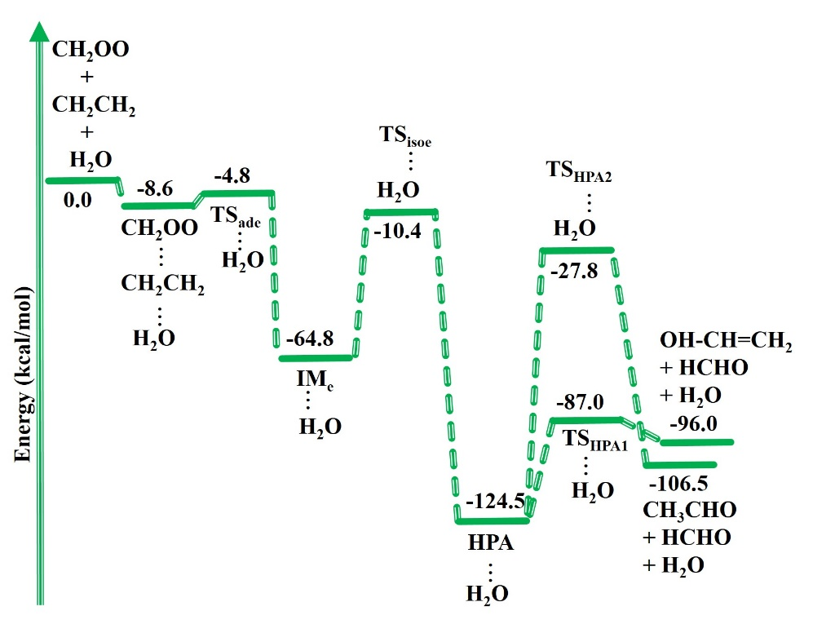

Figure S1. Zero-point corrected potential energy surface for the water assisted CH₂OO + CH₂CH₂ reaction obtained using CCSD(T)/6-311++G (3df,3pd)//M06-2X/6-311++G(3df,3pd) level.

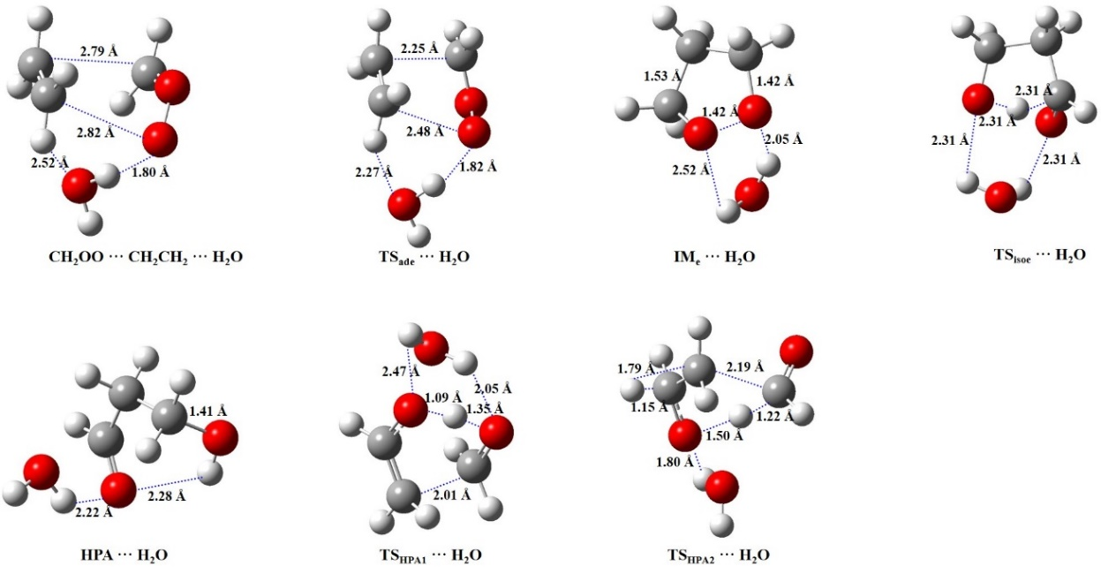
Figure S2. Structural and geometrical changes for the water-assisted •CH₂OO• + CH₂CH₂ reaction calculated using M06-2X/6–311++G (3df,3pd).

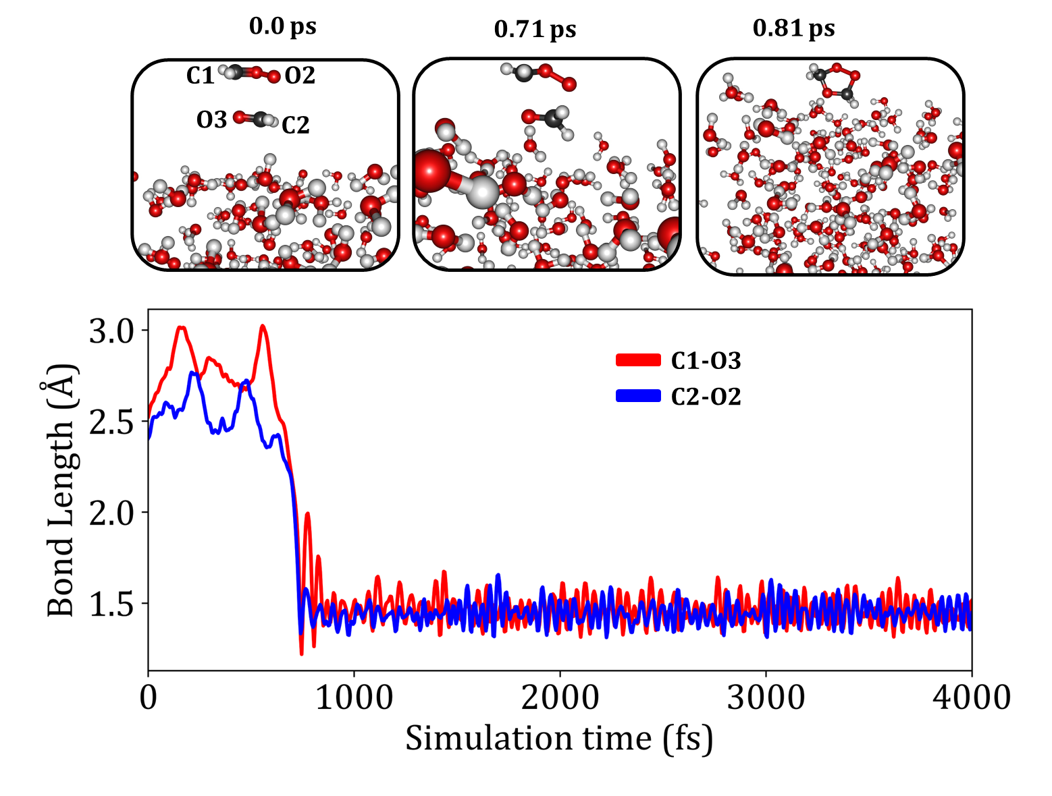
Figure S3. Dynamic trajectories and varying bond lengths for the cyclic ozonide (SOZ) formation from CH₂OO and CH₂O reaction at the air-water interface.

