Supplementary figures

Figure S1

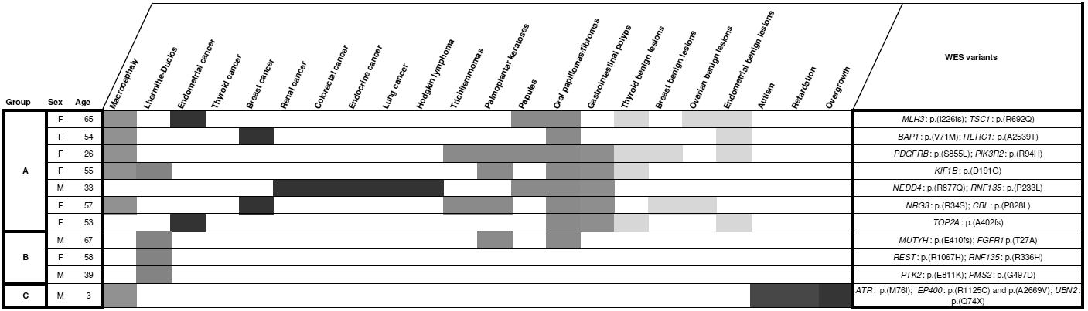

Figure S1. Clinical manifestations and selected gene variants for the 11 PTEN-wt patients studied through WES. Groups A: Patients who meet strict Pilarski8 diagnostic criteria; group B: patients who developed LDD but do not meet strict Pilarski8 diagnostic criteria; group C: pediatric case with macrocephaly together with neurological alterations and overgrowth.

5

Figure S2

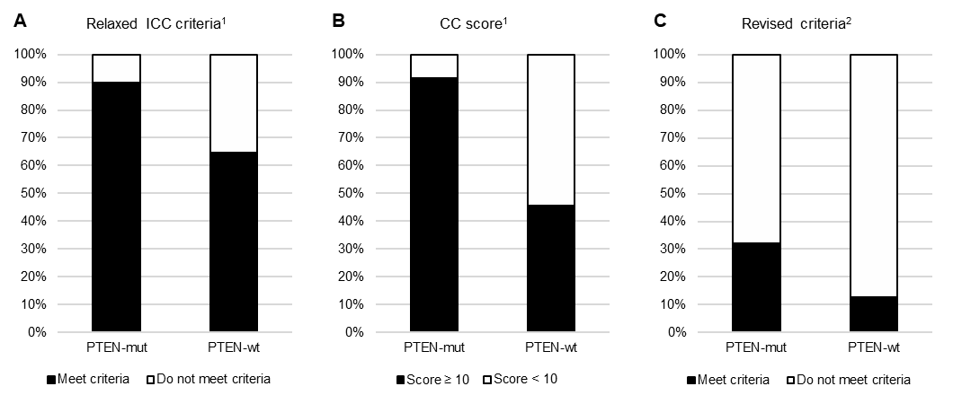

Figure S2. Proportion of individuals in each group of our series identified using the indicated diagnostic criteria from the literature (references are listed at the end of this document).

6

Supplementary tables
Table S1. PTEN pathogenic point variants found in our series.

Sample ID | DNA change | Protein change
803F | c.1_2delAT | p.0?
219F | c.17_18del | p.(Lys6Argfs*4)
186F | c.39_40del | p.(Arg14Glufs*29)
864F | c.39_40del | p.(Arg14Glufs*29)
700F | c.49C>T | p.(Gln17*)
427F | c.58_61dup | p.(Phe21Trpfs*24)
30F | c.68_69insA | p.(Asp24fs*20)
1041F | c.81_82insCT | p.(Ile28Leufs*27)
355F | c.254-1_257dup
1166F | c.255_256insAA | p.(Ala86Lysfs*14)
683F | c.302T>C | p.(Ile101Thr)
517F | c.332G>A | p.(Trp111*)
1126F | c.334C/G | p.(Leu112Val)
249F | c.379G>A | p.(Gly127Arg)
55F | c.388C>T | p.(Arg130*)
614F | c.388C>T | p.(Arg130*)
653F | c.388C>T | p.(Arg130*)
757F | c.389G>A | p.(Arg130Gln)
532F | c.395G>T | p.(Gly132Val)
794F | c.405dup | p.(Cys136Metfs*44)
1157F | c.406T>C | p.(Cys136Arg)
1251F | c.406T>C | p.(Cys136Arg)
910F | c.407G>A | p.(Cys136Tyr)
836F | c.492+1delG
582F | c.492+1G>C
44F | c.493-1G>A | p.(Gly165fs*)

Sample ID | DNA change | Protein change
724F | c.493-1G>C | p.(Gly165Ilefs*9)
817F | c.493G>C | p.(Gly165Arg)
805F | c.512A>G | p.(Gln171Arg)
777F | c.542T>C | p.(Leu181Pro)
232F | c.622_623insT | p.(Gly208Valfs*)
189F | c.634+5G>A
250F | c.635-1G>C
1085F | c.640C>T | p.(Gln214*)
788F | c.655C>T | p.(Gln219*)
1020F | c.686C>G | p.(Ser229*)
1274F | c.68T>G | p.(Leu23*)
499F | c.697C>T | p.(Arg233*)
518F | c.697C>T | p.(Arg233*)
762F | c.723_724insTT | p.(Glu242Leufs*15)
578F | c.817_818del | p.(Phe273*)
659F | c.825del | p.(Val275*)
1089F | c.829dup | p.(Thr277Asnfs*21)
981F | c.955_958del | p.(Thr319*)
120C | c.984_987del | p.(Asn329Lysfs*)
705F | c.985_986delAA | p.(Asn329*)
1105F | c.1003C>T | p.(Arg335*)
262F | c.1003C>T | p.(Arg335*)
687F | c.1003C>T | p.(Arg335*)
750F | c.1003C>T | p.(Arg335*)
795F | c.1003C>T | p.(Arg335*)
621F | c.1007dup | p.(Tyr336*)

7

Table S2. PTEN variants of unknown significance (VUS) found in our series.

Patient ID | DNA change (ClinVar submission ID) | Protein change | Protein domain | Deleteriousness prediction (Condel) | Phenotype | Variant origin
789F | c.77C>T (SCV001245482) | p.(Thr26Ile) | Phosphatase | Probably damaging | Male 11 yo. Macrocephaly, obesity, macular pigmentation penis, bilateral gynecomastia, autism, mental retardation, musculoskeletal alterations. | De novo
707F | c.254-21G>C (SCV001245485) | - | - | - | Male 10 yo. Macrocephaly, autism, hyperpigmented spots. | Unknown. (Relatives were not tested).
1170F | c.284C>G | p.(Pro95Arg) | Phosphatase | Probably damaging | Male 39 yo. Macrocephaly, overweight, papules, palmoplantar keratoses, trichilemmomas, oral papillomatosis, lipomas, macular pigmentation penis, goiter, Hashimoto’s thyroiditis, colonic and gastrointestinal polyps, cerebral hamartomas. | Unknown. (Relatives were not tested).
1201F | c.529T>A (SCV001245483) | p.(Tyr177Asn) | Phosphatase | Probably damaging | Male 5 yo. Macrocephaly, motor delay. | Familial. (Variant segregates in the family with the phenotype).
738F | c.781C>G (SCV001245484) | p.(Gln261Glu) | C2 | Probably damaging | Male 34 yo. Macrocephaly, lipomas, macular pigmentation penis, colorectal polyps, general overgrowth. | Familial. (Variant segregates in the family with the phenotype).
1115F | c.829A>G | p.(Thr277Ala) | C2 | Probably damaging | Male 9 yo. Macrocephaly, general developmental disorder, speech delay, general overgrowth. | De novo
1103F | c.929A>G | p.(Asp310Gly) | C2 | Probably neutral | Male 29 yo. Macrocephaly, papules, palmoplantar keratoses, thyroid adenomas, papillary-follicular thyroid cancer, colorectal polyps (inflammatory, lymphoid and hamartomatous), testicular cancer. | Unknown. (Only a sister was tested; she was a non- carrier).

Table S3. Chromosomal regions deleted found in our series through MLPA and aCGH.

ID | Deleted region (MLPA) | Deleted region (aCGH)
594F | Entire PTEN* | chr10:81,685,169-91,936,008 (10 Mb)
617F | BMPR1A, KLLN and entire PTEN | chr10:81,660,274-89,830,454 (8 Mb)
708F | KLLN and PTEN exon 1 | chr10:89,625,664-89,640,157 (14 kb)
858F | KLLN and PTEN exon 1 | chr10:89,625,664-89,640,157 (14 kb)
814F | KLLN and PTEN exon 1 | chr10:89,653,535-89,653,594 (59 pb)
712F | PTEN exon 6 | -
1054F | PTEN exon 3 | -
*Study performed in 2006 with a probe kit that did not include other genes besides PTEN; the remaining DNA could not be used to repeat the study.

8

Table S4. Risk of carrying a PTEN germline mutation according to different clinical features, based on analysis of our patient series. Odds ratios obtained with logistic regression.

Clinical feature | OR | CI95 | P value
Macrocephaly | 11.186 | 4.88 - 25.67 | 1.21E-08
Mucocutaneous lesions | 7.619 | 3.09 - 18.82 | 1.07E-05
Gastrointestinal polyps | 4.488 | 2.08 - 9.7 | 0.1E-03
Lhermitte-Duclos disease | 2.322 | 0.72 - 7.50 | 0.159
Obesity | 23.045 | 2.91 - 182.14 | 0.003
Breast cancer | 0.208 | 0.08 - 0.52 | 0.001
Thyroid cancer | 0.724 | 0.31 - 1.67 | 0.447
Endometrial cancer | 0.502 | 0.15 - 1.69 | 0.265
Renal cancer | 2.062 | 0.33 - 12.76 | 0.436
Colorectal cancer | 0.153 | 0.02 - 1.26 | 0.081
Family history | 1.477 | 0.64 - 3.40 | 0.359
No. of cancers per patient | 0.546 | 0.36 - 0.82 | 0.004
Cancer onset age | 0.907 | 0.86 - 0.96 | 0.001

Table S5. Risk of carrying a PTEN germline mutation when the patient presents only a certain clinical feature (for example, a patient who has only LDD and no other clinical manifestation). Odds ratios obtained with logistic regression.

Clinical feature | OR | CI95 | P value
Cancer | 0.399 | 0.16 - 1.01 | 0.052
Macrocephaly | 11.385 | 4.29 - 30.21 | 1.04E-06
Mucocutaneous lesions | 6.861 | 2.18 - 21.60 | 0.001
Gastrointestinal polyps | 4.220 | 1.60 - 11.16 | 0.004
Lhermitte-Duclos disease | 3.776 | 0.74 - 19.29 | 0.110

9

Table S6. Genotype-phenotype associations found in our series. Chi-square or t-test significance is shown.

PTEN genotype | Phenotype (p value)
Mutations in exon 1 | ↑Renal cancer (p = 0.045)  ↑Palmoplantar keratosis (p = 0.01)  ↑Papules (p = 0.02)
Mutations in exon 8 | ↑Musculoskeletal lesions (p = 0.03)
Large deletions | ↓Polyposis (gastric: p = 0.047, colorectal: p = 0.017)  ↓Neurological disorders (autism: p = 0.03, mental retardation  p = 0.03).

10

S7 Table. List of genes included in the multigene panel.

the promoter)
Nr | Gene Nr Gene
1 AKT1 24 FLCN
2 AKT2 25 TP53
3 AKT3 26 FH
4 DEPDC5 27 MET
5 MTOR 28 CDKN2A
6 PIK3C2B 29 AR
7 PIK3CA 30 KRAS
8 PIK3R1 31 BRAF
9 PTEN 32 NRAS
10 RICTOR 33 MEN1
11 RPTOR 34 DAXX
12 STK11 35 ATRX
13 TSC1 36 CUL3
14 TSC2 37 NF1
15 NF2 38 ARID1A
16 SETD2 39 CDKN1B
17 SMARCB1 40 EIF1AX
18 USP9X 41 NFE2L2
19 BAP1 42 STAG2
20 KDM5C 43 TERT_region ATG (250 nt of
21 KDM6A 44 TFE3 fusion (ex2-ex6; incl. in
22 PBRM1 45 TFEB fusion (1 kb intr2-ex3;
23 VHL 46 TFEB fusion (ex9, intr9, ex1

tr2-5; ENST00000315869.7) ENST00000230323.8)
0; ENST00000230323.8)

Table S8. Germline VUS found in mTOR-related genes by NGS.

1105F | PTEN-mut | 1:11273527G>A | MTOR | 0.46 | missense | MODERATE | ENSG00000198793 | 1072 | P/S
1251F | PTEN-mut | 1:204418411C>T | PIK3C2B | 0.49 | missense | MODERATE | ENSG00000133056 | 458 | R/Q | rs61755372 | 0.000658
30F | PTEN-mut | 16:2111938G>T | TSC2 | 0.50 | missense | MODERATE | ENSG00000103197 | 396 | D/Y | COSM6143684& COSM6143685
497F | PTEN-mut | 16:2122869T>A | TSC2 | 0.50 | missense | MODERATE | ENSG00000103197 | 747 | L/Q | CD010683
499F | PTEN-mut | 14:105246462G>T | AKT1 | 0.40 | missense | MODERATE | ENSG00000142208 | 232 | G/E
499F | PTEN-mut | 9:135771994G>C | TSC1 | 0.53 | missense | MODERATE | ENSG00000165699 | 692 | R/Q | rs199755731 | 0.000171 | uncertain_signi ficance&likely_ benign
594F | PTEN-mut | 17:78857246A>G | RPTOR | 0.49 | missense | MODERATE | ENSG00000141564 | 407 | P/L | rs922237067&C OSM1579117 | 1.63E-05
700F | PTEN-mut | 17:78820280C>T | RPTOR | 0.51 | missense | MODERATE | ENSG00000141564 | 1228 | V/M | rs147241989 | 0.000307
762F | PTEN-mut | 19:40761140T>C | AKT2 | 0.48 | missense | MODERATE | ENSG00000105221 | 71 | N/S | rs200272953 | 0.000219
794F | PTEN-mut | 1:11300579C>T | MTOR | 0.51 | missense | MODERATE | ENSG00000198793 | 523 | D/N | rs376836258&C OSM3930270 | 8.12E-06
836F | PTEN-mut | 1:204438908C>T | PIK3C2B | 0.49 | missense | MODERATE | ENSG00000133056 | 1029 | F/L | rs61763420 | 0.002197
981F | PTEN-mut | 17:78935270G>A | RPTOR | 0.49 | missense | MODERATE | ENSG00000141564 | 538 | I/V
981F | PTEN-mut | 19:1226587C>G | STK11 | 0.50 | missense | MODERATE | ENSG00000118046 | 415 | R/G | rs864622448 |  | uncertain_signi ficance
981F | PTEN-mut | 17:17131357C>T | FLCN | 0.49 | missense | MODERATE | ENSG00000154803 | 32 | G/E | rs587778366 | 1.22E-05
1065F | PTEN-wt | 5:38962438T>C | RICTOR | 0.50 | missense | MODERATE | ENSG00000164327 | 565 | Y/C | rs146754529 | 0.000707
1172F | PTEN-wt | 9:135779171C>T | TSC1 | 0.67 | missense | MODERATE | ENSG00000165699 | 1041 | S/R | rs753374839 | 5.31E-05 | uncertain_signi ficance&likely_ benign
1173F | PTEN-wt | 17:29663905T>G | NF1 | 0.50 | missense | MODERATE | ENSG00000196712 | 2113 | C/G | COSM3958176& COSM3958177
1174F | PTEN-wt | 17:17127234A>T | FLCN | 0.49 | splice_donor_ variant | HIGH | ENSG00000154803 |  |  | CS101080
1197F | PTEN-wt | 1:204429727C>T | PIK3C2B | 0.52 | missense | MODERATE | ENSG00000133056 | 750 | G/S | rs114917235 | 0.000557
1198F | PTEN-wt | 5:38953625G>A | RICTOR | 0.50 | missense | MODERATE | ENSG00000164327 | 910 | R/C | rs143469898 | 0.000187
1210F | PTEN-wt | 1:204411723G>T | PIK3C2B | 0.52 | missense | MODERATE | ENSG00000133056 | 458 | R/Q | rs61755372 | 0.000658
1210F | PTEN-wt | 1:204429727C>T | PIK3C2B | 0.48 | missense | MODERATE | ENSG00000133056 | 8 | G/E | rs115204119 | 0.001045
1708C | PTEN-wt | 14:105240256C>T | AKT1 | 0.49 | missense | MODERATE | ENSG00000142208 | 46 | D/E | rs146875699 | 0.000317 | uncertain_signi ficance&not_pr ovided
181F | PTEN-wt | 17:29553639A>T | NF1 | 0.48 | missense | MODERATE | ENSG00000196712 | 730 | N/Y | rs758893131 | 0.000061 | uncertain_signi ficance
308F | PTEN-wt | 5:67522555A>G | PIK3R1 | 0.51 | missense | MODERATE | ENSG00000145675 | 18 | R/G
308F | PTEN-wt | 16:2135023A>G | TSC2 | 0.48 | missense | MODERATE | ENSG00000103197 | 1522 | N/S | rs144062721&C OSM3787107&C OSM3787108 | 6.51E-05 | uncertain_signi ficance&not_pr ovided, prob.benign
612F | PTEN-wt | 17:17118598C>T | FLCN | 0.50 | missense | MODERATE | ENSG00000154803 | 445 | A/T | rs41419545 | 0.002648 | benign&likely benign&VUS
632F | PTEN-wt | 16:2110684C>T | TSC2 | 0.48 | missense | MODERATE | ENSG00000103197 | 330 | P/L | rs140910086 | 3.66E-05 | uncertain_signi ficance
672F | PTEN-wt | 1:204438340T>A | PIK3C2B | 0.49 | missense | MODERATE | ENSG00000133056 | 197 | Q/H | rs17847778 | 0.000599
681F | PTEN-wt | 19:1223163C>T | STK11 | 0.49 | missense | MODERATE | ENSG00000118046 | 367 | T/M | rs587782835&C OSM21358 | 1.67E-05 | uncertain_signi ficance
860F | PTEN-wt | 22:32234798C>A | DEPDC5 | 0.49 | missense | MODERATE | ENSG00000100150 | 819 | P/T
995F | PTEN-wt | 5:67591042GGAA>G | PIK3R1 | 0.49 | inframe_deleti on | MODERATE | ENSG00000145675 | 546 | E/-

11

Table S9. Germline PTEN status and NGS findings in the indicated tumor samples (each one from a different proband).

Cancer tissue | Germline  PTEN status | PTEN  status in the tumor (NGS) | Other somatic variants found by NGS
Thyroid | c.634+5G>A | c.634+5G>A | BRAF p.(V600E)
Rectum | WT | WT | TP53 p.(R282W)
Lung | WT | c.635-1G>A | ATRX p.(Q1877H)  PIK3C2B p.(Q197H)
Thyroid (papillary-follicular) | Large deletion (KLLN and PTEN exon 1) | * | PIK3CA p.(G1049R)  USP9X p.(I2120fs)
*Large deletions are not called in the NGS pipeline.

12

