2a
Chemical Formula: C₂₂H₁₈ClO₇
Exact Mass: 442.85
Molecular Weight: 465.07065

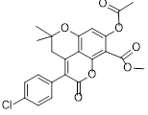
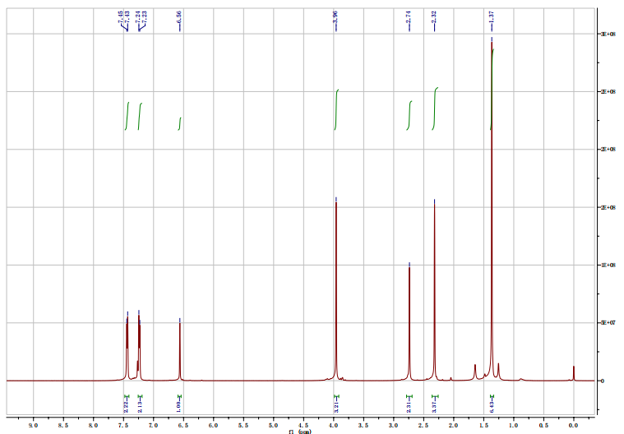

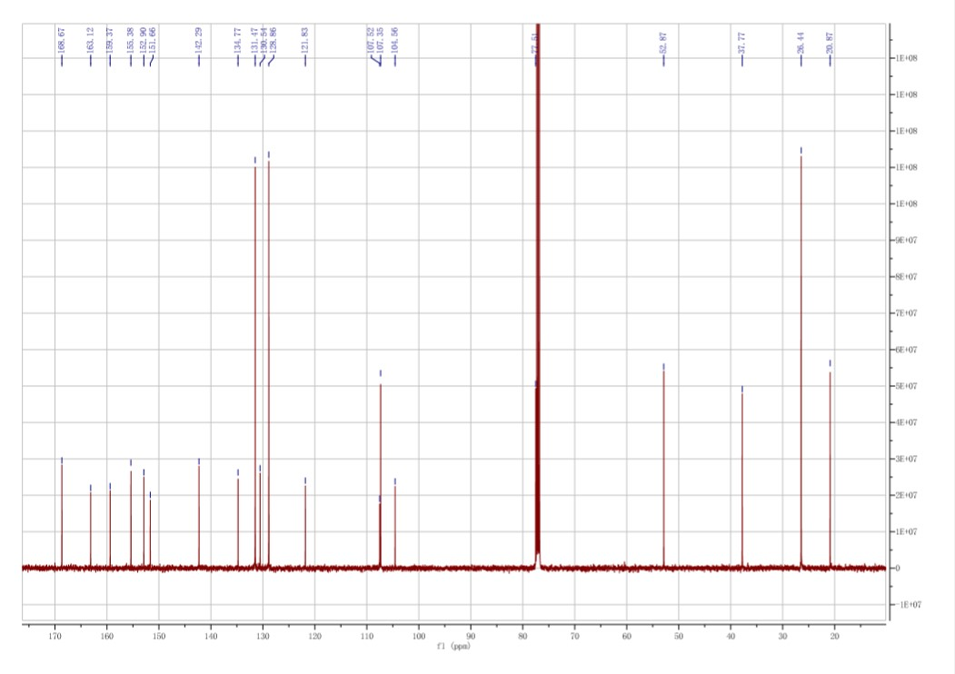

2b
Chemical Formula: C₂₂H₁₈ClO₇
Exact Mass: 544.10
Molecular Weight: 567.0845.

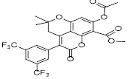
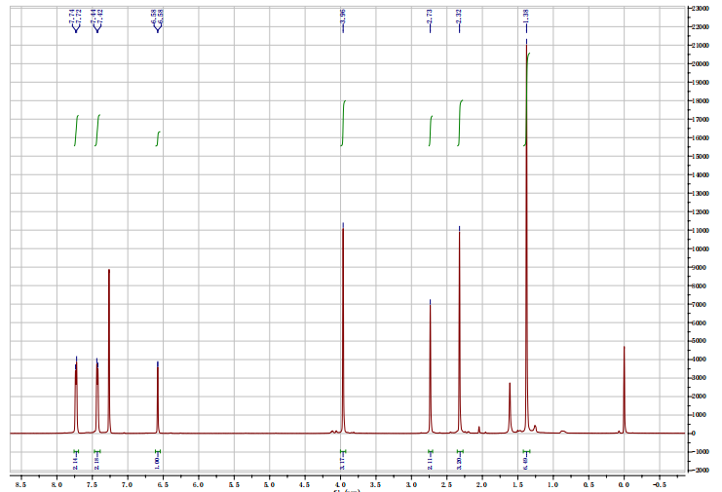

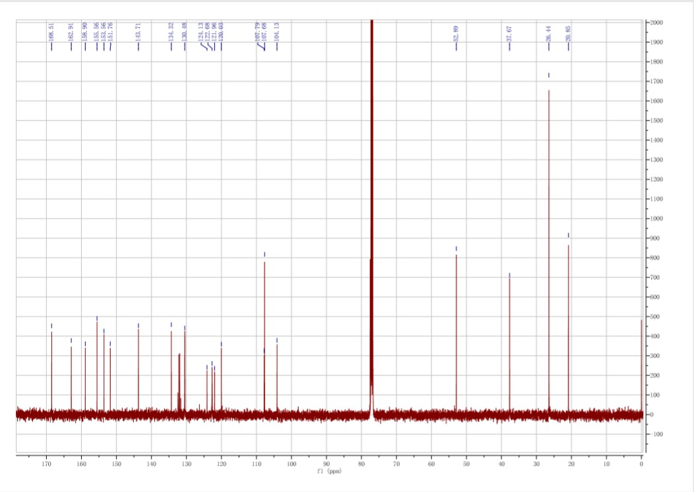

2c
Chemical Formula: C₂₅H₂₂O₉
Exact Mass: 466.44
MolecularWeight: 489.1143

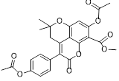
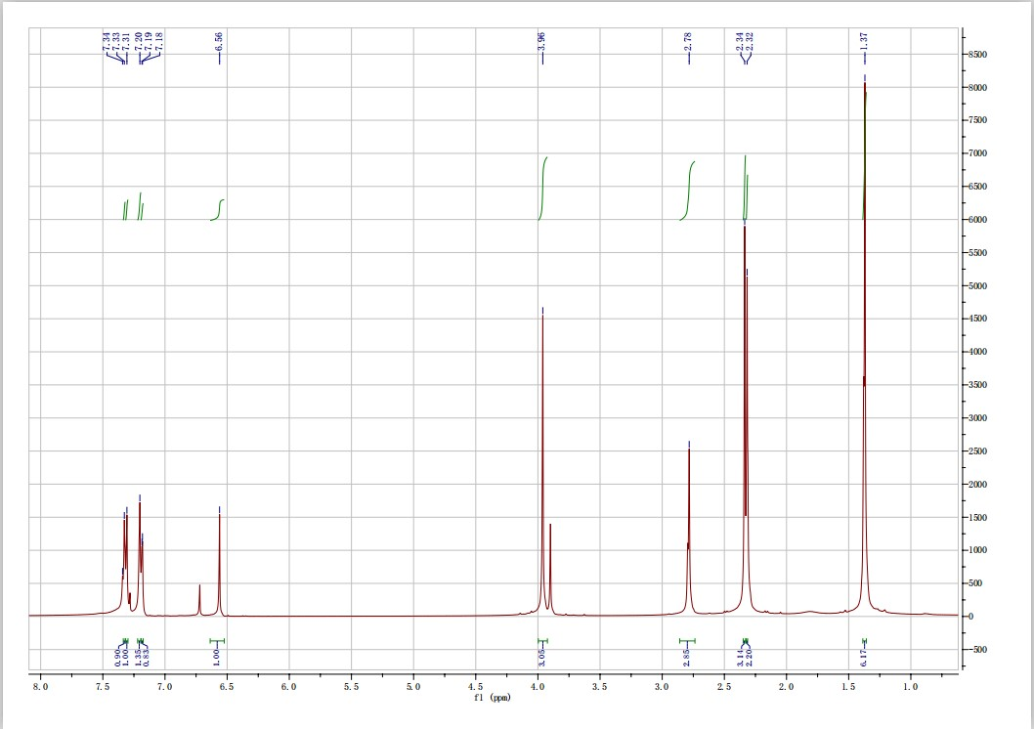

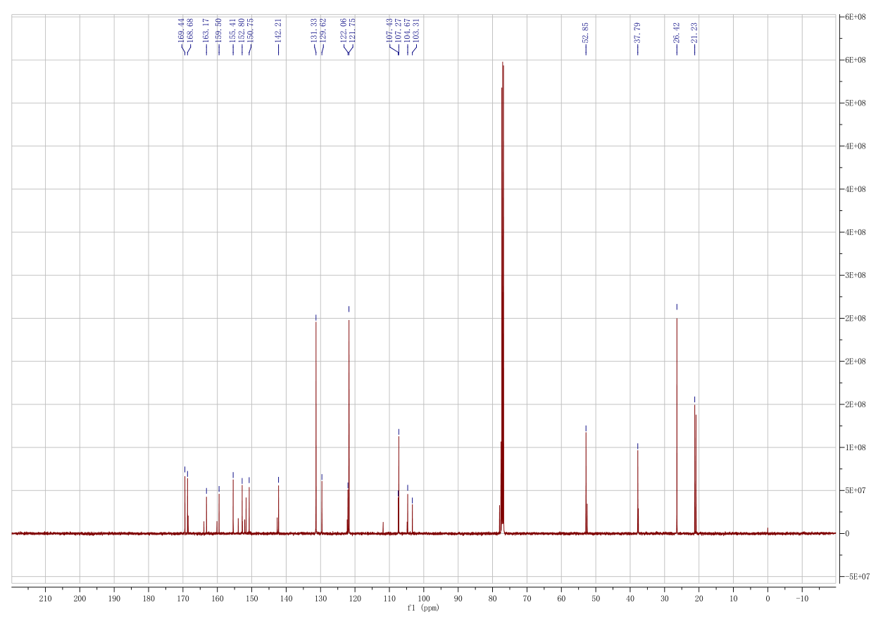

3a
Chemical Formula: C₂₁H₁₇ClO₆
Exact Mass: 400.81
Molecular Weight: 401.0784

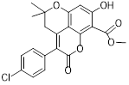
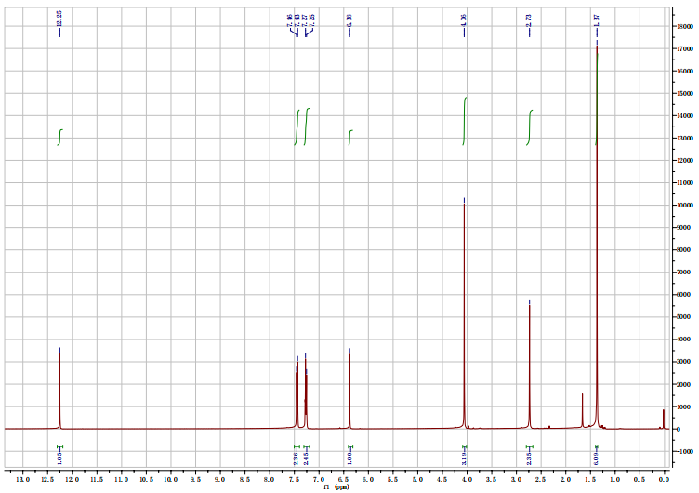

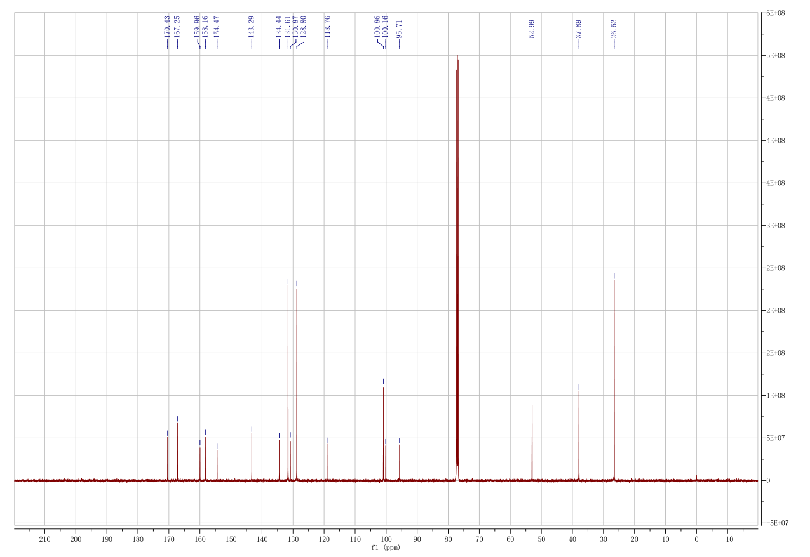

3b
Chemical Formula: C₂₃H₁₆F₆O₆
Exact Mass: 502.37
Molecular Weight: 503.0923

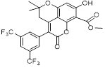
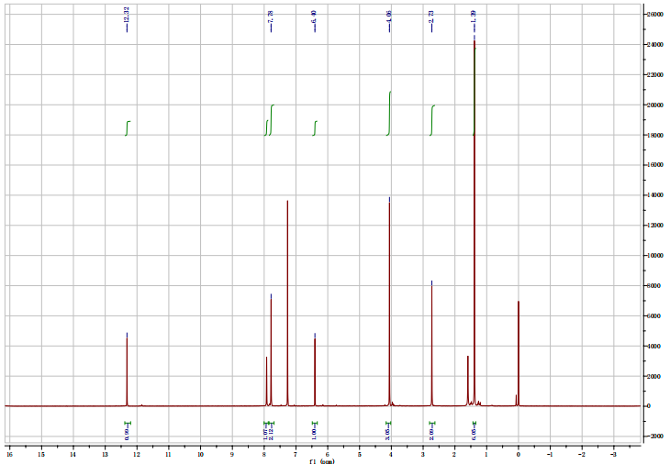

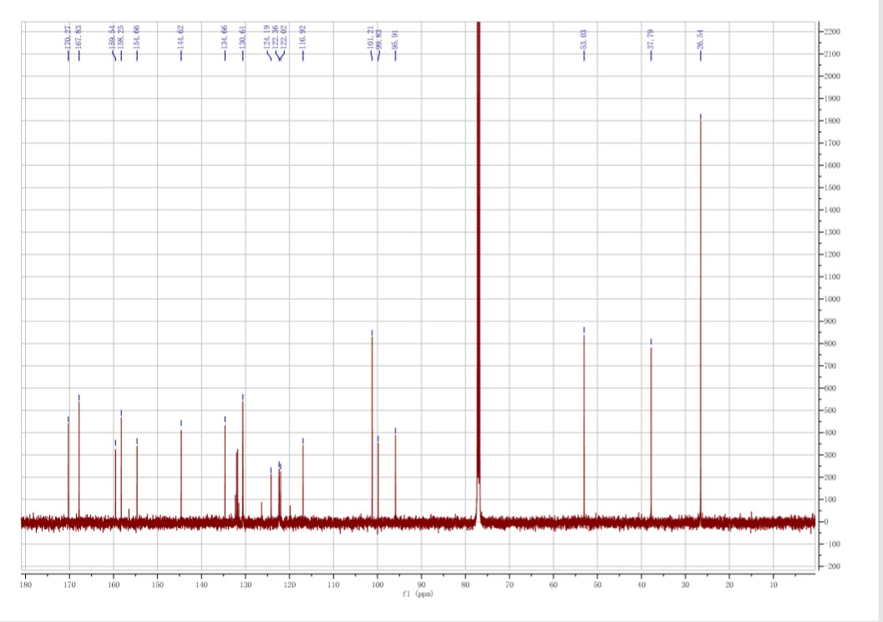

3c
Chemical Formula: C₂₁H₁₈O₇
Exact Mass: 382.37
Molecular Weight: 383.1125
