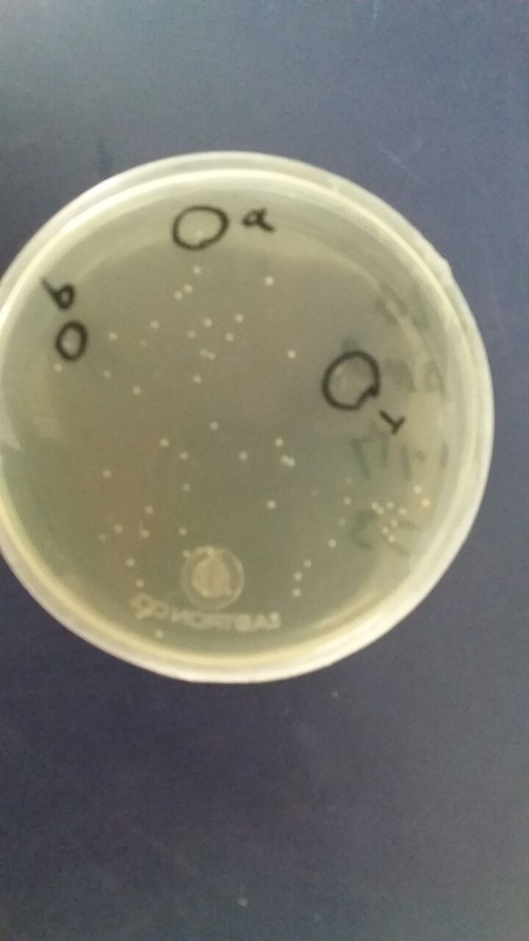 | 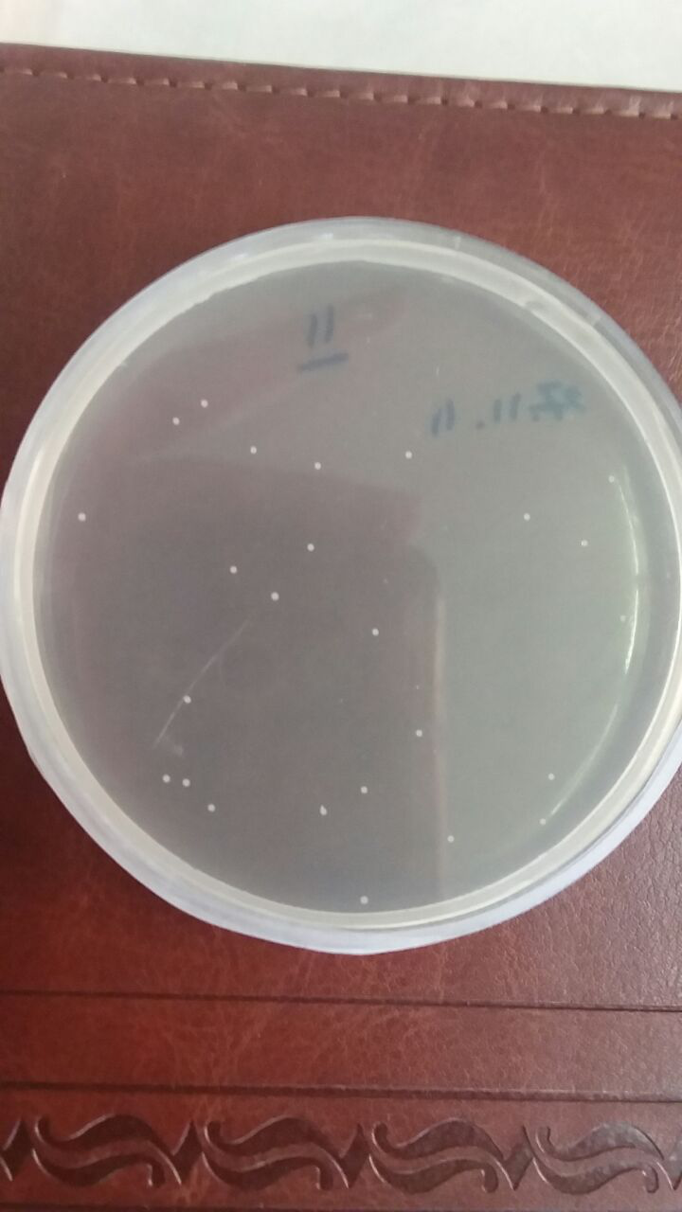
(a) | (b)
Sup1. Cloning confirmation of the SOD gene into the vectors pTG19 and pBI121 transformed in E. coli DH5α bacteria through the growth of bacterial colonies containing the desired vector. (a) Bacterial colonies containing vector pTG19+SOD. (b) Bacterial colonies containing vector pBI121+SOD.

