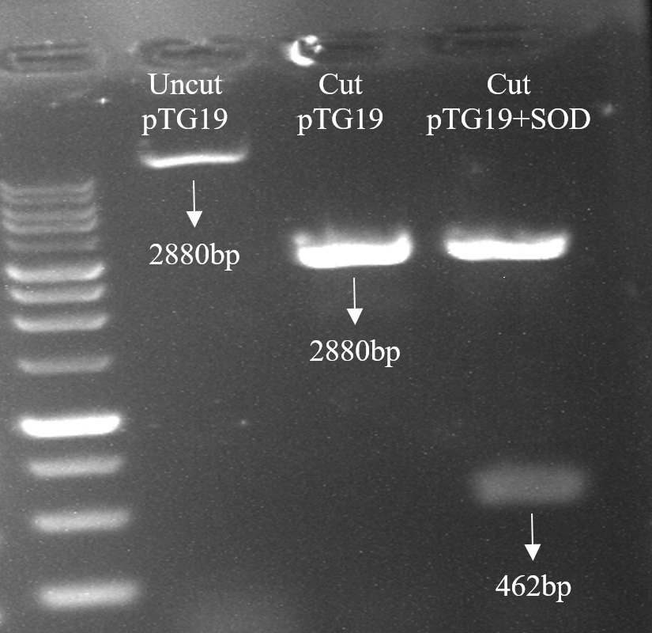 | 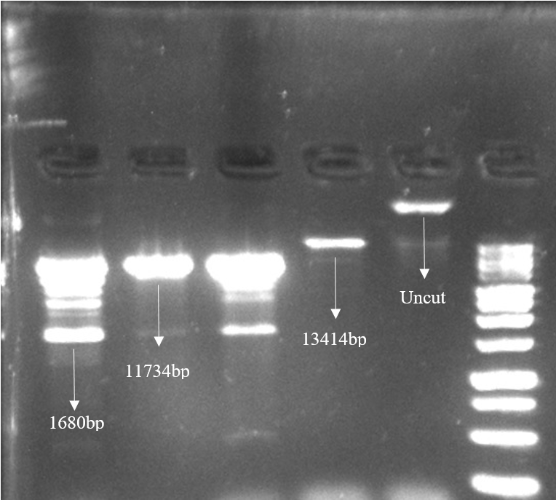
(a) | (b)
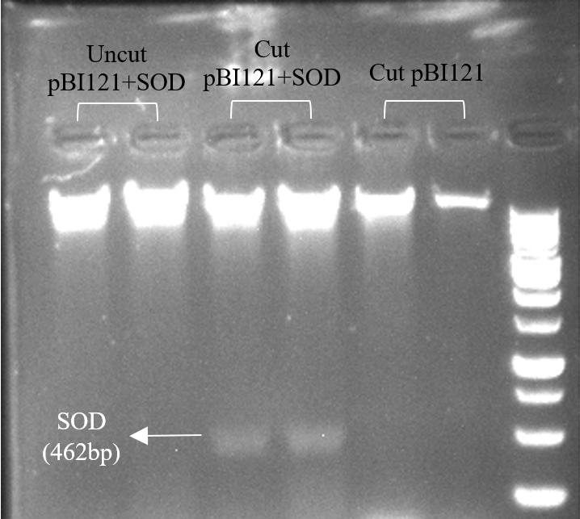 | 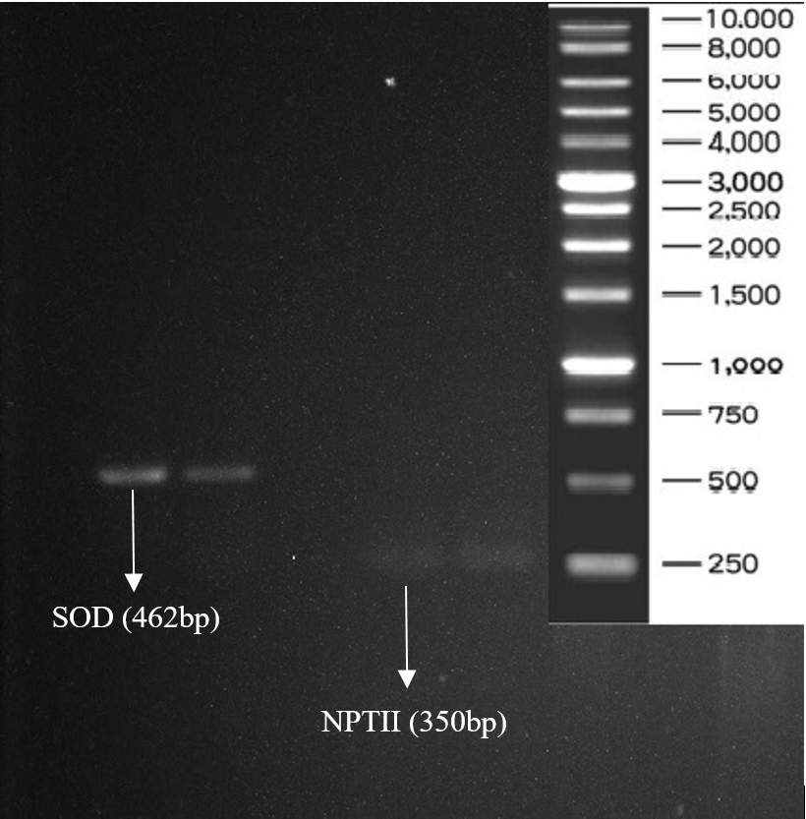
(c) | (d)
Sup2. Confirmation of vectors digestion pTG19 and pBI121 and PCR results on gel electrophoresis. (a) Digestion of pTG19+SOD vector with BamHI enzyme. (b) Digestion of pBI121+SOD vector with HindIII and EcoRI enzymes. (c) Digestion of pBI121+SOD vector with BamHI enzyme. (d) Confirmation of PCR results of transgenic plants with primers SOD and NPTII.

