Isolation and characterization of cellulolytic marine bacteria for Litopenaeus vannamei aquaculture using sugarcane bagasse as carbon source
Wei Ren^{1, 2, 3, a}, Xueni Xu^{1, 2, 3, a}, Hao Long^{1, 2, 3}, Xiang Zhang^{1, 2, 3}, Xiaoni Cai^{1, 2, 3}, Aiyou Huang^{1, 2, 3}, Zhenyu Xie^{1, 2, 3}*

1 State Key Laboratory of Marine Resource Utilization in the South China Sea, Hainan University, Haikou, 570228, Hainan Province, China.
2 Hainan Provincial Key Laboratory for Tropical Hydrobiology and Biotechnology, Hainan University, Haikou, 570228, Hainan Province, China.
3 College of Marine Sciences, Hainan University, Haikou, 570228, Hainan Province, China.
a The first two authors contributed equally to this work.
* Correspondence author (Zhenyu Xie, E-mail: xiezyscuta@163.com; Tel: +86-13648669016)

.

Table S1. The information of the antibiotic used in this study.
Antibiotic Classes | Antibiotic tested | Disc content | Abbreviation | Susceptible (mm) | Intermediary (mm) | Resistant (mm)
Penicillins | Penicillin | 10 μg | PEN | ≤19 |  | ≥20
Penicillins | Ampicillin | 10 μg | AMP | ≤13 | 14-16 | ≥17
Penicillins | Amoxicillin | 10 μg | AMX | ≤13 | 14-17 | ≥18
Penicillins | Oxacillin | 1 μg | OXA | ≤13 | 14-17 | ≥18
Penicillins | Piperacillin | 100 μg | PIP | ≤17 | 18-20 | ≥21
Penicillins | Carbenicillin | 100 μg | CAR | ≤19 | 20-22 | ≥23
Cephalosporins | Cefazolin | 30 μg | CFZ | ≤14 | 15-17 | ≥18
Cephalosporins | Cefalexin | 30 μg | LEX | ≤14 | 15-17 | ≥18
Cephalosporins | Cefoxitin | 30 μg | FOX | ≤14 | 15-17 | ≥18
Cephalosporins | Ceftriaxone | 30 μg | CRO | ≤13 | 14-20 | ≥21
Aminoglycosides | Streptomycin | 10 μg | STR | ≤11 | 12-14 | ≥15
Aminoglycosides | Kanamycin | 30 μg | KAN | ≤13 | 14-17 | ≥18
Aminoglycosides | Gentamicin | 10 μg | GEN | ≤12 | 13-14 | ≥15
Aminoglycosides | Amikacin | 30 μg | AMK | ≤14 | 15-16 | ≥17
Aminoglycosides | Neomycin | 30 μg | NEO | ≤12 | 13-16 | ≥17
Aminocyclitols | Spectinomycin | 100 μg | SPE | ≤14 | 15-17 | ≥18
Tetracyclines | Oxytetracycline | 30 μg | OXY | ≤4 | 4-16 | ≥17
Tetracyclines | Tetracycline | 30 μg | TCY | ≤14 | 15-18 | ≥19
Tetracyclines | Minocycline | 30 μg | MNO | ≤14 | 15-18 | ≥19
Tetracyclines | Doxycycline | 30 μg | DOX | ≤12 | 13-15 | ≥16
Amphenicols | Florfenicol | 30 μg | FFC | ≤25 | 26-28 | ≥29
Amphenicols | Chloramphenicol | 30 μg | CHL | ≤12 | 13-17 | ≥18
Nitrofurans | Furazolidone | 300 μg | FRZ3 | ≤14 | 15-16 | ≥17
Fluoroquinolones | Norfloxacin | 10 μg | NOR | ≤12 | 13-16 | ≥17
Fluoroquinolones | Levofloxacin | 5 μg | LVX | ≤13 | 14-16 | ≥17
Fluoroquinolones | Ofloxacin | 5 μg | OFX | ≤12 | 13-15 | ≥16
Fluoroquinolones | Ciprofloxacin | 5 μg | CIP | ≤15 | 16-20 | ≥21
Macrolides | Erythromycin | 15 μg | ERY | ≤13 | 14-22 | ≥23
Macrolides | Azithromycin | 15 μg | AZM | ≤13 | 14-17 | ≥18
Ansamycins | Rifampicin | 5 μg | RIF | ≤16 | 17-19 | ≥20

Table S2. Colony morphology and Fpase of 97 cellulolytic bacteria.
Isolates code and species |  |  | site | Shape | Pigmentation | Fpase (U/mL)
1 | MW-C2 | Bacillus aquimaris | D | Circular | Yellow | 0.017 ± 0.078
2 | MW-C3 | Microbulbifer sp. | D | Circular | Pale yellow | 0.090 ± 0.104
3 | MW-C4 | Microbulbifer sp. | D | Circular | Pale yellow | 0.196 ± 0.244
4 | CFW-C5 | Bacillus sp. | D | Circular | White | 0.017 ± 0.078
5 | CFW-C6 | Bacillus safensis sp. | D | Circular | Pale yellow | 0.288 ± 0.097
6 | CFW-C7 | Bacillus subtilis | D | Circular | White | 0.342 ± 0.056
7 | CFW-C8 | Bacillus sp. | D | Circular | White | 0.017 ± 0.078
8 | CFW-C9 | Bacillus sp. | D | Circular | White | 0.145 ± 0.003
9 | CFW-C10 | Bacillus cereus | D | Circular | White | 0.180 ± 0.231
10 | CFW-C11 | Vibrio alginolyticus | D | Circular | White | 0.017 ± 0.078
11 | CFW-C12 | Vibrio sp. | D | Circular | White | 0.172 ± 0.083
12 | CFW-C13 | Bacillus subtilis | D | Circular | White | 0.196 ± 0.071
13 | CFW-C14 | Vibrio alginolyticus | D | Circular | White | 0.111 ± 0.067
14 | CFW-C15 | Pseudomonas stutzeri | D | Circular | White | 0.211 ± 0.247
15 | CFW-C16 | Vibrio alginolyticus | D | Circular | White | 0.025 ± 0.012
16 | CFW-C17 | Bacillus subtilis | D | Circular | White | 0.428 ± 0.110
17 | CFW-C18 | Microbulbifer sp. | D | Irregular | White | 0.329 ± 0.118
18 | CFW-C19 | Microbulbifer sp. | D | Circular | Colorless | 0.043 ± 0.037
19 | CFW-C20 | Microbulbifer variabilis | D | Circular | White | 0.017 ± 0.078
20 | CFW-C21 | Pseudomonas stutzeri | D | Circular | White | 0.022 ± 0.007
21 | CFW-C22 | Vibrio sp. | D | Circular | White | 0.017 ± 0.078
22 | SBC-C23 | Bacillus sp. | A | Circular | White | 0.397 ± 0.047
23 | CFW-C24 | Bacillus subtilis | D | Circular | White | 0.017 ± 0.078
24 | CFW-C25 | Vibrio alginolyticus | D | Circular | White | 0.118 ± 0.075
25 | SBC-C26 | Tenacibaculum ascidiaceicola | A | Circular | White | 0.017 ± 0.078
26 | CFW-C27 | Pseudoalteromonas sp. | D | Circular | Pale yellow | 0.017 ± 0.078
27 | CFW-C28 | Bacillus sp. | D | Circular | White | 0.140 ± 0.175
28 | CFW-C29 | Bacillus sp. | D | Circular | Pale yellow | 0.100 ± 0.119
29 | SBC-C30 | Bacillus sp. | A | Circular | White | 0.085 ± 0.076
30 | CFW-C31 | Bacillus pumilus | D | Circular | White | 0.019 ± 0.004
31 | CFW-C32 | Bacillus pumilus | D | Circular | White | 0.160 ± 0.056
32 | CFW-C33 | Pseudoalteromonas sp. | D | Circular | White | 0.017 ± 0.078
33 | SBC-C34 | Muricauda sp. | A | Irregular | White | 0.327 ± 0.109
34 | SBW-C35 | Bacillus sp. | B | Irregular | White | 0.209 ± 0.144
35 | CFW-C36 | Bacillus pumilus | D | Circular | White | 0.017 ± 0.078
36 | CFW-C37 | Bacillus pumilus | D | Circular | Pale yellow | 0.085 ± 0.053
37 | CFW-C38 | Pseudoalteromonas sp. | D | Circular | Pale yellow | 0.350 ± 0.150
38 | CFW-C39 | Pseudoalteromonas sp. | D | Circular | Pale yellow | 0.017 ± 0.078
39 | SBW-C40 | Bacillus sp. | B | Circular | Yellow | 0.597 ± 0.261
40 | MW-C41 | Microbulbifer mangrovi | C | Circular | White | 0.250 ± 0.319
41 | MW-C42 | Bacillus paralicheniformis | C | Circular | White | 0.120 ± 0.084
42 | MW-C43 | Vibrio alginolyticus | C | Circular | White | 0.017 ± 0.078
43 | MW-C44 | Bacillus sp. | C | Circular | White | 0.017 ± 0.078
44 | MW-C45 | Bacillus sp. | C | Circular | White | 0.065 ± 0.069
45 | MW-C46 | Bacillus sp. | C | Circular | White | 0.017 ± 0.078
46 | MW-C47 | Bacillus sp. | C | Circular | Yellow | 0.017 ± 0.078
47 | MW-C48 | Vibrio sp. | C | Circular | Yellow | 0.554 ± 0.176
48 | MW-C49 | Bacillus sp. | C | Circular | White | 0.053 ± 0.028
49 | MW-C50 | Bacillus sp. | C | Circular | Colorless | 0.293 ± 0.224
50 | MW-C51 | Bacillus sp. | C | Circular | White | 0.017 ± 0.078
51 | MW-C52 | Bacillus subtilis | C | Circular | Pale yellow | 0.325 ± 0.125
52 | MW-C53 | Bacillus subtilis | C | Circular | White | 0.019 ± 0.004
53 | MW-C54 | Vibrionaceae bacterium | C | Irregular | Pale yellow | 0.060 ± 0.061
54 | MW-C55 | Bacillus cereus | C | Irregular | White | 0.046 ± 0.037
55 | MW-C56 | Bacillus altitudinis | C | Circular | White | 0.069 ± 0.074
56 | MW-C57 | Bacillus sp. | C | Circular | White | 2.325 ± 0.061
57 | MW-C58 | Microbulbifer mangrovi | C | Oval | White | 0.046 ± 0.025
58 | MW-C59 | Bacillus sp. | C | Circular | White | 0.017 ± 0.078
59 | MW-C60 | Bacillus firmus | C | Oval | White | 0.265 ± 0.141
60 | MW-C61 | Bacillus sp. | C | Irregular | White | 0.265 ± 0.068
61 | MW-C62 | Bacillus cereus | C | Circular | White | 0.042 ± 0.036
62 | MW-C63 | Vibrionaceae bacterium | C | Circular | White | 0.027 ± 0.015
63 | MW-C64 | Bacillus sp. | C | Circular | White | 0.017 ± 0.078
64 | MW-C65 | Microbulbifer mangrovi | C | Circular | White | 0.132 ± 0.163
65 | MW-C66 | Bacillus sp. | C | Circular | Orange | 0.095 ± 0.111
66 | MW-C67 | Bacillus cereus | C | Circular | White | 0.386 ± 0.204
67 | MW-C68 | Vibrionaceae bacterium | C | Circular | Pale red | 0.017 ± 0.078
68 | MW-C69 | Vibrionaceae bacterium | C | Circular | White | 0.020 ± 0.005
69 | MW-C70 | Bacillus sp. | C | Oval | Pale white | 0.323 ± 0.051
70 | MW-C71 | Vibrionaceae bacterium | C | Circular | White | 0.364 ± 0.077
71 | MW-C72 | Microbulbifer taiwanensis | C | Circular | White | 0.051 ± 0.049
72 | MW-C73 | Bacillus sp. | C | Irregular | Pale yellow | 0.101 ± 0.103
73 | MW-C74 | Vibrionaceae bacterium | C | Circular | Pale yellow | 0.170 ± 0.193
74 | MW-C75 | Bacillus altitudinis | C | Circular | White | 0.017 ± 0.078
75 | MW-C76 | Microbulbifer sp. | C | Circular | White | 0.017 ± 0.078
76 | MW-C77 | Bacillus altitudinis | C | Circular | White | 0.128 ± 0.079
77 | MW-C78 | Bacillus sp. | C | Circular | Pale yellow | 0.130 ± 0.125
78 | MW-C79 | Bacillus subtilis | C | Circular | White | 0.195 ± 0.127
79 | MW-C80 | Bacillus hwajinpoensis | C | Irregular | White | 0.209 ± 0.194
80 | MW-C81 | Bacillus subtilis | C | Circular | White | 0.200 ± 0.019
81 | MW-C82 | Vibrio sp. | C | Circular | White | 0.121 ± 0.136
82 | MW-C83 | Bacillus cereus | C | Circular | White | 0.018 ± 0.001
83 | MW-C84 | Bacillus sp. | C | Irregular | Orange | 0.017 ± 0.078
84 | MW-C85 | Bacillus cereus | C | Circular | White | 0.205 ± 0.083
85 | MW-C86 | Bacillus sp. | C | Circular | Orange | 0.077 ± 0.085
86 | MW-C87 | Bacillus sp. | C | Circular | Yellow | 0.093 ± 0.047
87 | MW-C88 | Bacillus sp. | C | Circular | Pale yellow | 0.071 ± 0.039
88 | MW-M4 | Bacillus sp. | C | Circular | White | 0.017 ± 0.078
89 | MW-M5 | Exiguobacterium sp. | C | Circular | Pale yellow | 0.017 ± 0.078
90 | MW-M9 | Vibrionaceae bacterium | C | Circular | Pale yellow | 0.017 ± 0.078
91 | MW-M10 | Bacillus sp. | C | Circular | Pale yellow | 0.028 ± 0.016
92 | MW-M13 | Bacillus sp. | C | Circular | Pale yellow | 0.049 ± 0.046
93 | MW-M14 | Bacillus cereus | C | Circular | Pale yellow | 0.017 ± 0.078
94 | MW-M15 | Bacillus sp. | C | Circular | Pale yellow | 0.053 ± 0.051
95 | MW-M17 | Bacillus sp. | C | Circular | Pale yellow | 0.017 ± 0.078
96 | MW-M19 | Vibrio sp. | C | Circular | Pale yellow | 0.018 ± 0.002
97 | MW-M20 | Bacillus sp. | C | Circular | Pale yellow | 0.907 ± 0.056
Note: A, B, C, and D represent four sampling sites, shrimp cultural base in Haiwei Town, shrimp cultural base in Huiwen Town, Mangrove in Huiwen Town, and Dongjiao Coconut Forest in Huiwen Town, respectively. The HC values of any isolates less than 1 are not shown, and the REC of those isolates are also not shown

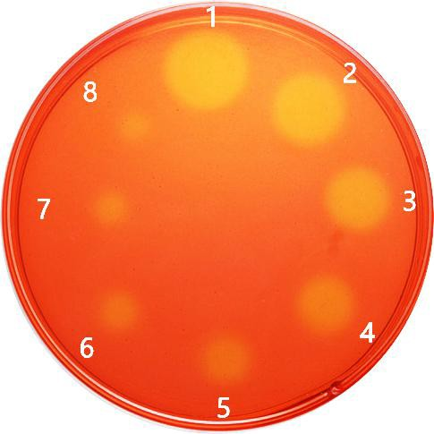
Fig. S1. Congo red staining of standard commercial enzymes at different dilution concentrations.
Note: 1: 0.0 mg/mL; 2: 0.05 mg/mL; 3: 0.025 mg/mL; 4: 0.0125 mg/mL; 5: 0.00625 mg/mL; 6: 0.003125 mg/mL; 7: 0.0015625 mg/mL; 8: 0.00078125 mg/mL.

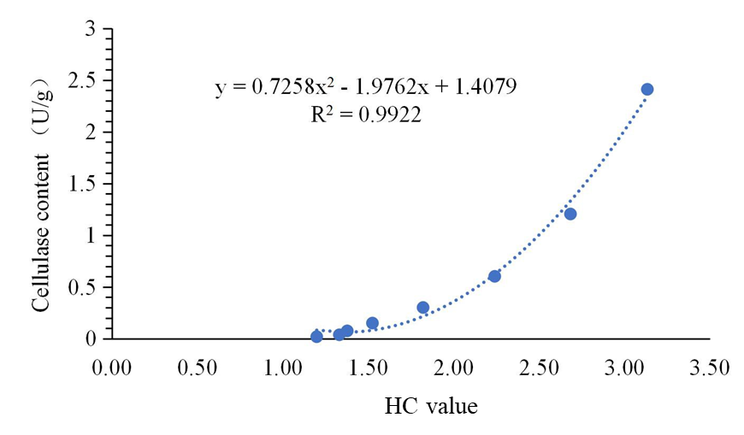
Fig. S2. Standard commercial enzyme standard curve.

Table S3. Resistance patterns of 28 cellulase-producing marine bacteria according to antimicrobial susceptibility test using 30 kinds of antibiotics.
 | PEN | AMP | AMX | OXA | PIP | CAR | CFZ | LEX | FOX | CRO | STR | KAN | GEN | AMK | NEO | SPE | OXY | TCY | MNO | DOX | FFC | CHL | FRZ3 | NOR | LVX | OFX | CIP | ERY | AZM | RIF
CFW-C18 | R | R | S | R | R | R | R | R | R | S | S | S | S | S | S | S | S | S | S | S | S | S | R | S | S | S | S | S | S | S
CFW-C32 | R | R | R | R | R | R | R | R | I | I | R | R | I | R | I | R | I | R | R | R | I | S | I | I | I | R | R | R | R | I
CFW-C6 | R | I | I | R | R | R | I | R | I | I | I | I | I | I | R | I | I | R | R | R | R | S | S | S | S | S | I | R | R | R
CFW-C7 | R | I | S | R | R | R | I | R | I | I | I | I | S | R | I | R | R | R | R | R | I | S | I | S | S | S | S | R | R | R
CFW-C9 | R | R | R | R | R | R | R | R | I | I | R | R | I | R | I | R | I | R | R | R | I | S | I | S | I | I | I | I | R | R
MW-C42 | R | R | R | R | R | R | R | R | I | I | R | R | R | R | I | R | I | R | R | R | I | S | I | I | R | R | R | R | R | S
MW-C44 | R | R | R | R | R | R | R | R | I | I | R | R | R | R | I | R | I | R | I | R | R | I | I | I | R | R | R | R | R | R
MW-C45 | R | R | R | R | R | R | R | R | I | I | R | R | R | I | I | R | I | R | I | R | I | S | S | I | R | R | R | R | R | R
MW-C47 | R | R | R | R | R | R | R | R | R | R | R | R | R | R | R | R | R | R | R | R | R | I | R | R | R | R | R | R | R | S
MW-C48 | R | R | R | R | R | R | R | R | I | S | R | R | I | R | I | R | I | R | I | R | R | S | I | I | R | R | R | R | R | R
MW-C52 | R | R | R | R | R | R | R | R | I | I | R | R | R | R | R | R | R | R | R | R | R | S | S | I | R | R | R | R | R | R
MW-C58 | R | R | R | R | R | R | R | R | R | I | R | R | I | R | R | R | R | R | R | R | R | S | I | I | I | I | I | R | R | R
MW-C61 | R | R | R | R | R | R | R | R | I | I | R | R | R | R | R | R | R | R | R | R | R | S | R | I | R | R | R | R | R | R
MW-C63 | R | R | R | R | R | R | R | R | I | I | R | R | R | R | R | R | I | R | I | R | R | S | I | I | I | I | I | R | R | R
MW-C77 | R | R | R | R | R | R | R | R | R | I | R | I | R | R | R | R | R | R | I | I | I | S | I | I | R | I | R | R | R | R
MW-C79 | R | R | R | R | R | R | R | R | I | I | R | R | R | R | R | R | R | R | R | R | I | S | I | I | R | R | I | R | R | I
MW-C81 | R | R | R | R | R | R | R | R | I | I | R | R | R | R | R | R | R | R | R | R | I | S | I | I | R | R | R | R | R | R
MW-M10 | R | R | R | R | R | R | R | R | I | I | R | R | R | R | I | R | I | R | R | I | R | S | I | S | I | I | I | R | R | R
MW-M13 | R | S | S | R | R | I | S | I | S | I | R | I | R | R | I | R | I | R | I | I | S | S | S | R | R | S | I | R | R | R
MW-M14 | R | I | S | R | R | R | I | R | I | I | R | I | S | I | I | I | I | R | R | R | R | S | I | R | I | I | I | R | R | R
MW-M15 | S | S | S | S | S | S | S | S | S | I | R | I | R | R | I | R | I | R | S | S | S | S | S | R | I | S | I | I | I | I
MW-M17 | I | S | S | R | S | S | S | S | R | R | R | R | S | I | I | R | R | R | S | S | R | I | S | S | R | S | S | R | R | S
MW-M19 | S | S | S | S | S | S | S | S | S | I | R | I | I | R | I | S | I | I | S | S | S | S | S | S | R | S | S | S | S | I
MW-M20 | R | I | S | R | R | R | I | R | I | R | R | I | R | R | I | R | R | R | R | R | I | I | S | R | R | R | R | R | R | R
MW-M4 | R | R | R | R | R | R | I | R | I | R | R | I | I | I | I | R | R | R | R | R | R | R | R | I | R | R | R | R | I | R
MW-M5 | R | I | S | R | R | R | I | R | I | I | S | I | R | R | R | I | I | R | R | R | R | S | I | S | S | S | R | R | R | R
MW-M9 | R | S | S | S | R | I | S | I | S | I | R | I | S | I | S | R | I | R | R | S | S | S | S | R | I | R | I | R | R | R
SBW-C23 | R | R | R | R | R | R | R | R | I | I | R | R | R | R | R | R | I | R | R | R | I | S | R | R | R | R | R | R | R | R
Note: S - sensitive to tested antibiotic; I - intermediate resistant to tested antibiotic; R - resistant to tested antibiotic.

