Supplementary material
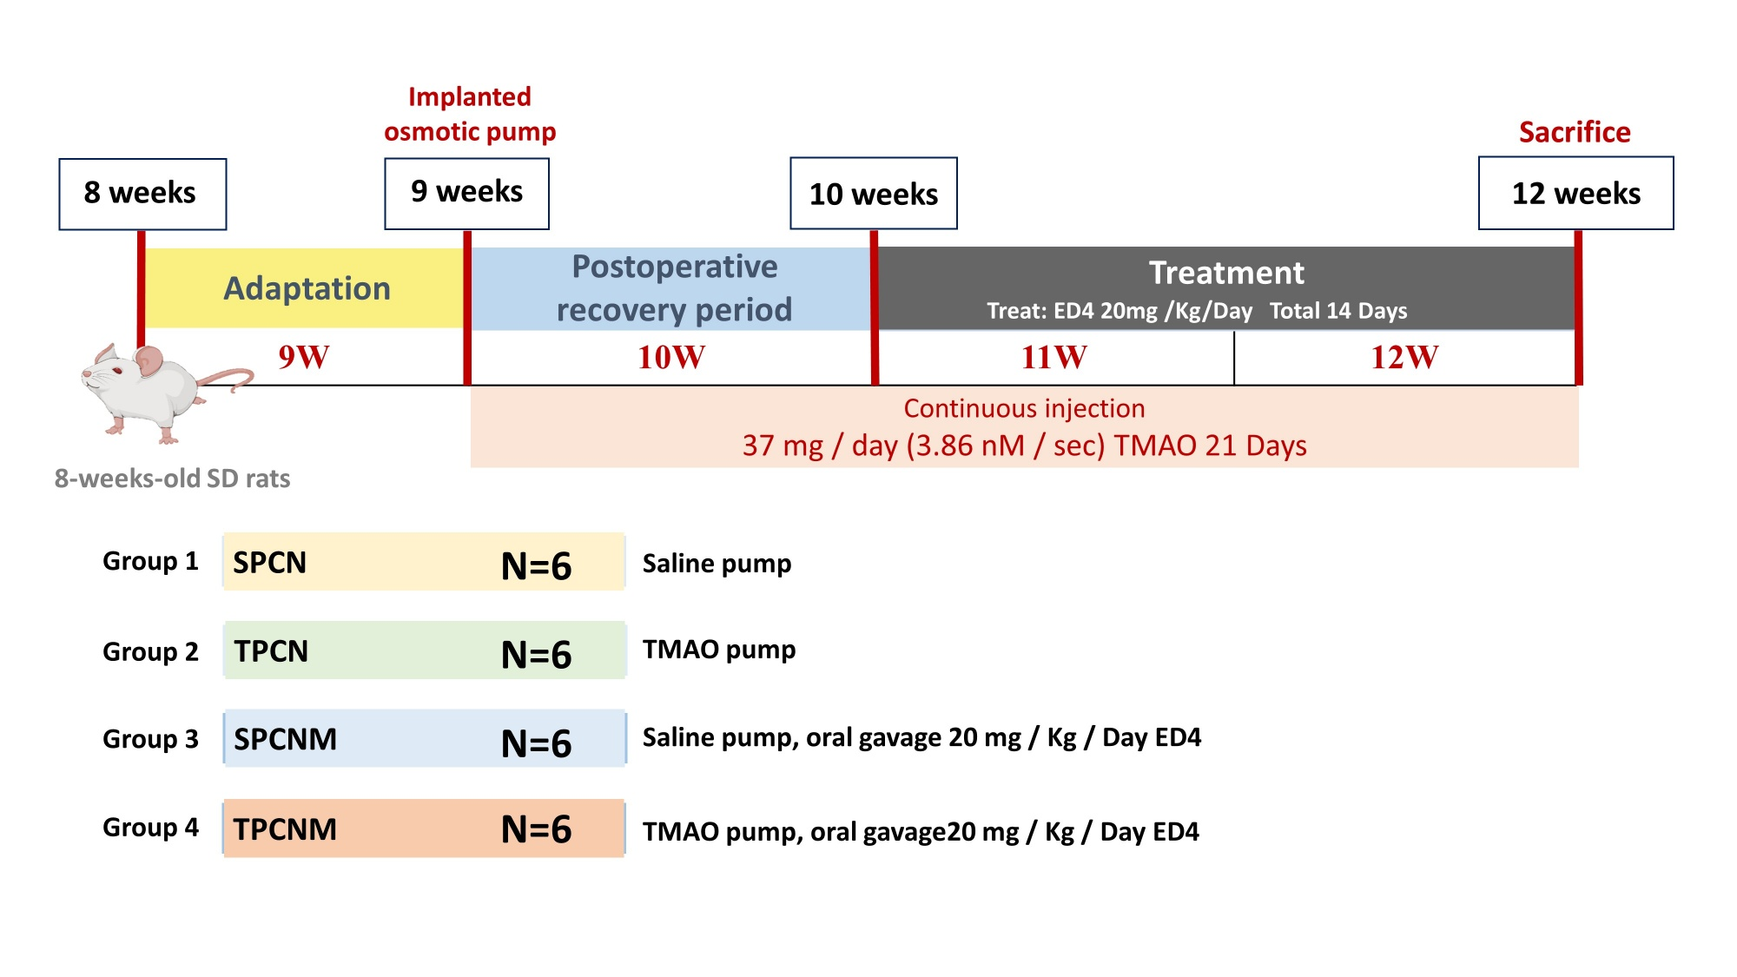
Fig. S1. Experiments design
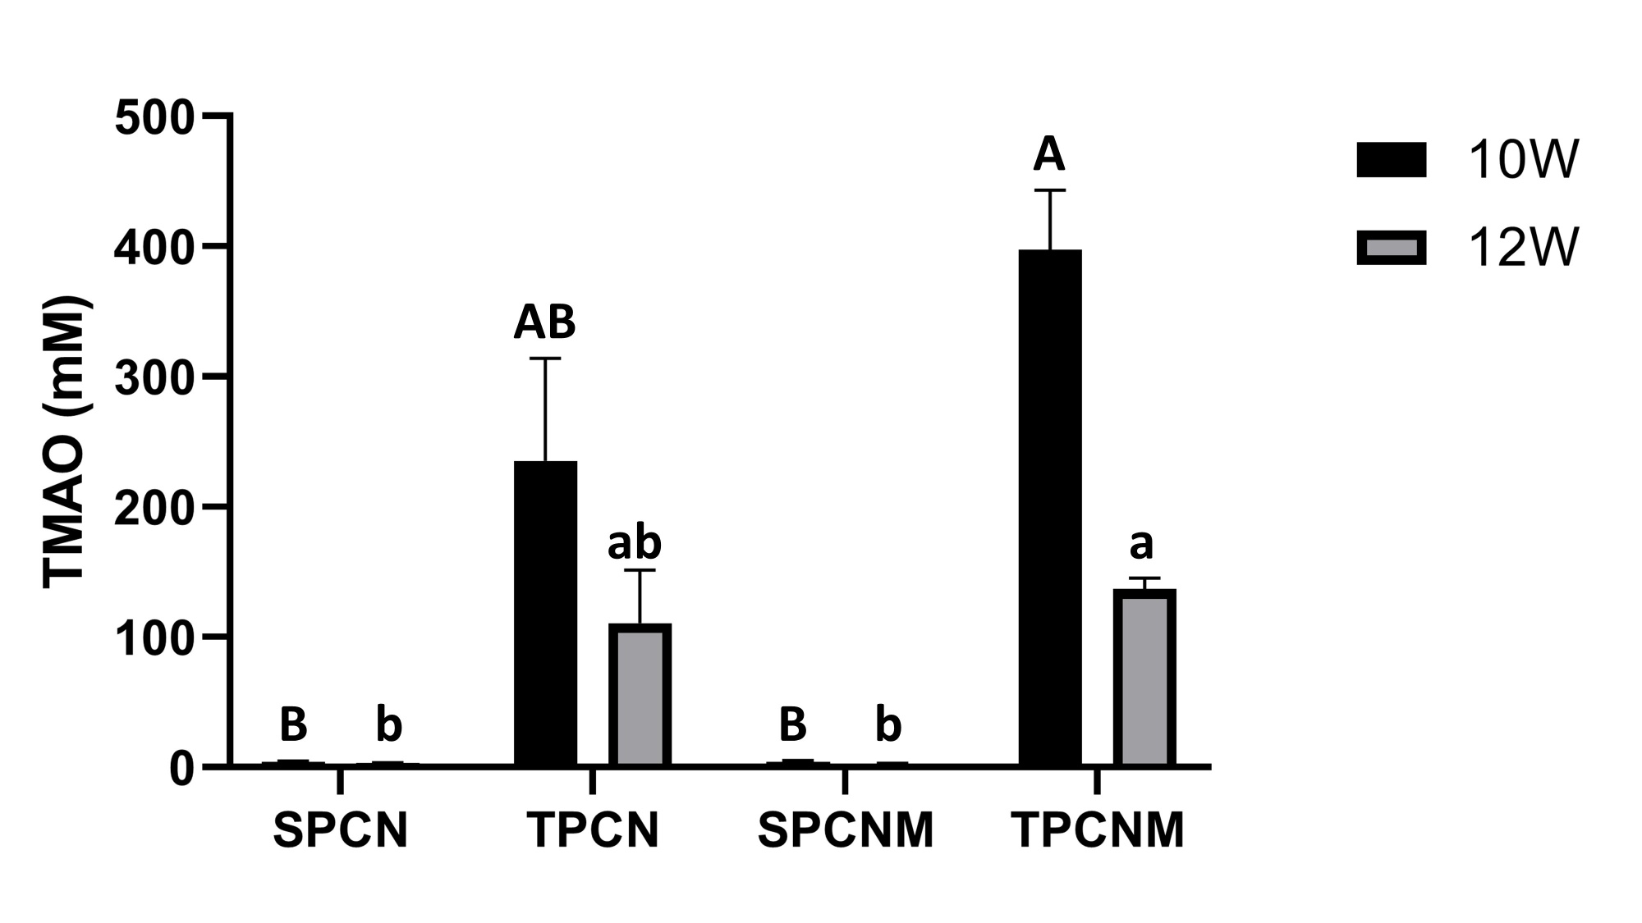
Fig. S2. Effect of continuous ED4 supplementation on urinary TMAP in rats exposed to high levels of systemic TMAO.
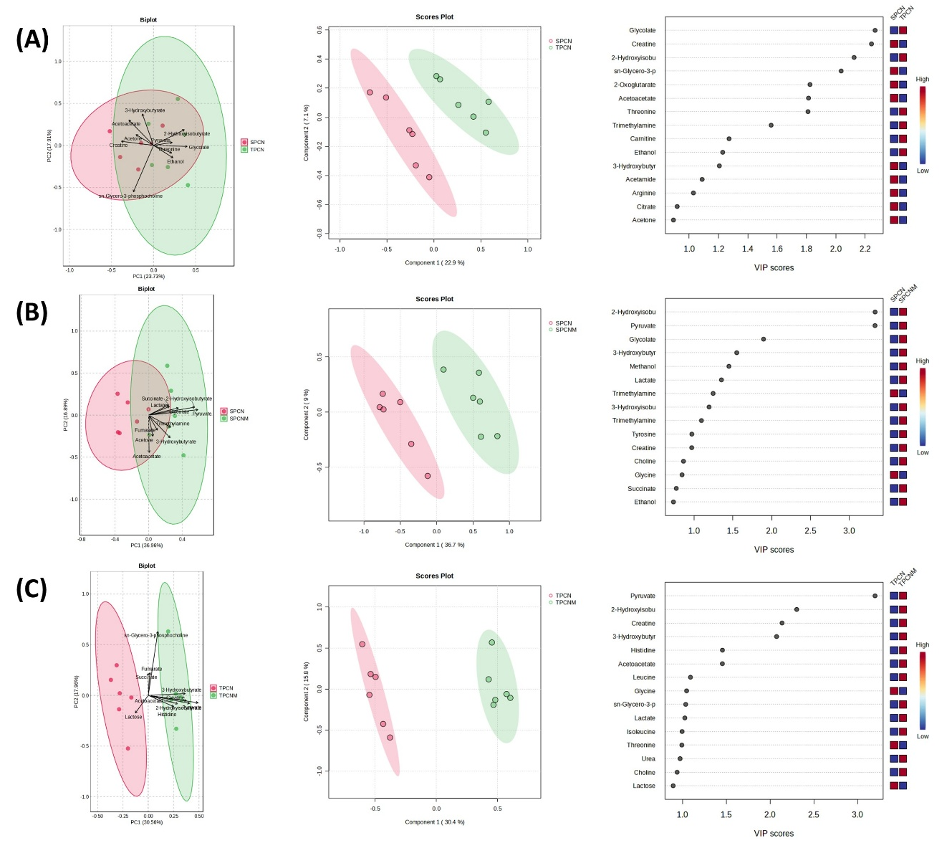
Fig. S3. Effect of continuous ED4 supplementation on serum metabolomics in rats exposed to high levels of systemic TMAO. Includes PCA plot, PLS-DA plot, and VIP scores from PLS-DA comparing SPCN vs. TPCN (A), SPCN vs. SPCNM (B), and TPCN vs. TPCNM (C).
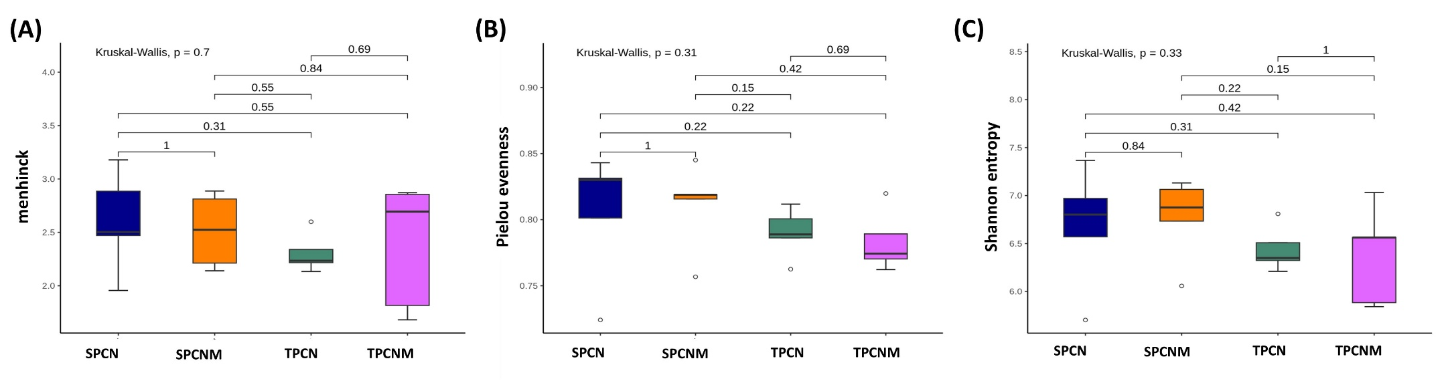

Fig. S4. Effects of continuous ED4 supplementation on α-diversity indices, including Menhinick index (A), Pielou's evenness (B), and Shannon entropy (C), in the intestinal microbiota of rats exposed to high systemic TMAO levels.

