Supplementary Data Information
Design, Synthesis, Structural, and Computational Studies of (Z)-2,2′,4,4′,5,5′-Hexahydroxy Stilbene as a Potential Antifungal Agent
Gopal Krishna Murthy H.R.^{* a}, Revanasiddappa H.D. ª, Shivaprakash. S ^{b}, Vennila Kailasam Natesan ^{c}, Mohammed Saleh Al Ansari ^{d}, Suhail Ahmad^{* e}
ª Department of Studies in Chemistry, University of Mysore, Mysuru-570005, Karnataka, India.
^{b} Former Scientist in Vittal Mallya Scientific Research Foundation, Bangalore, India.
^{c} Dept of Physics, PSNA College of Engineering and Technology, Dindigul, Tamil Nadu, India .
^{d}Department of Chemical Engineering, College of Engineering, University of Bahrain, Sakhir, Bahrain
^{e} Department of Chemistry, School of Sciences, Maulana Azad National Urdu University, Hyderabad, 500032, Telangana, India.

*Corresponding Author: suhailalig5187@gmail.com

Graphical Abstract

Figure 1: (Z)-2, 2', 4, 4', 5, 5'- Hexahydroxy stilbene

Figure 2: Synthesis of (Z)-2, 2', 4, 4', 5, 5'-Hexahydroxy stilbene

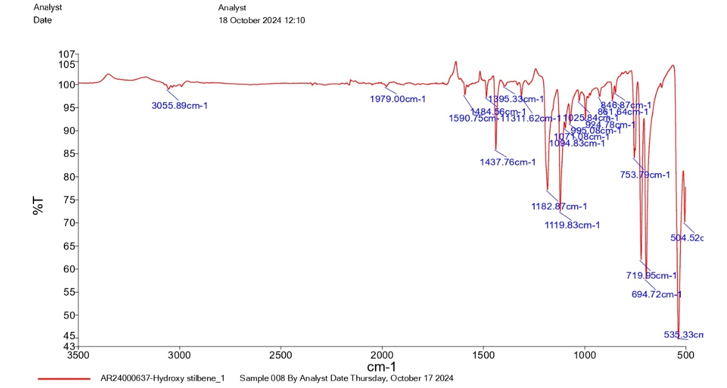
Figure 3: FTIR analysis of (Z) - 2, 2', 4, 4', 5, 5'-Hexahydroxy stilbene

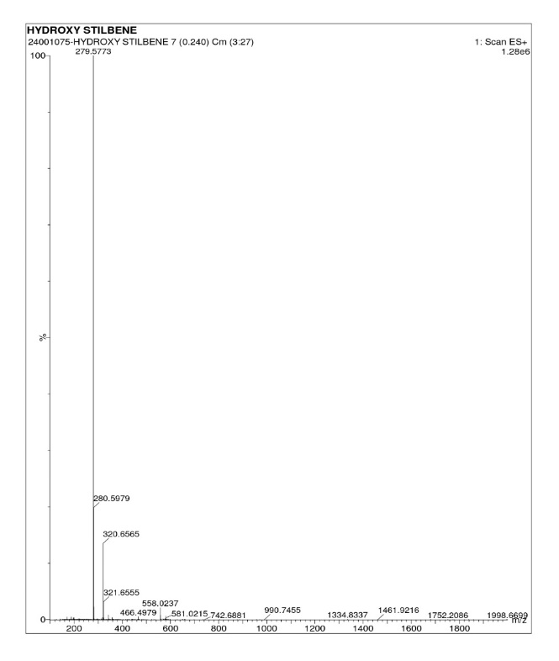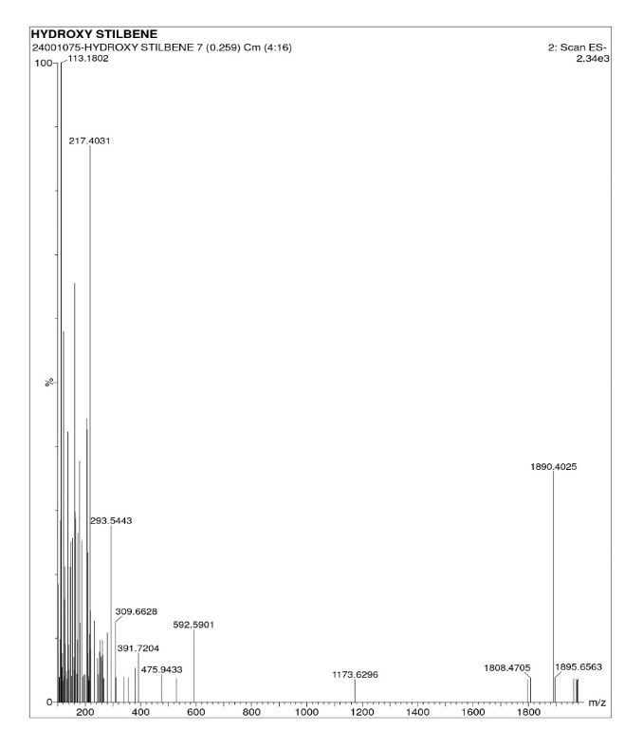
Figure 4: Mass spectrometry analysis of 2, 2', 4, 4', 5, 5'-Hexahydroxy stilbene

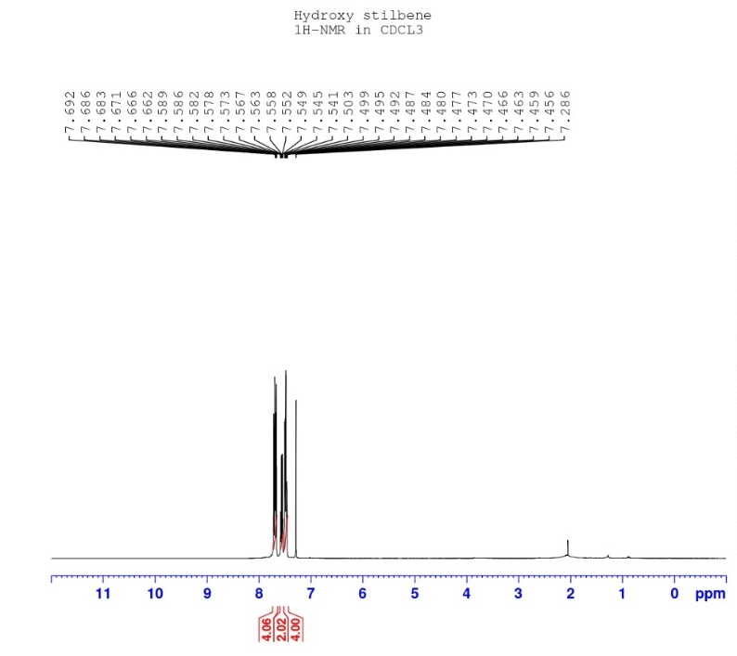
Figure 5: ¹H-NMR analysis of 2, 2', 4, 4', 5, 5'-Hexahydroxy stilbene

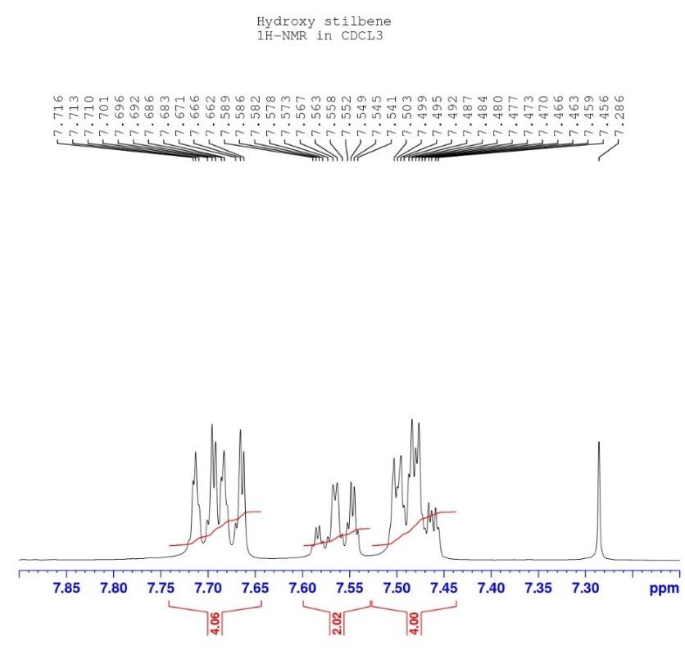
Figure 6: ¹H-NMR analysis of 2, 2', 4, 4', 5, 5'-Hexahydroxy stilbene

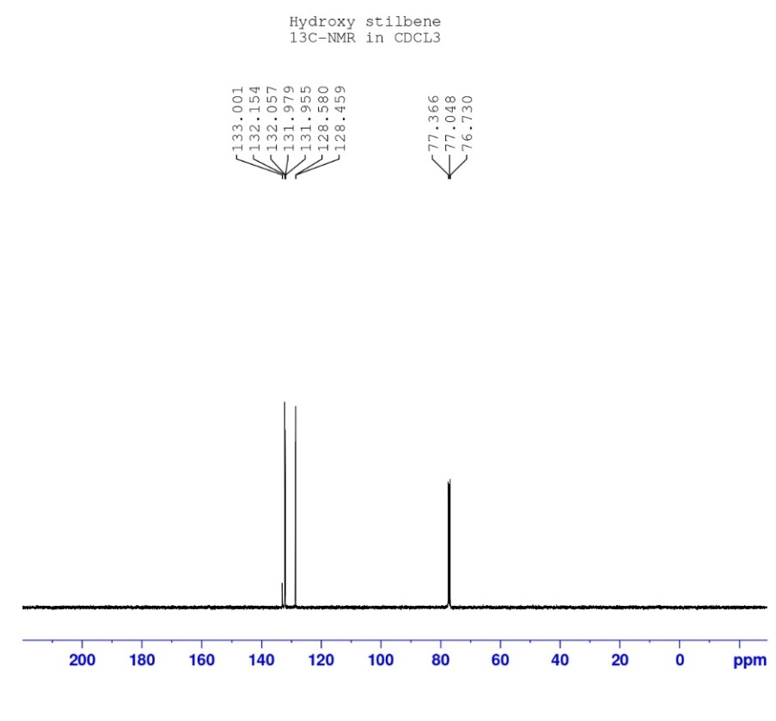
Figure 7: ¹³C-NMR analysis of 2, 2', 4, 4', 5, 5'-Hexahydroxy stilbene

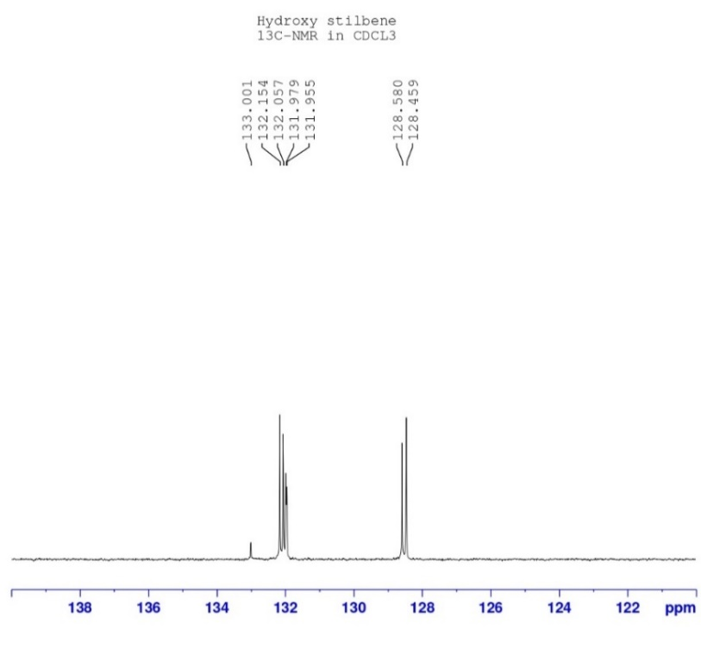
Figure 8: ¹³C-NMR analysis of 2, 2', 4, 4', 5, 5'-Hexahydroxy stilbene
Figure 9: XRD analysis of 2, 2', 4, 4', 5, 5'-Hexahydroxy stilbene

Table 1: Ramachandran plot favourable regions of proteins.
S.N. | -Protein Structure | Number of Residues in Favoured Regions (%) | Number of Residues in Allowed Regions (%) | Number of Residues in Disallowed Regions (%)
1 | Candida albicans (PDB ID:4HOE) |  |  | 0.0%
  93.3%
  6.7%

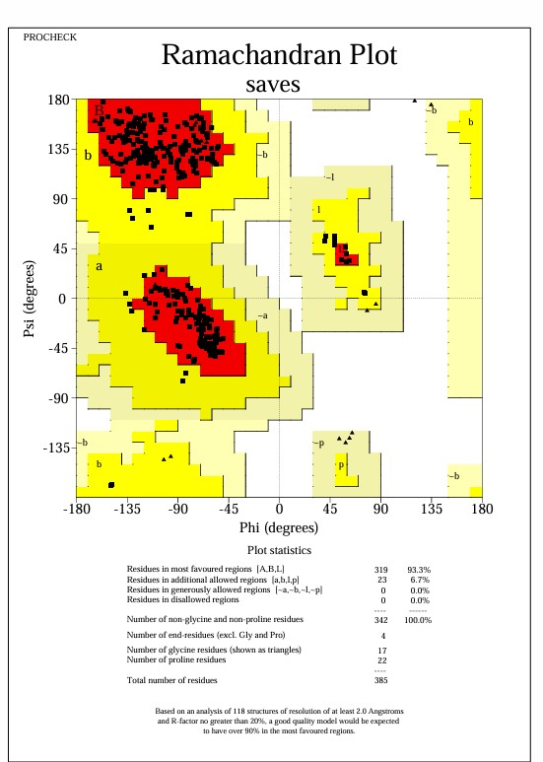
Figure 10: The Ramachandran plot generated from RAMPAGE. The Ramachandran plot representing energetically allowable regions for backbone dihedral angles ψ vs φ amino acid residues in selected protein structure (A) The structure Candida albicans (PDB ID:4HOE)

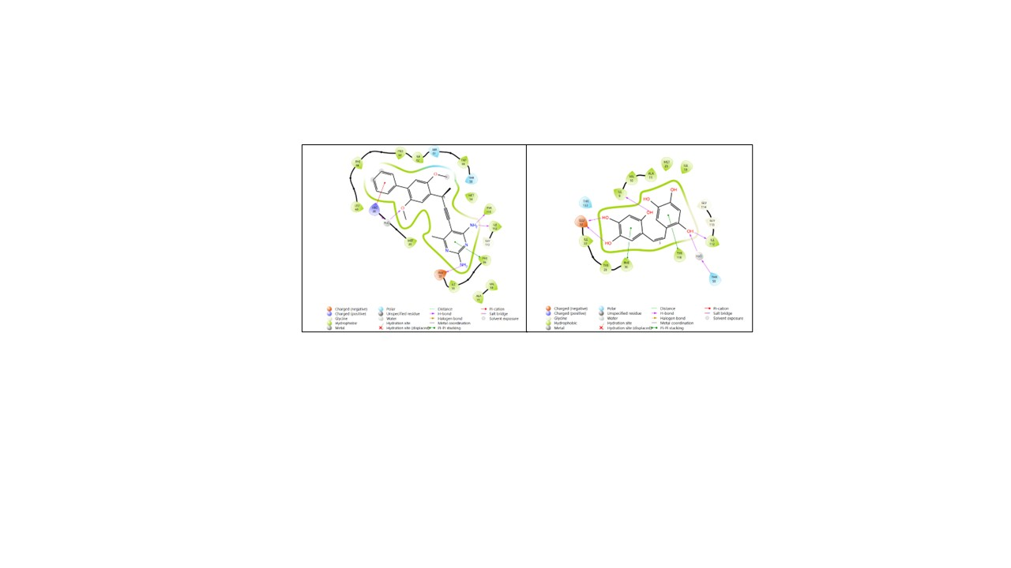
(A) (B)
Figure 11: 2-dimensional visualisation of molecular docking of Candida albicans (PDB ID: 4HOE) highlighting hydrogen bonds, hydrophobic interactions where (A) and (B) The molecular docking interactions of hydroxy stilbene with the fungal protein (PDB ID: 4HOE)

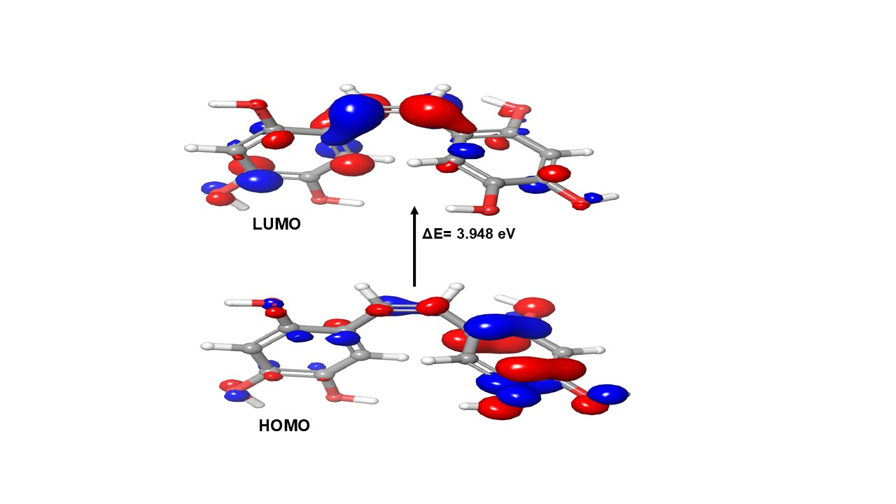
Figure 12 & Table 2: HOMO-LUMO Surface Structures energy gap (ΔE = 3.948 eV) of the stilbene derivative, highlighting its electronic stability and potential reactivity.

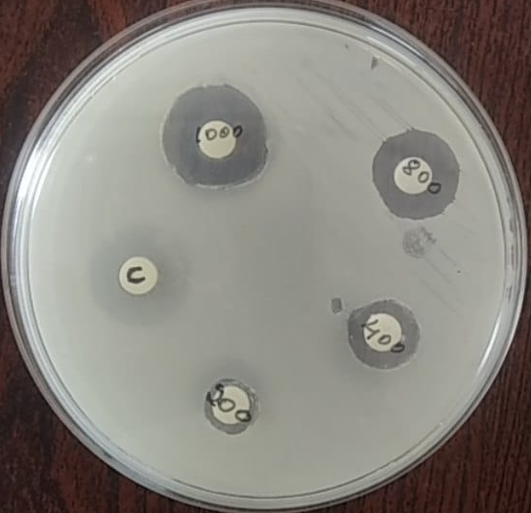
Figure 13: The inhibition of Candida albicans treated with 2, 2', 4, 4', 5, 5'-Hexahydroxystilbene at varying concentrations (200, 400, 800, 1000 µg/ml) and Itraconazole (10 µg/ml) as a positive control.

Table 3: Minimum inhibition concentration values
Compound | Concentration | Candida albicans
2, 2', 4, 4', 5, 5'-Hexahydroxystilbene | 200 µg/ml | 0.8 mm
2, 2', 4, 4', 5, 5'-Hexahydroxystilbene | 400 µg/ml | 2.4 mm
2, 2', 4, 4', 5, 5'-Hexahydroxystilbene | 800 µg/ml | 15.1mm
2, 2', 4, 4', 5, 5'-Hexahydroxystilbene | 1000 µg/ml | 18.2 mm
Itraconazole | 10 µg/ml | 16.1mm

