Supplement Table 1 Framework of PubChemFP Model with best performance

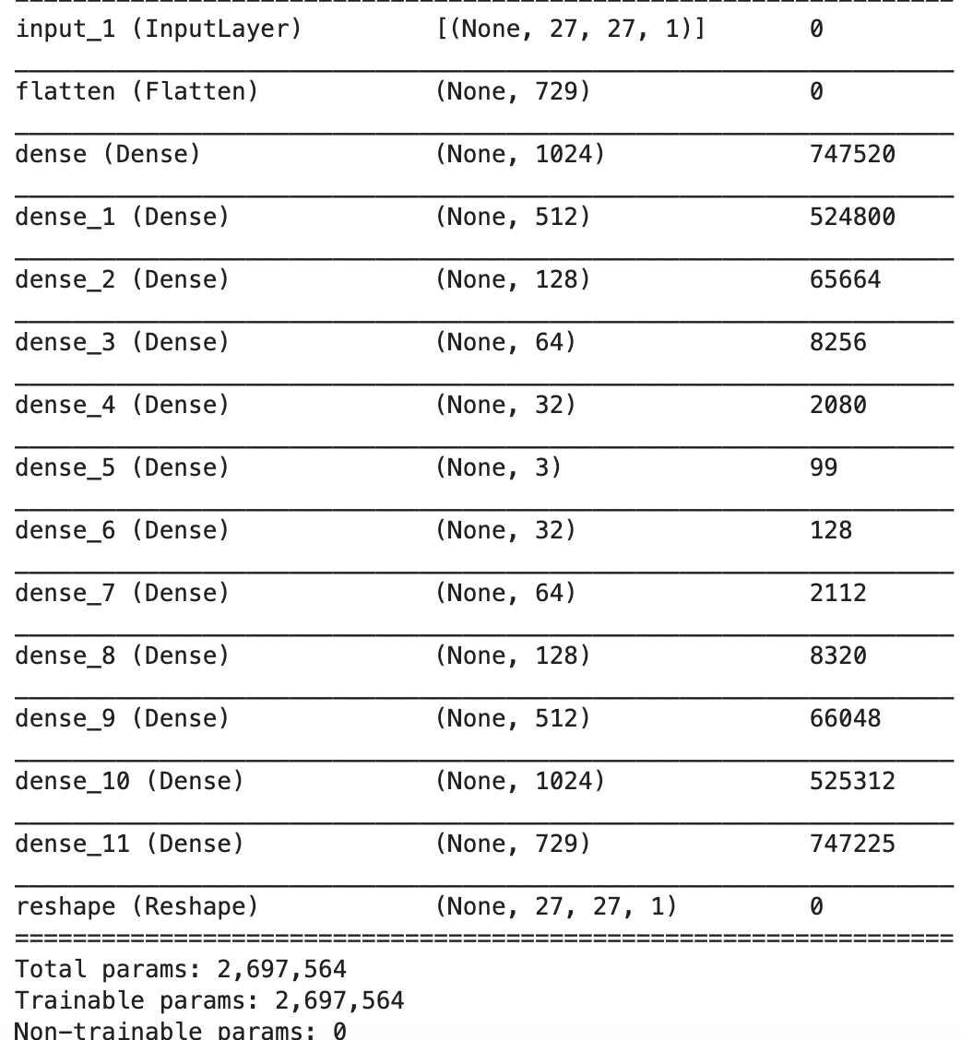

The first column represents input data, the numbering of fully connected layers, and output data. The second column displays the dimensions of input data, the node count of fully connected layers, and the dimensions of output data, with node counts such as "1024," "512," "128," etc. The last column indicates the parameter count required for connections between preceding and subsequent fully connected layers. Each Dense layer is followed by a activation ‘ReLU’ layer until the last reshape layer is preceded by a 'Sigmoid' activation layer.

Supplement Table 2 Framework of MACCSFP Model with best performance
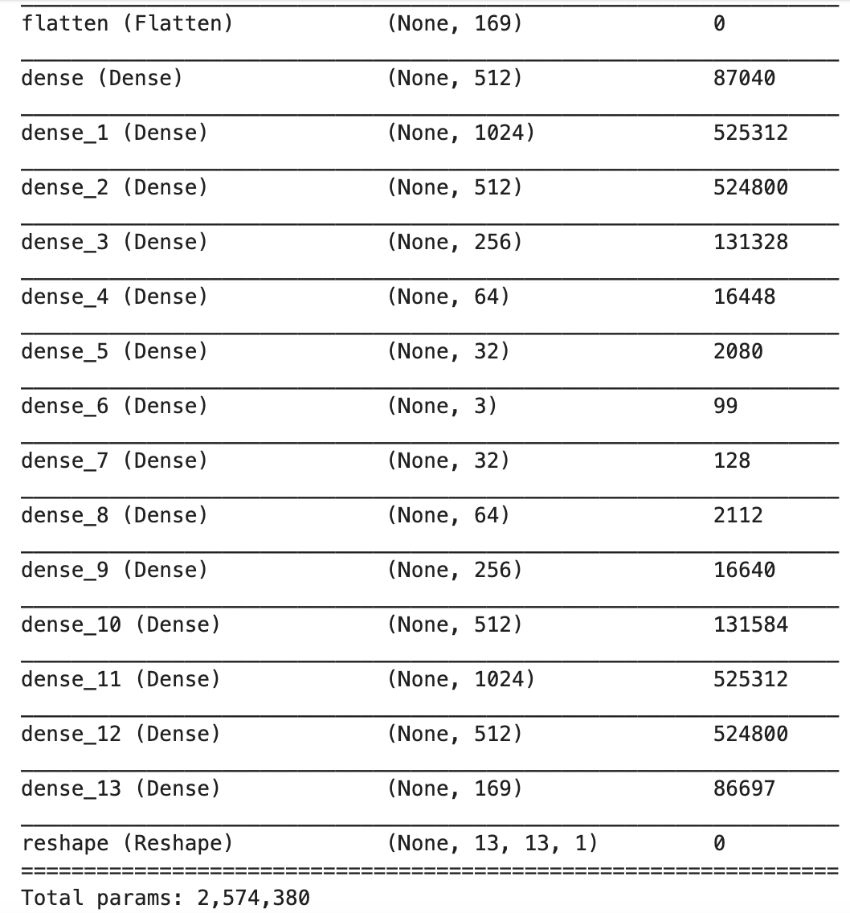

Supplement Table 3 Framework of PharmacoPFP Model with best performance
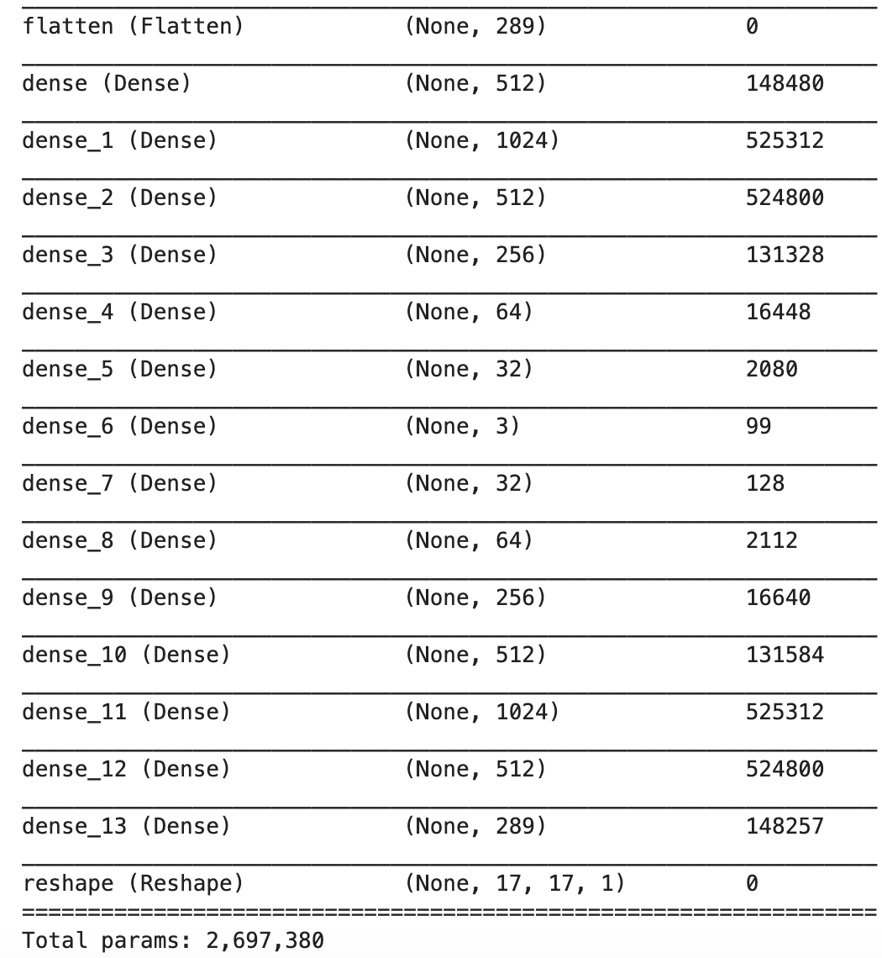

Supplement Table 4 Comparison of PubChemFP Parameters and Results
Parameter Number | Encoder Network Depth | Encoder Structure | Total Parameter Count | MSE
Parameter 1（best） | 5 | 1024-512-128-64-32 | 2697564 | 0.0245
Parameter 2 | 6 | 2048-1024-512-128-64-32 | 8388956 | 0.1400
Parameter 3 | 8 | 2048-1024-512-128-64-32-16-8 | 8390140 | 0.0750
Parameter 4 | 9 | 2048-1024-512-256-128-64-32-16-8 | 8587260 | 0.0690
Parameter 5 | 8 | 1024-512-256-128-64-32-16-8 | 2895868 | 0.0400
Parameter 6 | 7 | 1024-512-256-128-64-16-8 | 2892732 | 0.0525
Parameter 7 | 7 | 2048-1024-256-128-64-32-8 | 7799004 | 0.0800
Parameter 8 | 7 | 2048-1024-512-128-64-32-8 | 8389340 | 0.0848
Parameter 9 | 4 | 512-128-64-32 | 900444 | 0.0269
Supplement Table 5 Comparison of MACCSFP Parameters and Results
Parameter Number | Encoder Network Depth | Encoder Structure | Total Parameter Count | MSE
Parameter 1 | 5 | 1024-512-128-64-32 | 1550124 | 0.0555
Parameter 2 | 5 | 256-128-64-32-16 | 174828 | 0.0520
Parameter 3 | 5 | 512-512-256-64-16 | 997292 | 0.0455
Parameter 4 | 6 | 256-512-256-128-64-16 | 697516 | 0.0475
Parameter 5 | 6 | 512-1024-512-128-64-16 | 2424492 | 0.0455
Parameter 6 | 6 | 512-1024-512-256-64-16 | 2572204 | 0.0430
Parameter 7 | 6 | 512-1024-512-128-64-32 | 2426668 | 0.0462
Parameter 8 | 6 | 512-1024-512-128-64-32 | 2426668 | 0.0440
Parameter 9（best） | 6 | 512-1024-512-256-64-32 | 2574380 | 0.0390

Supplement Table 6 Comparison of PharmacoPFP Parameters and Results
Parameter Number | Encoder Network Depth | Encoder Structure | Total Parameter Count | MSE
Parameter 1（best） | 6 | 512-1024-512-256-64-32 | 2697380 | 0.0245
Parameter 2 | 6 | 1024-512-512-256-64-32 | 2469028 | 0.0250
Parameter 3 | 5 | 1024-512-256-64-32 | 1943716 | 0.0260
Parameter 4 | 5 | 512-512-256-64-32 | 1122468 | 0.0260

