Supplementary Figure 1 Comparison of Feature Maps before and after Reconstruction for 10 bioactive Molecules in PubChemFP channel. White pixels represent values of 1, colored dots represent values of 0. Transparency is proportional to the value of the predicted result.
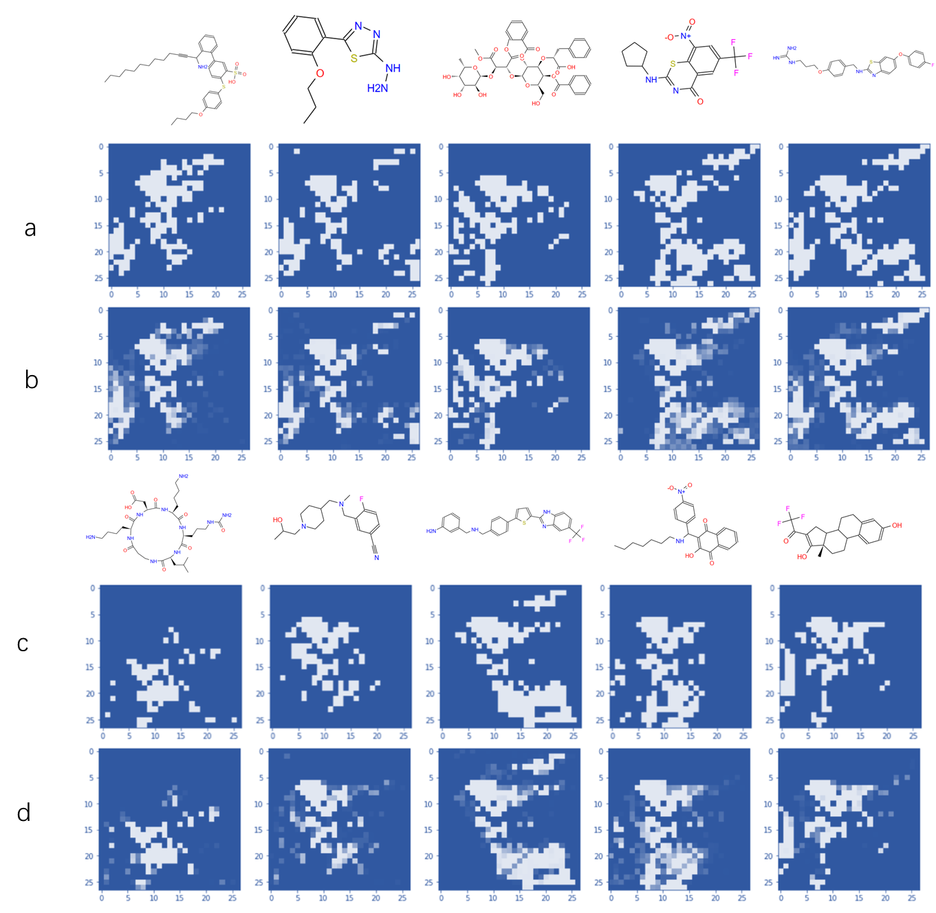

Supplementary Figure 2 Comparison of Feature Maps before and after Reconstruction for 10 bioactive Molecules in MACCSFP channel.

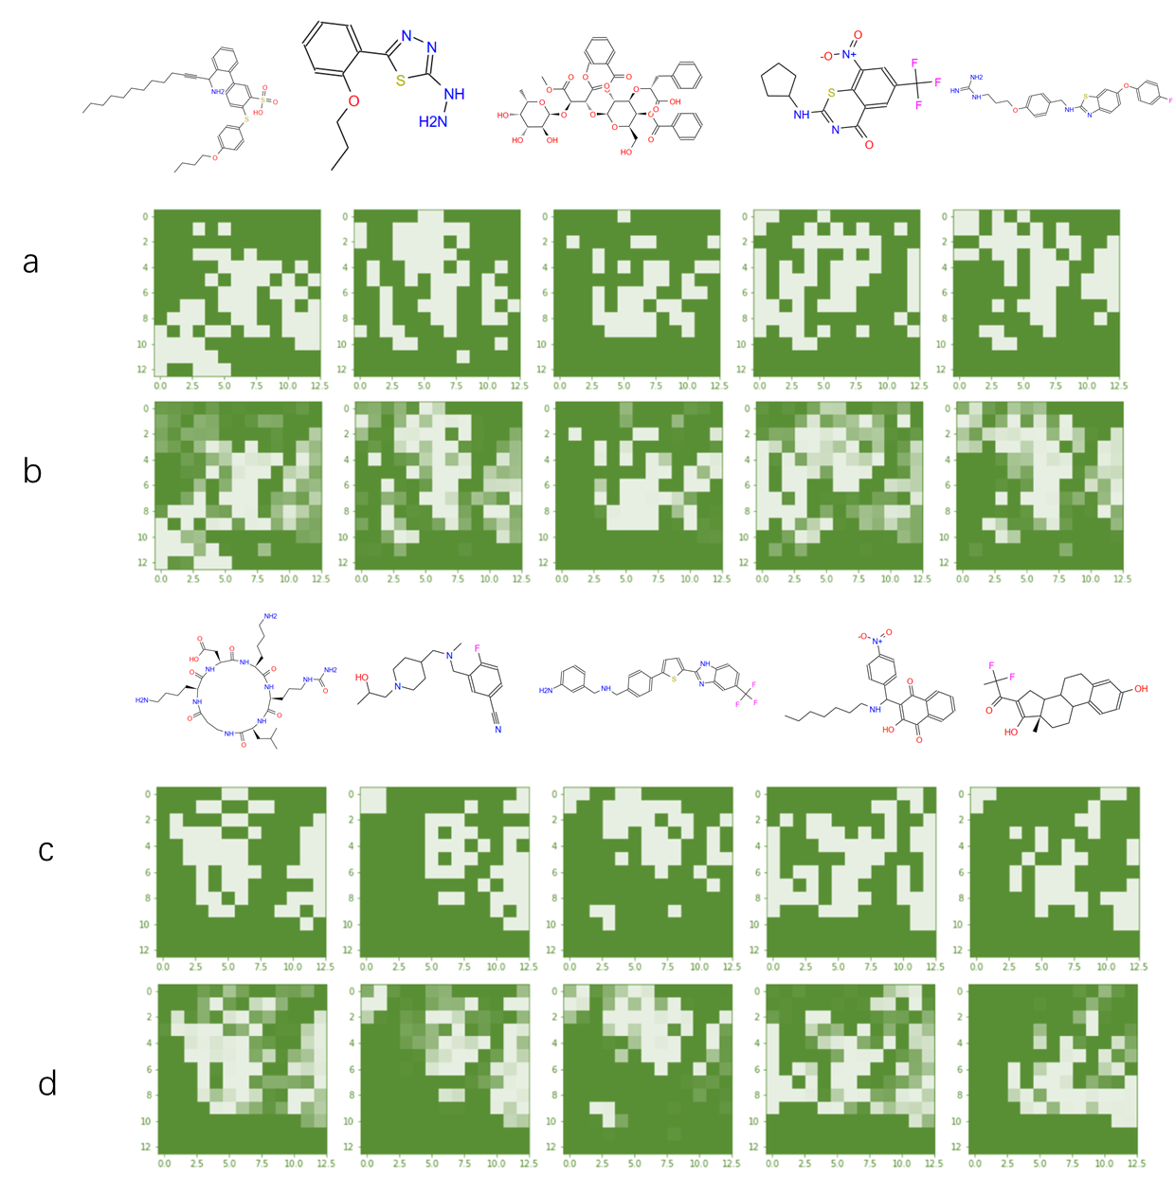

Supplementary Figure 3 Comparison of Feature Maps before and after Reconstruction for 10 bioactive Molecules in PharmacoErGFP channel.

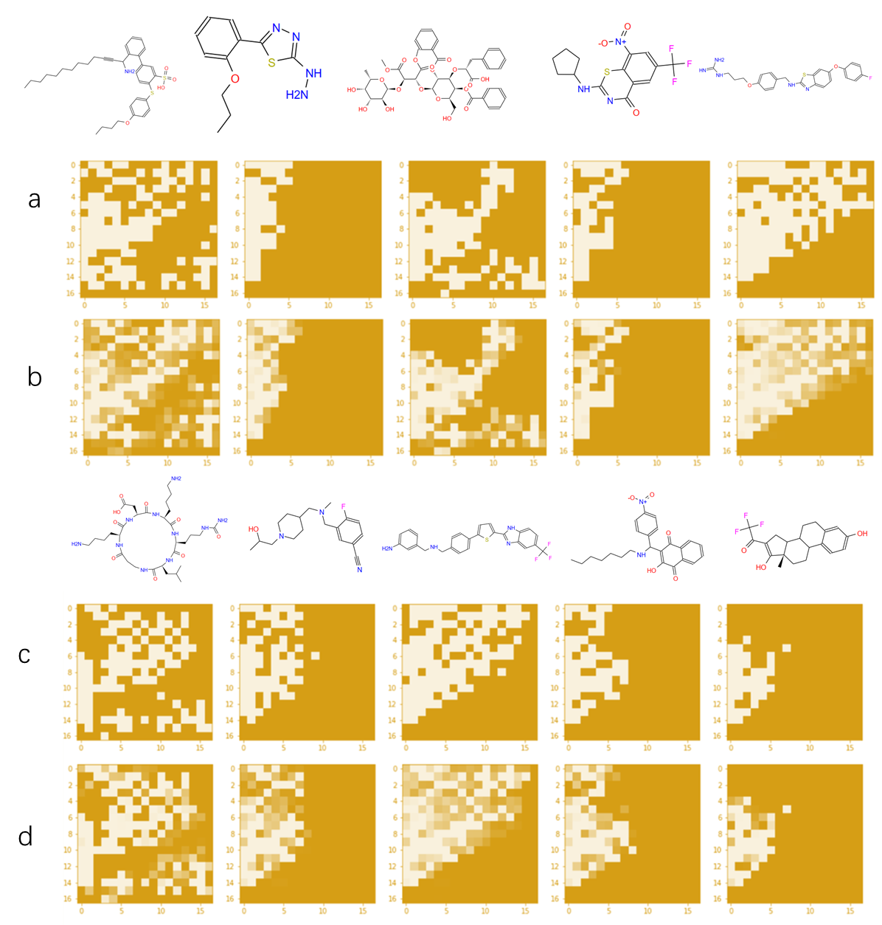

Supplementary Figure 4 (a) Original PubChemFP feature maps for 5 Bioactive Molecules. (b-j) Visual Reconstruction Effect of PubChemFP feature maps with Parameter 1-9.
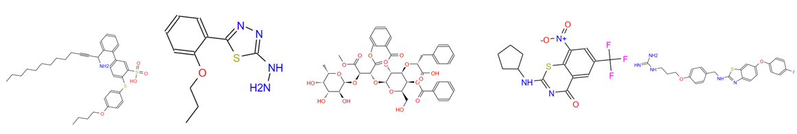
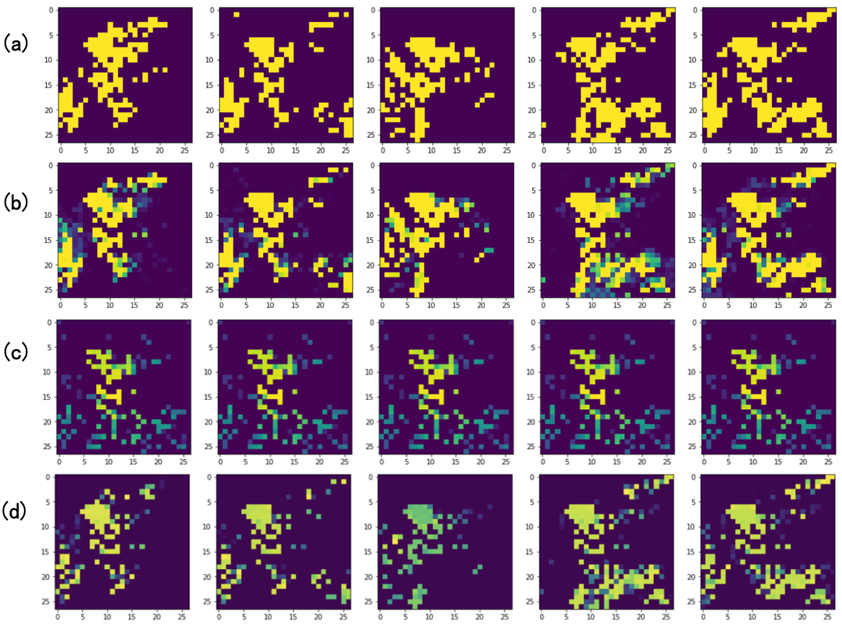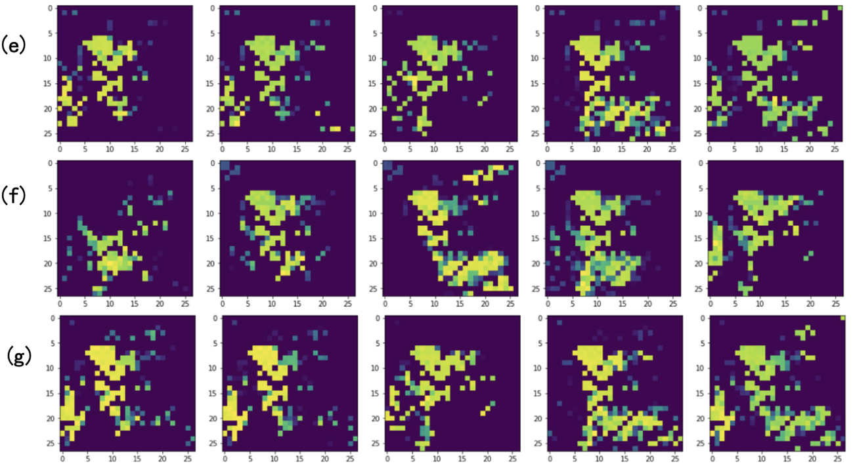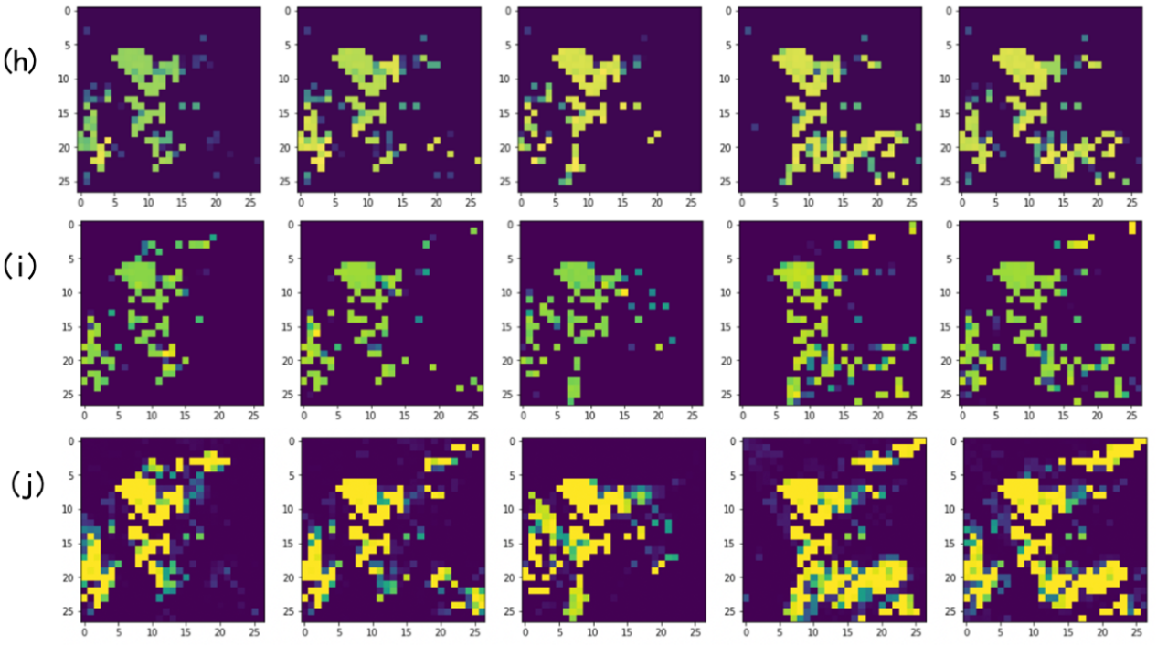
Supplementary Figure 5 (a) Original MACCSFP feature maps for 5 Bioactive Molecules. (b-j) Visual Reconstruction Effect of MACCSFP feature maps with Parameter 1-9.

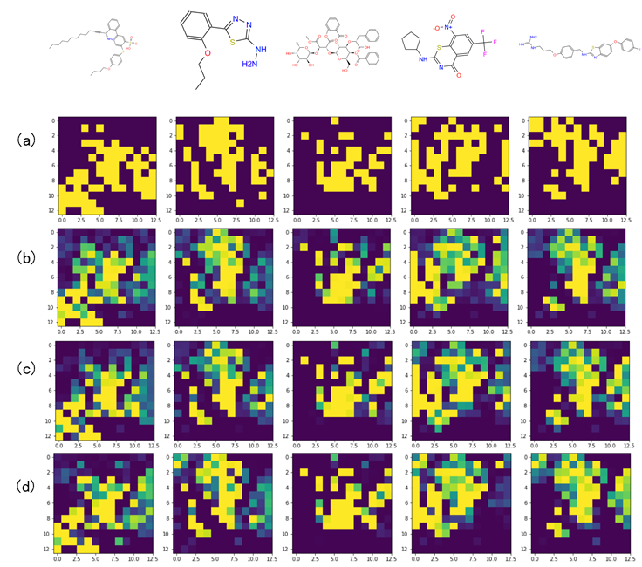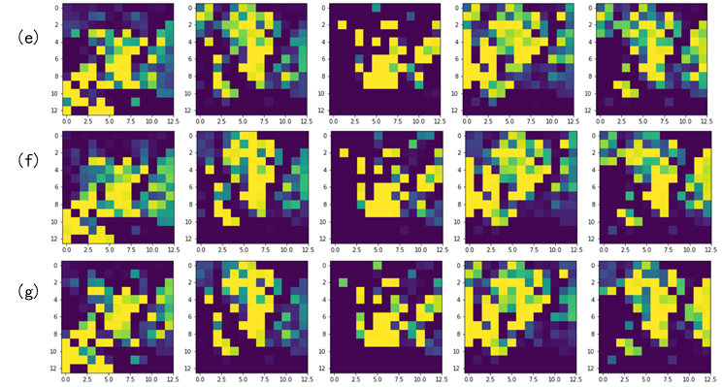
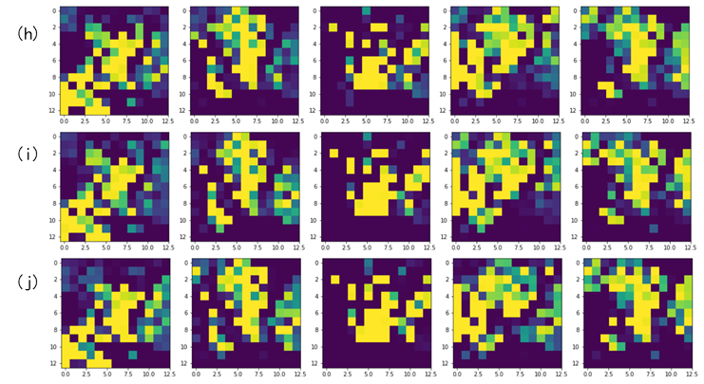

Supplementary Figure 6 (a) Original PharmacoErGFP feature maps for 5 Bioactive Molecules. (b-e) Visual Reconstruction Effect of PharmacoErGFP feature maps with Parameter 1-4.
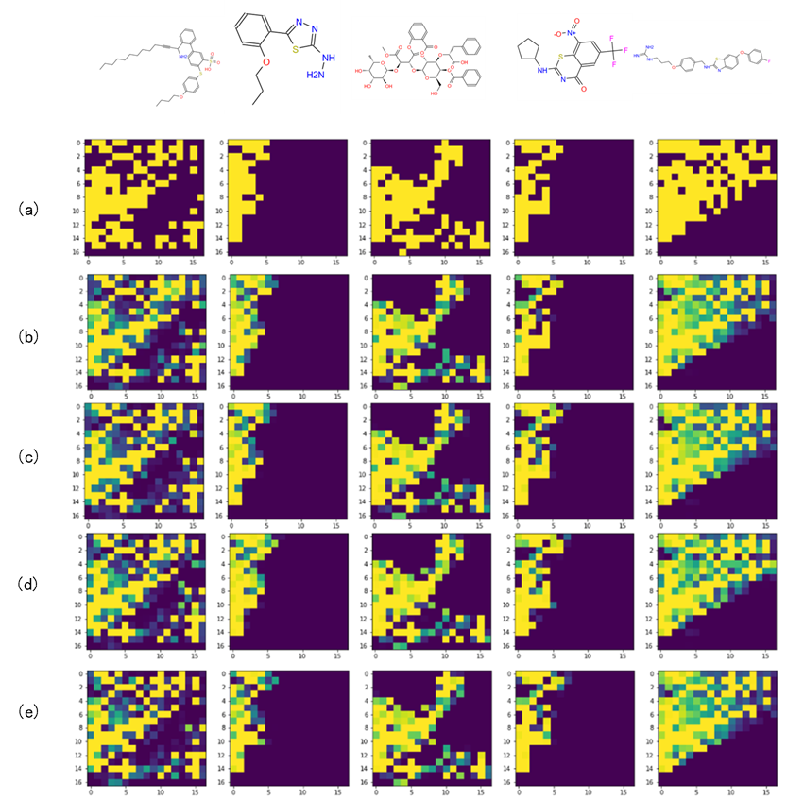

Supplementary Figure 7 Chempack software demonstrates the bioactive molecular distribution targeting different proteins in 3D latent space (PubChemFP channel). (a) Distribution of all samples (1.9 million data). (b) Distribution of samples corresponding to four target types (approximately 300,000 data). (c-d) Enrichment of bands Targeted Kinase. (e) Enrichment of bands Targeted protease. (f) Enrichment of bands Targeted GPCR.

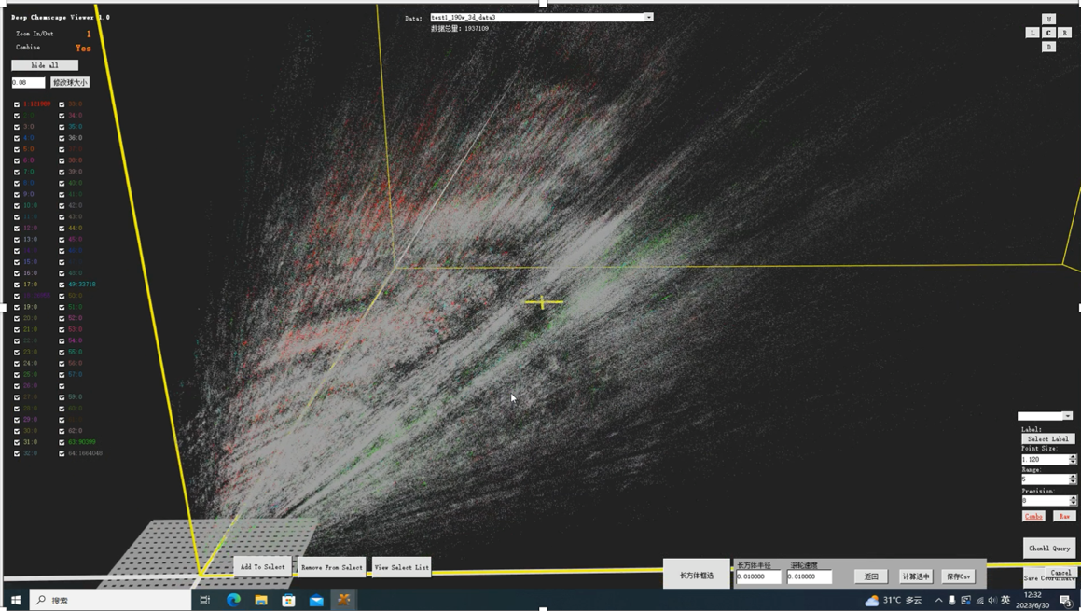

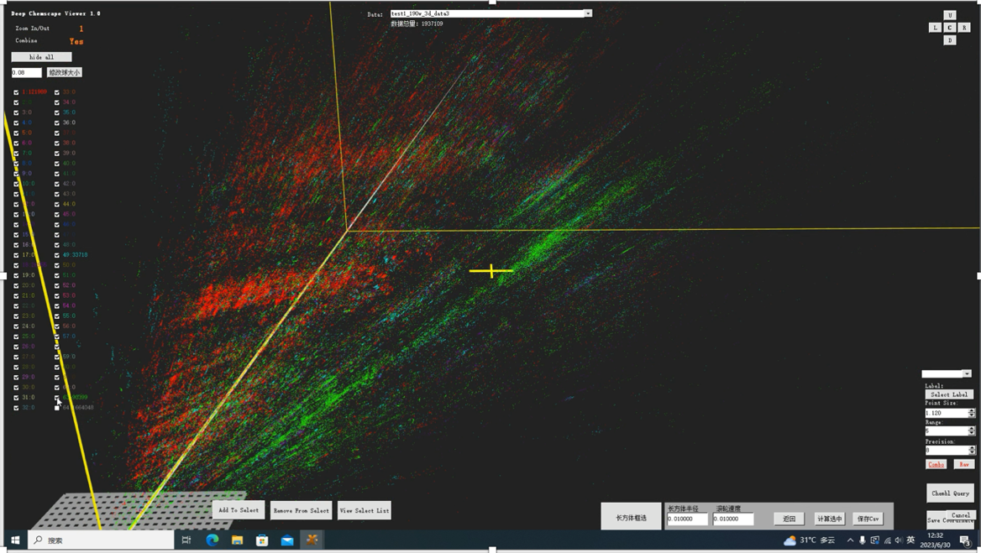

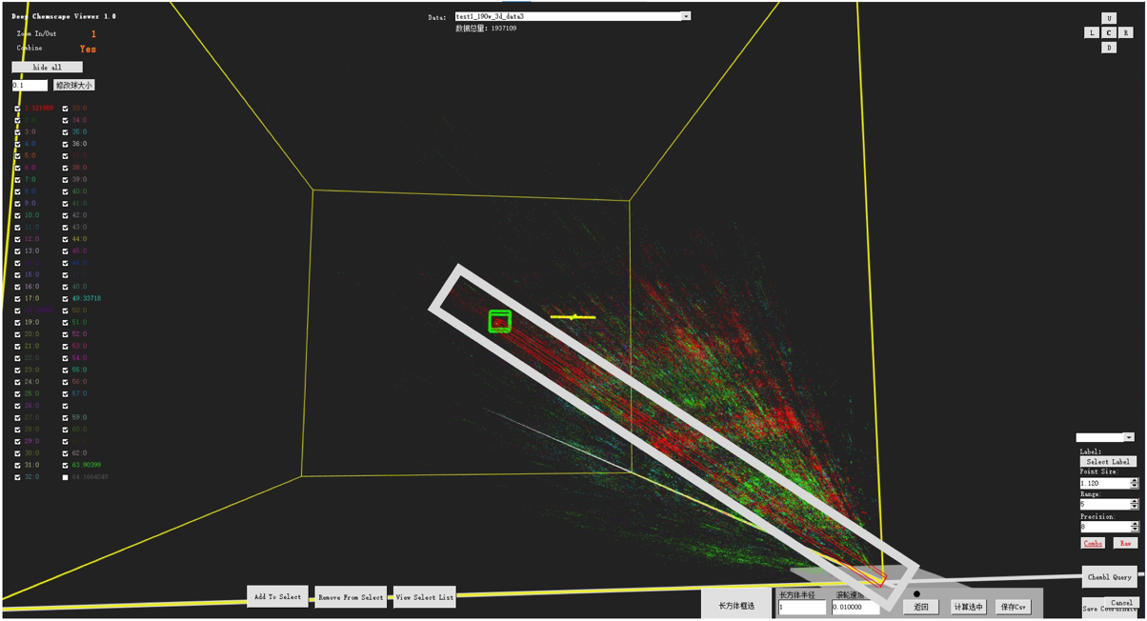

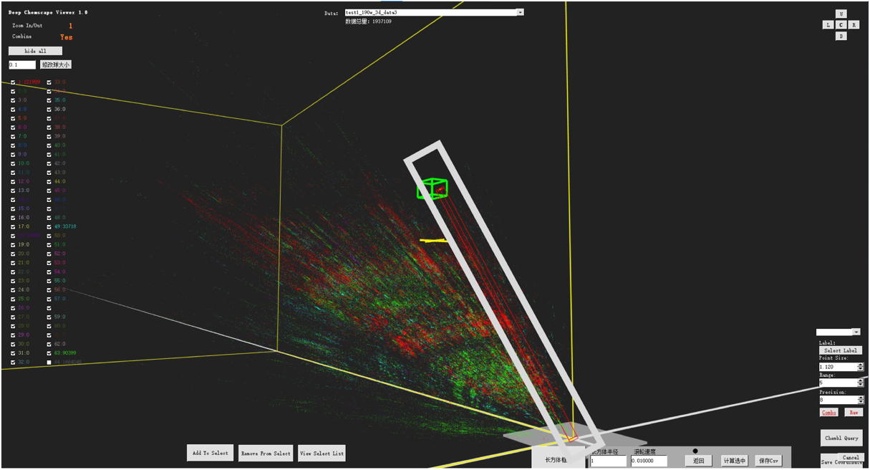
(e)
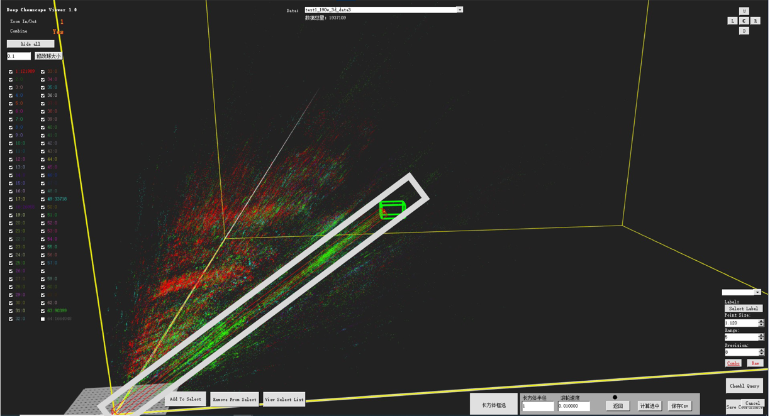
(f)
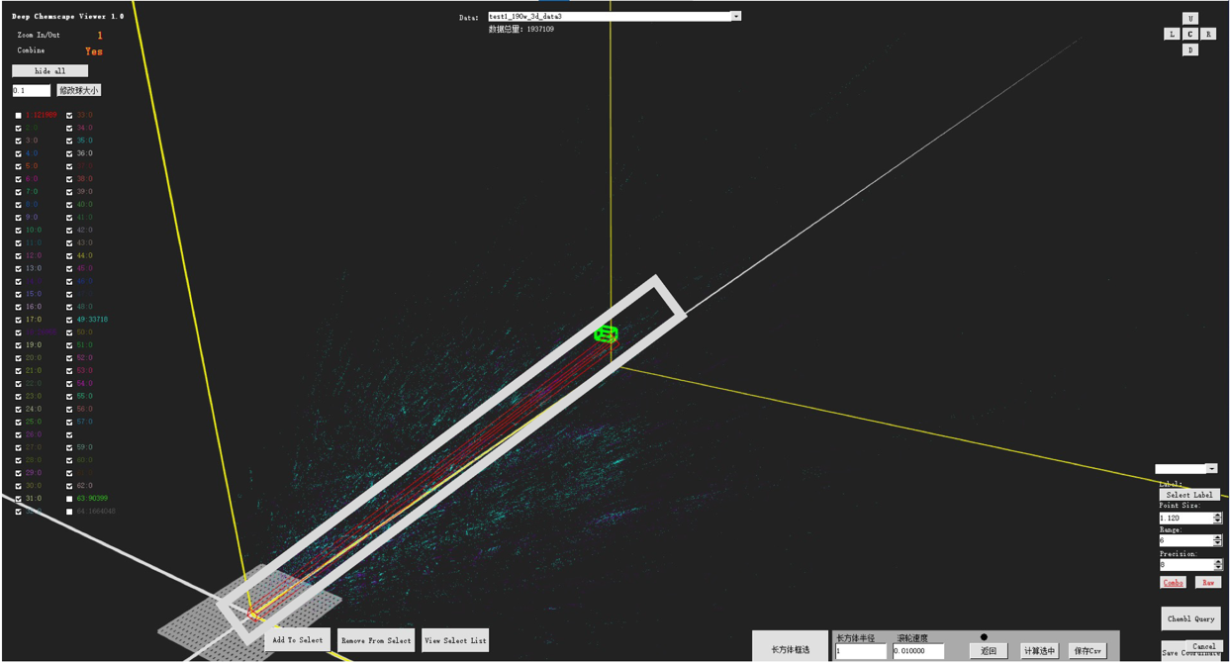

Supplementary Figure 8 Chempack software demonstrates the bioactive molecular distribution targeting different proteins in 3D latent space (MACCSFP channel). (a) Distribution of all samples (1.9 million data). (b) Distribution of samples corresponding to four target types (approximately 300,000 data). (c) Enrichment of band Targeted Kinase.

(b)
(c)
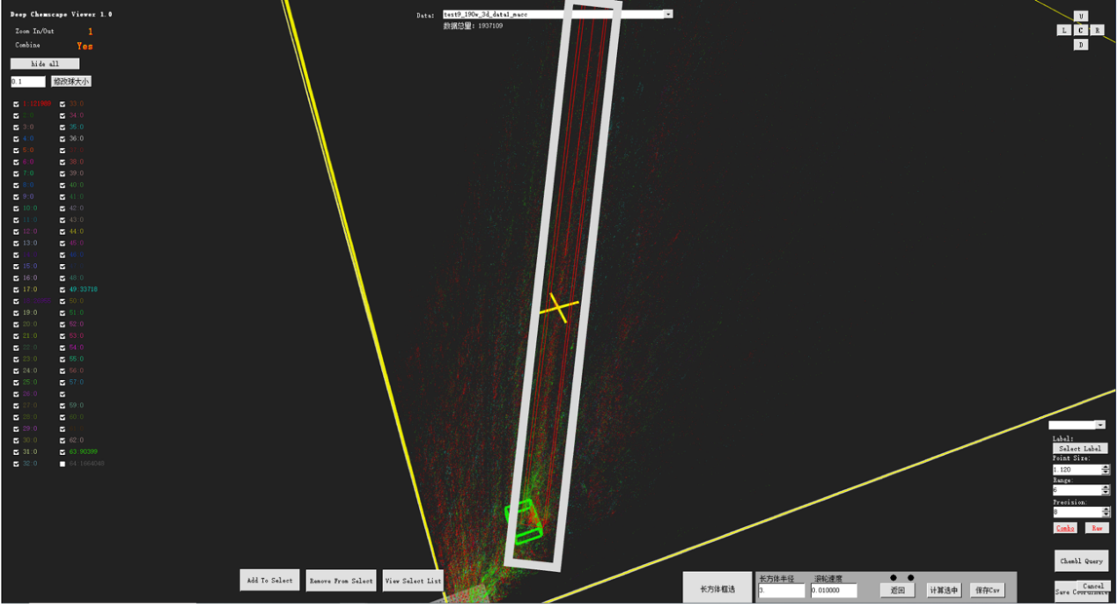
Supplementary Figure 9 Chempack software demonstrates the bioactive molecular distribution targeting different proteins in 3D latent space (PharmacoPFP channel). (a) Distribution of all samples (1.9 million data). (b) Distribution of samples corresponding to four target types (approximately 300,000 data). (c) Enrichment of band Targeted Kinase.

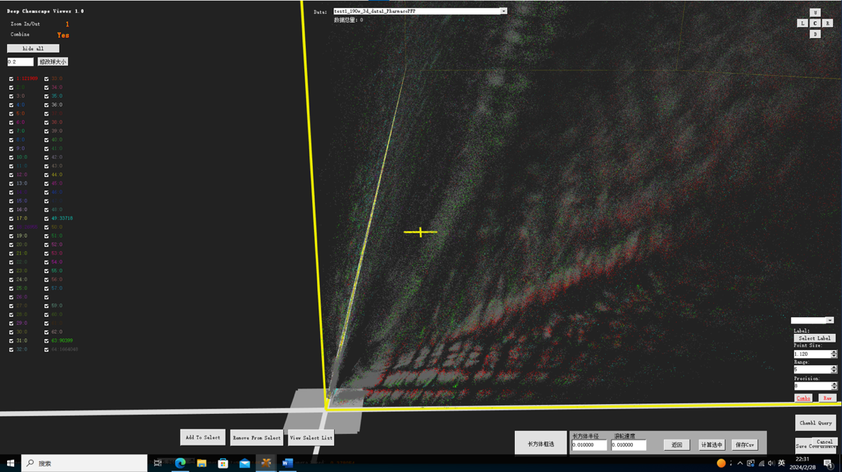

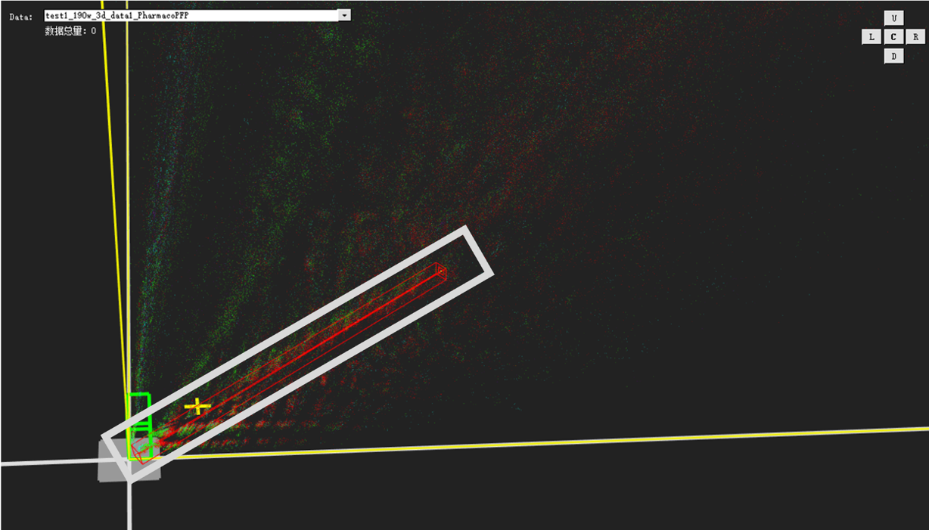

Supplementary Figure 10 The distribution of different types of targets in each set of bands.

Supplementary Figure 11 Position of the top 10 target families mapped onto a phylogenetic representation of the human kinome, and the proportion in the band. The families are classified according to different groups. The height of the columns represents the properties in a specific family in different enrichment bands (PubChem: Band1, band2; MACCSFP: band5; PharmacoErGFP: band6). The purple dots are the locations and tags of the representative kinases of the targeted family. (b) FDA approved drug mapped onto a phylogenetic representation of the human kinome.
(a)
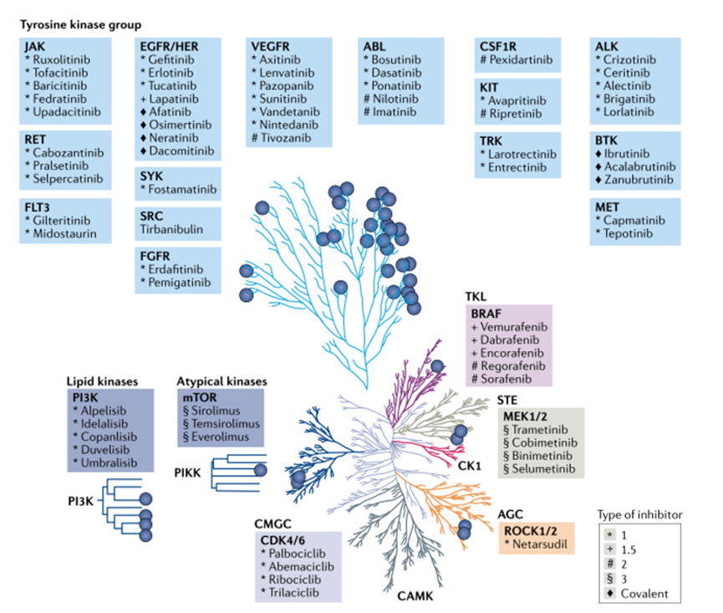
(b)

Supplementary Figure 12 The proportion of the substructural characteristics of different molecular fingerprints channels (PubChemFP: band1-4 MACCSFP: band5 PharmacoErGFP: band6; Kinase-enriched:band1-2,5-6, Protease:band3, GPCR:band4). (a) The top 20 substructural features in and proportions in Protease (Band3) and GPCR (band4). (b) Top20 in PubChemFP bands (band1,2) in comparison with Protease (band3) and GPCR (band4). (c) The most frequently occurring substructures in the four kinase-enriched bands (Band 1: 14.72%, Band 2: 23.92%, Band 5: 24.48%, Band 6: 19.64%). The . illustrates the top 20 substructures. 2D structure for 3 examples randomly selected in band1 and band5 (d-e) Complete list of substructures sorted by band1 (Top 0~25, 25~50).
(a)
(b)

(c)
(d)

(e)

Supplementary Figure 13 Different types of A-B-C substructural elements used in the article.

A | B | C
a1aaaaa1  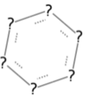 | NC-N-CN  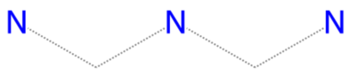 | a1aaaaa1
Blank | NC-N-C  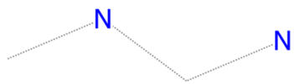 | a1aaaa1  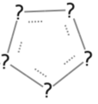
 | C-N-CS  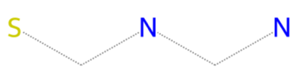 | Blank
NC-N-CCN
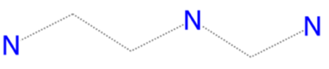
N-N-N
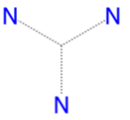
N-O-N
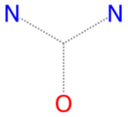
N-S-N
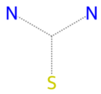
O-N-O
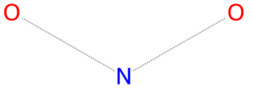
N-N-CN
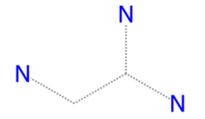
N-N-CCN
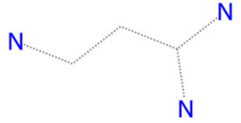
N-N-C
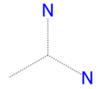
N-O-CN
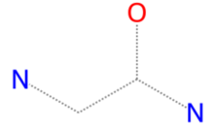
N-O-C
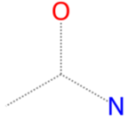
N-S-CN
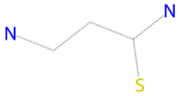
ON-CO
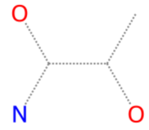
 | NC-NC-CN 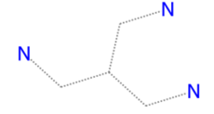
 | N-N-CN
 | N-N-CCN
 | N-N-C
 | N-O-CN
 | N-O-C
N-S-CN
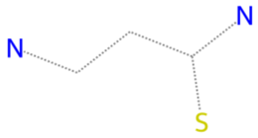
 | ON-CO
 | NC-NC-CN

Supplementary Figure 14 Landscape of local islands in band 1-6.
(a) Band1
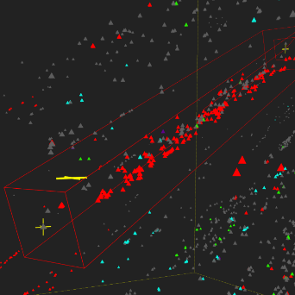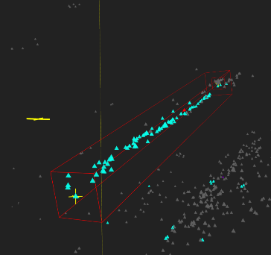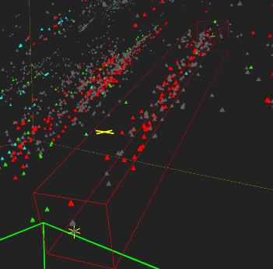
(b) Band2
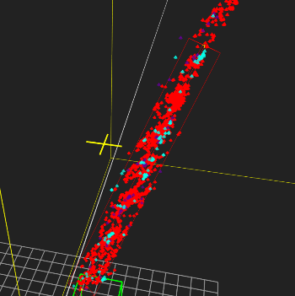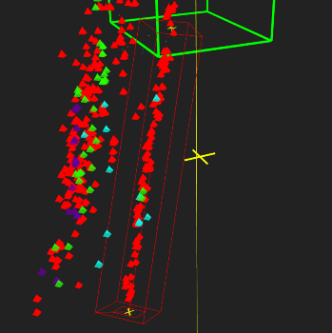
(c) Band3
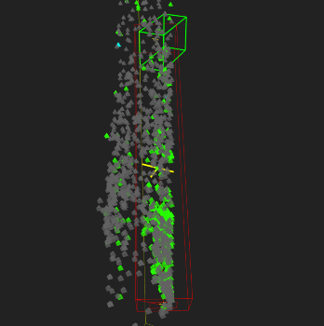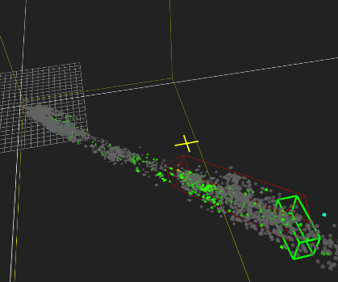
(d) Band4
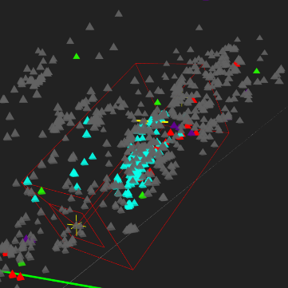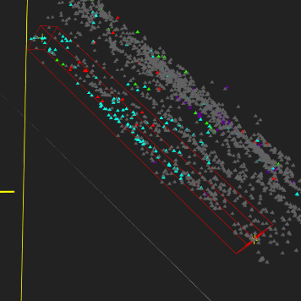

(e) Band5
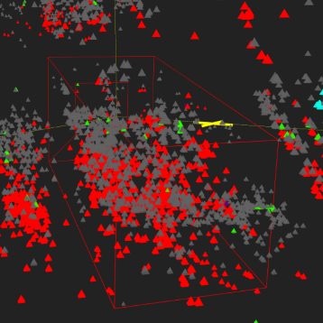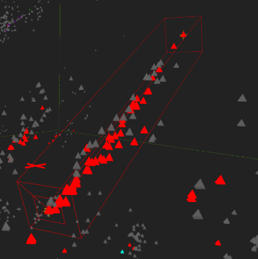
Supplementary Figure 15 (a-c) Randomly choose Molecule Properties in the GPCR island of Kinase Band 1. (d-f) Randomly choose Molecule properties in Kinase band1.
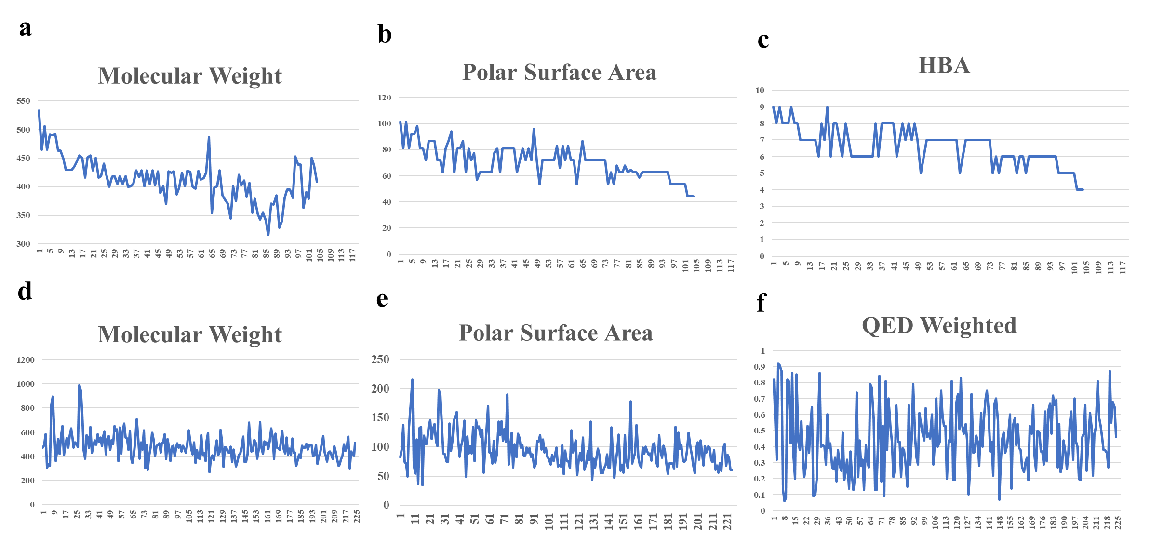
- Long and short island in GPCR and Kinase band. (b) Kinase privilege band 1 island for kinase-1, GPCR, kinase-2. (c) Kinase privilege band 2.
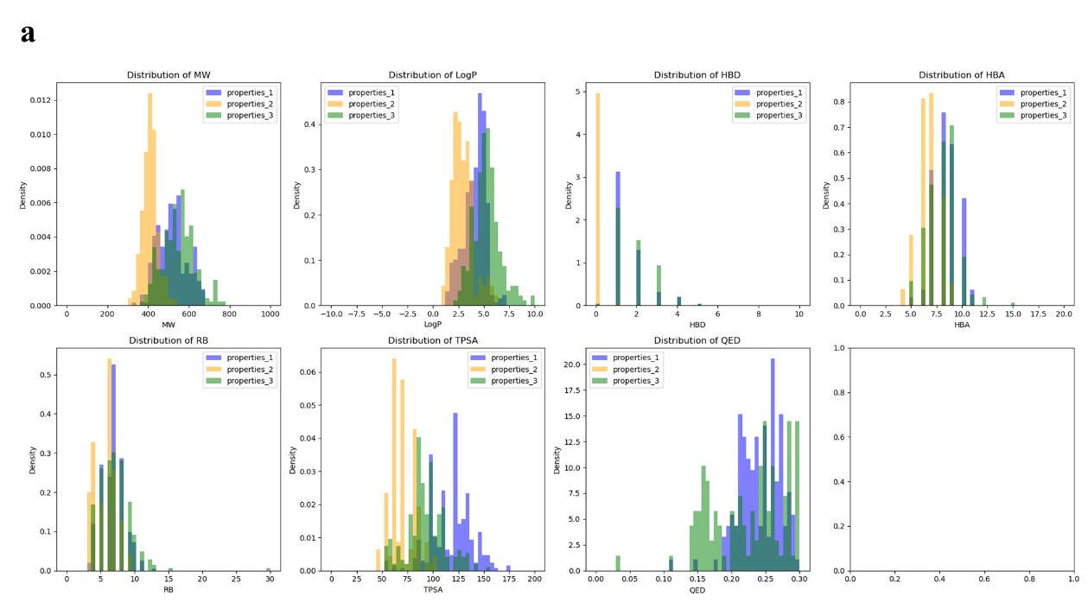
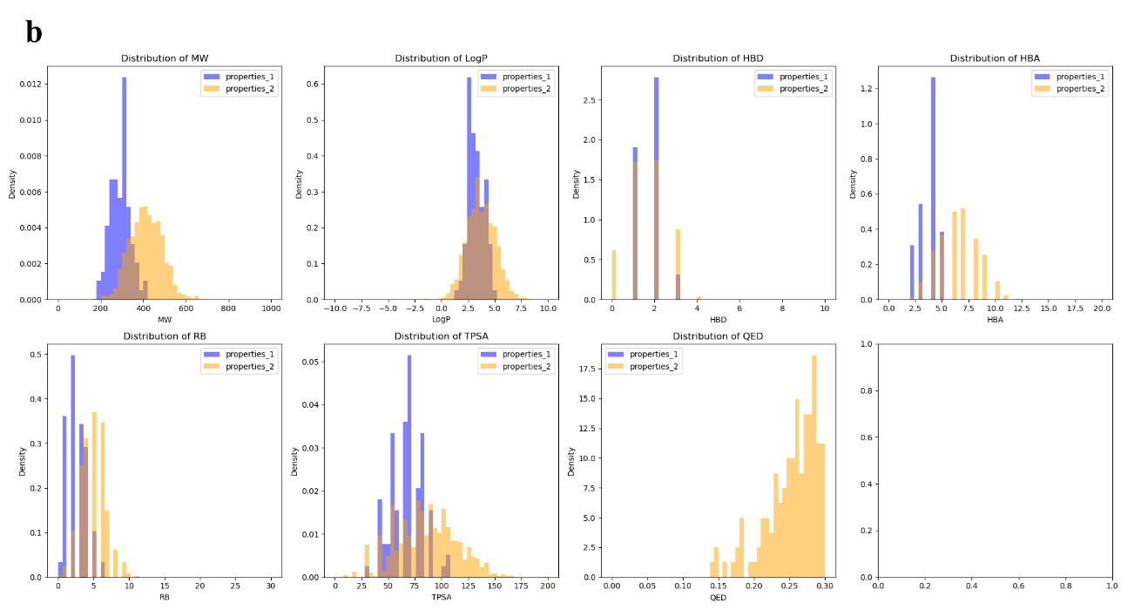
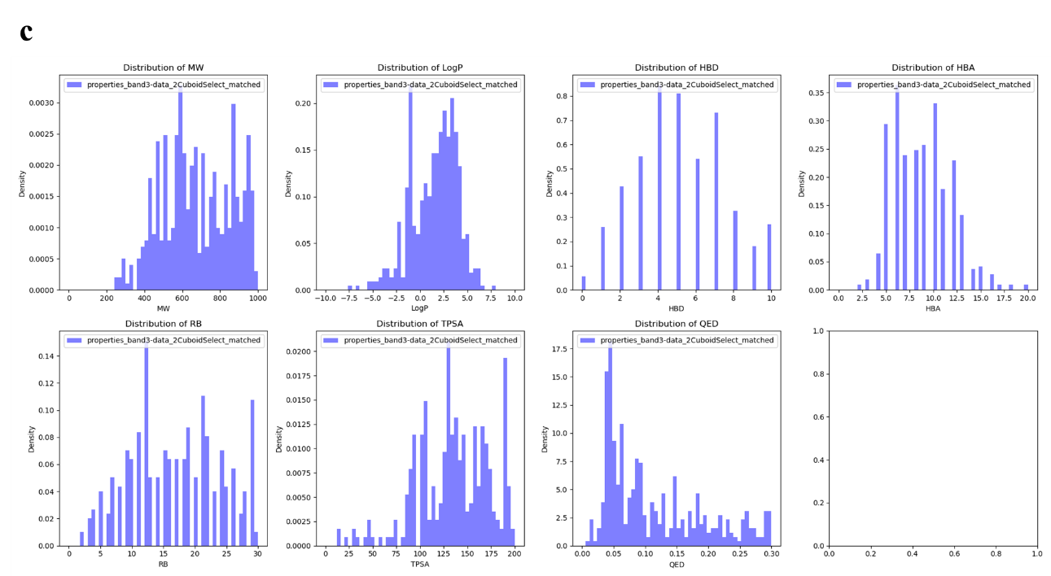
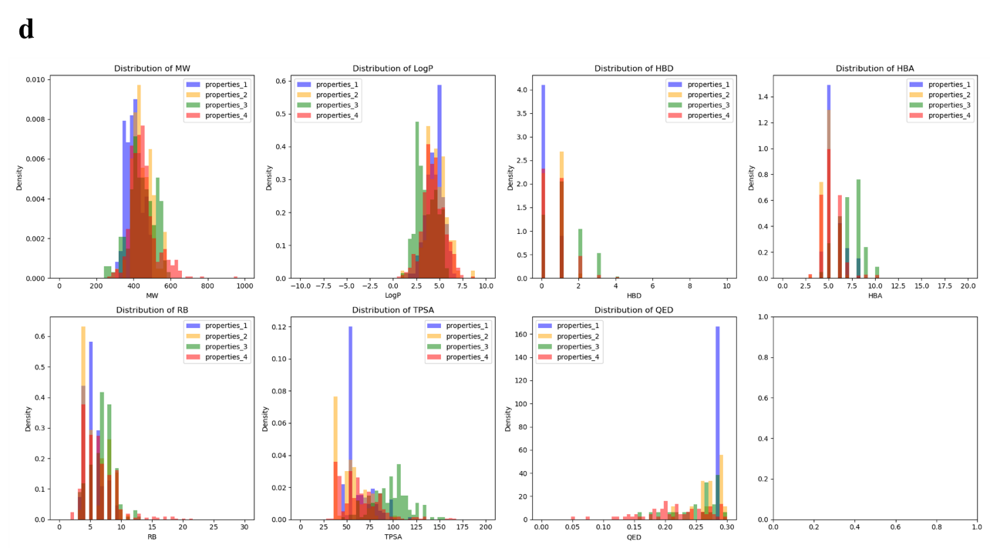
Supplementary Figure 16 Randomly Choose Molecule Properties in band 1-6 with internal size 1000. Color type 1: Kinase inhibitor. Color type 18: Protease binding. Color type 49: Nuclear Receptor binding. Color type 63: GPCR inhibitor. Color type 64: Other compounds.
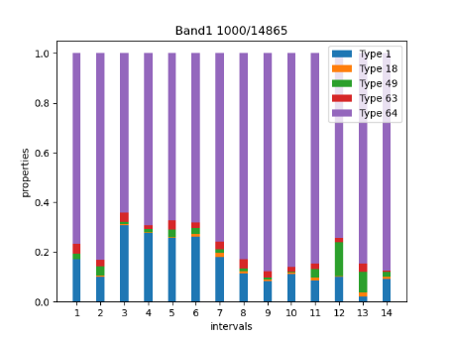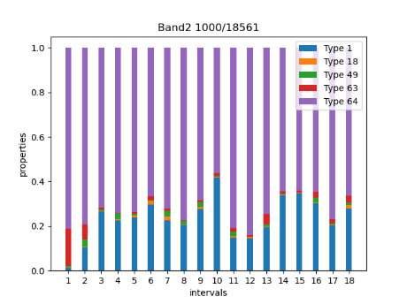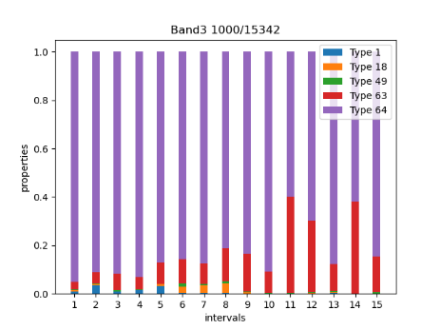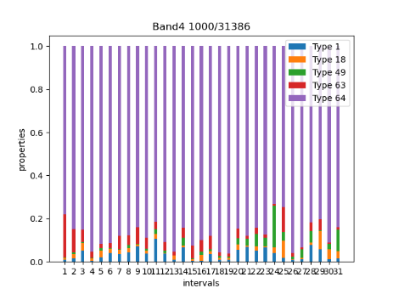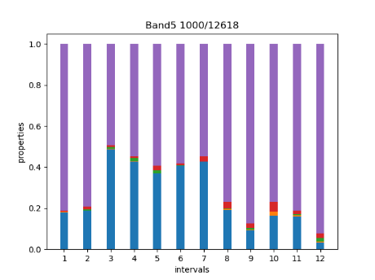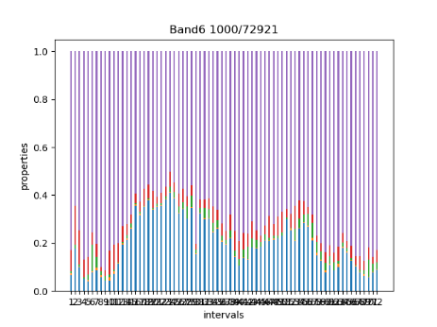

Supplementary Figure 17 Random selected biomolecule and conserved structure in kinase enriched island 1 in PubChemFPM band 1.

Supplementary Figure 18 Random selected biomolecule and conserved structure in kinase enriched island 2 in PubChemFPM band 1.
Supplementary Figure 19 Random selected biomolecule and conserved structure in GPCR enriched island 1 in PubChemFPM band 1.
Supplementary Figure 21 Random selected biomolecule and conserved structure in GPCR enriched islands in PubChemFPM (band 4).

Supplementary Figure 20 Random selected biomolecule and conserved structure in Protease enriched island in PubChemFPM (band 3).

Supplementary Figure 21 Clustering of 1.9 million of bioactivate molecules using (a-b) UMAP and (c-d) PCA visualization in 3D space from 128 dimension latent space based on PubChemFP-based DAE (reference MolF-DAEs).
(a) (b)
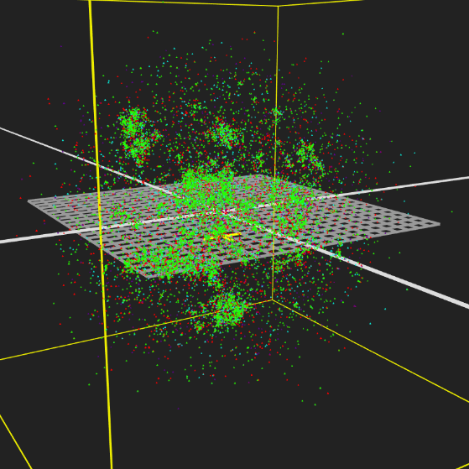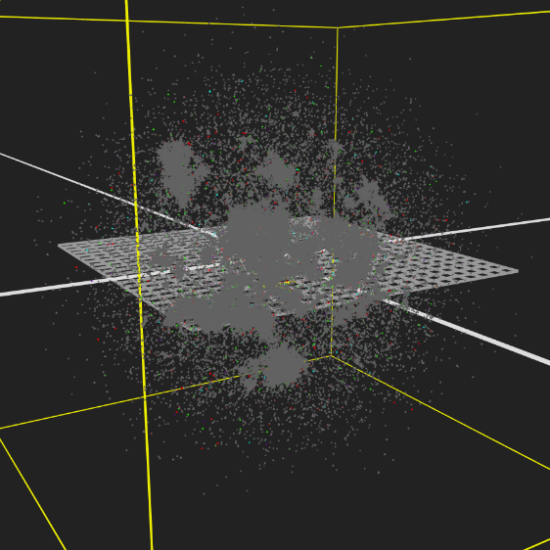
(c) (d)
