Design and Performance Evaluation of Nitrogen-Rich Bis-Six-Membered Fused Ring Energetic Materials via Density Functional Theory
Qian Zhang*, You-Xiang Guo, Tao Long, Lan-Ying Xu, Yan Huang*
School of Chemistry and Chemical Engineering Huanggang Normal University, Huanggang 438000, China
Fig. S1 Designed series I molecular structures
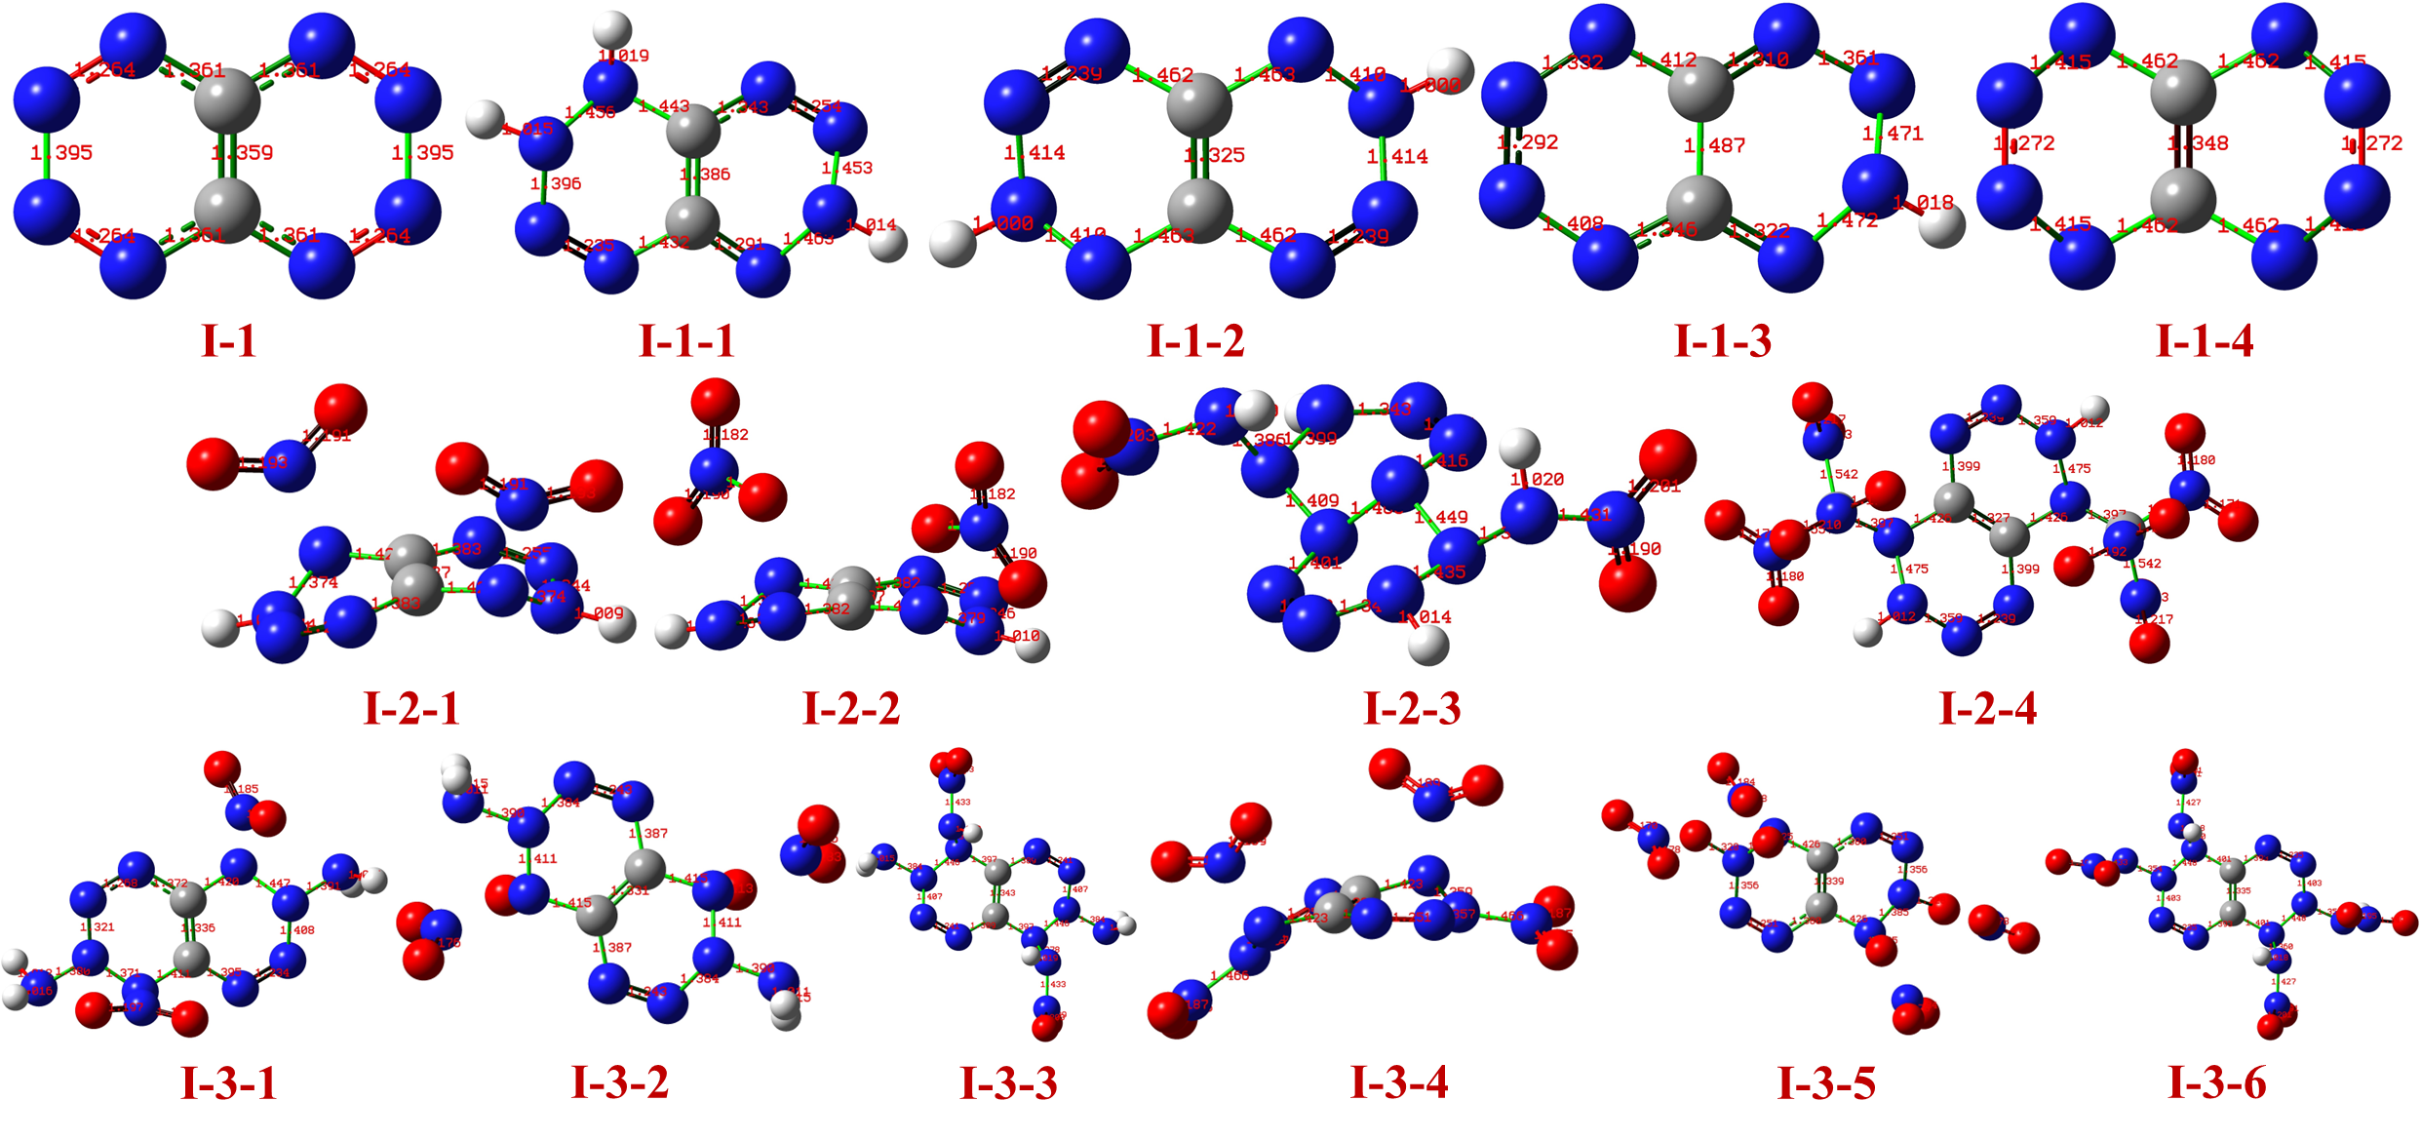
Fig. S2 The optimized geometric structure of series I (at M06-2X/def2-TZVP level)
Fig. S3 Designed series II molecular structures
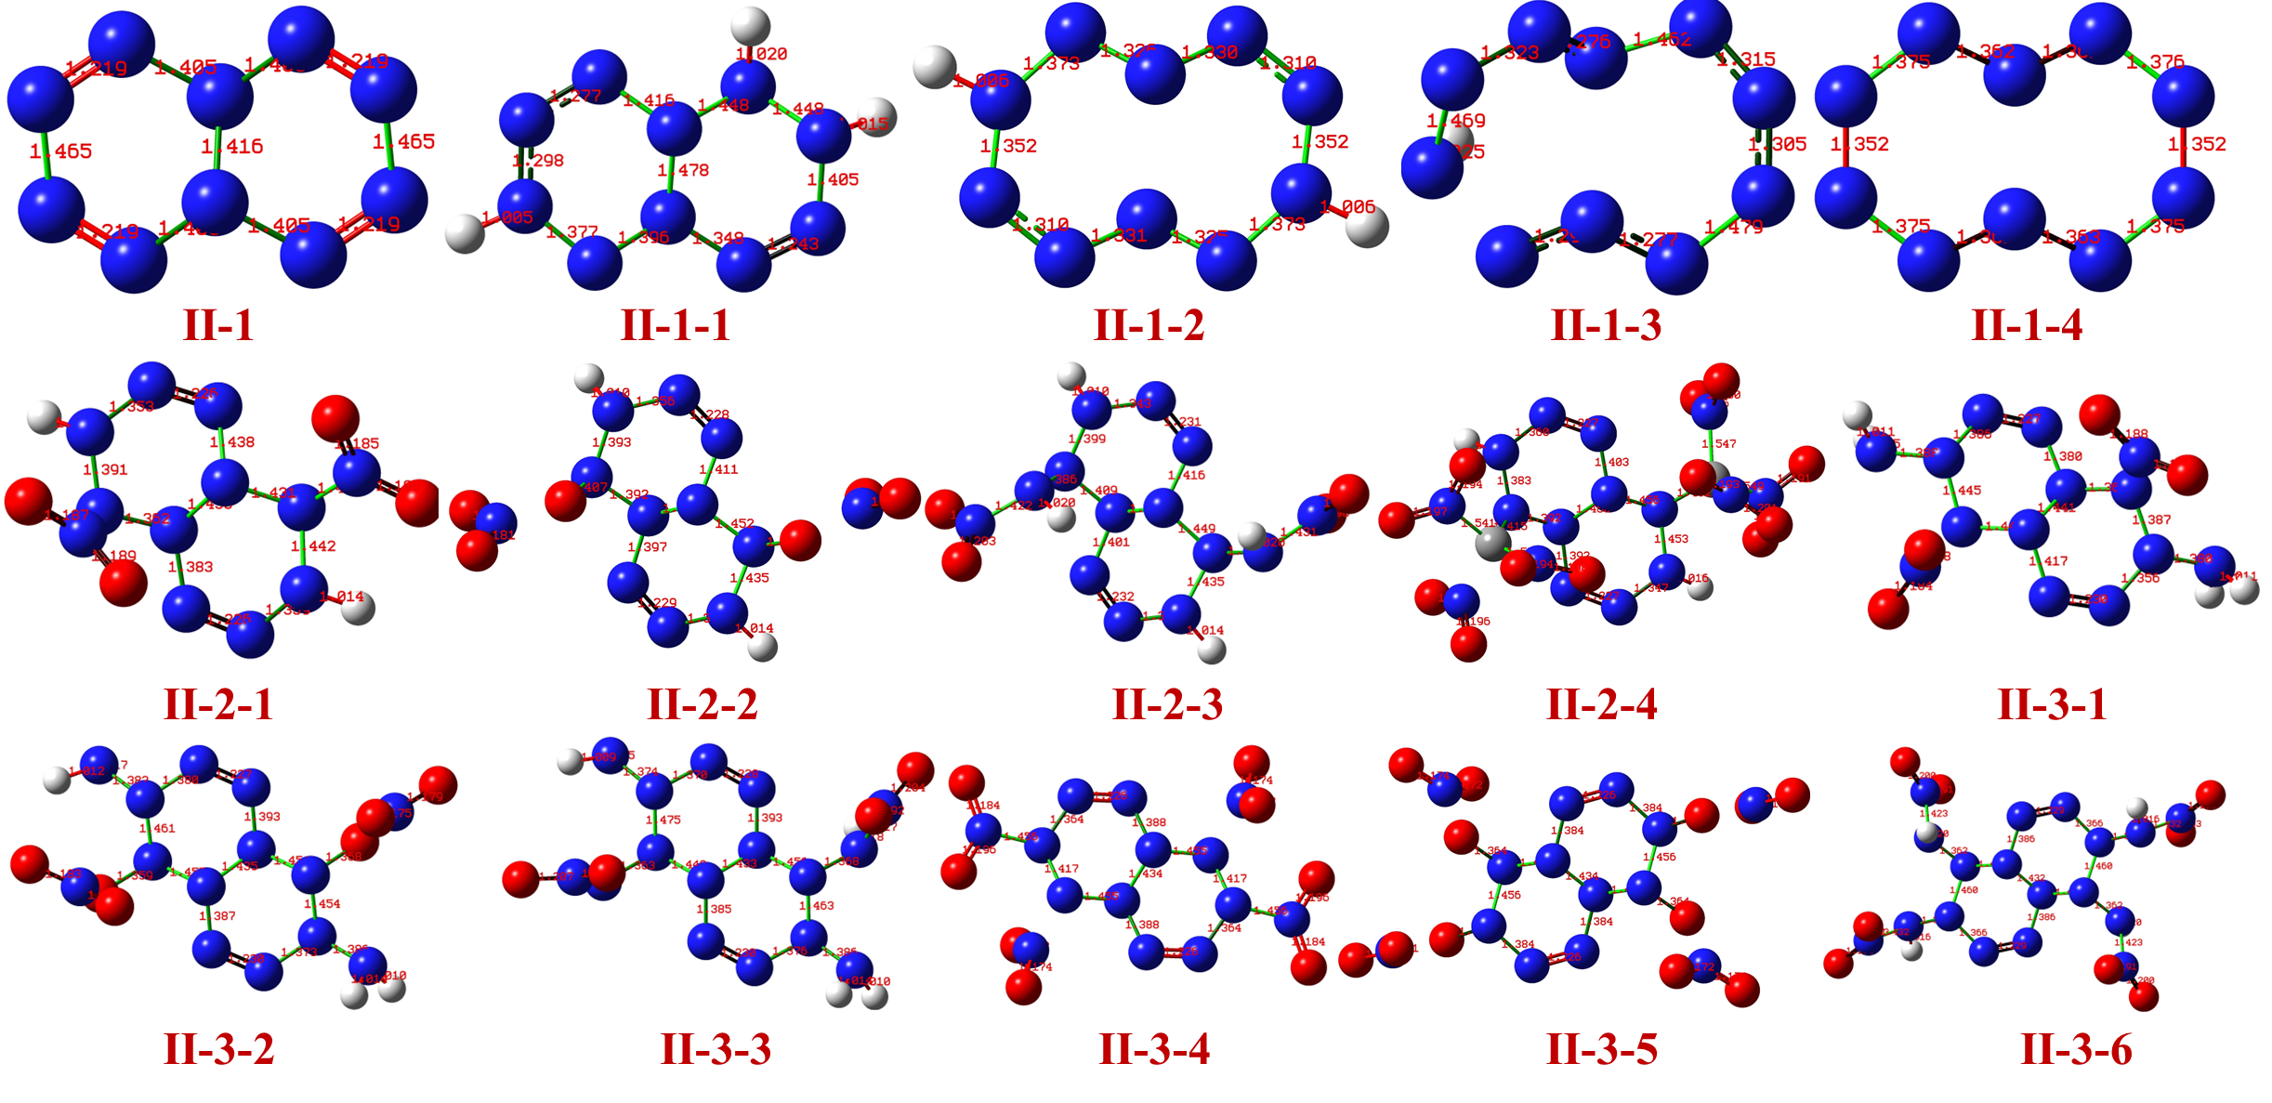
Fig. S4 The optimized geometric structure of series II (at M06-2X/def2-TZVP level)
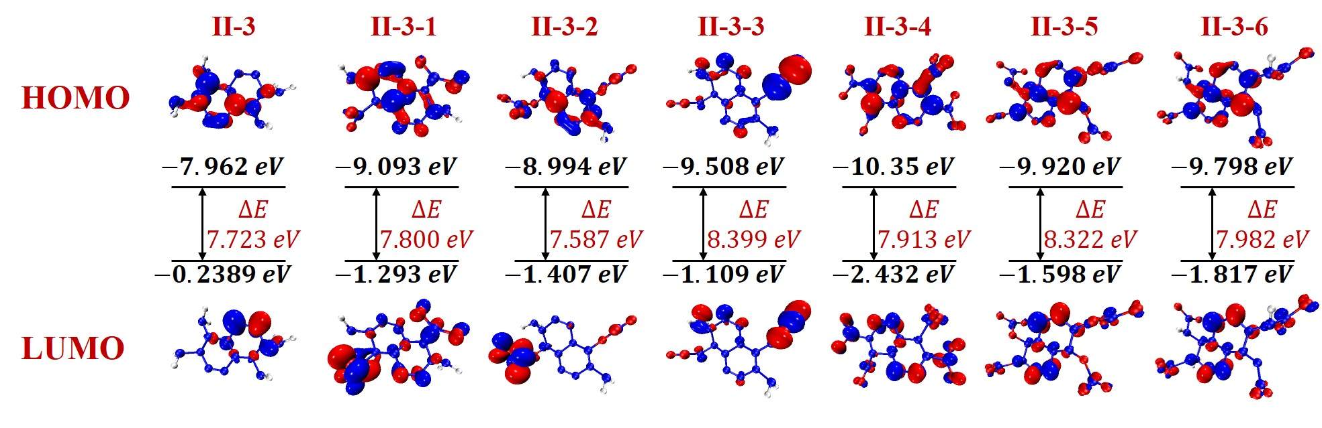
Fig. S5 HOMO and LUMO orbitals map and energy gaps of series II-3 at M06-2X/def2-TZVP level
Table S1. Bond order of the designed molecules at M06-2X/def2-TZVP level
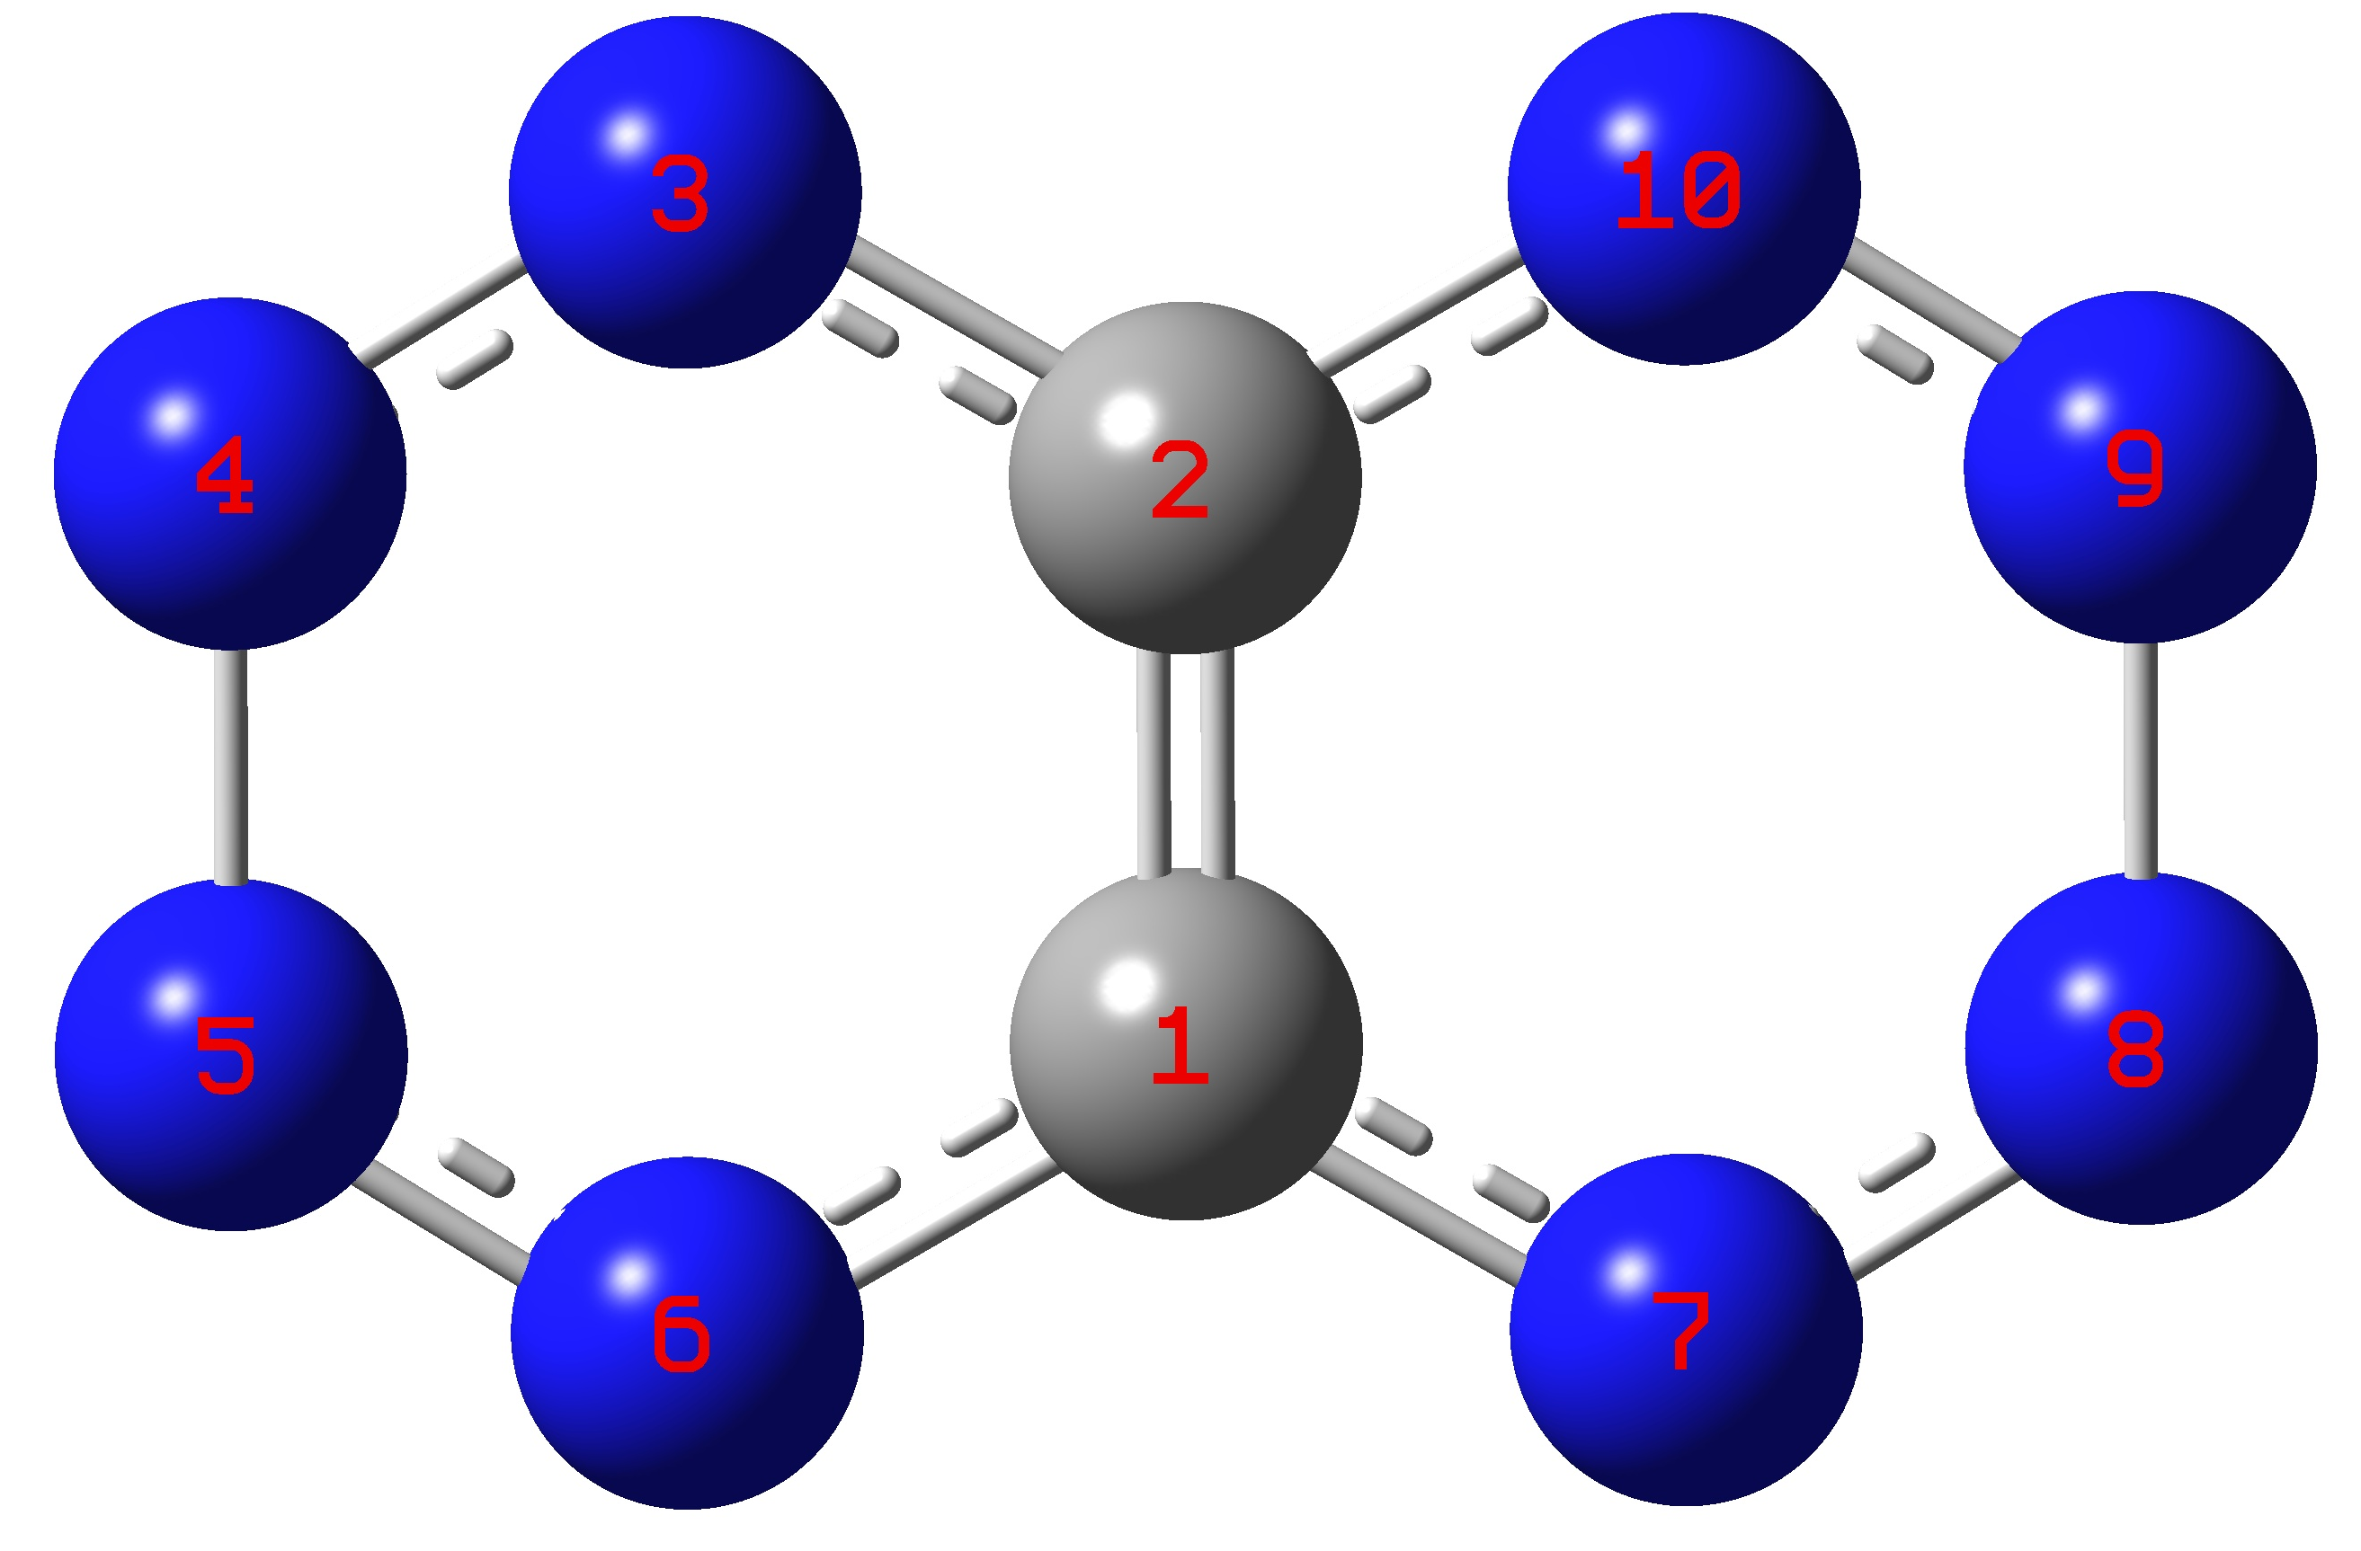 |  | 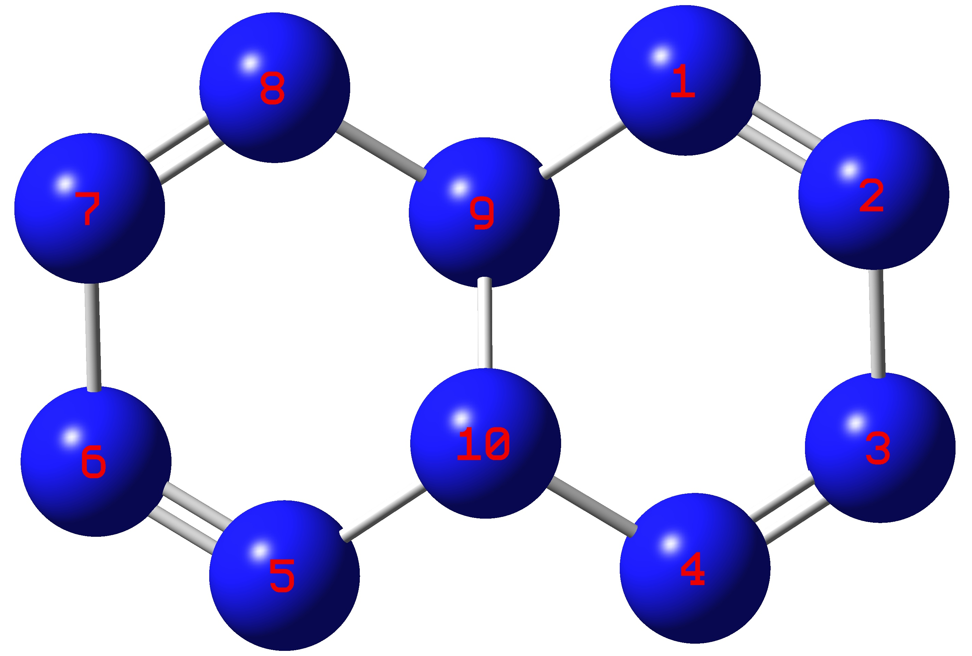 |  | 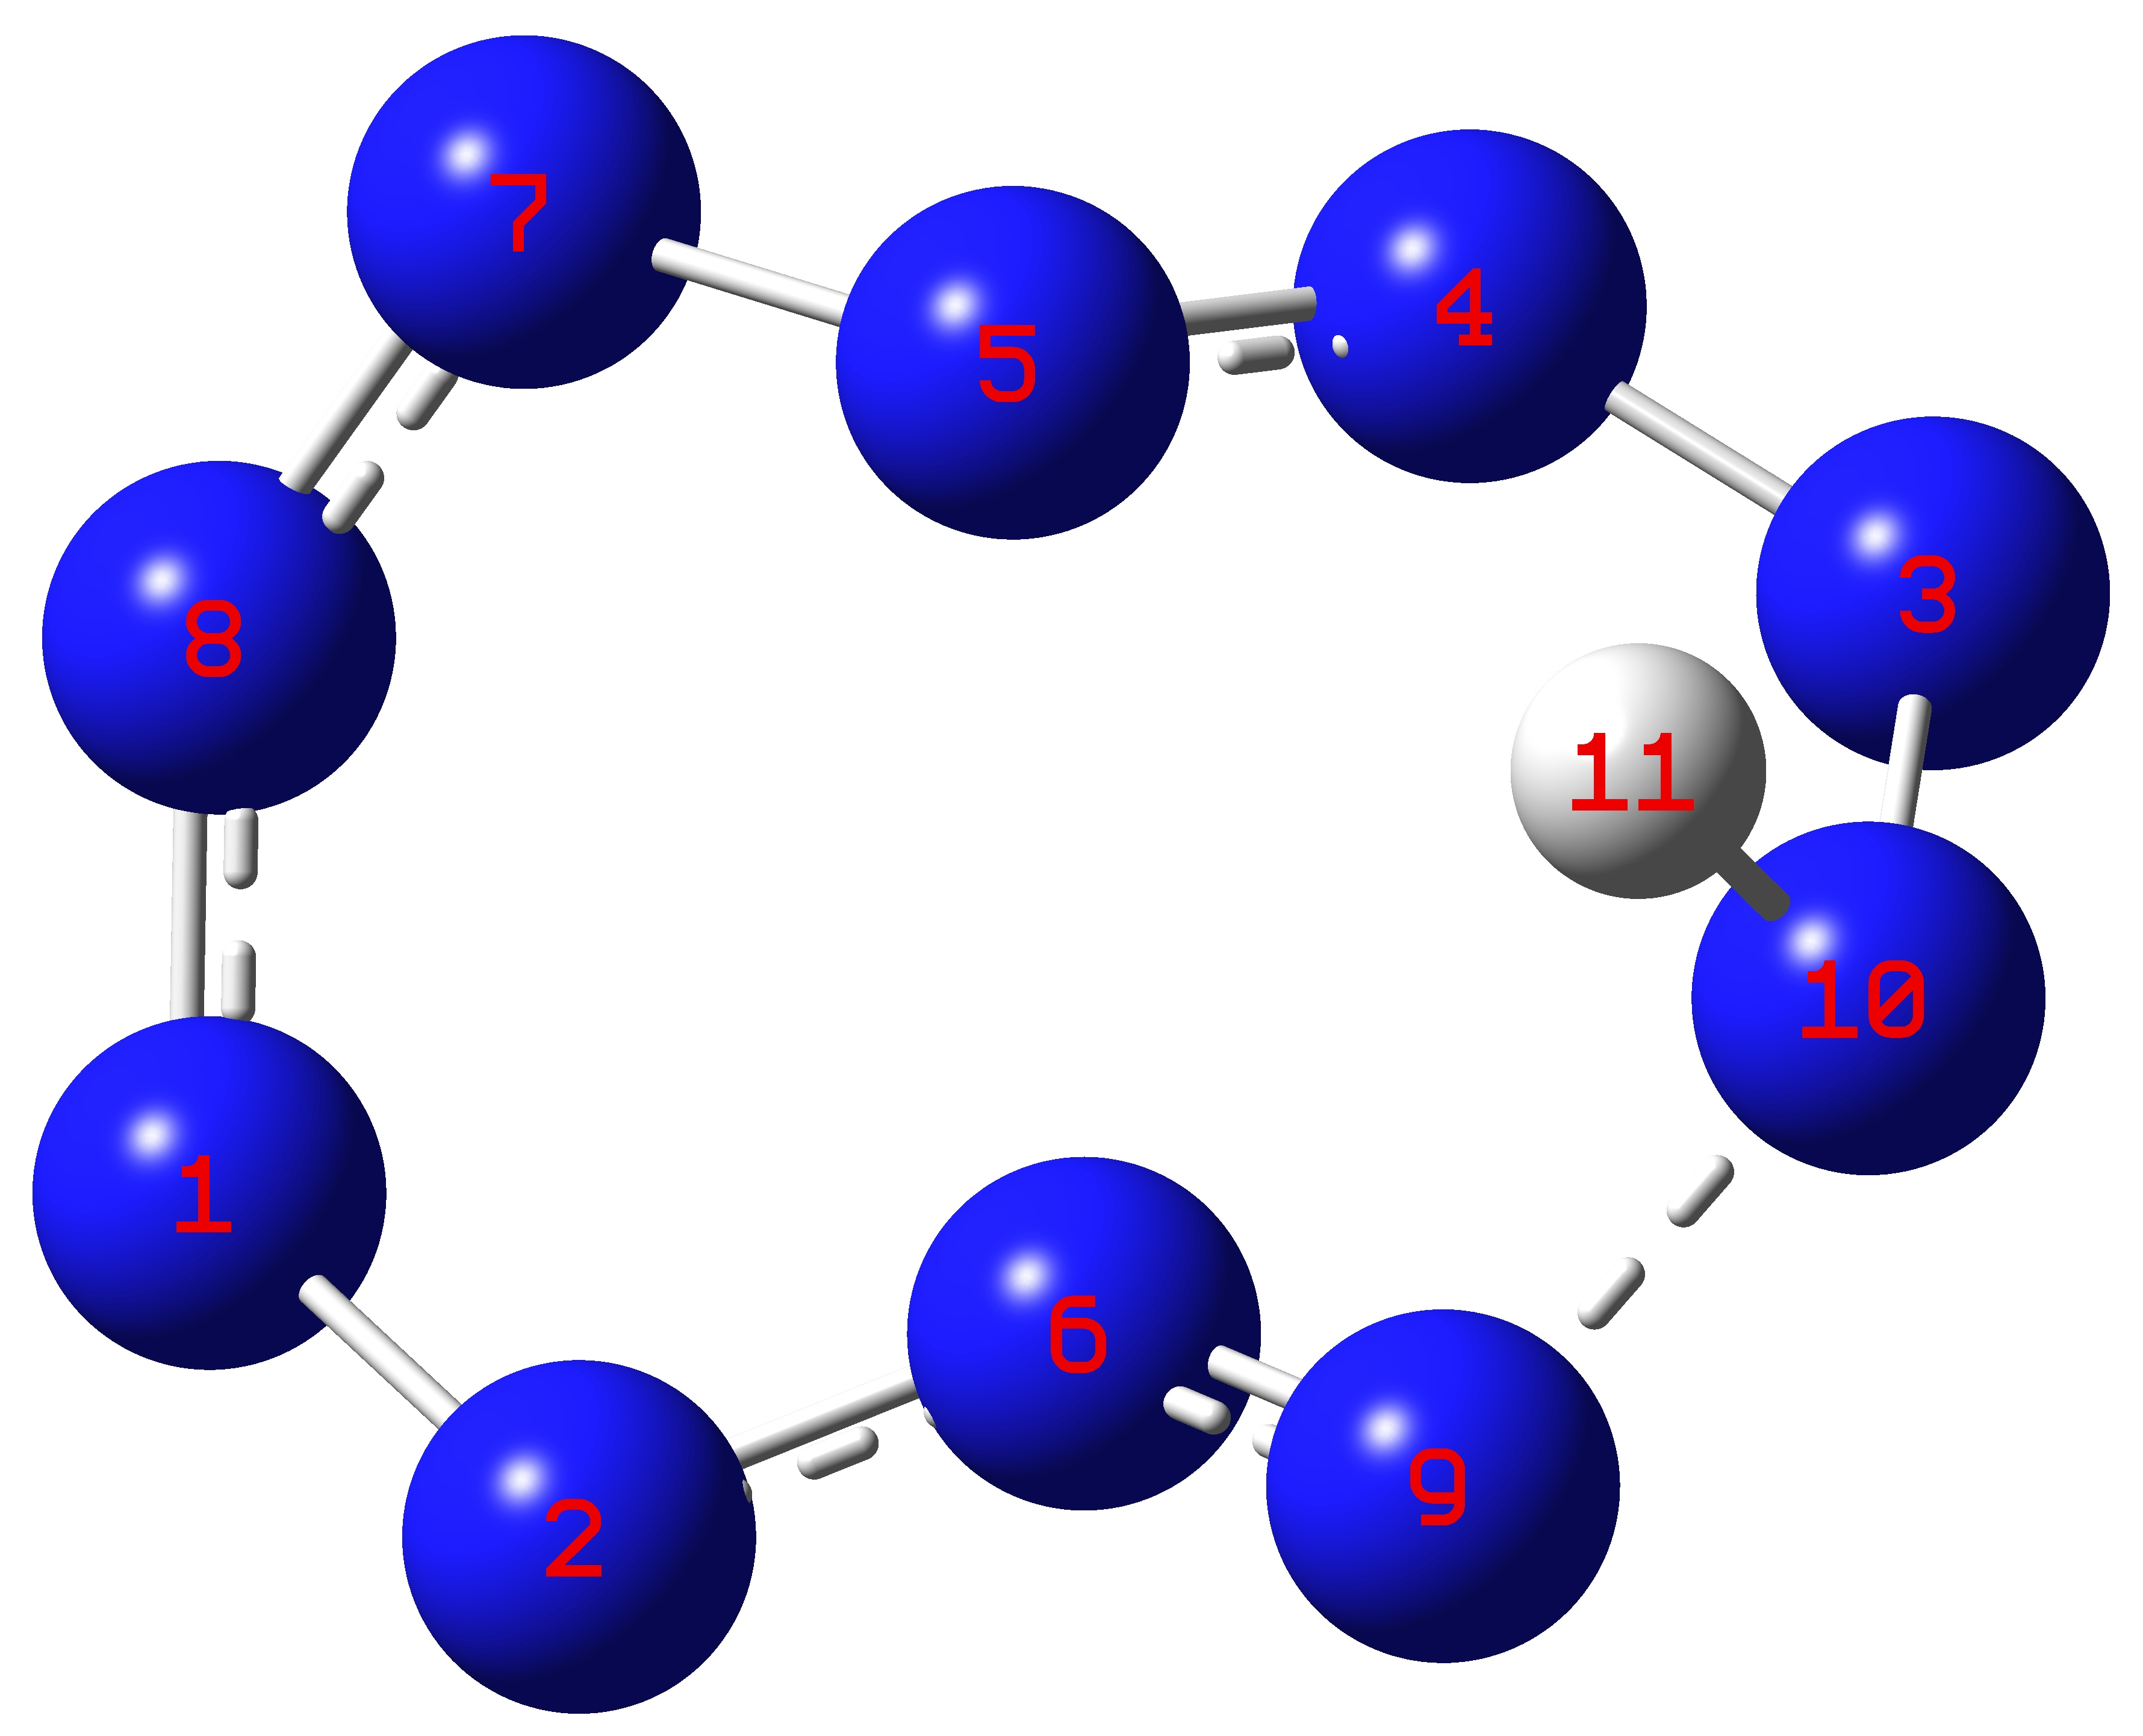
I-1 |  | II-1 |  | II-1-3
Molecule | bond | MBO | FBO | LBO
I-1 | C1-C2 | 1.37178 | 1.28432 | 1.69478
I-1 | C1-N6 | 1.24556 | 1.30494 | 1.17846
I-1 | C1-N7 | 1.24523 | 1.30466 | 1.17797
I-1 | C2-N3 | 1.24553 | 1.30491 | 1.17836
I-1 | C2-N10 | 1.24526 | 1.30469 | 1.17805
I-1 | N3-N4 | 1.47001 | 1.83961 | 1.39004
I-1 | N4-N5 | 1.03811 | 1.38903 | 0.73112
I-1 | N5-N6 | 1.46999 | 1.83959 | 1.39
I-1 | N7-N8 | 1.47038 | 1.83996 | 1.39053
I-1 | N8-N9 | 1.03776 | 1.38865 | 0.73041
I-1 | N9-N10 | 1.47036 | 1.83994 | 1.3905
II-1 | N1-N2 | 1.76893 | 2.04476 | 1.75744
II-1 | N1-N9 | 0.90034 | 1.19331 | 0.65915
II-1 | N2-N3 | 0.83134 | 1.17694 | 0.47986
II-1 | N3-N4 | 1.76893 | 2.04476 | 1.75744
II-1 | N4-N10 | 0.90034 | 1.19331 | 0.65915
II-1 | N10-N5 | 0.90034 | 1.19331 | 0.65915
II-1 | N5-N6 | 1.76893 | 2.04476 | 1.75744
II-1 | N6-N7 | 0.83134 | 1.17694 | 0.47986
II-1 | N7-N8 | 1.76893 | 2.04476 | 1.75744
II-1 | N8-N9 | 0.90034 | 1.19331 | 0.65915
II-1 | N9-N10 | 0.85514 | 1.11553 | 0.59161
II-1-3 | N1-N2 | 0.8391 | 1.2815 | 0.4213
II-1-3 | N1-N8 | 1.33946 | 1.81232 | 1.04394
II-1-3 | N2-N6 | 1.3833 | 1.75204 | 1.27558
II-1-3 | N3-N4 | 1.25852 | 1.68496 | 1.01831
II-1-3 | N3-N10 | 0.8859 | 1.2917 | 0.4412
II-1-3 | N4-N5 | 1.43125 | 1.77249 | 1.29726
II-1-3 | N5-N7 | 0.8421 | 1.2422 | 0.4728
II-1-3 | N6-N9 | 1.31592 | 1.70234 | 1.20167
II-1-3 | N7-N8 | 1.32588 | 1.76173 | 0.99593
II-1-3 | N9-N10 | 0.7978 | 1.2189 | 0.2888
Table S2. Total Energy ($E_{0}$), Zero Point Energy ($ZPE$), Thermal Correction ($∆H_{T}$) of designed molecules at M06-2X/def2-TZVP level
Molecule | Theoretical value [g/cm³] | Experimental value [g/cm³] | Error margin
RDX | 1.65 | 1.80 | -8%
HMX | 1.83 | 1.91 | -4%
Compound 1 | 1.80 | 1.86 | -3%
Compound 2 | 1.66 | 1.85 | -10%
Compound 3 | 1.92 | 1.93 | -1%
Table S3. Total Energy ($E_{0}$), Zero Point Energy ($ZPE$), Thermal Correction ($∆H_{T}$) of designed molecules at M06-2X/def2-TZVP level
Molecule | Formula | $E_{0}$ [a.u.] | $ZPE$ [a.u.] | $∆H_{T}$ [a.u.]
I-1 | C₂N₈ | -513.929313 | 0.048231 | 0.055622
I-1-1 | C₂H₃N₈⁻ | -515.771971 | 0.086081 | 0.093715
I-1-2 | C₂H₂N₈²⁻ | -515.043197 | 0.07171 | 0.079158
I-1-3 | C₂HN₈³⁻ | -514.204404 | 0.057965 | 0.065596
I-1-4 | C₂N₈⁴⁻ | -513.085481 | 0.041446 | 0.049517
I-2-1 | C₂H₂O₄N₁₀ | -925.287116 | 0.103172 | 0.116152
I-2-2 | C₂H₂O₆N₁₀ | -1075.60573 | 0.110722 | 0.125703
I-2-3 | C₂H₄O₄N₁₂ | -1035.902137 | 0.137513 | 0.15269
I-2-4 | C₄H₂O₁₂N₁₄ | -1821.786309 | 0.169605 | 0.19549
I-3 | C₂H₈N₁₂ | -737.533295 | 0.165359 | 0.178795
I-3-1 | C₂H₄O₄N₁₂ | -1035.879665 | 0.13565 | 0.151565
I-3-2 | C₂H₄O₆N₁₂ | -1186.215888 | 0.143244 | 0.161238
I-3-3 | C₂H₆O₄N₁₄ | -1146.5154 | 0.169859 | 0.187762
I-3-4 | C₂O₈N₁₂ | -1334.214967 | 0.106122 | 0.124247
I-3-5 | C₂O₁₂N₁₂ | -1634.864935 | 0.121725 | 0.143651
I-3-6 | C₂H₄O₈N₁₆ | -1555.480991 | 0.17517 | 0.197512
II-1 | N₁₀ | -547.09641 | 0.045965 | 0.053614
II-1-1 | H₃N₁₀⁻ | -548.926299 | 0.083299 | 0.091599
II-1-2 | H₂N₁₀²⁻ | -548.227813 | 0.067823 | 0.076517
II-1-3 | HN₁₀³⁻ | -547.357736 | 0.053229 | 0.061539
II-1-4 | N₁₀⁴⁻ | -546.301467 | 0.040229 | 0.0482
II-2-1 | H₂O₄N₁₂ | -958.445435 | 0.101409 | 0.114279
II-2-2 | H₂O₆N₁₂ | -1108.773288 | 0.108938 | 0.123992
II-2-3 | H₄O₄N₁₄ | -1069.082346 | 0.136105 | 0.151035
II-2-4 | C₂H2O₁₂N₁₆ | -1854.954645 | 0.168048 | 0.193499
II-3 | H₈N₁₄ | -770.713232 | 0.163649 | 0.176843
II-3-1 | H₄O₄N₁₄ | -1069.054082 | 0.133954 | 0.14971
II-3-2 | H₄O₆N₁₄ | -1219.367256 | 0.141616 | 0.159218
II-3-3 | H₆O₄N₁₆ | -1179.676423 | 0.168519 | 0.186297
II-3-4 | O₈N₁₄ | -1367.348608 | 0.103318 | 0.121627
II-3-5 | O₁₂N₁₄ | -1668.021662 | 0.119501 | 0.141863
II-3-6 | H₄O₈N₁₈ | -1588.651787 | 0.173465 | 0.195933
Table S4. Quantitative analysis of molecular surface for the designed energetic ionic salt at M06-2X/def2-TZVP level
Salt | M.W. | V⁺ | V⁻ | V [cm³] | M/V | $${\overline{V}}_{S(cation)}^{+}$$ | $$A_{cation}^{+}$$ | $${\overline{V}}_{S(anion)}^{-}$$ | $$A_{anion}^{-}$$
I-1-1 (anion): cation = 1: 1
salt 1 | 157.1 | 50.07 | 1026.7 | 1.08E-21 | 0.2423 | 1593.9 | 67.14 | -96.12 | 152.7
salt 2 | 172.2 | 70.06 | 1026.7 | 1.1E-21 | 0.2606 | 2455.7 | 85.77 | 152.7 | 152.7
salt 3 | 173.1 | 61.97 | 1026.7 | 1.09E-21 | 0.2640 | 2557.8 | 78.79 | -96.12 | 152.7
salt 4 | 224.2 | 121.0 | 1026.7 | 1.15E-21 | 0.3244 | 4800.4 | 129.6 | -96.12 | 152.7
salt 5 | 224.2 | 121.9 | 1026.7 | 1.15E-21 | 0.3241 | 4800.3 | 129.1 | -96.12 | 152.7
salt 6 | 239.2 | 139.9 | 1026.7 | 1.17E-21 | 0.3405 | 5341.9 | 147.0 | -96.12 | 152.7
salt 7 | 199.2 | 103.6 | 1026.7 | 1.13E-21 | 0.2926 | 3723.8 | 115.0 | -96.12 | 152.7
salt 8 | 214.2 | 122.5 | 1026.7 | 1.15E-21 | 0.3095 | 4358.2 | 131.4 | -96.12 | 152.7
salt 9 | 229.2 | 141.7 | 1026.7 | 1.17E-21 | 0.3257 | 4931.1 | 148.2 | -96.12 | 152.7
salt 10 | 244.2 | 161.5 | 1026.7 | 1.19E-21 | 0.3413 | 5498.6 | 164.7 | -96.12 | 152.7
I-1-2 (anion): cation = 1: 2
salt 1 | 174.2 | 50.07 | 1076.4 | 1.18E-21 | 0.2458 | 1593.9 | 67.14 | -191.2 | 150.6
salt 2 | 204.2 | 70.06 | 1076.4 | 1.22E-21 | 0.2787 | 2455.7 | 85.77 | -191.2 | 150.6
salt 3 | 206.2 | 61.97 | 1076.4 | 1.2E-21 | 0.2852 | 2557.8 | 78.79 | -191.2 | 150.6
salt 4 | 308.3 | 121.0 | 1076.4 | 1.32E-21 | 0.3883 | 4800.4 | 129.6 | -191.2 | 150.6
salt 5 | 308.3 | 121.9 | 1076.4 | 1.32E-21 | 0.3878 | 4800.3 | 129.1 | -191.2 | 150.6
salt 6 | 338.3 | 139.9 | 1076.4 | 1.36E-21 | 0.4142 | 5341.9 | 147.0 | -191.2 | 150.6
salt 7 | 258.3 | 103.6 | 1076.4 | 1.28E-21 | 0.3341 | 3723.8 | 115.0 | -191.2 | 150.6
salt 8 | 288.3 | 122.5 | 1076.4 | 1.32E-21 | 0.3623 | 4358.2 | 131.4 | -191.2 | 150.6
salt 9 | 318.3 | 141.7 | 1076.4 | 1.36E-21 | 0.3887 | 4931.1 | 148.2 | -191.2 | 150.6
salt 10 | 348.3 | 161.5 | 1076.4 | 1.4E-21 | 0.4133 | 5498.6 | 164.7 | -191.2 | 150.6
I-1-3 (anion): cation = 1: 3
salt 1 | 191.2 | 50.07 | 959.7 | 1.11E-21 | 0.2861 | 1593.9 | 67.14 | -280.9 | 162.2
salt 2 | 236.2 | 70.06 | 959.7 | 1.17E-21 | 0.3353 | 2455.7 | 85.77 | -280.9 | 162.2
salt 3 | 239.2 | 61.97 | 959.7 | 1.15E-21 | 0.3467 | 2557.8 | 78.79 | -280.9 | 162.2
salt 4 | 392.4 | 121.0 | 959.7 | 1.32E-21 | 0.4926 | 4800.4 | 129.6 | -280.9 | 162.2
salt 5 | 392.4 | 121.9 | 959.7 | 1.33E-21 | 0.4916 | 4800.3 | 129.1 | -280.9 | 162.2
salt 6 | 437.4 | 139.9 | 959.7 | 1.38E-21 | 0.5265 | 5341.9 | 147.0 | -280.9 | 162.2
salt 7 | 317.3 | 103.6 | 959.7 | 1.27E-21 | 0.4148 | 3723.8 | 115.0 | -280.9 | 162.2
salt 8 | 362.4 | 122.5 | 959.7 | 1.33E-21 | 0.4534 | 4358.2 | 131.4 | -280.9 | 162.2
salt 9 | 407.4 | 141.7 | 959.7 | 1.38E-21 | 0.4885 | 4931.1 | 148.2 | -280.9 | 162.2
salt 10 | 452.5 | 161.5 | 959.7 | 1.44E-21 | 0.5202 | 5498.6 | 164.7 | -280.9 | 162.2
I-1-4 (anion): cation = 1: 4
salt 1 | 208.2 | 50.07 | 932.6 | 1.13E-21 | 0.3052 | 1593.9 | 67.14 | -371.0 | 167.1
salt 2 | 268.3 | 70.06 | 932.6 | 1.21E-21 | 0.3673 | 2455.7 | 85.77 | -371.0 | 167.1
salt 3 | 272.2 | 61.97 | 932.6 | 1.18E-21 | 0.3829 | 2557.8 | 78.79 | -371.0 | 167.1
salt 4 | 476.4 | 121.0 | 932.6 | 1.42E-21 | 0.5585 | 4800.4 | 129.6 | -371.0 | 167.1
salt 5 | 476.4 | 121.9 | 932.6 | 1.42E-21 | 0.5571 | 4800.3 | 129.1 | -371.0 | 167.1
salt 6 | 536.5 | 139.9 | 932.6 | 1.49E-21 | 0.5970 | 5341.9 | 147.0 | -371.0 | 167.1
salt 7 | 376.4 | 103.6 | 932.6 | 1.35E-21 | 0.4641 | 3723.8 | 115.0 | -371.0 | 167.1
salt 8 | 436.5 | 122.5 | 932.6 | 1.42E-21 | 0.5094 | 4358.2 | 131.4 | -371.0 | 167.1
salt 9 | 496.5 | 141.7 | 932.6 | 1.5E-21 | 0.5499 | 4931.1 | 148.2 | -371.0 | 167.1
salt 10 | 556.6 | 161.5 | 932.6 | 1.58E-21 | 0.5855 | 5498.6 | 164.7 | -371.0 | 167.1
II-1-1 (anion): cation = 1: 1
salt 1 | 161.1 | 50.07 | 149.1 | 1.99E-22 | 1.344 | 1593.9 | 67.14 | -97.44 | 150.9
salt 2 | 176.1 | 70.06 | 149.1 | 2.19E-22 | 1.335 | 2455.7 | 85.77 | -97.44 | 150.9
salt 3 | 177.1 | 61.97 | 149.1 | 2.11E-22 | 1.394 | 2557.8 | 78.79 | -97.44 | 150.9
salt 4 | 228.2 | 121.0 | 149.1 | 2.7E-22 | 1.403 | 4800.4 | 129.6 | -97.44 | 150.9
salt 5 | 228.2 | 121.9 | 149.1 | 2.71E-22 | 1.399 | 4800.3 | 129.1 | -97.44 | 150.9
salt 6 | 243.2 | 139.9 | 149.1 | 2.89E-22 | 1.398 | 5341.9 | 147.0 | -97.44 | 150.9
salt 7 | 203.12 | 103.6 | 149.1 | 2.53E-22 | 1.335 | 3723.8 | 115.0 | -97.44 | 150.9
salt 8 | 218.2 | 122.5 | 149.1 | 2.72E-22 | 1.334 | 4358.2 | 131.4 | -97.44 | 150.9
salt 9 | 233.2 | 141.7 | 149.1 | 2.91E-22 | 1.332 | 4931.1 | 148.2 | -97.44 | 150.9
salt 10 | 248.2 | 161.5 | 149.1 | 3.11E-22 | 1.327 | 5498.6 | 164.7 | -97.44 | 150.9
II-1-2 (anion): cation = 1: 2
salt 1 | 178.2 | 50.07 | 157.3 | 2.57E-22 | 1.149 | 1593.9 | 67.14 | -192.5 | 156.0
salt 2 | 208.2 | 70.06 | 157.3 | 2.97E-22 | 1.162 | 2455.7 | 85.77 | -192.5 | 156.0
salt 3 | 210.2 | 61.97 | 157.3 | 2.81E-22 | 1.241 | 2557.8 | 78.79 | -192.5 | 156.0
salt 4 | 312.3 | 121.0 | 157.3 | 3.99E-22 | 1.299 | 4800.4 | 129.6 | -192.5 | 156.0
salt 5 | 312.3 | 121.9 | 157.3 | 4.01E-22 | 1.293 | 4800.3 | 129.1 | -192.5 | 156.0
salt 6 | 342.3 | 139.9 | 157.3 | 4.37E-22 | 1.300 | 5341.9 | 147.0 | -192.5 | 156.0
salt 7 | 262.2 | 103.6 | 157.3 | 3.64E-22 | 1.195 | 3723.8 | 115.0 | -192.5 | 156.0
salt 8 | 292.3 | 122.5 | 157.3 | 4.02E-22 | 1.206 | 4358.2 | 131.4 | -192.5 | 156.0
salt 9 | 322.3 | 141.7 | 157.3 | 4.41E-22 | 1.214 | 4931.1 | 148.2 | -192.5 | 156.0
salt 10 | 352.3 | 161.5 | 157.3 | 4.8E-22 | 1.218 | 5498.6 | 164.7 | -192.5 | 156.0
II-1-3 (anion): cation = 1: 3
salt 1 | 195.2 | 50.07 | 141.8 | 2.92E-22 | 1.110 | 1593.9 | 67.14 | -282.6 | 161.3
salt 2 | 240.2 | 70.06 | 141.8 | 3.52E-22 | 1.133 | 2455.7 | 85.77 | -282.6 | 161.3
salt 3 | 243.2 | 61.97 | 141.8 | 3.28E-22 | 1.232 | 2557.8 | 78.79 | -282.6 | 161.3
salt 4 | 396.3 | 121.0 | 141.8 | 5.05E-22 | 1.303 | 4800.4 | 129.6 | -282.6 | 161.3
salt 5 | 396.3 | 121.9 | 141.8 | 5.07E-22 | 1.297 | 4800.3 | 129.1 | -282.6 | 161.3
salt 6 | 441.4 | 139.9 | 141.8 | 5.62E-22 | 1.305 | 5341.9 | 147.0 | -282.6 | 161.3
salt 7 | 321.3 | 103.6 | 141.8 | 4.53E-22 | 1.179 | 3723.8 | 115.0 | -282.6 | 161.3
salt 8 | 366.4 | 122.5 | 141.8 | 5.09E-22 | 1.1947 | 4358.2 | 131.4 | -282.6 | 161.3
salt 9 | 411.4 | 141.7 | 141.8 | 5.67E-22 | 1.205 | 4931.1 | 148.2 | -282.6 | 161.3
salt 10 | 456.5 | 161.5 | 141.8 | 6.26E-22 | 1.210 | 5498.6 | 164.7 | -282.6 | 161.3
II-1-4 (anion): cation = 1: 4
salt 1 | 212.2 | 50.07 | 172.3 | 3.73E-22 | 0.9460 | 1593.9 | 67.14 | -373.6 | 164.8
salt 2 | 272.3 | 70.06 | 172.3 | 4.53E-22 | 0.9991 | 2455.7 | 85.77 | -373.6 | 164.8
salt 3 | 276.2 | 61.97 | 172.3 | 4.2E-22 | 1.092 | 2557.8 | 78.79 | -373.6 | 164.8
salt 4 | 480.4 | 121.0 | 172.3 | 6.56E-22 | 1.215 | 4800.4 | 129.6 | -373.6 | 164.8
salt 5 | 480.4 | 121.9 | 172.3 | 6.6E-22 | 1.209 | 4800.3 | 129.1 | -373.6 | 164.8
salt 6 | 540.5 | 139.9 | 172.3 | 7.32E-22 | 1.226 | 5341.9 | 147.0 | -373.6 | 164.8
salt 7 | 380.4 | 103.6 | 172.3 | 5.87E-22 | 1.077 | 3723.8 | 115.0 | -373.6 | 164.8
salt 8 | 440.5 | 122.5 | 172.3 | 6.62E-22 | 1.104 | 4358.2 | 131.4 | -373.6 | 164.8
salt 9 | 500.5 | 141.7 | 172.3 | 7.39E-22 | 1.125 | 4931.1 | 148.2 | -373.6 | 164.8
salt 10 | 560.6 | 161.5 | 172.3 | 8.18E-22 | 1.138 | 5498.6 | 164.7 | -373.6 | 164.8
Table S5. AV1245 index of I-1 and II-2 at M06-2X/def2-TZVP level
I-1 | cycle  1,7,8,9,10,2,3,4,5,6 | cycle  1,2,3,4,5,6 | cycle  2,1,7,8,9,10
 | Value: 5.46730267 | Value: 8.62178472 | Value: 8.61377582
II-1 | cycle  1,2,3,4,10,5,6,7,8,9 | cycle  1,2,3,4,10,9 | cycle  10,5,6,7,8,9
 | Value: -0.38304599 | Value: 0.25872711 | Value: 0.25872711
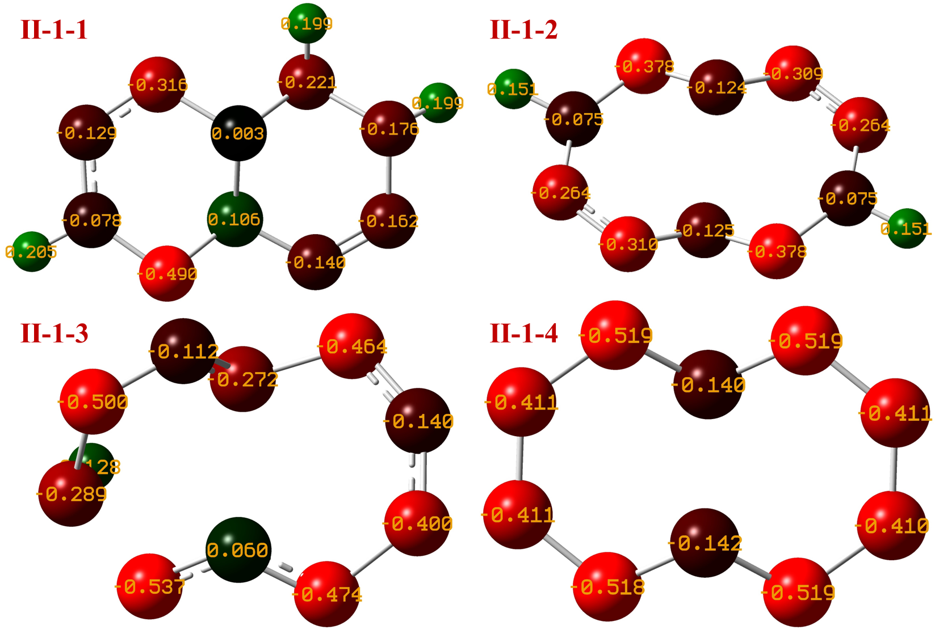
Fig S6. Charge distribution of II-1-1 to II-1-4
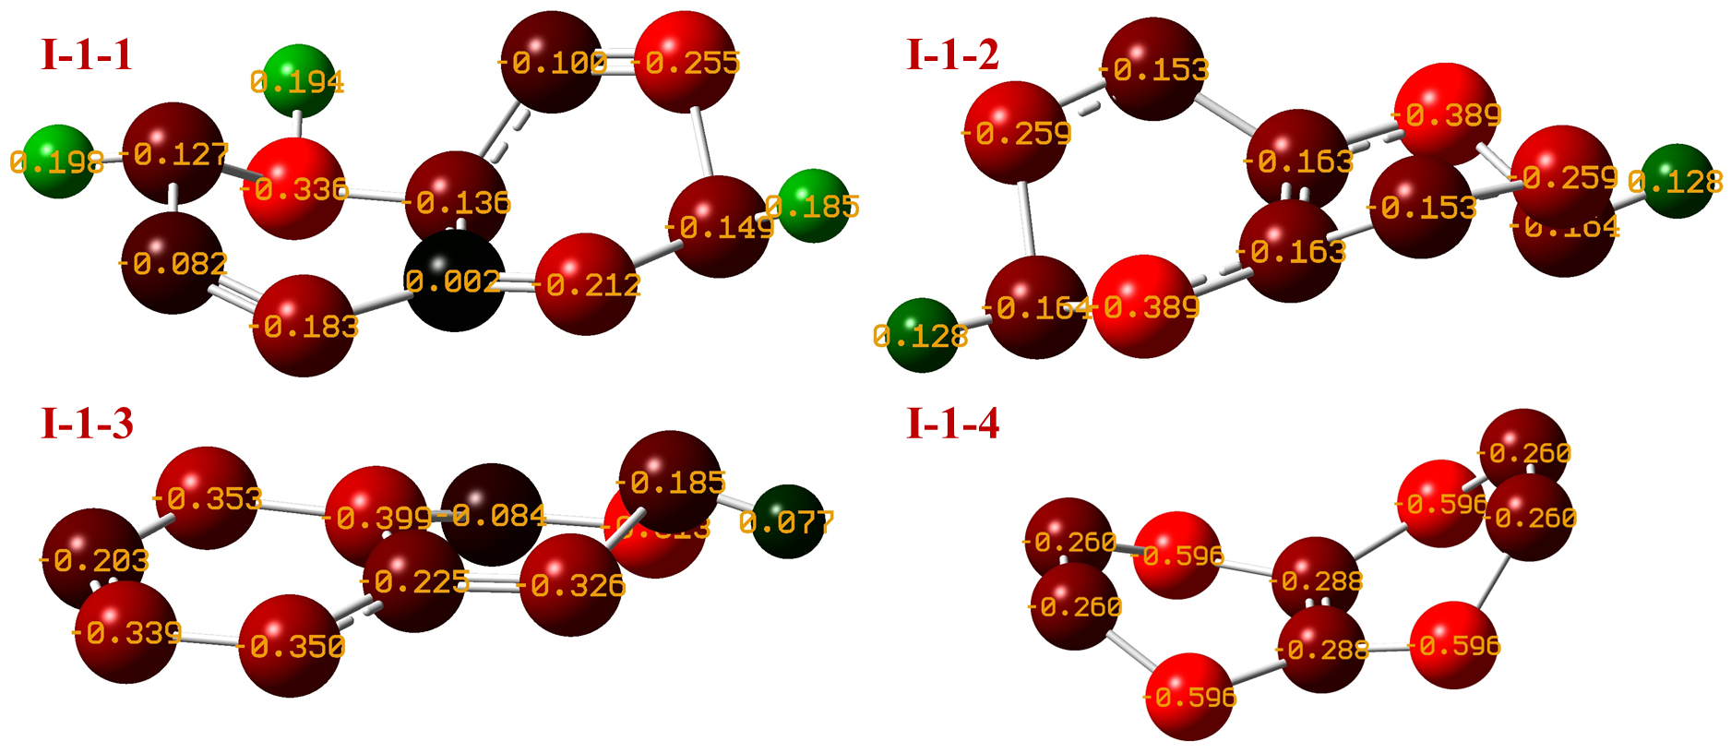
Fig S7. Charge distribution of I-1-1 to I-1-4
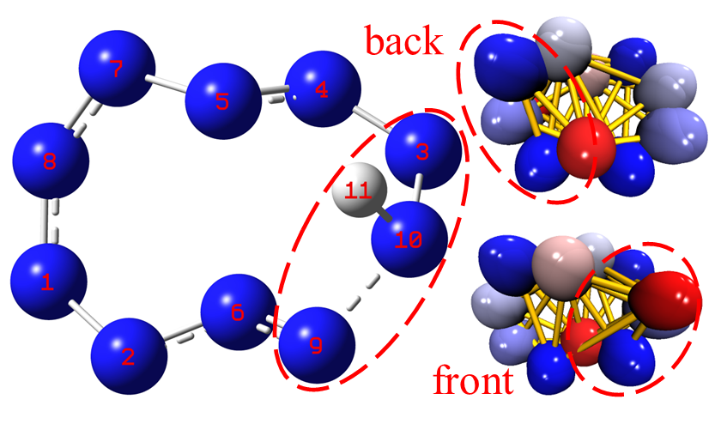
Fig S8. Charge distribution of II-1-1 to II-1-4

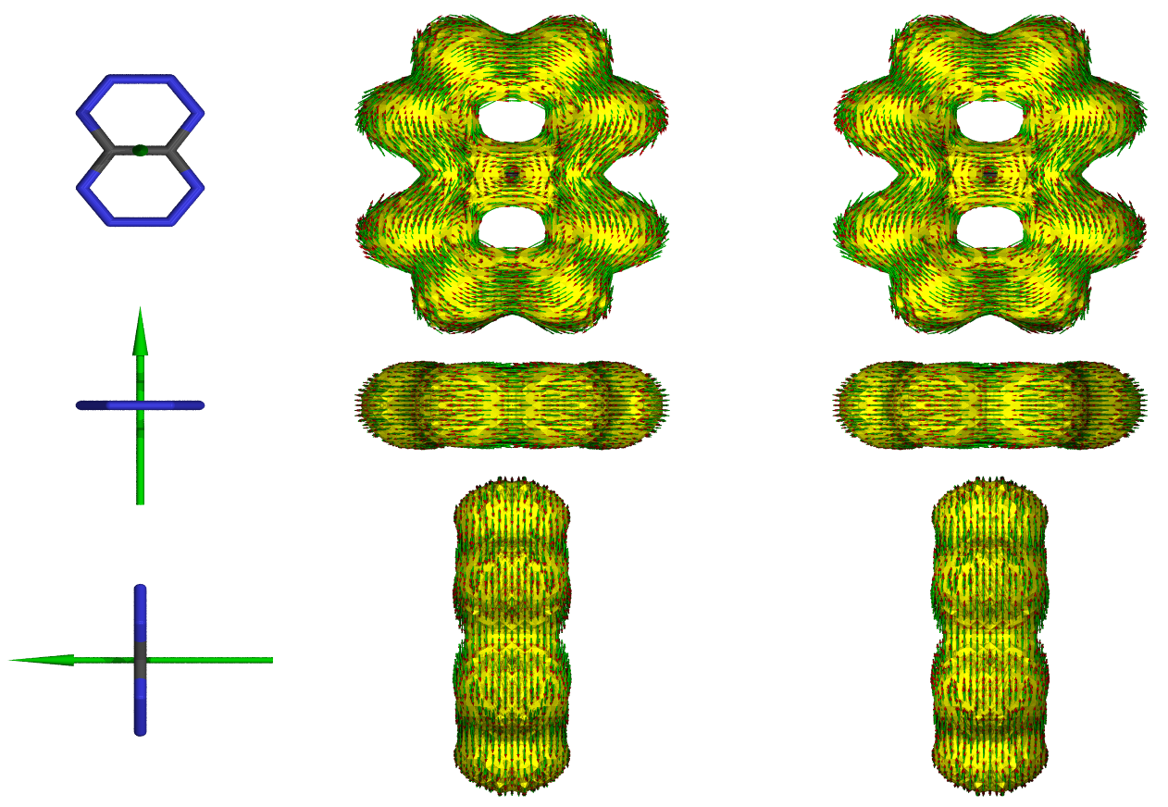
Fig S9. AICD map of I-1 (small arrows indicate direction and magnitude of magnetically induced currents on AICD isosurface of 0.05 a.u.)
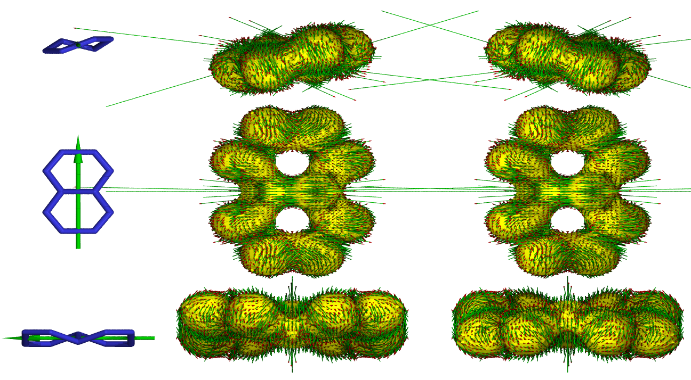
Fig S10. AICD map of II-1 (small arrows indicate direction and magnitude of magnetically induced currents on AICD isosurface of 0.05 a.u.)
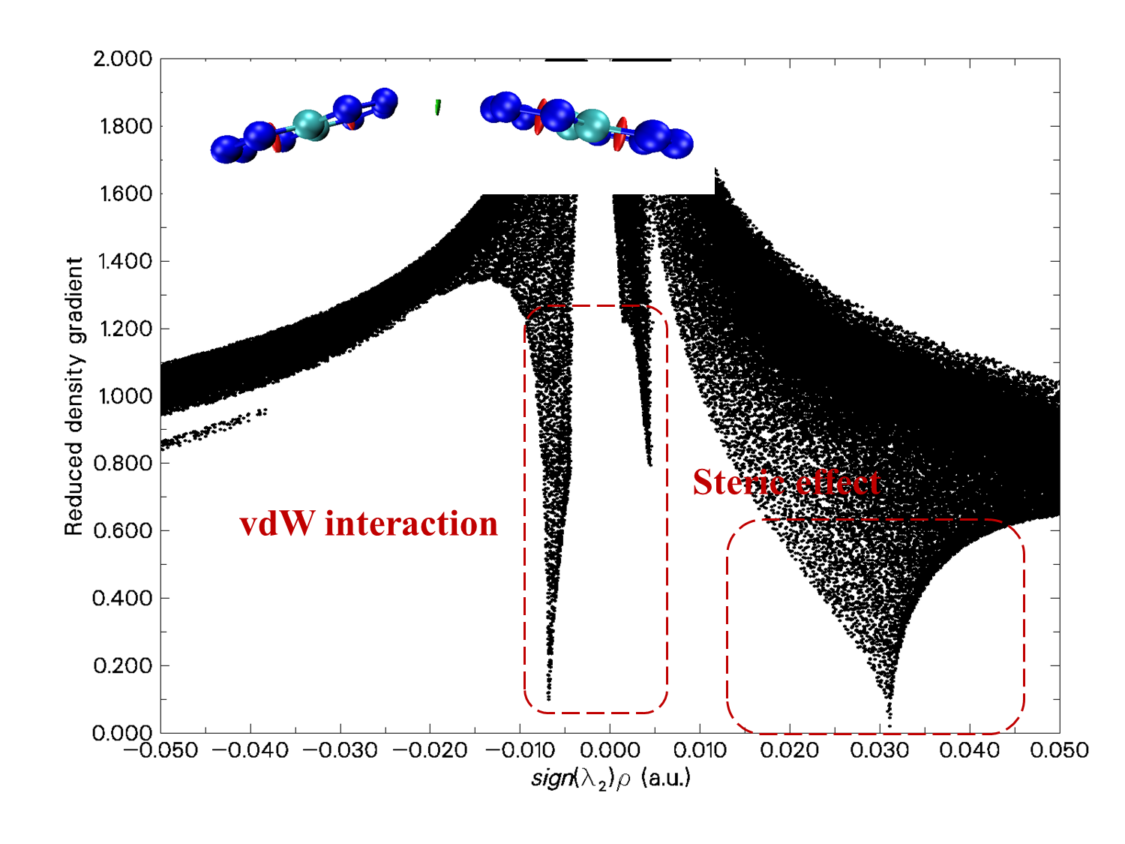
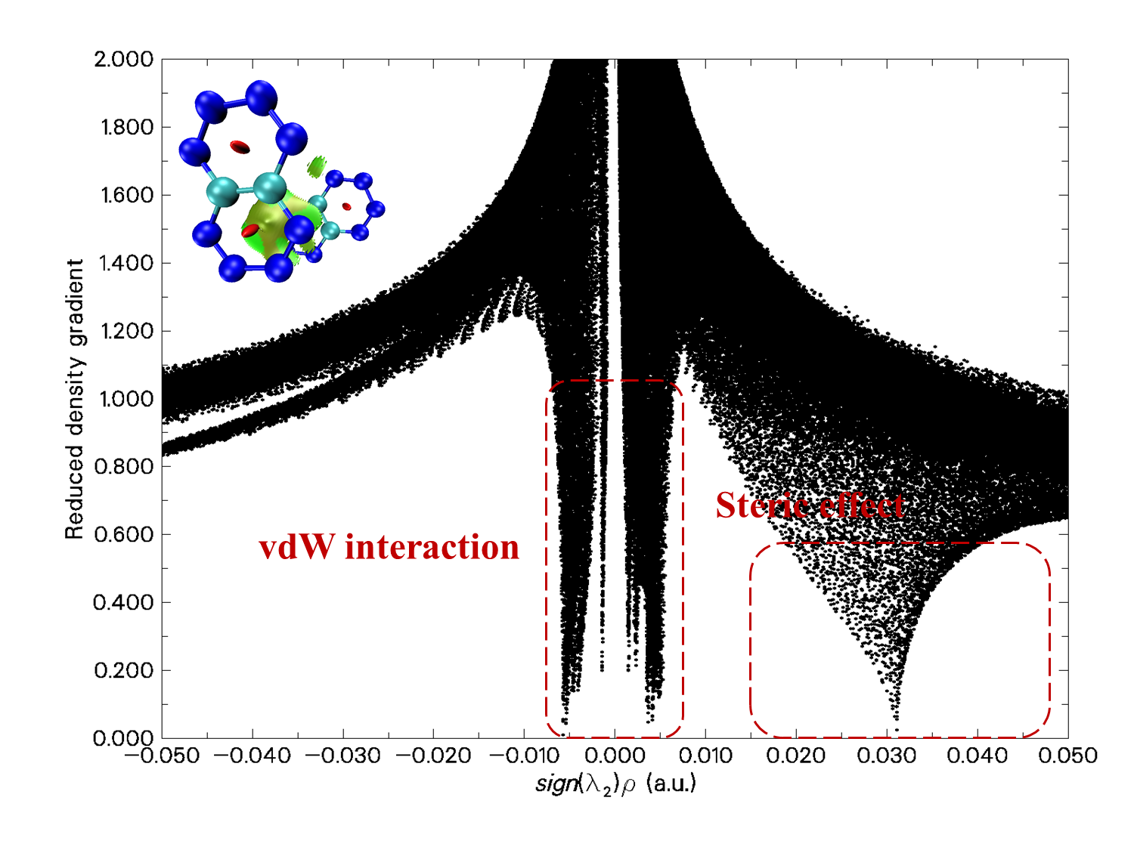
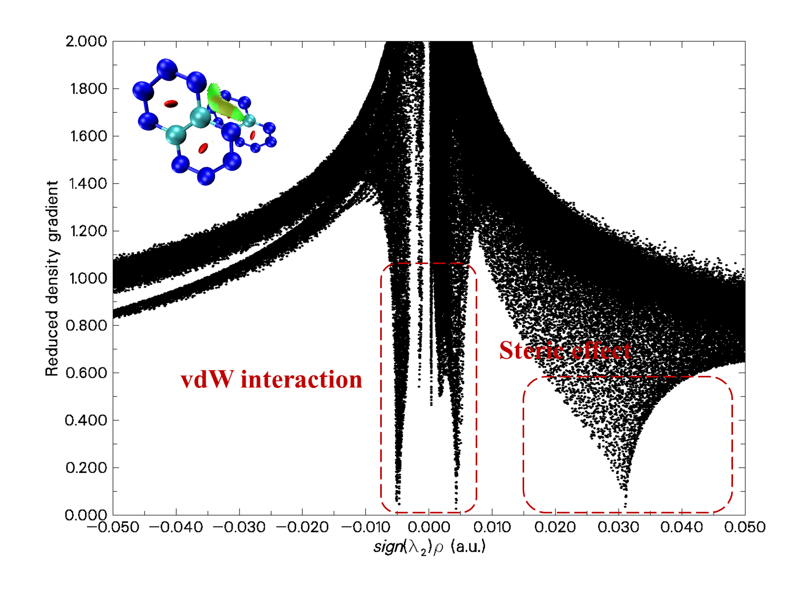
Fig. S11 RDG isosurfaces filling color map of I-1 dimer
Fig. S12 Possible pathways of decomposition of II-3-2

