APPENDIX A: BEAD COLOUR ARRANGEMENTS
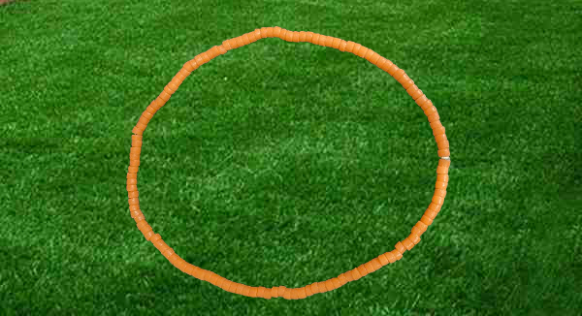
Figure 1: Single Colour Bead Arrangement
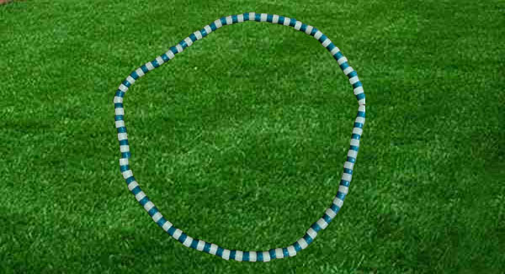
Figure 2: Two-Colour Bead Arrangement
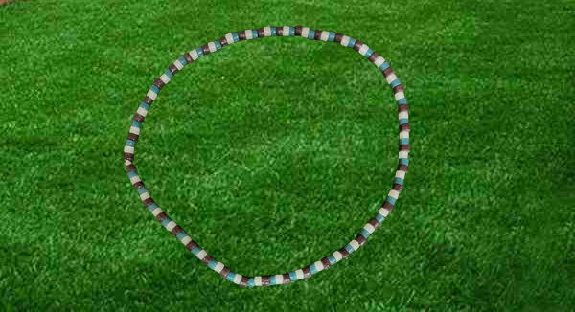
Figure 3: Three-Colour Bead Arrangement
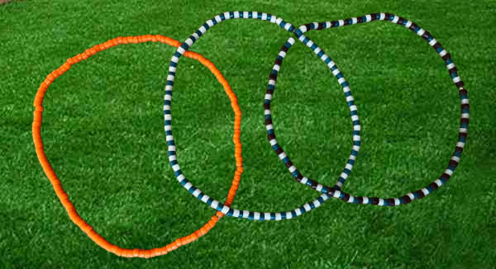
Figure 4:Bead Colour Arrangement (Combined)
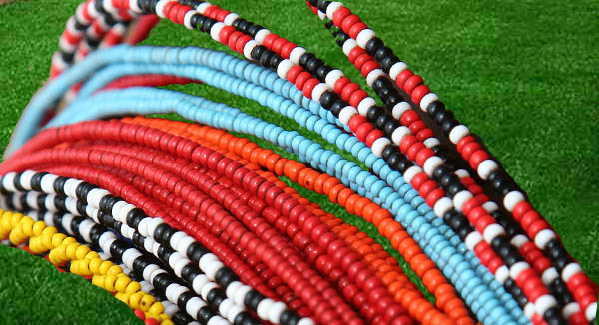
Figure 5: Bead Colour Combinations

