Supplementary Information
Direct and indirect land conversion caused by urban expansion under the meta-coupling framework
Human-nature coupled systems have traditionally focused on local-scale dynamics (Liu et al., 2007). The telecoupling framework extends and enriches this understanding by incorporating interactions that occur over distances. With accelerating urbanization and globalization, coupled human–nature systems are no longer confined to specific spatial or temporal boundaries, but are interconnected through flows of material, information, and energy. Introduced by Jianguo Liu in 2013, the concept of telecoupling provides a theoretical framework for understanding socio-economic and environmental interactions between distant human-environment systems (Liu et al., 2013).
This study adopts the telecoupling framework to analyze cropland displacement and vegetation encroachment caused by urban expansion, and to evaluate the resulting trade-offs between gains in agricultural production and losses in vegetation ecosystems across regions. The framework identifies three main components for each system: the sending system, receiving system, and spillover system. Each system comprises three basic elements—drivers, agents, and impacts—and these systems are interconnected through direct flows. Figure 1 illustrates the telecoupling framework applied in this study.
In the sending system, the primary driver is the demand for urban development space, with government and land use policies serving as key agents. These agents influence the direction of urban expansion, resulting in the conversion of cropland and vegetation into construction land. In the receiving system, the main driver is the relocation of cropland to suburban areas, with agriculture and forestry sectors acting as agents. The primary impacts are the gains from newly cultivated cropland and the corresponding losses to natural ecosystems. In the spillover system, drivers include agricultural suitability in remote areas and the advancement of transportation, which together facilitate long-distance food trade. Key agents here include the agricultural and forestry sectors and the food supply chain. The resulting impacts include offsite conversion of natural land, bringing both agricultural benefits and ecological losses.
The sending system connects to the receiving system through flows that meet urban food demand and drive cropland relocation. In return, the receiving system generates feedback—through food supply pressures and ecological degradation—that influences the sending system and poses risks to the broader human–environment system. Flows from the sending to the spillover system involve regional coordination and food demand, while flows in the opposite direction include food imports from distant areas and climate change caused by carbon cycle dynamics. Flows from the receiving system to the spillover system reflect cropland shortages in suburban zones, while reverse flows represent cropland compensation from remote regions to address this shortfall.
Building upon the telecoupling framework, Liu further introduced a more detailed classification metacoupling, which encompasses focal, adjacent, and distant interactions across multiple spatial scales (Liu, 2017). This extended framework defines three types of systems: focal, adjacent, and distant. The focal system concerns internal components of a given human–environment system. The adjacent system refers to spatially neighboring systems that interact with the focal system, while the distant system interacts with the focal system across long distances.
In this study, the focal system includes urban areas before and after expansion. The adjacent system encompasses urban areas newly incorporated through expansion, while the distant system involves remote vegetation ecosystems. Local coupling refers to the direct relationship between urban expansion and the cropland and vegetation it encroaches. Adjacent coupling captures the displacement of cropland due to urban growth and the subsequent encroachment on vegetation at the urban fringe. Distant coupling relates to remote cropland expansion driven by food trade, carbon cycle dynamics, and regional coordination, ultimately resulting in vegetation loss in distant ecosystems.
Based on the metacoupling framework, this study defines the direct effects of urban expansion on land conversion as the direct occupation of cropland and forest by construction land within the focal system. The indirect effects refer to the displacement of cropland into adjacent and distant systems after its initial loss, which leads to subsequent encroachment on forests in other land systems.
Given that land area is finite, when urbanization occurs in a specific region (e.g., tropical zones) and only partially encroaches on local vegetation, it may still induce an imbalance in the proportion of agricultural land elsewhere—an effect fundamentally driven by the global food supply chain. To validate this indirect influence, it is also necessary to account for local population growth and the resulting increase in agricultural demand. If the expansion of cropland exceeds the increase in demand due to population growth, the associated loss of vegetation carbon sinks can be attributed to the telecoupled effects of urbanization.
This study focuses on the resulting land cover transitions triggered by this process and the corresponding impacts on agricultural output and vegetation-related carbon dynamics.
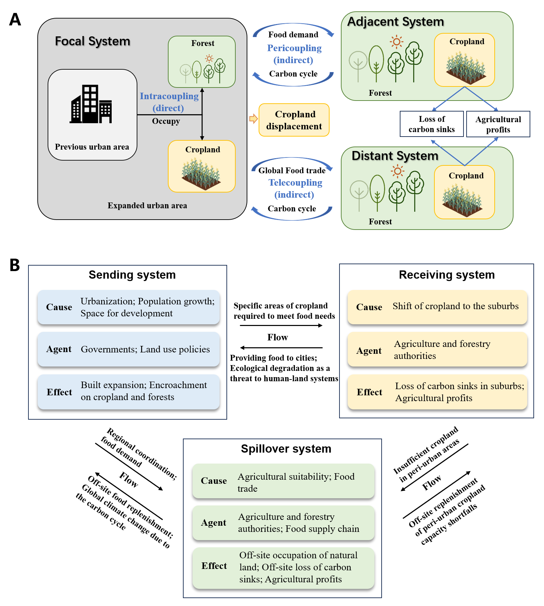
Supplementary Fig. S1 Direct and indirect land conversion caused by urban expansion under the meta-coupling framework. A, Land conversion mechanism in three types of spatial systems under the meta-coupling analysis framework. B, Interaction mechanism among three types of role systems under the meta-coupling analysis framework.

Based on the above framework, we divide the world into sending and receiving systems, and further divide them into 5 categories based on their characteristics (Supplementary Fig. 2). For instance, Region A as China and Region B as Europe lose cropland due to urbanization and increased population, increasing its dependence on food imports. This, in turn, indirectly drives cropland expansion in Region C and D, resulting in vegetation loss, because these areas are more suitable for farming, or agriculture is still the main industry. At a global scale, urbanization indirectly affects the balance between cropland and vegetation through supply chains, particularly in tropical regions where cropland expansion beyond local demand can be attributed to the distant coupling effects of urbanization. This framework highlights the complex cross-regional impacts of urbanization on land cover change.
Supplementary Fig. S2 Partitioning of sending and receiving systems in a meta-coupling framework based on global locations and administrative boundaries.

Agricultural value simulation and adjustments
In this study, a Random Forest (RF) regression model was employed to simulate global crop production value. As an ensemble learning algorithm based on decision trees, RF offers strong capabilities for modeling non-linear relationships and demonstrates robust performance, making it particularly suitable for handling high-dimensional remote sensing and environmental datasets (Lian et al., 2023; Huang et al., 2021).
This study used gridded crop production value data of 2010 from GAEZ v4 Theme 5: Actual Yields and Production as the response variable. A suite of predictor variables (Yao et al., 2021; Bond-Lamberty et al., 2018; Gbode et al., 2023; Wang et al., 2019) was incorporated into the model, including climate factors (potential evapotranspiration, precipitation, and temperature), soil properties (soil carbon content, soil nitrogen density, and soil moisture), solar radiation, and vegetation conditions (Enhanced Vegetation Index, EVI). Details of the input datasets are provided in Supplementary Table S1. Some variables were obtained directly from publicly available annual datasets, while others were preprocessed and downloaded via the Google Earth Engine platform. The preprocessing steps involved filtering datasets for the specific target year, computing annual means, and exporting the data for local use.
Prior to model implementation, all predictor datasets were harmonized in terms of spatial resolution, extent, and coordinate reference system using Python-based resampling, projection, and clipping operations. The RF model was then constructed using Python. To train and validate the model, valid data points were extracted from both predictor and response layers, with 80% of the samples allocated for training and the remaining 20% reserved for validation. Model performance was evaluated using the coefficient of determination (R²), where a value closer to 1 indicates stronger predictive accuracy. The model achieved an R² of 0.818 on the test set, indicating that the model explained 81.8% of the variance in crop production value, and thus exhibited strong predictive power.
Using the trained model, global agricultural production values were further simulated for the years 2001 and 2020. To ensure comparability across time, simulated values for 2001 and 2020 were adjusted using crop price normalization coefficients provided by the Food and Agriculture Organization (FAO), generating comparable gridded value maps. Finally, by spatially overlaying changes in cropland extent with per-unit agricultural production values at national and regional scales, we quantified the changes in agricultural income driven by three distinct types of land conversion.

Supplementary Table S1 Data sources and details of the agricultural value modeling
Data | Detail | Sources
Enhanced Vegetation Index (EVI) | MOD13A2.061 Terra Vegetation Indices 16-Day Global 1km | NASA LP DAAC at the USGS EROS Center; Preprocess and download from Google Earth Engine
Temperature; Potential Evapotranspiration (PET); Precipitation | CRU TS4.08: Climatic Research Unit (CRU) Time-Series (TS) version 4.08 of high-resolution gridded data of month-by-month variation in climate (Jan. 1901- Dec. 2023) | https://catalogue.ceda.ac.uk/uuid/715abce1604a42f396f81db83aeb2a4b. University of East Anglia Climatic Research Unit; Harris, I.C.; Jones, P.D.; Osborn, T. (2024): CRU TS4.08: Climatic Research Unit (CRU) Time-Series (TS) version 4.08 of high-resolution gridded data of month-by-month variation in climate (Jan. 1901- Dec. 2023). NERC EDS Centre for Environmental Data Analysis,
Radiation; soil moisture | ERA5-Land Monthly Averaged by Hour of Day - ECMWF Clim | https://cds.climate.copernicus.eu/; Preprocess and download from Google Earth Engine
Soil carbon content | Soil carbon content is extracted from Harmonized World Soil Database (HWSD), | Produced by FAO and IIASA by combining existing global regional and national inventories for soil information in over 15,000 different soil mapping units
Soil nitrogen density | Soil nitrogen density data set (unit: g N m⁻²) from Global Gridded Surfaces of Selected Soil Characteristics | International Geosphere-Biosphere Program Data and Information System (IGBP-DIS).

References
Bond-Lamberty, B., Bailey, V. L., Chen, M., Gough, C. M., & Vargas, R. (2018). Globally rising soil heterotrophic respiration over recent decades. Nature, 560(7716), 80-83.
Gbode, I. E., Babalola, T. E., Diro, G. T., & Intsiful, J. D. (2023). Assessment of ERA5 and ERA-interim in reproducing mean and extreme climates over West Africa. Advances in Atmospheric Sciences, 40(4), 570-586.
Lian, Y., Li, H., Renyang, Q., Liu, L., Dong, J., Liu, X., ... & Zhang, H. (2023). Mapping the net ecosystem exchange of CO2 of global terrestrial systems. International Journal of Applied Earth Observation and Geoinformation, 116, 103176.
Huang, N., Wang, L., Zhang, Y., Gao, S., & Niu, Z. (2021). Estimating the net ecosystem exchange at global FLUXNET sites using a random forest model. IEEE Journal of Selected Topics in Applied Earth Observations and Remote Sensing, 14, 9826-9836.
Liu, J., Dietz, T., Carpenter, S. R., Alberti, M., Folke, C., Moran, E., ... & Taylor, W. W. (2007). Complexity of coupled human and natural systems. science, 317(5844), 1513-1516.
Liu, J., Hull, V., Batistella, M., DeFries, R., Dietz, T., Fu, F., ... & Zhu, C. (2013). Framing sustainability in a telecoupled world. Ecology and Society, 18(2).
Liu, J. (2017). Integration across a metacoupled world. Ecology and Society, 22(4).
Wang, C., Graham, R. M., Wang, K., Gerland, S., & Granskog, M. A. (2019). Comparison of ERA5 and ERA-Interim near-surface air temperature, snowfall and precipitation over Arctic sea ice: effects on sea ice thermodynamics and evolution. The Cryosphere, 13(6), 1661-1679.
Yao, Y., Ciais, P., Viovy, N., Li, W., Cresto‐Aleina, F., Yang, H., ... & Bond‐Lamberty, B. (2021). A data‐driven global soil heterotrophic respiration dataset and the drivers of its inter‐annual variability. Global Biogeochemical Cycles, 35(8), e2020GB006918.

