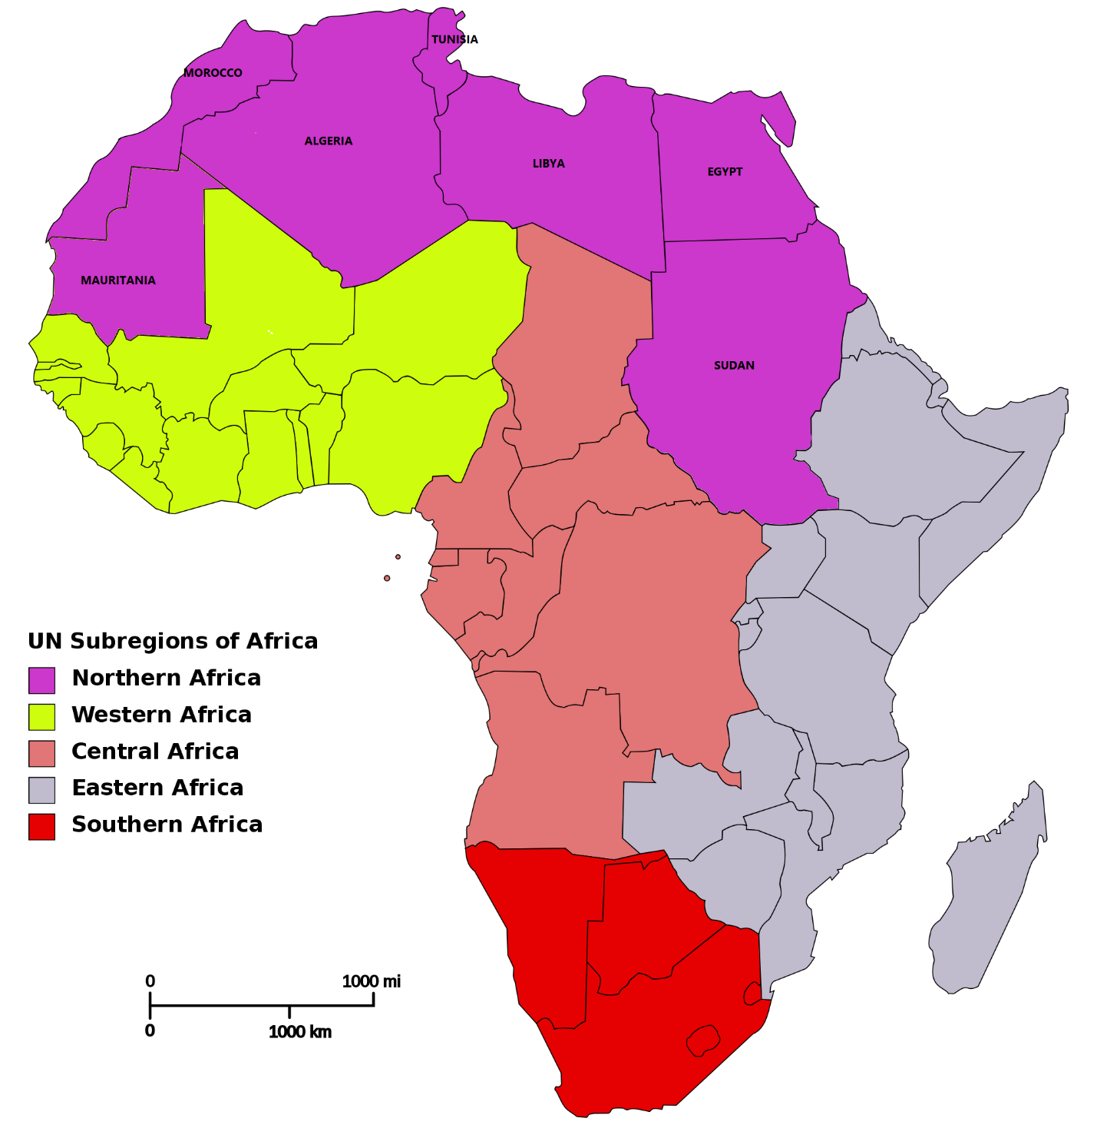

___________________________________________________________________________
Country Algeria Egypt Libya Mauritania Morocco Sudan Tunisia
____________________________________________________________________________
Populations(Millions) 37 83.5 6.4 3.5 33 44.6 11.5

Population density - 16 90 4 4 76 20 71
(people/Km2)
Literacy rate (M:F) 95.59% 91.12% 99.95% 62.63% 83.19% 89.57% 98.06%
(95.65; 95.52) (93.42; 88.73) (99.97; 99.93) (70.04; 54.98) (90.10; 75.87) (91.29; 87.81) (98.35; 97.76)

GNI(PPP-US$) 4420 6120 16500 2770 2400 2120 3720
HDI(2010=2014) 0.736 0.664 0.849 0.628 0.453 0.408 0.712
Country Classification LMI LMI HI LMI LMI LI LMI

GNI; Gross National Income.
PPP; Purchasing Power Parity.
HDI; Human Development Index.
HI; High Income. LMI; Lower Middle Income. LI; Low Income.

References;
-Salehi-Isfahani D. Human Development in the Middle East and North Africa. Human Development. 2010;26.
- Akkari A. Education in the Middle East and North Africa: The current situation and future challenges. International Education Journal. 2004;5(2):144-53.
- Aubert JE, Reiffers JL, editors. Knowledge economies in the Middle East and North Africa: Toward new development strategies. World Bank Publications; 2003.
Your username is: mohamedadaw@gmail.com
Daw3334474
https://www.editorialmanager.com/arty/default.aspx

