1,3,4-oxadiazole encompassed benzoxazole derivatives: Synthesis, Structural characterization, Biological evaluation, Molecular docking and their DFT studies
Anees Fathimaª, Amith Nayak P H^{b}, Mohammed Shafeeullaª R, Lubna Afroz^{c}

a. Depaertment of Chemistry, Sahyadri Science College, Shimoga-577201, India
b. Department of Industrial Chemistry, Kuvempu University, Shankaraghatta, Shimoga-577451
c. Depaertment of Chemistry, JNNCE, Navule, Shimoga-577203, India

Supplementary Information (SI)

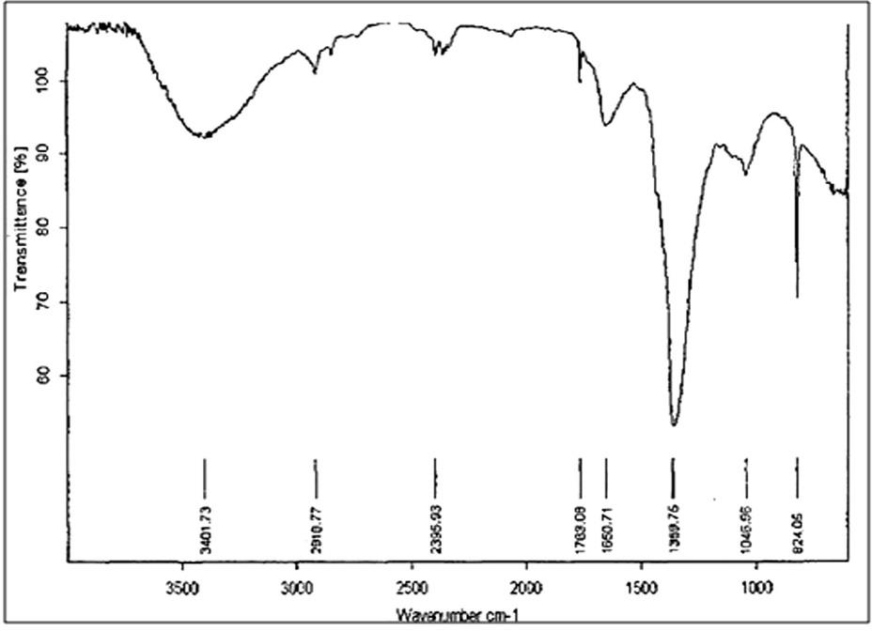
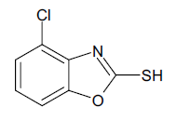
Fig SI.1: IR Spectrum of Compound 2a

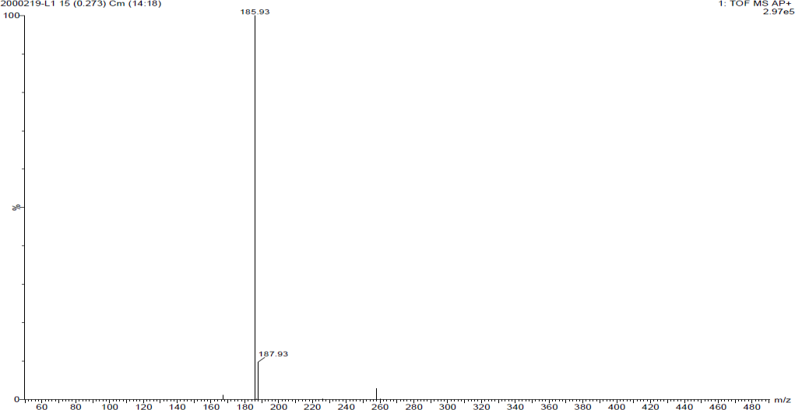
Fig SI.2: Mass Spectrum of Compound 2a

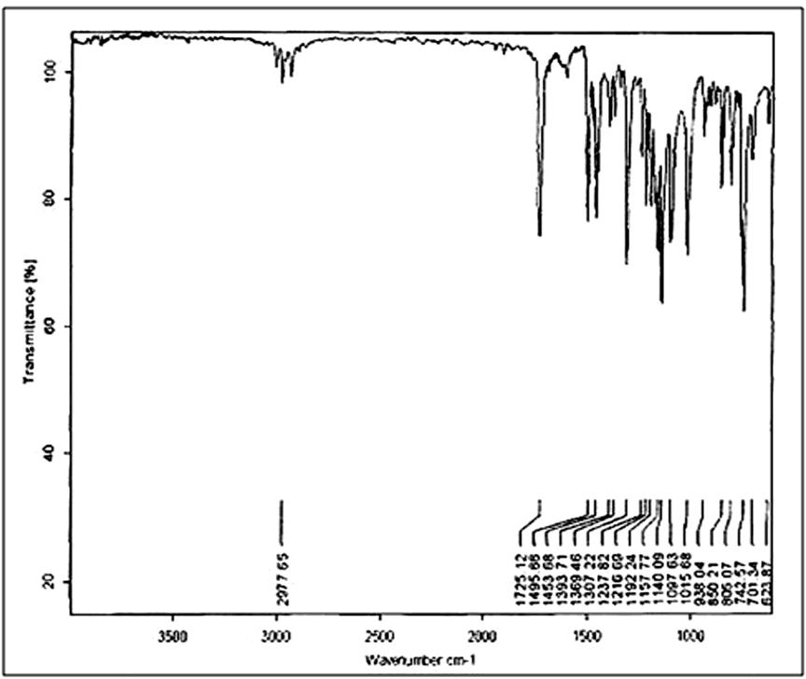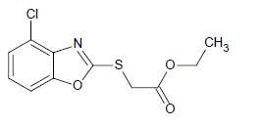
Fig SI.3: IR Spectrum of Compound 3a

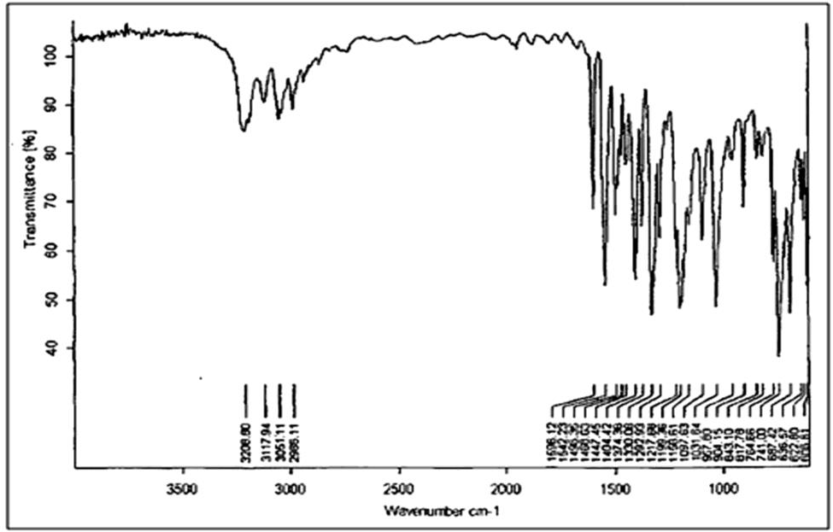
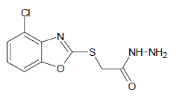
Fig SI.4: IR Spectrum of Compound 4a

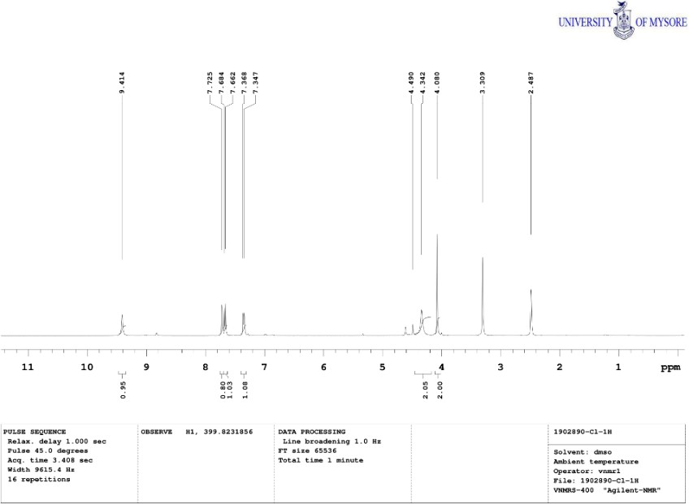
Fig SI.5: ¹H-NMR Spectrum of Compound 4a

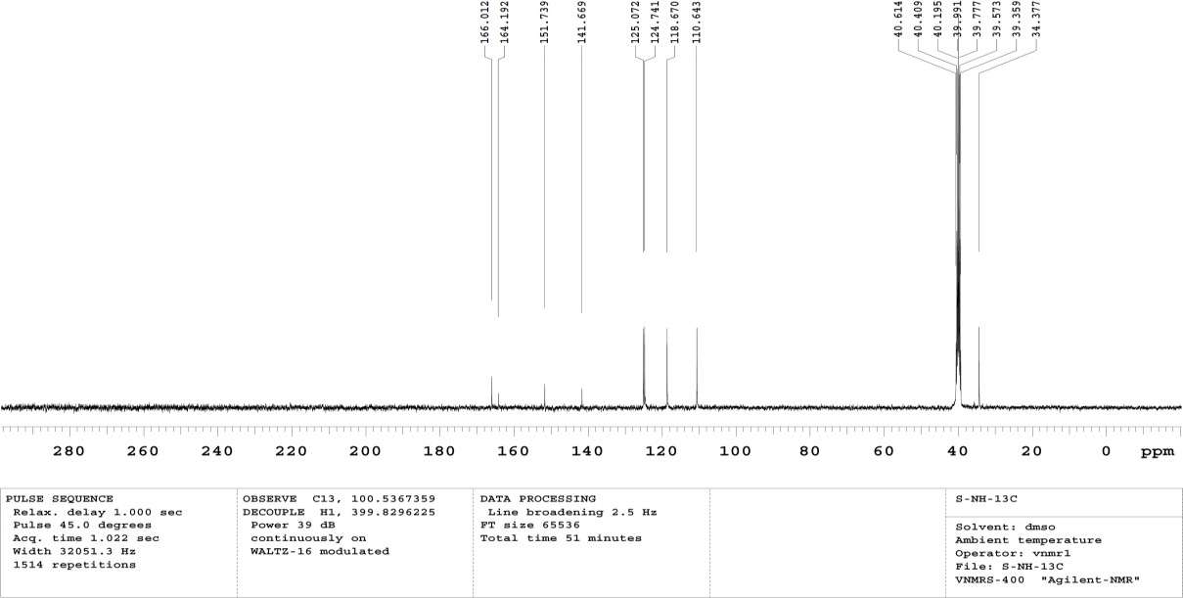
Fig SI.6: ¹³C-NMR Spectrum of Compound 4a

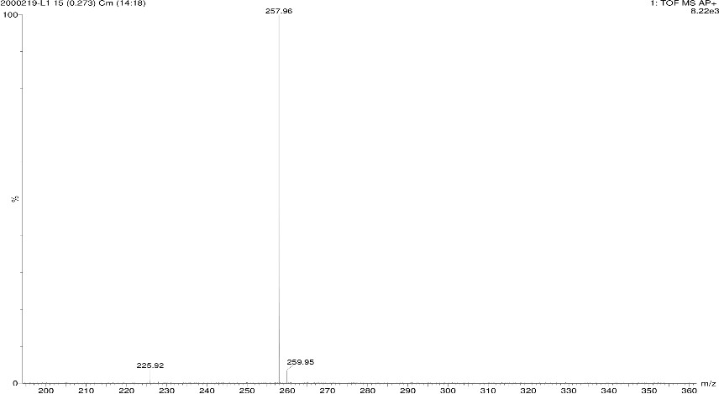
Fig SI.7: - Mass Spectrum of Compound 4a

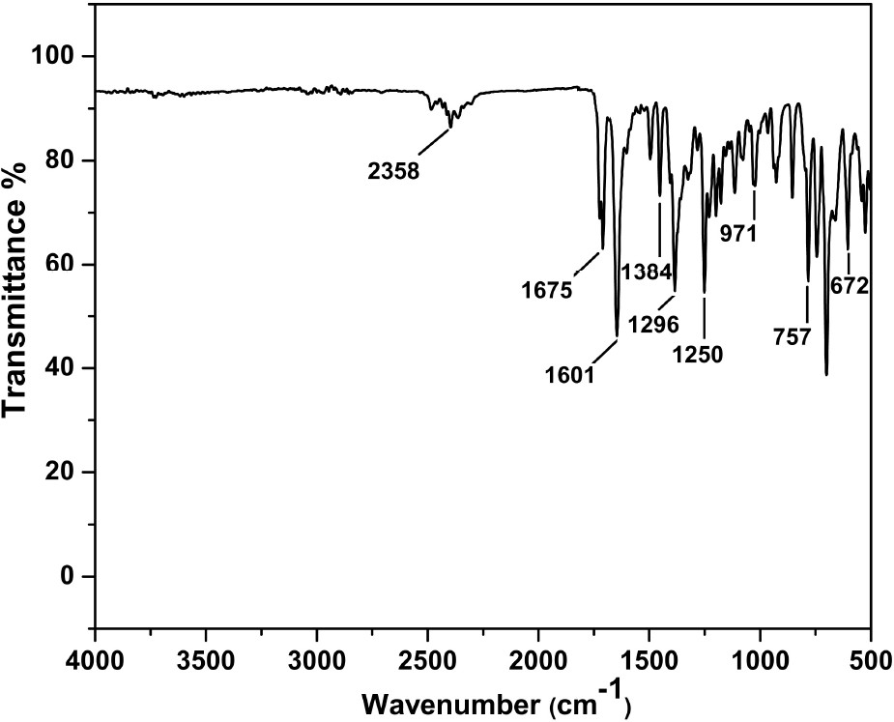
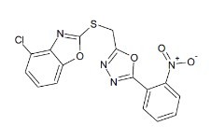
Fig SI.8: IR Spectrum of Compound 5e

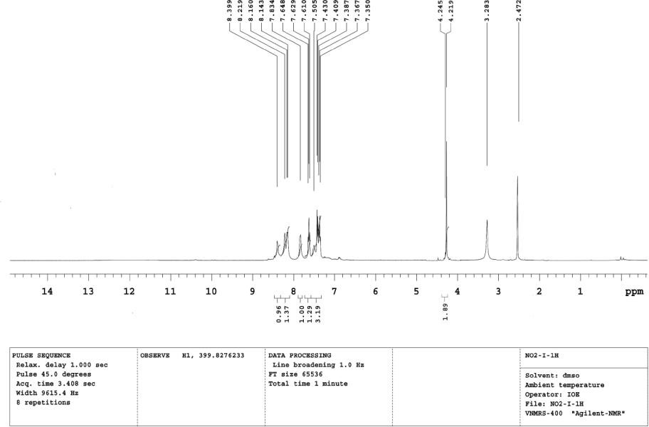
Fig SI.9: ¹H-NMR Spectrum of Compound 5e

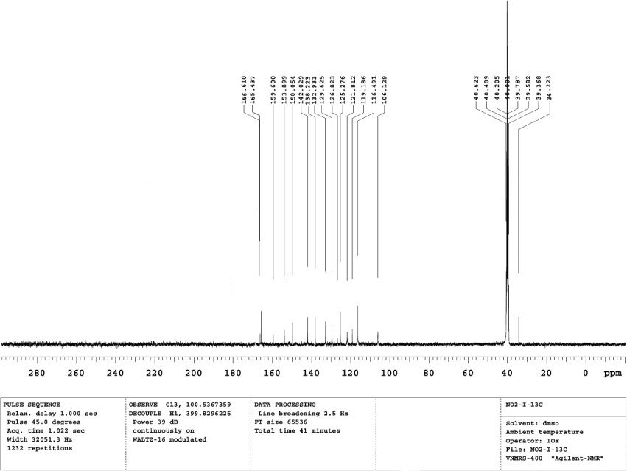

Fig SI.10: ¹³C-NMR Spectrum of Compound 5e

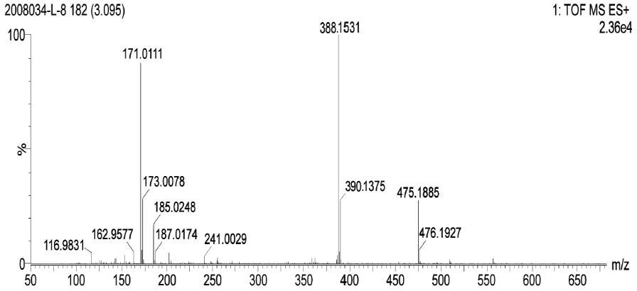
Fig SI.11: Mass Spectrum of Compound 5e
10b

10c

10d
10e

10f

Fig SI.12: DFT structure of compounds 10b-10f.

