Supplementary Information

Year-Round Daily Wildfire Prediction and Key Factor Analysis Using Machine Learning: A Case Study of Gangwon State, South Korea

Chanjung Lee¹, Eun Hyoung Choi¹, Youngju Han¹, and Yohan Lee^{1,2*}
¹ Department of Agriculture, Forestry and Bioresources, Seoul National University, Seoul, 08826, Republic of Korea
² Research Institute of Agriculture and Life Sciences, Seoul National University, 1 Gwanak-ro, Gwanak-gu, Seoul 08826, Republic of Korea
*Corresponding author: johnlee@snu.ac.kr

ABSTRACT
Under climate change and human’s dominant influence, wildfires have been increasing in frequency and scale, highlighting the demand of effective wildfire prediction and response. While prior research often maps high-risk areas, a few studies predict wildfire occurrences at specific dates and locations. This study aims to develop a year-round daily wildfire prediction model using machine learning, targeting Gangwon State in the Republic of Korea, and examine major influencing factors. We integrate meteorological elements (e.g., temperature, humidity, precipitation), forest-related variables (e.g., coniferous forest ratio, forest growing stock volume), and socioeconomic indicators (e.g., agricultural and cemetery land ratios) to identify salient predictors. We compare multiple algorithms, including Logistic Regression, XGBoost, and Random Forest, and use SHAP (SHapley Additive exPlanations) to enhance interpretability. The Extra Tree model achieves the highest AUC (0.839), and Random Forest demonstrates the best recall (0.828). SHAP results confirm that meteorological factors—especially relative humidity, precipitation, and temperature—are crucial, with forest- and socioeconomic variables also showing consistent effects. Applying a machine learning–based approach to daily wildfire prediction, integrating climate, environmental, and anthropogenic factors nationwide, and refining the temporal and spatial resolution of input data helps to advance wildfire prevention and response strategies in practice.

KEYWORDS
wildfire, daily wildfire prediction, machine learning, SMOTE, SHAP, Gangwon State

Supplementary Table 1. Definitions and descriptions of variables used in this study

 | Variables | Meaning (unit) | Range
[1] | TMAX | Daily/Si·Gun Maximum Temperature (℃) | [-15.2, 41.0]
[1] | RHM | Daily/Si·Gun Relative Humidity (%) | [10.4, 100.0]
[1] | RNCD† | Daily/Si·Gun Precipitation (-) | [0, 3]
[1] | WSMN | Daily/Si·Gun Mean Wind Speed (m/s) | [0.0, 14.6]
[2] | CFRT | Si·Gun Coniferous Forest Cover Ratio (%) | [23.0, 50.2]
[2] | PFRT | Si·Gun Private Forest Ownership Ratio (%) | [13.3, 72.4]
[2] | FGSV | Si·Gun Mean Forest Growing Stock Volume (m³/ha) | [150.8, 193.2]
[3] | ALRT | Si·Gun Agricultural Land Use Ratio (%) | [2.2, 14.1]
[3] | CLRT | Si·Gun Cemetery Land Use Ratio (%) | [0.0, 0.1]
[3] | FPDN | Si·Gun Forest-Adjusted Population Density (-) | [1.9, 24.8]
[3] | YDCD† | Yeongdong Region Indicator (-) | [0, 1]
[4] | FOCR† | Daily/Si·Gun Forest Fire Occurrence (-) | [0, 1]

†These variables were coded separately and converted to discrete integers
*Si·Gun means city or county (administrative district level) in South Korea
*The independent variables are categorized into [1] Meteorological factors, [2] Forest-related factors, and [3] Socioeconomic factors, while the wildfire occurrence variable is classified as [4]

Supplementary Table 2. Results of variable independence and interaction analyses

 | Factors | VIF | Tolerance | Mutual Information
[1] | ALRT | 3.643 | 0.275 | 0.104
[2] | FGSV | 3.235 | 0.309 | 0.098
[3] | CLRT | 2.650 | 0.377 | 0.103
[4] | FPDN | 2.593 | 0.386 | 0.101
[5] | PFRT | 2.204 | 0.454 | 0.101
[6] | CFRT | 1.884 | 0.531 | 0.102
[7] | RHM | 1.816 | 0.551 | 0.616
[8] | YDCD | 1.813 | 0.552 | 0.015
[9] | RNCD | 1.571 | 0.637 | 0.136
[10] | WSMN | 1.368 | 0.731 | 0.515
[11] | TMAX | 1.033 | 0.968 | 0.621

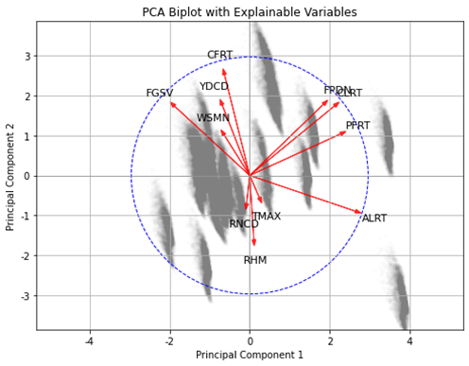

Supplementary Fig. 1. Principal Component Analysis (PCA) results and associated biplots

Supplementary Fig. 2. Confusion matrices illustrating model performance in wildfire prediction

