Supplementary Information for
Muted Global Changes Despite Large Regional Responses: The Contrasting Future Trajectories of Inundated and Saturated Wetlands
Donghui Xu^{1,*}, Zeli Tan^{1,*}, Etienne Fluet-Chouinard², Gautam Bisht¹, Dalei Hao¹, Dongyu Feng¹, Tian Zhou¹, Hong-Yi Li³, L. Ruby Leung¹

¹Atmospheric, Climate, & Earth Sciences Division, Pacific Northwest National Laboratory, Richland, WA, 99354, USA
²Earth Systems Science Division, Pacific Northwest National Laboratory, Richland, WA, 99354, USA
³Department of Civil and Environmental Engineering, University of Houston, Houston, TX, 77204, USA

Correspondence to: Donghui Xu, donghui.xu@pnnl.gov, Zeli Tan, zeli.tan@pnnl.gov

This file includes:
Supplementary Figure 1 to Supplementary Figure 17

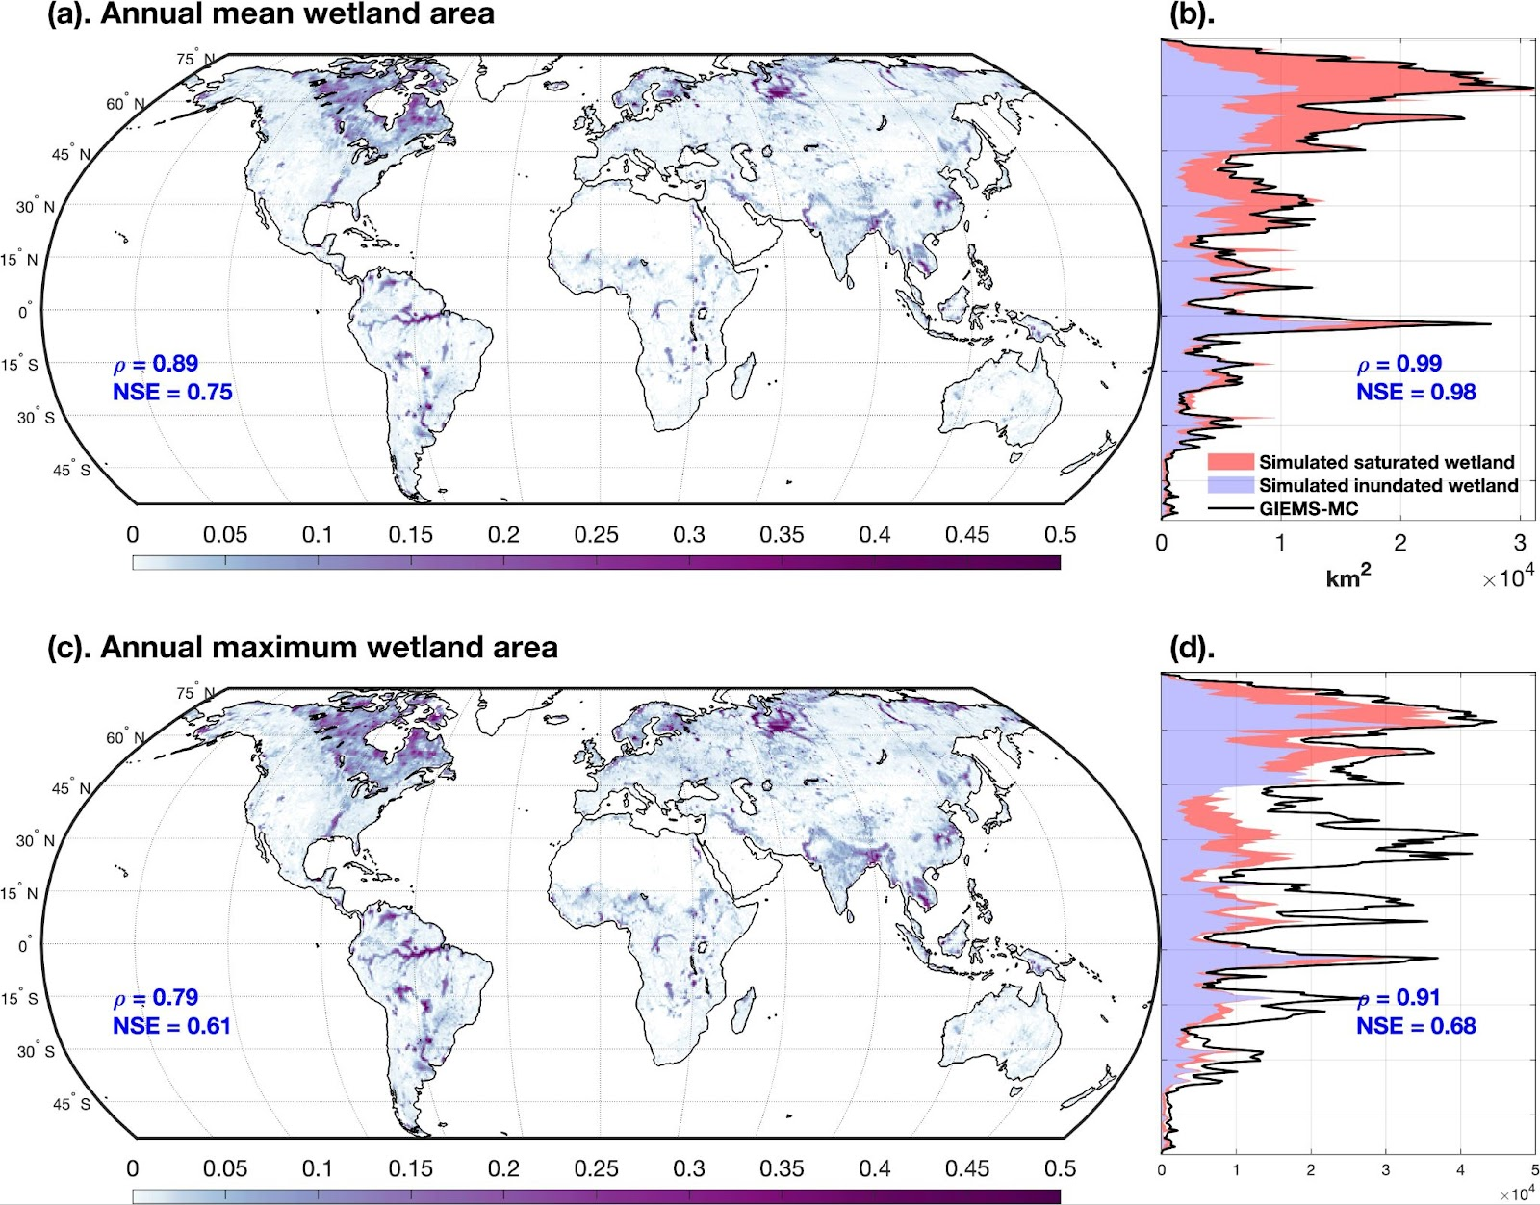
Figure S1. Comparison of E3SM simulated annual mean and maximum wetland area (including both saturated and inundated wetlands) against satellite observations. (a). Simulated annual mean wetland area during 1999-2014 (unit: fraction of a grid cell). (b). Latitudinal distribution of annual mean wetland area (unit: Mkm²). (c). Simulated annual maximum monthly wetland area during 1999-2014 (unit: fraction of a grid cell). (d). Latitudinal distribution of annual maximum monthly wetland area (unit: Mkm²). The evaluation metrics against the modified GIEMS-MC are shown inside each panel. $ρ$ is the correlation coefficient, and NSE represents the Nash-Sutcliffe model efficiency. Note, for consistency, the simulated values at certain locations or times are masked out if the corresponding observations are not available.

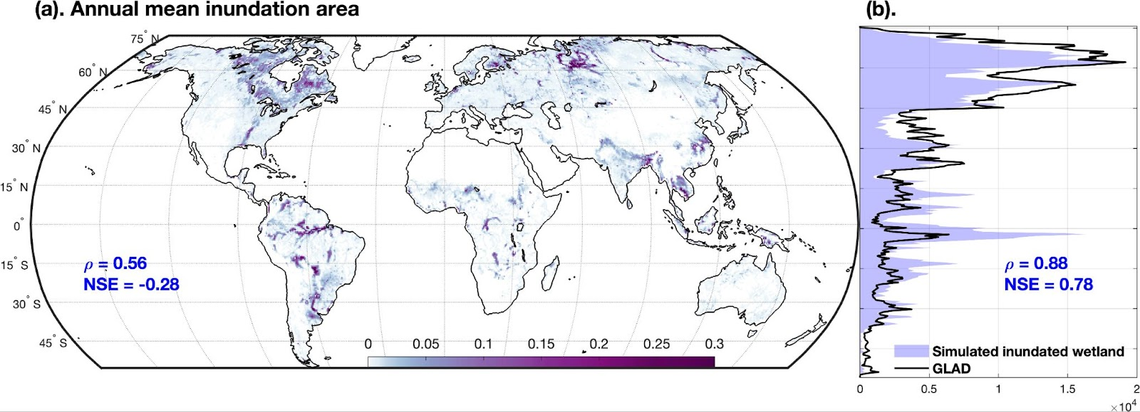
Figure S2. Comparison of E3SM simulated annual mean inundated wetland area against satellite observations. (a). Simulated annual mean inundated wetland area during 1999-2014 (unit: fraction of a grid cell). (b). Latitudinal distribution of annual mean inundated wetland area. The evaluation metrics for model validation against GLAD are shown in each panel. is the correlation coefficient, and NSE represents the Nash-Sutcliffe model efficiency.

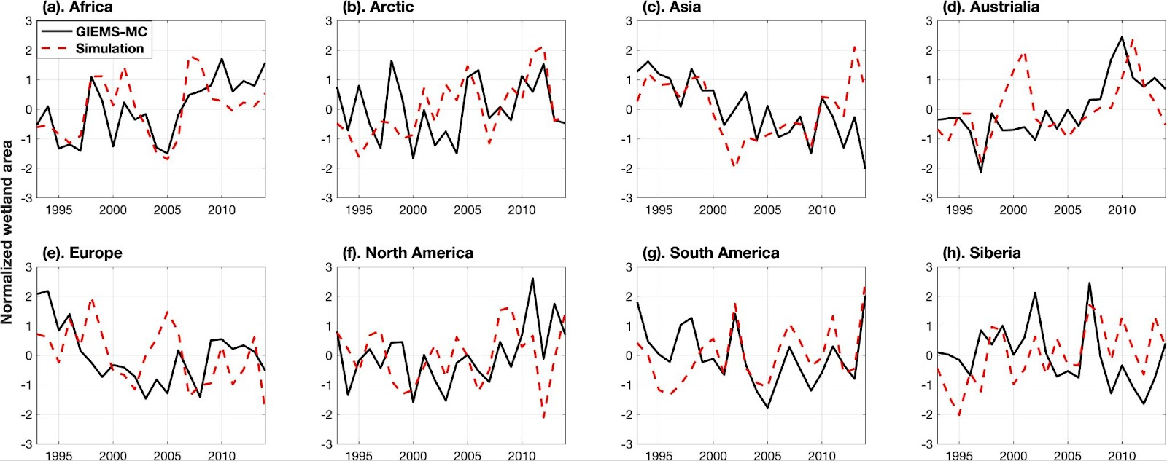
Figure S3. Comparison of simulated total wetland areas (red dashed line) against GIEMS-MC (black solid line) at an annual scale. Subregions of HydroBASINS level 1 were used, and the delineation can be found in Figure S5.

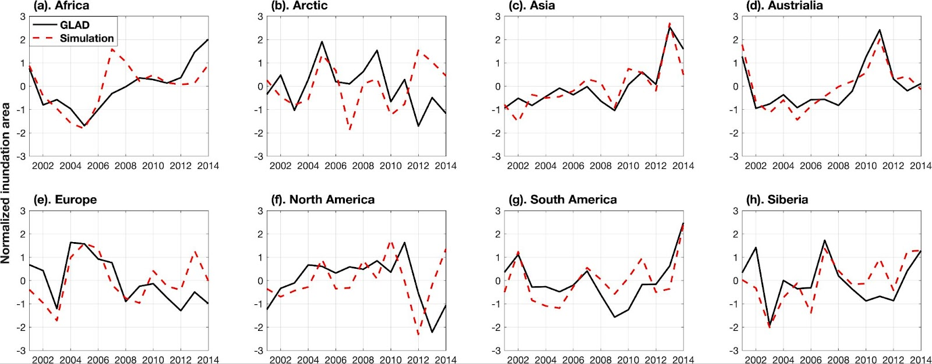
Figure S4. Comparison of simulated inundated wetland areas (red dashed line) against GLAD (black solid line) at an annual scale. Subregions of HydroBASINS level 1 were used, and the delineation can be found in Figure S5.

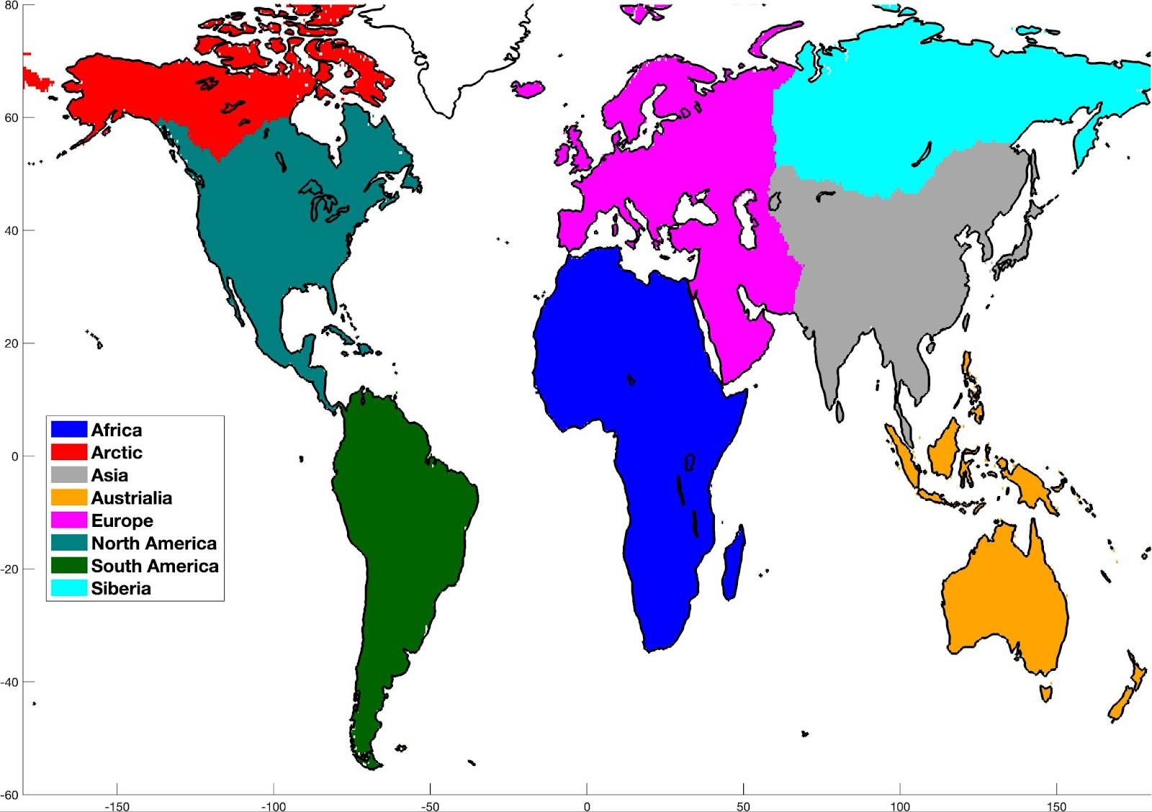
Figure S5. Subregion delineation based on HydroBASINS level 1. The data is available at https://www.hydrosheds.org/products/hydrobasins.

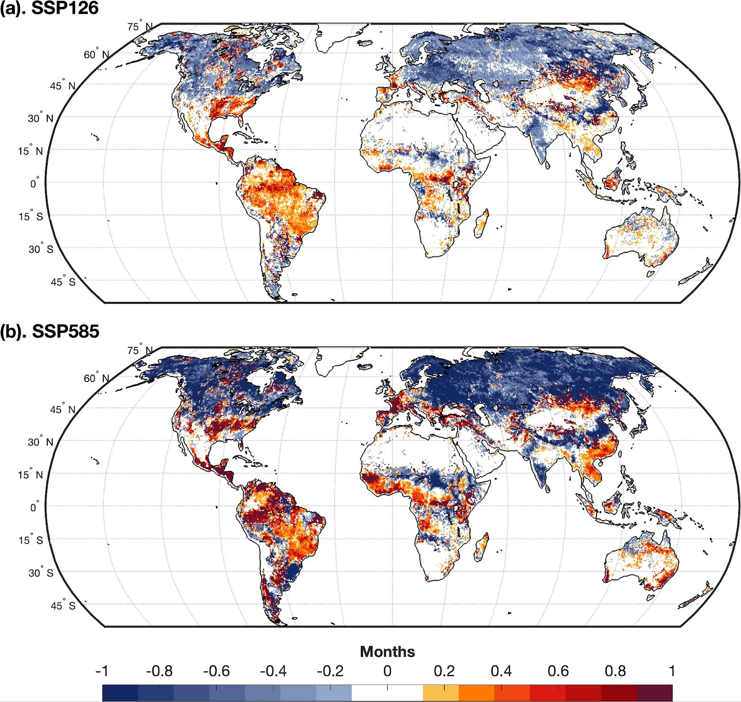

Figure S6. Change of timing for the maximum wetland area occurrence between the end-of-century period (2071-2100) and the historical period (1985-2014). Since our simulation outputs were saved at monthly scales, the change of timing was estimated in months.

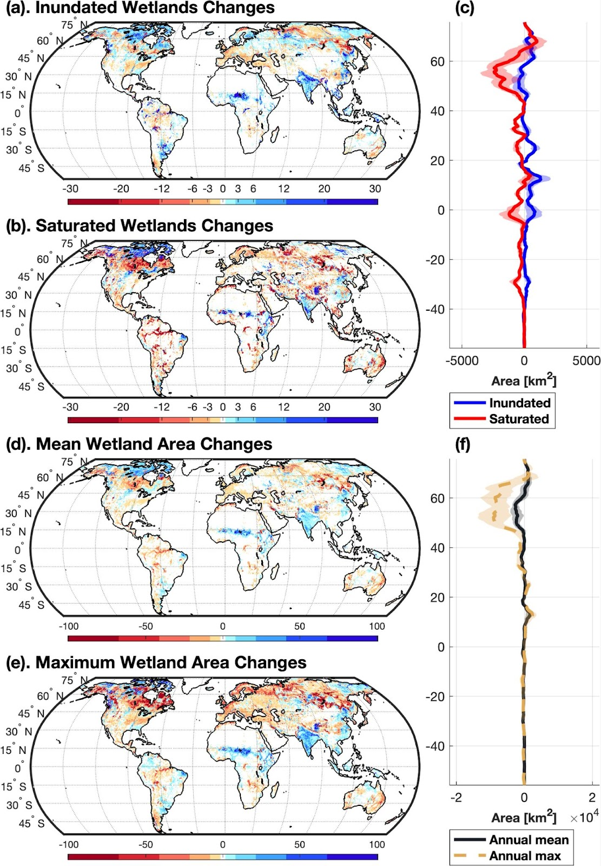
Figure S7. Projected wetland changes between future and historical periods under the SSP126 scenario. Absolute change of (a) inundated wetland area [km²], (b) saturated wetland area [km²], (d) mean total wetland area [km²], and (e) maximum wetland area [km²] between end-of-century (2071-2100) and historical (1985-2014) periods. The changes were estimated as the multi-model ensemble mean. (c) and (f) shows the latitudinal distribution of the changes in wetland area. The solid and dashed lines represent the multi-model ensemble mean, and the shaded area represents the range of the multi-model ensemble.

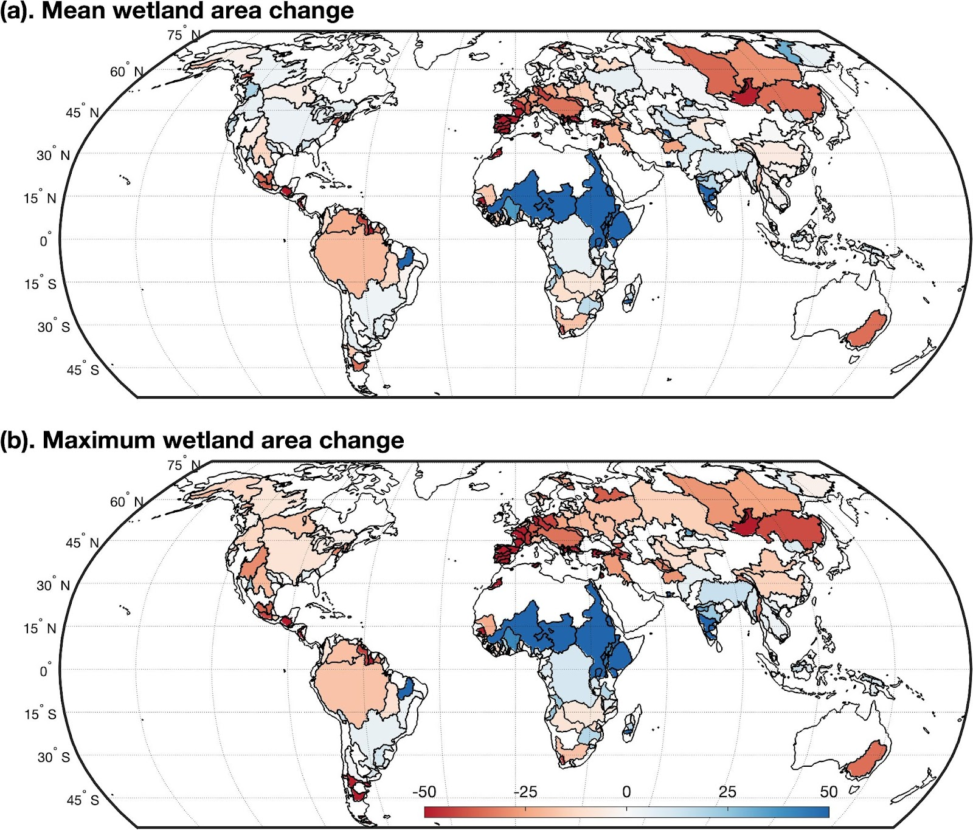
Figure S8. Relative change [%] of (a). mean wetland area and (b). Maximum wetland area at basin scales between future (2071-2100) and historical (1985-2014) periods. 254 major river basins were selected from https://datacatalog.worldbank.org/search/dataset/0041426.

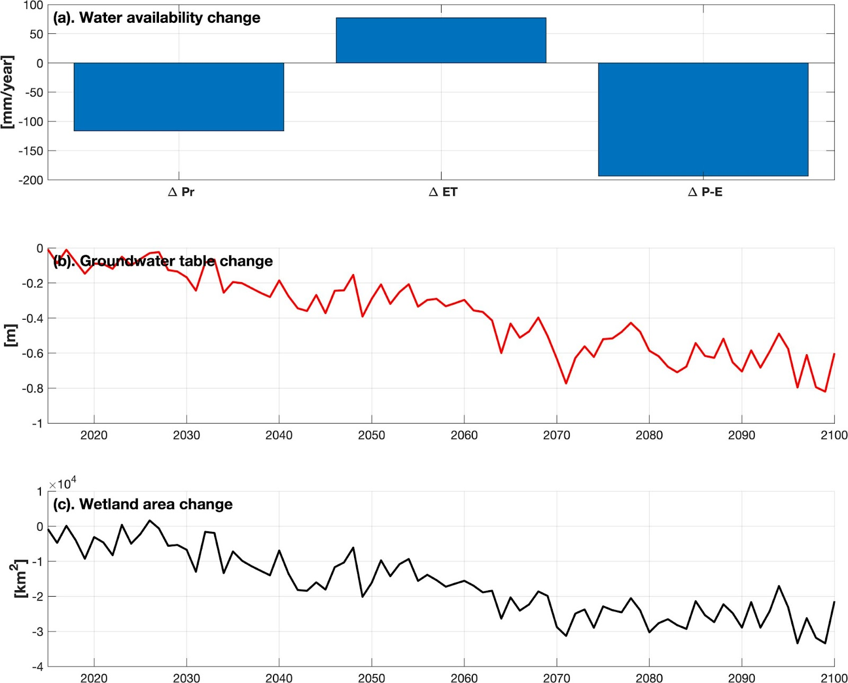
Figure S9. Projected change in (a). Water availability, (b). Annual groundwater table, and (c). Total wetland area in Amazon River Basin under SSP585. In subplot (a), the change of precipitation (Pr), evapotranspiration (ET), and precipitation - evapotranspiration (P-E) were calculated as the mean of the projection period (2016 - 2100).

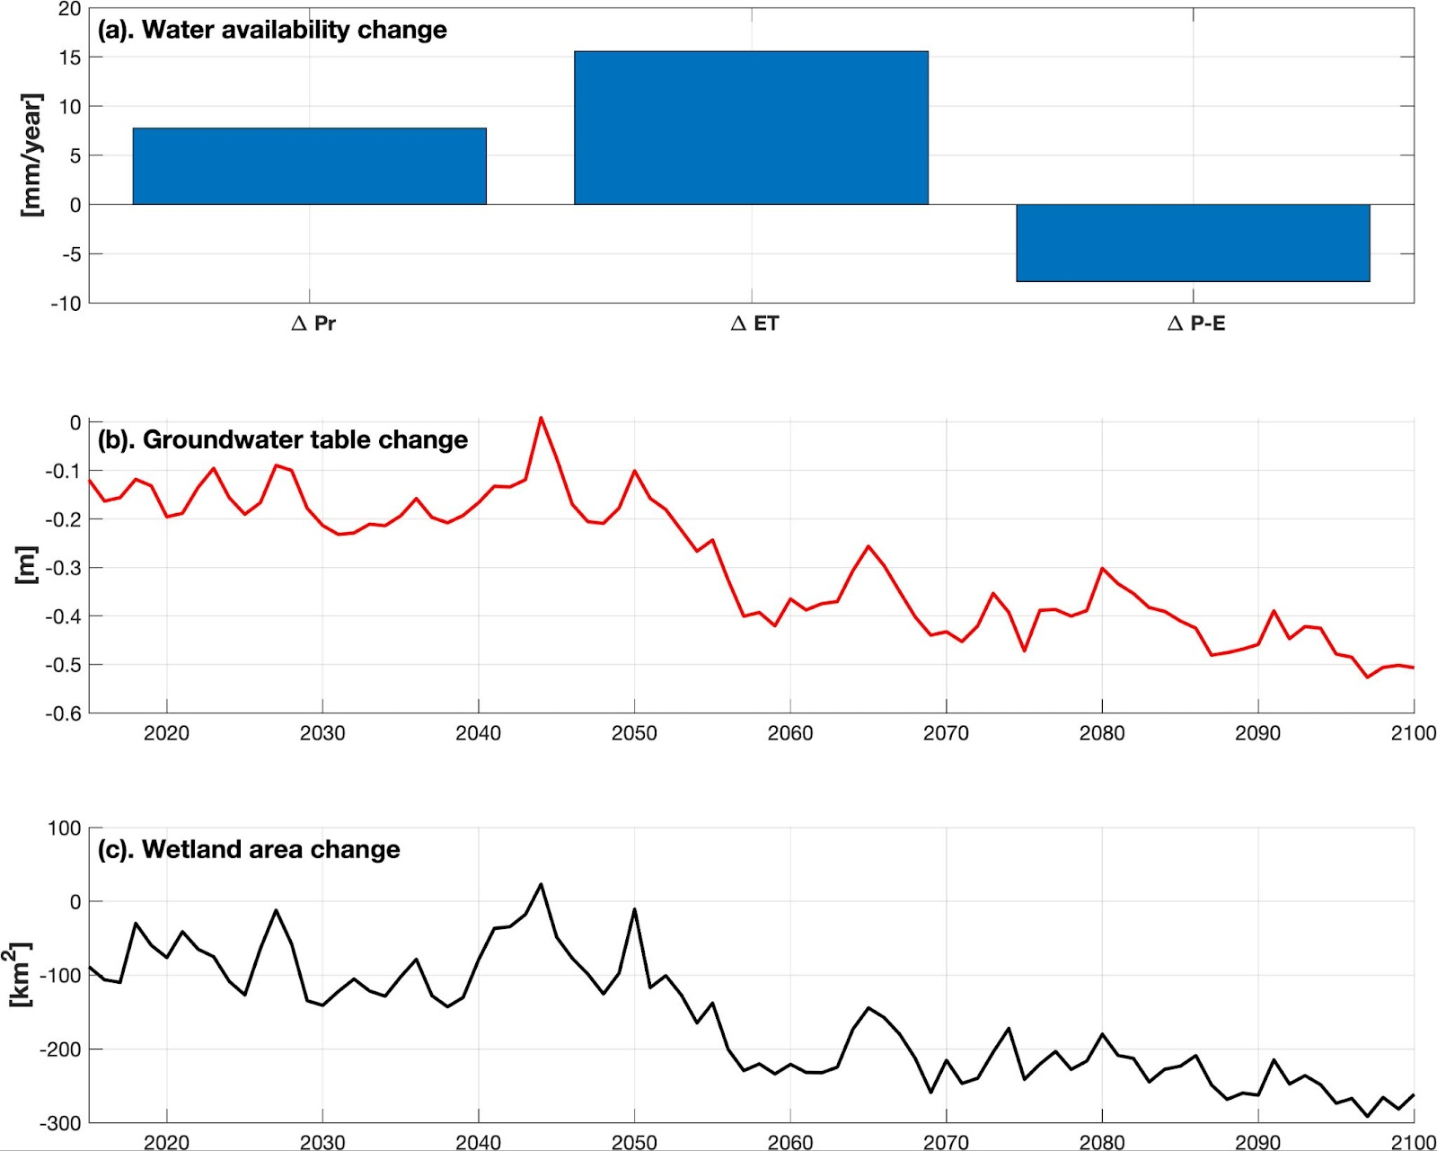
Figure S10. Projected change in (a). Water availability, (b). Annual groundwater table, and (c). Total wetland area in Kura Araks River Basin under SSP585. In subplot (a), the change of precipitation (Pr), evapotranspiration (ET), and precipitation - evapotranspiration (P-E) were calculated as the mean of the projection period (2016 - 2100).

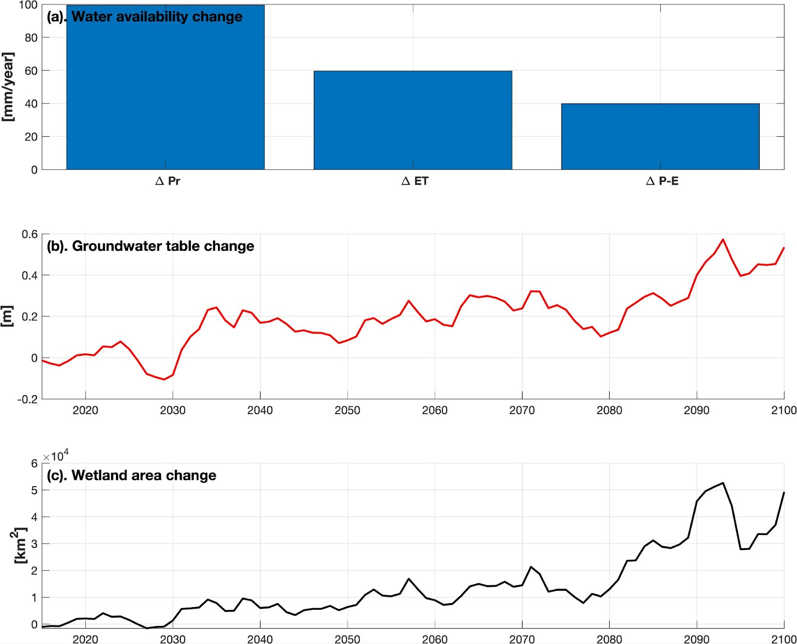
Figure S11. Projected change in (a). Water availability, (b). Annual groundwater table, and (c). Total wetland area in Nile River Basin under SSP585. In subplot (a), the change of precipitation (Pr), evapotranspiration (ET), and precipitation - evapotranspiration (P-E) were calculated as the mean of the projection period (2016 - 2100).

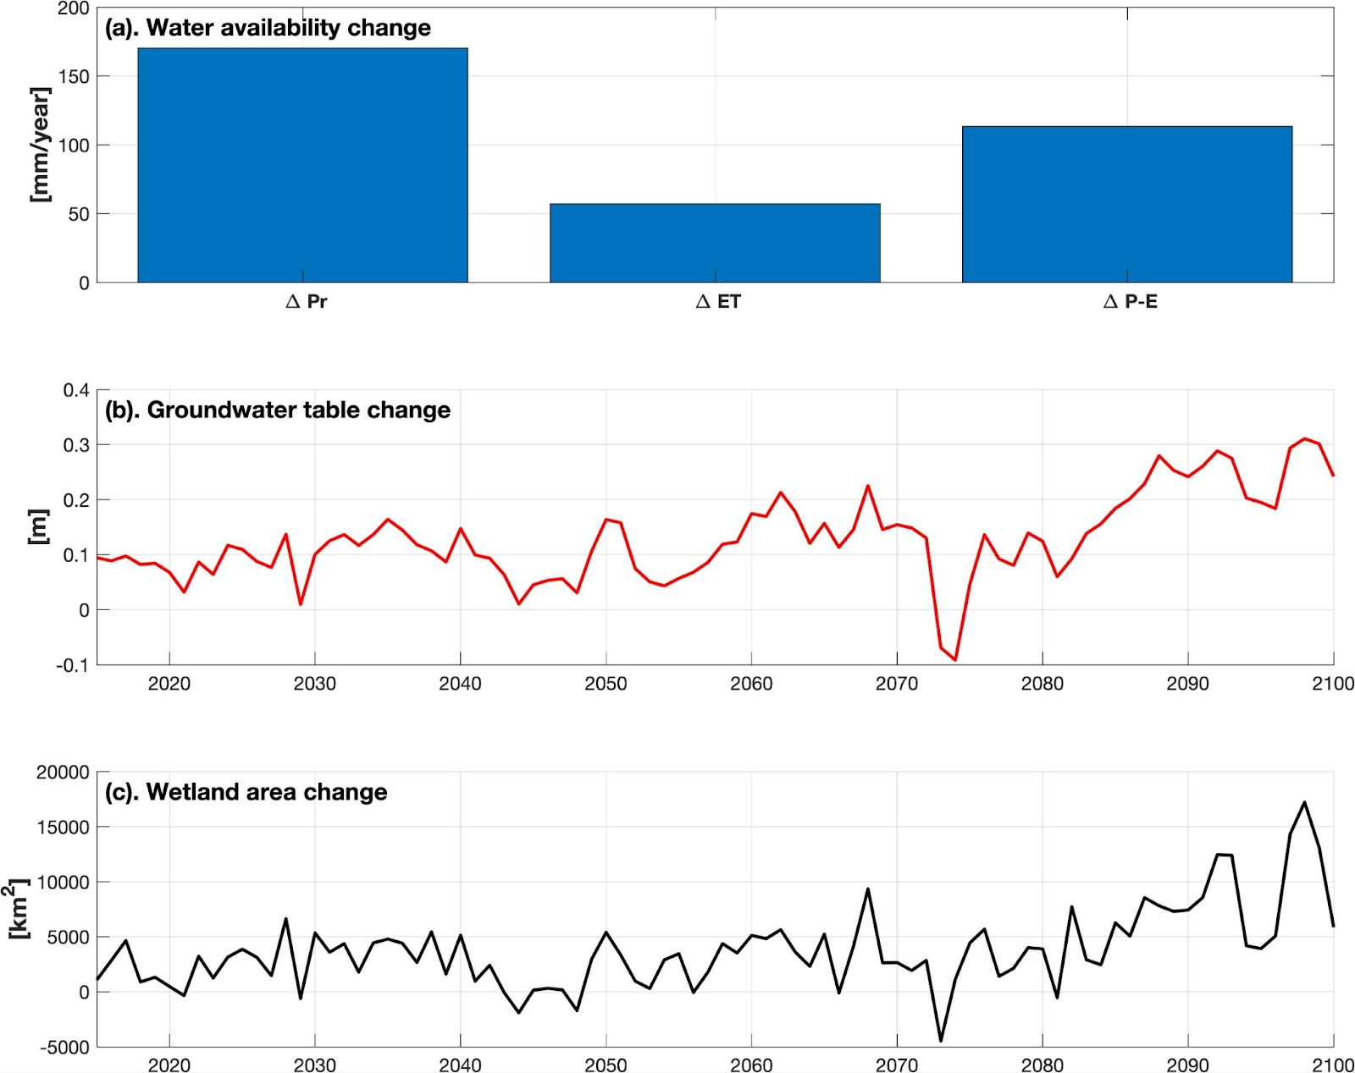
Figure 12. Projected change in (a). Water availability, (b). Annual groundwater table, and (c). Total wetland area in Ganges Brahmaputra River Basin under SSP585. In subplot (a), the change of precipitation (Pr), evapotranspiration (ET), and precipitation - evapotranspiration (P-E) were calculated as the mean of the projection period (2016 - 2100).

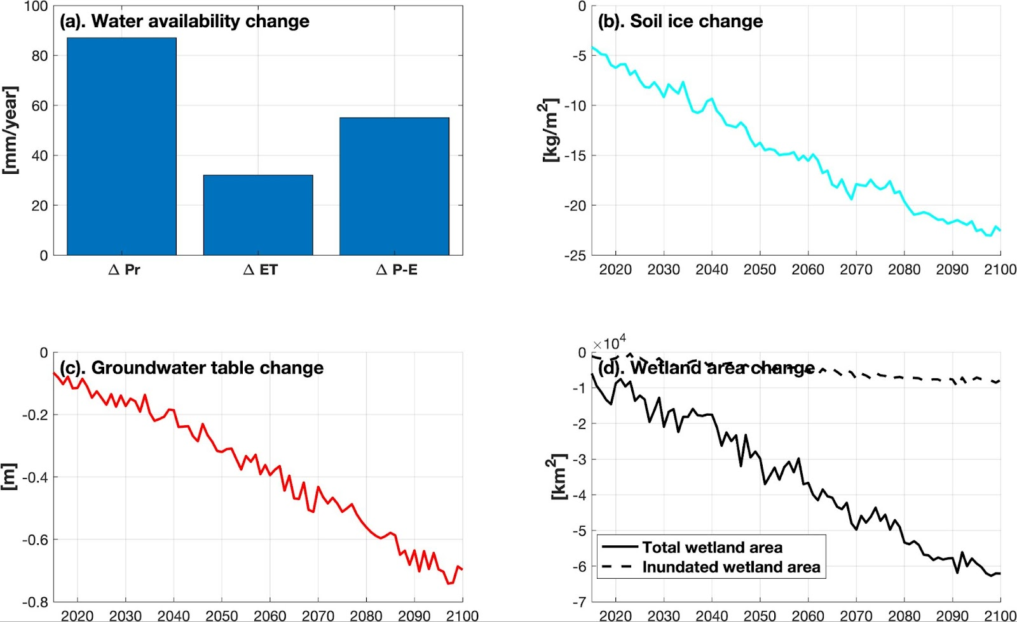
Figure S13. Projected change in (a). Water availability, (b). Soil ice, (c). Perched groundwater table, and (d). Total wetland area in Yenisey River Basin under SSP585. In subplot (a), the change of precipitation (Pr), evapotranspiration (ET), and precipitation - evapotranspiration (P-E) were calculated as the mean of the projection period (2016 - 2100).

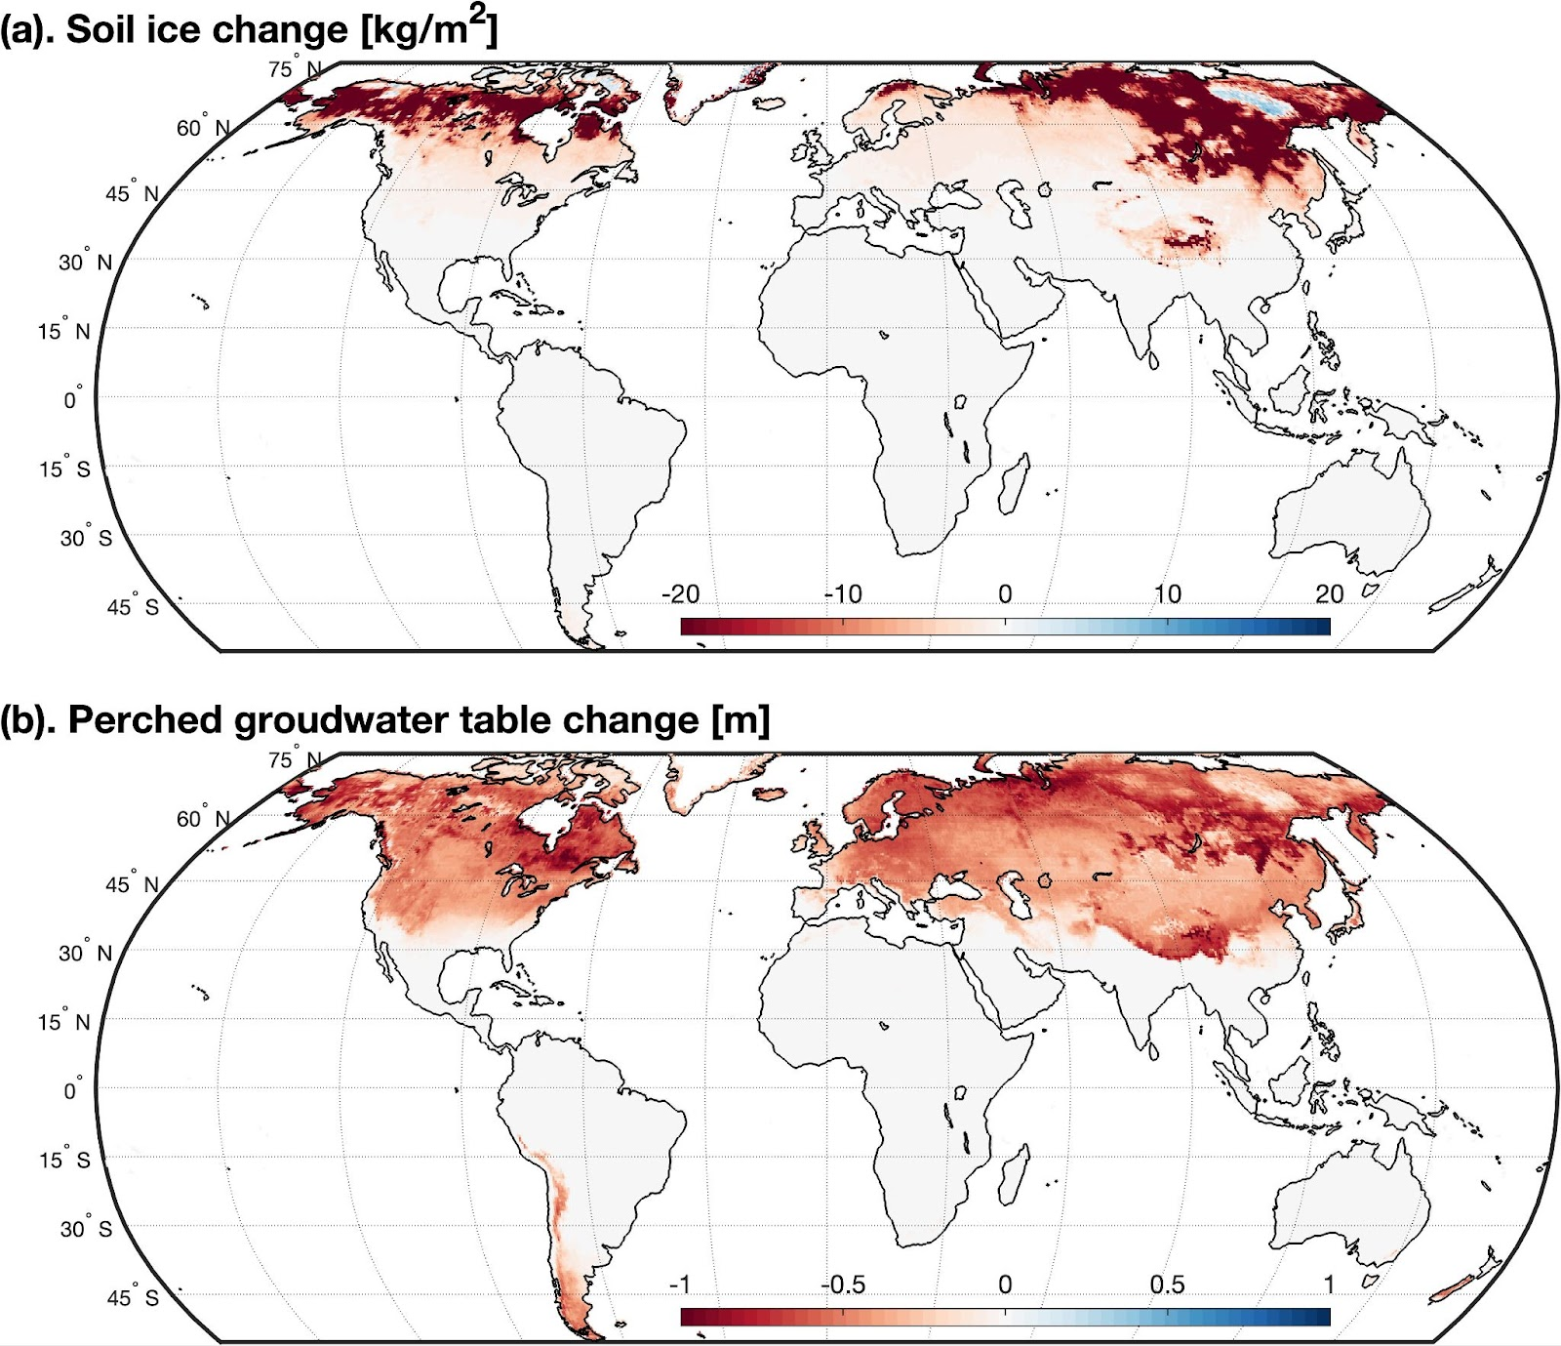
Figure S14. Projected absolute changes in (a). Soil ice and (b). Perched groundwater table between end-century (2071-2100) and historical (1985-2014) periods under SSP585 scenarios. The changes were estimated as the mean of the equal-weighted multi-model ensemble.

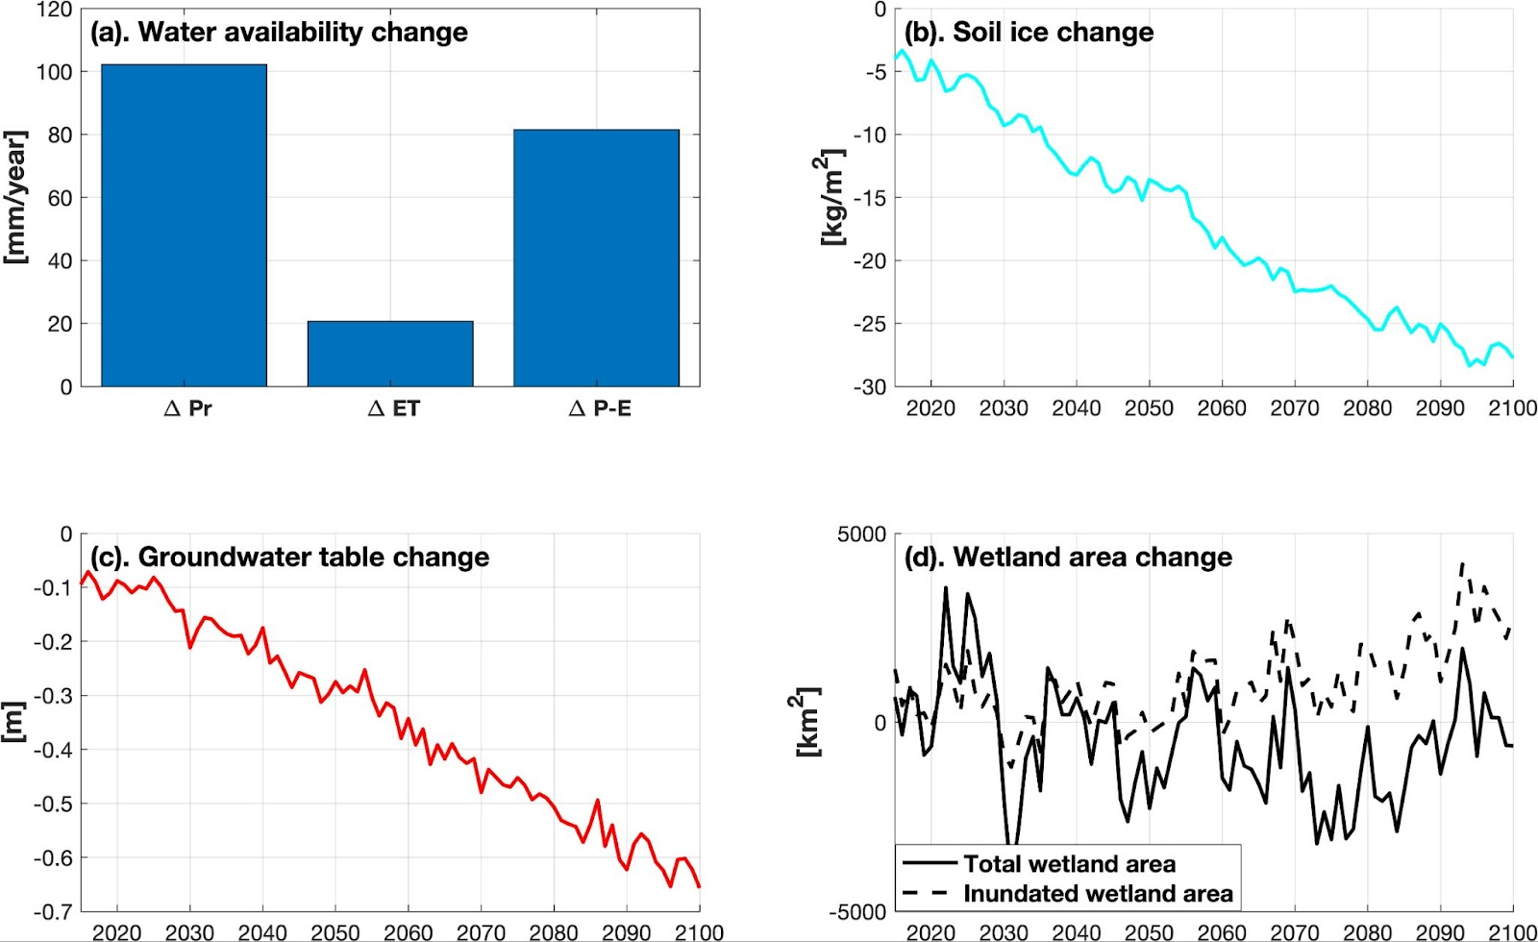
Figure S15. Projected change in (a). Water availability, (b). Soil ice, (c). Perched groundwater table, and (d). Total wetland area in Yukon River Basin under SSP585. In subplot (a), the change of precipitation (Pr), evapotranspiration (ET), and precipitation - evapotranspiration (P-E) were calculated as the mean of the projection period (2016 - 2100).

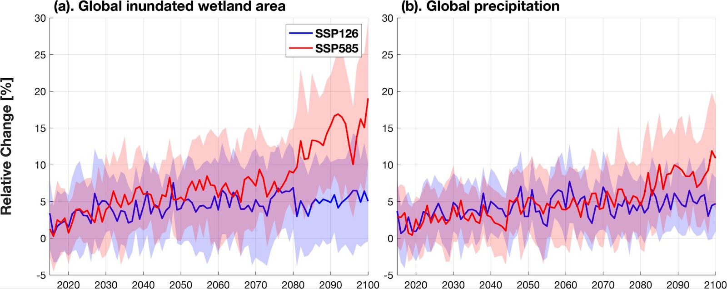
Figure S16. Relative change of (a). Global inundated wetland area and (b). Global precipitation. The solid line represents the multi-model ensemble mean, and the shaded area denotes the uncertainty of the multi-model ensemble.

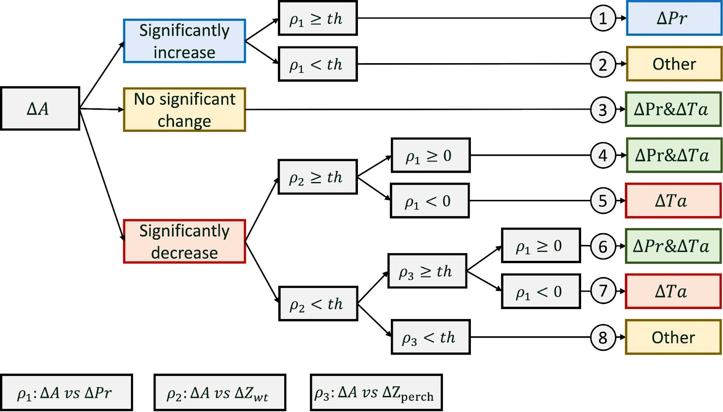
Figure S17. Attribution analysis linking projected wetland changes ($ΔA$) to temperature $ΔTa$ and precipitation $ΔPr$ changes. The threshold (th) was selected with 0.4, which indicates a moderate correlation between two variables.

