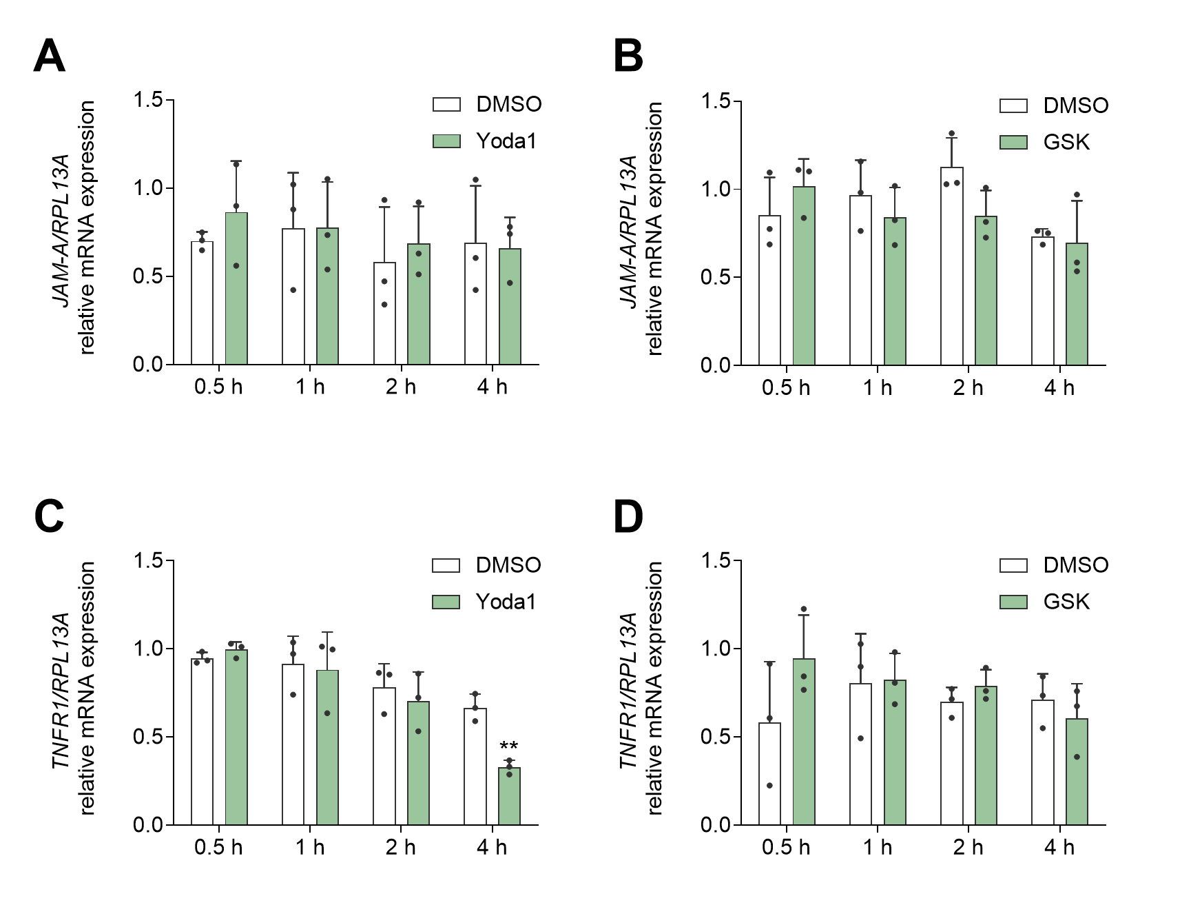
Suppl. Fig. 1: Piezo1-mediates no change on the transcriptional level of JAM-A and TNFR1.
HUVECs were treated with 1 µM Yoda1 or 0.6 nM GSK for 0.5, 1, 2, or 4 h. JAM-A A, B and TNFR1 C, D mRNA expression was measured in relation to the expression of the reference gene RPL13A in the cell lysates. Quantitative data are shown as mean + SD of at least three independent experiments. Statistical differences to the control are indicated by asterisks (* p≤0.05, ** p≤0.01, *** p≤0.001), while differences between the treatments are indicated by hashes (# p≤0.05, ## p≤0.01, ### p≤0.001).

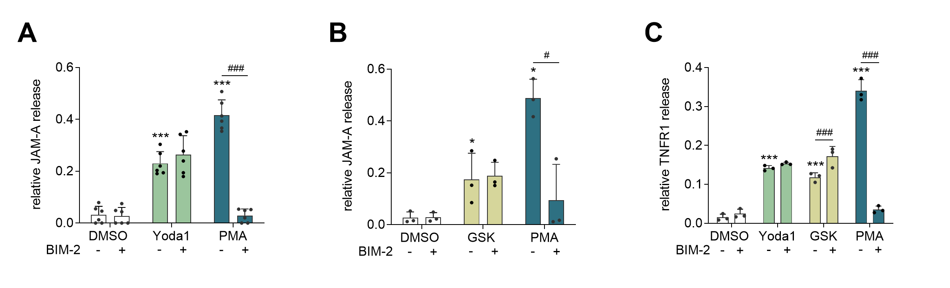
Suppl. Fig. 2: Piezo1- and TRPV4-mediated ADAM activation is independent of PKC signaling.
HUVECs were pre-incubated with BIM-2 (1 µM), followed by addition of Yoda1 (1 µM) A, C or GSK (0.6 nM) B, C and further incubation for 4 h. Concentrations of soluble JAM-A A and B, or TNFR1 C, were determined via ELISA. Quantitative data are shown as mean + SD of at least three independent experiments. Statistical differences to the control are indicated by asterisks (* p≤0.05, ** p≤0.01, *** p≤0.001), while differences between the treatments are indicated by hashes (# p≤0.05, ## p≤0.01, ### p≤0.001).
Figure 1: Flow-induced ADAM activation involves Piezo1 and TRPV4
A |  |  | B
0 dyne/cm2 | DMSO | 39.65 ± 8.67 | 0 dyne/cm2 | DMSO | 5.84 ± 3.67
0 dyne/cm2 | GW | 33.44 ± 10.58 | 0 dyne/cm2 | GW | 3.52 ± 4.4
15 dyne/cm2 | DMSO | 177.30 ± 30.83 | 15 dyne/cm2 | DMSO | 47.52 ± 6.73
15 dyne/cm2 | GW | 49.06 ± 14.56 | 15 dyne/cm2 | GW | 12.54 ± 7.42
C |  |  | E
0 dyne/cm2 | DMSO | 129.91 ± 73.07 | 0 dyne/cm2 | shControl | 109.94 ± 59.39
0 dyne/cm2 | SalB | 150.04 ± 57.17 | 0 dyne/cm2 | shPIEZO1 | 212.62 ± 89.19
15 dyne/cm2 | DMSO | 289.6 ± 26.02 | 15 dyne/cm2 | shControl | 501.51 ± 392.54
15 dyne/cm2 | SalB | 207.99 ± 61.86 | 15 dyne/cm2 | shPIEZO1 | 629.68 ± 497.62
F |  |  | G
0 dyne/cm2 | DMSO | 110.75 ± 65.86 | 0 dyne/cm2 | DMSO | 131.05 ± 47.37
0 dyne/cm2 | HC | 108.73 ± 60.63 | 0 dyne/cm2 | GsMTx4 | 126.63 ± 57.67
15 dyne/cm2 | DMSO | 322.87 ± 90.37 | 15 dyne/cm2 | DMSO | 746.99 ± 121.43
15 dyne/cm2 | HC | 224.29 ± 52.99 | 15 dyne/cm2 | GsMTx4 | 449.79 ± 127.21
Supp. table 1: ELISA mean raw values of Figure 1 in pg/ml.

Figure 2: Release of ADAM10- & ADAM17-specific substrates is induced by chemical activation of Piezo1 and TRPV4
C |  |  | D
0.5 h | DMSO | 13.17 ± 9.75 | 0.5 h | DMSO | 50.59 ± 1
0.5 h | Yoda1 | 12.12 ± 4.3 | 0.5 h | GSK | 66.78 ± 6.48
0.5 h | PMA | 31.16 ± 11.26 | 0.5 h | PMA | 81.48 ± 3.97
1 h | DMSO | 12.63 ± 7.78 | 1 h | DMSO | 55.78 ± 3.17
1 h | Yoda1 | 25.36 ± 12.97 | 1 h | GSK | 132.92 ± 22.07
1 h | PMA | 88.22 ± 40.45 | 1 h | PMA | 190.12 ± 24.13
2 h | DMSO | 8.9 ± 6.49 | 2 h | DMSO | 60,42 ± 3.63
2 h | Yoda1 | 49.13 ± 14.03 | 2 h | GSK | 717.28 ± 38.27
2 h | PMA | 174.58 ± 80.39 | 2 h | PMA | 300.3 ± 70.77
4 h | DMSO | 8.81 ± 7.3 | 4 h | DMSO | 65.87 ± 0.15
4 h | Yoda1 | 199.99 ± 25.94 | 4 h | GSK | 772 ± 84.21
4 h | PMA | 264.13 ± 24.27 | 4 h | PMA | 256.87 ± 86.01
E |  |  | F
0.5 h | DMSO | 9.49 ± 0.42 | 0.5 h | DMSO | 9.5 ± 0.42
0.5 h | Yoda1 | 26.81 ± 1.82 | 0.5 h | GSK | 22.71 ± 2.77
0.5 h | PMA | 28 ± 2.48 | 0.5 h | PMA | 28 ± 2.48
1 h | DMSO | 11.5 ± 0.814 | 1 h | DMSO | 11.5 ± 0.27
1 h | Yoda1 | 33.06 ± 0.77 | 1 h | GSK | 25.63 ± 3.46
1 h | PMA | 37.48 ± 3.8 | 1 h | PMA | 37.48 ± 3.8
2 h | DMSO | 13.34 ± 0.81 | 2 h | DMSO | 13.34 ± 0.81
2 h | Yoda1 | 35.69 ± 5.7 | 2 h | GSK | 36.25 ± 6.75
2 h | PMA | 56.3 ± 9.15 | 2 h | PMA | 56.3 ± 9.15
4 h | DMSO | 19.07 ± 0.5 | 4 h | DMSO | 19.07 ± 0.5
4 h | Yoda1 | 37.2 ± 1.12 | 4 h | GSK | 26.19 ± 2.45
4 h | PMA | 43.81 ± 17.09 | 4 h | PMA | 43.81 ± 17.09
Suppl. table 2: ELISA mean raw values of Figure 2 in pg/ml.

Figure 3: Ion channel-mediated JAM-A and TNFR1 release is specific for the corresponding mechanoresponsive ion channel and ADAM protease
A |  |  | B
DMSO | DMSO | 41.44 ± 6.31 | DMSO | DMSO | 46.88 ± 8.91
DMSO | GI | 13.21 ± 2.38 | DMSO | GI | 27.48 ± 5.7
DMSO | GW | 4.53 ± 2.61 | DMSO | GW | 17.01 ± 1.56
Yoda1 | DMSO | 241.89 ± 53.63 | GSK | DMSO | 434.07 ± 187.1
Yoda1 | GI | 107.71 ± 53.63 | GSK | GI | 251.56 ± 110.86
Yoda1 | GW | 16.58 ± 8.18 | GSK | GW | 22.44 ± 6.6
C |  |  | D
DMSO | DMSO | 10.56 ± 4.91 | DMSO | DMSO | 15.09 ± 4.4
DMSO | GI | 3.09 ± 3.1 | DMSO | GI | 13.92 ± 5.7
DMSO | GW | 0.84 ± 1.19 | DMSO | GW | 7.99 ± 6.66
Yoda1 | DMSO | 40.79 ± 6.09 | GSK | DMSO | 28.19 ± 7.84
Yoda1 | GI | 40.61 ± 4.2 | GSK | GI | 23.25 ± 4.68
Yoda1 | GW | 1.19 ± 1.68 | GSK | GW | 9.51 ± 6.54
E |  |  | E
DMSO | DMSO | 21.15 ± 5.84 | DMSO | DMSO | 15.09 ± 4.4
DMSO | SalB | 21.33 ± 4.44 | DMSO | HC | 16.59 ± 5.9
Yoda1 | DMSO | 100.71 ± 24.12 | Yoda1 | DMSO | 28.19 ± 7.84
Yoda1 | SalB | 37.33 ± 17.15 | Yoda1 | HC | 12.95 ± 4.88
F |  |  | G
DMSO | control | 55.42 ± 36.1 | DMSO | control | 11.26 ± 0.98
DMSO | PIEZO1 | 65.56 ± 44.15 | DMSO | TRPV4 | 10.76 ± 0.19
Yoda1 | control | 490.66 ± 113.57 | Yoda1 | control | 226.24 ± 98.14
Yoda1 | PIEZO1 | 160.65 ± 30.76 | Yoda1 | TRPV4 | 68.5 ± 62.67
PMA | control | 960.07 ± 248.18 | PMA | control | 290.38 ± 49.06
PMA | PIEZO1 | 1065.04 ± 217.07 | PMA | TRPV4 | 267.32 ± 45.66
H |  |  | J
DMSO | DMSO | 42.28 ± 17.7 | DMSO | DMSO | 46.88 ± 8.91
DMSO | HC | 38.73 ± 21.31 | DMSO | SalB | 44.22 ± 11.91
Yoda1 | DMSO | 267.75 ± 80.94 | GSK | DMSO | 434.07 ± 187.1
Yoda1 | HC | 280.24 ± 65.08 | GSK | SalB | 516 ± 254.13
Suppl. table 3: ELISA mean raw values of Figure 3 in pg/ml.

Suppl. Figure 2: Piezo1- and TRPV4-mediated ADAM activation is independent of PKC signaling
A |  |  | B
DMSO | DMSO | 14.45 ± 12.09 | DMSO | DMSO | 39.34 ± 28.81
DMSO | BIM-2 | 12.12 ± 13.23 | DMSO | BIM-2 | 41.67 ± 24.13
Yoda1 | DMSO | 104.13 ± 59.85 | GSK | DMSO | 260.1 ± 150.91
Yoda1 | BIM-2 | 122.63 ± 82.7 | GSK | BIM-2 | 270.59 ± 97.18
PMA | DMSO | 180.07 ± 83.92 | PMA | DMSO | 680.33 ± 131.59
PMA | BIM-2 | 12.3 ± 12.47 | PMA | BIM-2 | 107.05 ± 119.62
C
DMSO | DMSO | 4.05 ± 2.19
DMSO | BIM-2 | 6.51 ± 3.1
Yoda1 | DMSO | 36.52 ± 3.63
Yoda1 | BIM-2 | 39.59 ± 4.21
GSK | DMSO | 30.36 ± 2.76
GSK | BIM-2 | 44.83 ± 9.33
PMA | DMSO | 87.23 ± 5.22
PMA | BIM-2 | 8.92 ± 1.18
Suppl. table 4: ELISA mean raw values of Suppl. Fig. 2 in pg/ml.

Target | Sequence (5'-3') | Temperature (°C)
hRPL13A_for | GCC CTA CGA CAA GAA AAG CG | 60
hRPL13A_rev | TAC TTC CAG CCA ACC TCG TGA | 60
hJAM-A_for | TGA CAG AAC AAA GAA AGG GAC | 60
hJAM-A_rev | GTG AAA CTA CAG ACA TCA GGG | 60
hHEY1_for | CCCAACTACATCTTCCCA | 59
hHEY1_rev | GTCAAAGTAACCTTTCCCTC | 59
hTNFR1_for | CAG TTC CAC CTT CAC CTC | 59
hTNFR1_rev | GGG TCA TCA GTG TCT AGG | 59
hPIEZO1_for | ATCTCAACCTCTTCCTCTTCC | 57
hPIEZO1_rev | CGGGTATTTCTTCTCTGTCTC | 57
hTRPV4_for | GTGACCTACATCATCCTCACCT | 60
hTRPV4_rev | CCTCATCCACCCTGAAGCAC | 60
Suppl. table 5: Used primers with corresponding sequences and annealing temperatures.

