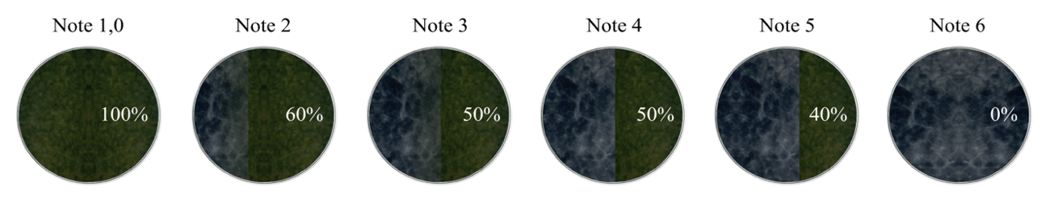

Supplementary material 1 Scale from Bell, Wells & Markham (1982) with adaptations proposed by the authors, where: score 1: Trichoderma completely overgrew the pathogen and covered the entire surface of the medium; score 2: Trichoderma overgrew at least two-thirds of the surface of the medium and partially colonized the pathogen; score 3: Trichoderma and the pathogen each colonized approximately one-half of the surface of the medium, partially colonizing the pathogen; score 4: Trichoderma and the pathogen each colonized approximately one-half of the surface of the medium, with neither microorganism appearing to dominate the other; score 5: Trichoderma grew on 40% of the surface of the medium without colonizing the pathogen; score 6: The pathogen completely overgrew Trichoderma and occupied the entire surface of the medium

