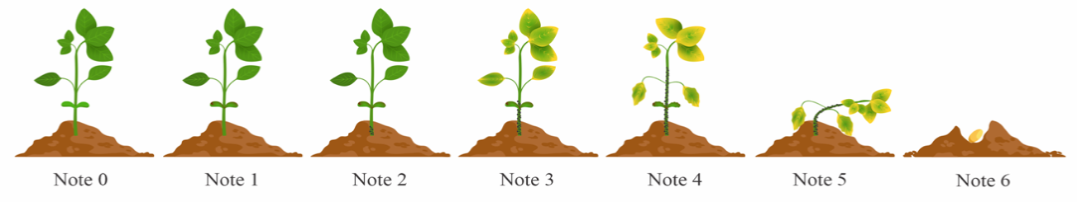
Supplementary material 2 Visual Rating Scale Adapted from Abawi & Pastor Corrales (1990). This scale is used to assess the severity of symptoms in soybean seedlings, categorized as follows: score 0: absence of visible symptoms; score 1: lesions limited to the cotyledon tissues; score 2: root lesions and/or cotyledon lesions reaching the hypocotyl tissues at approximately 2 cm; score 3: extensive lesions longer than 2 cm on the stem and branches, with leaf spotting; score 4: most plant tissues infected, with the production of pycnidia and microsclerotia; score 5: seedling collapse; score 6: seeds that did not germinate

