Extended Data Figures

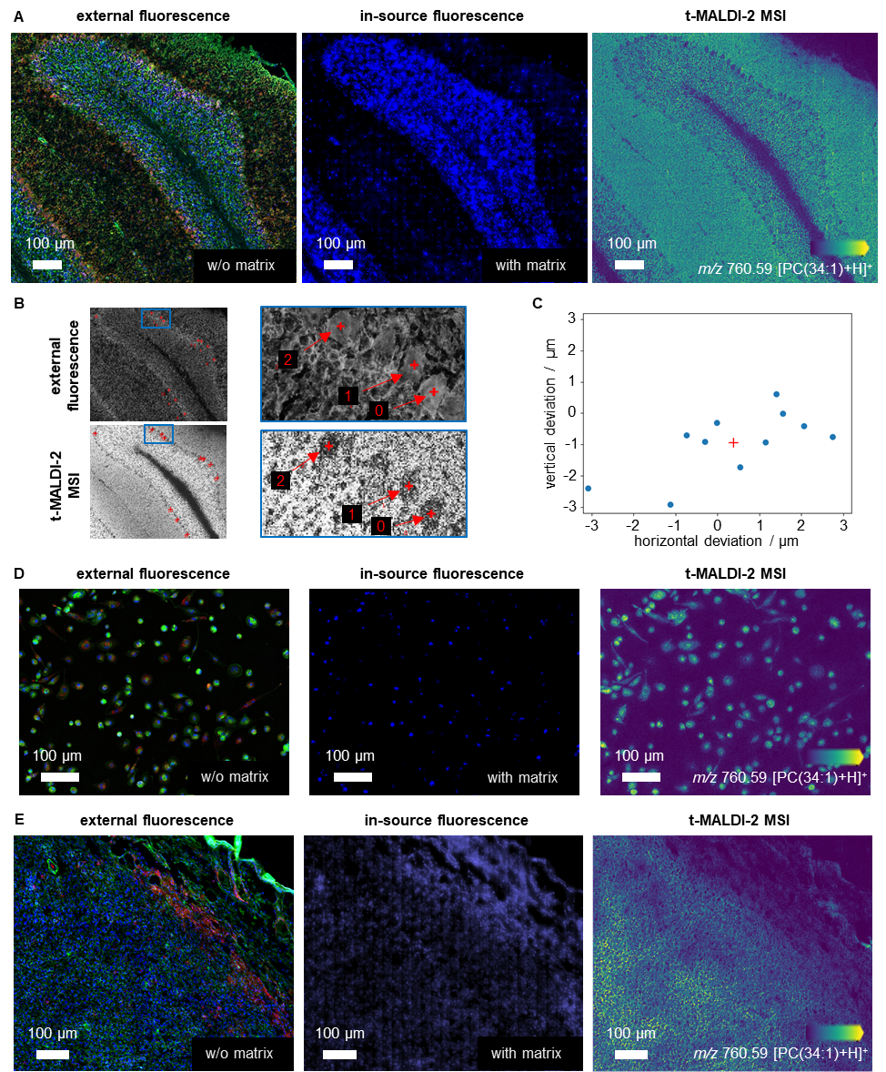

Extended Data Figure 1: Co-registration of external fluorescence image to t-MALDI-2 MSI across the different sample systems
(A) Mouse cerebellum: To begin, an external fluorescence image is acquired using the following stains: Hoechst 33342 (nuclei, DAPI channel, blue), CellMask Green Actin Tracking Stain (actin, FITC channel, green), and Alexa Fluor 594 Anti-calbindin antibody (calbindin, Cy3 channel, red). The sample is subsequently coated with CHCA MALDI matrix by resublimation and loaded into the ion source, where an in-source fluorescence image is acquired using the DAPI channel. The t-MALDI-2-MSI data is inherently co-registered with the in-source fluorescence image, facilitated by the consistent use of optics and the sample stage, ensuring accurate alignment of data sets. In post-processing, the external fluorescence image is effectively co-registered with the in-source fluorescence and the t-MALDI-2-MSI data.
(B) The center of eleven Purkinye cell bodies are manually selected in the external FM and the t-MALDI-2-MSI images respectively to produces pairs of marker points. This manual selection is subjective and therefore lacks high precision (see Note S1).
(C) After co-registration, the spatial deviation between the manually selected pairs of marker points is measured in x- and y-dimension for each pair (blue dots) and the average deviation is calculated (red cross).
(D) THP-1 derived macrophages: Initially, an external fluorescence image is obtained using three specific stains: Hoechst 33342 (nuclei, DAPI channel, blue), CellMask Green Actin Tracking Stain (actin, FITC channel, green), and pHrodo (phagolysosomes, Cy3 channel, red). The sample is then coated with CHCA MALDI matrix via resublimation. Subsequently, the sample is placed into the ion source. A second fluorescence image is then taken inside the ion source using the DAPI channel. The resulting t-MALDI-2 MSI is automatically aligned with the in-source fluorescence image due to the shared optics and sample stage, ensuring precise data alignment. During post-processing, the external fluorescence image is precisely co-registered to the in-source image and, consequently, to the t-MALDI-2 MSI data.
(E) Murine 4T1 tumor: An external fluorescence image is first captured using Hoechst 33342 (nuclei, DAPI channel, blue), CellMask Green Actin Tracking Stain (actin, FITC channel, green), and an immunofluorescence stain for neutrophil cells (Anti-Ly6G, Cy3 channel, red). The sample is then coated with CHCA MALDI matrix using the resublimation method and introduced into the ion source. Here, a second fluorescence image, termed the in-source fluorescence image, is recorded with the DAPI fluorescence channel. The t-MALDI-2 MSI data is inherently aligned with this in-source fluorescence image due to the consistent optics and sample stage setup. In post-processing, precise co-registration of the external fluorescence image with the in-source fluorescence image, and therefore the t-MALDI-2-MSI data, is achieved.

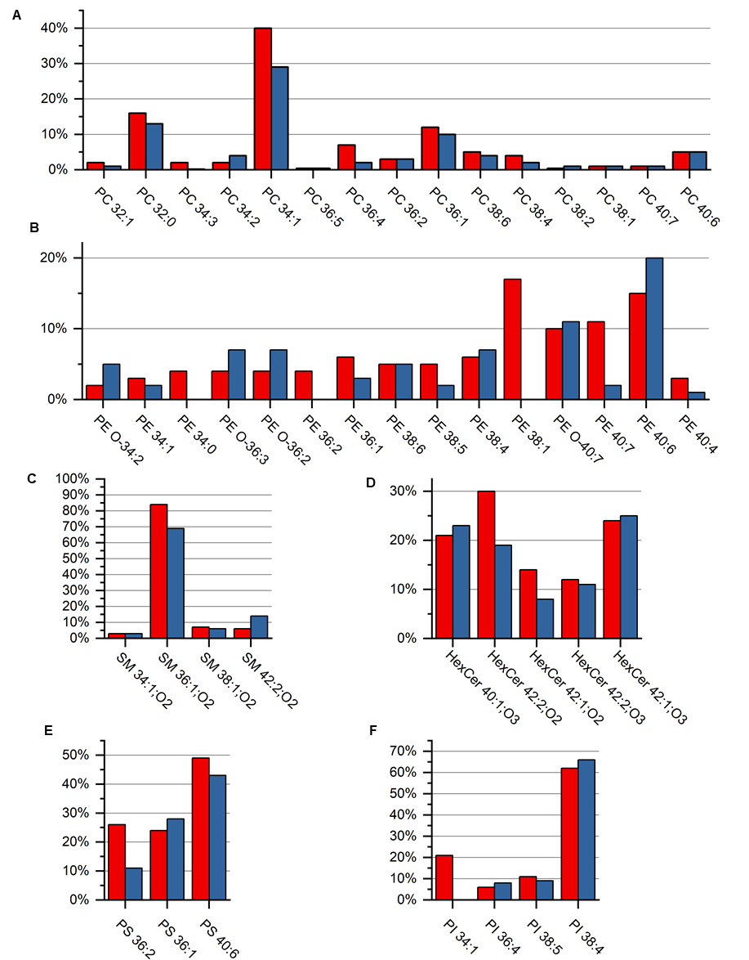

Extended Data Figure 2: Comparison of lipid signal intensities from murine cerebellum acquired with t-MALDI-MSI and reported values from bulk analysis ²⁹
(A) Molar percentage of different types of phosphatidylcholines (PC) in cerebellum derived from Fitzner et al. ²⁹ (blue bars) in comparison with percentages of signal intensities for PCs detected in t-MALDI-2 MSI (red bars) from the whole region depicted in Fig. 1. In both cases values are normalized to the sum of all reported/detected species from this lipid class.
(B) Comparison for phosphatidylethanolamine (PE) species; analogous to (A)
(C) Comparison for sphingomyelin (SM) species; analogous to (A)
(D) Comparison for hexosylceramide (HexCer) species; analogous to (A)
(E) Comparison for phosphatidylserine (PS) species; analogous to (A) (measured in negative ion mode)
(F) Comparison for phosphatidylinositol (PI) species; analogous to (A) (measured in negative ion mode)

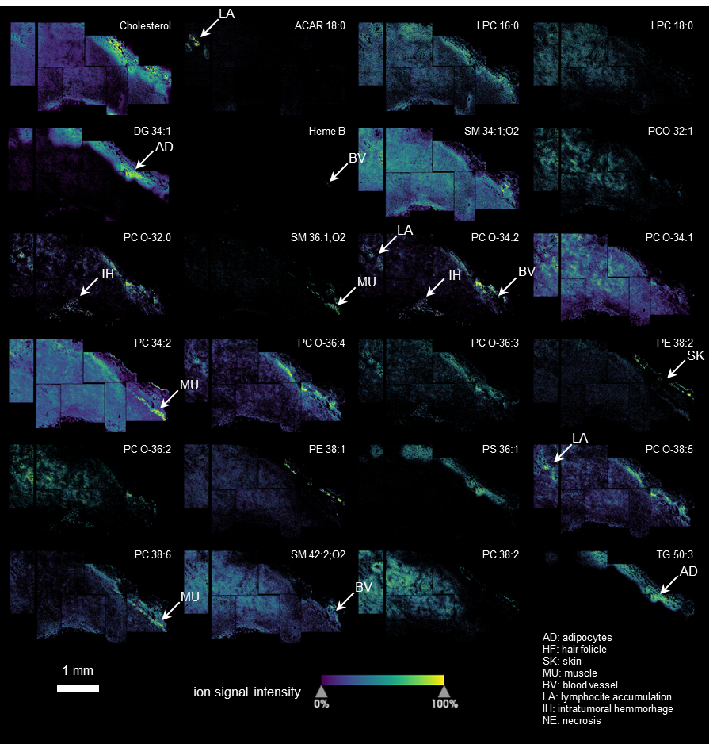

Extended Data Figure 3: Murine 4T1 tumor t-MALDI-2 MSI overview.
Ion signal intensity distributions of different molecules from the measurement presented in Fig. 3 and 4. Annotation was performed according to “ion signal annotation” found in the methods.

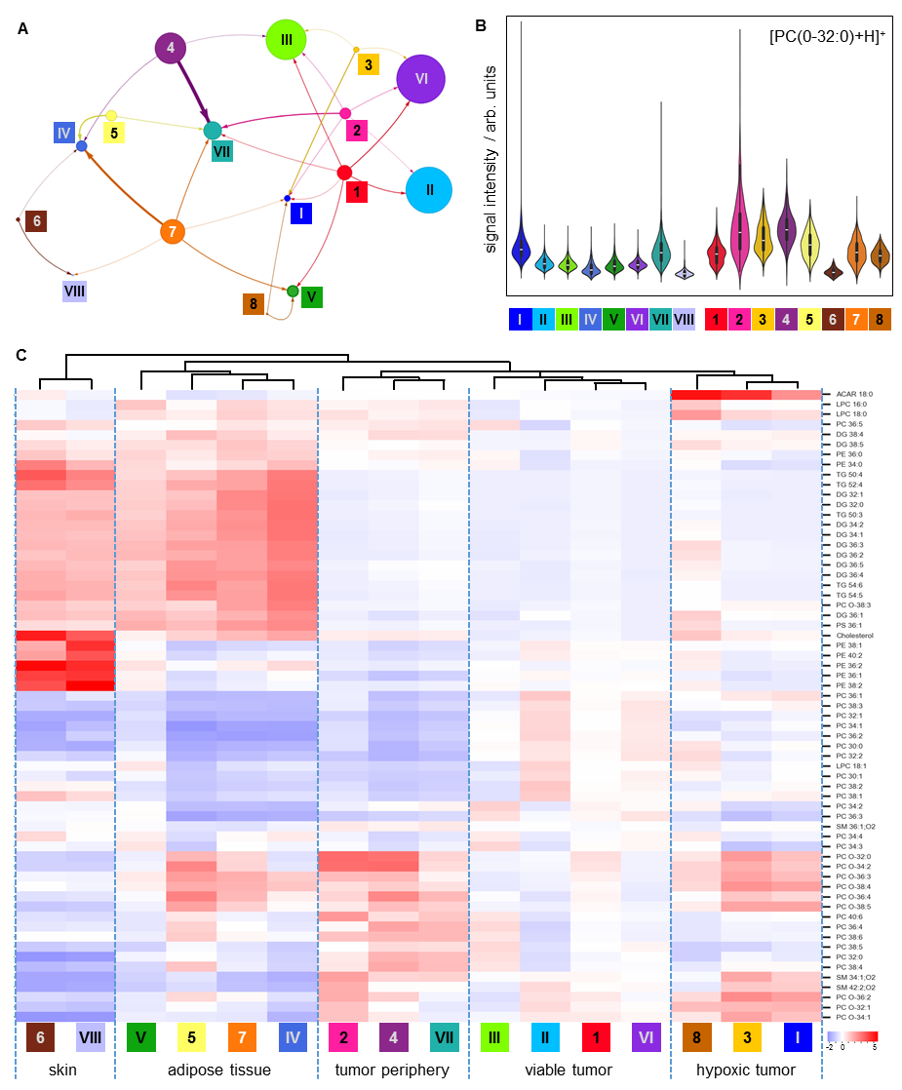
Extended Data Figure 4: Neighborhood analysis and lipid profile of neutrophils in context of their tissue microenvironment
(A) Visualization of the neighborhood analysis for all investigated neutrophils (Fig. 4G). Each circle symbolizes one cluster of cells (Roman numerals) or one cluster of neutrophils (Arabic numerals), respectively. Size of the circle represents the number of underlying cells, for tissue cluster, this number was divided by 10. Arrows and arrow thickness describe the affiliation of neutrophil subtypes to specific tissue clusters.
(B) Violin plots describing the signal intensity distribution for [PC(O-32:0)+H]⁺ at m/z 720.59 on the cellular level for all tissue clusters and all subtypes of neutrophils, respectively.
(C) The standardized intensities of 63 ion species for all tissue clusters and neutrophils are presented as a heat map to visualize similarities and differences in lipid profiles between the different groups. Annotations of tissue regions are tentative and based on inspection of an adjacent slide stained with H&E as well as clues from FM and MALDI-MSI measurements such as ACAR or DG signal intensities and immune cell agglomerations.

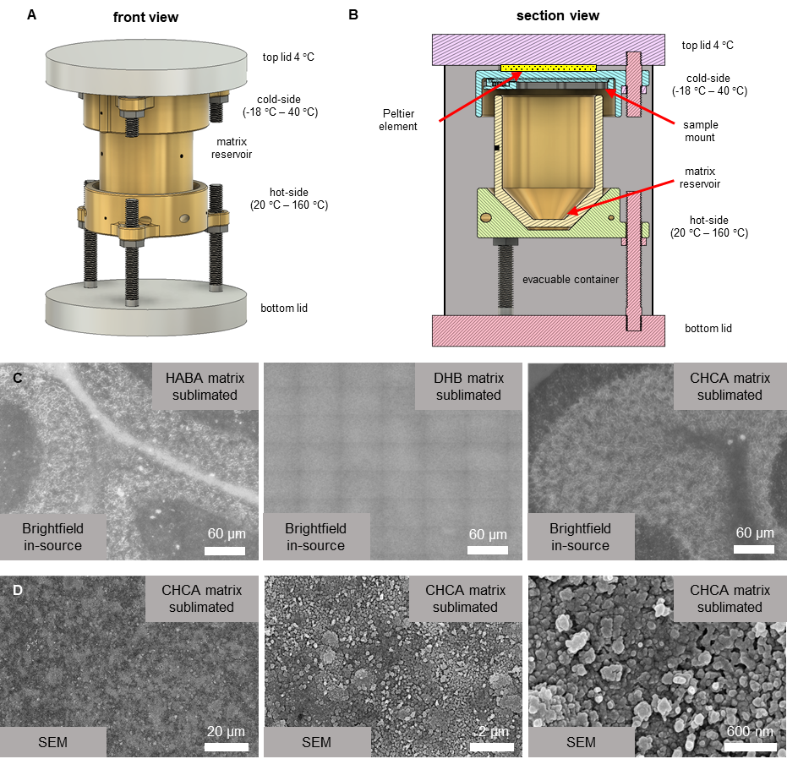

Extended Data Figure 5: Homogenous coating of samples with MALDI-matrix by resublimation.
(A) Schematic of the custom-designed resublimation chamber. The top lid is actively water-cooled to 4 °C and serves as a heatsink for a Peltier element, which can heat up or chill the cold-side from -18 °C to 40 °C. The hot-side is heated by 3 heater cartridges with a total of 300 W heating power. Temperatures of the cold-side and hot-side are monitored using NTC thermistors.
(B) Section view of the custom-designed resublimation chamber. This view of the resublimation chamber reveals the inner details of the setup. The sample can be magnetically clamped to the cold-side. The removable matrix reservoir is contacted to the hot-side using thermally conductive pads. An aluminum tube is mounted between the top and bottom lid to form an evacuable container. Using a turbomolecular pump, the whole setup can be evacuated to 10⁻³ mbar.
(C) In-source BF image of three samples of mouse cerebellum coated with different MALDI matrices by resublimation. The choice of MALDI-matrix heavily influenced the quality of the in-source BF image. Here the specific interplay between matrix and underlying tissue material produces the contrast. With 2-(4-Hydroxyphenylazo)benzoic acid (HABA) and CHCA matrix, the layers of the cerebellum can be easily defined, while resublimation with 2,5-Dihydroxybenzoic acid (DHB) prevents recording of a decent contrast image.
(D) Scanning electron microscopy (SEM) images of a mouse cerebellum coated with CHCA MALDI matrix by resublimation. At three different levels of magnification, the homogenous matrix coating as well as the small matrix crystal size can be observed. A homogeneous coating is crucial to minimize local artifacts in t-MALDI-2 MSI. The matrix crystal size is between 50 nm and 200 nm and therefore is not likely to noticeably limit the t-MALDI-2 MSI lateral resolution.

