S.Figure 1 Weight and liver index of mice
* = P < 0.05, ** = P < 0.01, *** = P < 0.001, liver index = liver weight g/ body weight g*100%

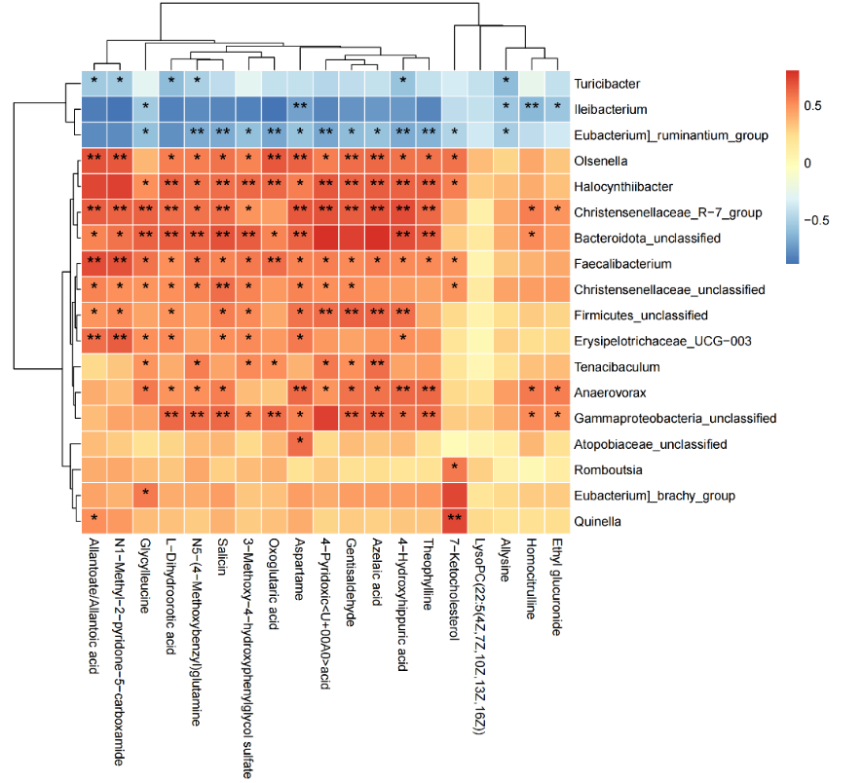
S.Figure 2 The correlation between the differential genera in the Lsa group and the plasma metabolites
The horizontal axis is the differential metabolites in plasma of the Lsa group, and the vertical axis is the changing genera of the Lp group. Red indicates a positive correlation, blue indicates a negative correlation, and the darker the color, the stronger the correlation. * represents P < 0.05, and ** represents P < 0.01.

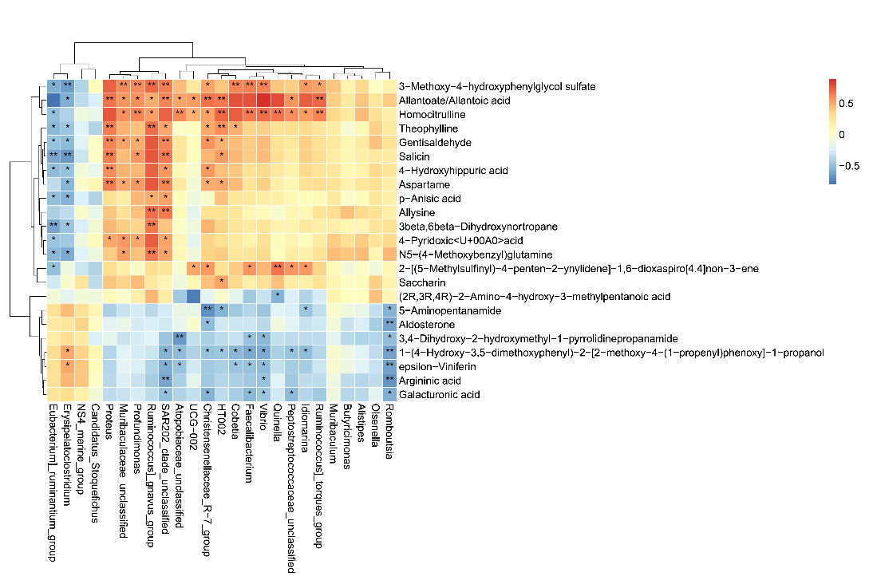
S.Figure 3 The correlation between the differential genera in the Lre group and the plasma metabolites
The horizontal axis is the differential metabolites in plasma of the Lre group, and the vertical axis is the changing genera of the Lp group. Red indicates a positive correlation, blue indicates a negative correlation, and the darker the color, the stronger the correlation. * represents P < 0.05, and ** represents P < 0.01.

S Table 1 The Effect of Lsa on the Gut Microbiota of Alcoholic Liver Injury Mice

Genera with rising relative abundance | Genera with decreased relative abundance
Halocynthiibacter | Ileibacterium
Faecalibacterium | Eubacterium]_ruminantium_group
Psychrobium | Turicibacter
Coriobacteriaceae_unclassified | Leucothrix
Idiomarina | SAR86_clade_unclassified
Olsenella | Paracoccus
Bacteroidota_unclassified
Quinella
Christensenellaceae_R-7_group
Butyricimonas
Gammaproteobacteria_unclassified
Cobetia
Eubacterium]_brachy_group
Campylobacterales_unclassified
Halovibrio
Firmicutes_unclassified
Muribaculaceae_unclassified
Bacteroides
Muribaculum
Dialister
Erysipelotrichaceae_UCG-003
Paludicola
Haematobacter
Tenacibaculum
Alloprevotella
HT002
Paramuribaculum
NK4A214_group
Romboutsia
Anaerovorax
Christensenellaceae_unclassified
Family_XIII_AD3011_group
Rubritalea
Atopobiaceae_unclassified
Aliivibrio

Genera with rising relative abundance | Genera with decreased relative abundance
Faecalibacterium | Eubacterium]_ruminantium_group
Vibrio | Erysipelatoclostridium
Cobetia | Candidatus_Stoquefichus
HT002 | NS4_marine_group
Quinella
Idiomarina
Christensenellaceae_R-7_group
Muribaculaceae_unclassified
Proteus
Profundimonas
Butyricimonas
Ruminococcus]_torques_group
Olsenella
Peptostreptococcaceae_unclassified
Ruminococcus]_gnavus_group
UCG-002
Alistipes
Romboutsia
Muribaculum
Atopobiaceae_unclassified
SAR202_clade_unclassified
S Table 2 The Effect of Lre on the Gut Microbiota of Alcoholic Liver Injury Mice

