Supplementary File:

Supplementary Figure 1: Acute pancreatitis-related age-adjusted mortality rates (AAMRs) per 1,000,000 stratified by ethnicity in the United States, 1999 to 2020.

Supplementary Figure 2: Acute pancreatitis-related age-adjusted mortality rates (AAMRs) per 1,000,000 stratified by census region in the United States, 1999 to 2020.

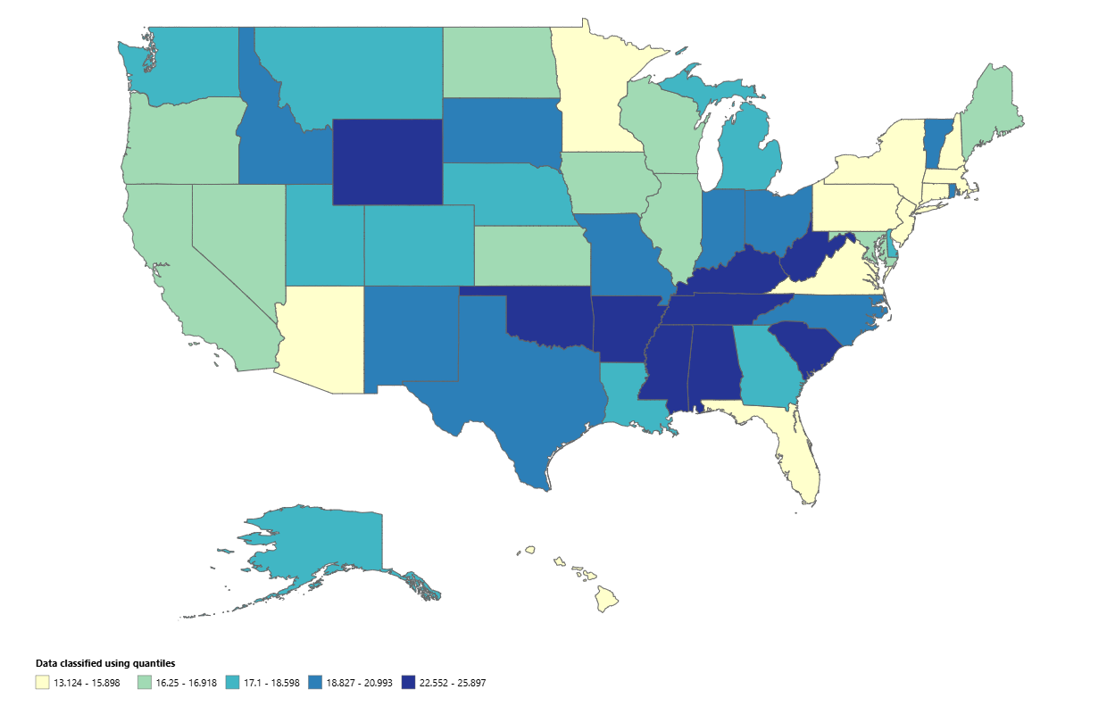
Supplementary Figure 3: State-level acute pancreatitis-related age-adjusted mortality rates (AAMRs) per 1,000,000 in the United States, 1999 to 2020.

Supplementary Figure 4: Acute pancreatitis-related age-adjusted mortality rates (AAMRs) per 1,000,000 stratified by urbanization in the United States, 1999 to 2020.

