Supporting information

Enhancing Photoelectrochemical CO₂ Reduction with CuBi₂O₄-Cellulose Nanofibers Hybrid Photocathodes
A Young Cho^{1,2}†, Ji Hyun Yoon^{1,2}†, Sangwoo Lee^{1,2}, Heeseo Yun^{1,2}, Jun-Young Park^{1,2}, Jonghun Lee^{3,4*} and Taekjib Choi^{1,2}*
¹ Hybrid Materials Research Center, Sejong University, Seoul 05006, Korea
² Department of Nanotechnology and Advanced Materials Engineering, Sejong University, Seoul 05006, Korea
³Institute of Science and Technology, 333 Techno Jungang‑daero, Hyeonpung‑eup, Dalseong‑gun, Daegu 42988, Republic of Korea
⁴Department of Interdisciplinary Engineering, Graduate School, Daegu Gyeongbuk Institute of Science and Technology, 333 Techno Jungang‑daero, Hyeonpung‑eup, Dalseong‑gun, Daegu 42988, Republic of Korea
†These authors contributed equally to this work.
*Corresponding authors: jhlee@dgist.ac.kr; tjchoi@sejong.ac.kr

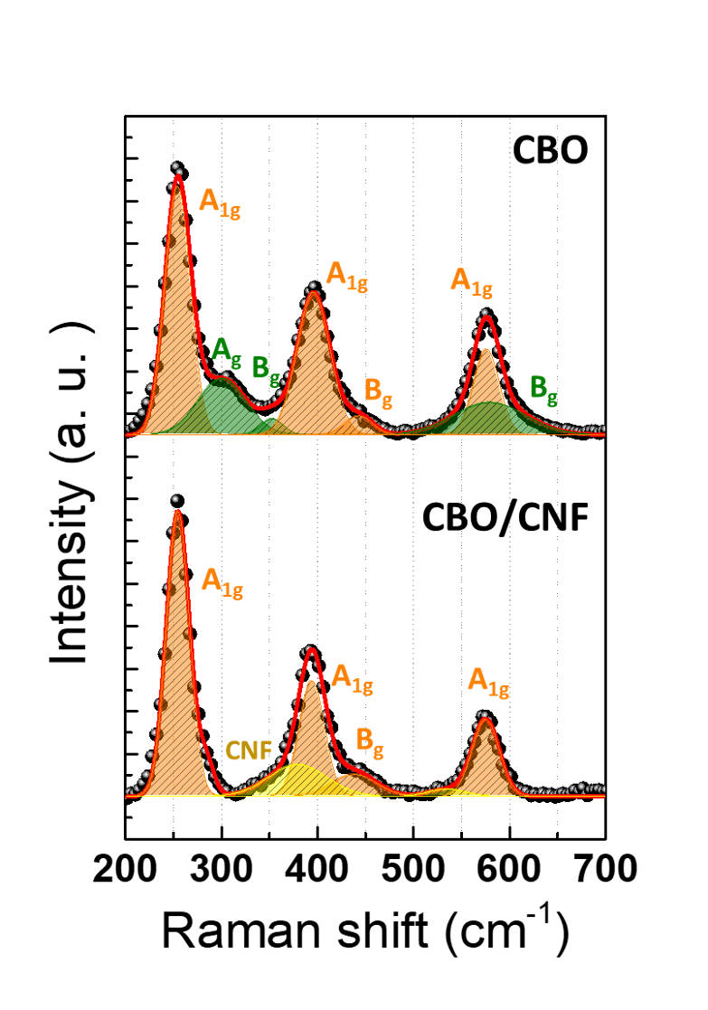
Fig. S1 Room temperature Raman spectra of CBO (above) and CBO/CNF (below). The orange lines represent peaks of the CuBi₂O₄ phases, green line represents CuO, and the yellow lines indicates the CNF. The open circles are experimental data, and the red lines mean the sum of Lorentzian functions
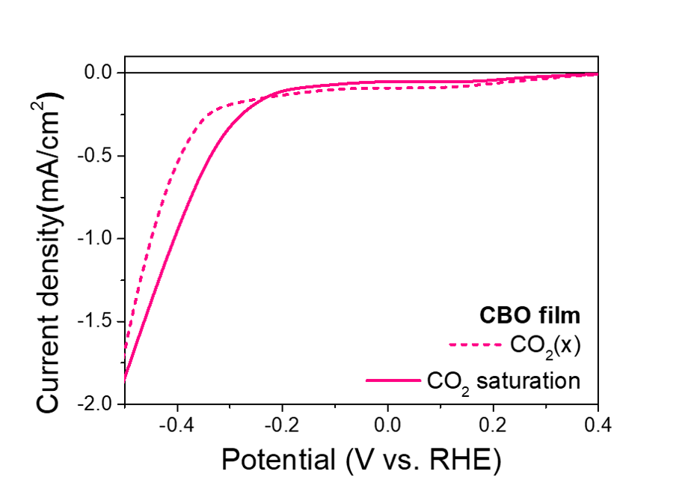
Fig. S2 LSV curves of CBO film in 0.1 M Na₂SO₄ (dotted line) and CO₂ saturated 0.1 M NaHCO₃ aqueous solution (solid line) under illumination

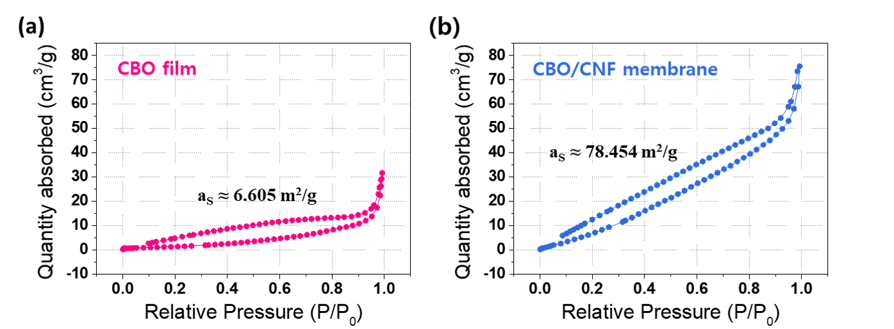
Fig. S3 BET surface areas measured from nitrogen adsorption-desorption isotherms for (a) CBO film and (b) CBO/CNF membrane, respectively

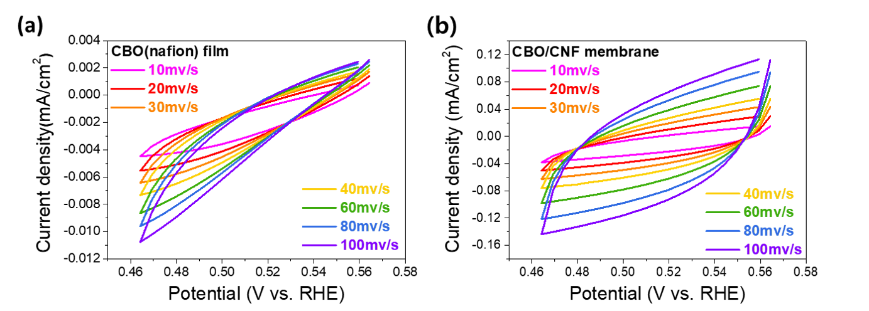
Fig. S4 CV curves measured in CO₂ saturated 0.1 M NaHCO₃ aqueous solution within a potential range (0.465 - 0.565 V_{RHE}) of the (a) CBO film and (b) CBO/CNF membrane under illumination

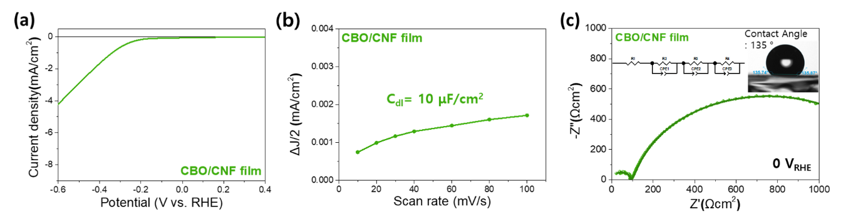
Fig. S5 PEC performances of CBO/CNF film in CO₂ saturated 0.1 M NaHCO₃ aqueous solution. (a) LSV curves. (b) Double layer capacitance calculated from CV. (c) Nyquist plot measured from 1 MHz to 1 Hz at 0 V_{RHE} in PEIS. Inset data is static contact angle of the aqueous electrolyte (0.1 M NaHCO₃) on the photoelectrode

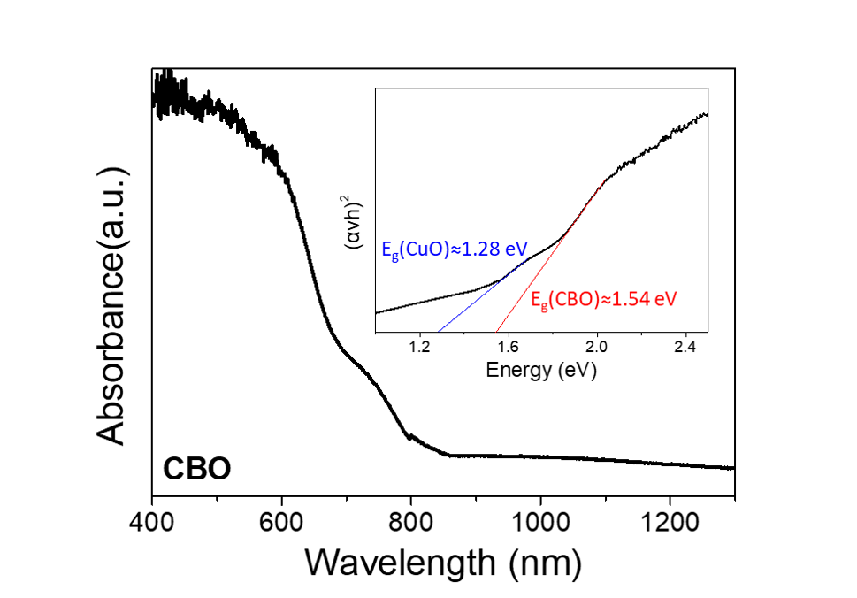
Fig. S6 UV-vis light absorption spectrum of the CBO film. The inset graph shows the calculated optical band gap by Tauc plot
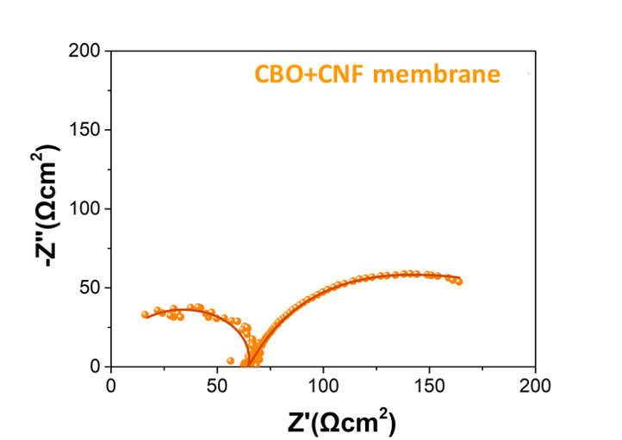
Fig. S7 PEIS Nyquist plot measured from 1 MHz to 1Hz at 0 V_{RHE} of CBO+CNF membrane in CO₂ saturated 0.1 M NaHCO₃ aqueous solution

