Supplementary Material

Resolving Coral Temperature Vulnerability through Heat and Cold Bleaching Thresholds

Yusuf C. El-Khaled^{1*}, Francisca C. García¹, Neus Garcias-Bonet¹, Matteo Monti¹, Erika P. Santoro¹, Matilde Marques^{2,3}, Natalie Dunn¹, Tina Keller-Costa^{2,3}, Christian R. Voolstra⁴, Raquel S. Peixoto^{1,5}

*corresponding author: Yusuf Christian El-Khaled, yusuf.khaled@kaust.edu.sa

Supplementary Table S1: Bleaching prevalence associated with cold water temperatures observed for various hard corals and octocorals and hydrozoan species, both in the present study and in reports from various locations around the world. Reports are listed chronologically starting with the most recent one, according to their respective geographic location. Values in parentheses indicate the total number of colonies found at the respective location with ‘n/a’ as an indication of no information given in the respective reference.
Species | Bleaching prevalence [% of total colonies found at location] | Depth [m] | Location | Minimum water temperature | Year of observation | Reference
P. verrucosa, Echinopora sp. | 38 % (16) | 22 m | Shib Nazar, Central Red Sea | 24.2 °C | 2025 | Present study
Acropora sp. | 13 % (8) | 8 – 11 m | Al Fahal, Central Red Sea | 25.1 °C | 2023 | Present study
Galaxea fasicularis | 11 % (9) | 10 | Shib Nazar, Central Red Sea | 25.3 °C | 2023 | Present study
Pocillopora verrucosa | 25 % (8) | 8 – 11 m | Al Fahal, Central Red Sea | 25.1 °C | 2023 | Present study
S. pistillata | 100% (n/a) | 0 – 1.5 m | Abu Shousha, Tahla Reef, Shark Reef, Cement Wreck, Shib Nazar, all Central Red Sea | 18 °C | 2020 | (Rich et al., 2022)
Acropora pharaonis, Platygyra daedalea | 100 %** | Reef flat* | Manifa Reef, Gulf of Arabia | 11 – 12 °C | 1988/89 | (Coles & Fadlallah, 1991)
Porites sp., Acropora spp., P. daedalea, Pavona varians, Psammocora cf. contigua, Coscinarea monile, Leptastrea purpurea, Cyphastrea micropthalma, Favia cf. pallida, F. cf. speciaosa, F. cf. faus, Favites pentagona, Tubinaria crater | 100 %** | >7 m | Manifa Reef, Gulf of Arabia | 11 – 12 °C | 1988/89 | (Coles & Fadlallah, 1991)
P. compressa, Favia spp. | 90 – 100 % | >7 m | Tarut Bay Reef, Gulf of Arabia | 12 – 13 °C | 1988/89 | (Coles & Fadlallah, 1991)
Acropora sp. | 90 – 100 % | 7 - 8 m | Offshore Qatar, Gulf of Arabia | 14 °C | 1964 | (Shinn, 1975)
Porites loboa, Pocillopra sp. | Widespread* | ~ 15 m | Galapagos Archipelago, Pacific | 16 °C | 2007/08 | (Banks et al., 2009; Glynn et al., 2009)
Pavona sp. | Little* | ~ 15 m | Galapagos Archipelago, Pacific | 16 °C | 2007/08 | (Glynn et al., 2009)
Porites sp., Pavona varians | >70% (n/a) | 32 m | Clipperton Atoll, Eastern Pacific | 14 – 18 °C | 2023 | (Foreman et al., 2024)
Pocillopora spp. | 43 % (n/a) | 3 – 5 m | Punta Diablo, Gulf of California | 19 – 20 °C | 2021 | (Olivier et al., 2023)
Pocillopora spp. | 84 % (n/a) | 2 – 3 m | Isla Gaviotas Reef, Punta Galeras Reef, Gulf of California, Pacific | 18 – 19 °C | 2011 | (Paz-García et al., 2012)
Pocillopora spp. | 90 – 99% (177 - 350) | n/a | La Paz Bay, Loreto Bay, Gulf of California, Pacific | 17 – 18°C | 2008 | (Hernández et al., 2010; LaJeunesse et al., 2010)
n/a | 10 – 60% (n/a) | n/a | SW Gulf of California, Pacific | < 19 °C | 2006 | (Paz-García et al., 2012)
Pocillopora spp. | 50 – 70 % | 3 m | Bahia Pulmo, Gulf of California, Pacific | 19 – 20 °C | 1988 | (Wilson, 1988, 1990)
Pocillopora spp. | < 10 % | 5 – 7 m | Bahia Pulmo, Gulf of California, Pacific | 19 – 20 °C | 1988 | (Wilson, 1988, 1990)
Pavona spp., Porites spp., Tubastrea spp. | 0 % | 3 m | Bahia Pulmo, Gulf of California, Pacific | 19 – 20 °C | 1988 | (Wilson, 1988, 1990)
Montastraea annularis, Porites astreoides, Acropora cervicornis, Favia fragum, Colpophyllia natans, Dendrogyra cylindrus, | 100% (n/a)** | 1 – 2 m | Admiral Reef, Florida Keys, Caribbean | 12 – 18 °C | 2010 | (Kemp et al., 2011; Lirman et al., 2011)
M. faveolata | 90% (n/a)** | 1-2 m | Admiral Reef, Florida Keys, Caribbean | 12 – 18 °C | 2010 | (Kemp et al., 2011; Lirman et al., 2011)
Diploria strigose | 67% (n/a)** | 1 – 2 m | Admiral Reef, Florida Keys, Caribbean | 12 – 18 °C | 2010 | (Kemp et al., 2011; Lirman et al., 2011)
D. clivosa | 50% (n/a)** | 1 – 2 m | Admiral Reef, Florida Keys, Caribbean | 12 – 18 °C | 2010 | (Kemp et al., 2011; Lirman et al., 2011)
M. cavernosa | 33% (n/a)** | 1 – 2 m | Admiral Reef, Florida Keys, Caribbean | 12 – 18 °C | 2010 | (Kemp et al., 2011; Lirman et al., 2011)
Gorgonia ventalina | 17% (n/a)** | 1 – 2 m | Admiral Reef, Florida Keys, Caribbean | 12 – 18 °C | 2010 | (Kemp et al., 2011; Lirman et al., 2011)
Siderastrea sidereal, P. divaricate, Dichocoenia stokesii, Millepora alcicornis, Psedopterogorgonia americana, Palythoa carbaeroum | <5% (n/a)** | 1 – 2 m | Admiral Reef, Florida Keys, Caribbean | 12 – 18 °C | 2010 | (Kemp et al., 2011; Lirman et al., 2011)
Siderastrea siderea, Porites astereoides, Stephanocoenia intersepta, Agaricia agaricites, Montastraea cavernosa, P. porites, Dichocoenia stokesi, Siderastrea radians, Montastraea faveolata, Calpophyllia natans, P. furcata, Solenastrea bournoni, Diploria strigosa, M. annularis, P. divaricata, D. labyrinthiformis, M. franksi, Eusmilia fastigiata, Meandrina meandrites, Oculina sp., Diploria divosa, Mycetophyllia sp., Agaricia lamarcki, Acropora cervicornis, Madracis deactis | 1-56** | 2-7 m | Florida Reef Tract, Florida, Caribbean | 9.5 °C | 2010 | (Lirman et al., 2011)
M. annularis, Agaricia agaricites | Partially** | 5 m | Outer reefs, Florida Key, Caribbean | 9 – 16 °C | 1981 | (Walker et al., 1982)
P. astreoides, A. cervicornis | 100 %** | 5 m | Outer reefs, Florida Key, Caribbean | 9 – 16 °C | 1981 | (Walker et al., 1982)
A. cervicornis, others | 96 % | < 2 m | Dry Tortugas Reef & Outer Reefs, Florida Key, Caribbean; Northern Bahamas | 14 °C (surface) | 1976/77 | (Davis, 1982; Porter et al., 1982; Roberts et al., 1982)
A. cervicornis, others | Insignificant** | 13 m | Dry Tortugas Reef, Florida Key, Caribbean | 14 °C (surface) | 1976/77 | (Porter et al., 1982)
Acropora sp., Platygyra sp., Montastrea annularis | High** | n/a | Florida Keys | 9 – 10 °C | 1977/78 | (Hudson, 1981)
M. annularis | 80 – 90 % | n/a | Hen & Chicken Reef, Florida Keys, Caribbean | 8 – 9 °C (air) | 1969/70 | (Hudson et al., 1976; Voss, 1973)
M. annularis | n/a*** | n/a | Hen & Chicken Reef, Florida Keys, Caribbean | Unusually cold* | 1963/64 | (Hudson et al., 1976)
A. cervicornis | 100 % (2) | 0 – 1 m | Key Largo Island, Florida Keys, Caribbean | 13 – 14 °C | 1962 | (Shinn, 1966)
Montastrea annularis | n/a*** | n/a | Hen & Chicken Reef, Florida Keys, Caribbean | Unusually cold* | 1957/58 | (Hudson et al., 1976)
Montastrea annularis | n/a*** | n/a | Hen & Chicken Reef, Florida Keys, Caribbean | Unusually cold* | 1941/42 | (Hudson et al., 1976)
Acroporidae* | 100 % (n/a) | 0 – 1 m | Capricorn Bunker group, Southern Great Barrier Reef, Australia | 13 °C | 2003 | (Hoegh-Guldberg et al., 2005; Hoegh-Guldberg & Fine, 2004)
* Phrasing used in the original reference as no further information was available
** studies reported mortality as a cause of bleaching
*** studies reported bleaching prevalence indicated by skeleton marks

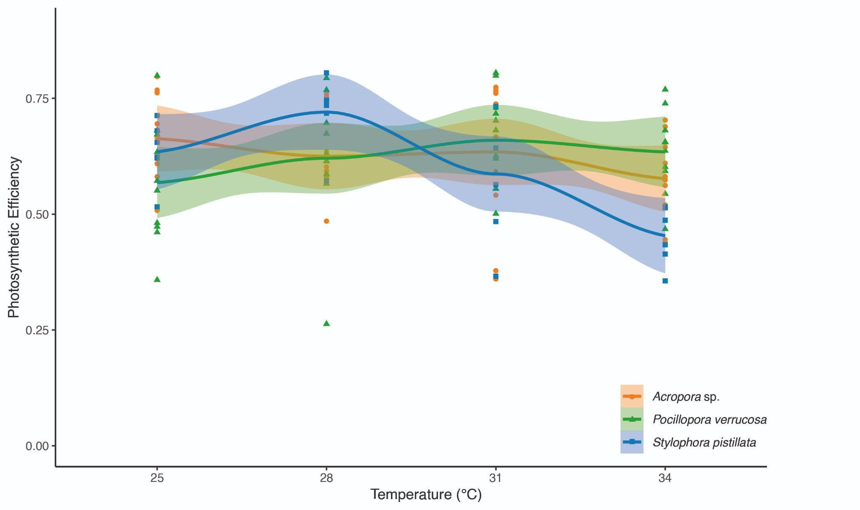
Supplementary Figure S1: Photosynthetic efficiency (F_{v}/F_{m}) of Acropora sp. (orange), Pocillopora verrucosa (green) and Stylophora pistillata (blue) measured in classical CBASS assay conducted in winter (February) 2024 using 25°C, 28°C, 31°C and 34°C as target temperatures. Chosen temperatures did not alter the photosynthetic efficiency of the hard coral species below 50 % to calculate the corresponding thermal tolerance thresholds (ED50).

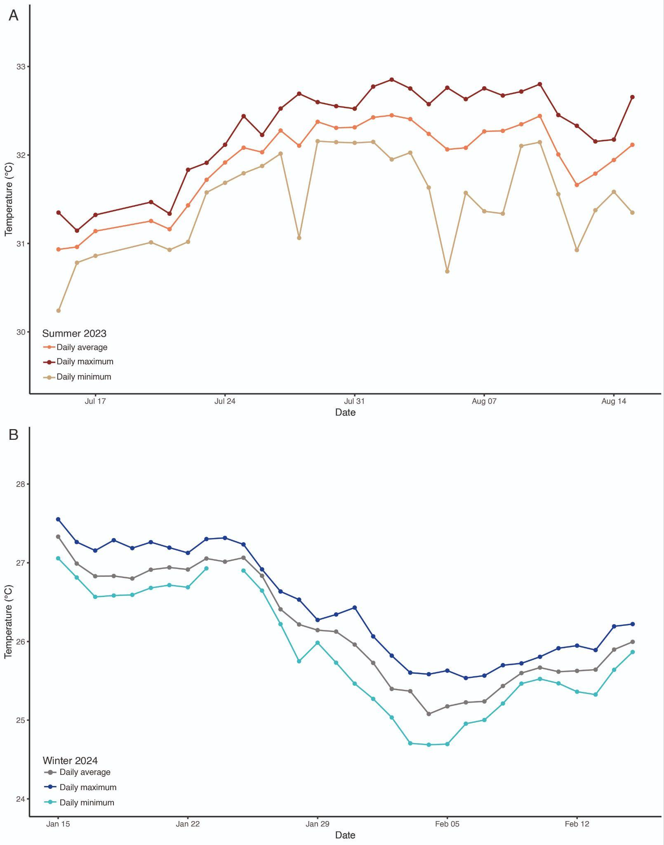

Supplementary Figure S2: Daily average, maximum and minimum in-situ temperatures measured in the Coral Probiotic Village (CPV), Al Fahal reef, Central Red Sea, before and during the experimental periods in summer 2023 (A) and winter 2024 (B).

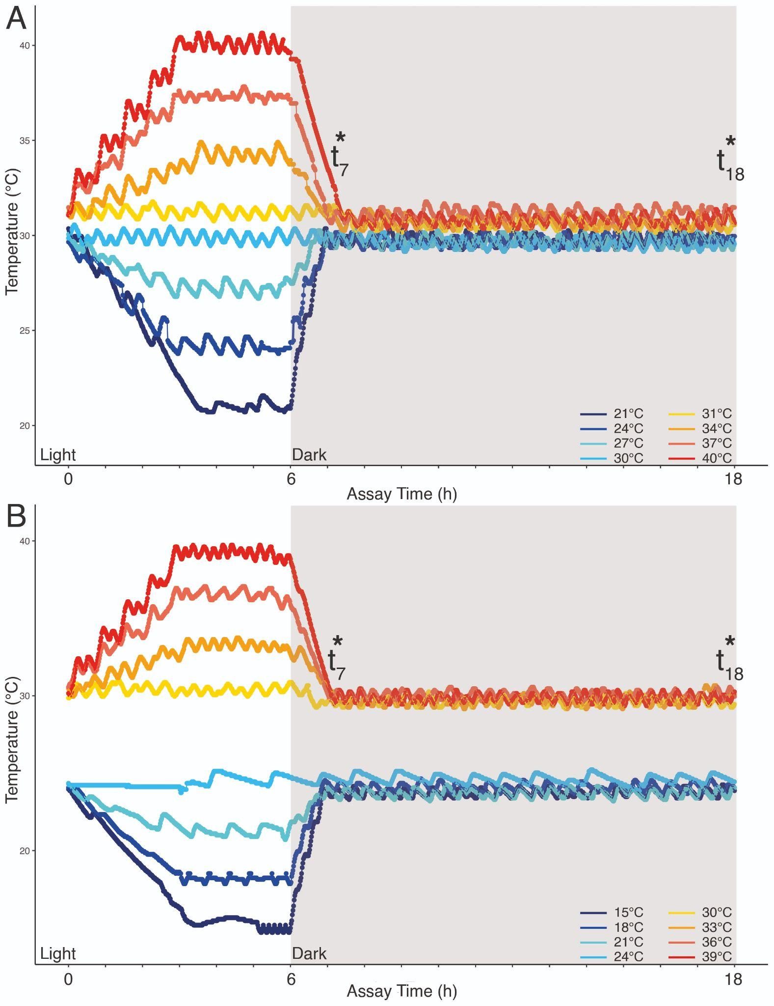

Supplementary Figure S3: Temperature profiles for 18-hour heat and cold acute temperature stress assays conducted in summer 2023 (A) and winter 2024 (B). Start and end times for the assays are indicated below the x-axis; asterisks indicate the time point of dark-adapted photosynthetic efficiency measurements immediately after the stress phase (t₇) and after an 11-hour recovery period (t₁₈).

Supplementary Table S2: Results of Spearman rank correlation for heat (red) and cold (blue) ED50 thresholds for the three most dominant bacterial families (Endozoicomonaceae, Rhodobacteraceae, Simkaniaceae) for all three coral species of the present study during summer (heat ED50) and winter (cold ED50), with rho values indicating the strength and direction of the investigated relationships and p-values indicating statistical significance with p < 0.05. Asterisks indicate values close to statistical significance. NA indicating insufficient replication.
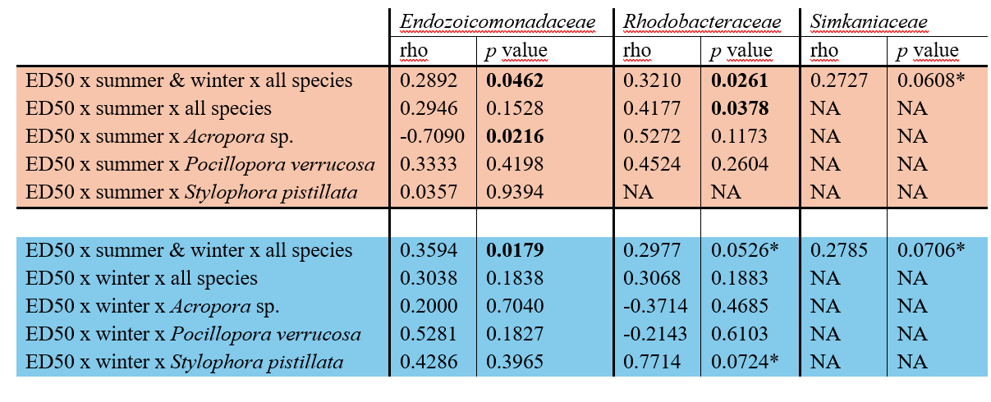

Supplementary Table S3: Comparisons of calculated ED50 from classical and cold CBASS assays in summer and winter for Acropora sp., Pocillopora verrucosa, and Stylophora pistillata presenting Dunn’s multiple comparison post-hoc test. Given values are adjusted p-values with the Holm method (see method section for further details). In case ‘n/a’ is reported, Kruskal Wallis test did not show any significant results. Significant values with p < 0.05 are given in bold.

Comparison | Classical CBASS - Summer | Cold CBASS - Summer | Classical CBASS- Winter | Cold CBASS- Winter
Acropora sp. - P. verrucosa | 0.026 | 0.099 | n/a | 0.15
Acropora sp. - S. pistillata | 0.395 | 0.59 | n/a | 0.012
P. verrucosa - S. pistillata | 0.257 | 0.076 | n/a | 0.147

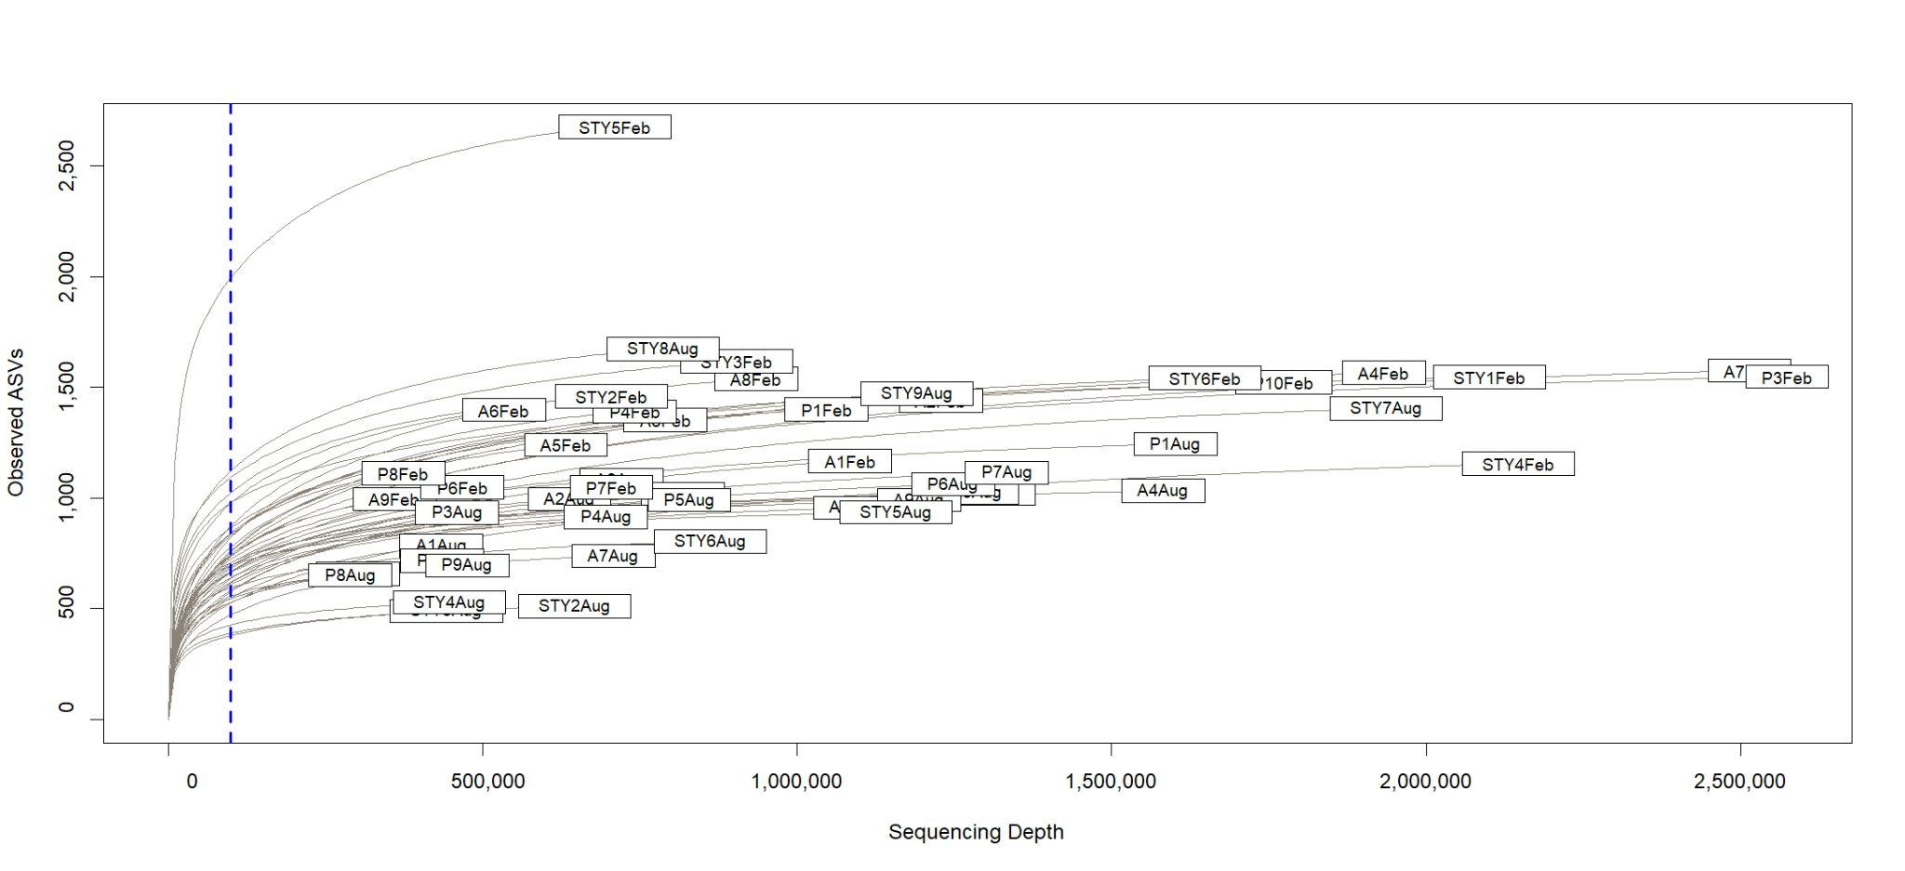
Supplementary Figure S4: Rarefaction curve (rarefaction was applied at 100,000 reads, blue dotted line) for all specimens of the three targeted coral species’ microbiome data (Acropora sp. = ‘A’; Pocillopora verrucosa = ‘P”’; and Stylophora pistillata = ‘STY’, respectively) for both summer 2023 (‘Aug’) and winter 2024 (‘Feb’).

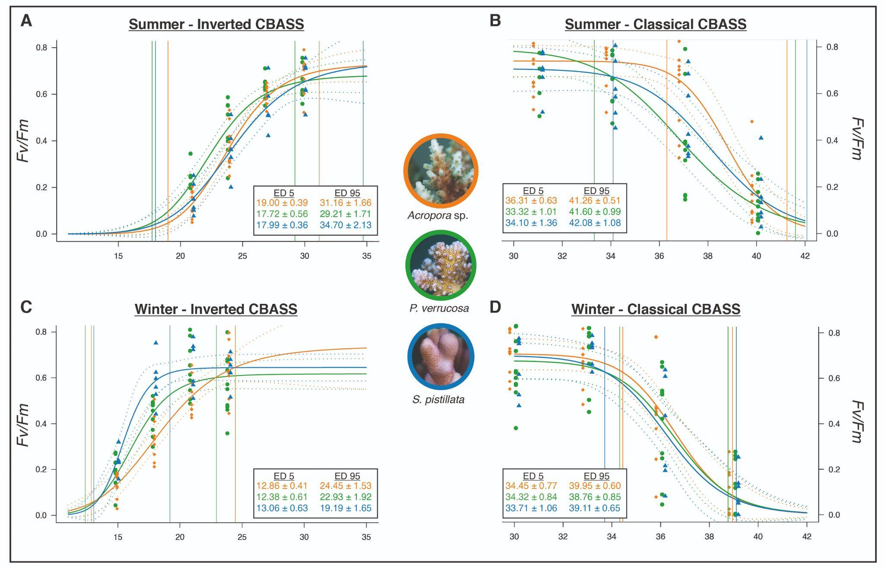
Supplementary Figure S5: Calculated effective dose 5 (ED5) and effective dose 95 (ED95) changes in Fv/Fm with cold (A, C) and heat (B, D) assay temperature profiles for each CBASS experiment performed in summer (A, B) and winter (C, D) using Acropora sp. (orange), Pocillopora verrucosa (green) and Stylophora pistillata (blue). Dots, triangles and squares, respectively, represent the measured photosynthetic efficiency (Fv/Fm) at each experimental temperature for each CBASS assay and species. Lines reflect the log-logistic model fitted to each experiment (see methods) with dotted lines indicating the 95% confidence intervals of each log-logistic model. Color-coded temperature values show the ED5 and ED95 of each species in °C ± standard error. Representative pictures of the coral species taken by Matteo Monti.

Supplementary Table S4: Decline width (DW, in °C) expressed as DW = ED95 – ED5 (see Supplementary Fig. S5) as an approximation to describe the shape of the fitted F_{v}/F_{m} response curves (wide or narrow) as shown in Fig. 2 and Supplementary Figure S5.
Species | Heat CBASS - Summer | Cold CBASS - Summer | Heat CBASS - Winter | Cold CBASS - Winter
Acropora sp. | 4.95 ± 0.92 | 12.16 ± 2.11 | 4.50 ± 1.11 | 11.59 ± 1.57
Pocillopora verrucosa | 8.28 ± 1.99 | 11.50 ± 2.28 | 4.44 ± 1.57 | 10.53 ± 2.44
Stylophora pistillata | 7.98 ± 2.52 | 16.71 ± 2.59 | 5.40 ± 1.50 | 6.13 ± 2.50

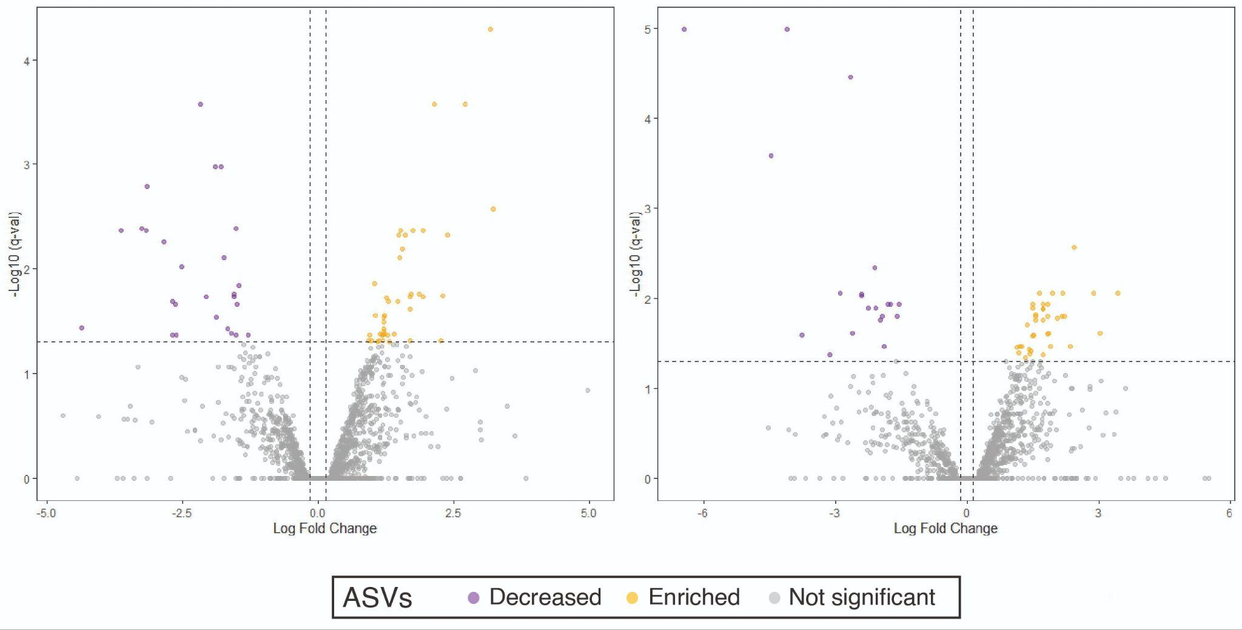
Supplementary Figure S6: Volcano plots displaying differentially abundant ASVs (dots) identified in the ANCOM-BC2 analysis for Acropora sp. (left; n = 69 differentially abundant ASVs in summer compared to winter) and Pocillopora verrucosa (right; n = 49 differentially abundant ASVs in summer compared to winter). The log fold change (X-axis) and the p-adj. (Y-axis) value for each ASV is represented. Yellow dots indicate enriched ASVs and purple dots indicate decreased ASVs with a q value (adjusted p value) < 0.05. ASVs that are not significantly different in abundance between seasons (summer vs. winter) are colored gray. Note: Different scales for y-axes; no significant changes in ASVs between summer and winter were observed for Stylophora pistillata, hence it is missing in this figure.

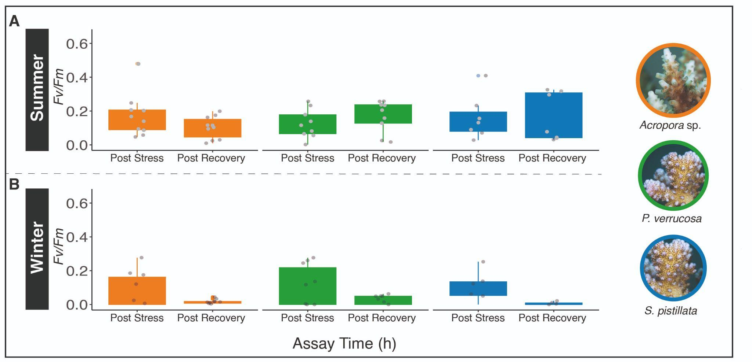
Supplementary Figure S7: Photosynthetic efficiency (F_{v}/F_{m}) at the most extreme heat CBASS assay temperatures (i.e., 40°C in summer, 39°C in winter) measured immediately after the stress phase (t7) and an 11-hour recovery phase (t18) in summer (A) and winter (B) for Acropora sp. (orange), Pocillopora verrucosa (green), and Stylophora pistillata (blue).
References
Banks, S. ;, Vera, M. ;, & Chiriboga, A. (2009). Establishing reference points to assess long-term change in zooxanthellate coral communities of the northern Galapagos coral reefs. Galapagos Research. http://hdl.handle.net/1834/36274
Coles, S. L., & Fadlallah, Y. H. (1991). Coral Reefs Reef coral survival and mortality at low temperatures in the Arabian Gulf: new species-specific lower temperature limits. In Coral Reefs (Vol. 9).
Davis, G. E. (1982). A Century of Natural Change in Coral Distribution at the Dry Tortugas: A Comparison of Reef Maps from 1881 and 1976. Bulletin of Marine Science, 32, 608–623.
Foreman, A. D., Duprey, N. N., Yuval, M., Dumestre, M., Leichliter, J. N., Rohr, M. C., Dodwell, R. C. A., Dodwell, G. A. S., Clua, E. E. G., Treibitz, T., & Martínez-García, A. (2024). Severe cold-water bleaching of a deep-water reef underscores future challenges for Mesophotic Coral Ecosystems. Science of the Total Environment, 951. https://doi.org/10.1016/j.scitotenv.2024.175210
Glynn, P. W., Riegl, B., Correa, A. M. S., & Baums, I. B. (2009). Rapid recovery of a coral reef at Darwin Island, Galapagos Islands. Galapagos Research. http://hdl.handle.net/1834/36237
Hernández, L., Reyes-Bonilla, H., & Balart, E. F. (2010). Effect of coral bleaching induced by low temperature on reef-associated decapod crustaceans of the southwestern Gulf of California. Revista Mexicana de Biodiversidad, 81, 113–119.
Hoegh-Guldberg, O., & Fine, M. (2004). Low temperatures cause coral bleaching. Coral Reefs, 23(3), 444. https://doi.org/10.1007/s00338-004-0401-2
Hoegh-Guldberg, O., Fine, M., Skirving, W., Johnstone, R., Dove, S., & Strong, A. (2005). Coral bleaching following wintry weather. Limnology and Oceanography, 50(1), 265–271. https://doi.org/10.4319/lo.2005.50.1.0265
Hudson, J. H. (1981). Response of Montastrea annularis to environmental change in the Florida Keys. Proceedings of the 4th International Coral Reef Symposium.
Hudson, J. H., Shinn, E. A., Halley, R. B., & Lidz, B. (1976). Sclerochronology: A tool for interpreting past environments. Geology, 4, 361–364. http://pubs.geoscienceworld.org/gsa/geology/article-pdf/4/6/361/3541223/i0091-7613-4-6-361.pdf
Kemp, D. W., Oakley, C. A., Thornhill, D. J., Newcomb, L. A., Schmidt, G. W., & Fitt, W. K. (2011). Catastrophic mortality on inshore coral reefs of the Florida Keys due to severe low-temperature stress. Global Change Biology, 17(11), 3468–3477. https://doi.org/10.1111/j.1365-2486.2011.02487.x
LaJeunesse, T. C., Smith, R., Walther, M., Pinzón, J., Pettay, D. T., McGinley, M., Aschaffenburg, M., Medina-Rosas, P., Cupul-Magaña, A. L., Pérez, A. L., Reyes-Bonilla, H., & Warner, M. E. (2010). Host-symbiont recombination versus natural selection in the response of coral-dinoflagellate symbioses to environmental disturbance. Proceedings of the Royal Society B: Biological Sciences, 277(1696), 2925–2934. https://doi.org/10.1098/rspb.2010.0385
Lirman, D., Schopmeyer, S., Manzello, D., Gramer, L. J., Precht, W. F., Muller-Karger, F., Banks, K., Barnes, B., Bartels, E., Bourque, A., Byrne, J., Donahue, S., Duquesnel, J., Fisher, L., Gilliam, D., Hendee, J., Johnson, M., Maxwell, K., McDevitt, E., … Thanner, S. (2011). Severe 2010 cold-water event caused unprecedented mortality to corals of the Florida reef tract and reversed previous survivorship patterns. PLoS ONE, 6(8). https://doi.org/10.1371/journal.pone.0023047
Olivier, D., Quiñonez-Valenzuela, F., Hernández, L., & Reyes-Bonilla, H. (2023). Bleaching coral event due to cold waters in the Gulf of California: effect on Pocillopora cryptofauna. Coral Reefs, 42(5), 1175–1185. https://doi.org/10.1007/s00338-023-02422-3
Paz-García, D. A., Balart, E. F., & García-De-Léon, F. J. (2012). Cold water bleaching of Pocillopora in the Gulf of California (Issue 13). http://las.pfeg.noaa.gov/oceanWatch
Porter, J. W., Battey, J. F., & Smith, G. J. (1982). Perturbation and change in coral reef communities (Acropora cervicornis/spatial analysis/Dry Tortugas/temperature effects). In Population Biology UNIVERSITY OF SCIENCE & TECHNOLOGY KAUST on August (Vol. 79). https://www.pnas.org
Rich, W. A., Carvalho, S., & Berumen, M. L. (2022). Coral bleaching due to cold stress on a central Red Sea reef flat. Ecology and Evolution, 12(10). https://doi.org/10.1002/ece3.9450
Roberts, H. H., Rouse, L. J., Walker, N. D., & Hudson, J. H. (1982). Cold-water stress in Florida Bay and Northern Bahamas: a product of winter cold-air outbreaks. Journal of Sedimentary Petrology, 51. http://pubs.geoscienceworld.org/sepm/jsedres/article-pdf/52/1/145/2808645/145.pdf
Shinn, E. A. (1966). Coral Growth-Rate, an Environmental Indicator. Source: Journal of Paleontology, 40(2), 233–240.
Shinn, E. A. (1975). Coral Reef Recovery in Florida and the Persian Gulf. Environmental Geology, 1, 241–254.
Voss, G. L. (1973). Sickness and Death in Florida’s coral reefs. Natural History, 72, 41–47.
Walker, N. D., Roberts, H. H., Rouse, L. J., & Huh, O. K. (1982). Thermal History of Reef-Associated Environments During a Record Cold-Air Outbreak Event. In Coral Reefs (Vol. 1).
Wilson, E. C. (1988). The Hermatypic Coral Pocillopora at Cabo San Lucas, Mexico. Bulletin Southern California Academic Science. http://meridian.allenpress.com/scasbulletin/article-pdf/87/2/79/3154837/i0038-3872-87-2-79.pdf
Wilson, E. C. (1990). Mass Mortality of the Reef Coral Pocillopora on the South Coast of Baja California Sur, Mexico. Bulletin Southern California Academic Science, 80, 39. http://meridian.allenpress.com/scasbulletin/article-pdf/89/1/39/3154642/i0038-3872-89-1-39.pdf

