Supplementary File 2
Periodontitis and the risk of all-cause and cause-specific mortality among individuals with osteoarthritis in U.S.: A population-based cohort study

Table of Contents
- Supplementary Tables and Figures title................................................................2
- Supplementary Tables.............................................................................................3
- Supplementary Figures ........................................................................................18

Supplementary Tables and Figures title
Supplementary Table 1. Details regarding the missing rate and multiple imputation methods of covariates
Supplementary Table 2. Socioeconomic characteristics of participants with osteoarthritis according to periodontal status
Supplementary Table 3. Event Numbers and crude absolute mortality for all-cause and cause-specific mortality in participants with osteoarthritis
Supplementary Table 4. Stratified analyses of the associations between periodontitis and all-cause and cause-specific mortality among participates with osteoarthritis
Supplementary Table 5. The results of the sensitivity analysis of duration> 2 years
Supplementary Table 6. The results of the sensitivity analysis of omitted participants with cancer or CVD
Supplementary Table 7. Baseline characteristics of participants of original data with osteoarthritis according to periodontal status
Supplementary Table 8. The results of the sensitivity analysis of original data without multiple interpolation
Supplementary Table 9. Baseline characteristics of participants of complete data with osteoarthritis according to periodontal status
Supplementary Table 10. The results of the sensitivity analysis of complete data without multiple interpolation
Supplementary Table 11. The results of the sensitivity analysis of participants only with major osteoarthritis

Supplementary Figures
Supplementary Fig. 1. Flowchart of the study participants
Supplementary Fig. 2. The results of directed acyclic graphs (DAGs)
Supplementary Fig. 3. Details of the socioeconomic status (SES) classification using latent class analysis

Supplementary Tables:
Supplementary Table 1. Details regarding the missing rate and multiple imputation methods of covariates
Covariate | Variable type | defect rate, % | imputation method*
Age | continuous | No missing values | /
Gender | categorical | No missing values | /
Race/ ethnicity | categorical | No missing values | /
Socioeconomic index | categorical | 1.362 | BMLR
Poverty income ratio | categorical | 1.042 | BMLR
Health insurance | categorical | 6.731 | BMLR
Education levels | categorical | 0.641 | BMLR
Smoking status | categorical | 0.321 | /
Drinking status | categorical | No missing values | BMLR
Physical status | categorical | 2.244 | /
Healthy eating index | categorical | No missing values | BMLR
Body mass index, kg/m² | continuous | 1.763 | PMM
Hypertension | categorical | 0.641 | /
Diabetes mellitus | categorical | No missing values | /
*PMM was used to continuous covariates and BMLR was used to categorical covariates.
PMM:predicting mean matching; BMLR:Bayesian multivariate logistic regression

Supplementary Table 2. Socioeconomic characteristics of participants with major osteoarthritis according to periodontal status
 |  |  | Periodontal status
 | Over all |  | No/ Mild periodontitis |  | Moderate/ Severe periodontitis
Characteristics | Mean/ %* | SE* | Mean/ % | SE | Mean/ % | SE | P†
No. (Unweighted) | 1248 |  | 740 |  | 508
No. (Weighted) | 13,643,072 |  | 4,926,496 |  | 8,716,576
Socioeconomic index, % |  |  |  |  |  |  | 0.598
Unemployment | 15.6 | 1.4 | 15.4 | 1.7 | 15.9 | 2.3
Lower | 60 | 1.7 | 59 | 2.2 | 61.8 | 2.7
Upper | 24.4 | 1.5 | 25.6 | 1.8 | 22.3 | 2.9
Poverty income ratio, % |  |  |  |  |  |  | 0.030
<1.00 | 8.1 | 1.1 | 7.3 | 1.2 | 9.5 | 1.6
1.00-3.99 | 50.6 | 1.8 | 48.2 | 2.4 | 54.8 | 2.9
≥4.00 | 41.3 | 2 | 44.4 | 2.5 | 35.7 | 2.9
Health insurance, % |  |  |  |  |  |  | 0.269
No insurance | 6 | 0.9 | 5.8 | 1.1 | 6.3 | 1.6
Public insurance only | 20.5 | 1.7 | 18.8 | 1.7 | 23.6 | 3.1
Private insurance | 73.5 | 1.9 | 75.4 | 1.8 | 70.1 | 3.4
Education levels, % |  |  |  |  |  |  | 0.012
Less than high school | 18.1 | 1.4 | 14.8 | 1.7 | 24.1 | 2.7
High school or equivalent | 23.1 | 1.4 | 25.3 | 2.3 | 19.1 | 2.4
Hispanic | 4.8 | 0.8 | 4.5 | 0.8 | 5.3 | 1.3
Socioeconomic Status, % |  |  |  |  |  |  | 0.140
Low | 11.6 | 1.3 | 10.5 | 1.3 | 13.5 | 2.2
Medium | 55.4 | 1.9 | 54.2 | 2.3 | 57.3 | 3
High | 33.1 | 1.9 | 35.3 | 2.3 | 29.2 | 3.1
* Normally distributed continuous variables are described as means ± SEs; Categorical variables are presented as numbers (percentages). All estimates accounted for complex survey designs.
† The t test was used for continuous variables and the χ test for categorical variables.
‡ Income, education level, occupation, and insurance was integrated into SES (Socioeconomic Status), to better measure the economic and social status of participants. Latent class analysis was used to generate SES, which was ultimately divided into three mutually exclusive latent classes: high, medium, and low level.

Supplementary Table 3. Event Numbers and crude absolute mortality for all-cause and cause-specific mortality in participants with osteoarthritis
Outcome | No/Mild periodontitis |  | Moderate/Severe periodontitis
Outcome | Events, n/N | Incidence Rate (95% CI) | Events, n/N | Incidence Rate (95% CI)
All  cause | 1,994,296/  4,926,496 | 18.17  (18.15-18.19) | 2,356,381/  8,716,576 | 32.02 (31.97-32.06)
CVD-  related | 573,816/  4,926,496 | 5.58 (5.57-5.59) | 723,976/  8,716,576 | 9.21 (9.19-9.24)
Cancer-  related | 389,289/  4,926,496 | 3.97 (3.95-3.98) | 514,286/  8,716,576 | 6.26 (6.24-6.28)
CVD: cardiovascular disease.

Supplementary Table 4. Stratified analyses of the associations between periodontitis and all-cause and cause-specific mortality among participates with osteoarthritis
 | Periodontal status
 | No/Mild periodontitis | Moderate/Severe periodontitis | P
All cause*
Age <45† | 1.00 [Reference] | 1.13 (0.78, 1.63) | 0.519
Age ≥45 | 1.00 [Reference] | 1.56 (0.91, 2.66) | 0.106
Male | 1.00 [Reference] | 0.90 (0.61, 1.34) | 0.605
Female | 1.00 [Reference] | 1.60 (1.19, 2.16) | 0.002
CVD-related*
Age <45 | 1.00 [Reference] | 0.94 (0.54, 1.63) | 0.822
Age ≥45 | 1.00 [Reference] | 1.52 (0.56, 4.13) | 0.411
Male | 1.00 [Reference] | 0.50 (0.26, 0.98) | 0.044
Female | 1.00 [Reference] | 1.89 (1.18, 3.02) | 0.008
Cancer-related*
Age <45 | 1.00 [Reference] | 1.13 (0.52, 2.47) | 0.75
Age ≥45 | 1.00 [Reference] | 1.63 (0.71, 3.75) | 0.247
Male | 1.00 [Reference] | 1.68 (0.61, 4.63) | 0.312
Female | 1.00 [Reference] | 0.96 (0.50, 1.87) | 0.914
* All-cause mortality used Cox proportional hazards model, and cause-specific mortality used competing risk model. All the models were adjusted for age (30-44, 45-64 or ≥65 years old), gender (male and female), race/ethnicity (non-Hispanic white, non-Hispanic black, Hispanic, and other races), SES (high, medium, and low level), alcohol consumption (nondrinkers, heavier drinkers, and light/moderate drinkers), physical activity status (inactive, insufficient, recommended), BMI status (body mass index, normal, overweight, and obesity), HTN status (hypertension, yes or no), HPL (hyperlipidemia status, yes or no), and diabetes status (yes or no). Stratified variables are excluded from the covariates of the models included in the group.
†When stratified analyses are performed, the covariates for constructing the model remain grouped as described above and simplifying the grouped variables into two groups: Age (<45, ≥45 years old), Gender (male and female)

Supplementary Table 5. The results of the sensitivity analysis of duration> 2 years
 | Periodontal status
 | No/ Mild periodontitis | Moderate/ Severe periodontitis | P
All cause*
Deaths/total (Unweighted) | 249/719 | 253/489
Deaths/total (Weighted) | 1,871,660/4,803,860 | 2,216,749/8,576,944
Model 1† | 1.00 [Reference] | 1.96 (1.54, 2.50) | <0.001
Model 2‡ | 1.00 [Reference] | 1.34 (1.04, 1.73) | 0.025
Model 3§ | 1.00 [Reference] | 1.31 (1.01, 1.70) | 0.040
Model 4¶ | 1.00 [Reference] | 1.34 (1.02, 1.77) | 0.036
CVD-related
Deaths/total (Unweighted) | 91/719 | 84/489
Deaths/total (Weighted) | 492,618/4,803,860 | 672,649/8,576,944
Model 1 | 1.00 [Reference] | 1.71 (1.17, 2.49) | 0.006
Model 2 | 1.00 [Reference] | 1.08 (0.73, 1.59) | 0.709
Model 3 | 1.00 [Reference] | 1.07 (0.73, 1.59) | 0.721
Model 4 | 1.00 [Reference] | 1.05 (0.70, 1.57) | 0.831
Cancer-related
Deaths/total (Unweighted) | 50/719 | 46/489
Deaths/total (Weighted) | 364,400/4,803,860 | 464,599/8,576,944
Model 1 | 1.00 [Reference] | 1.81 (1.06, 3.06) | 0.028
Model 2 | 1.00 [Reference] | 1.35 (0.79, 2.33) | 0.277
Model 3 | 1.00 [Reference] | 1.26 (0.71, 2.25) | 0.428
Model 4 | 1.00 [Reference] | 1.42 (0.77, 2.64) | 0.261
* All-cause mortality used Cox proportional hazards model, and cause-specific mortality used competing risk model.
† Model 1 was univariate analysis.
‡ Model 2 included age (30-44, 45-64 or ≥65 years old), gender, race/ethnicity (non-Hispanic white, non-Hispanic black, Hispanic or other races), SES (Socioeconomic Status, low, middle, high).
§ Model 3 additionally included smoking habit (never smokers, former or current smokers), alcohol consumption (nondrinker, heavier drinker, or light/ moderate drinker), physical activity status (inactive, insufficient, recommended) and BMI status (body measure index, normal (≤24.9 [kg/m²]), overweight (25.0-29.9 [kg/m²]), and obesity (≥30.0 [kg/m²]) based on Model 2.
¶ Model 4 was further adjusted for HTN status (hypertension, yes or no) , HPL (hyperlipidemia, yes or no), and diabetes status (yes or no) based on Model 3.

Supplementary Table 6. The results of the sensitivity analysis of omitted participants with cancer or CVD
 | Periodontal status
 | No/ Mild periodontitis | Moderate/ Severe periodontitis | P
All cause*
Deaths/total (Unweighted) | 249/719 | 253/489
Deaths/total (Weighted) | 1,871,660/4,803,860 | 2,216,749/8,576,944
Model 1† | 1.00 [Reference] | 1.96 (1.54, 2.50) | <0.001
Model 2‡ | 1.00 [Reference] | 1.34 (1.04, 1.73) | 0.025
Model 3§ | 1.00 [Reference] | 1.31 (1.01, 1.70) | 0.040
Model 4¶ | 1.00 [Reference] | 1.34 (1.02, 1.77) | 0.036
CVD-related
Deaths/total (Unweighted) | 91/719 | 84/489
Deaths/total (Weighted) | 492,618/4,803,860 | 672,649/8,576,944
Model 1 | 1.00 [Reference] | 1.71 (1.17, 2.49) | 0.006
Model 2 | 1.00 [Reference] | 1.08 (0.73, 1.59) | 0.709
Model 3 | 1.00 [Reference] | 1.07 (0.73, 1.59) | 0.721
Model 4 | 1.00 [Reference] | 1.05 (0.70, 1.57) | 0.831
Cancer-related
Deaths/total (Unweighted) | 50/719 | 46/489
Deaths/total (Weighted) | 364,400/4,803,860 | 464,599/8,576,944
Model 1 | 1.00 [Reference] | 1.81 (1.06, 3.06) | 0.028
Model 2 | 1.00 [Reference] | 1.35 (0.79, 2.33) | 0.277
Model 3 | 1.00 [Reference] | 1.26 (0.71, 2.25) | 0.428
Model 4 | 1.00 [Reference] | 1.42 (0.77, 2.64) | 0.261
* All-cause mortality used Cox proportional hazards model, and cause-specific mortality used competing risk model.
† Model 1 was univariate analysis.
‡ Model 2 included age (30-44, 45-64 or ≥65 years old), gender, race/ethnicity (non-Hispanic white, non-Hispanic black, Hispanic or other races), SES (Socioeconomic Status, low, middle, high) .
§ Model 3 additionally included smoking habit (never smokers, former or current smokers), alcohol consumption (nondrinker, heavier drinker, or light/ moderate drinker), physical activity status (inactive, insufficient, recommended) and BMI status (body measure index, normal (≤24.9 [kg/m²]), overweight (25.0-29.9 [kg/m²]), and obesity (≥30.0 [kg/m²]) based on Model 2.
¶ Model 4 was further adjusted for HTN status (hypertension, yes or no), HPL (hyperlipidemia, yes or no), and diabetes status (yes or no) based on Model 3.

Supplementary Table 7. Baseline characteristics of participants of original data with osteoarthritis according to periodontal status
 |  |  |  | Periodontal status
 | Over all |  |  | No/ Mild periodontitis |  | Moderate/ Severe periodontitis
Characteristics | Mean/ %* |  | SE* | Mean/ % | SE | Mean/ % |  | SE | P†
No.(Unweighted) | 1,248 |  |  | 740 |  | 508
No.(Weighted) | 13,643,072 |  |  | 4,926,496 |  | 8,716,576
Age (years), mean | 59.8 | 0.4 |  | 58 | 0.5 | 62.9 | 0.7 |  | <0.001
Age status, % |  |  |  |  |  |  |  |  | <0.001
<45 | 11.8 | 1.2 |  | 14.2 | 1.7 | 7.4 | 1.6
[45, 65) | 51.5 | 2 |  | 55.5 | 2.4 | 44.5 | 2.8
≥65 | 36.7 | 1.7 |  | 30.3 | 2 | 48.1 | 3
Gender, Female | 65 | 1.8 |  | 71.8 | 2.1 | 52.9 | 3.2 |  | <0.001
Race/ ethnicity, % |  |  |  |  |  |  |  |  | 0.315
Non-Hispanic white | 86.1 | 1.4 |  | 87.4 | 1.4 | 83.9 | 2.3
Non-Hispanic black | 6.3 | 0.7 |  | 5.9 | 0.8 | 7.1 | 1.2
Hispanic | 4.8 | 0.8 |  | 4.5 | 0.8 | 5.3 | 1.3
Other race/ ethnicity | 2.8 | 0.9 |  | 2.3 | 0.9 | 3.6 | 1.5
Socioeconomic Status, % |  |  |  |  |  |  |  |  | 0.140
Low | 42.8 | 2.4 |  | 36.1 | 2.6 | 56.9 | 3.7
Medium | 32.8 | 2.0 |  | 35.5 | 2.3 | 27.2 | 3.1
High | 24.4 | 2.1 |  | 28.4 | 2.5 | 15.9 | 3.2
Smoking habit, % |  |  |  |  |  |  |  |  | 0.018
Never smoker | 49.2 | 1.7 |  | 53.6 | 2.6 | 41.4 | 3.4
Former smoker | 36.6 | 1.8 |  | 33.9 | 2.6 | 41.3 | 3.2
Current smoker | 14.2 | 1.4 |  | 12.5 | 1.5 | 17.3 | 2.7
Alcohol consumption, % |  |  |  |  |  |  |  |  | 0.067
Nondrinker | 12 | 1.4 |  | 13.5 | 2 | 9.3 | 1.8
Light/moderate drinker | 67.5 | 1.5 |  | 64.5 | 1.9 | 72.8 | 2.7
Heavier drinker | 20.5 | 1.5 |  | 22 | 2.1 | 17.9 | 2.4
Physical status, % |  |  |  |  |  |  |  |  | 0.187
Inactive | 18.5 | 1.5 |  | 18.9 | 2.1 | 17.8 | 2.1
Insufficient | 48.9 | 2 |  | 50.9 | 2.4 | 45.4 | 3.5
Recommended | 32.6 | 2 |  | 30.2 | 2.3 | 36.7 | 3.2
BMI, Mean | 29.6 | 0.2 |  | 29.7 | 0.3 | 29.2 | 0.4 |  | 0.342
BMI status (kg/m2), % |  |  |  |  |  |  |  |  | 0.469
<25 | 25.5 | 1.6 |  | 25.1 | 2.1 | 26.1 | 2.6
[25.0 -30) | 34.3 | 2.3 |  | 33.1 | 2.5 | 36.2 | 3.1
≥30 | 40.3 | 2 |  | 41.7 | 2.5 | 37.7 | 3
Comorbidities, %
Hypertension | 56.6 | 1.9 |  | 52.3 | 2.4 | 64.3 | 3 |  | 0.002
Hyperlipidemia | 70 | 2 |  | 68.2 | 2.4 | 73.2 | 3.2 |  | 0.165
Diabetes mellitus | 16.7 | 1.6 |  | 14.9 | 2 | 19.9 | 2.4 |  | 0.086
Cohort period, % |  |  |  |  |  |  |  |  | <0.001
NHANES III | 12.4 | 1.1 |  | 12.8 | 1.4 | 11.8 | 1.6
NHANES 1999-2004 | 56 | 2.9 |  | 61.8 | 2.9 | 45.8 | 4.4
NHANES 2009-2014 | 31.6 | 3.1 |  | 25.5 | 2.7 | 42.4 | 4.7
*Normally distributed continuous variables are described as means ± SEs; Categorical variables are presented as numbers (percentages). All estimates accounted for complex survey designs.
†The t test was used for continuous variables and the χ test for categorical variables.

Supplementary Table 8. The results of the sensitivity analysis of original data without multiple interpolation
 | Periodontal status
 | No/ Mild periodontitis | Moderate/ Severe periodontitis | P
All cause*
Deaths/total (Unweighted) | 270/740 | 272/508
Deaths/total (Weighted) | 1,994,296/4,926,496 | 2,356,381/8,716,576
Model 1† | 1.00 [Reference] | 1.93 (1.53, 2.45) | <0.001
Model 2‡ | 1.00 [Reference] | 1.31 (1.02, 1.68) | 0.034
Model 3§ | 1.00 [Reference] | 1.33 (1.03, 1.71) | 0.030
Model 4¶ | 1.00 [Reference] | 1.34 (1.04, 1.74) | 0.026
CVD-related
Deaths/total (Unweighted) | 99/740 | 93/508
Deaths/total (Weighted) | 573,816/4,926,496 | 723,876/8,716,576
Model 1 | 1.00 [Reference] | 1.80 (1.25, 2.59) | 0.002
Model 2 | 1.00 [Reference] | 1.14 (0.77, 1.69) | 0.513
Model 3 | 1.00 [Reference] | 1.16 (0.78, 1.74) | 0.454
Model 4 | 1.00 [Reference] | 1.09 (0.74, 1.61) | 0.667
Cancer-related
Deaths/total (Unweighted) | 57/740 | 51/508
Deaths/total (Weighted) | 389,829/4,926,496 | 514,286/8,716,576
Model 1 | 1.00 [Reference] | 1.71 (1.05, 2.77) | 0.031
Model 2 | 1.00 [Reference] | 1.24 (0.76, 2.03) | 0.381
Model 3 | 1.00 [Reference] | 1.23 (0.74, 2.06) | 0.426
Model 4 | 1.00 [Reference] | 1.45 (0.83, 2.53) | 0.198
* All-cause mortality used Cox proportional hazards model, and cause-specific mortality used competing risk model.
† Model 1 was univariate analysis.
‡ Model 2 included age (30-44, 45-64 or ≥65 years old), gender, race/ethnicity (non-Hispanic white, non-Hispanic black, Hispanic or other races), SES (Socioeconomic Status, low, middle, high).
§ Model 3 additionally included smoking habit (never smokers, former or current smokers), alcohol consumption (nondrinker, heavier drinker, or light/ moderate drinker), physical activity status (inactive, insufficient, recommended) and BMI (body measure index, normal (≤24.9 [kg/m²]), overweight (25.0-29.9 [kg/m²]), and obesity (≥30.0 [kg/m²]) based on Model 2.
¶ Model 4 was further adjusted for HTN status (hypertension, yes or no) , HPL (hyperlipidemia, yes or no),diabetes status (yes or no) and cohort period based on Model 3.

Supplementary Table 9. Baseline characteristics of participants of complete data with osteoarthritis according to periodontal status
 |  |  |  | Periodontal status
 | Over all |  |  | No/ Mild periodontitis |  | Moderate/ Severe periodontitis
Characteristics | Mean/ %* |  | SE* | Mean/ % | SE | Mean/ % |  | SE | P†
No.(Unweighted) | 1,081 |  |  | 631 |  | 450
No.(Weighted) | 12,031,132 |  |  | 4,319,149 |  | 7,711,983
Age (years), mean | 59.8 | 0.4 |  | 58 | 0.6 | 63 | 0.8 |  | <0.001
Age status, % |  |  |  |  |  |  |  |  | <0.001
<45 | 12 | 1.3 |  | 14.5 | 1.9 | 7.6 | 1.8
[45, 65) | 51.1 | 2.2 |  | 55 | 2.7 | 44.1 | 3
≥65 | 36.9 | 1.7 |  | 30.6 | 2.1 | 48.3 | 2.9
Gender, Female | 64.7 | 2 |  | 71.3 | 2.3 | 53 | 3.5 |  | <0.001
Race/ ethnicity, % |  |  |  |  |  |  |  |  | 0.234
Non-Hispanic white | 86.8 | 1.4 |  | 88.3 | 1.4 | 84 | 2.4
Non-Hispanic black | 5.9 | 0.7 |  | 5.1 | 0.7 | 7.4 | 1.2
Hispanic | 4.7 | 0.8 |  | 4.2 | 0.8 | 5.6 | 1.5
Other race/ ethnicity | 2.6 | 0.9 |  | 2.3 | 0.9 | 3 | 1.4
Socioeconomic Status, % |  |  |  |  |  |  |  |  | 0.141
Low | 11.3 | 1.4 |  | 10 | 1.3 | 13.6 | 2.5
Medium | 56.3 | 2.1 |  | 55.3 | 2.6 | 58 | 3.5
High | 32.4 | 2.2 |  | 34.7 | 2.4 | 28.4 | 3.8
Smoking habit, % |  |  |  |  |  |  |  |  | 0.017
Never smoker | 49.4 | 1.8 |  | 53.8 | 2.5 | 41.6 | 4
Former smoker | 37 | 1.9 |  | 35 | 2.7 | 40.6 | 3.8
Current smoker | 13.5 | 1.5 |  | 11.2 | 1.3 | 17.7 | 3
Alcohol consumption, % |  |  |  |  |  |  |  |  | 0.061
Nondrinker | 12.4 | 1.5 |  | 13.8 | 2 | 10 | 2
Light/moderate drinker | 67.8 | 1.7 |  | 64.7 | 2.2 | 73.4 | 2.6
Heavier drinker | 19.8 | 1.7 |  | 21.5 | 2.3 | 16.6 | 2.3
Physical status, % |  |  |  |  |  |  |  |  | 0.210
Inactive | 17.6 | 1.6 |  | 17.5 | 2.1 | 17.8 | 2.5
Insufficient | 50.4 | 2 |  | 52.7 | 2.5 | 46.3 | 3.7
Recommended | 32 | 2 |  | 29.8 | 2.3 | 35.9 | 3.2
BMI, Mean | 29.5 | 0.2 |  | 29.7 | 0.4 | 29.2 | 0.4 |  | 0.393
BMI status (kg/m2), % |  |  |  |  |  |  |  |  | 0.567
<25 | 25.4 | 1.6 |  | 25 | 2.2 | 26.3 | 2.7
[25.0 -30) | 34.3 | 2.4 |  | 33.5 | 2.7 | 35.8 | 3.3
≥30 | 40.3 | 1.8 |  | 41.6 | 2.6 | 37.9 | 2.8
Comorbidities, %
Hypertension | 57.6 | 2 |  | 53.1 | 2.5 | 65.8 | 3.3 |  | 0.002
Hyperlipidemia | 69.5 | 2.1 |  | 67.7 | 2.5 | 72.8 | 3.6 |  | 0.219
Diabetes mellitus | 16.8 | 1.6 |  | 14.9 | 2 | 20.2 | 2.6 |  | 0.091
Cohort period, % |  |  |  |  |  |  |  |  | <0.001
NHANES III | 12.3 | 1.2 |  | 12.6 | 1.6 | 11.7 | 1.7
NHANES 1999-2004 | 56.3 | 3.1 |  | 62.3 | 3.3 | 45.5 | 4.6
NHANES 2009-2014 | 31.5 | 3.2 |  | 25.1 | 3 | 42.9 | 4.8
*Normally distributed continuous variables are described as means ± SEs; Categorical variables are presented as numbers (percentages). All estimates accounted for complex survey designs.
†The t test was used for continuous variables and the χ test for categorical variables.

Supplementary Table 10. The results of the sensitivity analysis of complete data without multiple interpolation
 | Periodontal status
 | No/ Mild periodontitis | Moderate/ Severe periodontitis | P
All cause*
Deaths/total (Unweighted) | 169/558 | 158/340
Deaths/total (Weighted) | 1,116,540/3,436,951 | 1,535,650/6,776,694
Model 1† | 1.00 [Reference] | 1.92 (1.44, 2.57) | <0.001
Model 2‡ | 1.00 [Reference] | 1.28 (0.94, 1.75) | 0.120
Model 3§ | 1.00 [Reference] | 1.26 (0.91, 1.76) | 0.162
Model 4¶ | 1.00 [Reference] | 1.25 (0.89, 1.76) | 0.196
CVD-related
Deaths/total (Unweighted) | 55/558 | 55/340
Deaths/total (Weighted) | 347,564/3,436,951 | 402,068/6,776,694
Model 1 | 1.00 [Reference] | 2.28 (1.37, 3.80) | 0.001
Model 2 | 1.00 [Reference] | 1.44 (0.81, 2.55) | 0.214
Model 3 | 1.00 [Reference] | 1.46 (0.81, 2.64) | 0.208
Model 4 | 1.00 [Reference] | 1.14 (0.61, 2.15) | 0.685
Cancer-related
Deaths/total (Unweighted) | 39/558 | 30/340
Deaths/total (Weighted) | 201,245/3,436,951 | 345,018/6,776,694
Model 1 | 1.00 [Reference] | 1.48 (0.76, 2.89) | 0.252
Model 2 | 1.00 [Reference] | 1.11 (0.57, 2.15) | 0.757
Model 3 | 1.00 [Reference] | 1.10 (0.54, 2.26) | 0.795
Model 4 | 1.00 [Reference] | 1.34 (0.58, 3.11) | 0.489
* All-cause mortality used Cox proportional hazards model, and cause-specific mortality used competing risk model.
† Model 1 was univariate analysis.
‡ Model 2 included age (30-44, 45-64 or ≥65 years old), gender, race/ethnicity (non-Hispanic white, non-Hispanic black, Hispanic or other races), SES (Socioeconomic Status, low, middle, high) .
§ Model 3 additionally included smoking habit (never smokers, former or current smokers), alcohol consumption (nondrinker, heavier drinker, or light/ moderate drinker), physical activity status (inactive, insufficient, recommended) and BMI (body measure index, normal (≤24.9 [kg/m²]), overweight (25.0-29.9 [kg/m²]), and obesity (≥30.0 [kg/m²]) based on Model 2.
¶ Model 4 was further adjusted for HTN status (hypertension, yes or no) , HPL (hyperlipidemia, yes or no),diabetes status (yes or no) and cohort period based on Model 3.

Supplementary Table 11. The results of the sensitivity analysis of participants only with major osteoarthritis
 | Periodontal status
 | No/ Mild periodontitis | Moderate/ Severe periodontitis | P
All cause*
Deaths/total (Unweighted) | 223/631 | 240/450
Deaths/total (Weighted) | 1,739,071/4,319,149 | 1,991,062/7,711,983
Model 1† | 1.00 [Reference] | 2.06 (1.60, 2.67) | <0.001
Model 2‡ | 1.00 [Reference] | 1.45 (1.11, 1.88) | 0.006
Model 3§ | 1.00 [Reference] | 1.42 (1.08, 1.86) | 0.011
Model 4¶ | 1.00 [Reference] | 1.43 (1.11, 1.83) | 0.006
CVD-related
Deaths/total (Unweighted) | 86/631 | 89/450
Deaths/total (Weighted) | 545,724/4,319,149 | 623,684/7,711,983
Model 1 | 1.00 [Reference] | 2.04 (1.41, 2.97) | <0.001
Model 2 | 1.00 [Reference] | 1.33 (0.88, 1.99) | 0.173
Model 3 | 1.00 [Reference] | 1.32 (0.88, 1.98) | 0.184
Model 4 | 1.00 [Reference] | 1.20 (0.82, 1.76) | 0.353
Cancer-related
Deaths/total (Unweighted) | 45/631 | 38/450
Deaths/total (Weighted) | 252,258/4,319,149 | 408,947/7,711,983
Model 1 | 1.00 [Reference] | 1.43 (0.80, 2.56) | 0.231
Model 2 | 1.00 [Reference] | 1.07 (0.59, 1.92) | 0.822
Model 3 | 1.00 [Reference] | 1.04 (0.55, 1.95) | 0.901
Model 4 | 1.00 [Reference] | 1.14 (0.59, 2.19) | 0.700
* All-cause mortality used Cox proportional hazards model, and cause-specific mortality used competing risk model.
† Model 1 was univariate analysis.
‡ Model 2 included age (30-44, 45-64 or ≥65 years old), gender, race/ethnicity (non-Hispanic white, non-Hispanic black, Hispanic or other races), SES (Socioeconomic Status, low, middle, high) .
§ Model 3 additionally included smoking habit (never smokers, former or current smokers), alcohol consumption (nondrinker, heavier drinker, or light/ moderate drinker), physical activity status (inactive, insufficient, recommended) and BMI status (body measure index, normal (≤24.9 [kg/m²]), overweight (25.0-29.9 [kg/m²]), and obesity (≥30.0 [kg/m²]) based on Model 2.
¶ Model 4 was further adjusted for HTN status (hypertension, yes or no), HPL (hyperlipidemia, yes or no), and diabetes status (yes or no) based on Model 3.

- Supplementary Figures:
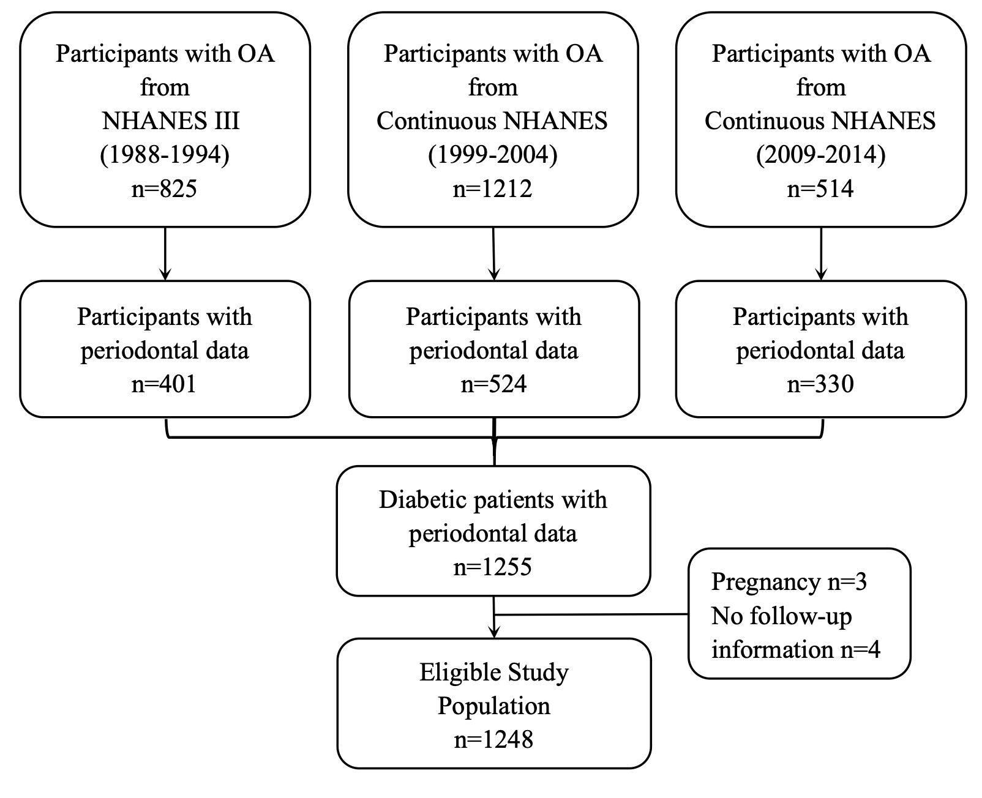
Supplementary Fig. 1. Flowchart of the study participants

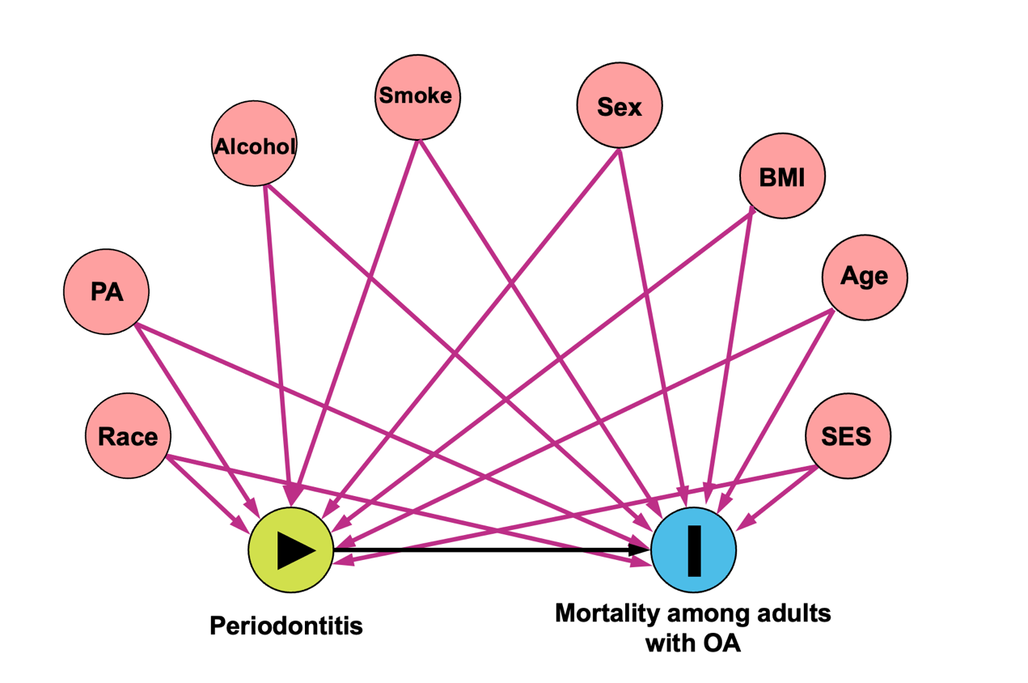
Supplementary Fig. 2. The results of directed acyclic graphs (DAGs). Nine covariates were selected into the minimal sufficient adjustment set. Including race / ethnicity, physical activity status (PA), alcohol consumption (Alcohol), smoking habit (Smoke), gender, body mass index (BMI), age, and socioeconomic status (SES).

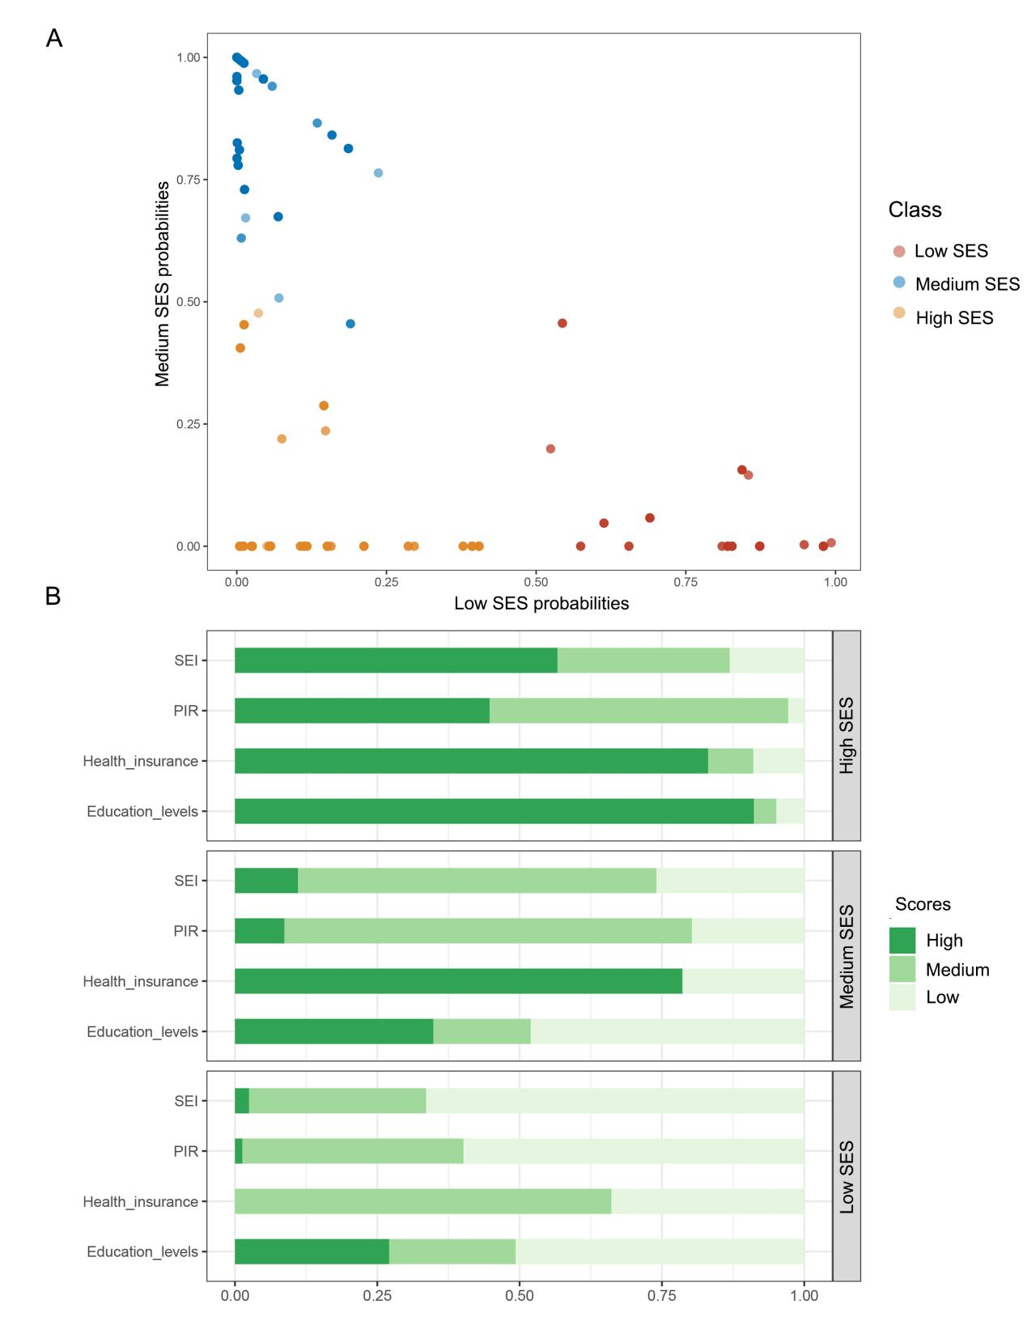
Supplementary Fig. 3. Details of the socioeconomic status (SES) classification using latent class analysis. A: Probability distribution of SES triple classification; B: Distribution of the characteristics of SES.
Feature definition: High: socioeconomic index (SEI): upper, Poverty Income Ratio (PIR): ≥4.00, insurance: private, education: college graduation or higher; Medium: SEI: lower, PIR: 1.00-3.99, insurance: public only, education: high school graduation or equivalent; Low: SEI: unemployment, PIR: <1.00, insurance: none, education: no high school graduation.

