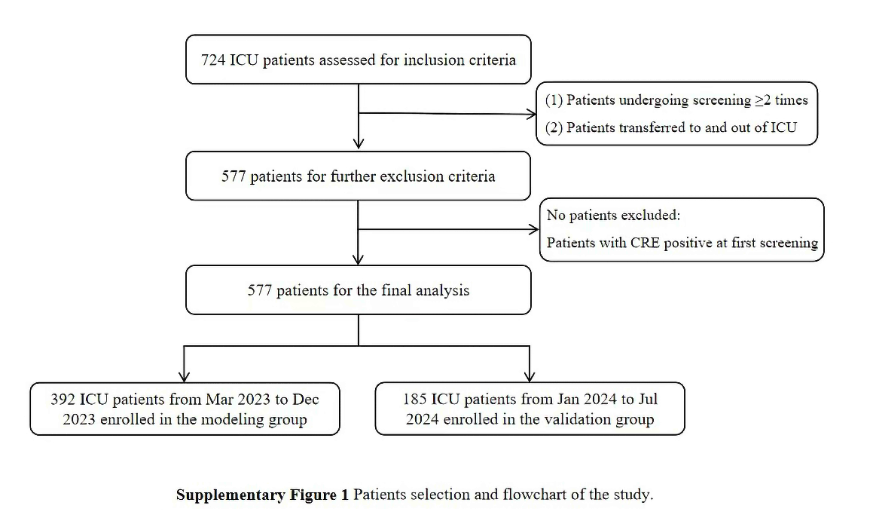
Supplementary Figure 1 Patients selection and flowchart of the study. ICU, Intensive Care Unit; CRE, Carbapenem-resistant Enterobacteriaceae.

